CSE 4308

Database Management Systems Lab

Lab-04

Group-B

Mohammod Mahbub Ur Rahman

220042148

BSc. in Software Engineering

**Tasks**

**1.**

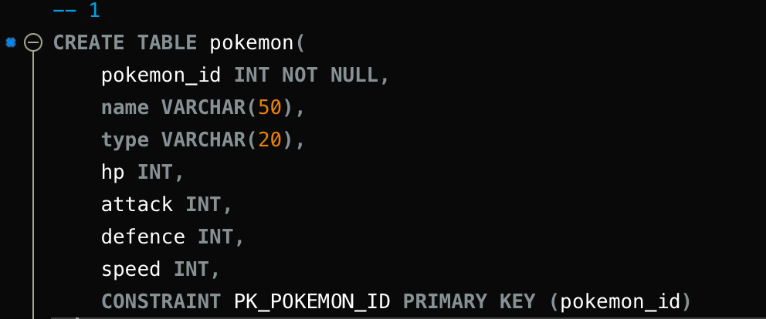

Here I am creating pokemon table. And setting pokemon_id as primary key.

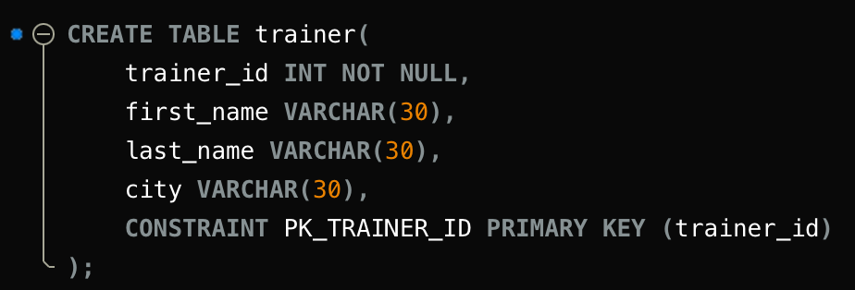

Here I am creating trainer table. And setting trainer_id as primary key.

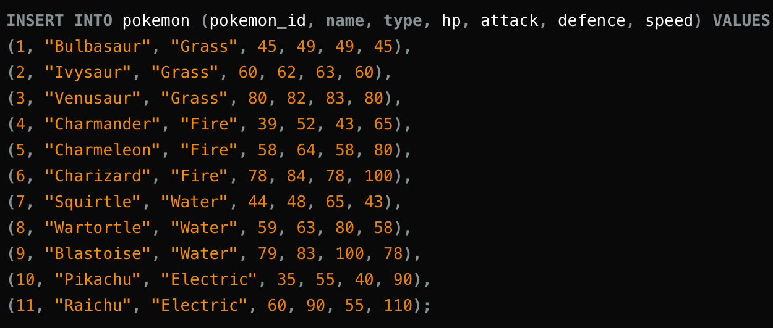

Inserting data into pokemon table.

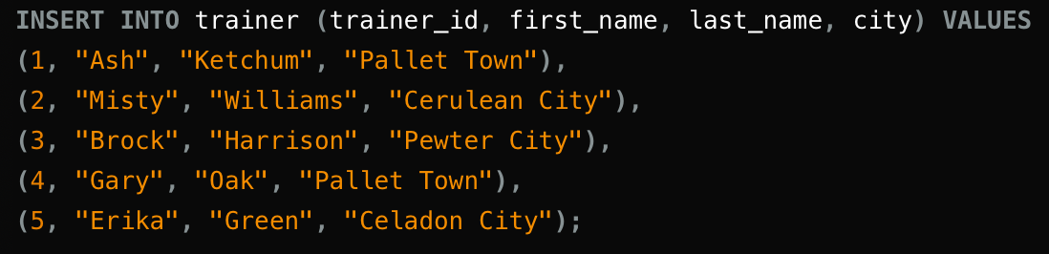

Inserting data into trainer table.

**2**.

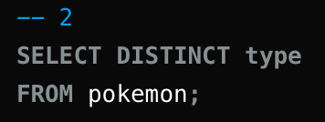

Here the distinct keyword selects only the unique ones and ignores the duplicate data.

Output:

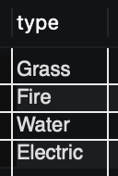

**3.**

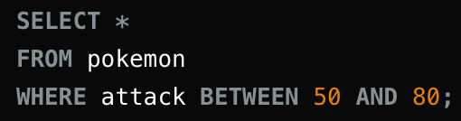

Here the between keyword only selects the data of attack if it is (50 <= attack <= 80)

Output:

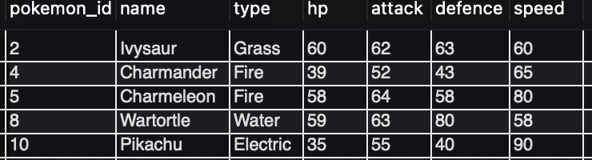

**4**

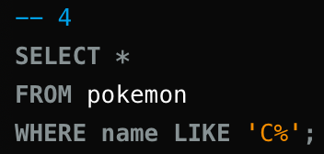

Here like keyword compares the string given after it with the name and gives us the matching ones. The % in string means substrings. ‘C%’ means the name starts with C and then it can have any number of characters.

Output:

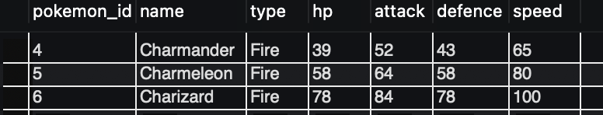

**5**

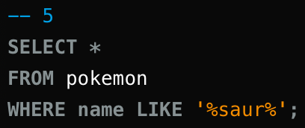

Same as the last one. Here ‘%saur%’ means that the name should contain ‘saur’ and any number of character/substrings can come before or after it.

Output:

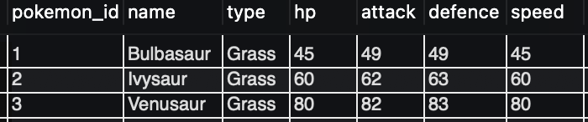

**6**

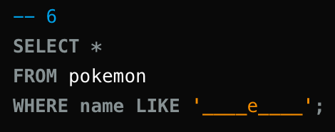

Here ‘_’ specifies the character count in name and ‘e’ sets that the 5th character in name must be e

Output:

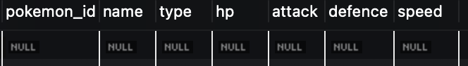

Null cause no such name exists.

**7**

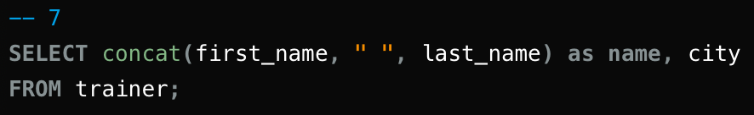

Here concat() takes multiple strings as input and returns a single string containing those input.

Output:

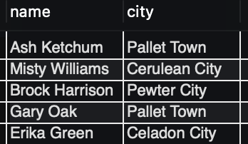

**8**

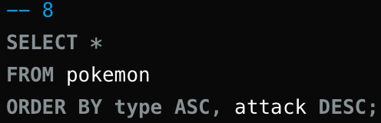

Here ‘order by’ is used to order the result. ‘Type ASC’ means the data will be ordered first by ‘type’ in ascending order then if there is more than one data of ‘type’ then those data will be sorted in descending order.

Output:

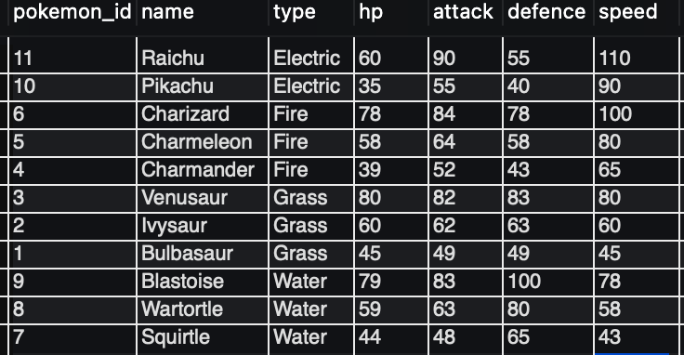

**9**

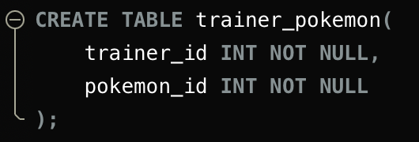

Created trainer_pokemon table.

**10**

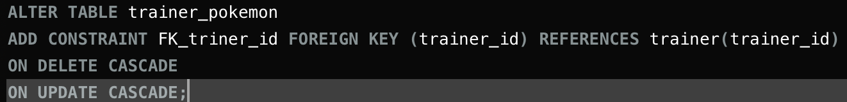

Here I am adding foreign key constraint in trainer_pokemon table referencing trainer tables trainer_id. Cascade keyword updates the primary key data if the foreign key data is changed and vice versa.

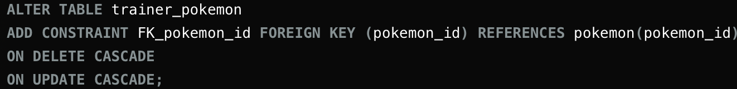

Same as before