CSE 4308

Database Management Systems Lab

Lab-05

Group-B

Mohammod Mahbub Ur Rahman

220042148

BSc. in Software Engineering

**Task 1**

Creating tables and inserting values

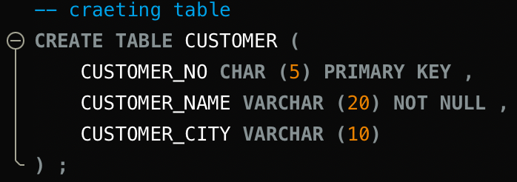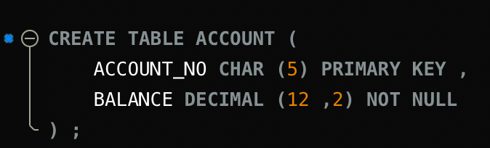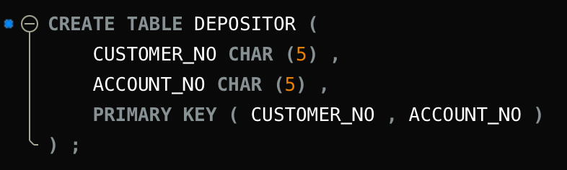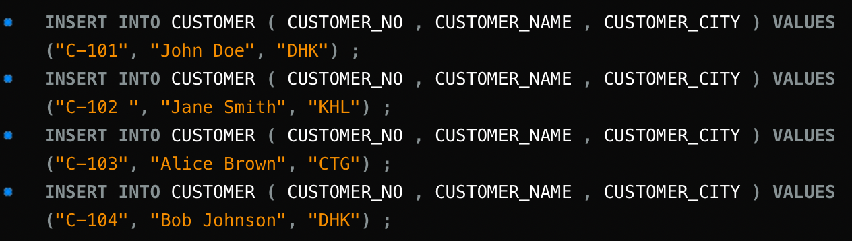

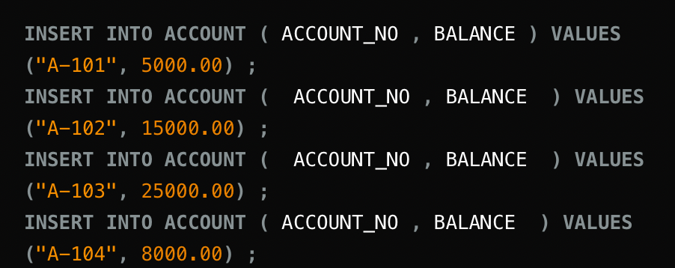

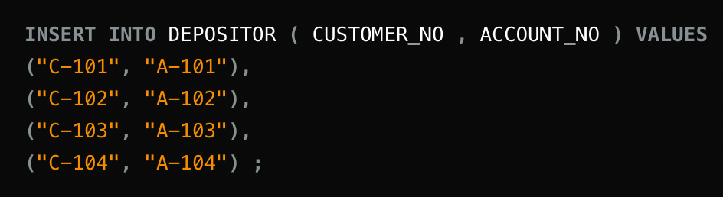

**1.**



Adding DATE_OF_BIRTH column in customer table.

**2.**



Renaming table DEPOSITOR to DEPOSITOR_INFO

**3.**



Changing the name of the columns in DEPOSITOR_INFO TABLE.

**4.**

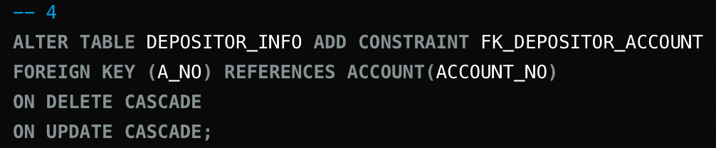

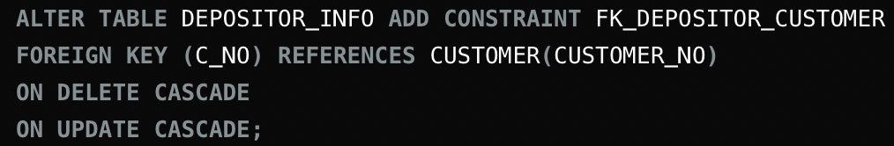Adding foreign key constraint in the DEPOSITOR_INFO table. Adding on delete cascade and on update cascade ensures that the update in this table also sync across other table (Account).

**5.**

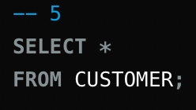

Select all records from customer.

**6.**

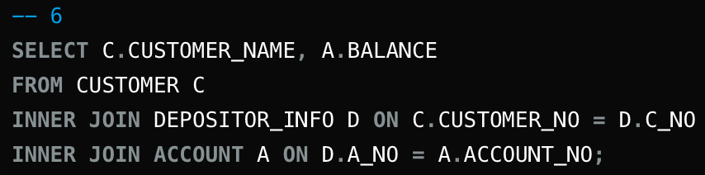

Selecting name and balance of customer by inner joining customer, depositor, account table. Here inner join is achieved by comparing column that have same value.

OUTPUT:

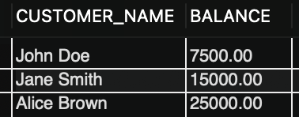

**7.**

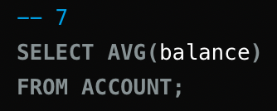

Getting average balance from account table.

Output:

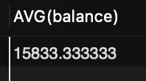

**8.**

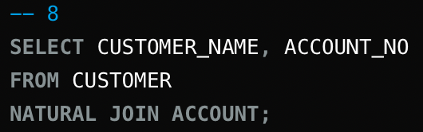

Selecting name and account number from customer and account table by natural joining.

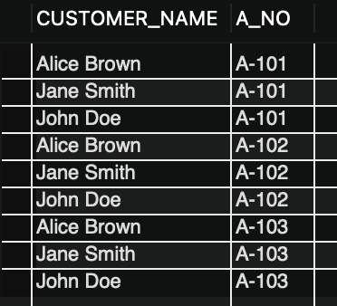

**9.**

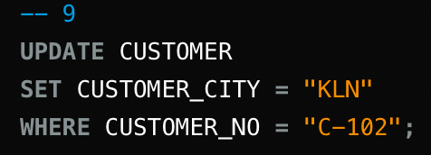

Updating the customer city where customer no is C-102.

**10.**

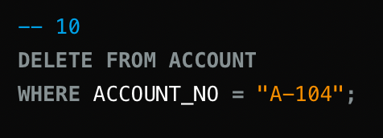

Deleting the account entry whose account_no is A-104

**11.**

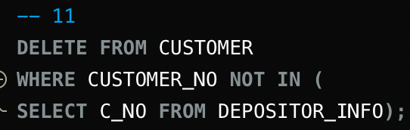

Deleting the data from customer table who is not in the depositor_info table.

**Task 2**

**1.**

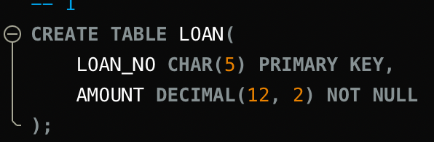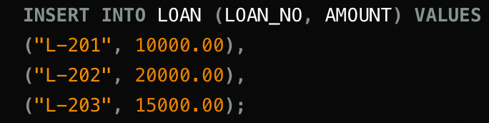

Creating loan table and inserting data.

**2.**

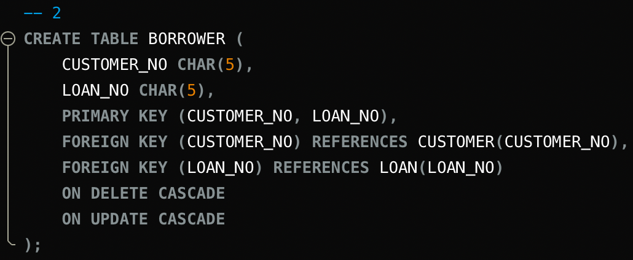

Creating borrower table, adding primary key and foreign key. Then adding data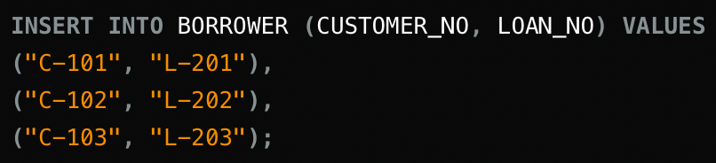

**3.**

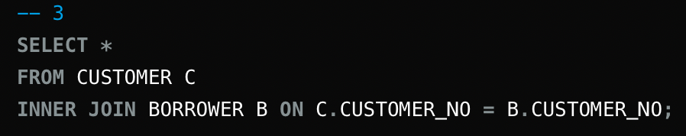

Inner joining borrower and customer to find out who have both account and loan.

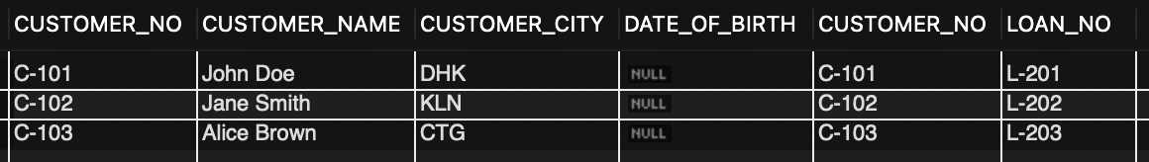

**4.**

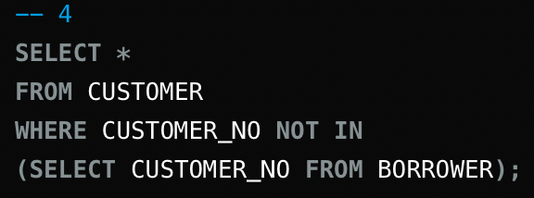

Selecting customer who is not in borrower table/who doesn’t have any loan.

**5.**

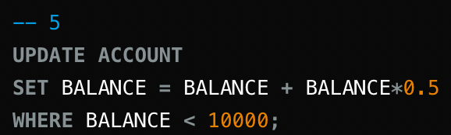

Updating account table and making balance = balance*1.5 where balance < 10000.