As a way for the UAV to find its distance from the UGV and land with the appropriate roll, pitch, and yaw, we decided to use the AR tag tracking technology offered by the ar_track_alvar package. The main functionalities of this package that we used are:

1. Generating AR tags of different size, resolution, and data encoding
2. Identifying and tracking the pose of individual AR tags

After setting up the ar_track_alvar package, generating an AR tag is as easy as running the following command: rosrun ar_track_alvar createMarker and follow the instructions.

Here are some AR tag examples:

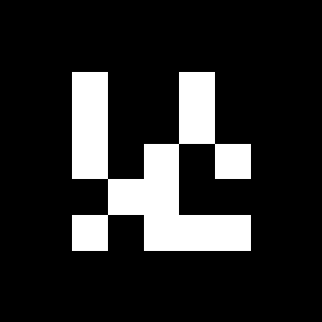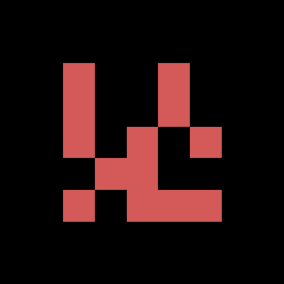

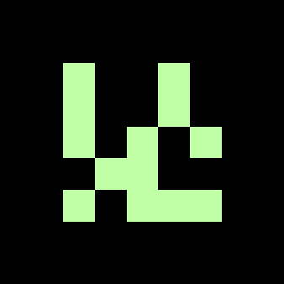





The reason they are in different colors is that I played around to find the highest accuracy and find to find the best combination that can be detected from the farthest. I did not end up finding any combination which would give better results than the black and white.

As far as tracking goes, after starting up the roscore, launching the camera and AR tag related files, it publishes the ar_pose_marker topic, which contains some information about the tag it is detecting and a pose message (geometry_msgs/Pose.msg) regarding the tag. The pose message contains a point (for position, geometry_msgs/Point.msg) and a quaternion (for orientation, geometry_msgs/Quaternion.msg). The point contains x, y, z, and the quaternion contains x, y, z, w values, that are later converted to roll, pitch, and yaw in the control panel. Here is a snapshot of the ar_pose_marker topic:

