Control Panel:
The control panel is a centralized tool where it displays all the sensor data and is able to control the UGV via the computer keyboard or a PS3 controller.
The control panel was initially built by Matt Richard and Scott Logan, but we added the functionalities we needed from it. For instance, the blob detection data, the AR tag data, and distance display. We wrote the GUI and the ROS nodes (to subscribe to the topics published from the nodes above and display them on control panel) for these and added them to the existing control panel code.

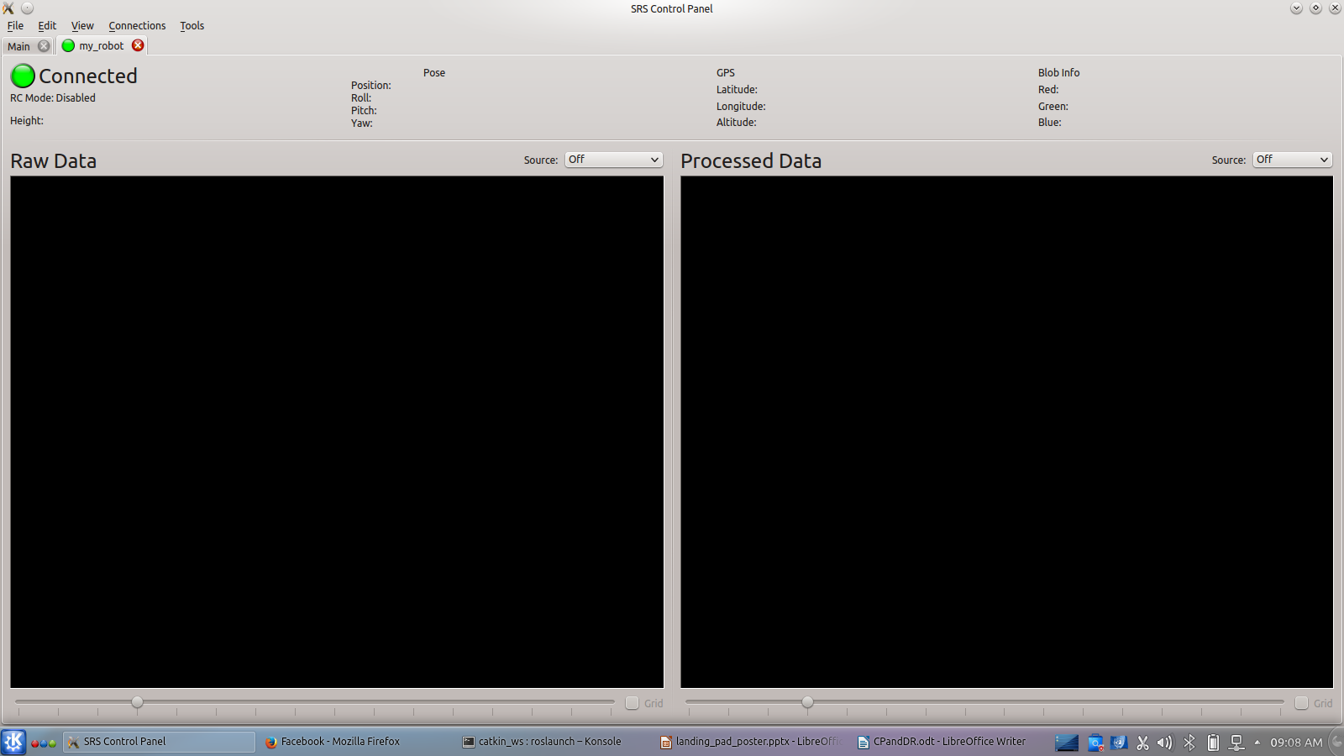
The Raw Data portion subscribes to the UAV’s view (camera), and the Processed Data displays the cv image published by the blob detection


Displays the (x, y) coordinates of the red, green, and blue blobs on the landing pad



This portion subscribes to the ar_pose_marker topic from AR tags and displays (x, y, z) from the UAV to the landing pad on the UGV in the “Position” field. I also takes the quaternion values and displays roll, pitch and yaw instead
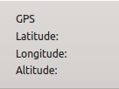
Subscribes to the GPS node in the UAV and displays the latitude, longitude, and altitude

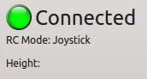
The first line indicated that the control panel is up and running
The second one confirms that it is connected to a joystick (PS3 controller in our case)
The “Height” field shows the distance between UAV and the landing pad at all times

Drive:
The drive system is based on Ackerman Steering, meaning that the back wheels control the velocity and the front wheels do the steering. We used the skid_steer drive (which was differential and written by Andrew Pierson) and modified it so it works for an Ackerman System.

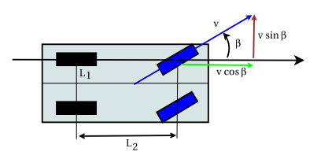
(Taken from Dr. Jeff McGough’s book on Robotics)
The way the code works is that it takes input (angular and linear velocities) from the PS3 controller and uses the following equations to send the velocity to the back wheels through the motor controller attached to the back wheels, and send the turn angle to the front wheels through the motor controller connected to the front wheels.
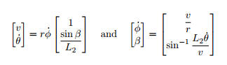
(Taken from Dr. Jeff McGough’s book on Robotics)

