MADHUSHAN R.

E/17/194

SEMESTER 4

26.12.2020

**EM 215 – NUMERICAL METHODS**

**LAB ASSIGNMENT 2**

**Question:**

**Use four iterations of Romberg integration to estimate $\int_{0}^{1}{\frac{4}{1+ x^{2}}dx}=π$**

**Comment on the accuracy of your result.**

**You may use the given following MatLab codes for generating the Romberg table and the error table.**

(Used python to the entire lab)

Exact result will be $π= 3.141592653589793…$

Romberg Table

|  |  |  |  |  |
| --- | --- | --- | --- | --- |
| $$R_{(i,j)}$$ | $$j=1$$ | $$j=2$$ | $$j=3$$ | $$j=4$$ |
| $$i=1$$ | 3.0 |  |  |  |
| $$i=2$$ | 3.1 | 3.1333333333333333 |  |  |
| $$i=3$$ | 3.1311764705882354 | 3.1415686274509804 | 3.1421176470588237 |  |
| $$i=4$$ | 3.138988494491089 | 3.141592502458707 | 3.1415940941258884 | 3.1415857837618737 |

Error Table

|  |  |  |  |  |
| --- | --- | --- | --- | --- |
| $$E_{(i,j)}$$ | $$j=1$$ | $$j=2$$ | $$j=3$$ | $$j=4$$ |
| $$i=1$$ | 0.14159265358979312 |  |  |  |
| $$i=2$$ | 0.04159265358979303 | 0.0082593202564598 |  |  |
| $$i=3$$ | 0.01041618300155767 | 2.402613881269e-05 | -0.000524993469031 |  |
| $$i=4$$ | 0.00260415909870426 | 1.511310863122e-07 | -1.4405360953e-06 | 6.86982791942e-06 |

The numerical approximation is quite close to the actual value as the 4th iterative error is in the order of ${ 10}^{-6}$. Therefore the result is more accurate and acceptable.

When applying 10 iterations the error reaches ${10}^{-15}$

**Question:**

1. **Compare the convergence of trapezoidal rule and the Simpsons rule using the given codes for the same integral as in 1.**
2. **Use the code comp_error.m to plot the logarithm of the error versus the logarithm of h. Use this code to plot the errors for N = 10; 20; 40; 60 80**

**Using the same interval and function as in problem 1. How does the slope of your log-log plot compare to the error term given for composite Simpson's rule and composite trapezoid rule?**

$i)$

Comparison of the convergence of trapezoidal and Simpson’s rules

|  |  |  |  |  |
| --- | --- | --- | --- | --- |
| n | Approximation | | Error | |
| Trapezoidal | Simpson’s | Trapezoidal | Simpson’s |
| 10 | 3.1399259889071587 | 3.141592613939215 | 0.0016666646826344333 | 3.9650577932093256e-08 |
| 20 | 3.1411759869541287 | 3.141592652969785 | 0.00041666663566441997 | 6.200080449048073e-10 |
| 40 | 3.1414884869236115 | 3.141592653580106 | 0.00010416666618162651 | 9.687362023669266e-12 |
| 60 | 3.1415463572935387 | 3.141592653588943 | 4.629629625441112e-05 | 8.504308368628699e-13 |
| 80 | 3.141566611923134 | 3.141592653589642 | 2.6041666659093465e-05 | 1.509903313490213e-13 |

From the results from the above table it is obvious that Simpson’s rule converges exponentially faster than Trapezoidal rule.

The errors for each n value by both rules have a clear cut difference.

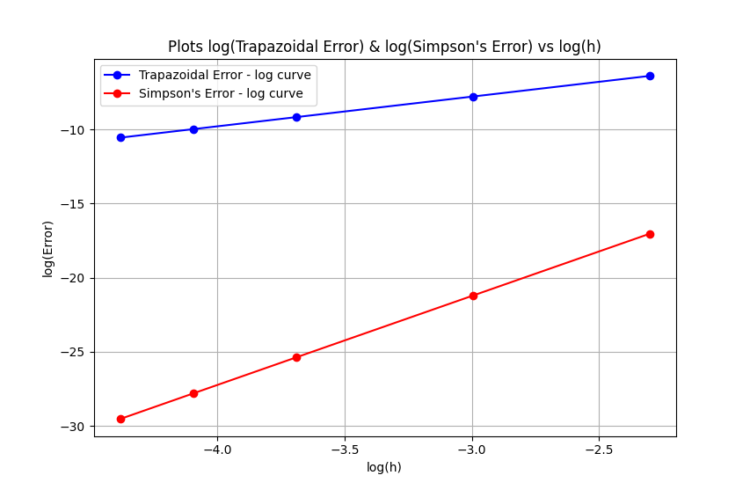 $ii)$

Comment:

The slope of the log(Simpson’s curve) is higher than the slope of the log(Trapezoidal Curve) and both the curves show linear gradient.

Theoretically the order of error of Simpson’s $\frac{1}{3}$ rule is higher than the order of error of Trapezoidal rule. The plot well illustrates that.

**Question:**

1. **Observe the convergence of Gaussian Quadrature rule using the given codes for the same integral as in 1.**
2. **Use the code given to plot the logarithm of the error versus the logarithm of h. Use this code to plot the errors for N = 10; 20; 40; 60 80**

**Using the same interval and function as in problem 1. How does this quadrature compare to composite Simpson's method from problem1?**

$$i)$$

Observation of the convergence of Gaussian Quadrature rule

|  |  |  |
| --- | --- | --- |
| n | Gaussian Approximation | Error |
| 10 | 3.141592653560034 | 2.9759306130472396e-11 |
| 20 | 3.1415926535893273 | 4.658495811327157e-13 |
| 40 | 3.141592653589786 | 7.105427357601002e-15 |
| 60 | 3.1415926535897927 | 4.440892098500626e-16 |
| 80 | 3.1415926535897927 | 4.440892098500626e-16 |

Comment:

The Gaussian Quadrature approximates the result better than Trapezoidal and Simpson’s Rules.

For higher n values the error become too small. The convergence of Gaussian quadrature rule is similar to the Simpson’s Rule.

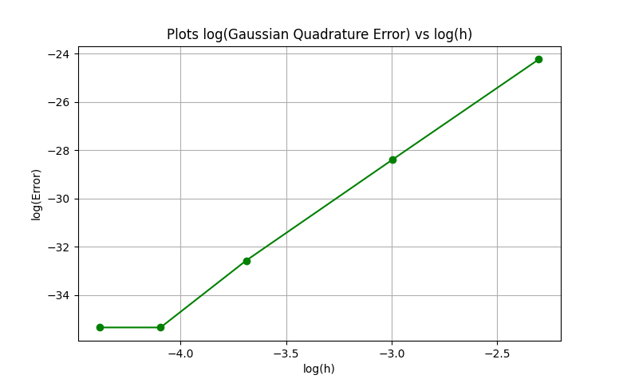 $ii)$

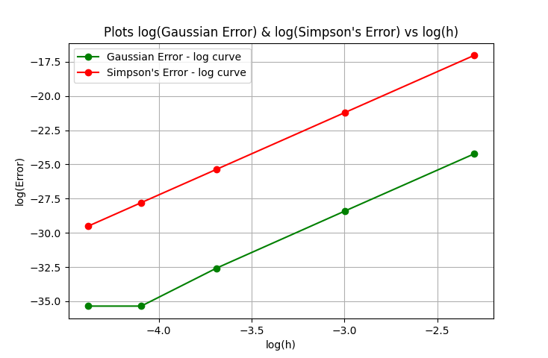

Both Gaussian Quadrature and Simpson’s rule have a similar convergence but GQ rule produces lesser error than Simpson’s rule

**Find the code used to plot and compare these error and approximations in the Appendix section at the end.**

**APPENDIX A : Python program used for the lab**

**Implementations function, Trapezoidal rule, Simpson’s rule, Composite Gaussian Quadrature and Romberg table.**

Used numpy library and matplotlib library for numerical calculations and graphical representation.

import math

import numpy as np

import matplotlib.pyplot as plt

def f(x):

    return (4/(x**2 + 1))

def trapazoid(n, a, b):

    h = (b - a) / n

    result = f(a) + f(b)

    for i in range(1, n):

        result += 2 * f(a + (i*h))

    result = result * h / 2

    return result

def simpson(n, a, b):

    h = (b - a) / n

    result = f(a) + f(b)

    r1 = 0

    r2 = 0

    for i in range(1, n):

        if(i%2 == 0):

            r2 += f(a + (i*h))

        else:

            r1 += f(a + (i*h))

    result = (result + (4 * r1 + 2 * r2)) * (h / 3)

    return result

def gaussianQuadrature(a, b):

    nodes = [-math.sqrt(3/5), 0, math.sqrt(3/5)]

    weights = [(5/9), (8/9), (5/9)]

    result = 0

    for i in range(3):

        result += weights[i] * f(nodes[i]*(b-a)/2 + (a+b)/2)

    result *= (b-a)/2

    return result

def comp_gaussQuadrature(n, a, b):

    intervals = list(np.linspace(a,b,n+1))

    result = 0

    for i in range(n):

        result += gaussianQuadrature(intervals[i], intervals[i+1])

    return result

def romberg(a, b, t, type):

    Rs = []

    Es = []

    r = []

    e = []

    exact = math.pi

    for i in range(t):

        if type == "trapazoid":

            p = trapazoid((2**i), a, b)

        elif type == "simpson":

            p = simpson((2**i), a, b)

        r.append(p)

        e.append(exact-p)

    Rs.append(r)

    Es.append(e)

    for k in range(t-1):

        r = []

        e = []

        for j in range(1, t-k):

            v = Rs[-1][j] + ((Rs[-1][j] - Rs[-1][j-1])/(4**(k+1) - 1))

            r.append(v)

            e.append(exact-v)

        Rs.append(r)

        Es.append(e)

    return [Rs,Es]

**Functions used to plot the curves**

n_lst = [10,20,40,60,80]

def comp_error_TrapAndSimpson(n_lst, a, b):

    trapError_arr = []

    simpError_arr = []

    h_arr = []

    for n in n_lst:

        trapAprx = trapazoid(n,a,b)

        simpAprx = simpson(n,a,b)

        exact = math.pi

        trapError_arr.append(math.log(exact-trapAprx))

        simpError_arr.append(math.log(exact-simpAprx))

        _h = (b - a) / n

        h_arr.append(math.log(_h))

    y1 = np.array(trapError_arr)

    y2 = np.array(simpError_arr)

    h = np.array(h_arr)

    plt.plot(h,y1, 'bo-')

    plt.plot(h,y2,'ro-')

    plt.title("Plots log(Trapazoidal Error) & log(Simpson's Error) vs log(h)")

    plt.xlabel("log(h)")

    plt.ylabel("log(Error)")

    plt.legend(["Trapazoidal Error - log curve", "Simpson's Error - log curve"])

    plt.grid()

    plt.show()

comp_error_TrapAndSimpson(n_lst, 0, 1) #function call

def plot_GaussError_vs_h(n_lst, a, b):

    y = []

    h_arr = []

    for n in n_lst:

        gaussAprx = comp_gaussQuadrature(n,a,b)

        exact = math.pi

        _h = (b - a) / n

        h_arr.append(math.log(_h))

        y.append(math.log(exact-gaussAprx))

    plt.plot(np.array(h_arr),np.array(y),'go-')

    plt.title("Plots log(Gaussian Quadrature Error) vs log(h)")

    plt.xlabel("log(h)")

    plt.ylabel("log(Error)")

    plt.grid()

    plt.show()

plot_GaussError_vs_h(n_lst, 0, 1)   #function call

def comp_error_GaussAndSimpson(n_lst, a, b):

    gaussError_arr = []

    simpError_arr = []

    h_arr = []

    for n in n_lst:

        gaussAprx = comp_gaussQuadrature(n,a,b)

        simpAprx = simpson(n,a,b)

        exact = math.pi

        gaussError_arr.append(math.log(exact-gaussAprx))

        simpError_arr.append(math.log(exact-simpAprx))

        _h = (b - a) / n

        h_arr.append(math.log(_h))

    y1 = np.array(gaussError_arr)

    y2 = np.array(simpError_arr)

    h = np.array(h_arr)

    plt.plot(h, y1, 'go-')

    plt.plot(h, y2, 'ro-')

    plt.title("Plots log(Gaussian Error) & log(Simpson's Error) vs log(h)")

    plt.xlabel("log(h)")

    plt.ylabel("log(Error)")

    plt.legend(["Gaussian Error - log curve", "Simpson's Error - log curve"])

    plt.grid()

    plt.show()

comp_error_GaussAndSimpson(n_lst, 0, 1)     #function call