**CSCE315 – Project 3**

**Database Management System**

**Team 5:** Jared Wheeler, Mishael Gonzalez, Richard Padilla, Xiaoda Liu

## Statement of Problem and Significance:

The Purpose of project 3 is to implement a database and to develop a product using the AGILE methodology. We will learn about SQL style languages, how users interface with an application, how databases work with data, how to best set up sets and relations on data, and how to overcome unexpected challenges that can arise in the development of a product. Our finished product will be able to take in a query from a user, and take the necessary action to pull results from a database. Learn what the basic operations of an SQL database do. Become familiar with databases and SQL. It will be used by people who need to store large amounts of informaion that consists of many attributes.

## Explanation of Approach:

Figure 1 shows an overview of project 3. This project consists of two parts. The task of the first part is to implement the core functions of a simple database management system (DBMS). In the second part, you will manually test the DBMS's basic functionality with real data. In both parts use Test-Driven Design and the Agile methodology.

Follow the Agile methodology as described in the slides, including:

• We created a master burn-down list of remaining tasks and estimated time for each task.

• Weekly meetings to assign tasks from the burndown list to the next sprint backlog.

• Scrums meetings every day to report progress and problems and update the burn-down list items and time still needed (Scrum process is shown in Figure 2). In Figure 2, the work is separated to Sprint 1: Design doc and Parser code and Sprint 2: DB engine and overall function. Features are assigned from the product backlog to a sprint backlog

• As shown in Figure 3, a graph of projected and actual burn-down rate shows that during sprint #1, we tried to squeeze time from the beginning of the timeframe to make sure the software can be delivered on time. From the second sprint, actual remaining and ideal remaining tend to end at the same point since the database engine and the overall function test took more time than we expected.

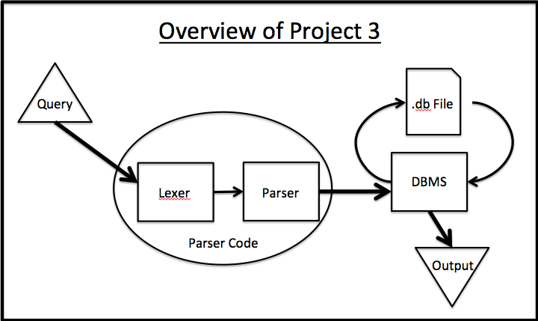

Figure 1 Overview of Project 3

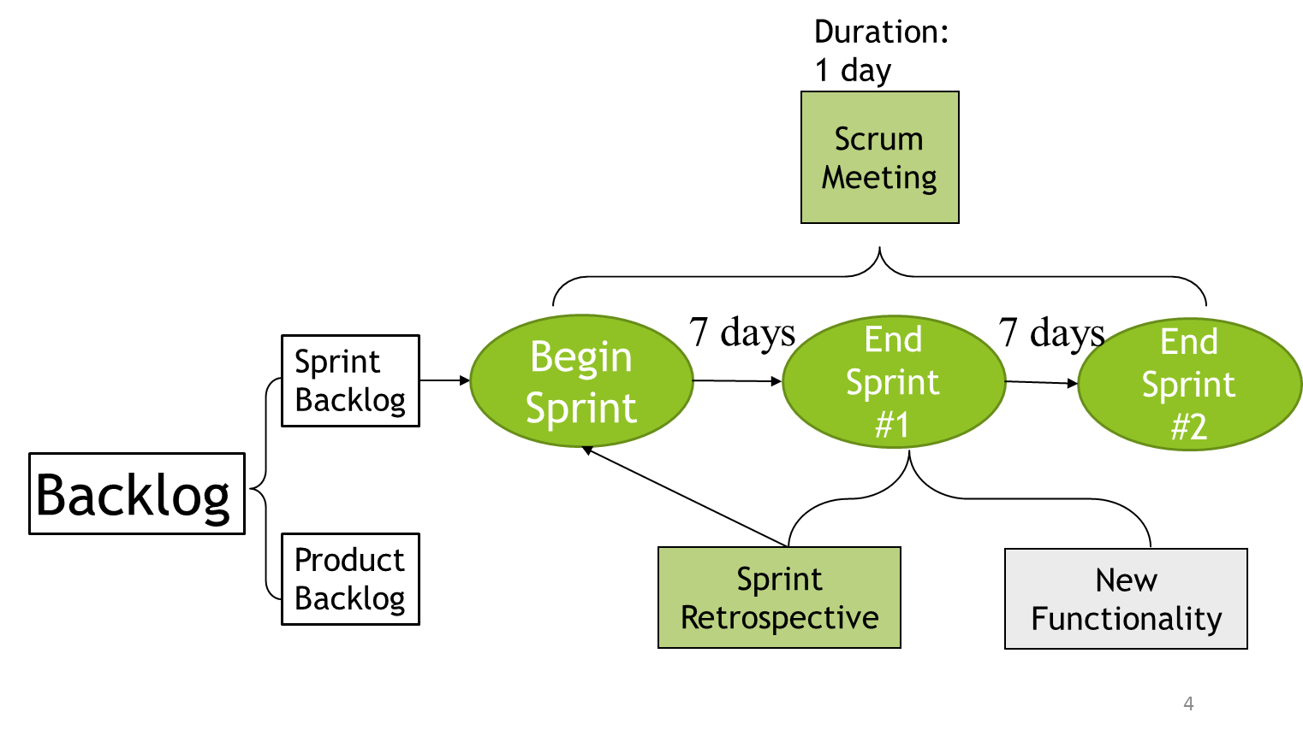

Figure 2 Scrum Processes

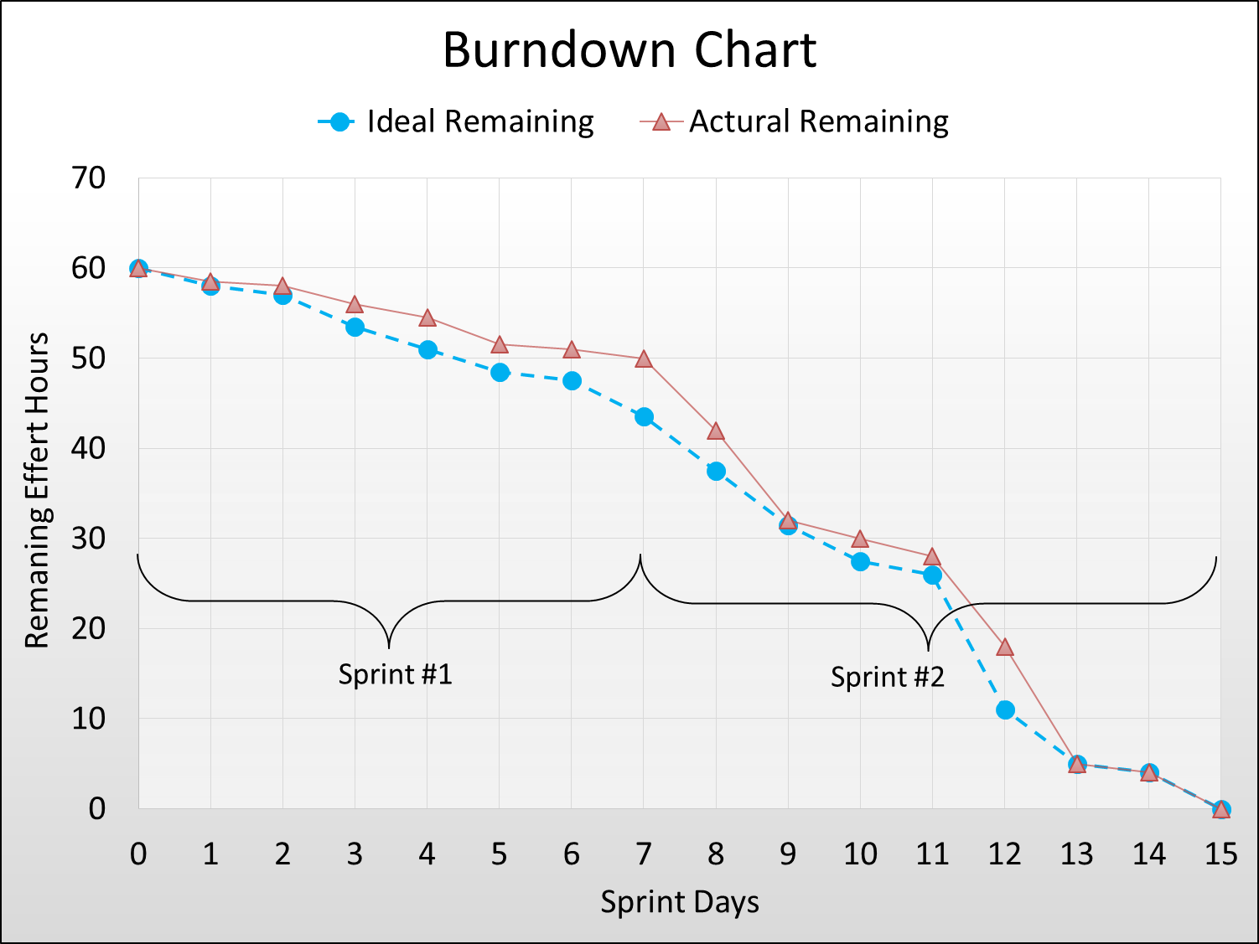

Figure 3 Burndown List

Input entity relations is shown in Figure 4.

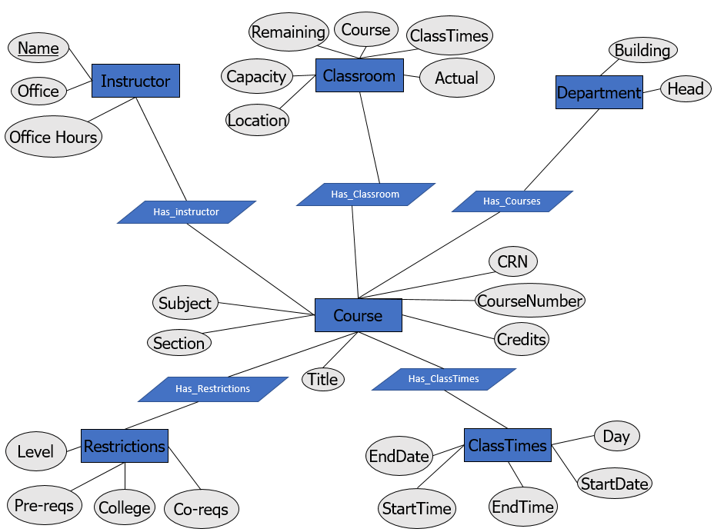

Figure 4 Entity Relation Diagram

## Sample runs (screen shots):

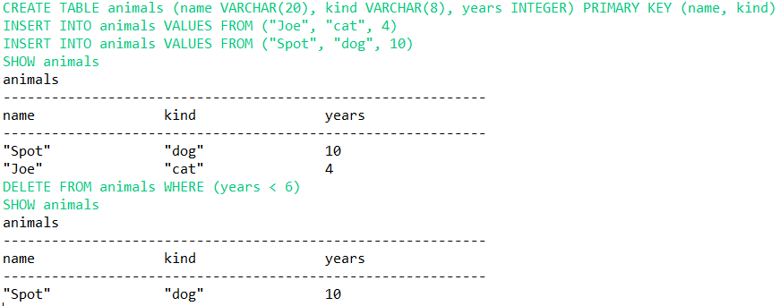

## Results and analysis:

In the end, we were able to connect the parser to the database, and the file readers and writers to the program. Running tests were good for finding logic errors and for formatting our relation views. Using java helped us speed up the process by allowing us to use helpful documentation on ANTLR. Our actual work complete per hour ratio would have been better had we focused on figuring out the parser instead of building a parser and a database at the same time. Had we done this, it may have reduced the number of times we had to revise our database core functions. All in all, this was one of the most involved projects we have ever worked on and we are proud to say that our blood, sweat, and tears went into making a functioning database.

## Conclusions

## Learned ANTLR which will be beneficial for future use.

1. Got the idea of overall database management system design.
2. Learned how to work in a team by using Agile development method.

## Instructions on how to run program