**UNIT-II**

**Inheritance**

Inheritance is one of the cornerstones of object-oriented programming because it allows the creation of hierarchical classifications. Using inheritance, you can create a general class that defines traits common to a set of related items. This class can then be inherited by other, more specific classes, each adding those things that are unique to it. In the terminology of Java, a class that is inherited is called a *superclass*. The class that does the inheriting is called a *subclass*. Therefore, a subclass is a specialized version of a superclass. It inherits all of the members defined by the superclass and adds its own, unique elements.

**Inheritance Basics**

To inherit a class, you simply incorporate the definition of one class into another by using the **extends** keyword. To see how, let’s begin with a short example. The following program creates a superclass called **A** and a subclass called **B**. Notice how the keyword **extends** is used to create a subclass of **A**.

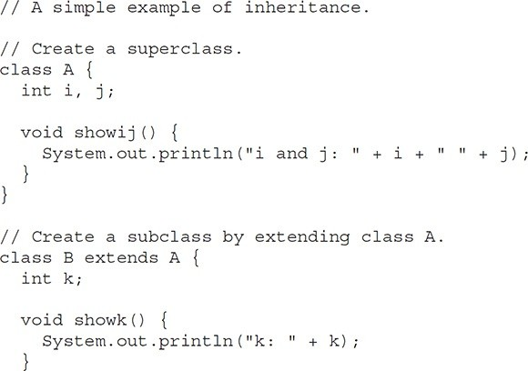

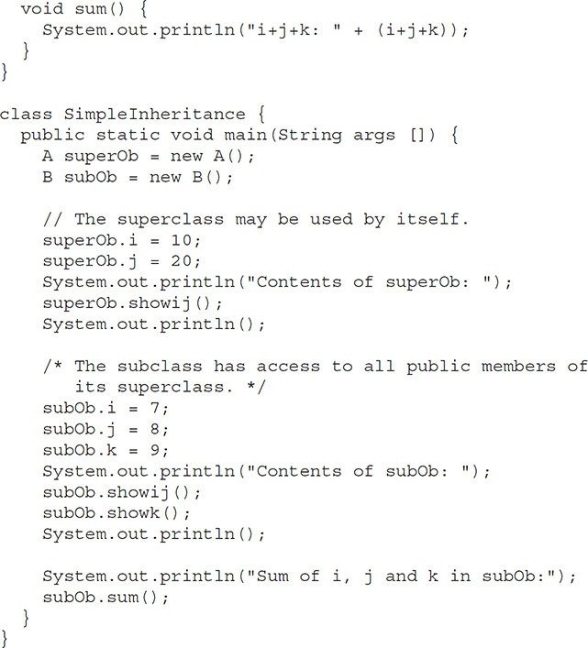

The output from this program is shown here:

Contents of superOb: i and j: 10 20

Contents of subOb: i and j: 7 8

k: 9

Sum of i, j and k in subOb:

i+j+k: 24

As you can see, the subclass **B** includes all of the members of its superclass, **A**. This is why **subOb** can access **i** and **j** and call **showij( )**. Also, inside **sum( )**, **i** and **j** can be referred to directly, as if they were part of **B**.

Even though **A** is a superclass for **B**, it is also a completely independent, stand-alone class. Being a superclass for a subclass does not mean that the superclass cannot be used by itself. Further, a subclass can be a superclass for another subclass. The general form of a **class** declaration that inherits a superclass is shown here:

class *subclass-name* extends *superclass-name* {

// body of class

}

You can only specify one superclass for any subclass that you create. Java does not support the inheritance of multiple superclasses into a single subclass. You can, as stated, create a hierarchy of inheritance in which a subclass becomes a superclass of another subclass. However, no class can be a superclass of itself.

**Member Access and Inheritance**

Although a subclass includes all of the members of its superclass, it cannot access those members of the superclass that have been declared as **private**. For example, consider the following simple class hierarchy:

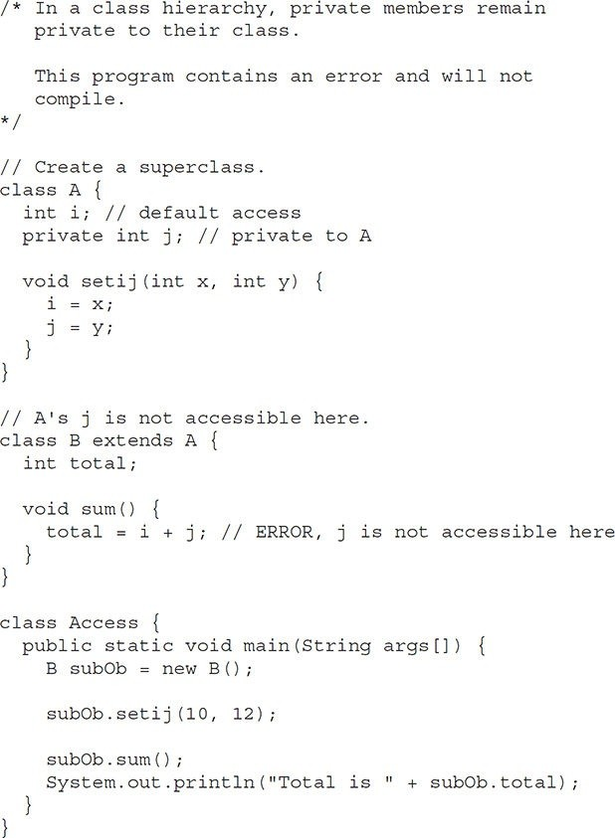

This program will not compile because the use of **j** inside the **sum( )** method of **B** causes an access violation. Since **j** is declared as **private**, it is only accessible by other members of its own class. Subclasses have no access to it.

**A More Practical Example**

Let’s look at a more practical example that will help illustrate the power of inheritance. Here, the final version of the **Box** class developed in the preceding chapter will be extended to include a fourth component called **weight**. Thus, the new class will contain a box’s width, height, depth, and weight.

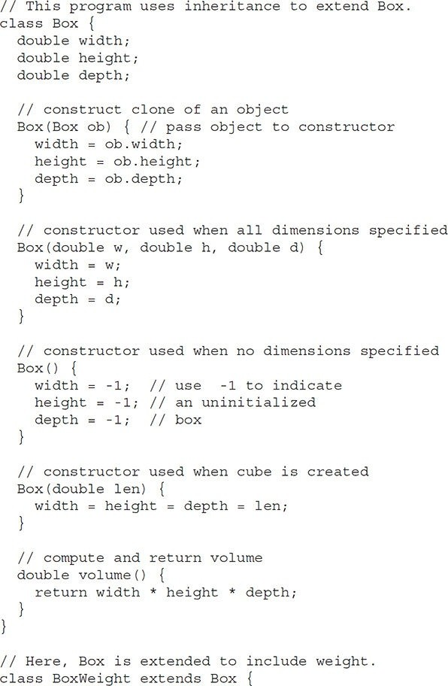

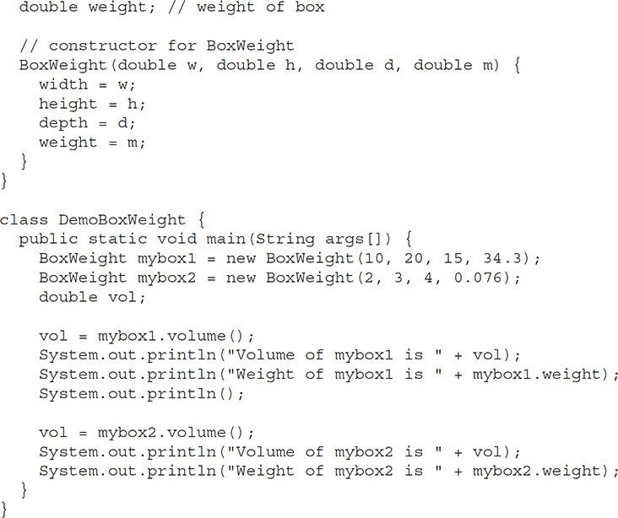

The output from this program is shown here:

Volume of mybox1 is 3000.0 Weight of mybox1 is 34.3

Volume of mybox2 is 24.0 Weight of mybox2 is 0.076

**BoxWeight** inherits all of the characteristics of **Box** and adds to them the **weight** component. It is not necessary for **BoxWeight** to re-create all of the features found in **Box**. It can simply extend **Box** to meet its own purposes.

A major advantage of inheritance is that once you have created a superclass that defines the attributes common to a set of objects, it can be used to create any number of more specific subclasses. Each subclass can precisely tailor its own classification. For example, the following class inherits **Box** and adds a color attribute:

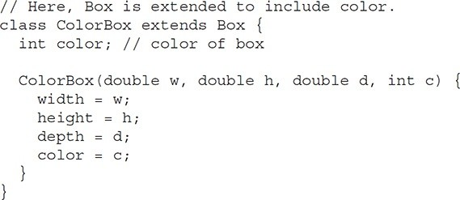Remember, once you have created a superclass that defines the general aspects of an object, that superclass can be inherited to form specialized classes. Each subclass simply adds its own unique attributes. This is the essence of inheritance.

**A Superclass Variable Can Reference a Subclass Object**

A reference variable of a superclass can be assigned a reference to any subclass derived from that superclass. You will find this aspect of inheritance quite useful in a variety of situations. For example, consider the following:

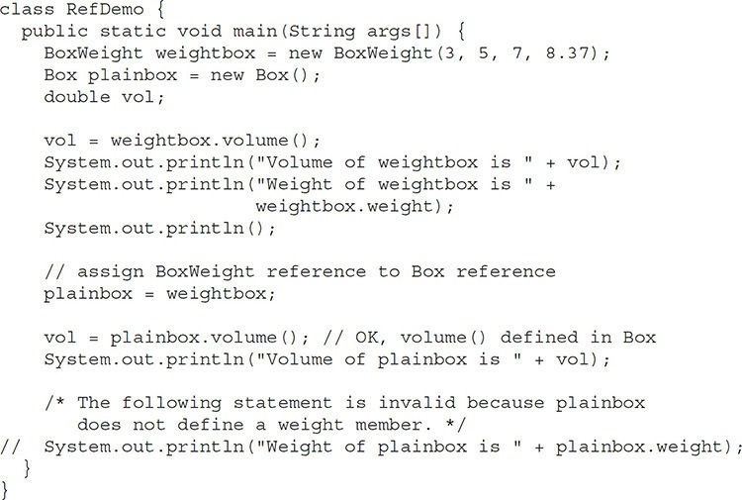

Here, **weightbox** is a reference to **BoxWeight** objects, and **plainbox** is a reference to **Box** objects. Since **BoxWeight** is a subclass of **Box**, it is permissible to assign **plainbox** a reference to the **weightbox** object.

It is important to understand that it is the type of the reference variable—not the type of the object that it refers to—that determines what members can be accessed. That is, when a reference to a subclass object is assigned to a superclass reference variable, you will have access only to those parts of the object defined by the superclass. This is why **plainbox** can’t access **weight** even when it refers to a **BoxWeight** object. If you think about it, this makes sense, because the superclass has no knowledge of what a subclass adds to it.

This is why the last line of code in the preceding fragment is commented out. It is not possible for a **Box** reference to access the **weight** field, because **Box** does not define one.

**Using super**

In the preceding examples, classes derived from **Box** were not implemented as efficiently or as robustly as they could have been. For example, the constructor for **BoxWeight** explicitly initializes the **width**, **height**, and **depth** fields of **Box**. Not only does this duplicate code found in its superclass, which is inefficient, but it implies that a subclass must be granted access to these members. However, there will be times when you will want to create a superclass that keeps the details of its implementation to itself (that is, that keeps its data members private). In this case, there would be no way for a subclass to directly access or initialize these variables on its own. Since encapsulation is a primary attribute of OOP, it is not surprising that Java provides a solution to this problem. Whenever a subclass needs to refer to its immediate superclass, it can do so by use of the keyword **super**.

**super** has two general forms. The first calls the superclass’ constructor. The second is used to access a member of the superclass that has been hidden by a member of a subclass. Each use is examined here.

**Using super to Call Superclass Constructors**

A subclass can call a constructor defined by its superclass by use of the following form of **super**:

super(*arg-list*);

Here, *arg-list* specifies any arguments needed by the constructor in the superclass. **super( )** must always be the first statement executed inside a subclass’ constructor. To see how **super( )** is used, consider this improved version of the **BoxWeight** class:

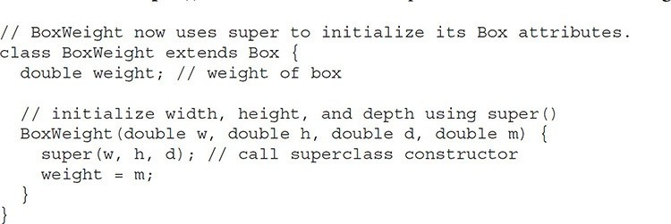

Here, **BoxWeight( )** calls **super( )** with the arguments **w**, **h**, and **d**. This causes the **Box** constructor to be called, which initializes **width**, **height**, and **depth** using these values. **BoxWeight** no longer initializes these values itself. It only needs to initialize the value unique to it: **weight**. This leaves **Box** free to make these values **private** if desired.

In the preceding example, **super( )** was called with three arguments. Since constructors can be overloaded, **super( )** can be called using any form defined by the superclass. The constructor executed will be the one that matches the arguments. For example, here is a complete implementation of **BoxWeight** that provides constructors for the various ways that a box can be constructed. In each case, **super( )** is called using the appropriate arguments. Notice that **width**, **height**, and **depth** have been made private within **Box**.

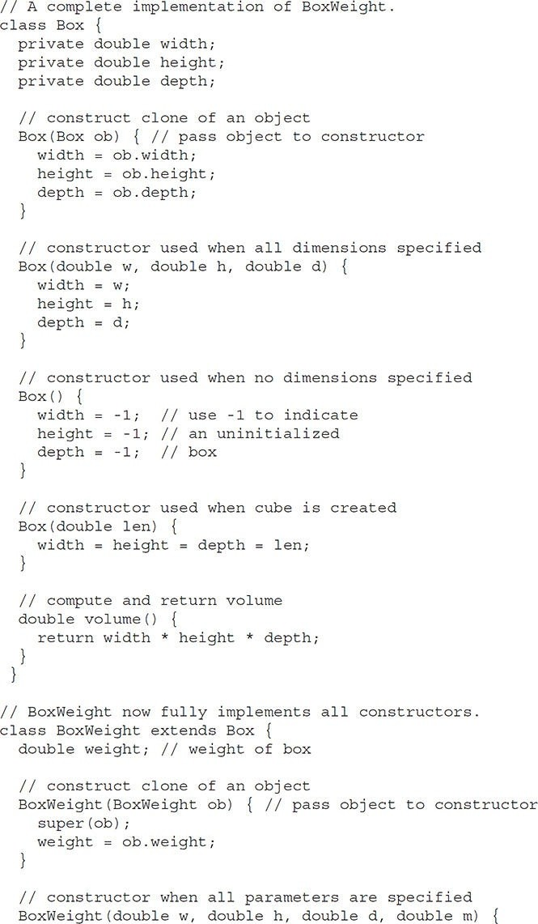

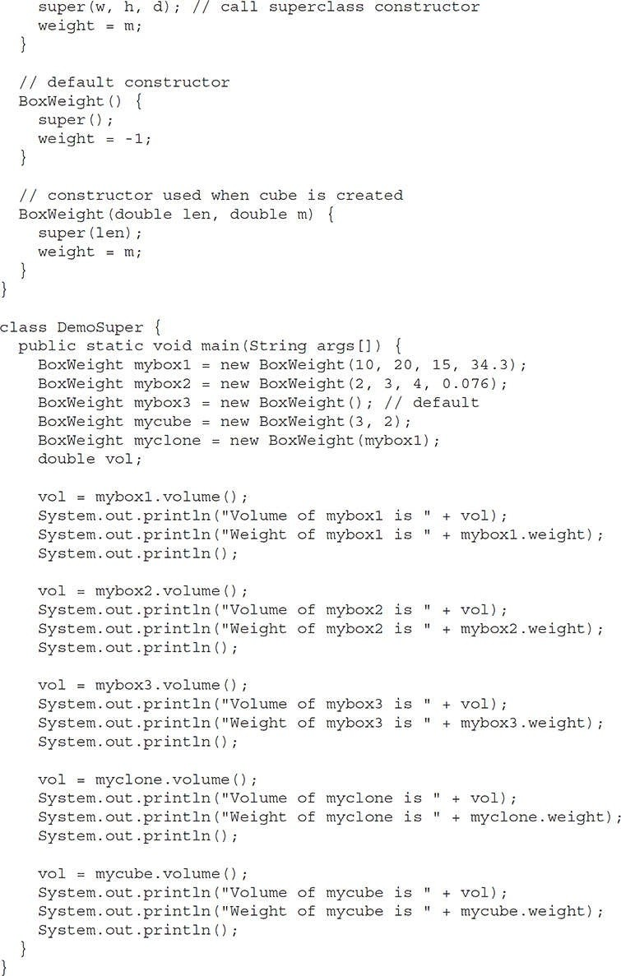

This program generates the following output:

Volume of mybox1 is 3000.0 Weight of mybox1 is 34.3

Volume of mybox2 is 24.0 Weight of mybox2 is 0.076

Volume of mybox3 is -1.0 Weight of mybox3 is -1.0

Volume of myclone is 3000.0 Weight of myclone is 34.3

Volume of mycube is 27.0 Weight of mycube is 2.0

Pay special attention to this constructor in **BoxWeight**:

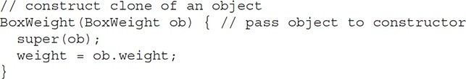Notice that **super( )** is passed an object of type **BoxWeight**—not of type **Box**. This still invokes the constructor **Box(Box ob)**. As mentioned earlier, a superclass variable can be used to reference any object derived from that class. Thus, we are able to pass a **BoxWeight** object to the **Box** constructor. Of course, **Box** only has knowledge of its own members.

Let’s review the key concepts behind **super( )**. When a subclass calls **super()**, it is calling the constructor of its immediate superclass. Thus, **super( )** always refers to the superclass immediately above the calling class. This is true even in a multileveled hierarchy. Also, **super( )** must always be the first statement executed inside a subclass constructor.

**A Second Use for super**

The second form of **super** acts somewhat like **this**, except that it always refers to the superclass of the subclass in which it is used. This usage has the following general form:

super.*member*

Here, *member* can be either a method or an instance variable.

This second form of **super** is most applicable to situations in which member names of a subclass hide members by the same name in the superclass. Consider this simple class hierarchy:

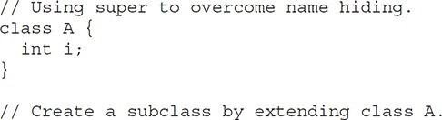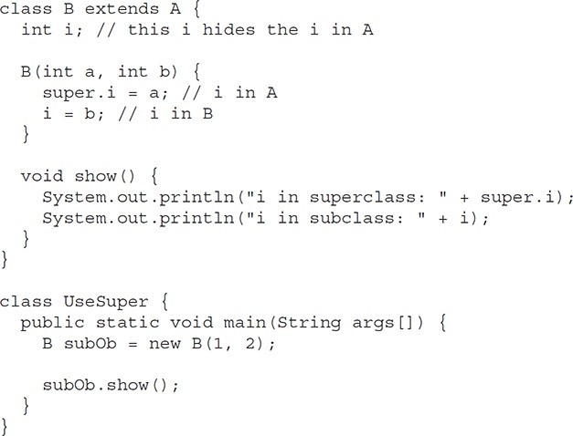

T his program displays the following:

i in superclass: 1 i in subclass: 2

Although the instance variable **i** in **B** hides the **i** in **A**, **super** allows access to the **i** defined in the superclass. As you will see, **super** can also be used to call methods that are hidden by a subclass.

**Creating a Multilevel Hierarchy**

Up to this point, we have been using simple class hierarchies that consist of only a superclass and a subclass. However, you can build hierarchies that contain as many layers of inheritance as you like. As mentioned, it is perfectly acceptable to use a subclass as a superclass of another. For example, given three classes called **A**, **B**, and **C**, **C** can be a subclass of **B**, which is a subclass of **A**. When this type of situation occurs, each subclass inherits all of the traits found in all of its superclasses. In this case, **C** inherits all aspects of **B** and **A**. To see how a multilevel hierarchy can be useful, consider the following program. In it, the subclass **BoxWeight** is used as a superclass to create the subclass called **Shipment**. **Shipment** inherits all of the traits of **BoxWeight** and **Box**, and adds a field called **cost**, which holds the cost of shipping such a parcel.

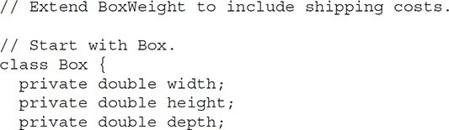

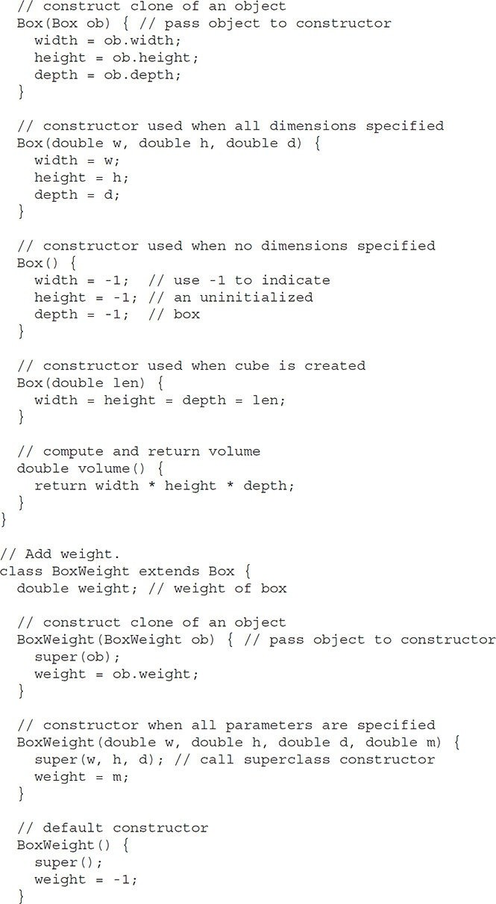

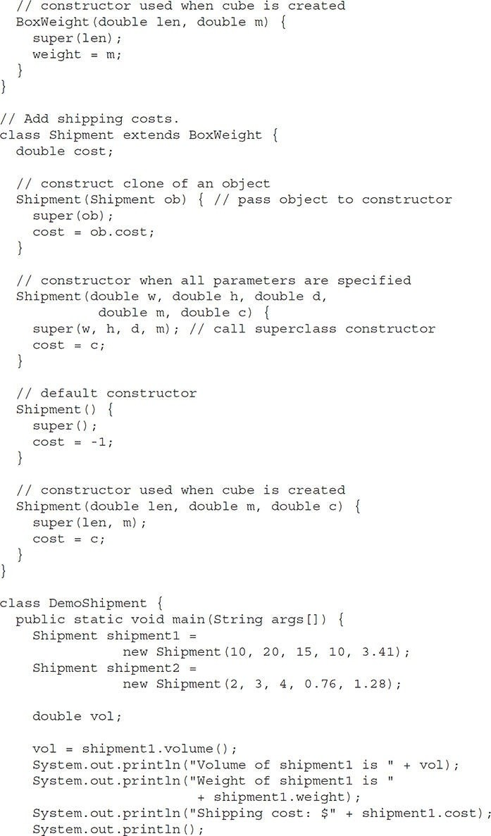

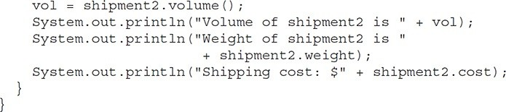

The output of this program is shown here:

Volume of shipment1 is 3000.0 Weight of shipment1 is 10.0 Shipping cost: $3.41

Volume of shipment2 is 24.0 Weight of shipment2 is 0.76 Shipping cost: $1.28

Because of inheritance, **Shipment** can make use of the previously defined classes of **Box** and **BoxWeight**, adding only the extra information it needs for its own, specific application. This is part of the value of inheritance; it allows the reuse of code.

This example illustrates one other important point: **super( )** always refers to the constructor in the closest superclass. The **super( )** in **Shipment** calls the constructor in **BoxWeight**. The **super( )** in **BoxWeight** calls the constructor in **Box**. In a class hierarchy, if a superclass constructor requires arguments, then all subclasses must pass those arguments “up the line.” This is true whether or not a subclass needs arguments of its own.

**When Constructors Are Executed**

When a class hierarchy is created, in what order are the constructors for the classes that make up the hierarchy executed? For example, given a subclass called **B** and a superclass called **A**, is **A**’s constructor executed before **B**’s, or vice versa? The answer is that in a class hierarchy, constructors complete theirexecution in order of derivation, from superclass to subclass. Further, since **super( )** must be the first statement executed in a subclass’ constructor, this order is the same whether or not **super( )** is used. If **super( )** is not used, then the default or parameterless constructor of each superclass will be executed. The following program illustrates when constructors are executed:

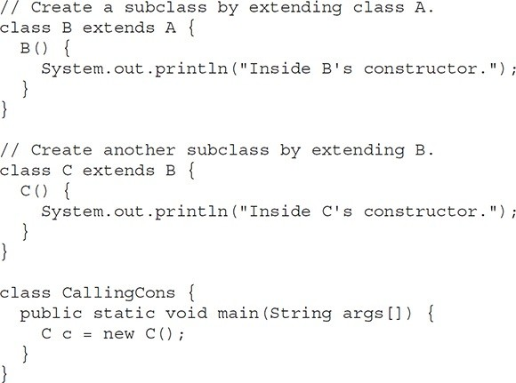

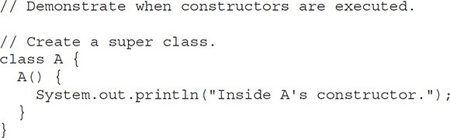

The output from this program is shown here:

Inside A's constructor Inside B's constructor Inside C's constructor As you can see, the constructors are executed in order of derivation.

If you think about it, it makes sense that constructors complete their execution in order of derivation. Because a superclass has no knowledge of any subclass, any initialization it needs to perform is separate from and possibly prerequisite to any initialization performed by the subclass. Therefore, it must complete its execution first.

**Method Overriding**

In a class hierarchy, when a method in a subclass has the same name and type signature as a method in its superclass, then the method in the subclass is said to *override* the method in the superclass. When an overridden method is called from within its subclass, it will always refer to the version of that method defined by the subclass. The version of the method defined by the superclass will be hidden. Consider the following:

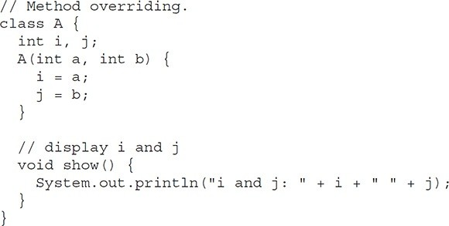

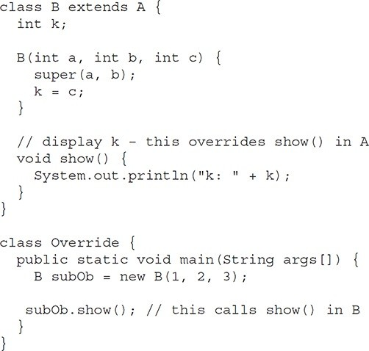

The output produced by this program is shown here: k: 3

When **show( )** is invoked on an object of type **B**, the version of **show( )** defined within **B** is used. That is, the version of **show( )** inside **B** overrides the version declared in **A**.

If you wish to access the superclass version of an overridden method, you can do so by using **super**. For example, in this version of **B**, the superclass version of **show( )** is invoked within the subclass’ version. This allows all instance variables to be displayed.

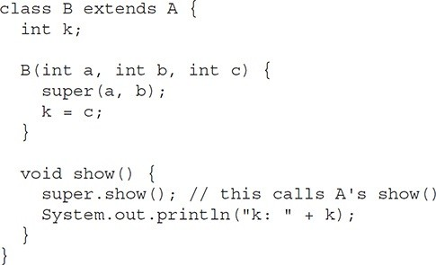

If you substitute this version of **A** into the previous program, you will see the following output:

i and j: 1 2

k: 3

Here, **super.show( )** calls the superclass version of **show( )**.

Method overriding occurs *only* when the names and the type signatures of the two methods are identical. If they are not, then the two methods are simply overloaded. For example, consider this modified version of the preceding example:

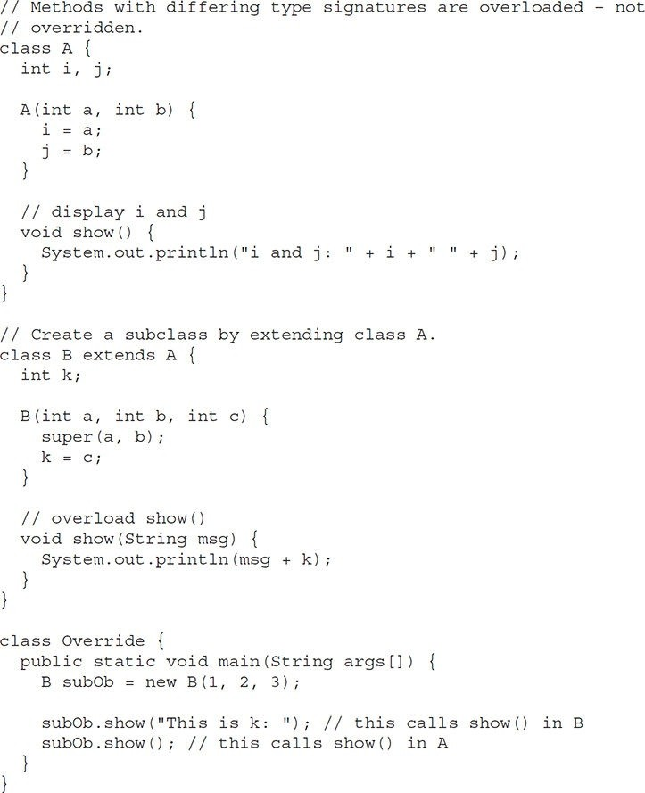

The output produced by this program is shown here:

This is k: 3 i and j: 1 2

The version of **show( )** in **B** takes a string parameter. This makes its type signature different from the one in **A**, which takes no parameters. Therefore, no overriding (or name hiding) takes place. Instead, the version of **show( )** in **B** simply overloads the version of **show( )** in **A**.

**Dynamic Method Dispatch**

While the examples in the preceding section demonstrate the mechanics of method overriding, they do not show its power. Indeed, if there were nothing more to method overriding than a name space convention, then it would be, at best, an interesting curiosity, but of little real value. However, this is not the case. Method overriding forms the basis for one of Java’s most powerful concepts: *dynamic method dispatch*. Dynamic method dispatch is the mechanism by which a call to an overridden method is resolved at run time, rather than compile time. Dynamic method dispatch is important because this is how Java implements run-time polymorphism.

Let’s begin by restating an important principle: a superclass reference variable can refer to a subclass object. Java uses this fact to resolve calls to overridden methods at run time. Here is how. When an overridden method is called through a superclass reference, Java determines which version of that method to execute based upon the type of the object being referred to at the time the call occurs. Thus, this determination is made at run time. When different types of objects are referred to, different versions of an overridden method will be called. In other words, *it is the type of the object being referred to* (not the type of the reference variable) that determines which version of an overridden method will be executed. Therefore, if a superclass contains a method that is overridden by a subclass, then when different types of objects are referred to through a superclass reference variable, different versions of the method are executed.

Here is an example that illustrates dynamic method dispatch:

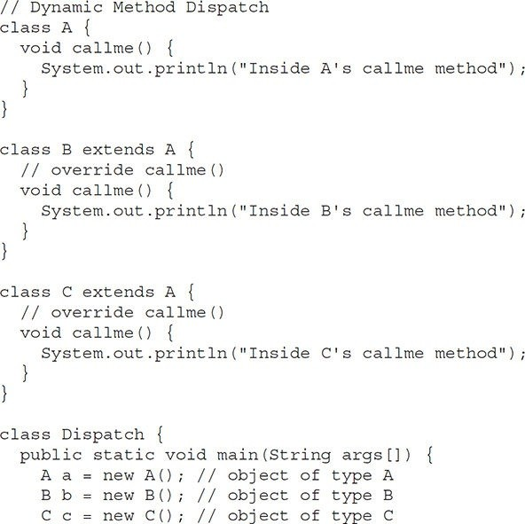

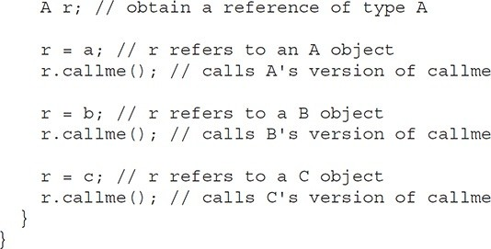

The output from the program is shown here:

Inside A's callme method Inside B's callme method Inside C's callme method

This program creates one superclass called **A** and two subclasses of it, called **B** and **C**. Subclasses **B** and **C** override **callme( )** declared in **A**. Inside the **main()** method, objects of type **A**, **B**, and **C** are declared. Also, a reference of type **A**, called **r**, is declared. The program then in turn assigns a reference to each type of object to **r** and uses that reference to invoke **callme( )**. As the output shows, the version of **callme( )** executed is determined by the type of object being referred to at the time of the call. Had it been determined by the type of the reference variable, **r**, you would see three calls to **A**’s **callme( )** method.

**Why Overridden Methods?**

Overridden methods allow Java to support run-time polymorphism. Polymorphism is essential to object-oriented programming for one reason: it allows a general class to specify methods that will be common to all of its derivatives, while allowing subclasses to define the specific implementation of some or all of those methods. Overridden methods are another way that Java implements the “one interface, multiple methods” aspect of polymorphism.

Part of the key to successfully applying polymorphism is understanding that the superclasses and subclasses form a hierarchy which moves from lesser to greater specialization. Used correctly, the superclass provides all elements that a subclass can use directly. It also defines those methods that the derived class must implement on its own. This allows the subclass the flexibility to define its own methods, yet still enforces a consistent interface. Thus, by combining inheritance with overridden methods, a superclass can define the general form of the methods that will be used by all of its subclasses.

Dynamic, run-time polymorphism is one of the most powerful mechanisms that object-oriented design brings to bear on code reuse and robustness. The ability of existing code libraries to call methods on instances of new classes without recompiling while maintaining a clean abstract interface is a profoundly powerful tool.

**Applying Method Overriding**

Let’s look at a more practical example that uses method overriding. The following program creates a superclass called **Figure** that stores the dimensions of a two-dimensional object. It also defines a method called **area( )** that computes the area of an object. The program derives two subclasses from **Figure**. The first is **Rectangle** and the second is **Triangle**. Each of these subclasses overrides **area( )** so that it returns the area of a rectangle and a triangle, respectively.

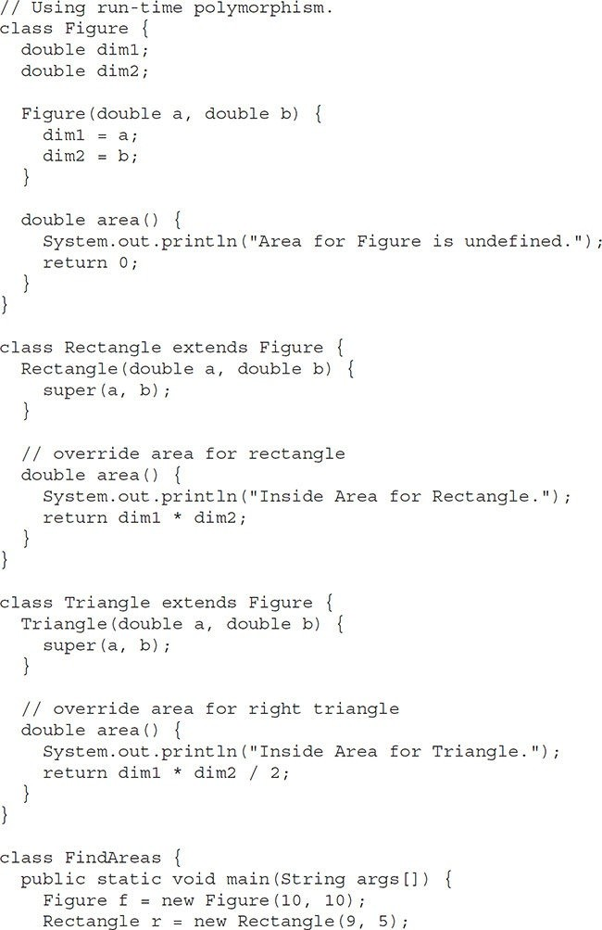

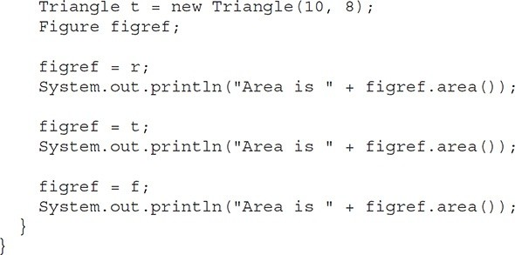

The output from the program is shown here:

Inside Area for Rectangle. Area is 45

Inside Area for Triangle. Area is 40

Area for Figure is undefined. Area is 0

Through the dual mechanisms of inheritance and run-time polymorphism, it is possible to define one consistent interface that is used by several different, yet related, types of objects. In this case, if an object is derived from **Figure**, then its area can be obtained by calling **area( )**. The interface to this operation is the same no matter what type of figure is being used.

**Using Abstract Classes**

There are situations in which you will want to define a superclass that declares the structure of a given abstraction without providing a complete implementation of every method. That is, sometimes you will want to create a superclass that only defines a generalized form that will be shared by all of its subclasses, leaving it to each subclass to fill in the details. Such a class determines the nature of the methods that the subclasses must implement. One way this situation can occur is when a superclass is unable to create a meaningful implementation for a method. This is the case with the class **Figure** used in the preceding example. The definition of **area( )** is simply a placeholder. It will not compute and display the area of any type of object.

As you will see as you create your own class libraries, it is not uncommon for a method to have no meaningful definition in the context of its superclass. You can handle this situation two ways. One way, as shown in the previous example, is to simply have it report a warning message. While this approach can be useful in certain situations—such as debugging—it is not usually appropriate. You may have methods that must be overridden by the subclass in order for the subclass to have any meaning. Consider the class **Triangle**. It has no meaning if **area( )** is not defined. In this case, you want some way to ensure that a subclass does, indeed, override all necessary methods. Java’s solution to this problem is the *abstract method*.

You can require that certain methods be overridden by subclasses by specifying the **abstract** type modifier. These methods are sometimes referred to as *subclasser responsibility* because they have no implementation specified in the superclass. Thus, a subclass must override them—it cannot simply use the version defined in the superclass. To declare an abstract method, use this general form:

abstract *type name*(*parameter-list*);

As you can see, no method body is present.

Any class that contains one or more abstract methods must also be declared abstract. To declare a class abstract, you simply use the **abstract** keyword in front of the **class** keyword at the beginning of the class declaration. There can be no objects of an abstract class. That is, an abstract class cannot be directly instantiated with the **new** operator. Such objects would be useless, because an abstract class is not fully defined. Also, you cannot declare abstract constructors, or abstract static methods. Any subclass of an abstract class must either implement all of the abstract methods in the superclass, or be declared **abstract** itself.

Here is a simple example of a class with an abstract method, followed by a class which implements that method:

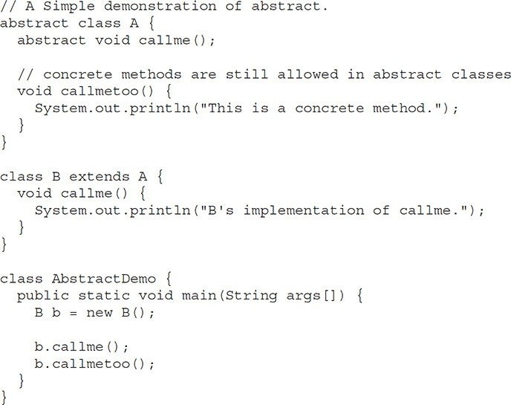

Notice that no objects of class **A** are declared in the program. As mentioned, it is not possible to instantiate an abstract class. One other point: class **A** implements a concrete method called **callmetoo( )**. This is perfectly acceptable. Abstract classes can include as much implementation as they see fit.

Although abstract classes cannot be used to instantiate objects, they can be used to create object references, because Java’s approach to run-time polymorphism is implemented through the use of superclass references. Thus, it must be possible to create a reference to an abstract class so that it can be used to point to a subclass object. You will see this feature put to use in the next example.

Using an abstract class, you can improve the **Figure** class shown earlier.

Since there is no meaningful concept of area for an undefined two-dimensional figure, the following version of the program declares **area( )** as abstract inside **Figure**. This, of course, means that all classes derived from **Figure** must override **area( )**.

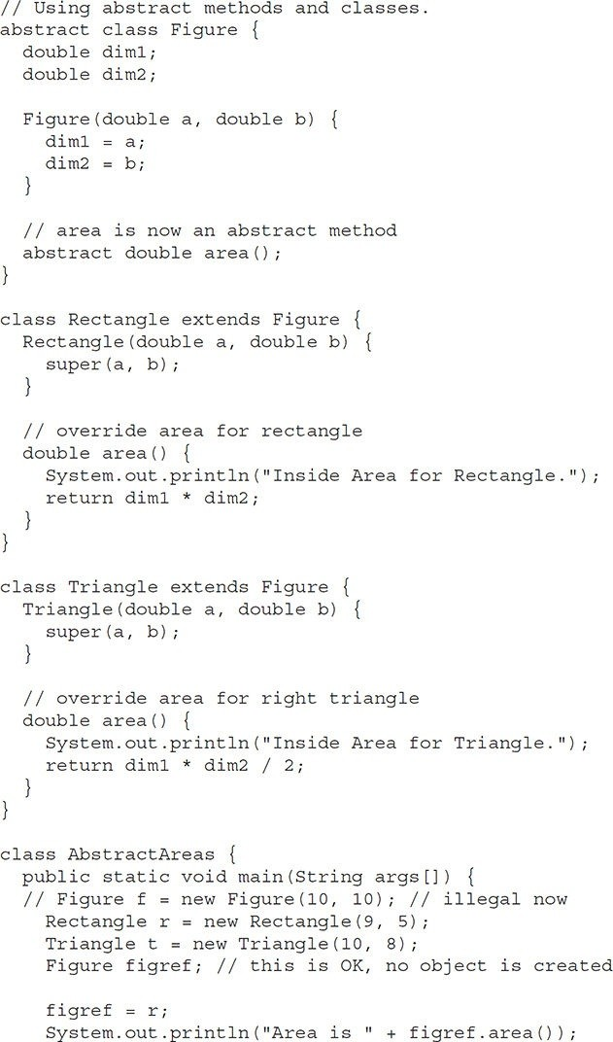

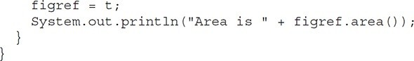

As the comment inside **main( )** indicates, it is no longer possible to declare objects of type **Figure**, since it is now abstract. And, all subclasses of **Figure** must override **area( )**. To prove this to yourself, try creating a subclass that does not override **area( )**. You will receive a compile-time error.

Although it is not possible to create an object of type **Figure**, you can create a reference variable of type **Figure**. The variable **figref** is declared as a reference to **Figure**, which means that it can be used to refer to an object of any class derived from **Figure**. As explained, it is through superclass reference variables that overridden methods are resolved at run time.

**Using final with Inheritance**

The keyword **final** has three uses. First, it can be used to create the equivalent of a named constant. This use was described in the preceding chapter. The other two uses of **final** apply to inheritance. Both are examined here.

**Using final to Prevent Overriding**

While method overriding is one of Java’s most powerful features, there will be times when you will want to prevent it from occurring. To disallow a method from being overridden, specify **final** as a modifier at the start of its declaration. Methods declared as **final** cannot be overridden. The following fragment illustrates **final**:

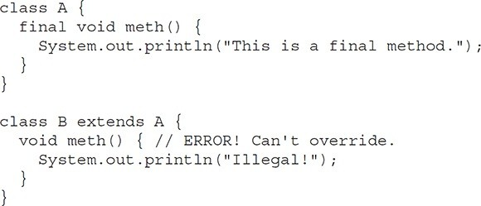

Because **meth( )** is declared as **final**, it cannot be overridden in **B**. If you attempt to do so, a compile-time error will result. Methods declared as **final** can sometimes provide a performance enhancement: The compiler is free to *inline* calls to them because it “knows” they will not be overridden by a subclass. When a small **final** method is called, often the Java compiler can copy the bytecode for the subroutine directly inline with the compiled code of the calling method, thus eliminating the costly overhead associated with a method call. Inlining is an option only with **final** methods. Normally, Java resolves calls to methods dynamically, at run time.

This is called *late binding*. However, since **final** methods cannot be overridden, a call to one can be resolved at compile time. This is called *early binding*.

**Using final to Prevent Inheritance**

Sometimes you will want to prevent a class from being inherited. To do this, precede the class declaration with **final**. Declaring a class as **final** implicitly declares all of its methods as **final**, too. As you might expect, it is illegal to declare a class as both **abstract** and **final** since an abstract class is incomplete by itself and relies upon its subclasses to provide complete implementations.

Here is an example of a **final** class:

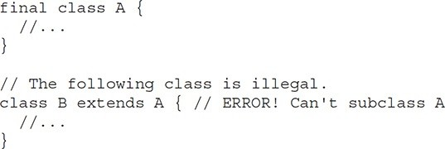

As the comments imply, it is illegal for **B** to inherit **A** since **A** is declared as **final**.

**Local Variable Type Inference and Inheritance**

In JDK 10 added local variable type inference to the Java language, which is supported by the reserved type name **var**. It is important to have a clear understanding of how type inference works within an inheritance hierarchy. Recall that a superclass reference can refer to a derived class object, and this feature is part of Java’s support for polymorphism.

However, it is critical to remember that, when using local variable type inference, the inferred type of a variable is based on the declared type of its initializer. Therefore, if the initializer is of the superclass type, that will be the inferred type of the variable. It does not matter if the actual object being referred to by the initializer is an instance of a derived class. For example, consider this program:

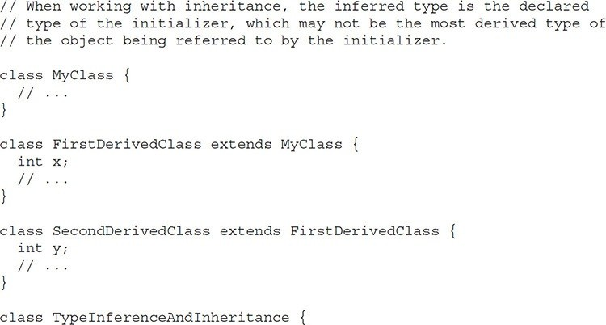

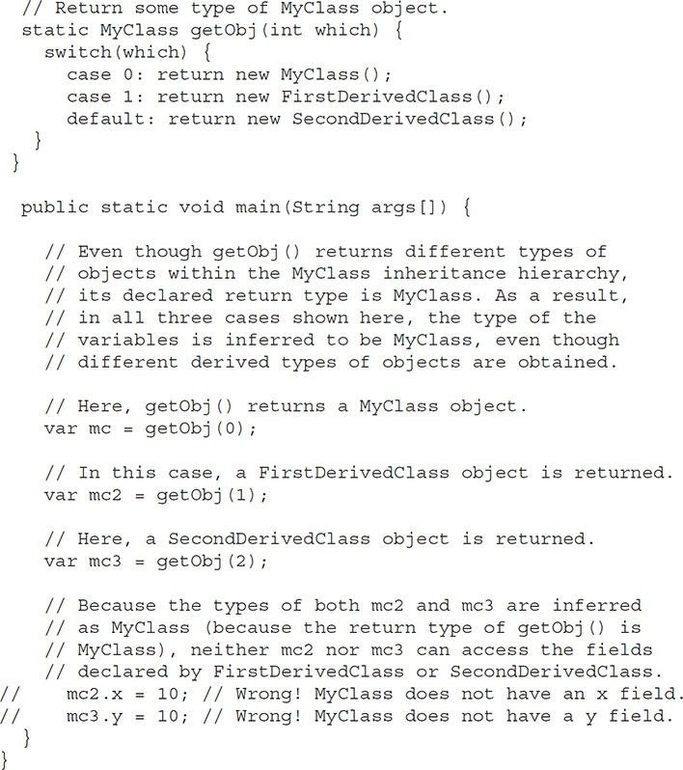

In the program, a hierarchy is created that consists of three classes, at the top of which is **MyClass**. **FirstDerivedClass** is a subclass of **MyClass**, and **SecondDerivedClass** is a subclass of **FirstDerivedClass**. The program then

uses type inference to create three variables, called **mc**, **mc2**, and **mc3** by calling **getObj( )**. The **getObj( )** method has a return type of **MyClass** (the superclass), but returns objects of type **MyClass**, **FirstDerivedClass**, or **SecondDerivedClass**, depending on the argument that it is passed. As the output shows, the inferred type is determined by the return type of **getObj( )**, not by the actual type of the object obtained. Thus, all three variables will be of type **MyClass**.

**The Object Class**

There is one special class, **Object**, defined by Java. All other classes are subclasses of **Object**. That is, **Object** is a superclass of all other classes. This means that a reference variable of type **Object** can refer to an object of any other class. Also, since arrays are implemented as classes, a variable of type **Object** can also refer to any array.

**Object** defines the following methods, which means that they are available in every object.

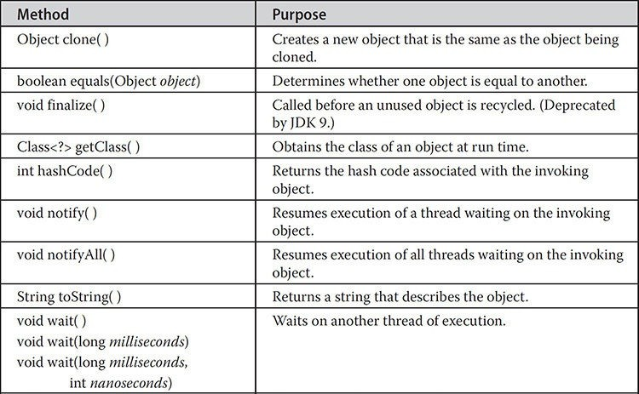

The methods **getClass( )**, **notify( )**, **notifyAll( )**, and **wait( )** are declared as **final**. You may override the others. These methods are described elsewhere in this book. However, notice two methods now: **equals( )** and **toString( )**. The **equals( )** method compares two objects. It returns **true** if the objects are equal, and **false** otherwise. The precise definition of equality can vary, depending on the type of objects being compared. The **toString( )** method returns a string that contains a description of the object on which it is called. Also, this method is automatically called when an object is output using **println( )**. Many classes override this method. Doing so allows them to tailor a description specifically for the types of objects that they create. One last point: Notice the unusual syntax in the return type for **getClass( )**.

**Exception Handling**

An *exception* is an abnormal condition that arises in a code sequence at run time. In other words, an exception is a run-time error. In computer languages that do not support exception handling, errors must be checked and handled manually— typically through the use of error codes, and so on. This approach is as cumbersome as it is troublesome. Java’s exception handling avoids these problems and, in the process, brings run-time error management into the object-oriented world.

**Exception-Handling Fundamentals**

A Java exception is an object that describes an exceptional (that is, error) condition that has occurred in a piece of code. When an exceptional condition arises, an object representing that exception is created and *thrown* in the method that caused the error. That method may choose to handle the exception itself, or pass it on. Either way, at some point, the exception is *caught* and processed. Exceptions can be generated by the Java run-time system, or they can be manually generated by your code. Exceptions thrown by Java relate to fundamental errors that violate the rules of the Java language or the constraints of the Java execution environment. Manually generated exceptions are typically used to report some error condition to the caller of a method.

Java exception handling is managed via five keywords: **try**, **catch**, **throw**, **throws**, and **finally**. Briefly, here is how they work. Program statements that you want to monitor for exceptions are contained within a **try** block. If an exception occurs within the **try** block, it is thrown. Your code can catch this exception (using **catch**) and handle it in some rational manner. System- generated exceptions are automatically thrown by the Java run-time system. To manually throw an exception, use the keyword **throw**. Any exception that is thrown out of a method must be specified as such by a **throws** clause. Any code that absolutely must be executed after a **try** block completes is put in a **finally** block.

This is the general form of an exception-handling block:

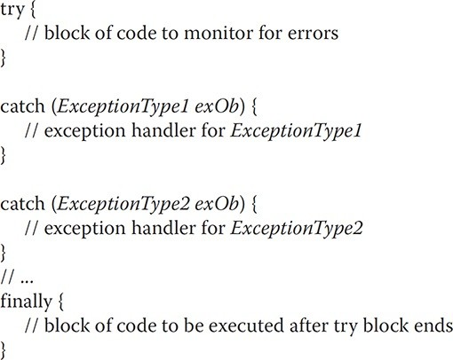

Here, *ExceptionType* is the type of exception that has occurred. The remainder of this chapter describes how to apply this framework.

**Exception Types**

All exception types are subclasses of the built-in class **Throwable**. Thus, **Throwable** is at the top of the exception class hierarchy. Immediately below **Throwable** are two subclasses that partition exceptions into two distinct branches. One branch is headed by **Exception**. This class is used for exceptional conditions that user programs should catch. This is also the class that you will subclass to create your own custom exception types. There is an important subclass of **Exception**, called **RuntimeException**. Exceptions of this type are automatically defined for the programs that you write and include things such as division by zero and invalid array indexing.

The other branch is topped by **Error**, which defines exceptions that are not expected to be caught under normal circumstances by your program. Exceptions of type **Error** are used by the Java run-time system to indicate errors having to do with the run-time environment, itself. Stack overflow is an example of such an error. This chapter will not be dealing with exceptions of type **Error**, because these are typically created in response to catastrophic failures that cannot usually be handled by your program.

The top-level exception hierarchy is shown here:

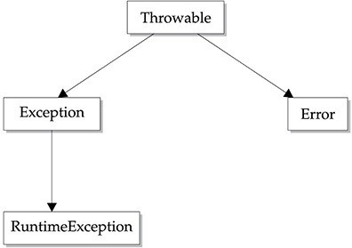

**Uncaught Exceptions**

Before you learn how to handle exceptions in your program, it is useful to see what happens when you don’t handle them. This small program includes an expression that intentionally causes a divide-by-zero error:

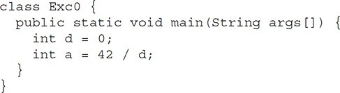

When the Java run-time system detects the attempt to divide by zero, it constructs a new exception object and then *throws* this exception. This causes the execution of **Exc0** to stop, because once an exception has been thrown, it must be *caught* by an exception handler and dealt with immediately. In this example, we haven’t supplied any exception handlers of our own, so the exception is caught by the default handler provided by the Java run-time system. Any exception that is not caught by your program will ultimately be processed by the default handler. The default handler displays a string describing the exception, prints a stack trace from the point at which the exception occurred, and terminates the program.

Here is the exception generated when this example is executed:



Notice how the class name, **Exc0**; the method name, **main**; the filename, **Exc0.java**; and the line number, **4**, are all included in the simple stack trace. Also, notice that the type of exception thrown is a subclass of **Exception** called **ArithmeticException**, which more specifically describes what type of error happened. As discussed later in this chapter, Java supplies several built-in exception types that match the various sorts of run-time errors that can be generated. One other point: The exact output you see when running this and other example programs in this chapter that use Java’s built-in exceptions may vary slightly from what is shown because of differences between JDKs.

The stack trace will always show the sequence of method invocations that led up to the error. For example, here is another version of the preceding program that introduces the same error but in a method separate from **main( )**:

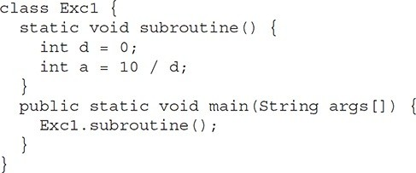

The resulting stack trace from the default exception handler shows how the entire call stack is displayed:

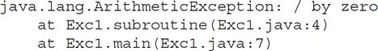

As you can see, the bottom of the stack is **main**’s line 7, which is the call to **subroutine( )**, which caused the exception at line 4. The call stack is quite useful for debugging, because it pinpoints the precise sequence of steps that led to the error.

**Using try and catch**

Although the default exception handler provided by the Java run-time system is useful for debugging, you will usually want to handle an exception yourself.

Doing so provides two benefits. First, it allows you to fix the error. Second, it prevents the program from automatically terminating. Most users would be confused (to say the least) if your program stopped running and printed a stack trace whenever an error occurred! Fortunately, it is quite easy to prevent this.

To guard against and handle a run-time error, simply enclose the code that you want to monitor inside a **try** block. Immediately following the **try** block, include a **catch** clause that specifies the exception type that you wish to catch. To illustrate how easily this can be done, the following program includes a **try** block and a **catch** clause that processes the **ArithmeticException** generated by the division-by-zero error:

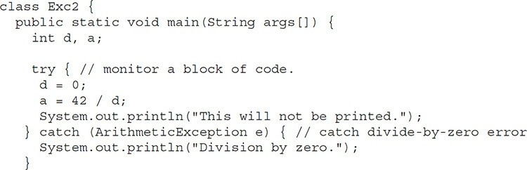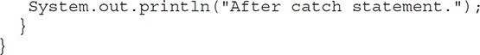

This program generates the following output:

Division by zero. After catch statement.

Notice that the call to **println( )** inside the **try** block is never executed. Once an exception is thrown, program control transfers out of the **try** block into the **catch** block. Put differently, **catch** is not “called,” so execution never “returns” to the **try** block from a **catch**. Thus, the line "This will not be printed." is not displayed. Once the **catch** statement has executed, program control continues with the next line in the program following the entire **try / catch** mechanism.

A **try** and its **catch** statement form a unit. The scope of the **catch** clause is restricted to those statements specified by the immediately preceding **try** statement. A **catch** statement cannot catch an exception thrown by another **try** statement (except in the case of nested **try** statements, described shortly). The statements that are protected by **try** must be surrounded by curly braces. (That is, they must be within a block.) You cannot use **try** on a single statement.

The goal of most well-constructed **catch** clauses should be to resolve the exceptional condition and then continue on as if the error had never happened. For example, in the next program each iteration of the **for** loop obtains two random integers. Those two integers are divided by each other, and the result is used to divide the value 12345. The final result is put into **a**. If either division operation causes a divide-by-zero error, it is caught, the value of **a** is set to zero, and the program continues.

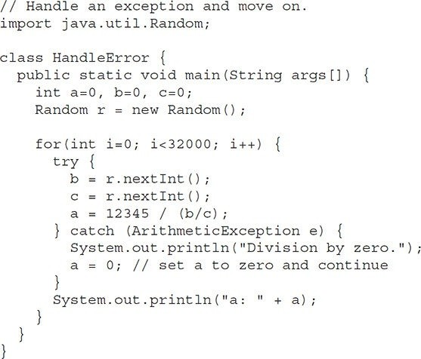

**Displaying a Description of an Exception**

**Throwable** overrides the **toString( )** method (defined by **Object**) so that it returns a string containing a description of the exception. You can display this description in a **println( )** statement by simply passing the exception as an argument. For example, the **catch** block in the preceding program can be rewritten like this:

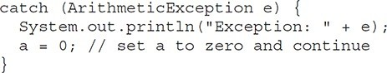When this version is substituted in the program, and the program is run, each divide-by-zero error displays the following message:

Exception: java.lang.ArithmeticException: / by zero

While it is of no particular value in this context, the ability to display a description of an exception is valuable in other circumstances—particularly when you are experimenting with exceptions or when you are debugging.

**Multiple catch Clauses**

In some cases, more than one exception could be raised by a single piece of code. To handle this type of situation, you can specify two or more **catch** clauses, each catching a different type of exception. When an exception is thrown, each **catch** statement is inspected in order, and the first one whose type matches that of the exception is executed. After one **catch** statement executes, the others are bypassed, and execution continues after the **try / catch** block.

The following example traps two different exception types:

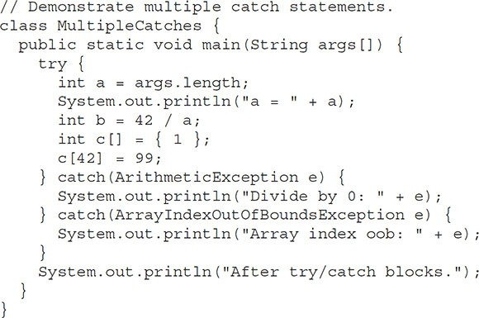

This program will cause a division-by-zero exception if it is started with no command-line arguments, since **a** will equal zero. It will survive the division if you provide a command-line argument, setting **a** to something larger than zero. But it will cause an **ArrayIndexOutOfBoundsException**, since the **int** array **c** has a length of 1, yet the program attempts to assign a value to **c[42]**.

Here is the output generated by running it both ways:

C:\>java MultipleCatches a = 0

Divide by 0: java.lang.ArithmeticException: / by zero After try/catch blocks.

C:\>java MultipleCatches TestArg a = 1

Array index oob: java.lang.ArrayIndexOutOfBoundsException: Index 42 out of bounds for length 1

After try/catch blocks.

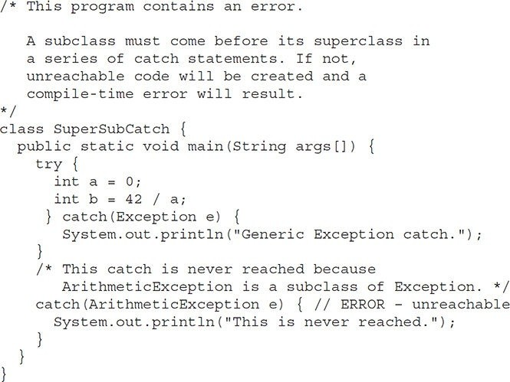When you use multiple **catch** statements, it is important to remember that exception subclasses must come before any of their superclasses. This is because a **catch** statement that uses a superclass will catch exceptions of that type plus any of its subclasses. Thus, a subclass would never be reached if it came after its superclass. Further, in Java, unreachable code is an error. For example, consider the following program:

If you try to compile this program, you will receive an error message stating that the second **catch** statement is unreachable because the exception has already been caught. Since **ArithmeticException** is a subclass of **Exception**, the first **catch** statement will handle all **Exception**-based errors, including **ArithmeticException**. This means that the second **catch** statement will never execute. To fix the problem, reverse the order of the **catch** statements.

**Nested try Statements**

The **try** statement can be nested. That is, a **try** statement can be inside the block of another **try**. Each time a **try** statement is entered, the context of that exception is pushed on the stack. If an inner **try** statement does not have a **catch** handler for a particular exception, the stack is unwound and the next **try** statement’s **catch** handlers are inspected for a match. This continues until one of the **catch** statements succeeds, or until all of the nested **try** statements are exhausted. If no **catch** statement matches, then the Java run-time system will handle the exception. Here is an example that uses nested **try** statements:

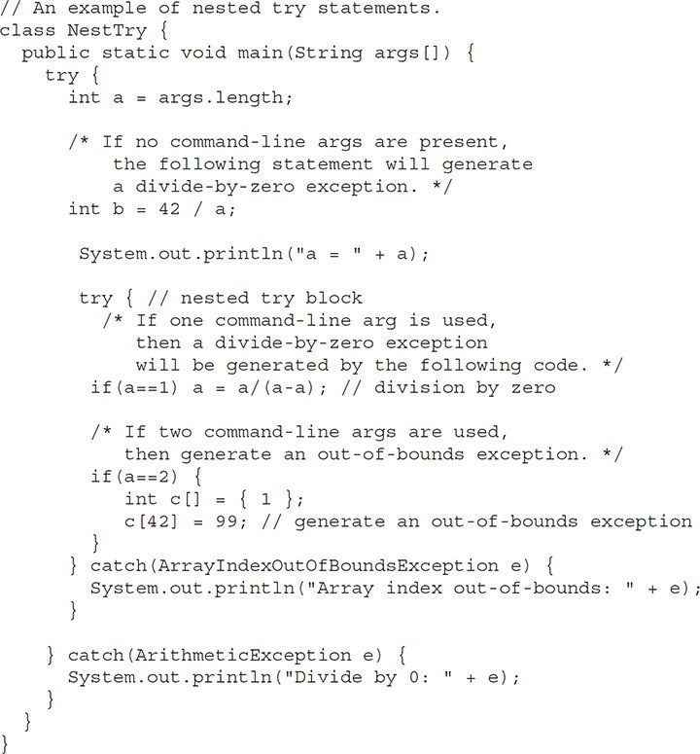

As you can see, this program nests one **try** block within another. The program works as follows. When you execute the program with no command- line arguments, a divide-by-zero exception is generated by the outer **try** block. Execution of the program with one command-line argument generates a divide-

by-zero exception from within the nested **try** block. Since the inner block does not catch this exception, it is passed on to the outer **try** block, where it is handled. If you execute the program with two command-line arguments, an array boundary exception is generated from within the inner **try** block. Here are sample runs that illustrate each case:

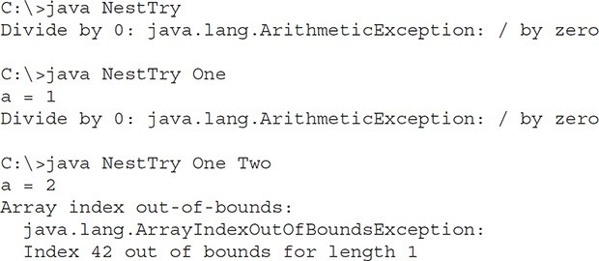

Nesting of **try** statements can occur in less obvious ways when method calls are involved. For example, you can enclose a call to a method within a **try** block. Inside that method is another **try** statement. In this case, the **try** within the method is still nested inside the outer **try** block, which calls the method.

Here is the previous program recoded so that the nested **try** block is moved inside the method **nesttry( )**:

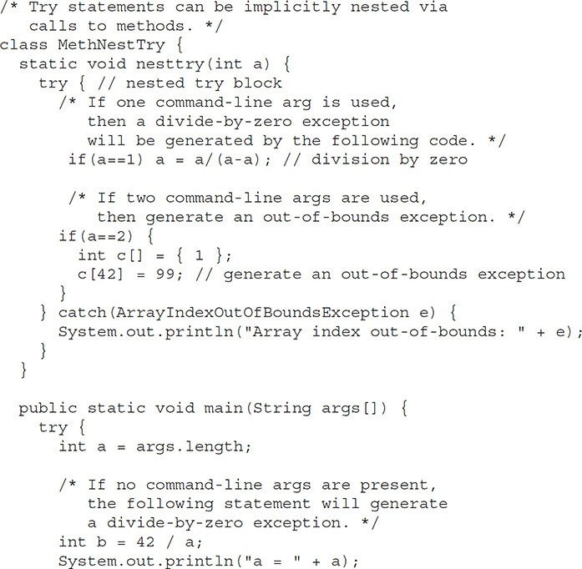

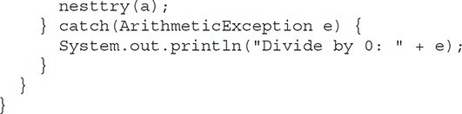

The output of this program is identical to that of the preceding example.

**throw**

So far, you have only been catching exceptions that are thrown by the Java run- time system. However, it is possible for your program to throw an exception explicitly, using the **throw** statement. The general form of **throw** is shown here:

throw *ThrowableInstance*;

Here, *ThrowableInstance* must be an object of type **Throwable** or a subclass of **Throwable**. Primitive types, such as **int** or **char**, as well as non-**Throwable** classes, such as **String** and **Object**, cannot be used as exceptions. There are two ways you can obtain a **Throwable** object: using a parameter in a **catch** clause or creating one with the **new** operator.

The flow of execution stops immediately after the **throw** statement; any subsequent statements are not executed. The nearest enclosing **try** block is inspected to see if it has a **catch** statement that matches the type of exception. If it does find a match, control is transferred to that statement. If not, then the next enclosing **try** statement is inspected, and so on. If no matching **catch** is found, then the default exception handler halts the program and prints the stack trace.

Here is a sample program that creates and throws an exception. The handler that catches the exception rethrows it to the outer handler.

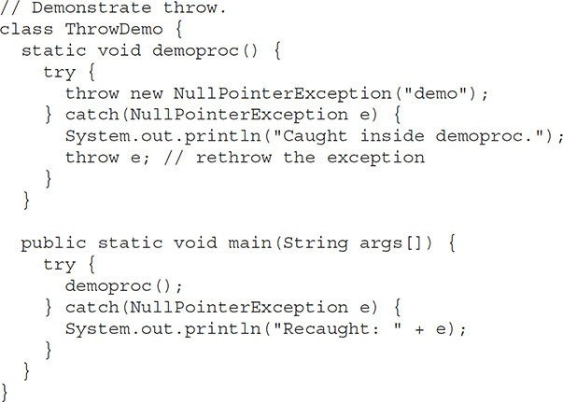

This program gets two chances to deal with the same error. First, **main( )** sets up an exception context and then calls **demoproc( )**. The **demoproc( )** method then sets up another exception-handling context and immediately throws a new instance of **NullPointerException**, which is caught on the next line. The exception is then rethrown. Here is the resulting output:

Caught inside demoproc.

Recaught: java.lang.NullPointerException: demo

The program also illustrates how to create one of Java’s standard exception objects. Pay close attention to this line:

throw new NullPointerException("demo");

Here, **new** is used to construct an instance of **NullPointerException**. Many of Java’s built-in run-time exceptions have at least two constructors: one with no parameter and one that takes a string parameter. When the second form is used, the argument specifies a string that describes the exception. This string is displayed when the object is used as an argument to **print( )** or **println( )**. It can also be obtained by a call to **getMessage( )**, which is defined by **Throwable**.

**throws**

If a method is capable of causing an exception that it does not handle, it must specify this behavior so that callers of the method can guard themselves against that exception. You do this by including a **throws** clause in the method’s declaration. A **throws** clause lists the types of exceptions that a method might throw. This is necessary for all exceptions, except those of type **Error** or **RuntimeException**, or any of their subclasses. All other exceptions that a method can throw must be declared in the **throws** clause. If they are not, a compile-time error will result.

This is the general form of a method declaration that includes a **throws**

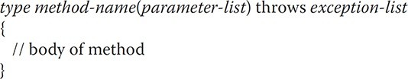clause:

Here, *exception-list* is a comma-separated list of the exceptions that a method can throw.

Following is an example of an incorrect program that tries to throw an exception that it does not catch. Because the program does not specify a **throws** clause to declare this fact, the program will not compile.

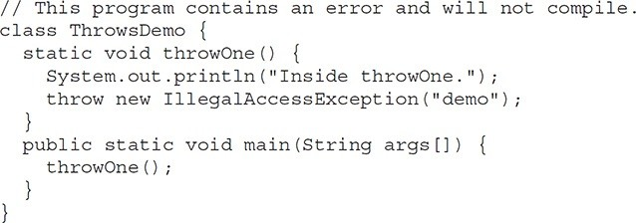

To make this example compile, you need to make two changes. First, you need to declare that **throwOne( )** throws **IllegalAccessException**. Second, **main( )** must define a **try / catch** statement that catches this exception.

The corrected example is shown here:

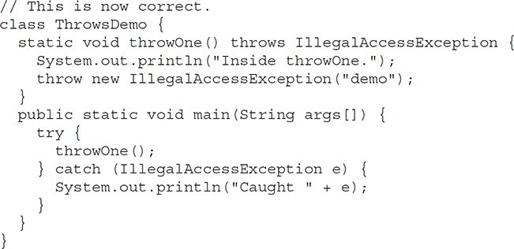

Here is the output generated by running this example program:

inside throwOne

caught java.lang.IllegalAccessException: demo

**finally**

When exceptions are thrown, execution in a method takes a rather abrupt, nonlinear path that alters the normal flow through the method. Depending upon how the method is coded, it is even possible for an exception to cause the method to return prematurely. This could be a problem in some methods. For example, if a method opens a file upon entry and closes it upon exit, then you will not want the code that closes the file to be bypassed by the exception- handling mechanism. The **finally** keyword is designed to address this contingency.

**finally** creates a block of code that will be executed after a **try /catch** block has completed and before the code following the **try/catch** block. The **finally** block will execute whether or not an exception is thrown. If an exception is thrown, the **finally** block will execute even if no **catch** statement matches the exception. Any time a method is about to return to the caller from inside a **try/catch** block, via an uncaught exception or an explicit return statement, the **finally** clause is also executed just before the method returns. This can be useful for closing file handles and freeing up any other resources that might have been allocated at the beginning of a method with the intent of disposing of them before returning. The **finally** clause is optional. However, each **try** statement requires at least one **catch** or a **finally** clause.

Here is an example program that shows three methods that exit in various ways, none without executing their **finally** clauses:

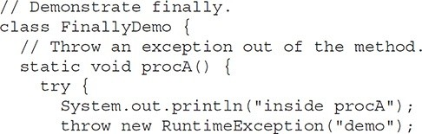

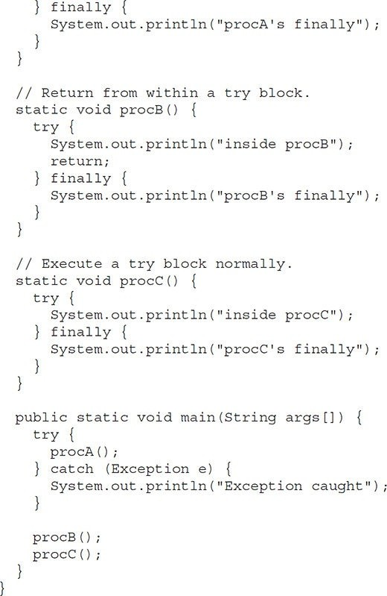

In this example, **procA( )** prematurely breaks out of the **try** by throwing an exception. The **finally** clause is executed on the way out. **procB( )**’s **try** statement is exited via a **return** statement. The **finally** clause is executed before **procB( )** returns. In **procC( )**, the **try** statement executes normally, without error. However, the **finally** block is still executed.

Here is the output generated by the preceding program:

inside procA procA's finally Exception caught inside procB procB's finally inside procC procC's finally

**Java’s Built-in Exceptions**

Inside the standard package **java.lang**, Java defines several exception classes. A few have been used by the preceding examples. The most general of these exceptions are subclasses of the standard type **RuntimeException**. As previously explained, these exceptions need not be included in any method’s **throws** list. In the language of Java, these are called *unchecked exceptions* because the compiler does not check to see if a method handles or throws these exceptions. The unchecked exceptions defined in **java.lang** are listed in Table 10-1. Table 10-2 lists those exceptions defined by **java.lang** that must be included in a method’s **throws** list if that method can generate one of these exceptions and does not handle it itself. These are called *checked exceptions*. In addition to the exceptions in **java .lang**, Java defines several more that relate to its other standard packages.

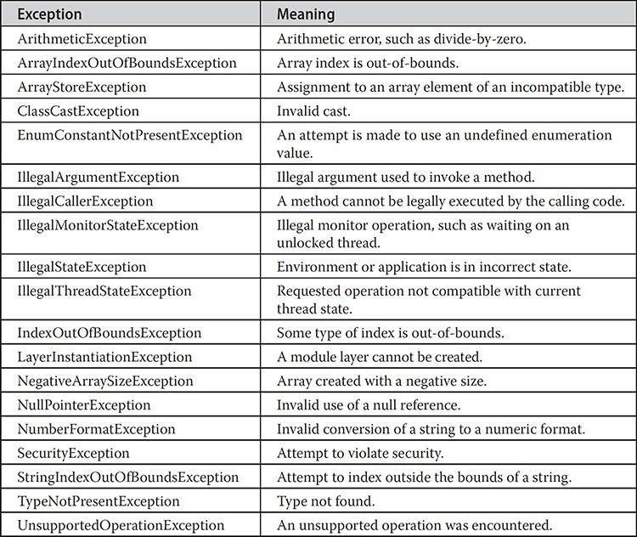

**Table 10-1** Java’s Unchecked **RuntimeException** Subclasses Defined in **java.lang**

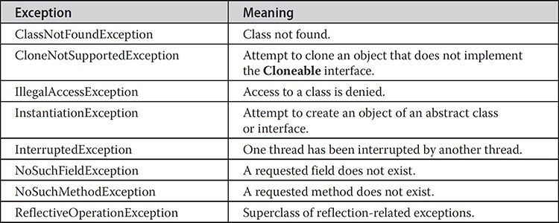

**Table 10-2** Java’s Checked Exceptions Defined in **java.lang**

**Creating Your Own Exception Subclasses**

Although Java’s built-in exceptions handle most common errors, you will probably want to create your own exception types to handle situations specific to your applications. This is quite easy to do: just define a subclass of **Exception** (which is, of course, a subclass of **Throwable**). Your subclasses don’t need to actually implement anything—it is their existence in the type system that allows you to use them as exceptions.

The **Exception** class does not define any methods of its own. It does, of course, inherit those methods provided by **Throwable**. Thus, all exceptions, including those that you create, have the methods defined by **Throwable** available to them. They are shown in Table 10-3. You may also wish to override one or more of these methods in exception classes that you create.

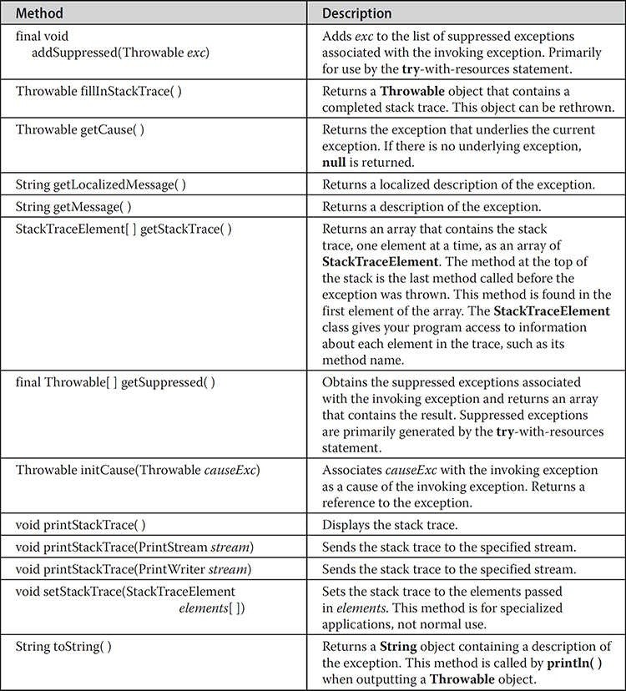

**Table 10-3** The Methods Defined by **Throwable**

**Exception** defines four public constructors. Two support chained

exceptions, described in the next section. The other two are shown here:

Exception( ) Exception(String *msg*)

The first form creates an exception that has no description. The second form lets you specify a description of the exception.

Although specifying a description when an exception is created is often useful, sometimes it is better to override **toString( )**. Here’s why: The version of **toString( )** defined by **Throwable** (and inherited by **Exception**) first displays the name of the exception followed by a colon, which is then followed by your description. By overriding **toString( )**, you can prevent the exception name and colon from being displayed. This makes for a cleaner output, which is desirable in some cases.

The following example declares a new subclass of **Exception** and then uses that subclass to signal an error condition in a method. It overrides the **toString()** method, allowing a carefully tailored description of the exception to be displayed.

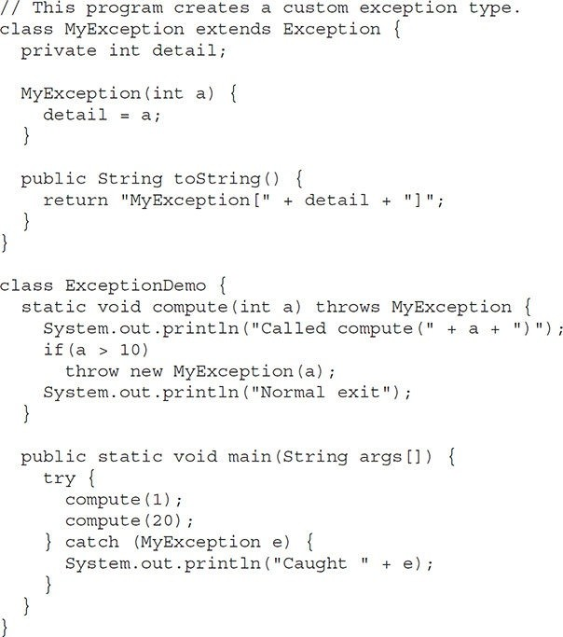

This example defines a subclass of **Exception** called **MyException**. This subclass is quite simple: It has only a constructor plus an overridden **toString()** method that displays the value of the exception. The **ExceptionDemo** class defines a method named **compute( )** that throws a **MyException** object. The exception is thrown when **compute( )**’s integer parameter is greater than 10. The **main( )** method sets up an exception handler for **MyException**, then calls **compute( )** with a legal value (less than 10) and an illegal one to show both paths through the code. Here is the result:

Called compute(1) Normal exit

Called compute(20) Caught MyException[20]

**Chained Exceptions**

A number of years ago, a feature was incorporated into the exception subsystem: *chained exceptions*. The chained exception feature allows you to associate another exception with an exception. This second exception describes the cause of the first exception. For example, imagine a situation in which a method throws an **ArithmeticException** because of an attempt to divide by zero. However, the actual cause of the problem was that an I/O error occurred, which caused the divisor to be set improperly. Although the method must certainly throw an **ArithmeticException**, since that is the error that occurred, you might also want to let the calling code know that the underlying cause was an I/O error. Chained exceptions let you handle this, and any other situation in which layers of exceptions exist.

To allow chained exceptions, two constructors and two methods were added to **Throwable**. The constructors are shown here:

Throwable(Throwable *causeExc*) Throwable(String *msg*, Throwable *causeExc*)

In the first form, *causeExc* is the exception that causes the current exception. That is, *causeExc* is the underlying reason that an exception occurred. The second form allows you to specify a description at the same time that you specify a cause exception. These two constructors have also been added to the **Error**, **Exception**, and **RuntimeException** classes.

The chained exception methods supported by **Throwable** are **getCause( )** and **initCause( )**. These methods are shown in Table 10-3 and are repeated here for the sake of discussion.

Throwable getCause( )

Throwable initCause(Throwable *causeExc*)

The **getCause( )** method returns the exception that underlies the current exception. If there is no underlying exception, **null** is returned. The **initCause( )** method associates *causeExc* with the invoking exception and returns areference to the exception. Thus, you can associate a cause with an exception after the exception has been created. However, the cause exception can be set only once. This means that you can call **initCause( )** only once for each exception object. Furthermore, if the cause exception was set by a constructor, then you can’t set it again using **initCause( )**. In general, **initCause( )** is used to set a cause for legacy exception classes that don’t support the two additional constructors described earlier.

Here is an example that illustrates the mechanics of handling chained exceptions:

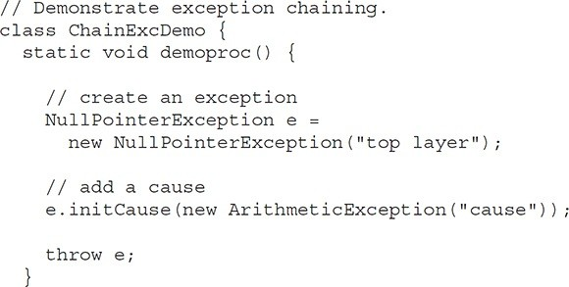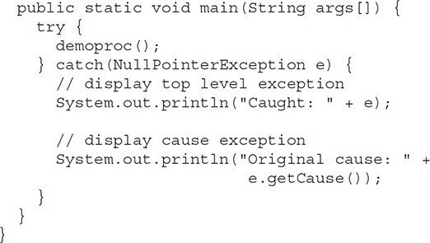The output from the program is shown here: Caught: java.lang.NullPointerException: top layer Original cause: java.lang.ArithmeticException: cause In this example, the top-level exception is **NullPointerException**. To it is added a cause exception, **ArithmeticException**. When the exception is thrown out of **demoproc( )**, it is caught by **main( )**. There, the top-level exception is displayed, followed by the underlying exception, which is obtained by calling **getCause( )**. Chained exceptions can be carried on to whatever depth is necessary. Thus, the cause exception can, itself, have a cause. Be aware that overly long chains of exceptions may indicate poor design. Chained exceptions are not something that every program will need. However, in cases in which knowledge of an underlying cause is useful, they offer an elegant solution.

**Three Additional Exception Features**

Beginning with JDK 7, three interesting and useful features have been part of the exception system. The first automates the process of releasing a resource, such as a file, when it is no longer needed. It is based on an expanded form of the **try** statement called ***try****-with-resources*. The second feature is called *multi-catch*, and the third is sometimes referred to as *final rethrow* or *more precise rethrow*. These two features are described here.

The multi-catch feature allows two or more exceptions to be caught by the same **catch** clause. It is not uncommon for two or more exception handlers to use the same code sequence even though they respond to different exceptions. Instead of having to catch each exception type individually, you can use a single **catch** clause to handle all of the exceptions without code duplication.

To use a multi-catch, separate each exception type in the **catch** clause with the OR operator. Each multi-catch parameter is implicitly **final**. (You can explicitly specify **final**, if desired, but it is not necessary.) Because each multi- catch parameter is implicitly **final**, it can’t be assigned a new value.

Here is a **catch** statement that uses the multi-catch feature to catch both

**ArithmeticException** and **ArrayIndexOutOfBoundsException**: catch(ArithmeticException | ArrayIndexOutOfBoundsException e) { The following program shows the multi-catch feature in action:

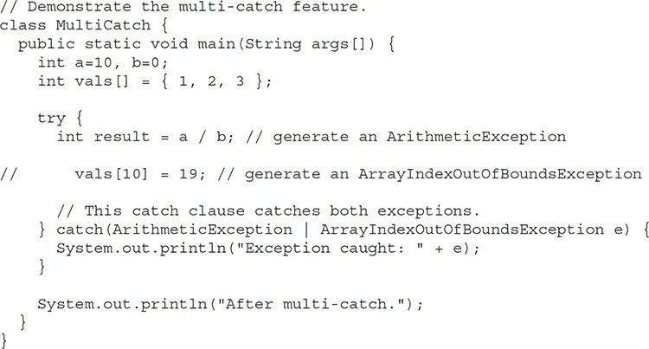

The program will generate an **ArithmeticException** when the division by zero is attempted. If you comment out the division statement and remove the comment symbol from the next line, an **ArrayIndexOutOfBoundsException** is generated. Both exceptions are caught by the single **catch** statement.

The more precise rethrow feature restricts the type of exceptions that can be rethrown to only those checked exceptions that the associated **try** block throws, that are not handled by a preceding **catch** clause, and that are a subtype or supertype of the parameter. Although this capability might not be needed often, it is now available for use. For the more precise rethrow feature to be in force, the **catch** parameter must be either effectively **final**, which means that it must not be assigned a new value inside the **catch** block, or explicitly declared **final**.

**Using Exceptions**

Exception handling provides a powerful mechanism for controlling complex programs that have many dynamic run-time characteristics. It is important to think of **try**, **throw**, and **catch** as clean ways to handle errors and unusual boundary conditions in your program’s logic. Instead of using error return codes to indicate failure, use Java’s exception handling capabilities. Thus, when a method can fail, have it throw an exception. This is a cleaner way to handle failure modes.

One last point: Java’s exception-handling statements should not be considered a general mechanism for nonlocal branching. If you do so, it will only confuse your code and make it hard to maintain.