**UNIT-III**

**Packages and Interfaces**

**Packages**

In the preceding chapters, the name of each example class was taken from the same name space. This means that a unique name had to be used for each class to avoid name collisions. After a while, without some way to manage the name space, you could run out of convenient, descriptive names for individual classes. You also need some way to be assured that the name you choose for a class will be reasonably unique and not collide with class names chosen by other programmers. (Imagine a small group of programmers fighting over who gets to use the name “Foobar” as a class name. Or, imagine the entire Internet community arguing over who first named a class “Espresso.”) Thankfully, Java provides a mechanism for partitioning the class name space into more manageable chunks. This mechanism is the package. The package is both a naming and a visibility control mechanism. You can define classes inside a package that are not accessible by code outside that package. You can also define class members that are exposed only to other members of the same package. This allows your classes to have intimate knowledge of each other, but not expose that knowledge to the rest of the world.

**Defining a Package**

To create a package is quite easy: simply include a **package** command as the first statement in a Java source file. Any classes declared within that file will belong to the specified package. The **package** statement defines a name space in which classes are stored. If you omit the **package** statement, the class names are put into the default package, which has no name. (This is why you haven’t had to worry about packages before now.) While the default package is fine for short, sample programs, it is inadequate for real applications. Most of the time, you will define a package for your code.

This is the general form of the **package** statement:

package *pkg*;

Here, *pkg* is the name of the package. For example, the following statement creates a package called **mypackage**:

package mypackage;

Typically, Java uses file system directories to store packages, and that is the approach assumed by the examples in this book. For example, the **.class** files for any classes you declare to be part of **mypackage** must be stored in a directory called **mypackage**. Remember that case is significant, and the directory name must match the package name exactly.

More than one file can include the same **package** statement. The **package** statement simply specifies to which package the classes defined in a file belong. It does not exclude other classes in other files from being part of that same package. Most real-world packages are spread across many files.

You can create a hierarchy of packages. To do so, simply separate each package name from the one above it by use of a period. The general form of a multileveled package statement is shown here:

package *pkg1*[.*pkg2*[.*pkg3*]];

A package hierarchy must be reflected in the file system of your Java development system. For example, a package declared as **package a.b.c;** needs to be stored in **a\b\c** in a Windows environment. Be sure to choose your package names carefully. You cannot rename a package without renaming the directory in which the classes are stored.

**Finding Packages and CLASSPATH**

Packages are typically mirrored by directories. This raises an important question: How does the Java run-time system know where to look for packages that you create? As it relates to the examples in this chapter, the answer has three parts. First, by default, the Java run-time system uses the current working directory as its starting point. Thus, if your package is in a subdirectory of the current directory, it will be found. Second, you can specify a directory path or paths by setting the **CLASSPATH** environmental variable. Third, you can use the **-classpath** option with **java** and **javac** to specify the path to your classes. It is useful to point out that, beginning with JDK 9, a package can be part of a module, and thus found on the module path.

For example, consider the following package specification:

package mypack;

In order for a program to find **mypack**, the program can be executed from a directory immediately above **mypack**, or the **CLASSPATH** must be set to include the path to **mypack**, or the **-classpath** option must specify the path to **mypack** when the program is run via **java**. When the second two options are used, the class path *must not* include **mypack**, itself. It must simply specify the *path to* **mypack**. For example, in a Windows environment, if the path to **mypack** is

C:\MyPrograms\Java\mypack then the class path to **mypack** is C:\MyPrograms\Java

The easiest way to try the examples shown in this book is to simply create the package directories below your current development directory, put the **.class** files into the appropriate directories, and then execute the programs from the development directory. This is the approach used in the following example.

**A Short Package Example**

Keeping the preceding discussion in mind, you can try this simple package:

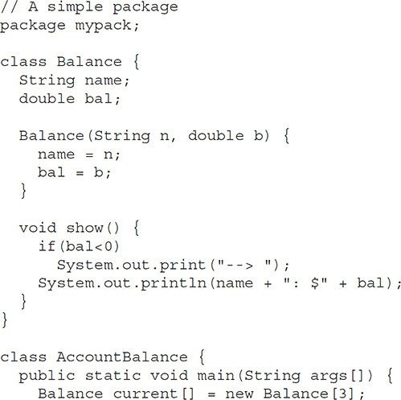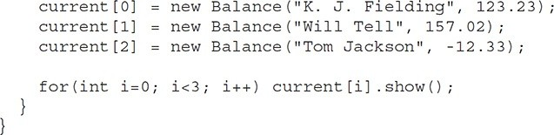

Call this file **AccountBalance.java** and put it in a directory called **mypack**. Next, compile the file. Make sure that the resulting **.class** file is also in the **mypack** directory. Then, try executing the **AccountBalance** class, using the following command line:

java mypack.AccountBalance

Remember, you will need to be in the directory above **mypack** when you execute this command. (Alternatively, you can use one of the other two options described in the preceding section to specify the path **mypack**.)

As explained, **AccountBalance** is now part of the package **mypack**. This means that it cannot be executed by itself. That is, you cannot use this command line:

java AccountBalance

**AccountBalance** must be qualified with its package name.

**Packages and Member Access**

Java provides many levels of protection to allow fine-grained control over the visibility of variables and methods within classes, subclasses, and packages.

Classes and packages are both means of encapsulating and containing the name space and scope of variables and methods. Packages act as containers for classes and other subordinate packages. Classes act as containers for data and code. The class is Java’s smallest unit of abstraction. As it relates to the interplay between classes and packages, Java addresses four categories of visibility for class members:

* Subclasses in the same package
* Non-subclasses in the same package
* Subclasses in different packages
* Classes that are neither in the same package nor subclasses

The three access modifiers, **private**, **public**, and **protected**, provide a variety of ways to produce the many levels of access required by these categories. Table 9-1 sums up the interactions.

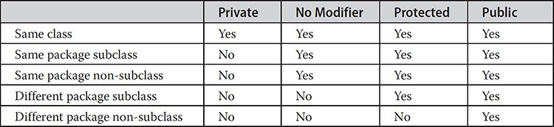

**Table 9-1** Class Member Access

While Java’s access control mechanism may seem complicated, we can simplify it as follows. Anything declared **public** can be accessed from different classes and different packages. Anything declared **private** cannot be seen outside of its class. When a member does not have an explicit access specification, it is visible to subclasses as well as to other classes in the same package. This is the default access. If you want to allow an element to be seen outside your current package, but only to classes that subclass your class directly, then declare that element **protected**.

Table 9-1 applies only to members of classes. A non-nested class has only two possible access levels: default and public. When a class is declared as **public**, it is accessible outside its package. If a class has default access, then it can only be accessed by other code within its same package. When a class is public, it must be the only public class declared in the file, and the file must have the same name as the class.

**An Access Example**

The following example shows all combinations of the access control modifiers. This example has two packages and five classes. Remember that the classes for the two different packages need to be stored in directories named after their respective packages—in this case, **p1** and **p2**.

The source for the first package defines three classes: **Protection**, **Derived**, and **SamePackage**. The first class defines four **int** variables in each of the legal protection modes. The variable **n** is declared with the default protection, **n_pri** is **private**, **n_pro** is **protected**, and **n_pub** is **public**.

Each subsequent class in this example will try to access the variables in an instance of this class. The lines that will not compile due to access restrictions are commented out. Before each of these lines is a comment listing the places from which this level of protection would allow access.

The second class, **Derived**, is a subclass of **Protection** in the same package, **p1**. This grants **Derived** access to every variable in **Protection** except for **n_pri**, the **private** one. The third class, **SamePackage**, is not a subclass of **Protection**, but is in the same package and also has access to all but **n_pri**.

This is file **Protection.java**:

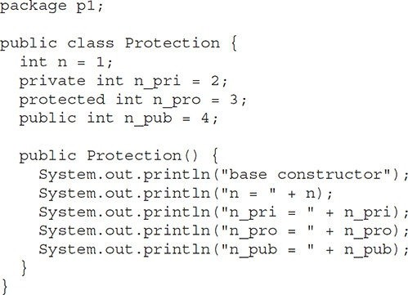

This is file **Derived.java**:

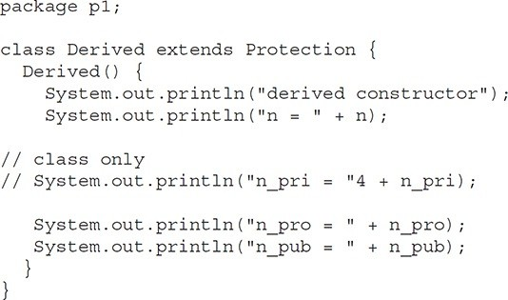

This is file **SamePackage.java**:

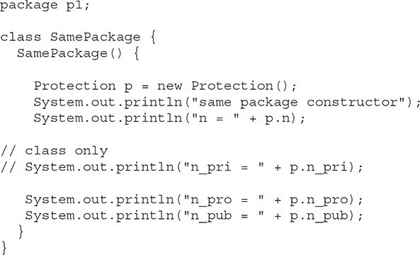Following is the source code for the other package, **p2**. The two classes defined in **p2** cover the other two conditions that are affected by access control. The first class, **Protection2**, is a subclass of **p1.Protection**. This grants access to all of **p1.Protection**’s variables except for **n_pri** (because it is **private**) and **n**, the variable declared with the default protection. Remember, the default only allows access from within the class or the package, not extra-package subclasses. Finally, the class **OtherPackage** has access to only one variable, **n_pub**, which was declared **public**.

This is file **Protection2.java**: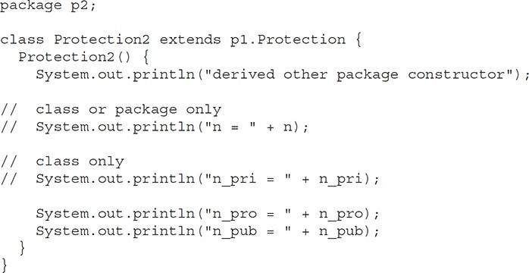

This is file **OtherPackage.java**:

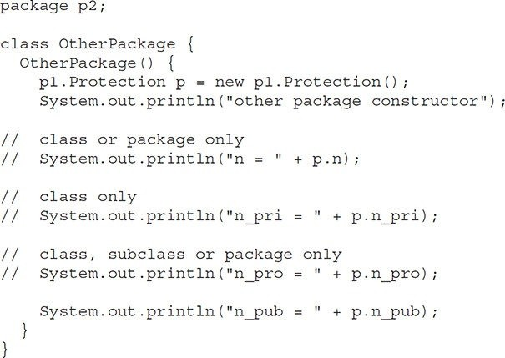

If you want to try these two packages, here are two test files you can use.

The one for package **p1** is shown here:

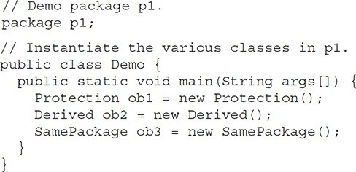

The test file for **p2** is shown next:

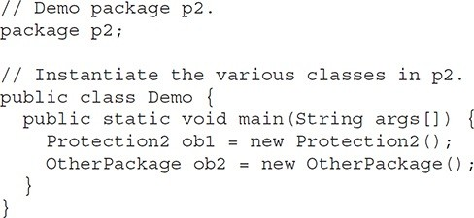

**Importing Packages**

Given that packages exist and are a good mechanism for compartmentalizing diverse classes from each other, it is easy to see why all of the built-in Java classes are stored in packages. There are no core Java classes in the unnamed default package; all of the standard classes are stored in some named package. Since classes within packages must be fully qualified with their package name or names, it could become tedious to type in the long dot-separated package path name for every class you want to use. For this reason, Java includes the **import** statement to bring certain classes, or entire packages, into visibility.

Once imported, a class can be referred to directly, using only its name. The **import** statement is a convenience to the programmer and is not technically needed to write a complete Java program. If you are going to refer to a few dozen classes in your application, however, the **import** statement will save a lot of typing.

In a Java source file, **import** statements occur immediately following the **package** statement (if it exists) and before any class definitions. This is the general form of the **import** statement:

import *pkg1* [.*pkg2*].(*classname* | *);

Here, *pkg1* is the name of a top-level package, and *pkg2* is the name of a subordinate package inside the outer package separated by a dot (**.**). There is no practical limit on the depth of a package hierarchy, except that imposed by the file system. Finally, you specify either an explicit *classname* or a star (*), which indicates that the Java compiler should import the entire package. This code fragment shows both forms in use:

import java.util.Date; import java.io.*;

All of the standard Java SE classes included with Java begin with the name

**java**. The basic language functions are stored in a package called **java.lang**. Normally, you have to import every package or class that you want to use, but since Java is useless without much of the functionality in **java.lang**, it is implicitly imported by the compiler for all programs. This is equivalent to the following line being at the top of all of your programs:

import java.lang.*;

If a class with the same name exists in two different packages that you import using the star form, the compiler will remain silent, unless you try to use one of the classes. In that case, you will get a compile-time error and have to explicitly name the class specifying its package.

It must be emphasized that the **import** statement is optional. Any place you use a class name, you can use its *fully qualified name*, which includes its full package hierarchy. For example, this fragment uses an import statement:

import java.util.*;

class MyDate extends Date {

}

The same example without the **import** statement looks like this:

class MyDate extends java.util.Date {

}

In this version, **Date** is fully-qualified.

As shown in Table 9-1, when a package is imported, only those items within the package declared as **public** will be available to non-subclasses in the importing code. For example, if you want the **Balance** class of the package **mypack** shown earlier to be available as a stand-alone class for general use outside of **mypack**, then you will need to declare it as **public** and put it into its own file, as shown here:

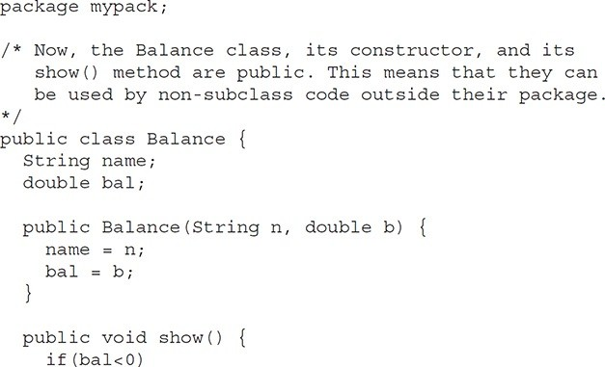

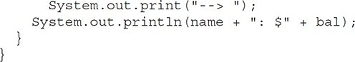

As you can see, the **Balance** class is now **public**. Also, its constructor and its **show( )** method are **public**, too. This means that they can be accessed by any type of code outside the **mypack** package. For example, here **TestBalance** imports **mypack** and is then able to make use of the **Balance** class:

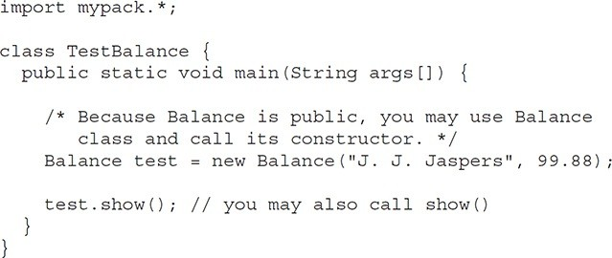

As an experiment, remove the **public** specifier from the **Balance** class and then try compiling **TestBalance**. As explained, errors will result.

**Interfaces**

Using the keyword **interface**, you can fully abstract a class’ interface from its implementation. That is, using **interface**, you can specify what a class must do, but not how it does it. Interfaces are syntactically similar to classes, but they lack instance variables, and, as a general rule, their methods are declared without any body. In practice, this means that you can define interfaces that don’t make assumptions about how they are implemented. Once it is defined, any number of classes can implement an **interface**. Also, one class can implement any number of interfaces.

To implement an interface, a class must provide the complete set of methods required by the interface. However, each class is free to determine the details of its own implementation. By providing the **interface** keyword, Java allows you to fully utilize the “one interface, multiple methods” aspect of polymorphism.

Interfaces are designed to support dynamic method resolution at run time. Normally, in order for a method to be called from one class to another, both classes need to be present at compile time so the Java compiler can check to ensure that the method signatures are compatible. This requirement by itself makes for a static and nonextensible classing environment. Inevitably in a system like this, functionality gets pushed up higher and higher in the class hierarchy so that the mechanisms will be available to more and more subclasses. Interfaces are designed to avoid this problem. They disconnect the definition of a method or set of methods from the inheritance hierarchy. Since interfaces are in a different hierarchy from classes, it is possible for classes that are unrelated in terms of the class hierarchy to implement the same interface.

This is where the real power of interfaces is realized.

### Defining an Interface

An interface is defined much like a class. This is a simplified general form of an interface:

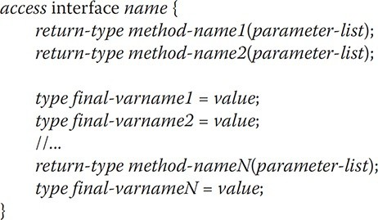

When no access modifier is included, then default access results, and the interface is only available to other members of the package in which it is declared. When it is declared as **public**, the interface can be used by code outside its package. In this case, the interface must be the only public interface declared in the file, and the file must have the same name as the interface. *name* is the name of the interface, and can be any valid identifier. Notice that the methods that are declared have no bodies. They end with a semicolon after the parameter list. They are, essentially, abstract methods. Each class that includes such an interface must implement all of the methods.

Before continuing an important point needs to be made. JDK 8 added a feature to **interface** that made a significant change to its capabilities. Prior to JDK 8, an interface could not define any implementation whatsoever. This is the type of interface that the preceding simplified form shows, in which no method declaration supplies a body. Thus, prior to JDK 8, an interface could define only “what,” but not “how.” JDK 8 changed this. Beginning with JDK 8, it is possible to add a *default implementation* to an interface method.

Furthermore, JDK 8 also added static interface methods, and beginning with JDK 9, an interface can include private methods. Thus, it is now possible for **interface** to specify some behavior. However, such methods constitute what are, in essence, special-use features, and the original intent behind **interface** still remains. Therefore, as a general rule, you will still often create and use interfaces in which no use is made of these new features. For this reason, we will begin by discussing the interface in its traditional form. The new interface features are described at the end of this chapter.

As the general form shows, variables can be declared inside interface declarations. They are implicitly **final** and **static**, meaning they cannot be changed by the implementing class. They must also be initialized. All methods and variables are implicitly **public**.

Here is an example of an interface definition. It declares a simple interface that contains one method called **callback( )** that takes a single integer parameter.

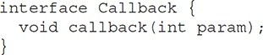

**Implementing Interfaces**

Once an **interface** has been defined, one or more classes can implement that interface. To implement an interface, include the **implements** clause in a class definition, and then create the methods required by the interface. The general form of a class that includes the **implements** clause looks like this:

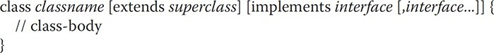

If a class implements more than one interface, the interfaces are separated with a comma. If a class implements two interfaces that declare the same method, then the same method will be used by clients of either interface. The methods that implement an interface must be declared **public**. Also, the type signature of the implementing method must match exactly the type signature specified in the **interface** definition.

Here is a small example class that implements the **Callback** interface shown earlier:

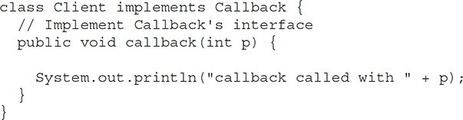

Notice that **callback( )** is declared using the **public** access modifier. It is both permissible and common for classes that implement interfaces to define additional members of their own. For example, the following version of **Client** implements **callback( )** and adds the method **nonIfaceMeth( )**:

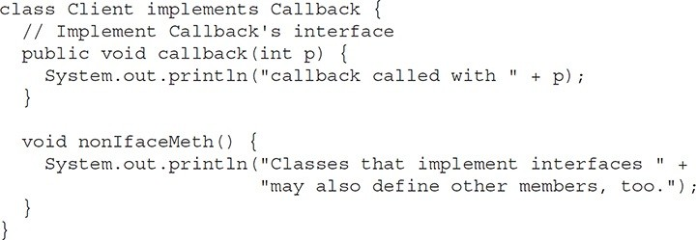

**Accessing Implementations Through Interface References**

You can declare variables as object references that use an interface rather than a class type. Any instance of any class that implements the declared interface can be referred to by such a variable. When you call a method through one of these references, the correct version will be called based on the actual instance of the interface being referred to. This is one of the key features of interfaces. The method to be executed is looked up dynamically at run time, allowing classes to be created later than the code which calls methods on them. The calling code can dispatch through an interface without having to know anything about the “callee.” This process is similar to using a superclass reference to access a subclass object.

The following example calls the **callback( )** method via an interface reference variable:

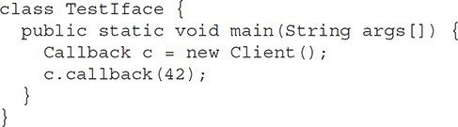

The output of this program is shown here:

callback called with 42

Notice that variable **c** is declared to be of the interface type **Callback**, yet it was assigned an instance of **Client**. Although **c** can be used to access the **callback( )** method, it cannot access any other members of the **Client** class. An interface reference variable has knowledge only of the methods declared by its **interface** declaration. Thus, **c** could not be used to access **nonIfaceMeth( )** since it is defined by **Client** but not **Callback**.

While the preceding example shows, mechanically, how an interface reference variable can access an implementation object, it does not demonstrate the polymorphic power of such a reference. To sample this usage, first create the second implementation of **Callback**, shown here:

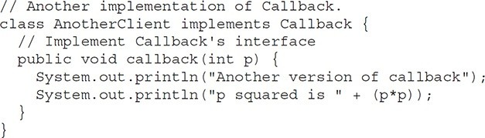

Now, try the following class:

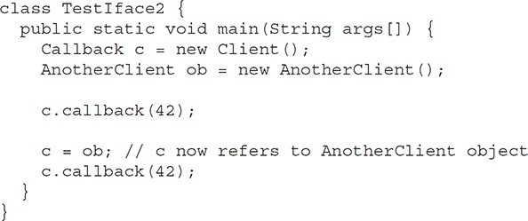

The output from this program is shown here:

callback called with 42 Another version of callback p squared is 1764

As you can see, the version of **callback( )** that is called is determined by the type of object that **c** refers to at run time. While this is a very simple example, you will see another, more practical one shortly.

**Partial Implementations**

If a class includes an interface but does not fully implement the methods required by that interface, then that class must be declared as **abstract**. For example:

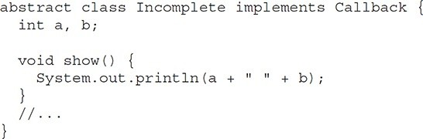

Here, the class **Incomplete** does not implement **callback( )** and must be declared as **abstract**. Any class that inherits **Incomplete** must implement **callback( )** or be declared **abstract** itself.

**Nested Interfaces**

An interface can be declared a member of a class or another interface. Such an interface is called a *member interface* or a *nested interface*. A nested interface can be declared as **public**, **private**, or **protected**. This differs from a top-level interface, which must either be declared as **public** or use the default access level, as previously described. When a nested interface is used outside of its enclosing scope, it must be qualified by the name of the class or interface of which it is a member. Thus, outside of the class or interface in which a nested interface is declared, its name must be fully qualified.

Here is an example that demonstrates a nested interface:

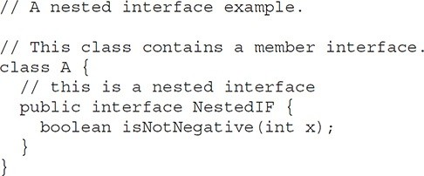

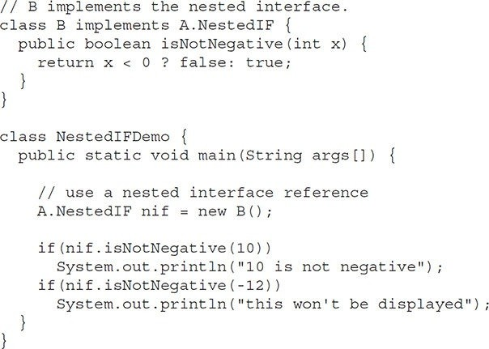

Notice that **A** defines a member interface called **NestedIF** and that it is declared **public**. Next, **B** implements the nested interface by specifying implements A.NestedIF

Notice that the name is fully qualified by the enclosing class’ name. Inside the **main( )** method, an **A.NestedIF** reference called **nif** is created, and it is assigned a reference to a **B** object. Because **B** implements **A.NestedIF**, this is legal.

**Applying Interfaces**

To understand the power of interfaces, let’s look at a more practical example. In earlier chapters, you developed a class called **Stack** that implemented a simple fixed-size stack. However, there are many ways to implement a stack. For example, the stack can be of a fixed size or it can be “growable.” The stack can also be held in an array, a linked list, a binary tree, and so on. No matter how the stack is implemented, the interface to the stack remains the same. That is, the methods **push( )** and **pop( )** define the interface to the stack independently of the details of the implementation. Because the interface to a stack is separate from its implementation, it is easy to define a stack interface, leaving it to each implementation to define the specifics. Let’s look at two examples.

First, here is the interface that defines an integer stack. Put this in a file called **IntStack.java**. This interface will be used by both stack implementations.

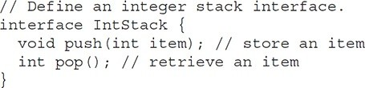

The following program creates a class called **FixedStack** that implements a fixed-length version of an integer stack:

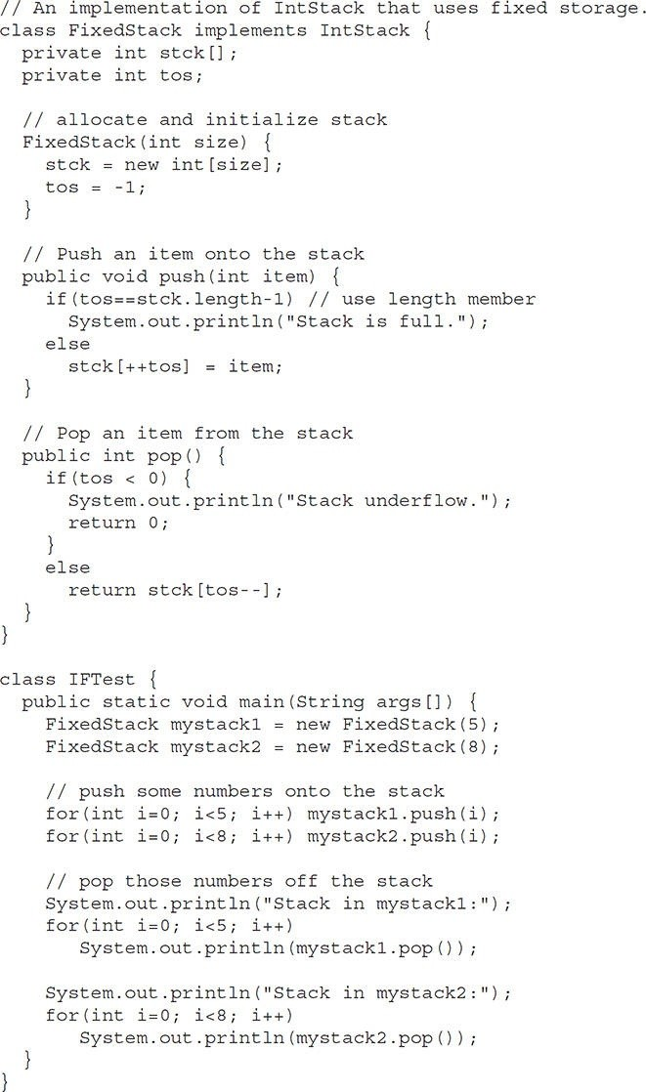

Following is another implementation of **IntStack** that creates a dynamic stack by use of the same **interface** definition. In this implementation, each stack is constructed with an initial length. If this initial length is exceeded, then the stack is increased in size. Each time more room is needed, the size of the stack is doubled.

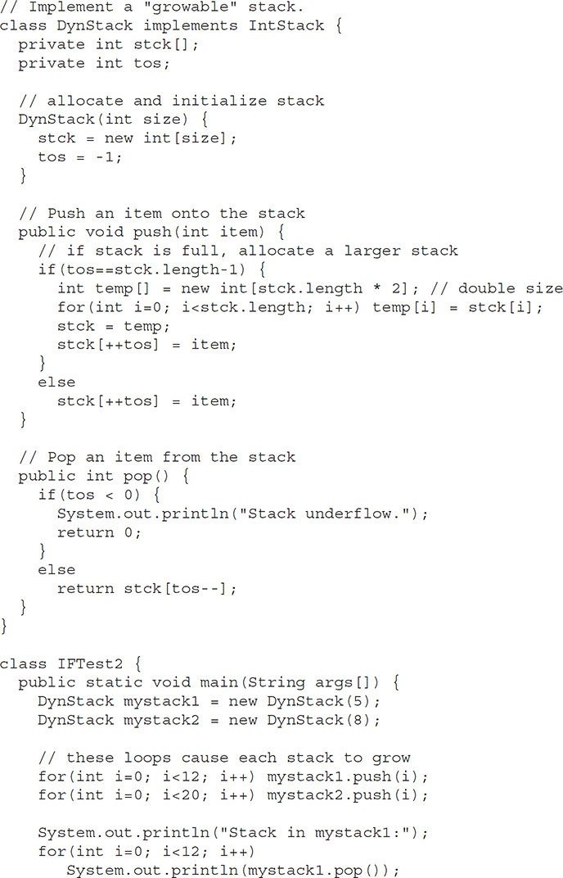

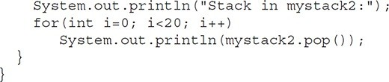

The following class uses both the **FixedStack** and **DynStack** implementations. It does so through an interface reference. This means that calls to **push( )** and **pop( )** are resolved at run time rather than at compile time.

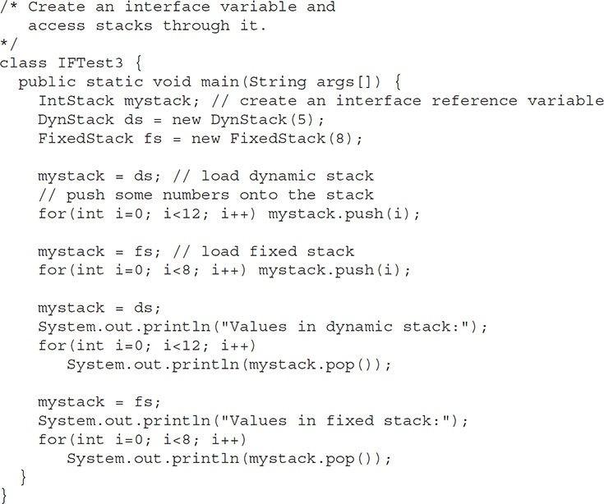In this program, **mystack** is a reference to the **IntStack** interface. Thus, when it refers to **ds**, it uses the versions of **push( )** and **pop( )** defined by the **DynStack** implementation. When it refers to **fs**, it uses the versions of **push( )** and **pop( )** defined by **FixedStack**. As explained, these determinations are made at run time. Accessing multiple implementations of an interface through an interface reference variable is the most powerful way that Java achieves run-time polymorphism.

### Variables in Interfaces

You can use interfaces to import shared constants into multiple classes by simply declaring an interface that contains variables that are initialized to the desired values. When you include that interface in a class (that is, when you “implement” the interface), all of those variable names will be in scope as constants. If an interface contains no methods, then any class that includes such an interface doesn’t actually implement anything. It is as if that class were importing the constant fields into the class name space as **final** variables. The next example uses this technique to implement an automated “decision maker”:

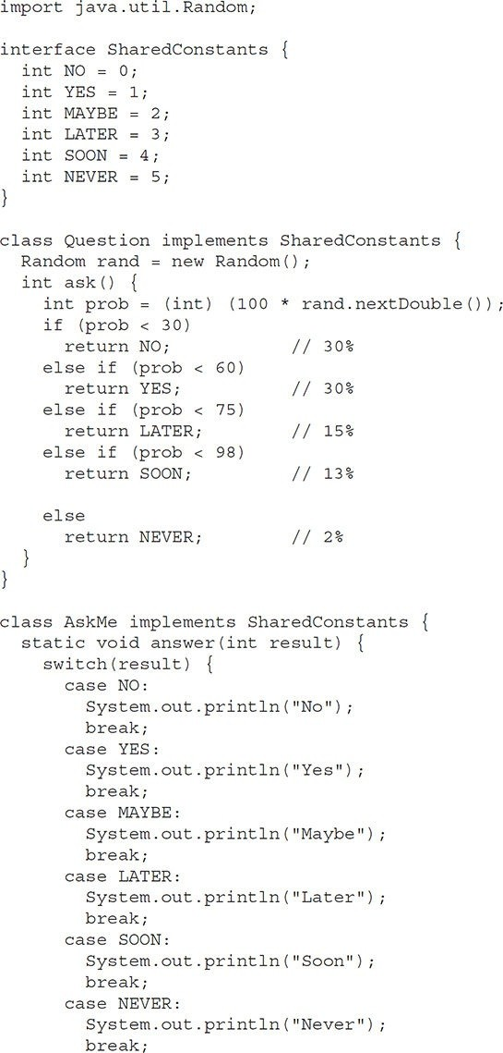

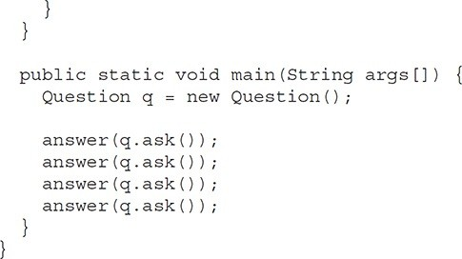

Notice that this program makes use of one of Java’s standard classes: **Random**. This class provides pseudorandom numbers. It contains several methods that allow you to obtain random numbers in the form required by your program. In this example, the method **nextDouble( )** is used. It returns random numbers in the range 0.0 to 1.0.

In this sample program, the two classes, **Question** and **AskMe**, both implement the **SharedConstants** interface where **NO**, **YES**, **MAYBE**, **SOON**, **LATER**, and **NEVER** are defined. Inside each class, the code refers to these constants as if each class had defined or inherited them directly. Here is the output of a sample run of this program. Note that the results are different each time it is run.

Later Soon No Yes

**Interfaces Can Be Extended**

One interface can inherit another by use of the keyword **extends**. The syntax is the same as for inheriting classes. When a class implements an interface that inherits another interface, it must provide implementations for all methods required by the interface inheritance chain. Following is an example:

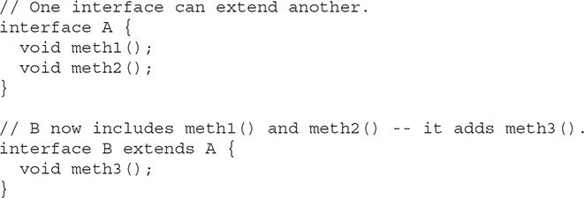

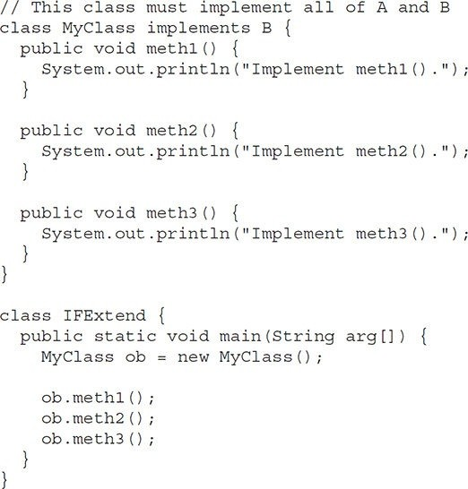

As an experiment, you might want to try removing the implementation for **meth1( )** in **MyClass**. This will cause a compile-time error. As stated earlier, any class that implements an interface must implement all methods required by that interface, including any that are inherited from other interfaces.

**Default Interface Methods**

Prior to JDK 8, an interface could not define any implementation whatsoever. This meant that for all previous versions of Java, the methods specified by an interface were abstract, containing no body. This is the traditional form of an interface and is the type of interface that the preceding discussions have used. The release of JDK 8 changed this by adding a new capability to **interface** called the *default method*. A default method lets you define a default implementation for an interface method. In other words, by use of a default method, it is possible for an interface method to provide a body, rather than being abstract. During its development, the default method was also referred to as an *extension method,* and you will likely see both terms used.

A primary motivation for the default method was to provide a means by which interfaces could be expanded without breaking existing code. Recall that there must be implementations for all methods defined by an interface. In the past, if a new method were added to a popular, widely used interface, then the addition of that method would break existing code because no implementation would be found for that new method. The default method solves this problem by supplying an implementation that will be used if no other implementation is explicitly provided. Thus, the addition of a default method will not cause preexisting code to break.

Another motivation for the default method was the desire to specify methods in an interface that are, essentially, optional, depending on how the interface is used. For example, an interface might define a group of methods that act on a sequence of elements. One of these methods might be called **remove( )**, and its purpose is to remove an element from the sequence. However, if the interface is intended to support both modifiable and nonmodifiable sequences, then **remove( )** is essentially optional because it won’t be used by nonmodifiable sequences. In the past, a class that implemented a nonmodifiable sequence would have had to define an empty implementation of **remove( )**, even though it was not needed. Today, a default implementation for **remove( )** can be specified in the interface that does nothing (or throws an exception). Providing this default prevents a class used for nonmodifiable sequences from having to define its own, placeholder version of **remove( )**. Thus, by providing a default, the interface makes the implementation of **remove( )** by a class optional.

It is important to point out that the addition of default methods does not change a key aspect of **interface**: its inability to maintain state information. An interface still cannot have instance variables, for example. Thus, the defining difference between an interface and a class is that a class can maintain state information, but an interface cannot. Furthermore, it is still not possible to create an instance of an interface by itself. It must be implemented by a class.

Therefore, even though, beginning with JDK 8, an interface can define default methods, the interface must still be implemented by a class if an instance is to be created. One last point: As a general rule, default methods constitute a special- purpose feature. Interfaces that you create will still be used primarily to specify *what* and not *how*. However, the inclusion of the default method gives you added flexibility.

### Default Method Fundamentals

An interface default method is defined similar to the way a method is defined by a **class**. The primary difference is that the declaration is preceded by the keyword **default**. For example, consider this simple interface:

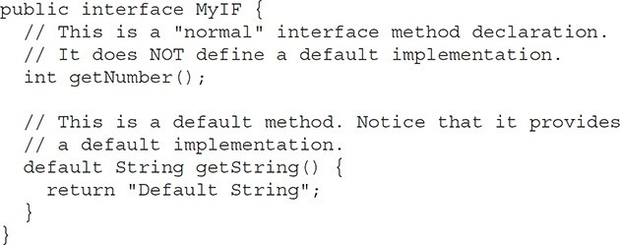**MyIF** declares two methods. The first, **getNumber( )**, is a standard interface method declaration. It defines no implementation whatsoever. The second method is **getString()**, and it does include a default implementation. In this case, it simply returns the string "Default String". Pay special attention to the way **getString( )** is declared. Its declaration is preceded by the **default** modifier. This syntax can be generalized. To define a default method, precede its declaration with **default**.

Because **getString( )** includes a default implementation, it is not necessary for an implementing class to override it. In other words, if an implementing class does not provide its own implementation, the default is used. For example, the **MyIFImp** class shown next is perfectly valid:

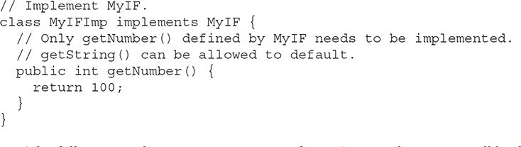

The following code creates an instance of **MyIFImp** and uses it to call both

**getNumber( )** and **getString( )**.

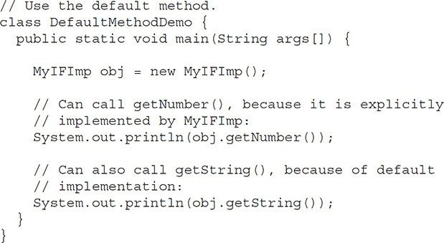

The output is shown here:

100

Default String

As you can see, the default implementation of **getString( )** was automatically used. It was not necessary for **MyIFImp** to define it. Thus, for **getString( )**, implementation by a class is optional. (Of course, its implementation by a class will be *required* if the class uses **getString( )** for some purpose beyond that supported by its default.)

It is both possible and common for an implementing class to define its own implementation of a default method. For example, **MyIFImp2** overrides **getString( )**:

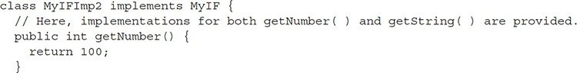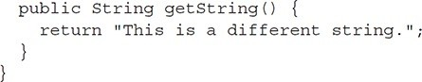

Now, when **getString( )** is called, a different string is returned.

### A More Practical Example

Although the preceding shows the mechanics of using default methods, it doesn’t illustrate their usefulness in a more practical setting. To do this, let’s once again return to the **IntStack** interface shown earlier in this chapter. For the sake of discussion, assume that **IntStack** is widely used and many programs rely on it. Further assume that we now want to add a method to **IntStack** that clears the stack, enabling the stack to be re-used. Thus, we want to evolve the **IntStack** interface so that it defines new functionality, but we don’t want to break any preexisting code. In the past, this would be impossible, but with the inclusion of default methods, it is now easy to do. For example, the **IntStack** interface can be enhanced like this:

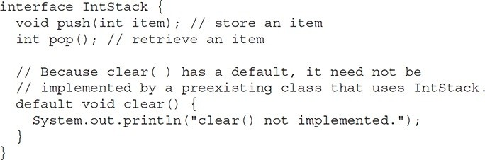

Here, the default behavior of **clear( )** simply displays a message indicating that it is not implemented. This is acceptable because no preexisting class that implements **IntStack** would ever call **clear( )** because it was not defined by the earlier version of **IntStack**. However, **clear( )** can be implemented by a new class that implements **IntStack**. Furthermore, **clear( )** needs to be defined by a new implementation only if it is used. Thus, the default method gives you

* a way to gracefully evolve interfaces over time, and
* a way to provide optional functionality without requiring that a class provide a placeholder implementation when that functionality is not needed.

One other point: In real-world code, **clear( )** would have thrown an exception, rather than displaying an error message. Exceptions are described in the next chapter. After working through that material, you might want to try modifying **clear( )** so that its default implementation throws an **UnsupportedOperationException**.

### Multiple Inheritance Issues

As explained earlier in this book, Java does not support the multiple inheritance of classes. Now that an interface can include default methods, you might be wondering if an interface can provide a way around this restriction. The answer is, essentially, no. Recall that there is still a key difference between a class and an interface: a class can maintain state information (especially through the use of instance variables), but an interface cannot.

The preceding notwithstanding, default methods do offer a bit of what one would normally associate with the concept of multiple inheritance. For example, you might have a class that implements two interfaces. If each of these interfaces provides default methods, then some behavior is inherited from both. Thus, to a limited extent, default methods do support multiple inheritance of behavior. As you might guess, in such a situation, it is possible that a name conflict will occur.

For example, assume that two interfaces called **Alpha** and **Beta** are implemented by a class called **MyClass**. What happens if both **Alpha** and **Beta** provide a method called **reset( )** for which both declare a default implementation? Is the version by **Alpha** or the version by **Beta** used by **MyClass**? Or, consider a situation in which **Beta** extends **Alpha**. Which version of the default method is used? Or, what if **MyClass** provides its own implementation of the method? To handle these and other similar types of situations, Java defines a set of rules that resolves such conflicts.

First, in all cases, a class implementation takes priority over an interface default implementation. Thus, if **MyClass** provides an override of the **reset( )** default method, **MyClass**’ version is used. This is the case even if **MyClass** implements both **Alpha** and **Beta**. In this case, both defaults are overridden by **MyClass**’ implementation.

Second, in cases in which a class implements two interfaces that both have the same default method, but the class does not override that method, then an error will result. Continuing with the example, if **MyClass** implements both **Alpha** and **Beta**, but does not override **reset( )**, then an error will occur.

In cases in which one interface inherits another, with both defining a common default method, the inheriting interface’s version of the method takes precedence. Therefore, continuing the example, if **Beta** extends **Alpha**, then **Beta**’s version of **reset( )** will be used.

It is possible to explicitly refer to a default implementation in an inherited interface by using this form of **super**. Its general form is shown here:

*InterfaceName*.super.*methodName( )*

For example, if **Beta** wants to refer to **Alpha**’s default for **reset( )**, it can use this statement:

Alpha.super.reset();

## Use static Methods in an Interface

Another capability added to **interface** by JDK 8 is the ability to define one or more **static** methods. Like **static** methods in a class, a **static** method defined by an interface can be called independently of any object. Thus, no implementation of the interface is necessary, and no instance of the interface is required, in order to call a **static** method. Instead, a **static** method is called by specifying the interface name, followed by a period, followed by the method name. Here is the general form:

*InterfaceName*.*staticMethodName*

Notice that this is similar to the way that a **static** method in a class is called.

The following shows an example of a **static** method in an interface by adding one to **MyIF**, shown in the previous section. The **static** method is **getDefaultNumber( )**. It returns zero.

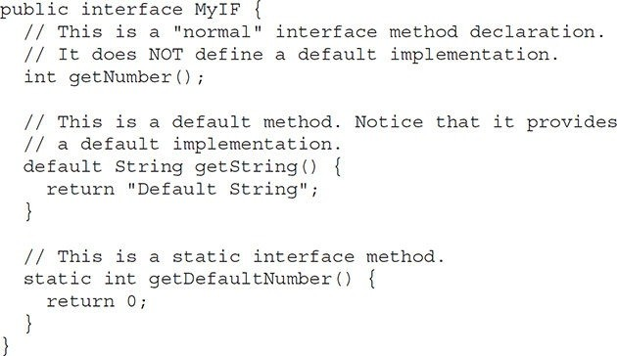

The **getDefaultNumber( )** method can be called, as shown here:

int defNum = MyIF.getDefaultNumber();

As mentioned, no implementation or instance of **MyIF** is required to call **getDefaultNumber( )** because it is **static**.

One last point: **static** interface methods are not inherited by either an implementing class or a subinterface.

**Private Interface Methods**

Beginning with JDK 9, an interface can include a private method. A private interface method can be called only by a default method or another private method defined by the same interface. Because a private interface method is specified **private**, it cannot be used by code outside the interface in which it is defined. This restriction includes subinterfaces because a private interface method is not inherited by a subinterface.

The key benefit of a private interface method is that it lets two or more default methods use a common piece of code, thus avoiding code duplication. For example, here is another version of the **IntStack** interface that has two default methods called **popNElements( )** and **skipAndPopNElements( )**. The first returns an array that contains the top *N* elements on the stack. The second skips a specified number of elements and then returns an array that contains the next *N* elements. Both use a private method called **getElements( )** to obtain an array of the specified number of elements from the stack.

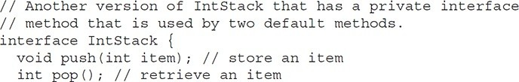

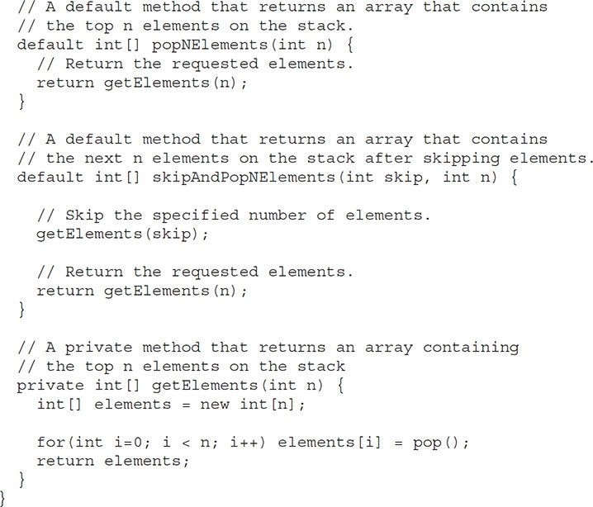

Notice that both **popNElements( )** and **skipAndPopNElements( )** use the private **getElements( )** method to obtain the array to return. This prevents both methods from having to duplicate the same code sequence. Keep in mind that because **getElements()** is private, it cannot be called by code outside **IntStack**. Thus, its use is limited to the default methods inside **IntStack**. Also, because **getElements( )** uses the **pop( )** method to obtain stack elements, it will automatically call the implementation of **pop()** provided by the **IntStack** is implementation. Thus, **getElements( )** will work for any stack class that implements **IntStack**.

Although the private interface method is a feature that you will seldom need, in those cases in which you *do* need it, you will find it quite useful.

## Final Thoughts on Packages and Interfaces

Although the examples we’ve included in this book do not make frequent use of packages or interfaces, both of these tools are an important part of the Java programming environment. Virtually all real programs that you write in Java will be contained within packages. A number will probably implement interfaces as well. It is important, therefore, that you be comfortable with their usage.

**Multithreaded Programming**

Java provides built-in support for *multithreaded programming*. A multithreaded program contains two or more parts that can run concurrently. Each part of such a program is called a *thread*, and each thread defines a separate path of execution. Thus, multithreading is a specialized form of multitasking.

You are almost certainly acquainted with multitasking because it is supported by virtually all modern operating systems. However, there are two distinct types of multitasking: process-based and thread-based. It is important to understand the difference between the two. For many readers, process-based multitasking is the more familiar form. A *process* is, in essence, a program that is executing. Thus, *process-based* multitasking is the feature that allows your computer to run two or more programs concurrently. For example, process- based multitasking enables you to run the Java compiler at the same time that you are using a text editor or visiting a web site. In process-based multitasking, a program is the smallest unit of code that can be dispatched by the scheduler.

In a *thread-based* multitasking environment, the thread is the smallest unit of dispatchable code. This means that a single program can perform two or more tasks simultaneously. For instance, a text editor can format text at the same time that it is printing, as long as these two actions are being performed by two separate threads. Thus, process-based multitasking deals with the “big picture,” and thread-based multitasking handles the details.

Multitasking threads require less overhead than multitasking processes. Processes are heavyweight tasks that require their own separate address spaces. Interprocess communication is expensive and limited. Context switching from one process to another is also costly. Threads, on the other hand, are lighter weight. They share the same address space and cooperatively share the same heavyweight process. Interthread communication is inexpensive, and context switching from one thread to the next is lower in cost. While Java programs make use of process-based multitasking environments, process-based multitasking is not under Java’s direct control. However, multithreaded multitasking is.

Multithreading enables you to write efficient programs that make maximum use of the processing power available in the system. One important way multithreading achieves this is by keeping idle time to a minimum. This is especially important for the interactive, networked environment in which Java operates because idle time is common. For example, the transmission rate of data over a network is much slower than the rate at which the computer can process it. Even local file system resources are read and written at a much slower pace than they can be processed by the CPU. And, of course, user input is much slower than the computer. In a single-threaded environment, your program has to wait for each of these tasks to finish before it can proceed to the next one—even though most of the time the program is idle, waiting for input. Multithreading helps you reduce this idle time because another thread can run when one is waiting.

If you have programmed for operating systems such as Windows, then you are already familiar with multithreaded programming. However, the fact that Java manages threads makes multithreading especially convenient because many of the details are handled for you.

**The Java Thread Model**

The Java run-time system depends on threads for many things, and all the class libraries are designed with multithreading in mind. In fact, Java uses threads to enable the entire environment to be asynchronous. This helps reduce inefficiency by preventing the waste of CPU cycles.

The value of a multithreaded environment is best understood in contrast to its counterpart. Single-threaded systems use an approach called an *event loop* with *polling*. In this model, a single thread of control runs in an infinite loop, polling a single event queue to decide what to do next. Once this polling mechanism returns with, say, a signal that a network file is ready to be read, then the event loop dispatches control to the appropriate event handler. Until this event handler returns, nothing else can happen in the program. This wastes CPU time. It can also result in one part of a program dominating the system and preventing any other events from being processed. In general, in a single- threaded environment, when a thread *blocks* (that is, suspends execution) because it is waiting for some resource, the entire program stops running.

The benefit of Java’s multithreading is that the main loop/polling mechanism is eliminated. One thread can pause without stopping other parts of your program. For example, the idle time created when a thread reads data from a network or waits for user input can be utilized elsewhere. Multithreading allows animation loops to sleep for a second between each frame without causing the whole system to pause. When a thread blocks in a Java program, only the single thread that is blocked pauses. All other threads continue to run.

As most readers know, over the past few years, multicore systems have become commonplace. Of course, single-core systems are still in widespread use. It is important to understand that Java’s multithreading features work in both types of systems. In a single-core system, concurrently executing threads share the CPU, with each thread receiving a slice of CPU time. Therefore, in a single-core system, two or more threads do not actually run at the same time, but idle CPU time is utilized. However, in multicore systems, it is possible for two or more threads to actually execute simultaneously. In many cases, this can further improve program efficiency and increase the speed of certain operations.

Threads exist in several states. Here is a general description. A thread can be *running*. It can be *ready to run* as soon as it gets CPU time. A running thread can be *suspended*, which temporarily halts its activity. A suspended thread can then be *resumed*, allowing it to pick up where it left off. A thread can be *blocked* when waiting for a resource. At any time, a thread can be terminated, which halts its execution immediately. Once terminated, a thread cannot be resumed.

**Thread Priorities**

Java assigns to each thread a priority that determines how that thread should be treated with respect to the others. Thread priorities are integers that specify the relative priority of one thread to another. As an absolute value, a priority is meaningless; a higher-priority thread doesn’t run any faster than a lower- priority thread if it is the only thread running. Instead, a thread’s priority is used to decide when to switch from one running thread to the next. This is called a *context switch*. The rules that determine when a context switch takes place are simple:

* *A thread can voluntarily relinquish control*. This occurs when explicitly yielding, sleeping, or when blocked. In this scenario, all other threads are examined, and the highest-priority thread that is ready to run is given the CPU.
* *A thread can be preempted by a higher-priority thread*. In this case, a lower-priority thread that does not yield the processor is simply preempted—no matter what it is doing—by a higher-priority thread. Basically, as soon as a higher-priority thread wants to run, it does. This is called *preemptive multitasking*.

In cases where two threads with the same priority are competing for CPU cycles, the situation is a bit complicated. For some operating systems, threads of equal priority are time-sliced automatically in round-robin fashion. For other types of operating systems, threads of equal priority must voluntarily yield control to their peers. If they don’t, the other threads will not run.

**Synchronization**

Because multithreading introduces an asynchronous behavior to your programs, there must be a way for you to enforce synchronicity when you need it. For example, if you want two threads to communicate and share a complicated data structure, such as a linked list, you need some way to ensure that they don’t conflict with each other. That is, you must prevent one thread from writing data while another thread is in the middle of reading it. For this purpose, Java implements an elegant twist on an age-old model of interprocess synchronization: the *monitor*. The monitor is a control mechanism first defined by C.A.R. Hoare. You can think of a monitor as a very small box that can hold only one thread. Once a thread enters a monitor, all other threads must wait until that thread exits the monitor. In this way, a monitor can be used to protect a shared asset from being manipulated by more than one thread at a time.

In Java, there is no class “Monitor”; instead, each object has its own implicit monitor that is automatically entered when one of the object’s synchronized methods is called. Once a thread is inside a synchronized method, no other thread can call any other synchronized method on the same object. This enables you to write very clear and concise multithreaded code, because synchronization support is built into the language.

### Messaging

After you divide your program into separate threads, you need to define how they will communicate with each other. When programming with some other languages, you must depend on the operating system to establish communication between threads. This, of course, adds overhead. By contrast, Java provides a clean, low-cost way for two or more threads to talk to each other, via calls to predefined methods that all objects have. Java’s messaging system allows a thread to enter a synchronized method on an object, and then wait there until some other thread explicitly notifies it to come out.

### The Thread Class and the Runnable Interface

Java’s multithreading system is built upon the **Thread** class, its methods, and its companion interface, **Runnable**. **Thread** encapsulates a thread of execution. Since you can’t directly refer to the ethereal state of a running thread, you will deal with it through its proxy, the **Thread** instance that spawned it. To create a new thread, your program will either extend **Thread** or implement the **Runnable** interface.

The **Thread** class defines several methods that help manage threads. Several of those used in this chapter are shown here:

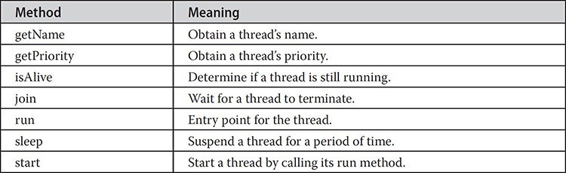

Thus far, all the examples in this book have used a single thread of execution. The remainder of this chapter explains how to use **Thread** and **Runnable** to create and manage threads, beginning with the one thread that all Java programs have: the main thread.

## The Main Thread

When a Java program starts up, one thread begins running immediately. This is usually called the *main thread* of your program, because it is the one that is executed when your program begins. The main thread is important for two reasons:

* It is the thread from which other “child” threads will be spawned.
* Often, it must be the last thread to finish execution because it performs various shutdown actions.

Although the main thread is created automatically when your program is started, it can be controlled through a **Thread** object. To do so, you must obtain a reference to it by calling the method **currentThread( )**, which is a **public static** member of **Thread**. Its general form is shown here:

static Thread currentThread( )

This method returns a reference to the thread in which it is called. Once you have a reference to the main thread, you can control it just like any other thread.

Let’s begin by reviewing the following example:

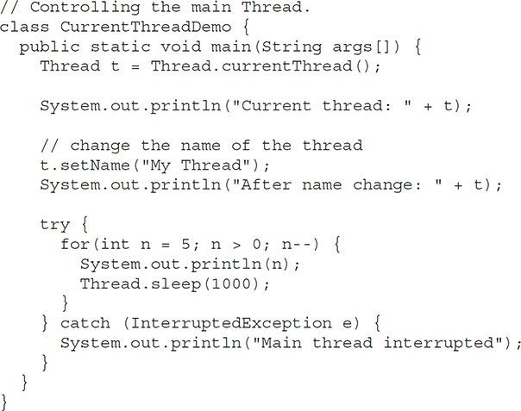

In this program, a reference to the current thread (the main thread, in this case) is obtained by calling **currentThread( )**, and this reference is stored in the local variable **t**. Next, the program displays information about the thread. The program then calls **setName( )** to change the internal name of the thread. Information about the thread is then redisplayed. Next, a loop counts down from five, pausing one second between each line. The pause is accomplished by the **sleep( )** method. The argument to **sleep( )** specifies the delay period in milliseconds. Notice the **try/catch** block around this loop. The **sleep( )** method in **Thread** might throw an **InterruptedException**. This would happen if some other thread wanted to interrupt this sleeping one. This example just prints a message if it gets interrupted. In a real program, you would need to handle this differently. Here is the output generated by this program:

Current thread: Thread[main,5,main]

After name change: Thread[My Thread,5,main] 5

4

3

2

1

Notice the output produced when **t** is used as an argument to **println( )**. This displays, in order: the name of the thread, its priority, and the name of its group. By default, the name of the main thread is **main**. Its priority is 5, which is the default value, and **main** is also the name of the group of threads to which this thread belongs. A *thread group* is a data structure that controls the state of a collection of threads as a whole. After the name of the thread is changed, **t** is again output. This time, the new name of the thread is displayed.

Let’s look more closely at the methods defined by **Thread** that are used in the program. The **sleep( )** method causes the thread from which it is called to suspend execution for the specified period of milliseconds. Its general form is shown here:

static void sleep(long *milliseconds*) throws InterruptedException

The number of milliseconds to suspend is specified in *milliseconds*. This method may throw an **InterruptedException**.

The **sleep( )** method has a second form, shown next, which allows you to specify the period in terms of milliseconds and nanoseconds:

static void sleep(long *milliseconds*, int *nanoseconds*) throws InterruptedException

This second form is useful only in environments that allow timing periods as short as nanoseconds.

As the preceding program shows, you can set the name of a thread by using **setName()**. You can obtain the name of a thread by calling **getName( )** (but note that this is not shown in the program). These methods are members of the **Thread** class and are declared like this:

final void setName(String *threadName*) final String getName( )

Here, *threadName* specifies the name of the thread.

**Creating a Thread**

In the most general sense, you create a thread by instantiating an object of type **Thread**. Java defines two ways in which this can be accomplished:

* You can implement the **Runnable** interface.
* You can extend the **Thread** class, itself.

The following two sections look at each method, in turn.

**Implementing Runnable**

The easiest way to create a thread is to create a class that implements the **Runnable** interface. **Runnable** abstracts a unit of executable code. You can construct a thread on any object that implements **Runnable**. To implement **Runnable**, a class need only implement a single method called **run( )**, which is declared like this:

public void run( )

Inside **run( )**, you will define the code that constitutes the new thread. It is important to understand that **run( )** can call other methods, use other classes, and declare variables, just like the main thread can. The only difference is that **run( )** establishes the entry point for another, concurrent thread of execution within your program. This thread will end when **run( )** returns.

After you create a class that implements **Runnable**, you will instantiate an object of type **Thread** from within that class. **Thread** defines several constructors. The one that we will use is shown here:

Thread(Runnable *threadOb*, String *threadName*)

In this constructor, *threadOb* is an instance of a class that implements the **Runnable** interface. This defines where execution of the thread will begin. The name of the new thread is specified by *threadName*.

After the new thread is created, it will not start running until you call its **start( )** method, which is declared within **Thread**. In essence, **start( )** initiates a call to **run( )**. The **start( )** method is shown here:

void start( )

Here is an example that creates a new thread and starts it running:

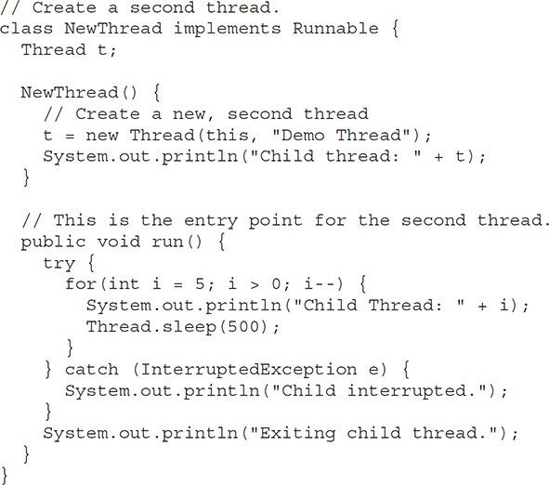

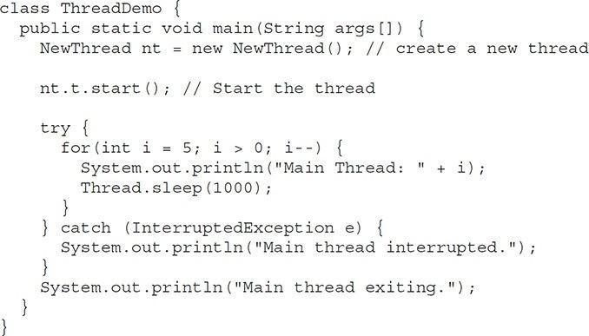

Inside **NewThread**’s constructor, a new **Thread** object is created by the following statement:

t = new Thread(this, "Demo Thread");

Passing **this** as the first argument indicates that you want the new thread to call the **run( )** method on **this** object. Inside **main( )**, **start( )** is called, which starts the thread of execution beginning at the **run( )** method. This causes the child thread’s **for** loop to begin. Next the main thread enters its **for** loop. Both threads continue running, sharing the CPU in single-core systems, until their loops finish. The output produced by this program is as follows.(Your output may vary based upon the specific execution environment.)

Child thread: Thread[Demo Thread,5,main] Main Thread: 5

Child Thread: 5

Child Thread: 4

Main Thread: 4

Child Thread: 3

Child Thread: 2

Main Thread: 3

Child Thread: 1 Exiting child thread.

Main Thread: 2

Main Thread: 1

Main thread exiting.

As mentioned earlier, in a multithreaded program, it is often useful for the main thread to be the last thread to finish running. The preceding program ensures that the main thread finishes last, because the main thread sleeps for 1,000 milliseconds between iterations, but the child thread sleeps for only 500 milliseconds. This causes the child thread to terminate earlier than the main thread. Shortly, you will see a better way to wait for a thread to finish.

**Extending Thread**

The second way to create a thread is to create a new class that extends **Thread**, and then to create an instance of that class. The extending class must override the **run()** method, which is the entry point for the new thread. As before, a call to **start( )** begins execution of the new thread. Here is the preceding program rewritten to extend

**Thread**:

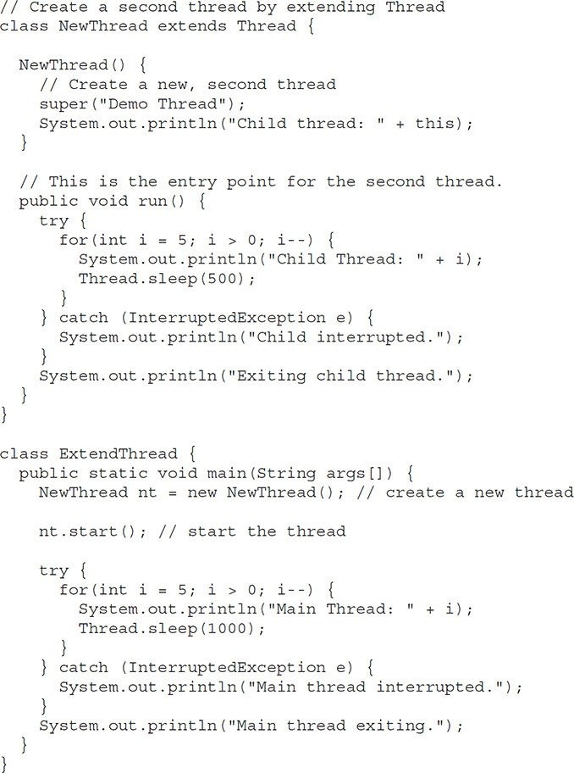

This program generates the same output as the preceding version. As you can see, the child thread is created by instantiating an object of **NewThread**, which is derived from **Thread**.

Notice the call to **super( )** inside **NewThread**. This invokes the following form of the **Thread** constructor:

public Thread(String *threadName*)

Here, *threadName* specifies the name of the thread.

**Choosing an Approach**

At this point, you might be wondering why Java has two ways to create child threads, and which approach is better. The answers to these questions turn on the same point. The **Thread** class defines several methods that can be overridden by a derived class. Of these methods, the only one that *must* be overridden is **run( )**. This is, of course, the same method required when you implement **Runnable**. Many Java programmers feel that classes should be extended only when they are being enhanced or adapted in some way. So, if you will not be overriding any of **Thread**’s other methods, it is probably best simply to implement **Runnable**. Also, by implementing **Runnable**, your thread class does not need to inherit **Thread**, making it free to inherit a different class. Ultimately, which approach to use is up to you. However, throughout the rest of this chapter, we will create threads by using classes that implement **Runnable**.

## Creating Multiple Threads

So far, you have been using only two threads: the main thread and one child thread. However, your program can spawn as many threads as it needs. For example, the following program creates three child threads:

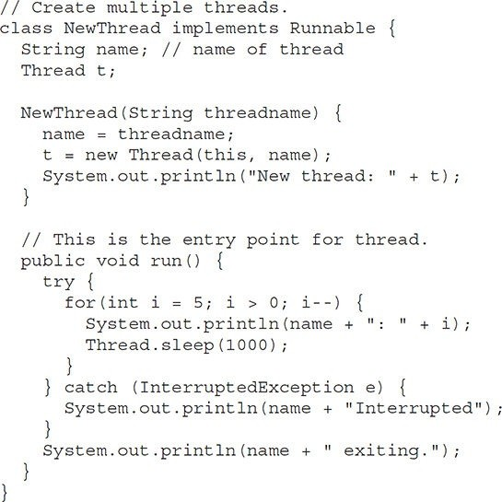

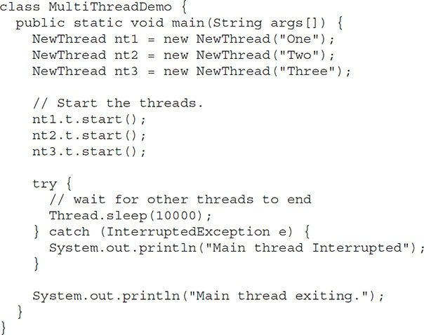

Sample output from this program is shown here. (Your output may vary based upon the specific execution environment.)

New thread: Thread[One,5,main] New thread: Thread[Two,5,main] New thread: Thread[Three,5,main] One: 5

Two: 5

Three: 5

One: 4

Two: 4

Three: 4

One: 3

Three: 3

Two: 3

One: 2

Three: 2

Two: 2

One: 1

Three: 1

Two: 1

One exiting. Two exiting. Three exiting.

Main thread exiting.

As you can see, once started, all three child threads share the CPU. Notice the call to **sleep(10000)** in **main( )**. This causes the main thread to sleep for ten seconds and ensures that it will finish last.

**Using isAlive( ) and join( )**

As mentioned, often you will want the main thread to finish last. In the preceding examples, this is accomplished by calling **sleep( )** within **main( )**, with a long enough delay to ensure that all child threads terminate prior to the main thread. However, this is hardly a satisfactory solution, and it also raises a larger question: How can one thread know when another thread has ended?

Fortunately, **Thread** provides a means by which you can answer this question.

Two ways exist to determine whether a thread has finished. First, you can call **isAlive( )** on the thread. This method is defined by **Thread**, and its general form is shown here:

final boolean isAlive( )

The **isAlive( )** method returns **true** if the thread upon which it is called is still running. It returns **false** otherwise.

While **isAlive( )** is occasionally useful, the method that you will more commonly use to wait for a thread to finish is called **join( )**, shown here:

final void join( ) throws InterruptedException

This method waits until the thread on which it is called terminates. Its name comes from the concept of the calling thread waiting until the specified thread *joins* it. Additional forms of **join( )** allow you to specify a maximum amount of time that you want to wait for the specified thread to terminate.

Here is an improved version of the preceding example that uses **join( )** to ensure that the main thread is the last to stop. It also demonstrates the **isAlive()** method.

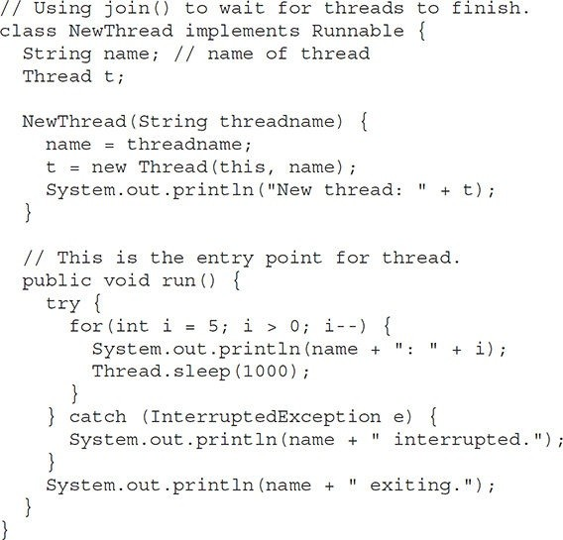

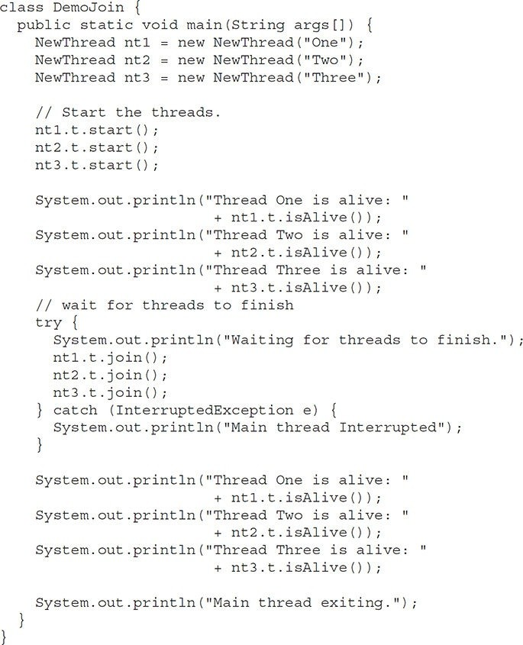

Sample output from this program is shown here. (Your output may vary based upon the specific execution environment.)

New thread: Thread[One,5,main] New thread: Thread[Two,5,main] New thread: Thread[Three,5,main] Thread One is alive: true

Thread Two is alive: true Thread Three is alive: true Waiting for threads to finish. One: 5

Two: 5

Three: 5

One: 4

Two: 4

Three: 4

One: 3

Two: 3

Three: 3

One: 2

Two: 2

Three: 2

One: 1

Two: 1

Three: 1

Two exiting. Three exiting. One exiting.

Thread One is alive: false Thread Two is alive: false Thread Three is alive: false Main thread exiting.

As you can see, after the calls to **join( )** return, the threads have stopped executing.

**Thread Priorities**

Thread priorities are used by the thread scheduler to decide when each thread should be allowed to run. In theory, over a given period of time, higher-priority threads get more CPU time than lower-priority threads. In practice, the amount of CPU time that a thread gets often depends on several factors besides its priority. (For example, how an operating system implements multitasking can affect the relative availability of CPU time.) A higher-priority thread can also preempt a lower-priority one. For instance, when a lower-priority thread is running and a higher-priority thread resumes (from sleeping or waiting on I/O, for example), it will preempt the lower-priority thread.

In theory, threads of equal priority should get equal access to the CPU. But you need to be careful. Remember, Java is designed to work in a wide range of environments. Some of those environments implement multitasking fundamentally differently than others. For safety, threads that share the same priority should yield control once in a while. This ensures that all threads have a chance to run under a non-preemptive operating system. In practice, even in non-preemptive environments, most threads still get a chance to run, because most threads inevitably encounter some blocking situation, such as waiting for I/O. When this happens, the blocked thread is suspended and other threads can run. But, if you want smooth multithreaded execution, you are better off not relying on this. Also, some types of tasks are CPU-intensive. Such threads dominate the CPU. For these types of threads, you want to yield control occasionally so that other threads can run.

To set a thread’s priority, use the **setPriority( )** method, which is a member of **Thread**. This is its general form:

final void setPriority(int *level*)

Here, *level* specifies the new priority setting for the calling thread. The value of *level* must be within the range **MIN_PRIORITY** and **MAX_PRIORITY**. Currently, these values are 1 and 10, respectively. To return a thread to default priority, specify **NORM_PRIORITY**, which is currently 5. These priorities are defined as **static final** variables within **Thread**.

You can obtain the current priority setting by calling the **getPriority( )** method of **Thread**, shown here: final int getPriority( )

Implementations of Java may have radically different behavior when it comes to scheduling. Most of the inconsistencies arise when you have threads that are relying on preemptive behavior, instead of cooperatively giving up CPU time. The safest way to obtain predictable, cross-platform behavior with Java is to use threads that voluntarily give up control of the CPU.

**Synchronization**

When two or more threads need access to a shared resource, they need some way to ensure that the resource will be used by only one thread at a time. The process by which this is achieved is called *synchronization*. As you will see, Java provides unique, language-level support for it.

Key to synchronization is the concept of the monitor. A *monitor* is an object that is used as a mutually exclusive lock. Only one thread can *own* a monitor at a given time. When a thread acquires a lock, it is said to have *entered* the monitor. All other threads attempting to enter the locked monitor will be suspended until the first thread *exits* the monitor. These other threads are said to be *waiting* for the monitor. A thread that owns a monitor can reenter the same monitor if it so desires.

You can synchronize your code in either of two ways. Both involve the use of the **synchronized** keyword, and both are examined here.

### Using Synchronized Methods

Synchronization is easy in Java, because all objects have their own implicit monitor associated with them. To enter an object’s monitor, just call a method that has been modified with the **synchronized** keyword. While a thread is inside a synchronized method, all other threads that try to call it (or any other synchronized method) on the same instance have to wait. To exit the monitor and relinquish control of the object to the next waiting thread, the owner of the monitor simply returns from the synchronized method.

To understand the need for synchronization, let’s begin with a simple example that does not use it—but should. The following program has three simple classes. The first one, **Callme**, has a single method named **call( )**. The **call( )** method takes a **String** parameter called **msg**. This method tries to print the **msg** string inside of square brackets. The interesting thing to notice is that after **call( )** prints the opening bracket and the **msg** string, it calls **Thread.sleep(1000)**, which pauses the current thread for one second.

The constructor of the next class, **Caller**, takes a reference to an instance of the **Callme** class and a **String**, which are stored in **target** and **msg**, respectively. The constructor also creates a new thread that will call this object’s **run( )** method. The **run( )** method of **Caller** calls the **call( )** method on the **target** instance of **Callme**, passing in the **msg** string. Finally, the **Synch** class starts by creating a single instance of **Callme**, and three instances of **Caller**, each with a unique message string. The same instance of **Callme** is passed to each **Caller**.

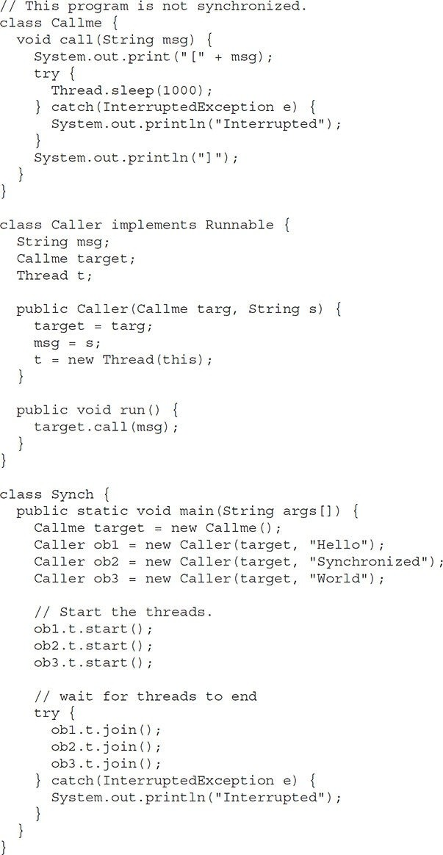

Here is the output produced by this program:

[Hello[Synchronized[World]

]

]

As you can see, by calling **sleep( )**, the **call( )** method allows execution to switch to another thread. This results in the mixed-up output of the three message strings. In this program, nothing exists to stop all three threads from calling the same method, on the same object, at the same time. This is known as a *race condition*, because the three threads are racing each other to complete the method. This example used **sleep( )** to make the effects repeatable and obvious. In most situations, a race condition is more subtle and less predictable, because you can’t be sure when the context switch will occur. This can cause a program to run right one time and wrong the next.

To fix the preceding program, you must *serialize* access to **call( )**. That is, you must restrict its access to only one thread at a time. To do this, you simply need to precede **call( )**’s definition with the keyword **synchronized**, as shown here:



This prevents other threads from entering **call( )** while another thread is using it. After **synchronized** has been added to **call( )**, the output of the program is as follows:

[Hello] [Synchronized] [World]

Any time that you have a method, or group of methods, that manipulates the internal state of an object in a multithreaded situation, you should use the **synchronized** keyword to guard the state from race conditions. Remember, once a thread enters any synchronized method on an instance, no other thread can enter any other synchronized method on the same instance. However, nonsynchronized methods on that instance will continue to be callable.

**The synchronized Statement**

While creating **synchronized** methods within classes that you create is an easy and effective means of achieving synchronization, it will not work in all cases. To understand why, consider the following. Imagine that you want to synchronize access to objects of a class that was not designed for multithreaded access. That is, the class does not use **synchronized** methods. Further, this class was not created by you, but by a third party, and you do not have access to the source code. Thus, you can’t add **synchronized** to the appropriate methods within the class. How can access to an object of this class be synchronized?

Fortunately, the solution to this problem is quite easy: You simply put calls to the methods defined by this class inside a **synchronized** block.

This is the general form of the **synchronized** statement:

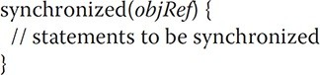

Here, *objRef* is a reference to the object being synchronized. A synchronized block ensures that a call to a synchronized method that is a member of *objRef*’s class occurs only after the current thread has successfully entered *objRef*’s monitor.

Here is an alternative version of the preceding example, using a synchronized block within the **run( )** method:

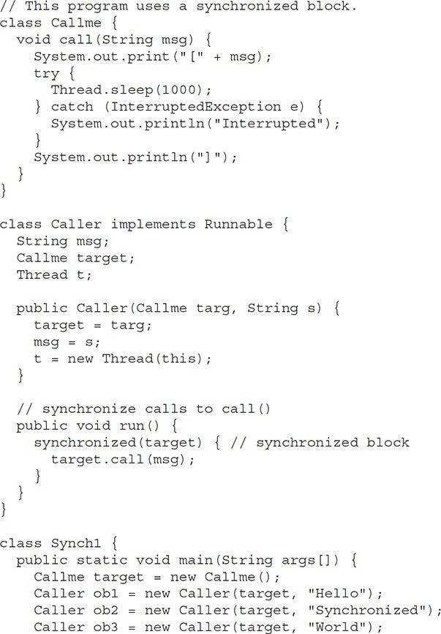

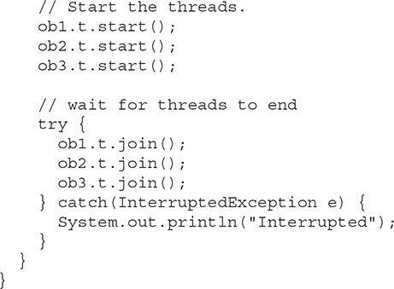

Here, the **call( )** method is not modified by **synchronized**. Instead, the **synchronized** statement is used inside **Caller**’s **run( )** method. This causes the same correct output as the preceding example, because each thread waits for the prior one to finish before proceeding.

**Interthread Communication**

The preceding examples unconditionally blocked other threads from asynchronous access to certain methods. This use of the implicit monitors in Java objects is powerful, but you can achieve a more subtle level of control through interprocess communication. As you will see, this is especially easy in Java.

As discussed earlier, multithreading replaces event loop programming by dividing your tasks into discrete, logical units. Threads also provide a secondary benefit: they do away with polling. Polling is usually implemented by a loop that is used to check some condition repeatedly. Once the condition is true, appropriate action is taken. This wastes CPU time. For example, consider the classic queuing problem, where one thread is producing some data and another is consuming it. To make the problem more interesting, suppose that the producer has to wait until the consumer is finished before it generates more data. In a polling system, the consumer would waste many CPU cycles while it waited for the producer to produce. Once the producer was finished, it would start polling, wasting more CPU cycles waiting for the consumer to finish, and so on. Clearly, this situation is undesirable.

To avoid polling, Java includes an elegant interprocess communication mechanism via the **wait( )**, **notify( )**, and **notifyAll( )** methods. These methods are implemented as **final** methods in **Object**, so all classes have them. All three methods can be called only from within a **synchronized** context. Although conceptually advanced from a computer science perspective, the rules for using these methods are actually quite simple:

* **wait( )** tells the calling thread to give up the monitor and go to sleep until some other thread enters the same monitor and calls **notify( )** or **notifyAll( )**.
* **notify( )** wakes up a thread that called **wait( )** on the same object.
* **notifyAll( )** wakes up all the threads that called **wait( )** on the same object. One of the threads will be granted access.

These methods are declared within **Object**, as shown here:

final void wait( ) throws InterruptedException final void notify( )

final void notify All( )

Additional forms of **wait( )** exist that allow you to specify a period of time to wait.

Before working through an example that illustrates interthread communication, an important point needs to be made. Although **wait( )** normally waits until **notify( )** or **notifyAll( )** is called, there is a possibility that in very rare cases the waiting thread could be awakened due to a *spurious wakeup*. In this case, a waiting thread resumes without **notify( )** or **notifyAll( )** having been called. (In essence, the thread resumes for no apparent reason.) Because of this remote possibility, the Java API documentation recommends that calls to **wait( )** should take place within a loop that checks the condition on which the thread is waiting. The following example shows this technique.

Let’s now work through an example that uses **wait( )** and **notify( )**. To begin, consider the following sample program that incorrectly implements a simple form of the producer/consumer problem. It consists of four classes: **Q**, the queue that you’re trying to synchronize; **Producer**, the threaded object that is producing queue entries; **Consumer**, the threaded object that is consuming queue entries; and **PC**, the tiny class that creates the single **Q**, **Producer**, and **Consumer**.

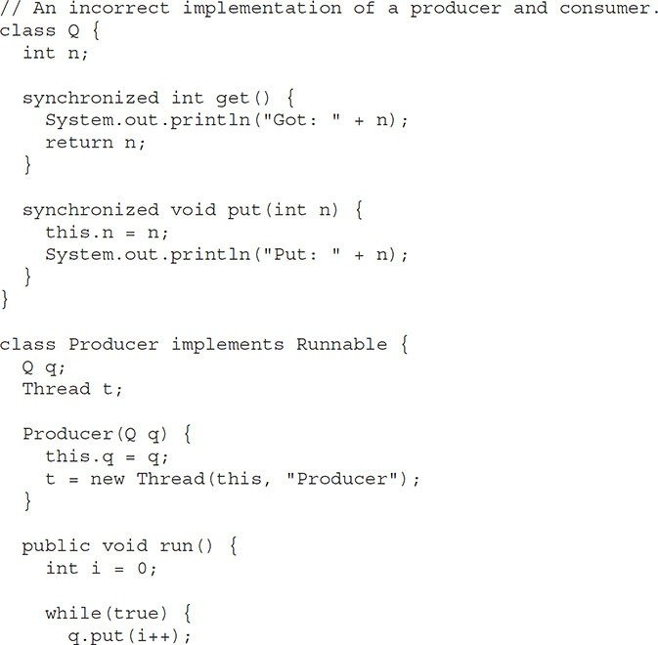

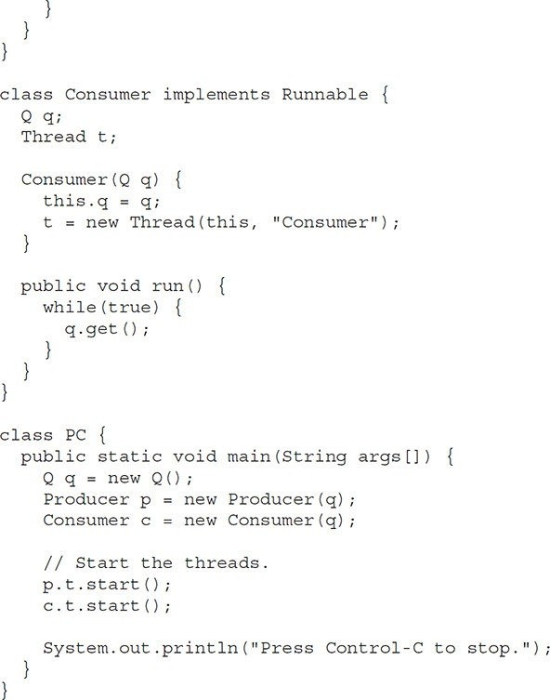

Although the **put( )** and **get( )** methods on **Q** are synchronized, nothing stops the producer from overrunning the consumer, nor will anything stop the consumer from consuming the same queue value twice. Thus, you get the erroneous output shown here (the exact output will vary with processor speed and task load):

|  |  |
| --- | --- |
| Put: | 1 |
| Got: | 1 |
| Got: | 1 |
| Got: | 1 |
| Got: | 1 |
| Got: | 1 |
| Put: | 2 |
| Put: | 3 |
| Put: | 4 |
| Put: | 5 |
| Put: | 6 |
| Put: | 7 |
| Got: | 7 |

As you can see, after the producer put 1, the consumer started and got the same 1 five times in a row. Then, the producer resumed and produced 2 through 7 without letting the consumer have a chance to consume them.

The proper way to write this program in Java is to use **wait( )** and **notify( )**

to signal in both directions, as shown here:

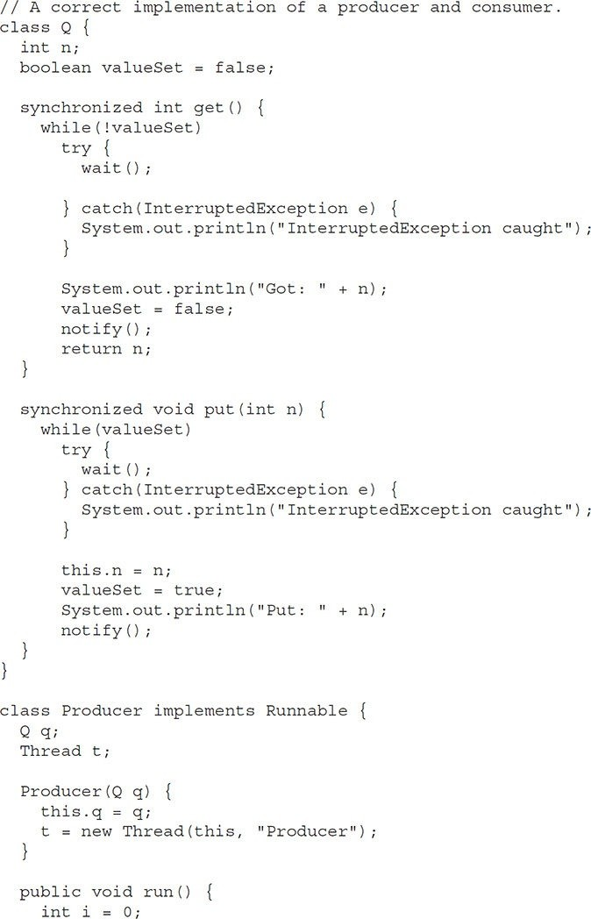

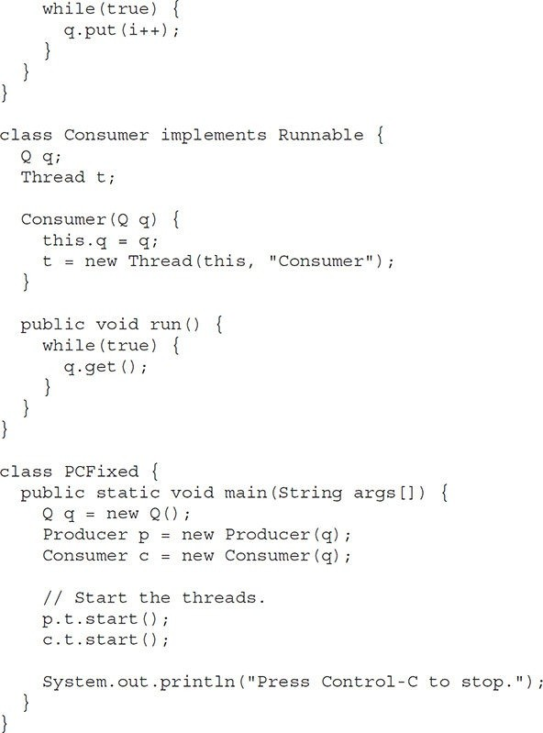

Inside **get( )**, **wait( )** is called. This causes its execution to suspend until **Producer** notifies you that some data is ready. When this happens, execution

inside **get( )** resumes. After the data has been obtained, **get( )** calls **notify( )**. This tells **Producer** that it is okay to put more data in the queue. Inside **put( )**, **wait( )** suspends execution until **Consumer** has removed the item from the queue. When execution resumes, the next item of data is put in the queue, and **notify( )** is called. This tells **Consumer** that it should now remove it.

Here is some output from this program, which shows the clean synchronous behavior:

|  |  |
| --- | --- |
| Put: | 1 |
| Got: | 1 |
| Put: | 2 |
| Got: | 2 |
| Put: | 3 |
| Got: | 3 |
| Put: | 4 |
| Got: | 4 |
| Put: | 5 |
| Got: | 5 |

**Deadlock**

A special type of error that you need to avoid that relates specifically to multitasking is *deadlock*, which occurs when two threads have a circular dependency on a pair of synchronized objects. For example, suppose one thread enters the monitor on object X and another thread enters the monitor on object Y. If the thread in X tries to call any synchronized method on Y, it will block as expected. However, if the thread in Y, in turn, tries to call any synchronized method on X, the thread waits forever, because to access X, it would have to release its own lock on Y so that the first thread could complete. Deadlock is a difficult error to debug for two reasons:

* In general, it occurs only rarely, when the two threads time-slice in just the right way.
* It may involve more than two threads and two synchronized objects. (That is, deadlock can occur through a more convoluted sequence of events than just described.)

To understand deadlock fully, it is useful to see it in action. The next example creates two classes, **A** and **B**, with methods **foo( )** and **bar( )**, respectively, which pause briefly before trying to call a method in the other class. The main class, named **Deadlock**, creates an **A** and a **B** instance, and then calls **deadlockStart( )** to start a second thread that sets up the deadlock condition. The **foo( )** and **bar( )** methods use **sleep( )** as a way to force the deadlock condition to occur.

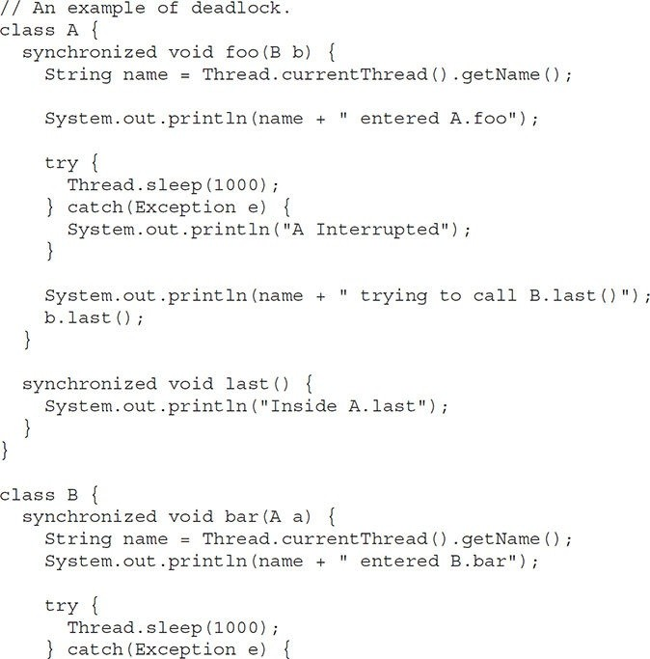

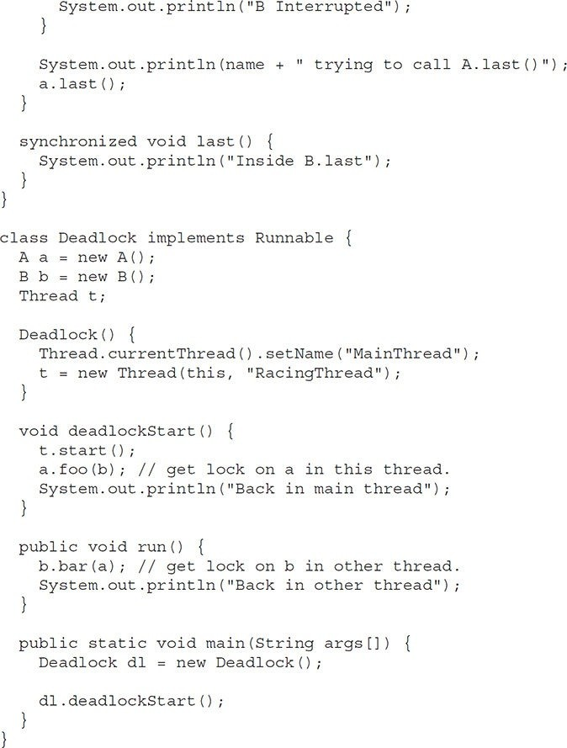

When you run this program, you will see the output shown here, although whether **A.foo( )** or **B.bar( )** executes first will vary based on the specific execution environment.

MainThread entered A.foo RacingThread entered B.bar MainThread trying to call B.last() RacingThread trying to call A.last()

Because the program has deadlocked, you need to press CTRL-C to end the program. You can see a full thread and monitor cache dump by pressing CTRL- BREAK on a PC. You will see that **RacingThread** owns the monitor on **b**, while it is waiting for the monitor on **a**. At the same time, **MainThread** owns **a** and is waiting to get **b**. This program will never complete. As this example illustrates, if your multithreaded program locks up occasionally, deadlock is one of the first conditions that you should check for.

**Suspending, Resuming, and Stopping Threads**

Sometimes, suspending execution of a thread is useful. For example, a separate thread can be used to display the time of day. If the user doesn’t want a clock, then its thread can be suspended. Whatever the case, suspending a thread is a simple matter. Once suspended, restarting the thread is also a simple matter.

The mechanisms to suspend, stop, and resume threads differ between early versions of Java, such as Java 1.0, and more modern versions, beginning with Java 2. Prior to Java 2, a program used **suspend( )**, **resume( )**, and **stop( )**, which are methods defined by **Thread**, to pause, restart, and stop the execution of a thread. Although these methods seem to be a perfectly reasonable and convenient approach to managing the execution of threads, they must not be used for new Java programs. Here’s why. The **suspend( )** method of the **Thread** class was deprecated by Java 2 several years ago. This was done because **suspend( )** can sometimes cause serious system failures. Assume that a thread has obtained locks on critical data structures. If that thread is suspended at that point, those locks are not relinquished. Other threads that may be waiting for those resources can be deadlocked.

The **resume( )** method is also deprecated. It does not cause problems, but cannot be used without the **suspend( )** method as its counterpart.

The **stop( )** method of the **Thread** class, too, was deprecated by Java 2. This was done because this method can sometimes cause serious system failures.

Assume that a thread is writing to a critically important data structure and has completed only part of its changes. If that thread is stopped at that point, that data structure might be left in a corrupted state. The trouble is that **stop( )** causes any lock the calling thread holds to be released. Thus, the corrupted data might be used by another thread that is waiting on the same lock.

Because you can’t now use the **suspend( )**, **resume( )**, or **stop( )** methods to control a thread, you might be thinking that no way exists to pause, restart, or terminate a thread. But, fortunately, this is not true. Instead, a thread must be designed so that the **run( )** method periodically checks to determine whether that thread should suspend, resume, or stop its own execution. Typically, this is accomplished by establishing a flag variable that indicates the execution state of the thread. As long as this flag is set to “running,” the **run( )** method must continue to let the thread execute. If this variable is set to “suspend,” the thread must pause. If it is set to “stop,” the thread must terminate. Of course, a variety of ways exist in which to write such code, but the central theme will be the same for all programs.

The following example illustrates how the **wait( )** and **notify( )** methods that are inherited from **Object** can be used to control the execution of a thread. Let us consider its operation. The **NewThread** class contains a **boolean** instance variable named **suspendFlag**, which is used to control the execution of the thread. It is initialized to **false** by the constructor. The **run( )** method contains a **synchronized** statement block that checks **suspendFlag**. If that variable is **true**, the **wait( )** method is invoked to suspend the execution of the thread. The **mysuspend( )** method sets **suspendFlag** to **true**. The **myresume( )** method sets **suspendFlag** to **false** and invokes **notify( )** to wake up the thread. Finally, the **main( )** method has been modified to invoke the **mysuspend( )** and **myresume(**

**)** methods.

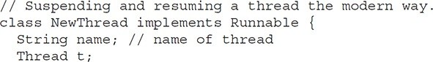

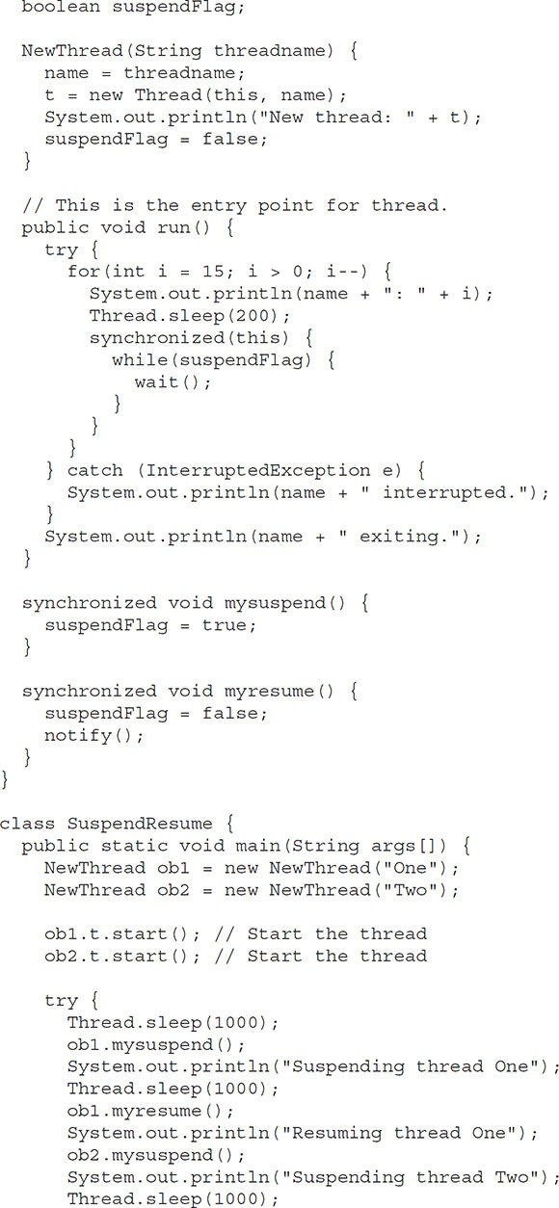

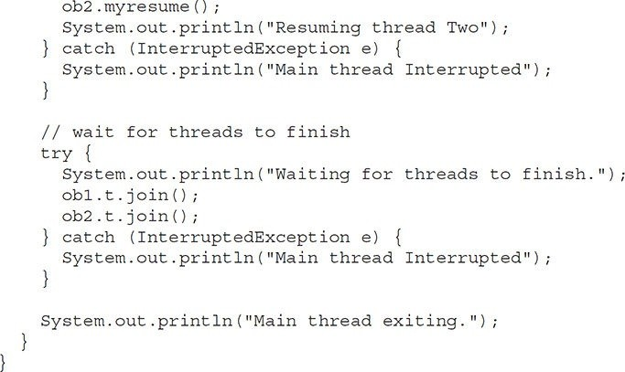

When you run the program, you will see the threads suspend and resume.

Later in this book, you will see more examples that use the modern mechanism of thread control. Although this mechanism may not appear as simple to use as the old way, nevertheless, it is the way required to ensure that run-time errors don’t occur. It is the approach that *must* be used for all new code.

## Obtaining a Thread’s State

As mentioned earlier in this chapter, a thread can exist in a number of different states. You can obtain the current state of a thread by calling the **getState( )** method defined by **Thread**. It is shown here:

Thread.State getState( )

It returns a value of type **Thread.State** that indicates the state of the thread at the time at which the call was made. **State** is an enumeration defined by **Thread**. (An enumeration is a list of named constants. It is discussed in detail in Chapter 12.) Here are the values that can be returned by **getState( )**:

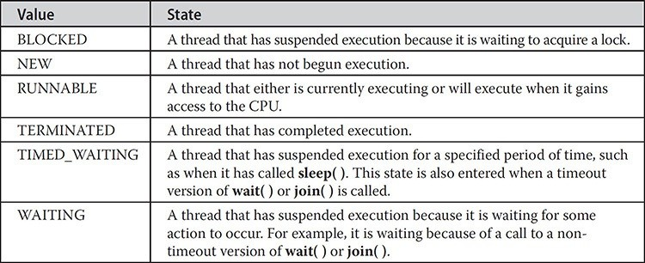

Figure 11-1 diagrams how the various thread states relate.

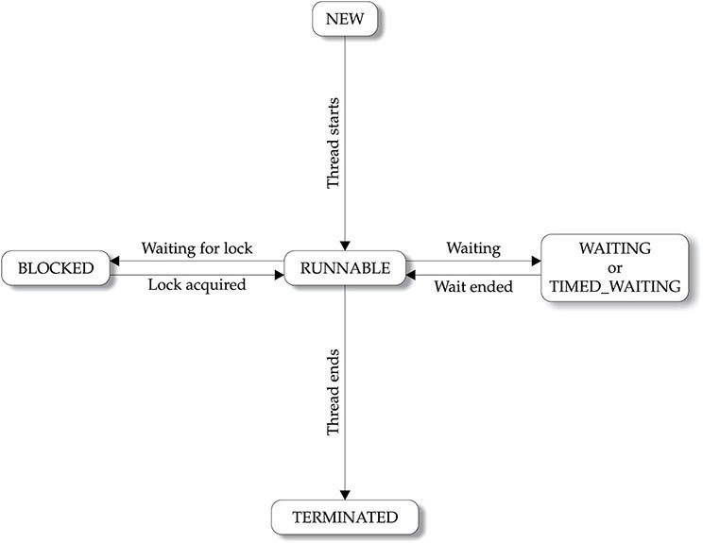

**Figure 11-1** Thread states

Given a **Thread** instance, you can use **getState( )** to obtain the state of a thread. For example, the following sequence determines if a thread called **thrd** is in the **RUNNABLE** state at the time **getState( )** is called:

Thread.State ts = thrd.getState(); if(ts == Thread.State.RUNNABLE) // ...

It is important to understand that a thread’s state may change after the call to **getState()**. Thus, depending on the circumstances, the state obtained by calling **getState( )** may not reflect the actual state of the thread only a moment later. For this (and other) reasons, **getState( )** is not intended to provide a means of synchronizing threads. It’s primarily used for debugging or for profiling a thread’s run-time characteristics.

**Using a Factory Method to Create and Start a Thread**

In some cases, it is not necessary to separate the creation of a thread from the start of its execution. In other words, sometimes it is convenient to create and start a thread at the same time. One way to do this is to use a static factory method. A *factory method* is a method that returns an object of a class.

Typically, factory methods are *static* methods of a class. They are used for a variety of reasons, such as to set an object to some initial state prior to use, to configure a specific type of object, or in some cases to enable an object to be reused. As it relates to creating and starting a thread, a factory method will create the thread, call **start( )** on the thread, and then return a reference to the thread. With this approach, you can create and start a thread through a single method call, thus streamlining your code.

For example, assuming the **ThreadDemo** program shown near the start of this chapter, adding the following factory method to **NewThread** enables you to create and start a thread in a single step:

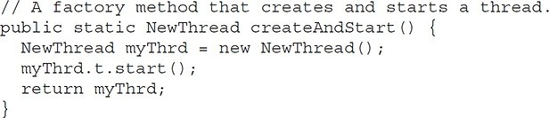

Using **createAndStart( )**, you can now replace this sequence:

NewThread nt = new NewThread(); // create a new thread nt.t.start(); // Start the thread

with

NewThread nt = NewThread.createAndStart();

Now the thread is created and started in one step.

In cases in which you don’t need to keep a reference to the executing thread, you can sometimes create and start a thread with one line of code, without the use of a factory method. For example, again assuming the **ThreadDemo** program, the following creates and starts a **NewThread** thread:

new NewThread().t.start();

However, in real-world applications, you will usually need to keep a reference to the thread, so the factory method is often a good choice.

**Using Multithreading**

The key to utilizing Java’s multithreading features effectively is to think concurrently rather than serially. For example, when you have two subsystems within a program that can execute concurrently, make them individual threads. With the careful use of multithreading, you can create very efficient programs. A word of caution is in order, however: If you create too many threads, you can actually degrade the performance of your program rather than enhance it.