MC-Dropout Dispersion Did Not Show Stable Incremental Predictive Value Beyond Sequence Length in an RNAbpFlow Evaluation Cohort
Pijush Kanti Dutta Pramanik

Abstract
We evaluated whether Monte Carlo (MC) dropout dispersion provides target-level uncertainty information beyond sequence length for RNAbpFlow, an RNA tertiary-structure prediction model, using an 82-structure cohort released after the model's documented training-data cutoff. Dispersion correlated strongly with structural error in raw terms (Pearson r=0.668; Spearman ρ=0.671; both p<0.0001). However, adding log-dispersion to a nonlinear sequence-length model reduced leave-one-out cross-validated RMSE by only 1.2% (0.3609 to 0.3567); the paired loss difference was imprecise (ΔMSE=0.0031, 95% CI [-0.0156, 0.0221], permutation p=0.76). Cross-fitted target triage likewise showed no clear advantage over length alone. This conclusion was stable across spline flexibility, resampling scheme, and an independent composition covariate (GC content), but the estimated effect grew larger, though still imprecise, as targets with progressively stronger global or local similarity to RNAbpFlow's training sequences were excluded (1.2% in the full 82-target cohort to 6.1% after excluding 21 training-similar targets). MC-dropout dispersion was therefore strongly associated with error but did not show a stable incremental benefit beyond the evaluated length-based baseline in this cohort; larger, homology-aware evaluations are needed to determine whether its utility differs for training-novel RNAs.
Keywords: RNA 3D structure prediction; uncertainty quantification; Monte Carlo dropout; conformal prediction; baseline-adjusted evaluation; out-of-sample validation

Introduction
RNA molecules perform diverse regulatory and catalytic roles that depend directly on three-dimensional structure, but experimentally solved RNA structures remain far scarcer than protein structures, motivating computational prediction. Deep learning has recently transformed this area: sequence-based methods including RhoFold+ [8], trRosettaRNA [9], RoseTTAFoldNA [10], and AlphaFold3 [7] now predict RNA tertiary structure directly from sequence, and generative approaches such as RNAbpFlow [1], the backbone evaluated here, produce full conformational ensembles rather than single point estimates.
Systematic benchmarking shows no single method dominates across all RNA targets, with accuracy remaining especially limited for structurally novel or evolutionarily orphan sequences [11]. Ensemble-generating models make it possible, in principle, to report a per-target confidence alongside each prediction — the spread of the sampled ensemble — but whether this spread constitutes genuine, useful uncertainty information has rarely been tested directly for RNA structure prediction. This mirrors a broader, unresolved pattern in structure prediction generally: even widely used confidence scores such as pLDDT are known to be imperfectly calibrated and to degrade under distribution shift, and Monte Carlo (MC) dropout [12], though computationally attractive because it requires no additional training, has itself been reported to give unreliable uncertainty estimates in general deep-learning benchmarks [13].
A further complication is that an uncertainty signal's raw correlation with error does not establish that the signal is informative for deployment. The correlation may be partly driven by a variable available before the model is run. For RNA, sequence length is a natural candidate: longer targets can be intrinsically harder to predict, so an error-correlated uncertainty signal may simply re-express target difficulty rather than add information. The relevant question is therefore not whether dispersion correlates with error, but whether it improves prediction or selection of reliable structures after a nonlinear length baseline has been fitted out of sample.
This study asks a deliberately narrow, directly testable question for RNAbpFlow: does MC-dropout ensemble dispersion predict structural error beyond what a flexible nonlinear model of sequence length already predicts, and does it improve practical identification of trustworthy predictions relative to sequence length alone?
The contribution is deliberately empirical rather than algorithmic. First, we provide an out-of-sample test of whether MC-dropout dispersion adds predictive information beyond an explicit, freely available length-based baseline for RNA 3D structure prediction, with GC content evaluated as a sensitivity covariate. Second, we provide a documented evaluation pipeline that separates raw association, incremental predictive value, and practical triage utility. Third, we document an analysis correction in which an in-sample significance test was superseded by an appropriate out-of-sample comparison; the correction is reported as an audit trail, not as evidence for the biological conclusion.

Related Work
RNA and biomolecular structure ensemble generation. Deep generative models increasingly produce multiple candidate structures rather than a single prediction. RNAbpFlow [1], the backbone evaluated here, and DynaRNA [18], a diffusion-based model for RNA conformational dynamics, both generate structural ensembles for RNA, while AlphaFold3 [7] and related protein–nucleic-acid methods [8–10] can be sampled multiple times. The RNA-Puzzles and CASP16 assessment literature further shows that RNA prediction quality remains strongly target-dependent, with target size, structural novelty, and difficult tertiary interactions affecting performance [22]. These studies establish the importance of ensemble generation and rigorous model assessment, but do not test whether ensemble spread itself provides incremental, decision-relevant uncertainty information beyond a simple target-difficulty variable.
Confidence and uncertainty estimation in structure prediction. The widely used per-residue confidence measure pLDDT can correlate with structural flexibility and disorder while remaining imperfectly calibrated, particularly under distribution shift and in interacting systems [16]. RNA-specific predictors have also begun to expose explicit confidence information. trRosettaRNA reports an estimated RMSD (eRMSD) derived from predicted distance-map confidence and model convergence, with eRMSD correlated with true RMSD [9]. RhoFold+ reports predicted LDDT values and showed that its confidence tracks prediction accuracy while also relating to modeling difficulty, including sequence length and homology [8]. More recently, RNArank introduced a deep-learning quality-assessment model for global and residue-level RNA 3D model quality, predicting intermediate contact and distance-deviation maps to estimate lDDT [19]. RNAdvisor 2 provides a broader quality-assessment framework that combines established metrics, scoring functions, and meta-scoring functions for ranking RNA models [20]. NUMonomer, a recent 2026 preprint, additionally produces per-nucleotide pLDDT confidence scores and uses confidence to select among sampled candidate structures [21]. These studies are important precedents for RNA model-confidence and quality assessment, but they primarily evaluate correlation, ranking, candidate selection, or benchmark accuracy rather than whether an inference-time uncertainty signal remains incrementally informative after adjustment for a length-based baseline, with GC content as a sensitivity covariate. MC-dropout itself [12] has not, to our knowledge, been systematically evaluated as an uncertainty signal for RNA 3D structure prediction.
Baseline-aware evaluation of uncertainty signals. The risk-coverage framework [14] underlies practical-value assessments of uncertainty signals, including the area-under-the-risk-coverage-curve comparison used here. A related but distinct line of work asks whether uncertainty estimates are systematically associated with observable properties of the prediction task. UNCERTAINTY-LINE [15], for example, shows that LLM uncertainty scores can remain associated with output length even after standard length normalization and proposes a regression-based debiasing correction. This establishes that length-associated uncertainty is a recognized cross-domain problem. The present study transfers that concern to RNA structure prediction, but evaluates it through a paired out-of-sample predictive comparison and a practical-utility analysis rather than in-sample residualization. Recent RNA confidence and quality-assessment systems similarly provide evidence that confidence can correlate with error, but they do not test whether the signal survives comparison with a pre-available target-difficulty baseline [8, 9, 19, 20, 21].
Gap and scope. The closest precedents therefore fall into three groups: model-generated confidence estimates such as trRosettaRNA and RhoFold+ [8, 9]; learned or composite RNA quality-assessment systems such as RNArank and RNAdvisor 2 [19, 20]; and ensemble-generation methods such as RNAbpFlow, DynaRNA, and related generative predictors [1, 7, 18]. NUMonomer further illustrates the current shift toward exposing explicit per-nucleotide confidence during RNA/nucleic-acid structure prediction [21]. To our knowledge, and based on the literature search described in Related Work above rather than a systematic review protocol, we found no prior published evaluation that directly tests whether an inference-only ensemble-spread signal for RNA 3D structure prediction adds predictive value beyond an available difficulty covariate using paired out-of-sample inference and practical risk-coverage evaluation. The scope is intentionally narrow: one backbone (RNAbpFlow), one uncertainty signal (MC-dropout dispersion), one explicit difficulty covariate (sequence length), and one post-training-cutoff evaluation cohort (N=82). The findings therefore should not be generalized to other backbones, uncertainty methods, or definitions of target difficulty without additional evidence.
Table 1. Comparison with the closest related work.
Study | Task | Confidence signal | Evaluation target | Comparator baseline | Validation design | Directly comparable?
Gal & Ghahramani (2016) [12] | General DL | MC-dropout (proposed method) | Predictive uncertainty calibration on regression/classification benchmarks | None (foundational method paper) | Standard train/test splits | No — foundational method paper, not an evaluation study
Djupskås et al. (2025) [13] | General DL (synthetic/GP) | MC-dropout (critiqued) | Reliability of MC-dropout uncertainty against known ground-truth uncertainty | Gaussian-process ground truth | Synthetic benchmark comparison | No — different domain, but directly motivates this study's caution
Vander Meersche et al. (2025) [16] | Protein | pLDDT | Correlation between pLDDT and MD-derived flexibility | None | Correlation analysis | No — different domain and question (flexibility, not incremental value)
Shihab et al. (2026) [17] | Protein | Evidential + conformal | Distribution-shift-robust confidence intervals | None stated (shift-focused) | Conformal calibration under shift | No — different domain and question
Vashurin et al. (2025) [15] | LLM text generation | Token-probability UQ | Whether uncertainty is associated with output length | Length (in-sample debiasing) | In-sample residualization | Partially — closest confound-aware precedent, but different domain and in-sample design
Wang et al. (2023) [9] | RNA | trRosettaRNA eRMSD confidence | Confidence-accuracy correlation | None | Confidence-accuracy correlation | No — same domain, different question
Shen et al. (2024) [8] | RNA | RhoFold+ pLDDT confidence | Confidence-accuracy correlation | Partial (difficulty factors noted, not tested) | Confidence-accuracy correlation | No — same domain, different question
Bernard et al. (2025) [20] | RNA | RNAdvisor 2 metrics / scoring / meta-scoring | Ranking predicted structure quality | None | Benchmark ranking | No — quality-assessment tool, not an uncertainty-value study
Liu et al. (2026) [19] | RNA | RNArank learned local/global QA | Held-out QA benchmark performance | None | Held-out QA benchmark | No — same domain, different question
Si et al. (2026) [21] | RNA / nucleic acids | NUMonomer per-nucleotide pLDDT | Candidate structure selection accuracy | None stated for confidence aspect | Benchmark + candidate selection | No — different question (selection utility, not incremental value)
Westhof et al. (2026) [22] | RNA | RNA-Puzzles / CASP16 assessment metrics | Blind prediction accuracy across groups/methods | None (blind community assessment) | Blind benchmark | No — community assessment exercise, not a signal evaluation
Tarafder & Bhattacharya (2026) [1]; Li et al. (2025) [18] | RNA | None (ensemble generation, no uncertainty validation) | Structure generation accuracy / diversity | None | Standard structure-prediction benchmarks | No — RNAbpFlow [1] is the backbone evaluated in this work, not a comparator
This work | RNA | MC-dropout dispersion | Incremental predictive/triage value beyond a difficulty covariate, out-of-sample | Sequence length (nonlinear) and GC content | Paired LOOCV + cross-fitted AURC + split-conformal, all out-of-sample | —
Table 1 places this study alongside the most directly relevant RNA confidence, model-quality, ensemble-generation, and baseline-aware literatures. trRosettaRNA and RhoFold+ show that RNA predictors can generate confidence estimates related to model accuracy; RNArank and RNAdvisor 2 provide increasingly sophisticated RNA-specific quality assessment and model ranking; and NUMonomer now exposes per-nucleotide confidence for sequence-only nucleic-acid prediction.

Methods
The overall analysis pipeline, from cohort construction through the final conclusion, is summarized in Figure 1.
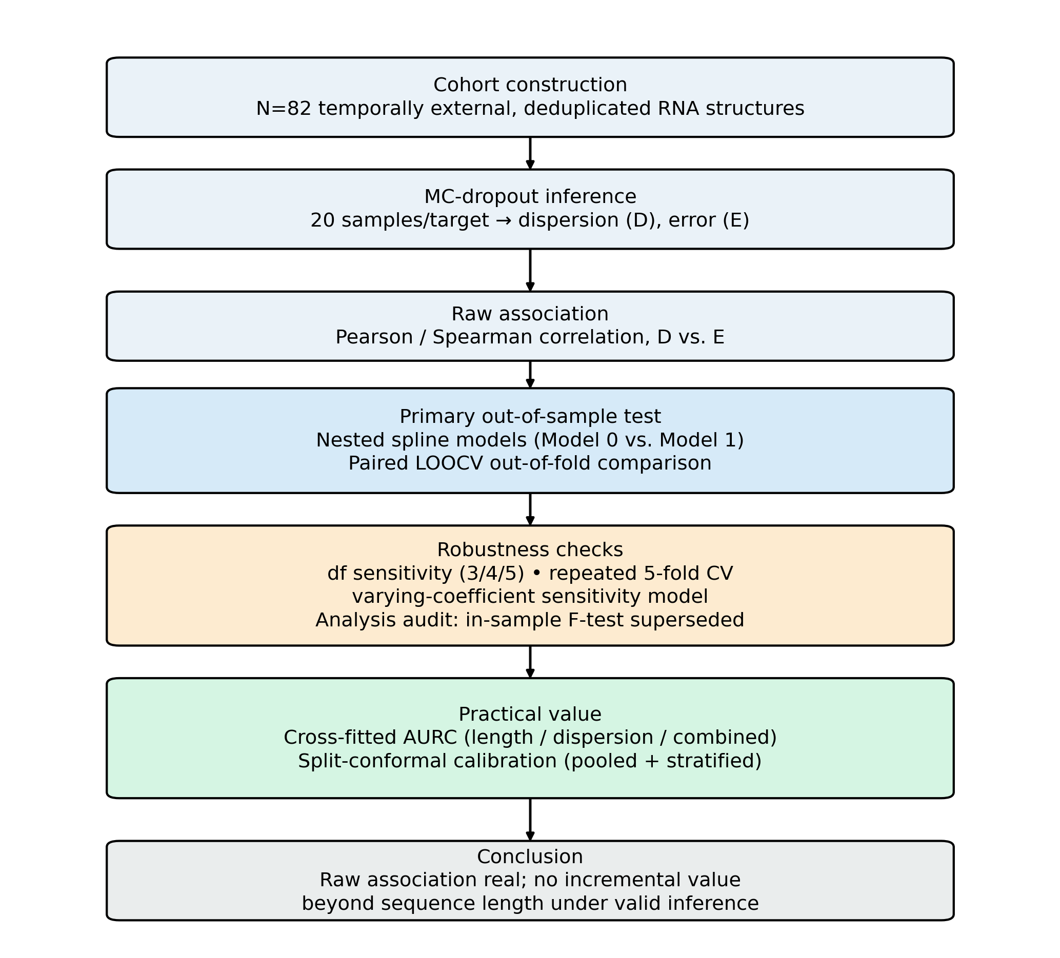
Figure 1. Overview of the analysis pipeline, from cohort construction through the final conclusion.

Backbone model and cohort construction
RNAbpFlow was used as the backbone, with inference run from its publicly released checkpoint. RNA monomer candidates were retrieved from RCSB PDB and separated by a 2025-01-01 initial-release-date freeze, chosen to fall comfortably after RNAbpFlow's documented training-data cutoff: the backbone was trained on the RNA3DB dataset as curated from the PDB on 26 April 2024 [1], roughly eight months before this cohort's freeze date. This establishes release-date separation between the evaluation cohort and the backbone's training data, but does not by itself rule out sequence or structural homology to training examples, which was not separately audited (Limitations). Structures containing modified nucleotides and structures solved by solution NMR were excluded from the candidate pool. Residue-level correspondence between predicted and observed structures was established by global pairwise sequence alignment: 151 of 196 candidate structures yielded usable residue correspondence, while 45 structures available only in mmCIF format were not processed. Exact-sequence deduplication of near-identical repeated depositions then yielded a final evaluation cohort of 82 exact-sequence-deduplicated structures (Figure 2).
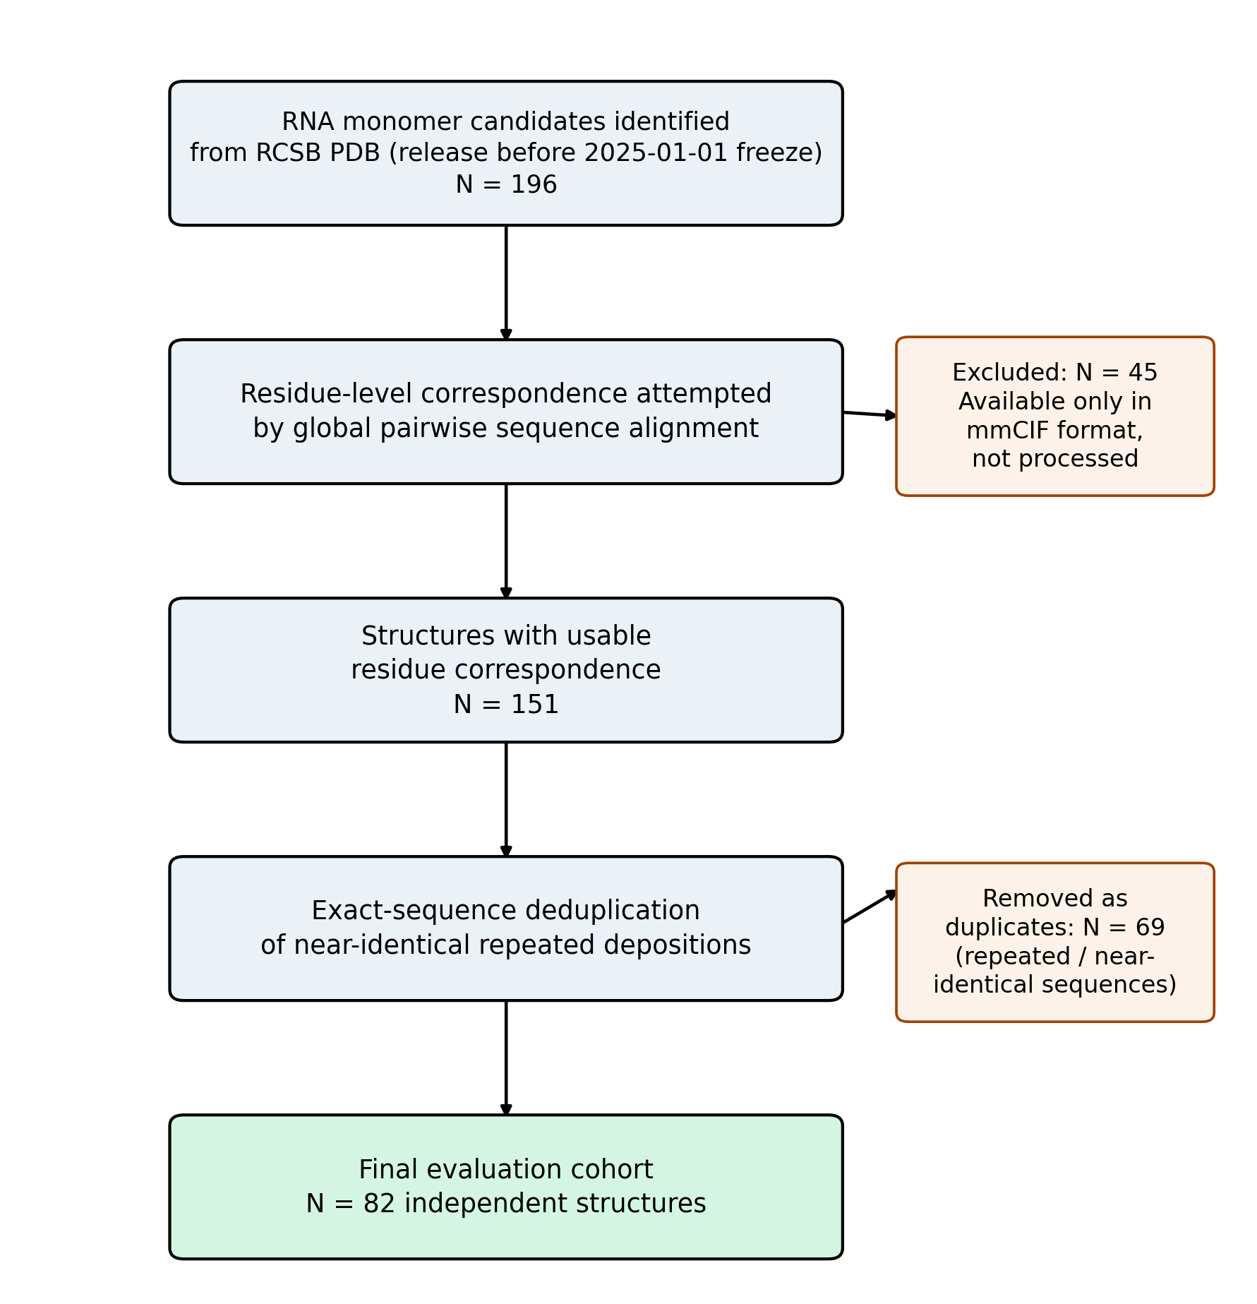
Figure 2. Cohort construction flow, from initial PDB candidate identification through the final evaluation cohort, with exclusion counts and reasons at each step.

MC-dropout inference and error computation
All dropout layers used during RNAbpFlow training (p=0.1, the backbone's native training-time dropout rate) were kept active at inference rather than tuned separately, so that the resulting ensemble reflects the model's own trained stochastic regularization rather than an independently chosen uncertainty hyperparameter; 20 samples per target were generated with per-sample seeding disabled. Dispersion was defined as the mean pairwise Kabsch-aligned C4′ RMSD among the 20 samples: for each of the C(20,2)=190 sample pairs, the two structures were aligned by the Kabsch procedure on C4′ coordinates only (no other atom types), and dispersion is the mean of these 190 pairwise RMSD values. Prediction error was defined analogously as the mean of the 20 Kabsch-aligned C4′ RMSD values between each sampled structure and the single reference (ground-truth) structure. Each target is a single RNA chain (monomer), not a multi-chain biological assembly; alignment and RMSD were computed only over residues resolved in the reference structure, so unresolved residues do not contribute to either dispersion or error, and residue correspondence between predicted and reference structures follows the same sequence-alignment-based mapping described above for cohort construction.
Reproducibility details are summarized in Table 1b; the checkpoint file and complete inference configuration are available in the accompanying code repository for exact reproduction beyond what is tabulated here.

Table 1b. Reproducibility reference details
Detail | Value
Dropout modules enabled | 36 (verified by explicit runtime count, not assumed)
Dropout probability | p=0.1 (backbone's native training-time rate)
Samples per target | 20 (primary analysis; convergence checked to 30, Limitations)
Hardware | Single GPU
Checkpoint | RNAbpFlow's publicly released RNA3DB checkpoint
Spline basis | patsy restricted cubic spline (cr()), 4 df primary
Knot placement | Automatic, default quantile positions of log(length), fixed before any incremental-value comparison
Boundary constraints | Natural (linear) outside outermost knots (basis default)

Raw association analysis
The unadjusted relationship between dispersion and error was quantified using both Pearson and Spearman correlation coefficients across all 82 cohort targets, with significance assessed by the standard asymptotic test for each coefficient. This raw association was treated purely as a descriptive baseline, established prior to and independently of the incremental-value analyses that follow, and was not used to support any claim of incremental predictive value on its own.

Primary out-of-sample analysis
The primary analysis compared two nested models of log(error). Writing Eᵢ, Lᵢ, and Dᵢ for the structural error, sequence length, and dispersion of target i, and s(·) for a restricted cubic spline with 4 degrees of freedom fixed in advance, the length-only model (Model 0) is given by Equation 1 and the length-plus-dispersion model (Model 1) by Equation 2:
$log(E_{i}) = s(log L_{i}) + ε_{i}$ (1)
$log(E_{i}) = s(log L_{i}) + β·log(D_{i}) + ε_{i}$ (2)
The 4-df specification was fixed for the primary analysis rather than selected by optimizing the observed incremental effect of dispersion; 4 degrees of freedom is a conventional default for a moderate-flexibility restricted cubic spline with a single predictor at this sample size, chosen before the incremental-value comparison was run, and 3-df and 5-df variants are reported as pre-specified robustness checks rather than as a post-hoc model search (see Robustness analyses). The spline basis, knot placement, and boundary-constraint details are in Table 1b. Predictive performance was assessed using leave-one-out cross-validation (LOOCV), with identical target-level folds for both models. The primary estimand was the out-of-sample difference in squared prediction error between Model 0 and Model 1; the raw dispersion-error correlation and practical triage performance were treated as separate descriptive and operational questions.
Inference for the incremental contribution of dispersion was based on paired out-of-fold squared prediction errors. Writing ê₀ᵢ and ê₁ᵢ for the leave-one-out out-of-fold residuals (log-error scale) for target i under Model 0 and Model 1 respectively, the paired difference (Equation 3)
$d_{i} = ê_{0i}^{2} − ê_{1i}^{2}$ (3)
was retained for each of the 82 targets individually; the quantity of inferential interest is the mean of dᵢ across targets, and uncertainty in this mean was quantified by a target-level bootstrap 95% confidence interval (10,000 resamples, resampling targets with replacement) and a permutation test (10,000 sign-flip resamples). This targets the same quantity as the predictive comparison: whether adding dispersion improves out-of-sample prediction for the observed targets. An in-sample nested-model F-test was not used to certify this out-of-sample contrast.

Robustness analyses
Six robustness checks were used. First, the length spline was refit with 3 and 5 degrees of freedom to assess sensitivity to local flexibility. Second, repeated 5-fold cross-validation (30 repeats) assessed stability under a different resampling scheme. Third, a low-complexity varying-coefficient sensitivity model (Equation 4) allowed the dispersion coefficient itself to vary smoothly with log(length), using a further 2-df function g(·):
$log(E_{i}) = s(log L_{i}) + [β_{0} + g(log L_{i})]·log(D_{i}) + ε_{i}$ (4)
The g(log Lᵢ)·log(Dᵢ) interaction term was residualized against the full main-effects design prior to fitting, to guarantee exact orthogonality and avoid the raw product term's confirmed sensitivity to uncaptured main-effect curvature. Interaction assessment was deliberately restricted to low complexity because of the sample size (N=82); the flexible interaction was treated as a sensitivity analysis, not a new primary model. Fourth, GC content — an independent, freely available sequence-composition covariate unrelated to the length spline — was added alongside length in place of dispersion's sole comparison, following the same three-model hierarchy and paired out-of-fold procedure as the primary analysis, to test whether the incremental-value conclusion depended specifically on using length as the only difficulty covariate. Fifth, a leave-cluster-out cross-validation was used in place of standard LOOCV: cohort targets were grouped into clusters by connected components of pairwise sequence identity at an 80% threshold (Limitations), and each target's training fold excluded every member of its own cluster, not only itself, to test whether the incremental-value conclusion depended on near-duplicate targets being treated as independent folds. Sixth, the primary analysis was repeated excluding the 15 targets found to be at 80% identity or above to a specific RNAbpFlow training sequence (Limitations), to test whether the conclusion depended on these targets specifically.

Practical triage
Target triage was evaluated by area under the risk-coverage curve (AURC), defined explicitly as follows: for a ranking policy that orders the 82 targets from most to least trustworthy, coverage c is the fraction of targets retained (most-trustworthy-first) at a given rejection threshold, risk R(c) is the mean structural error (in Å, not log-error) among the retained targets at that coverage level, and AURC is R(c) integrated over c from the full retained set (c=1) down to a single target, via the trapezoidal rule over the discrete per-target coverage grid; lower AURC indicates a policy that more effectively concentrates low error among its most-trusted predictions. Three ranking policies were compared: length alone, dispersion alone, and a combined length-plus-dispersion score. To avoid optimistic assessment, the combined score was generated from cross-fitted predictions. Bootstrap uncertainty (2,000 resamples) was estimated for the paired AURC difference between the length-only and combined policies.

Secondary conformal analysis
Split-conformal calibration used
$S_{i} = \frac{E_{i}}{D_{i}}$ (5)
as the nonconformity score (Equation 5), with 90% nominal coverage; this ratio was chosen because, given the positive raw association between dispersion and error established above, a target whose error is large relative to its own dispersion deviates further from the cohort-wide trend than the same absolute error would for a high-dispersion target, so the ratio scores nonconformity relative to what dispersion would predict rather than in absolute Å. Fifty random 50/50 calibration/test splits were evaluated both pooled and within two median-based length strata. Coverage was treated as an empirical calibration diagnostic rather than evidence of uniform conditional coverage. The previously observed interval-width pattern was examined directly by repeating the calculation after removing the single most extreme nonconformity value in each stratum and by comparing median as well as mean widths. The influence of individual targets on the calibration quantile was further assessed by a full leave-one-out jackknife, recomputing the quantile from all remaining targets for each exclusion in turn; and the observed difference in coverage and width between strata was formally tested against sampling noise using a bootstrap test (10,000 resamples per stratum pair). Because the E/D nonconformity score proved unstable for low-dispersion targets (Results), a residual-based score was also evaluated: the absolute residual |log(E) − pred| on the log-error scale, avoiding division by dispersion entirely. This was implemented as genuine split-conformal prediction with a clean three-way partition repeated over many random splits (train the point-prediction model / compute calibration residuals from that fixed model on a disjoint held-out set / evaluate coverage and width on a further disjoint held-out set), rather than reusing leave-one-out residuals as calibration scores, which we confirmed on synthetic data does not carry a clean split-conformal coverage guarantee (fitting and scoring the model on the same data undercovers, approximately 85% against a 90% target). The same three-way design was run for both a length-only and a length-plus-dispersion point-prediction model, so their calibrated interval widths could be compared directly at matched empirical coverage; calibration intervals were back-transformed to the original error scale by exponentiating the test-set prediction ± the calibrated quantile of calibration-set residuals.

Analysis audit
An initial in-sample nested F-test (p=0.011) was superseded by the prespecified out-of-sample paired comparison used throughout this study; all final conclusions rest on the paired out-of-fold evaluation, not the superseded test. Full analytical history is provided in Supplementary Table S1.

Results

Raw association with structural error
MC-dropout dispersion correlated strongly with true structural error in raw terms (Pearson r=0.668; Spearman ρ=0.671; both p<0.0001) (Figure 3). This establishes a strong unadjusted association, but not incremental usefulness. The single longest target in the cohort (787 nucleotides) had the highest observed error (72.3 Å) but only moderate dispersion, illustrating why target difficulty must be considered separately from raw uncertainty-error association.
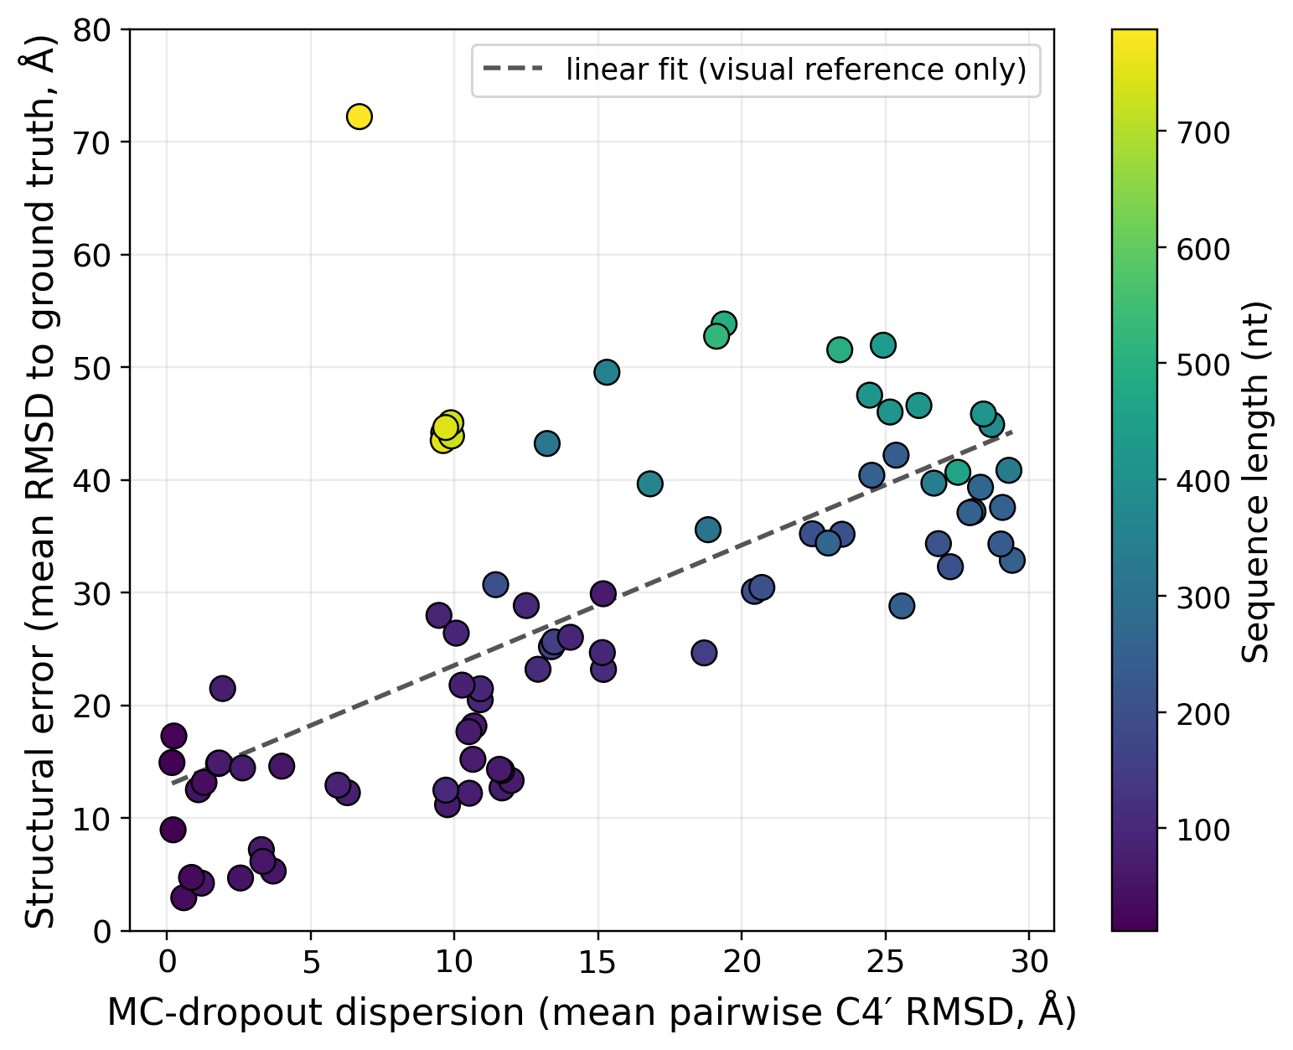
Figure 3. Raw association between MC-dropout dispersion and structural error across the N=82 external cohort, colored by sequence length. The dashed line is an unadjusted linear fit for visual reference only.

No robust incremental value beyond sequence length
Adding log(dispersion) to the 4-df length spline reduced LOOCV RMSE from 0.3609 to 0.3567, a 1.2% reduction. These values are RMSE of the model's log-error residuals, not log-transformed RMSD; because RMSE does not transform linearly under a nonlinear map, they cannot be converted to an original-scale (Å) prediction error by exponentiation. The original-scale error values themselves — ranging from 2.9 to 72.3 Å across the cohort — are shown directly in Figure 1 and used without transformation in the AURC and conformal analyses below. The paired out-of-fold analysis estimated a mean squared-error difference of 0.0031 (log-error-squared scale), with a bootstrap 95% CI of [-0.0156, 0.0221] and permutation p=0.76 (Figure 4). The observed reduction in cross-validated RMSE is small and is not statistically distinguishable from target-level variation in this cohort. We evaluated practical relevance against a prespecified 5% relative RMSE threshold (an illustrative practical threshold, not a field-standard convention), corresponding to a squared-error difference of approximately 0.0127. The bootstrap 95% CI [-0.0156, 0.0221] extended beyond this threshold on both sides while still including zero: it established neither a meaningful benefit nor practical equivalence to zero.

Table 2. Effect-size threshold sensitivity
Threshold (relative RMSE improvement) | Benefit of at least this size excluded? | Practical equivalence to zero established?
2% | No | No
5% | No | No
10% | Yes | Yes
20% | Yes | Yes
At the 2% and 5% thresholds, the bootstrap distribution neither excludes a benefit of at least this size nor establishes practical equivalence to zero; benefits of 10% or more are excluded, and practical equivalence is established at these coarser thresholds (Table 2). This threshold sensitivity, rather than a single prespecified value, is offered to avoid the appearance that 5% was chosen because it flatters a particular interpretation.
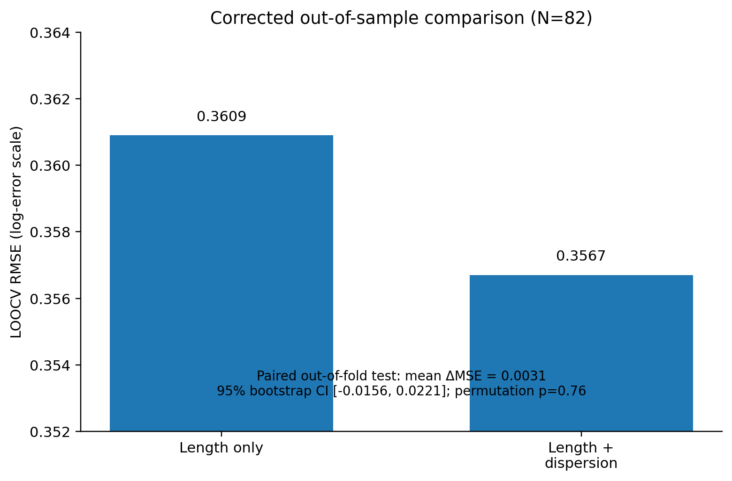
Figure 4. Corrected out-of-sample comparison of LOOCV RMSE for the length-only and length-plus-dispersion models.

Training-similarity sensitivity
The estimated incremental improvement increased from 1.2% in the full cohort to 2.2% after excluding 15 targets with high global-sequence identity to RNAbpFlow’s training data, and to 6.1% after additionally excluding 6 targets with high local alignment identity (Table 2b). All intervals remained wide and included zero. These analyses are hypothesis-generating rather than evidence that dispersion is more useful under training novelty; the available cohort cannot determine whether this pattern reflects a real novelty-dependent signal, or sampling variation and cohort-composition changes in progressively smaller subsets (Limitations).

Table 2b. Training-similarity sensitivity across nested cohorts
Cohort | Relative RMSE improvement | ΔMSE | 95% CI | Interpretation
Full cohort, N=82 | 1.2% | 0.0031 | [-0.0156, 0.0221] | Small, imprecise
Excl. 15 global-similarity, N=67 | 2.2% | 0.0066 | [-0.0174, 0.0331] | Larger, imprecise
Excl. 21 global+local, N=61 | 6.1% | 0.0328 | [-0.0135, 0.0986] | Much larger, very imprecise

Robustness to model flexibility and resampling
The absence of a statistically significant incremental effect was stable across nearby spline specifications. Relative improvement was 5.3% with 3 degrees of freedom (p=0.24), 1.2% with 4 degrees of freedom (p=0.76), and 0.1% with 5 degrees of freedom (p=0.98). The decline in apparent improvement as the length model became more flexible argues against a stable dispersion contribution that is merely hidden by one particular spline choice. Across the four model-specification checks, confidence intervals included zero or closely approached it (Figure 5A).
Repeated 5-fold cross-validation gave a mean improvement of 1.1%, but the estimate was variable across resamples (SD 3.3%; range -10.3% to +7.3%), and dispersion worsened prediction in 26.7% of resamples (Figure 5B). The low-complexity varying-coefficient model likewise did not establish an out-of-sample improvement; its paired LOOCV bootstrap 95% CI was [-0.0108, 0.0518]. Adding GC content alongside length as an independent difficulty covariate (N=81) produced the most tightly null result of any check: mean squared-error difference -0.0003, 95% CI [-0.0198, 0.0183], permutation p=0.97 (Figure 5A). A leave-cluster-out cross-validation, excluding every member of a target's own near-duplicate sequence cluster (not only the target itself) from its training fold, gave a mean squared-error difference of 0.0012 (95% CI [-0.0186, 0.0212], permutation p=0.91), closer to zero than the primary estimate, with an interval that also included zero (Figure 5A). Taken together, these analyses do not support a robust incremental contribution or detectable length-dependent effect modification, and this conclusion is not specific to sequence length as the sole covariate against which dispersion was compared, nor an artifact of near-duplicate targets being treated as independent cross-validation folds. Excluding the 15 targets found at 80% identity or above to a specific RNAbpFlow training sequence (Limitations) gave a mean squared-error difference of 0.0066 (95% CI [-0.0174, 0.0331], permutation p=0.63; N=67, Figure 5A) — still not statistically significant, though the point estimate was appreciably larger than in the full cohort; non-significance alone does not close the question here.
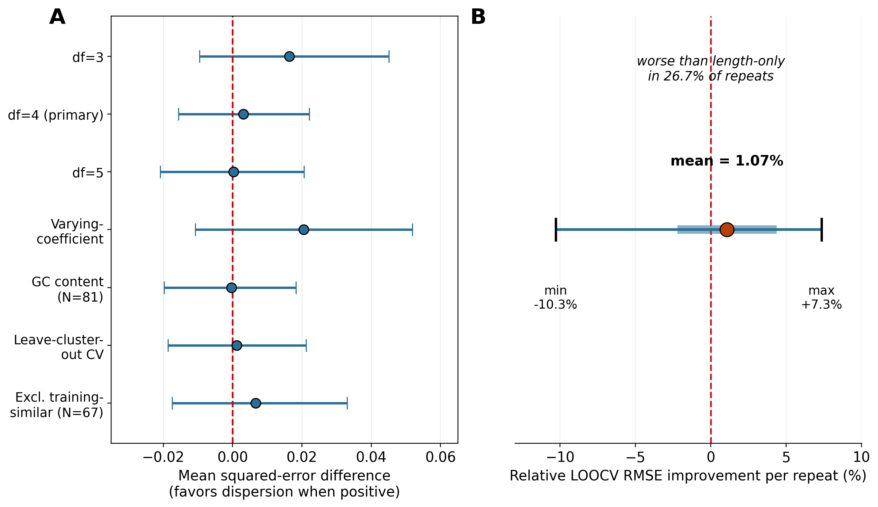
Figure 5. Robustness of the incremental-value result across model specification, resampling scheme, an independent difficulty covariate, and two audits for near-duplicate and training-overlap targets. (A) Point estimate and 95% bootstrap confidence interval for the squared-error difference attributable to dispersion, across seven checks: three length-spline flexibilities, a varying-coefficient sensitivity model, length paired with GC content in place of length alone, a leave-cluster-out cross-validation excluding near-duplicate targets from each other's training folds, and the primary analysis repeated after excluding targets at 80% identity or above to a specific RNAbpFlow training sequence. (B) Distribution summary (mean, ±1 SD band, and range) of the relative LOOCV RMSE improvement across 30 repeats of 5-fold cross-validation.

Practical triage
Cross-fitted triage showed no practical advantage from combining dispersion with length. AURC was 17.74 for length alone, 20.51 for dispersion alone, and 18.10 for the combined score. The bootstrap 95% CI for the paired AURC difference, defined as AURC(length-only) minus AURC(combined) so that positive values favor combining, was [-0.78, 0.14], spanning zero (Figure 6). Thus the raw dispersion-error relationship did not yield a clearly improved cross-fitted target-ranking result; the AURC difference remained imprecise. The selective-risk curves showed the same practical pattern: length-based ranking reduced mean error at least as quickly as dispersion-based ranking across most of the retention range. Because mean structural error can be dominated by a small number of very high-error targets — the cohort's longest target (787 nt) had the highest observed error (72.3 Å) — this ordering was checked under median and 10%-trimmed-mean risk in addition to the primary mean-risk AURC, using length-only and dispersion-only rankings exactly as before and a simplified rank-averaged combined score as a computationally lighter proxy for this sensitivity check specifically (not a replacement for the primary cross-fitted combined AURC reported above). Length-only ranking remained the best individual policy and dispersion-only the worst under all three risk functions (mean: 16.9 vs. 19.4; median: 16.6 vs. 17.0; trimmed mean: 16.8 vs. 18.3), and the same ordering held at fixed retention thresholds: mean error among the most-trusted 25%, 50%, and 75% of targets was lower for length-only than dispersion-only at every threshold (11.8 vs. 14.0 Å at 25% retained; 15.8 vs. 19.3 Å at 50%; 22.1 vs. 24.4 Å at 75%). The practical-triage conclusion is therefore not an artifact of the mean-risk objective or the single longest target. Target-level bootstrap intervals (2,000 resamples) support this directly for the comparison that bears on the paper's main question — length-only versus combined — which remained non-significant under both median (mean difference 0.01, 95% CI [-0.32, 0.31]) and trimmed-mean risk (mean difference -0.18, 95% CI [-0.50, 0.12]), consistent with the primary null conclusion. The separate comparison of length-only against dispersion-only was non-significant under median risk (95% CI [-1.16, 0.21]) but reached significance under trimmed-mean risk (mean difference -1.58, 95% CI [-3.39, -0.42]): dispersion alone was a reliably worse ranking than length alone once the influence of the single most extreme target was down-weighted, a finding about dispersion's standalone ranking quality rather than about whether adding dispersion to length provides incremental value, which remained unsupported throughout.
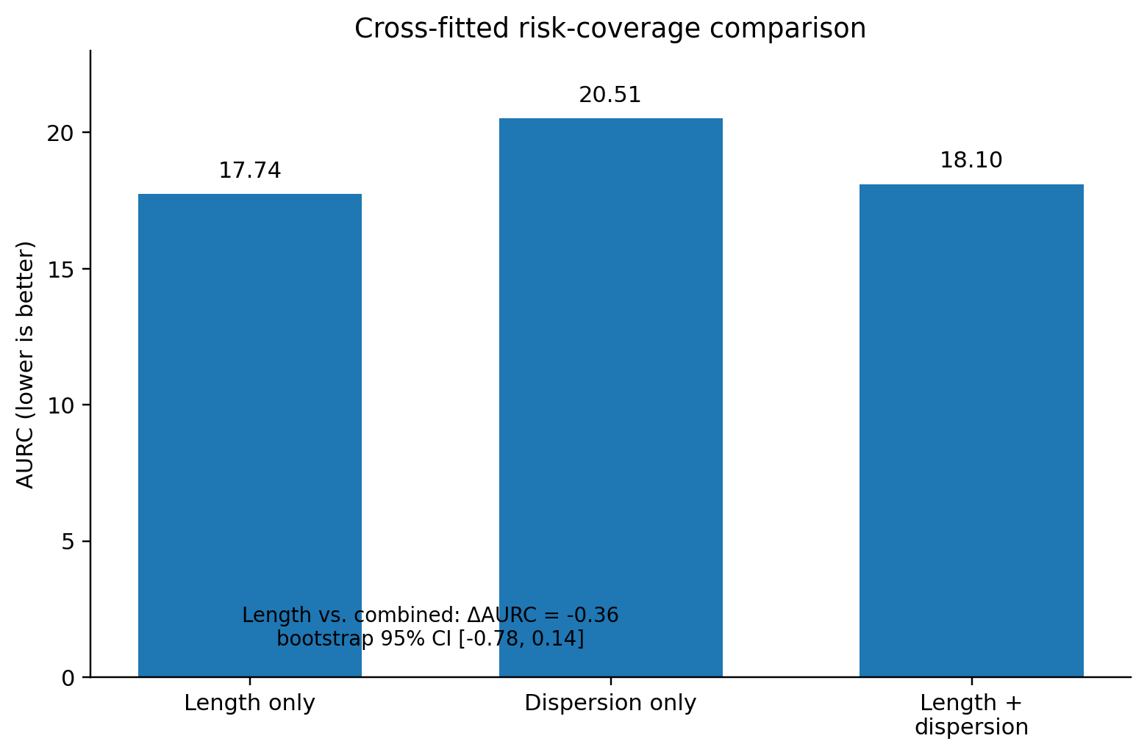
Figure 6. Cross-fitted risk-coverage comparison across the three ranking policies (length alone, dispersion alone, and combined).

Secondary conformal analysis
As a secondary interval-prediction analysis, distinct from the primary incremental-value question above, split-conformal calibration using the E/D nonconformity score yielded 89.1% pooled empirical coverage against a 90% nominal target (Figure 7B), but produced impractically wide intervals for short, low-dispersion targets: median interval width in the shorter stratum (408.9 Å) was roughly 14 times the largest error actually observed in that stratum (29.9 Å), because a small number of near-zero dispersion values inflated the calibrated quantile applied to every target in the stratum. We treated this score as unsuitable for practical deployment and evaluated a residual-based split-conformal alternative below; jackknife influence diagnostics, stratum bootstrap comparisons, and full outlier-removal detail are in Supplementary Note S4. A residual-based nonconformity score addressing this directly was therefore also evaluated, implemented as genuine split-conformal prediction with no double-dipping at any step: targets were repeatedly partitioned three ways (40% train, 30% calibrate, 30% test), the point-prediction model was fit on the training partition only, nonconformity scores (absolute log-error residuals) were computed on the held-out calibration partition using that fixed model, and coverage and width were evaluated on the further held-out test partition, averaged over 4,000 random three-way splits. This avoids dividing by dispersion entirely and, unlike a same-data model-fit-and-score design tested first and rejected as invalid (Methods), gave coverage closely matching the 90% nominal target for both a length-only and a length-plus-dispersion version (92.2% and 92.3% respectively, stable across split counts from 200 to 4,000). At matched coverage, the length-plus-dispersion intervals were nominally narrower than length-only: mean width 76.5 Å versus 79.9 Å (4.3% reduction), median width 45.7 Å versus 46.3 Å (1.3% reduction). This point estimate is not, by itself, evidence of a real effect: a target-level bootstrap that repeated the complete three-way procedure within each of 200 replicates gave a mean width difference of 2.5 Å with a 95% CI of [-64.5, 67.5] Å — roughly 25 times wider than the point estimate itself — and dispersion produced the narrower interval in only 55.5% of replicates, barely above chance. We therefore do not read the 4.3% and 1.3% reductions as evidence that dispersion improves interval efficiency; they are within the noise of which random three-way split happens to be drawn, consistent with, rather than an exception to, the primary analysis's null conclusion. This is the first result in this study that directly compares interval efficiency between the two models at matched coverage with an attached uncertainty estimate, rather than reporting point widths in isolation. Separately, the residual-based score substantially reduced the extreme interval widths caused by the E/D formulation: under the same three-way design, median interval width in the shorter stratum fell from 408.9 Å under the original E/D score to 45.7 Å pooled under the residual-based score — narrower than the original E/D-score intervals, though still broad relative to observed errors in the short-target stratum (2.9–29.9 Å), rather than the roughly 14-fold excess of the original score. We report both scores directly: the original E/D score's failure mode and the residual-based score's resolution of it, rather than presenting only the improved result.
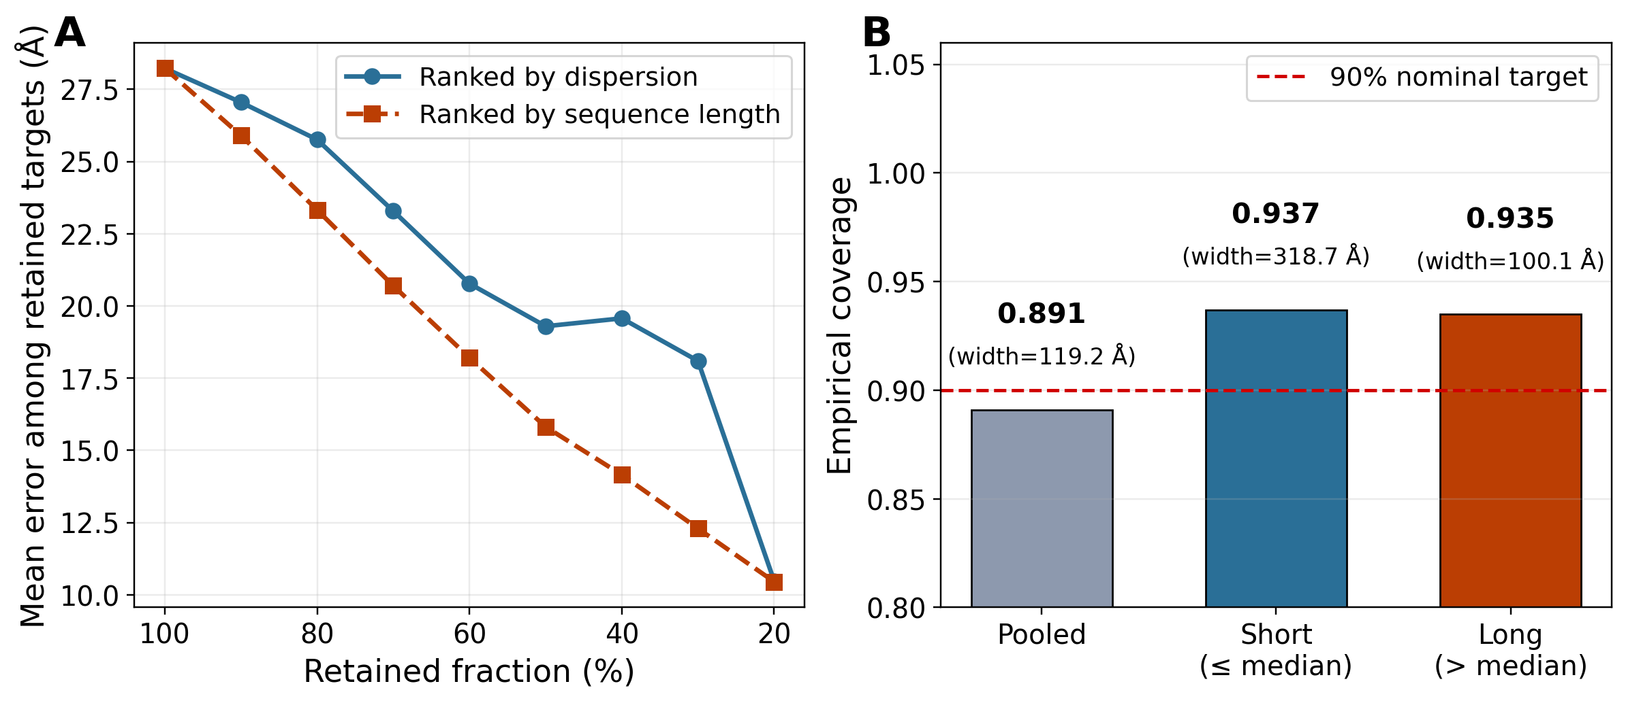
Figure 7. Practical target triage and length-stratified calibration. (A) Selective-risk curves for dispersion- and length-based ranking. (B) Split-conformal empirical coverage pooled and within two median-based length strata.

Discussion
The main result is specific rather than universal. MC-dropout dispersion is strongly associated with RNA structure prediction error in raw terms, yet the association does not provide demonstrable incremental information once sequence length is modeled nonlinearly and evaluated out of sample; the uncertainty intervals throughout remain wide enough that a meaningful benefit is not ruled out, only not established. An initial in-sample nested F-test tested a different inferential target than this out-of-sample question and is superseded by the paired out-of-fold comparison used for all final conclusions (Supplementary Table S1), reported here for methodological clarity rather than as evidence bearing on the biological conclusion. This absence of an incremental effect is supported by convergent evidence across model flexibility, resampling, interaction structure, and practical utility, but the study cannot exclude small effects outside its design; the findings should be read as a focused test of one uncertainty strategy, with scope conditions detailed in Limitations and Future Scope below.
These findings relate to, but are distinct from, the general MC-dropout critique of Djupskås et al., who report unreliable uncertainty estimates for MC-dropout on synthetic and Gaussian-process benchmarks. That critique concerns whether MC-dropout dispersion tracks true model uncertainty at all; this study's finding is better described as dispersion tracking something real — the raw association with error is strong and unambiguous — while its incremental value beyond the evaluated length-based baseline remained uncertain, rather than dispersion being an unreliable or spurious signal outright. Whether this reflects a genuine difference between the two studies' domains and architectures, or a difference in what "reliable" is being tested against, is not resolved by either study individually.
The broader practical implication is deliberately modest: an inexpensive internal ensemble-spread signal can correlate strongly with observed error without becoming a useful confidence measure after comparison with the evaluated length-based baseline. For RNA structure prediction, uncertainty claims should therefore distinguish association from incremental predictive value and should be evaluated against simple, freely available sequence-based covariates — not a comprehensive characterization of target difficulty — using the same out-of-sample criterion that motivates deployment.

Limitations and Future Scope
This study has several limitations that bound the generality of its conclusions. First, only a single backbone architecture (RNAbpFlow) was evaluated; whether the same result holds for other RNA structure predictors that support ensemble sampling is untested. Second, dispersion was estimated from 20 MC-dropout samples per target; a direct convergence check, generating 10 additional samples per target and using genuine without-replacement resampling from the resulting 30-sample pool, found the coefficient of variation of the dispersion estimate decreasing from 14.1% (n=5) to 8.4% (n=10) to 5.7% (n=15) to 3.9% (n=20) to 2.5% (n=25) across the cohort. This indicates the 20-sample estimate used throughout the primary analysis — reported here as a fixed operational sampling budget, not a claim that this count was sufficient for full convergence — had not fully converged, with a further, smaller improvement remaining available beyond it. Finite-sample variability of this magnitude likely reduces precision and may attenuate some associations, but its direction and magnitude after conditioning on length, and under the ranking-based AURC evaluation specifically, are not established here; we therefore do not claim the reported null result is conservative, only that residual Monte Carlo noise is a separate and substantially smaller source of uncertainty than the target-to-target variation already reflected in the primary analysis's confidence intervals. Third, the evaluation cohort was released after RNAbpFlow's documented training-data cutoff, but this release-date separation does not by itself establish freedom from sequence or structural homology to training examples. A within-cohort audit found that exact-sequence deduplication alone understated redundancy: 48.1% of the 81 audited targets belonged to a cluster of one or more other targets at 80% identity or above. A leave-cluster-out cross-validation gave a mean squared-error difference of 0.0012 (95% CI [-0.0186, 0.0212]), closer to zero than the primary estimate; this is a sensitivity analysis for near-duplicate sequences at one pragmatic threshold, not a full resolution of homology dependence, since connected-component clustering can chain together targets with only indirect similarity, and structurally related RNAs can fall below any fixed sequence-identity cutoff. At a 60% identity threshold specifically, clustering merged most targets into a small number of large clusters (largest: 27 targets), leaving too little effective training data per fold for a meaningful sensitivity analysis; full threshold detail is in Supplementary Note S4. A second audit compared all 81 targets against RNAbpFlow's actual training sequences and found 15 targets at 80% global identity or above, plus 6 further targets with substantial fragment-level local identity not captured by the global score (Results, Training-similarity sensitivity); full per-target alignment detail is in Supplementary Note S3. A direct comparison of structure length found the 69 structures removed during deduplication were substantially longer (mean 627.6 nt) than the 82 retained structures (mean 221.0 nt; Mann-Whitney p<0.0001), consistent with a small number of large, frequently redetermined RNA structures contributing disproportionately to near-identical repeated depositions; this comparison could not be extended to the 45 structures excluded for being available only in mmCIF format, so the selection process is only partially characterized. The retained cohort's length distribution is accordingly skewed toward shorter targets relative to the broader candidate pool, though the observed range (12 to 787 nucleotides) remains wide. Fourth, sequence length was the primary difficulty covariate tested; adding GC content as an independent, freely available sequence-composition covariate did not change the conclusion (Robustness analyses), but direct topological structural-complexity measures such as base-pair count, helix count, or junction count were not included, so the present conclusion remains bounded to incremental information beyond sequence length and composition rather than beyond structural difficulty in general. Fifth, MC-dropout dispersion is evaluated here on its own empirical merits and is not shown to approximate formal between-instance parameter uncertainty, since independently retrained RNAbpFlow instances could not be generated from the released training code. Sixth, the primary inference relies on leave-one-out cross-validated residuals, which are not mutually independent by construction; the bootstrap and permutation procedures applied to these residuals may not carry the exact nominal interpretation that fully independent data would provide. We explored two alternative resampling designs to address this directly, both fully detailed in Supplementary Note S2: a repeated-cross-validation significance test, found to be invalid for this purpose (its apparent significance was an artifact of the analyst-chosen repeat count rather than genuine sample size); and a hierarchical out-of-bootstrap validation that refits the length-only and length-plus-dispersion models within each bootstrap replicate, evaluating each replicate on held-out targets never used for that replicate's fitting. Unlike the first attempt, this design's estimate and interval were confirmed stable across bootstrap counts before being trusted, and gave a substantially wider but still zero-including interval for the relative improvement (mean 0.15%, 95% CI [-23.9%, 11.3%] at 2,000+ resamples), consistent with the primary conclusion once model-refitting uncertainty is propagated alongside target-sampling uncertainty. Neither alternative fully resolves the underlying dependency concern; we treat the primary LOOCV-based p-value and confidence interval as descriptive summaries of predictive stability under this study's cross-validation design, not as a fully calibrated hypothesis test.
These limitations motivate several directions for future work. Extending the same paired out-of-sample evaluation framework to additional RNA structure predictors would test whether the absence of incremental value is specific to RNAbpFlow or reflects a more general property of ensemble-spread uncertainty signals in this domain. Incorporating a direct, prespecified structural-complexity covariate alongside sequence length would test whether the present conclusion, currently bounded to length, extends to target difficulty more broadly. Should the released training code be clarified or corrected by the original authors, repeating this evaluation with genuinely independently retrained model instances would allow a test of whether MC-dropout dispersion approximates formal parameter uncertainty rather than only within-model sampling variability. Finally, applying the same baseline-adjusted, out-of-sample evaluation standard used here to other inference-time uncertainty methods, such as deep ensembles or evidential regression heads, would clarify whether the difficulty demonstrated here for MC-dropout is a property of the specific technique or a more general challenge for cheap uncertainty signals in RNA structure prediction.

Conclusion
In an 82-target, post-training-cutoff RNAbpFlow evaluation cohort, MC-dropout dispersion was strongly associated with structural error in raw terms, but did not show a stable incremental improvement over a nonlinear sequence-length baseline, or over length paired with GC content, across the evaluated cross-validation and triage analyses. Estimated incremental effects increased in subsets excluding targets with stronger global or local similarity to training sequences, but these subsets were smaller and their intervals were wider; this pattern is compatible with novelty-dependent utility but does not distinguish that explanation from sampling variation or cohort-composition changes. These findings motivate broader, homology-aware evaluation against richer pre-inference difficulty baselines, rather than a general claim that MC-dropout uncertainty is uninformative for RNA structure prediction.

Data and Code Availability
All data curation, featurization, inference, and analysis code, together with documentation of required modifications to the backbone model's released training and inference code, are available at [repository URL].

References
1. Tarafder, S. & Bhattacharya, D. RNAbpFlow: base pair-augmented SE(3) flow matching for conditional RNA 3D structure generation. Nat. Methods (2026).
2. Angelopoulos, A. N. & Bates, S. Conformal prediction: a gentle introduction. Found. Trends Mach. Learn. 16, 494–591 (2023).
3. Vovk, V., Gammerman, A. & Shafer, G. Algorithmic Learning in a Random World (Springer, 2005).
4. Berman, H. M. et al. The Protein Data Bank. Nucleic Acids Res. 28, 235–242 (2000).
5. Harrell, F. E. Regression Modeling Strategies, 2nd ed. (Springer, 2015).
6. Efron, B. & Tibshirani, R. J. An Introduction to the Bootstrap (Chapman and Hall/CRC, 1994).
7. Abramson, J. et al. Accurate structure prediction of biomolecular interactions with AlphaFold 3. Nature 630, 493–500 (2024).
8. Shen, T. et al. Accurate RNA 3D structure prediction using a language model-based deep learning approach. Nat. Methods 21, 2287–2298 (2024).
9. Wang, W., Feng, C., Han, R., Wang, Z., Ye, L., Du, Z., Wei, H., Zhang, F., Peng, Z. & Yang, J. trRosettaRNA: automated prediction of RNA 3D structure with a transformer network. Nat. Commun. 14, 7266 (2023).
10. Baek, M. et al. Accurate prediction of protein–nucleic acid complexes using RoseTTAFoldNA. Nat. Methods 21, 117–121 (2024).
11. Bahai, A., Kwoh, C. K., Mu, Y. & Li, Y. Systematic benchmarking of deep-learning methods for tertiary RNA structure prediction. PLoS Comput. Biol. 20, e1012715 (2024).
12. Gal, Y. & Ghahramani, Z. Dropout as a Bayesian approximation: representing model uncertainty in deep learning. Proc. 33rd Int. Conf. Mach. Learn. (PMLR) 48, 1050–1059 (2016).
13. Djupskås, A., Stasik, A. J. & Riemer-Sørensen, S. Unreliable uncertainty estimates with Monte Carlo dropout. Preprint at arXiv:2512.14851 (2025).
14. Geifman, Y. & El-Yaniv, R. Selective classification for deep neural networks. Adv. Neural Inf. Process. Syst. 30, 4878–4887 (2017).
15. Vashurin, R., Goloburda, M., Nakov, P. & Panov, M. UNCERTAINTY-LINE: length-invariant estimation of uncertainty for large language models. Proc. 2025 Conf. Empirical Methods in Natural Language Processing (EMNLP), 7881–7908 (2025).
16. Vander Meersche, Y. et al. Flexibility or uncertainty? A critical assessment of AlphaFold 2 pLDDT. Structure (2025).
17. Shihab, I. F., Akter, S. & Sharma, A. CalPro: prior-aware evidential–conformal prediction with structure-aware guarantees for protein structures. Preprint at arXiv:2601.07201 (2026).
18. Li, Z. et al. DynaRNA: accurate dynamic RNA conformation ensemble generation with diffusion model. Commun. Biol. 8, 1472 (2025).
19. Liu, X., Wang, W., Du, Z., Wang, Z., Peng, Z. & Yang, J. Quality assessment of RNA 3D structure models using deep learning and intermediate 2D maps. Commun. Biol. 9, 293 (2026). https://doi.org/10.1038/s42003-026-09582-2
20. Bernard, C., Postic, G., Ghannay, S. et al. RNAdvisor 2: A unified platform for RNA 3D model quality assessment using metrics, scoring functions, and meta-metrics. Sci. Rep. 15, 41487 (2025). https://doi.org/10.1038/s41598-025-23326-y
21. Si, Y., Zhang, S. & Chen, L. NUMonomer enables accurate and scalable nucleic acid structure prediction from primary sequence alone. bioRxiv (2026). https://doi.org/10.64898/2026.07.20.739453
22. Westhof, E., Sun, H., Bu, F. & Miao, Z. The RNA-Puzzles Assessments of RNA-Only Targets in CASP16. Proteins 94, 218–229 (2026). https://doi.org/10.1002/prot.70052

