Title Page

Title

Topology-Aware Calibration Reveals Target-Specific Ensemble Variation in Generative RNA Structure Prediction

Author information
- Pijush Kanti Dutta Pramanik
Center for Precision Health
McWilliams School of Biomedical Informatics
The University of Texas Health Science Center at Houston
Houston, Texas, USA
Email: pijush.k.duttapramanik@uth.tmc.edu
ORCID: 0000-0001-9438-9309

- Zhongming Zhao (Corresponding author)
Center for Precision Health
McWilliams School of Biomedical Informatics
The University of Texas Health Science Center at Houston
Houston, Texas, United States
Email: zhongming.zhao@uth.tmc.edu
ORCID: 0000-0002-3477-0914

Topology-Aware Calibration Reveals Target-Specific Ensemble Variation in Generative RNA Structure Prediction

Abstract
Generative RNA structure-prediction models produce a distribution of samples per target, not a single best-guess conformation. Whether this diversity reflects real conformational variation or other model-dependent variability remains largely untested. We evaluated RNAbpFlow against a leakage-audited cohort of 14 RNA systems with characterized structural alternatives. Candidates were screened for training-set exposure and apo structures resembling their bound-state counterparts. For each of 9 analyzable targets, inter-helix distance and angle collective coordinates were compared against a topology-preserving, target-specific perturbation baseline. Across these nine targets, six showed identical angle- and distance-clearing rates. The target-level mean difference was 0.036, the median was 0, and a bootstrap 95% interval spanned zero ($\left[-0.05,0.15\right]$). The small residual effect reversed sign after excluding the adenine riboswitch, showing sensitivity to individual targets. Two targets, 8F4O and 5E54, with independently characterized transitions, showed pronounced coordinate-class differences and are examined as case studies. Whether this reflects genuine conformational information or another target-specific source of variation could not be resolved by comparison against published transition magnitudes, available for only 3 targets. The present analysis did not test whether generated samples followed the experimentally observed displacement directions. A perturbation procedure preserving pseudoknot topology extended baseline calibration to most pseudoknotted targets but not to one with dense crossing base pairs. RNAbpFlow showed no stable cohort-wide preference for distance- or angle-based variation relative to this baseline, even where individual targets showed strong apparent variation. Whether this reflects genuine conformational sampling or only a narrower property of the selected coordinates was not tested here.
Keywords: RNA structure prediction; generative models; conformational ensembles; riboswitch; pseudoknot; training-data leakage; perturbation baseline

1. Introduction
RNA molecules perform diverse regulatory and catalytic roles that depend directly on their three-dimensional structure. Experimentally determined RNA structures remain far scarcer than protein structures, which motivates computational prediction and modeling [1]. RNA can form and interconvert between multiple secondary and tertiary structures. This ability, characterized experimentally by solution NMR, cryo-electron microscopy, chemical probing, and single-molecule methods, is increasingly understood through the framework of conformational energy landscapes; a single static structure no longer captures it [2], [3], [4]. Riboswitches illustrate this directly. They regulate gene expression by folding into one of two mutually exclusive conformations, depending on whether a small-molecule ligand is bound. The unbound (apo) and ligand-bound (holo) forms differ structurally in ways specific to each riboswitch class. In the absence of ligand, the adenine riboswitch’s three-way junction disorders and its P1 helix partially melt. The TPP riboswitch’s sensory domains splay apart into an extended, Y-shaped conformation. The glutamine riboswitch inverts from a closed “tuning fork” to an open “L-shape” on binding. These ligand-dependent structural changes are the regulatory mechanism itself. Riboswitches are under active investigation as antibacterial drug targets because they are common in pathogenic bacteria but absent from animals. Their populated conformational states accordingly bear directly on structure-based targeting.
Deep learning has separately transformed RNA three-dimensional structure prediction. Sequence-based methods, including RhoFold+ [5], trRosettaRNA [6], DRfold [7], NuFold [8], RoseTTAFoldNA [9], AlphaFold3-class [10] predictors, and Boltz-family [11] predictors, now predict tertiary structure directly from sequence. Generative approaches such as RNAbpFlow, the backbone evaluated here, and DynaRNA [12] instead produce full conformational ensembles; no single point estimate is returned. A recent extension, trRosettaRNA2, explicitly predicts conformers instead of one structure [23]. This reflects a broader shift: conformational alternatives are treated as an explicit modeling target, no longer merely a byproduct of stochastic inference. RNAbpFlow itself generates all-atom RNA structural ensembles from sequence and base-pair information alone, without multiple-sequence alignments or structural templates [16].
Systematic benchmarking through the RNA-Puzzles community experiment and CASP assessment rounds, external to the present study, shows that no single method dominates across all RNA targets. Prediction quality remains strongly target-dependent, shaped by target size, structural novelty, and difficult tertiary interactions including pseudoknots [13], [14]. CASP16’s dedicated nucleic-acid assessment, covering 42 targets, found 3D accuracy strongly dependent on the availability of a closely related structural template. No blind prediction of a previously unseen natural RNA fold reached a TM-score above 0.8 [26]. A recent independent benchmark of 10 deep-learning RNA structure-prediction methods extended this observation directly to training-set dependence. Overall accuracy declined sharply with structural divergence from training data, and fewer than one-third of predictions met stringent multi-metric success criteria across all methods tested [15]. If point-estimate accuracy depends this heavily on training-set similarity, ensemble diversity for a given target could plausibly track the same thing. Apparent agreement between a generated ensemble and known conformational variation may then reflect memorization instead of generalization. Such agreement cannot be interpreted as evidence of generalization without first establishing that the evaluated target was not exposed during training, directly or through a closely related sequence.
Prior work on ensemble- and confidence-derived signals from structure predictors has focused primarily on prediction accuracy or error estimation. Correspondence with independently determined RNA conformational states has received far less attention. Per-residue confidence measures such as pLDDT correlate with structural flexibility but remain imperfectly calibrated under distribution shift. Reference-free, ensemble-aware scoring methods such as RNAtive [24] and PARSEbp [25], the latter from the same group as RNAbpFlow, use structural agreement within a predicted ensemble to rank or select individual models relative to one another. These methods address which model within an ensemble is most reliable. Whether ensemble variation itself corresponds to experimentally characterized conformational alternatives is a separate question. Whether the direction of variation within a generative RNA ensemble reflects experimentally observed conformational alternatives remains unresolved. Answering this requires structural ground truth in place of a difficulty covariate, and it is a different question from whether ensemble spread predicts a model’s own point-estimate error. Table 1 situates this question relative to the closest prior work across RNA ensemble generation, confidence estimation, and baseline-aware evaluation.
Table 1. Comparison with the closest related work.
Study | Domain | Signal evaluated | Baseline used | Evaluation focus
Shen et al. [5]; Wang et al. [6] | RNA structure prediction | Model-reported confidence (pLDDT, eRMSD) | None | Confidence–accuracy association
Bu et al. [13]; Bernard et al. [14] | RNA structure prediction | Cross-method accuracy | None | Target-dependent prediction difficulty
Ludaic and Elofsson [15] | RNA structure prediction | Cross-method accuracy | Structural divergence from training data | Training-set dependence of accuracy
Pielesiak et al. [24]; Tarafder and Bhattacharya [25] | RNA structure prediction (ensemble scoring) | Within-ensemble structural agreement | None | Reference-free ranking of models within one ensemble
This study | RNA structure prediction (RNAbpFlow) | Ensemble diversity direction | Topology-preserving perturbation baseline, leakage-audited cohort | Correspondence with real conformational states, target- and coordinate-level
Several riboswitch classes have deposited apo structures that closely resemble their own holo counterparts. Crystallization conditions, not the unbound RNA’s own behavior in solution, are responsible, and the true unbound ensemble for these classes remains uncharacterized. This pattern is documented only for specific classes; no general claim is made about apo RNA structures as a whole [18]. The cohort was accordingly screened for crystallization-associated holo-like apo structures, in addition to sequence-level training exposure. Pseudoknots present a related but distinct problem for any null model built via local structural perturbation. Pseudoknots are defined by cross-serial base-pair interactions that impose coupled constraints on the RNA backbone, and the conventional nested dot-bracket representation used for most RNA secondary structures cannot encode such crossing interactions without ambiguity or loss of information [19]. A perturbation procedure that collapses those crossing interactions into ordinary nested pairs, or moves tightly coupled pseudoknot stems independently of one another, does not represent a valid local structural alternative for that topology.
We tested whether RNAbpFlow ensemble diversity showed a consistent preference for angle- over distance-based variation, or the reverse. This diversity was computed from a set of collective structural coordinates and compared against a topology-preserving, target-specific perturbation baseline, across a leakage-audited cohort of RNA targets. A real apo-to-holo transition may involve changes in distance, angle, or both, so this analysis tests coordinate-class preference; it does not test direct recovery of an experimental transition. We report complementary analyses at the coordinate, target, and experimentally benchmarked transition scales. These analyses address distinct questions, and together they reveal substantial target-level heterogeneity instead of a single cohort-wide pattern.

2. Methods

2.1 RNA target cohort
Candidate systems were identified from RNA targets with deposited unbound, bound, or alternative structural states in the Protein Data Bank. Each candidate was screened against RNAbpFlow’s training corpus (RNA3DB, release 2024-04-26; 1,204 training chains, 516 test chains) under four criteria: exact-deposition exposure of the candidate structure itself; sequence-level exposure of the candidate’s sequence embedded within any longer training-set chain; family-level overrepresentation within the training corpus; and homologous-structure exposure logged against the test-set split. For targets with more than one deposited structure of the same or overlapping sequence, the representative structure used was the one absent from the training corpus. Apo references were cross-checked against the primary literature for evidence that the deposited unbound structure resembles its bound-state counterpart due to crystallization conditions rather than a genuinely distinct unbound conformation. Apo structures meeting this criterion were excluded. The directional-analysis subset (§2.5) was further restricted to targets with a leakage-clean unbound reference and a corresponding bound or alternative-state reference compatible with the single-chain RNA input regime. Some primary-cohort targets lack a deposited unbound structure; these are retained for leakage accounting but not for directional analysis (Table 2).
The resulting primary cohort comprises 14 targets spanning nine riboswitch ligand classes (adenine, preQ1, fluoride, thiamine pyrophosphate, glutamine, tetrahydrofolate, cyclic-di-GMP, ZTP/ZMP, cobalamin) and two non-riboswitch regulatory elements (HIV-1 TAR; hepatitis C virus internal ribosome entry site domain IIa). Three targets have a leakage-clean bound-state structure with no leakage-clean unbound counterpart usable under this cohort’s single-sequence, no-partner conditioning. These were retained for cohort-level leakage accounting but not for the collective-coordinate directional analysis. A secondary cohort of three further targets has real experimental support for conformational variation but does not meet this input regime. An iron-responsive element’s bound conformation requires iron regulatory protein. The HIV-1 dimerization initiation site’s alternative conformations are a difference in molecular stoichiometry, distinct from one molecule adopting two shapes. A fluorogenic RNA aptamer was solved with an antibody fragment accounting for most of its crystal lattice contacts.

2.2 Structure generation
All-atom conformational ensembles were generated with RNAbpFlow from sequence and externally predicted base-pair conditioning; collective coordinates (§2.3) were subsequently computed from C1′-defined stem midpoints and principal axes only, not from the full atomic detail of each generated structure. For nested topologies, conditioning was derived from a three-predictor consensus (MXfold2, SimFold, CONTRAfold); pseudoknotted targets were conditioned using IPknot’s complete prediction in place of the consensus.
Sample count per target ($K$) was selected by a prespecified covariance-stability criterion. Let $Σ_{K}^{\left(b\right)}$ denote the collective-coordinate covariance matrix computed from bootstrap replicate $b$ using $K$ generative samples, drawn with replacement from the full ensemble at that $K$, over $B=10,000$ replicates. Define
$\text{CV}\left(K\right)=\frac{{SD}_{b}​\left[{∥Σ_{K}^{\left(b\right)}∥}_{F}\right]}{{Mean}_{b}​\left[{∥Σ_{K}^{\left(b\right)}∥}_{F}\right]}$ (1)
where $∥⋅∥_{F}$ is the Frobenius norm. Writing $K$ for the prespecified grid of tested sample counts and $K^{+}=min\{K'∈K:K'>K\}$ for the next larger tested value above $K$, the production sample count was
$K^{*}=min\left\{ K:\text{CV}\left(K\right)<0.10 \text{and} \text{CV}\left(K^{+}\right)<0.10 \right\}$ (2)
the smallest tested sample count for which the coefficient of variation fell below 10% and the next larger tested sample count also satisfied that condition. One target’s secondary structure, a single hairpin stem with no junction, admits no inter-helix collective coordinate and was excluded from convergence assessment on that basis.

2.3 Collective coordinates
For each target, inter-helix distance and relative-orientation (angle) coordinates were defined between every pair of stems related by a nested or crossing base-pairing interaction, using each stem’s midpoint and principal axis computed from C1′ atom coordinates. A stem was defined as a run of at least two consecutive canonical Watson–Crick or wobble base pairs; noncanonical pairs were not used to extend a stem boundary. Bulges and internal loops interrupt a stem into separate stems on either side, each defined and coordinated independently; the collective-coordinate vector accordingly reflects the helical segments directly, not the loop or bulge sequence between them.
For stem $s$ in target $t$, generative sample $k$, with residues $r=1,…,n_{s}$:
$m_{s,t}^{\left(k\right)}=\frac{1}{n_{s}}\sum_{r=1}^{n_{s}}{x_{r,s,t}^{\left(k\right)}}$ (3)
where $x_{r,s,t}^{\left(k\right)}$ is the C1′ coordinate of residue $r$ in stem $s$, for sample $k$, and $n_{s}$ is the number of residues used to define that stem. Writing $C_{s,t}^{\left(k\right)}$ for the stem-coordinate covariance matrix,
$C_{s,t}^{\left(k\right)}=\frac{1}{n_{s}}\sum_{r=1}^{n_{s}}{\left(x_{r,s,t}^{\left(k\right)}-m_{s,t}^{\left(k\right)}\right)}{\left(x_{r,s,t}^{\left(k\right)}-m_{s,t}^{\left(k\right)}\right)}^{⊤}$ (4)
the stem’s principal axis $v_{s,t}^{\left(k\right)}$ is the unit eigenvector of $C_{s,t}^{\left(k\right)}$ associated with its largest eigenvalue. For each matched stem pair $\left(s_{1},s_{2}\right)$, the distance coordinate is
$d_{\left(s_{1},s_{2}\right),t}^{\left(k\right)}={∥m_{s_{1},t}^{\left(k\right)}-m_{s_{2},t}^{\left(k\right)}∥}_{2}$ (5)
and the angle coordinate is
$θ_{\left(s_{1},s_{2}\right),t}^{\left(k\right)}=arccos​\left(\text{clip}​\left(\left|v_{s_{1},t}^{\left(k\right)}⋅v_{s_{2},t}^{\left(k\right)}\right|,-1,1\right)\right)$ (6)
Taking the absolute value of the dot product sign-normalizes the two principal axes before the angle is computed. This step is needed because $v$ and $-v$ represent the same physically undirected helix axis and would otherwise yield different angles for the same geometry. The angle is accordingly restricted to $\left[0,π/2\right]$. The clip operation separately prevents numerical errors when a floating-point dot product falls slightly outside $\left[-1,1\right]$. Each stem pair contributes exactly one distance value and one angle value, matched by construction to the same underlying helix-pair relationship. This pairing is what makes the two coordinate classes comparable as matched observations in §2.5. A target’s collective-coordinate vector is the concatenation of these pairwise distance and angle values across its own generative ensemble.

2.4 Perturbation-baseline calibration
A target-specific perturbation baseline was established by local perturbation of the base-pair map. Each stem’s outer and inner boundary was independently shifted by $δ∈\{-1,0,+1\}$ positions among the base pairs already present in that target’s predicted map (§2.2), giving up to nine boundary-shift combinations per stem. Every shift preserved the bracket type (nested or pseudoknot) of every retained base pair. Because shifts only reassign which already-predicted base pairs are included at each boundary, no base pair absent from the original prediction was ever introduced. Base pairs excluded by a shift were deleted, and retained base pairs kept their original nucleotide identities and pairing relationships. A perturbation was rejected if any shift reduced a stem below two base pairs, reversed a stem’s order, caused two stems to overlap, or reused a nucleotide position already assigned to another stem. Each accepted perturbed base-pair map was converted into a collective-coordinate vector via direct geometric reconstruction from the map. This used the same stem-midpoint and principal-axis definitions as for generative samples (§2.3); no new structure was generated with RNAbpFlow. The resulting vector was retained only if its dimensionality matched the unperturbed vector. 300 perturbations were attempted per target. A target’s perturbation baseline was estimated from its accepted perturbations when at least 10 were retained (validation and per-target counts in §3.2). One target’s topology, six crossing base pairs within a 61-nucleotide sequence, admits no perturbation satisfying this criterion under the present procedure. Its perturbation baseline is not estimable. It was excluded from the directional analysis while retained for convergence and cohort-composition reporting.
For target $t$ and collective-coordinate dimension $j$, let $c_{t,j}^{\left(k\right)}$ denote the coordinate value in RNAbpFlow sample $k=1,…,K_{t}$. Let ${\tilde{c}}_{t,j}^{\left(b\right)}$ denote the corresponding value for accepted perturbation $b=1,…,B_{t}$. The ensemble and perturbation variances are
${Var}_{k}​\left[c_{t,j}\right]=\frac{1}{K_{t}-1}\sum_{k=1}^{K_{t}}{{\left(c_{t,j}^{\left(k\right)}-{\overset{‾}{c}}_{t,j}\right)}^{2}}$ (7)
${Var}_{b}​\left[{\tilde{c}}_{t,j}\right]=\frac{1}{B_{t}-1}\sum_{b=1}^{B_{t}}{{\left({\tilde{c}}_{t,j}^{\left(b\right)}-{\overset{‾}{\tilde{c}}}_{t,j}\right)}^{2}}$ (8)
The signal-to-baseline ratio and binary clearing indicator are
$R_{t,j}=\frac{{Var}_{k}\left[c_{t,j}\right]}{{Var}_{b}\left[{\tilde{c}}_{t,j}\right]+ε}, Y_{t,j}=1​\left(R_{t,j}>1\right)$ (9)
Here $ε$ is a small numerical constant included only to prevent undefined division when the perturbation variance is zero. No target with an estimable perturbation baseline had zero perturbation variance in this cohort, so $ε$ played no role in any reported result. The primary clearing threshold of $R_{t,j}>1$ tests whether observed ensemble variance exceeds the variance induced by valid local perturbations of the same topology. Thresholds from 0.5 to 5.0 were prespecified as a sensitivity analysis (Appendix A1).

2.5 Statistical analysis
The primary analysis is target-level. For target $t$ with an estimable perturbation baseline and matched stem-pair set $P_{t}$,
pt,distance=1Pts1,s2∈Pt​Yt,s1,s2,distance, pt,angle=1Pts1,s2∈Pt​Yt,s1,s2,angle (10)
where $\left|P_{t}\right|$ is the number of matched stem-pair coordinate pairs for target $t$. Because $p_{t,\text{distance}}$ and $p_{t,\text{angle}}$ are each an average of $\left|P_{t}\right|$ binary indicators, a target with $\left|P_{t}\right|=1$ can only take the value 0 or 1 on each proportion. Three targets in this cohort (2MIY, 2L1V, 8THV) have $\left|P_{t}\right|=1$; this coarser resolution is addressed directly in §3.3. Each target’s contribution to the cohort-wide estimate is
$Δ_{t}=p_{t,\text{angle}}-p_{t,\text{distance}}, \overset{‾}{Δ}=\frac{1}{N}\sum_{t=1}^{N}{Δ_{t}}$ (11)
where $N$ is the number of fully analyzable targets. The distribution of $Δ_{t}$ across targets was summarized by its mean and median. A 95% confidence interval was obtained by bootstrap resampling of targets with replacement ($10,000$ resamples, percentile method), together with an exact sign test on non-zero values and leave-one-target-out sensitivity. A further sensitivity analysis excluding the three single-pair targets, and a pair-count-weighted mean $Δ$ reported as a descriptive contrast only, are given alongside the primary result in §3.3. Bootstrap resampling for $K$-convergence (§2.2) used the same $10,000$-replicate, with-replacement, percentile convention. Bootstrap procedures were implemented using a documented analysis environment. The complete analysis code, including pseudorandom-number-generator settings, will be released with the manuscript. A secondary, pooled-dimension analysis treats each collective-coordinate dimension across the cohort as a single matched distance/angle pair (McNemar’s exact test), with Wilson 95% confidence intervals for the two pooled proportions. Model signal magnitude was compared against published transition magnitude (all-atom RMSD between independently deposited apo and holo structures) [17] for the subset of targets with a directly comparable, same-methodology published value. All statistical tests were computed in Python (scipy 1.x, statsmodels 0.14).

3. Results

3.1 Leakage-audited cohort construction
Leakage and evidence-tier adjudication yielded 14 eligible primary targets (Fig. 1, Table 2): 5E54 (adenine), 2L1V/2MIY/3Q50/4RZD (preQ1), 5KH8 (fluoride), 8F4O (thiamine pyrophosphate), 5DDO (glutamine), 7KD1 (tetrahydrofolate), 3IRW (cyclic-di-GMP), 8FW4 (cobalamin), 6OD9 (ZTP/ZMP), 8THV (HIV-1 TAR), and 1P5M (HCV IRES domain IIa). Of these, three (3IRW, 8FW4, 6OD9) have a leakage-clean bound-state structure but no leakage-clean unbound counterpart usable under this study’s single-sequence, no-partner input regime. One further target (3Q50) has no inter-helix collective coordinate. A fifth (5DDO) has no estimable perturbation baseline (§3.2). Nine targets are fully analyzable.
A separate, three-target secondary cohort — an iron-responsive element, the HIV-1 dimerization initiation site, and a Fab-chaperoned fluorogenic aptamer — has real experimental support for conformational variation. The secondary cohort was defined separately from the primary cohort because its systems did not satisfy the single-chain RNA input with sequence-derived base-pair conditioning and no protein, ligand, or partner-RNA context used here (§2.1). These systems were retained as context-limited comparators but were not included in the primary or secondary analyses because their experimental state transitions require unmodeled protein, multimeric, or crystallization-partner contexts.
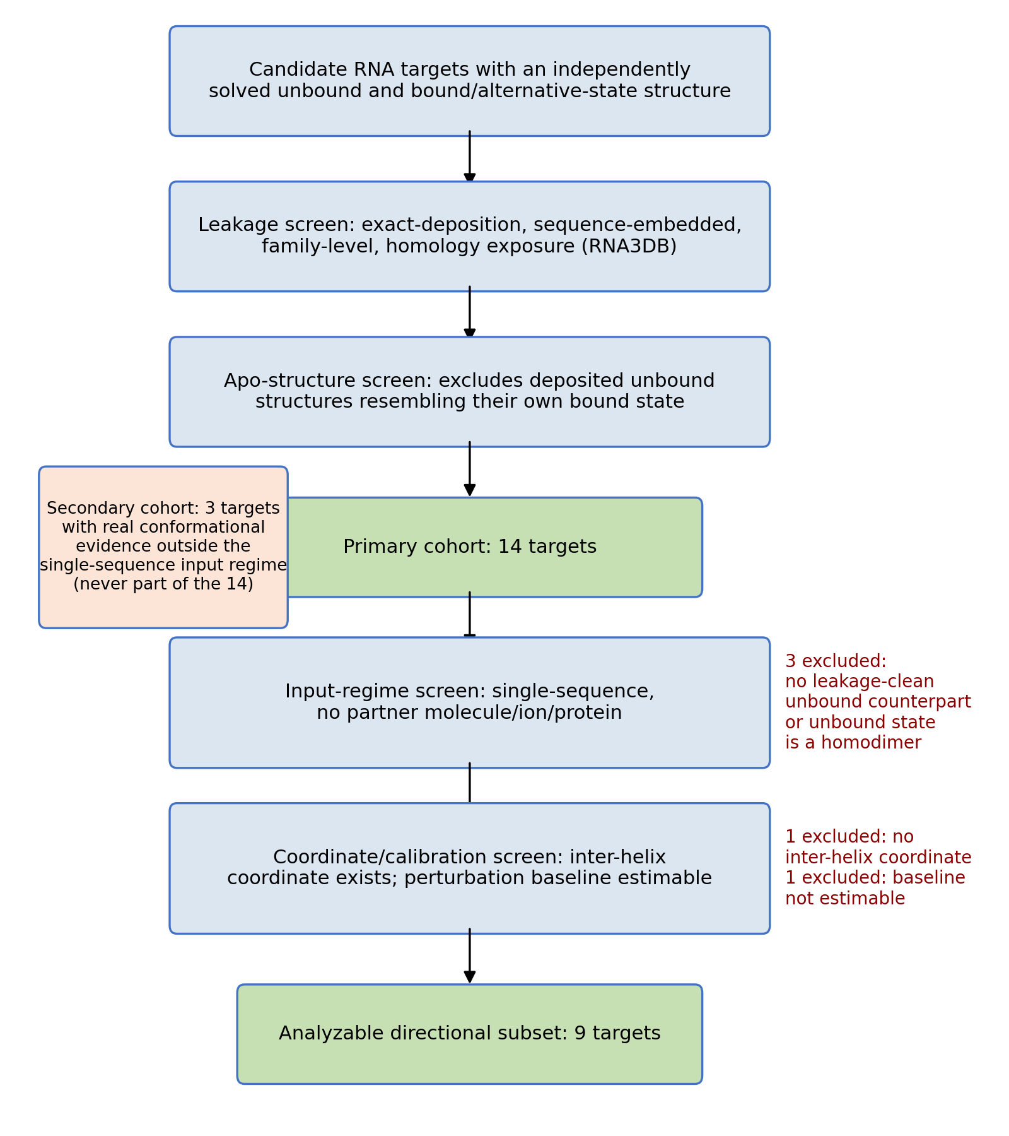
Fig. 1. Cohort construction, from candidate identification through the 9-target analyzable subset, with exclusion counts and reasons at each screening stage. The secondary cohort (orange) was defined separately because its systems did not satisfy the single-chain RNA input with sequence-derived base-pair conditioning and no protein, ligand, or partner-RNA context used here.
Table 2. Primary cohort composition and contribution status.
Target (PDB ID) | Riboswitch class / element | Contributes to directional analysis? | Reason if not
5E54 | Adenine | Yes | —
2L1V | preQ1 | Yes | —
2MIY | preQ1 | Yes | —
3Q50 | preQ1 | No | No inter-helix collective coordinate
4RZD | preQ1 | Yes | —
5KH8 | Fluoride | Yes | —
8F4O | Thiamine pyrophosphate | Yes | —
5DDO | Glutamine | No | No estimable perturbation baseline
7KD1 | Tetrahydrofolate | Yes | —
3IRW | Cyclic-di-GMP | No | No leakage-clean unbound counterpart
8FW4 | Cobalamin | No | Unbound structure is a homodimer
6OD9 | ZTP/ZMP | No | No leakage-clean unbound counterpart
8THV | HIV-1 TAR | Yes | —
1P5M | HCV IRES domain IIa | Yes | —

3.2 Ensemble convergence and topology-valid calibration
Production sample count ($K$) varied by target, following the covariance-stability criterion in §2.2 (Table 3); most targets converged at $K=50$, with four requiring $K=70$–$90$ before the bootstrap coefficient of variation fell and remained below 10%.
Table 3. Production sample count ($K$) by target.
$$K$$ | Targets
50 | 2MIY, 7KD1, 5KH8, 5DDO, HCV IRES domain IIa, 8F4O
70 | 5E54
80 | 8THV
90 | 4RZD, 2L1V
Accepted-perturbation counts for pseudoknotted targets, compared under the topology-preserving procedure against an earlier version that did not enforce it, are given in Table 4 and Fig. 2A–B. For 5KH8, only results from the corrected procedure were available. One target’s topology (5DDO, six crossing base pairs within 61 nucleotides) accepts no valid perturbations under either version, isolating structural density, not the procedure itself, as the cause (Fig. 2C).
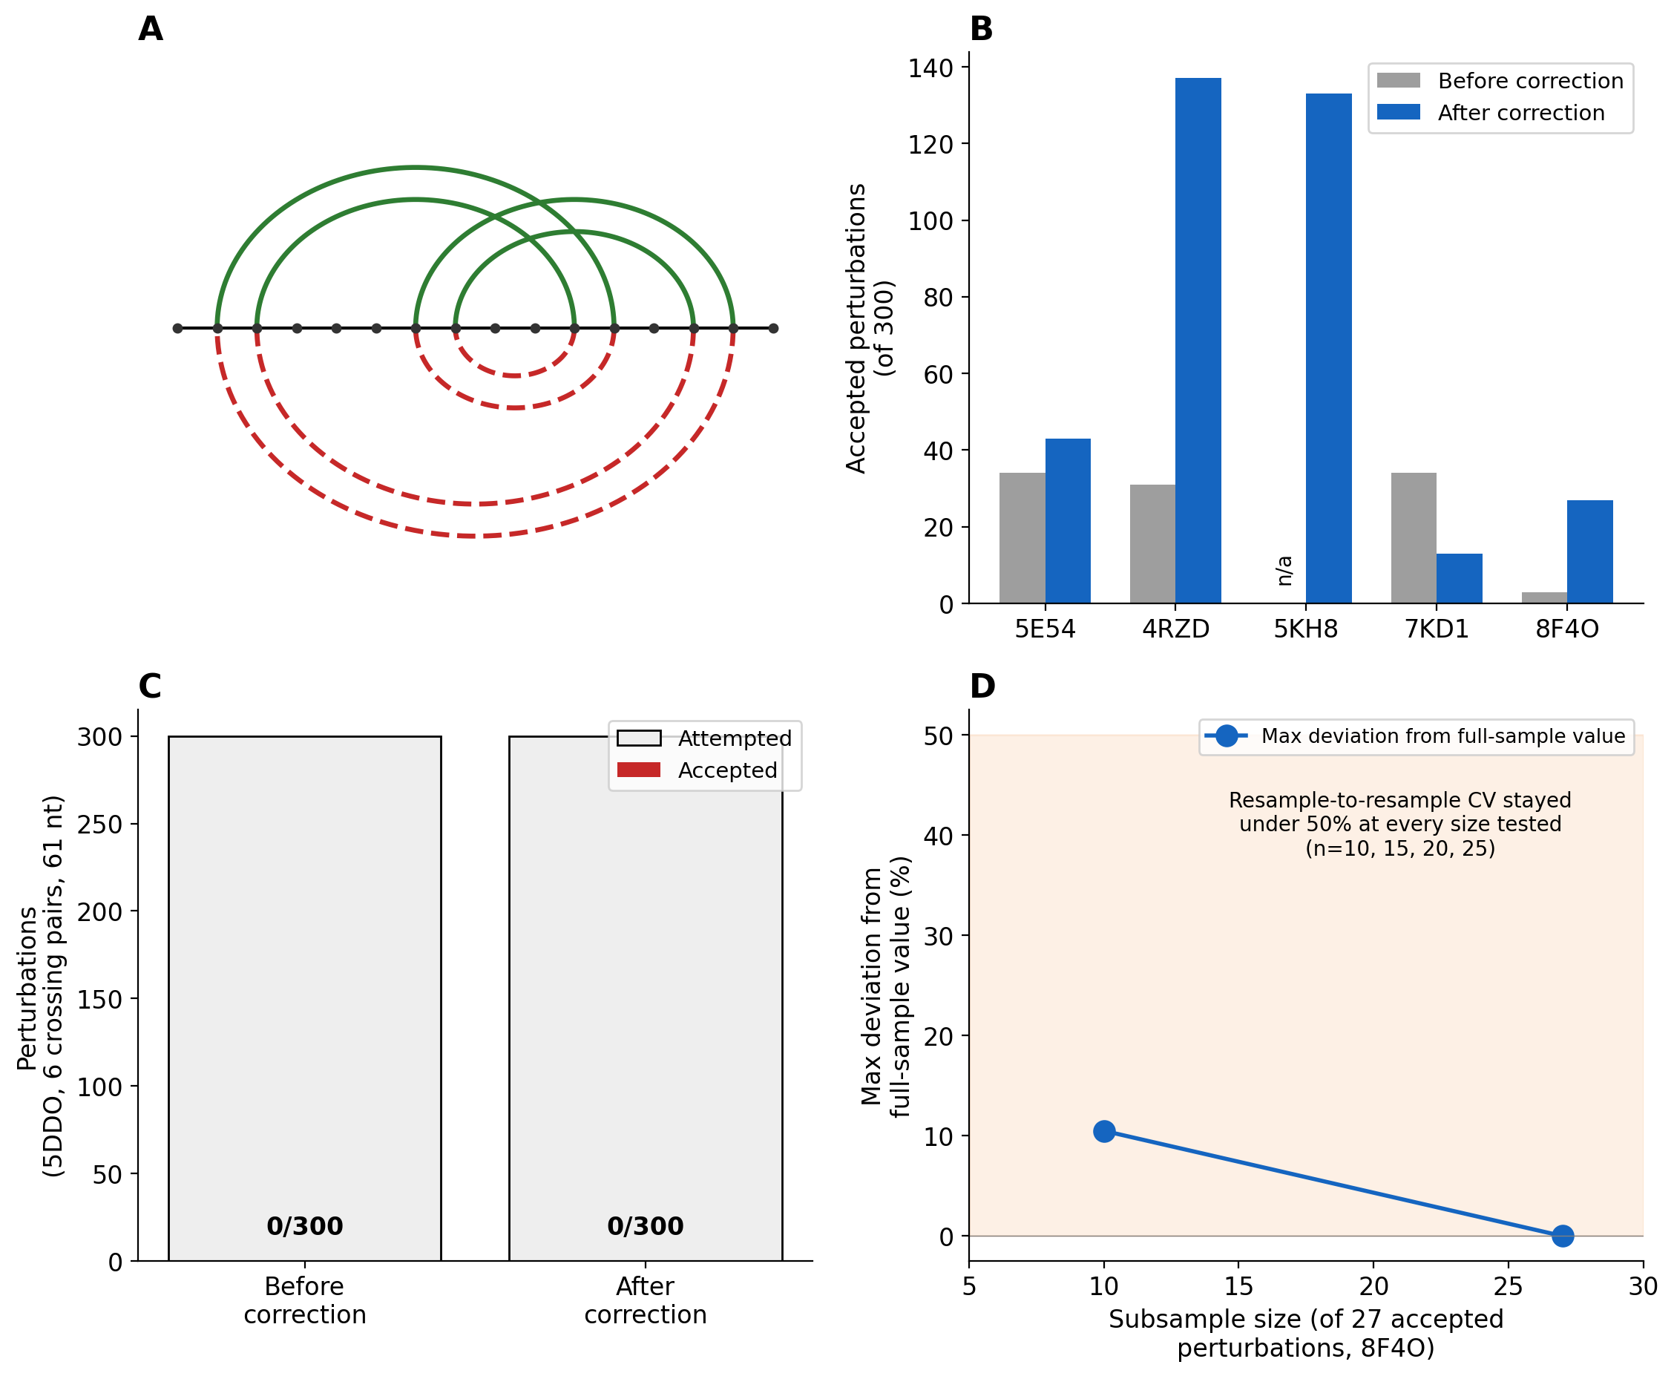
Fig. 2. Topology-aware perturbation calibration. (A) Synthetic crossing topology showing an invalid boundary-shift alternative. (B) Accepted perturbations before and after topology-preserving correction, all five pseudoknotted targets with a comparison run available. (C) Results for 5DDO, for which no valid perturbation was accepted. (D) Sensitivity of the 8F4O perturbation baseline to the number of accepted perturbations.
Table 4. Perturbation-validity audit: accepted perturbations (of 300 attempted) before and after the topology-preserving correction.
Target | Crossing pairs | Accepted, before correction | Accepted, after correction | Acceptance rate (after) | Perturbation baseline estimable?
5E54 | 2 | 34 | 43 | 14.3% | Yes
4RZD | 7 | 31 | 137 | 45.7% | Yes
5KH8 | 4 | n/a (generated post-correction only) | 133 | 44.3% | Yes
7KD1 | 2 | 34 | 13 | 4.3% | Yes
8F4O | 2 | 3 | 27 | 9.0% | Yes
5DDO | 6 | 0 | 0 | 0.0% | No

3.3 Target-level analysis finds no cohort-wide coordinate-class preference
Across the nine analyzable RNA systems, angle coordinates did not clear the perturbation baseline more frequently than matched distance coordinates at the target level. Six of the nine targets show no difference between their own angle- and distance-dimension clearing proportions (Table 5, Fig. 3). Of the remaining three, two favor angle and one favors distance. The mean target-level difference is 0.036; the median is 0.000.
The six zero-difference targets are not a uniform group (Table 5). Three (2MIY, 5KH8, and, at an equal-but-nonzero level, 4RZD) clear both coordinate classes at the same, comparatively high rate; three (2L1V, 8THV, HCV IRES domain IIa) clear neither class at all. These zero differences arise from either high clearing in both coordinate classes or low clearing in both.
Table 5. Target-level clearing proportions, difference ($Δ$ = angle − distance), and pattern classification. Pairs = collective-coordinate dimension count per block; valid pert. = accepted perturbations underlying the perturbation baseline; $K$ = production sample count.
Target | Pairs | Valid pert. | $$K$$ | Distance clearing | Angle clearing | $$Δ$$ | Pattern
2MIY | 1 | 300 | 50 | 1.000 | 1.000 | 0.000 | Both high
5KH8 | 2 | 133 | 50 | 1.000 | 1.000 | 0.000 | Both high
4RZD | 2 | 137 | 90 | 0.500 | 0.500 | 0.000 | Equal, intermediate
2L1V | 1 | 300 | 90 | 0.000 | 0.000 | 0.000 | Both low
8THV | 1 | 300 | 80 | 0.000 | 0.000 | 0.000 | Both low
HCV IRES domain IIa | 4 | 300 | 50 | 0.000 | 0.000 | 0.000 | Both low
7KD1 | 5 | 13 | 50 | 0.400 | 0.200 | -0.200 | Distance-favoring
5E54 | 5 | 43 | 70 | 0.200 | 0.600 | +0.400 | Angle-favoring
8F4O | 8 | 27 | 50 | 0.750 | 0.875 | +0.125 | Angle-favoring
Treating each of the 29 collective-coordinate dimensions as an independent observation ignores that several dimensions come from the same target; the target is the appropriate unit for the primary analysis because multiple coordinate measurements are nested within each target. A bootstrap 95% confidence interval on the mean target-level difference spans zero ($\left[-0.05,0.15\right]$), and the median difference’s own confidence interval has zero as its lower bound (Fig. 3). An exact sign test on the three targets with a non-zero difference is uninformative by construction ($p=1.00$). The estimated mean changed sign after excluding 5E54 from the target set, indicating that the direction and magnitude of the small residual average effect were sensitive to individual targets. It did not reflect a stable cohort-wide direction.
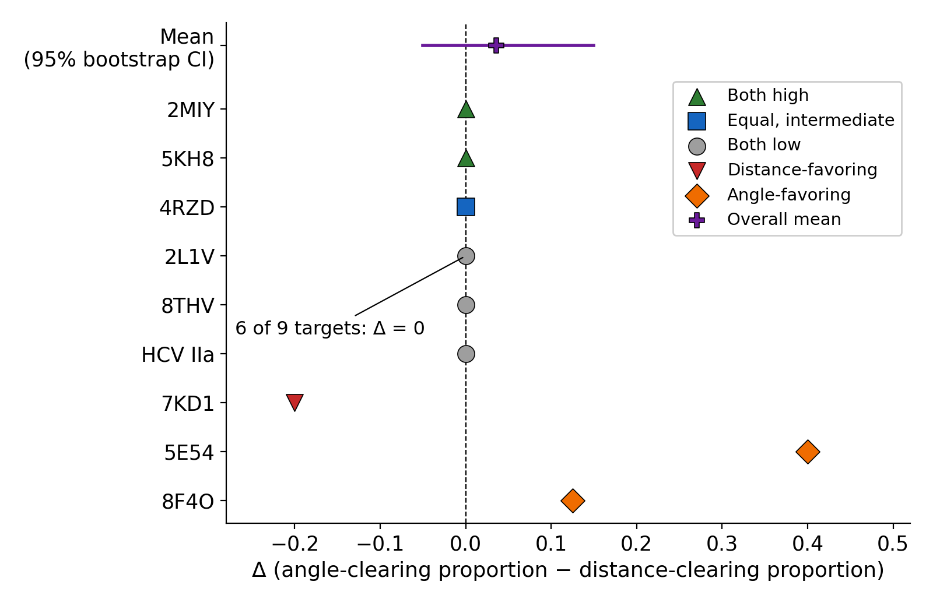
Fig. 3. Target-level $Δ$ for all nine targets, with the overall mean and 95% bootstrap confidence interval.
Three targets (2MIY, 2L1V, 8THV) have a single matched coordinate pair and therefore coarser clearing proportions. Each of their $Δ_{t}$ values can only be $-1$, $0$, or $+1$. Excluding these targets did not alter the overall conclusion. The mean $Δ$ for the remaining six targets was 0.054 (unchanged median 0.000; bootstrap 95% CI $\left[-0.079,0.217\right]$, $10,000$ resamples, percentile method), an interval that spans both signs. A pair-count-weighted mean,
${\overset{‾}{Δ}}_{\text{weighted}}=\frac{\sum_{t=1}^{N}{\left|P_{t}\right|} Δ_{t}}{\sum_{t=1}^{N}{\left|P_{t}\right|}}=0.069$ (12)
gives a similar descriptive contrast to the unweighted target-level mean.

3.4 Pooled-coordinate analysis (secondary sensitivity check)
As a secondary analysis (§2.5), all 29 matched coordinate pairs were pooled: 13 distance dimensions (45%) and 15 angle dimensions (52%) cleared the baseline (Table 6). McNemar’s exact test showed no difference ($p=0.69$). Removing 8F4O, which contributes the largest number of coordinate pairs, gave similar results (33% vs. 38%, $p=1.00$).
Table 6. Pooled-dimension clearing rates and statistical tests (secondary analysis), with a leave-one-target-out sensitivity check for the target contributing the largest number of coordinate pairs (8F4O was not removed as an outlier; every target in the cohort was retained throughout).
 | Distance | Angle | McNemar’s p | Wilson 95% CI (distance) | Wilson 95% CI (angle)
Full cohort (n=29 pairs) | 13/29 (45%) | 15/29 (52%) | 0.69 | [28%, 62%] | [34%, 69%]
Leave-one-target-out sensitivity, excl. 8F4O (n=21 pairs) | 7/21 (33%) | 8/21 (38%) | 1.00 | [17%, 55%] | [21%, 59%]

3.5 Case studies: targets with experimentally characterized ligand-responsive transitions
8F4O and 5E54 provide contrasting experimentally characterized apo-to-holo transitions and pronounced coordinate-class differences, and are examined as case studies on that basis. 7KD1 also has an independently characterized transition and a non-zero coordinate-class difference; it is discussed separately in §3.6. Both 8F4O and 5E54 were included on leakage-audit grounds established before any signal analysis was run (§2.1).
The TPP riboswitch (8F4O) clears 6 of 8 distance dimensions and 7 of 8 angle dimensions, the largest number of collective-coordinate dimensions cleared of any target in the cohort (Fig. 4A1–C1). This is distinct from clearing proportion, on which 2MIY and 5KH8 are equal or higher (Table 5), and from clearing magnitude, on which 7KD1 is substantially higher (§3.6, Appendix A5). Its apo structure is Y-shaped, with sensory domains splayed apart. Its holo structure is compact, with the sensory domains packed around the bound ligand (holo PDB 2GDI [20]; apo PDB 8F4O [21]). The published apo-to-holo transition is an all-atom RMSD of 11.2 Å. Its clearing values were checked for small-sample sensitivity by bootstrap resampling of its 27 accepted perturbations down to subsamples of 10, 15, 20, and 25. The baseline-variance estimate deviated by at most 10.5% from the full-sample value at the smallest subsample tested. Resample-to-resample coefficients of variation remained under 50% at every size, indicating the result is not an artifact of its comparatively small accepted-perturbation set.
The adenine riboswitch (5E54) clears 3 of 5 angle dimensions and 1 of 5 distance dimensions (Fig. 4A2–C2). Its apo structure has a disordered three-way junction with a partially melted P1 helix. Its holo structure has an ordered junction with P1 coaxially stacked on P3 (PDB 5E54 apo and 4TZX holo [22]). The published apo-to-holo transition is an all-atom RMSD of 3.6 Å, identical to the third same-methodology comparison available in this cohort (7KD1 to 4LVV, tetrahydrofolate riboswitch). This directly illustrates that the magnitude of the global transition alone does not predict the magnitude of the model signal, as addressed further in §3.6.
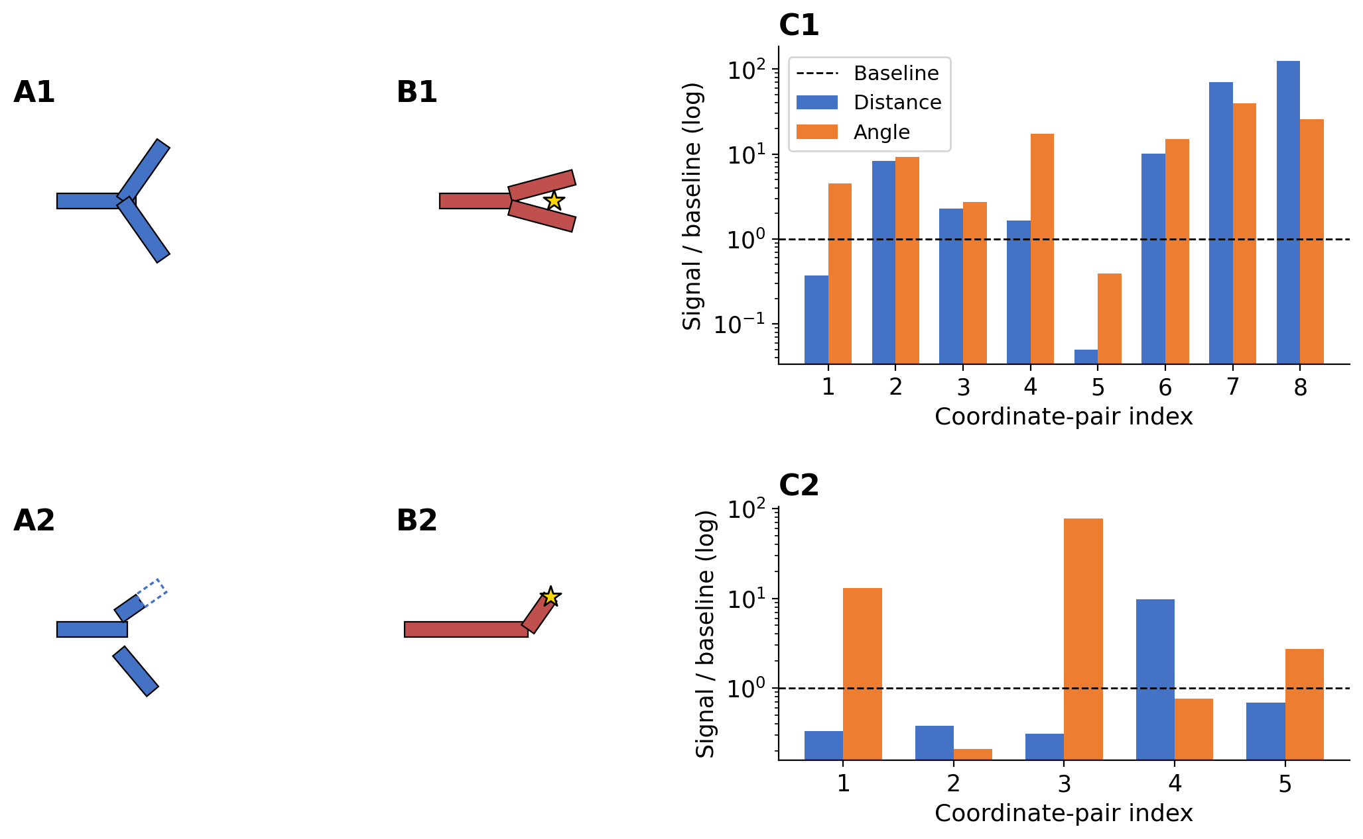
Fig. 4. Case studies: TPP riboswitch (top) and adenine riboswitch (bottom). Panels A and B schematize the published apo and holo structural transitions and are not model-generated or coordinate-derived overlays. Panel C reports the measured signal-to-baseline ratio for each matched inter-helix coordinate pair; the horizontal line is the clearing threshold $R_{t,j}=1$.
HIV-1 TAR (8THV) has a single matched distance–angle coordinate pair; its raw signal-to-baseline ratios were 0.14 for distance and 0.22 for angle, neither exceeding the clearing threshold (Table 5: 0.000, 0.000). The glutamine riboswitch (5DDO) has no estimable perturbation baseline (§3.2).

3.6 Model signal does not track published transition magnitude
Same-methodology published transition magnitudes [17] are available for three targets. 5E54 and 7KD1 share an identical published magnitude (3.6 Å), yet their model signals differ by more than tenfold (mean pooled signal: 10.6 versus 121.6). 8F4O’s published magnitude is more than three times either, yet its model signal does not exceed 7KD1’s. The three available directly comparable cases did not show monotonic ordering between model signal and global transition RMSD (Supplementary Table S5, Supplementary Fig. S5). At this sample size, formal correlation inference is not attempted, and the result is not extrapolated beyond these three targets. 7KD1’s signal magnitude rests on only 13 accepted perturbations (Table 4), fewer than 8F4O’s 27. Unlike 8F4O (§3.5), 7KD1’s baseline estimate has not been checked for small-sample stability. Its magnitude values in this comparison carry that caveat and should not be treated as an established stable quantity.

4. Discussion

4.1 Principal finding
The principal result is not that RNAbpFlow ensembles are devoid of biological signal, but that coordinate-class preference is heterogeneous across RNA systems and cannot be inferred from ensemble diversity or clearing rates alone. The absence of a consistent coordinate-class preference across the target-level systems in this cohort indicates that the observed ensemble variation is not characterized by a common directional pattern in the coordinates examined here. The target-level analysis is the decisive evidence for this: most targets show identical clearing rates for both coordinate classes, and the small residual average effect reverses sign depending on which single target is included.

4.2 What the two case-study targets may mean
8F4O and 5E54 provide contrasting experimentally characterized apo-to-holo transitions and pronounced coordinate-class differences, and are examined as case studies on that basis. 2MIY and 5KH8 clear a higher raw proportion of their smaller coordinate sets, and 7KD1 has a larger pooled signal magnitude (§3.6, Appendix A5). The two case studies are accordingly not the cohort’s strongest signals by every measure. Two targets with identical published transition magnitudes produced model signals that differed by more than tenfold, so the available data do not support a simple quantitative relation between model-derived signal and global transition RMSD. The observed signal may reflect genuine conformational information or target-specific model behavior. The present analysis cannot distinguish between these possibilities. Direct comparison with the experimental apo-to-holo displacement would be required to establish conformational recovery (§5).

4.3 Training exposure and the limits of leakage auditing
Whether ensemble diversity reflects genuine generalization or training-set memorization bears directly on how it should be used as evidence. An independent benchmark of deep-learning RNA structure-prediction methods has shown that point-estimate accuracy depends heavily on training-set similarity. Ensemble diversity for a given target plausibly depends on the same thing. Without independent structural information of the kind assembled here, a target-specific signal cannot, on its own, be distinguished from residual representational similarity not captured by the leakage audit, or another model- and target-specific source of variation. The present audit addresses direct and sequence-embedded training exposure specifically. It does not and cannot rule out subtler forms of representational similarity between a test target and the training corpus. The possibility that the two case-study targets in §3.5 benefit from such similarity cannot be excluded by this study’s methods.

4.4 Topology-preserving perturbation baseline: necessary, and not always sufficient
The perturbation baseline’s topology-preserving property materially changed accepted-perturbation counts for every pseudoknotted target checked (§3.2, Table 4). This is an important validity constraint for the structural reference, though not by itself a demonstration that every accepted perturbation is physically plausible (Appendix A4). It is not, however, sufficient for every topology. One target’s crossing base pairs are dense enough that no independent per-stem perturbation preserves a valid structure, regardless of bracket-type correctness, and its baseline remains unavailable under the present procedure. The perturbation procedure is the source of this limitation; the structural behavior of the affected target is not. The baseline is a topology-matched structural reference, constructed from the same target’s base-pair map, against which ensemble coordinate variance is compared. It is not intended to estimate RNAbpFlow’s own sampling variance.

5. Limitations and Future Scope
This paper reports a single-backbone result. Whether the directional pattern reported here is a general property of generative RNA structure models, or a property specific to this architecture and training regime, is untested; exploratory comparison across three candidate backbones did not provide a basis for testing it (Supplementary Materials). This study does not directly test whether generated samples extend along the specific experimentally observed apo-to-holo displacement direction for any target. The primary cohort comprises 14 targets, nine of which contribute to the directional analysis. A target-level statistic computed on nine systems has limited power to detect an effect of any given size. The present result accordingly establishes an absence of a stable, consistent direction. It does not establish an absence of any real effect at any magnitude. The magnitude comparison against published transition magnitudes is limited to three targets by the availability of directly comparable, same-methodology measurements in the literature. No independent structural-validity check (backbone completeness, steric clash, or agreement between a generated sample’s own geometry and its base-pair conditioning) was applied to generated samples before computing collective coordinates. A high clearing rate driven by malformed samples, as opposed to genuinely diverse ones, cannot be excluded by the present analysis; ruling this out would require such a check. The leakage audit’s family-level and homologous-structure exposure criteria (§2.1) are not documented here to the same level of methodological detail as the exact-deposition and sequence-level criteria. The specific database, search method, and similarity threshold used for these two criteria should be confirmed against the analysis pipeline directly if required for exact reproduction.
Extending this evaluation to a larger, more architecturally diverse cohort would clarify whether the present null result reflects a genuinely small or absent cohort-wide effect, or insufficient power to detect a real one. The size of such a cohort should be determined by a power calculation based on the target-level effect size observed here. An arbitrary expansion of target count would not serve this purpose. Computing the experimentally observed apo-to-holo displacement vector in the same collective-coordinate space for each characterized target would allow a direct test. Testing whether generated samples preferentially extend along that direction would extend the two case studies in §3.5 beyond an open question. The perturbation baseline’s boundary for densely pseudoknotted topologies could, in principle, be addressed by jointly perturbing interacting stems, rather than independently perturbing each, thereby extending calibration to the one topology class currently excluded. Applying the same leakage-audit, topology-aware calibration, and target-level statistical framework to other generative RNA structure-prediction backbones would establish whether the heterogeneity reported here is specific to RNAbpFlow or reflects the diversity of generative ensembles as currently constructed across the field.

6. Conclusions
Across a leakage-audited cohort of 14 RNA targets, RNAbpFlow ensemble diversity showed no stable cohort-wide preference for distance- or angle-based collective-coordinate variation relative to a topology-preserving perturbation baseline. The target-level mean difference was small and sensitive to individual targets. Most targets showed no difference between distance- and angle-coordinate clearing, and the small residual average effect reversed sign depending on which single target was included. Two experimentally characterized targets, 8F4O and 5E54, showed pronounced coordinate-class differences, but these observations do not establish recovery of their experimental conformational transitions. The origin of these target-specific signals, genuine conformational information, residual representational similarity not captured by the leakage audit, or another model- and target-specific source of variation, remains unresolved. A perturbation baseline that preserves pseudoknot topology by construction underlies every reported result. Its one identified boundary is structural: RNA topologies with sufficiently dense, interacting crossing base pairs admit no valid independent-stem perturbation, so their baseline cannot be estimated under the present procedure. The results are specific to RNAbpFlow, the present target cohort, and the selected collective coordinates and perturbation procedure. Direct comparison with experimentally observed displacement directions, and evaluation across additional generative backbones, will be needed to determine whether such ensemble variation carries reproducible conformational information.

Declarations
Funding: Z.Z. is partially funded by his startup at The University of Texas Health Science Center at Houston, Houston, Texas, USA.
Competing interests: The authors declare no competing interests.
Ethics approval and consent to participate: Not applicable.
Data availability: The following open datasets were used in this study:
- RCSB Protein Data Bank: https://www.rcsb.org
- RNA3DB: https://github.com/marcellszi/rna3db
- RNAbpFlow: https://github.com/Bhattacharya-Lab/RNAbpFlow
Code availability: All experimental and analysis code, along with relevant documentation, are available at https://github.com/Dr-PKDP/RNAbpFlow_Evaluation.
Author contributions: P.K.D.P.: Conceptualization, Data curation, Formal analysis, Investigation, Methodology, Software, Validation, Visualization, Writing – original draft, Writing – review & editing. Z.Z.: Funding acquisition, Writing – review & editing.
Acknowledgements: Not applicable.
Generative AI statement: During the preparation of this manuscript, the authors used Claude (Anthropic) to assist with drafting and revising text and with developing experimental code. All AI-assisted output was reviewed, verified, and edited by the author(s), who take full responsibility for the accuracy, integrity, and conclusions of this work.

References
[1] J. Zhang, C. Fei, Y. Zhang, and L. Ye, “Advances and opportunities in RNA structure experimental determination and computational modeling,” Nat. Methods, vol. 19, pp. 1193–1207, 2022.
[2] S. L. Bonilla, A. N. Jones, and D. Incarnato, “Structural and biophysical dissection of RNA conformational ensembles,” Curr. Opin. Struct. Biol., vol. 88, p. 102908, 2024.
[3] G. Bussi, M. Bonomi, P. Gkeka, M. Sattler, H. M. Al-Hashimi, P. Auffinger, M. Duca, Y. Foricher, D. Incarnato, A. N. Jones, S. Kirmizialtin, M. Krepl, M. Orozco, G. Palermo, S. Pasquali, L. Salmon, H. Schwalbe, E. Westhof, and M. Zacharias, “RNA dynamics from experimental and computational approaches,” Structure, vol. 32, pp. 1281–1287, 2024.
[4] C. Y. Li, S. Sandhu, and M. L. Ken, “RNA ensembles from in vitro to in vivo: toward predictive models of RNA cellular function,” Curr. Opin. Struct. Biol., vol. 89, p. 102915, 2024.
[5] T. Shen et al., “Accurate RNA 3D structure prediction using a language model-based deep learning approach,” Nat. Methods, vol. 21, pp. 2287–2298, 2024.
[6] W. Wang, C. Feng, R. Han, Z. Wang, L. Ye, Z. Du, H. Wei, F. Zhang, Z. Peng, and J. Yang, “trRosettaRNA: automated prediction of RNA 3D structure with transformer network,” Nat. Commun., vol. 14, p. 7266, 2023.
[7] Y. Li, C. Zhang, C. Feng, R. Pearce, P. Lydia Freddolino, and Y. Zhang, “Integrating end-to-end learning with deep geometrical potentials for ab initio RNA structure prediction,” Nat. Commun., vol. 14, p. 5745, 2023. DOI: 10.1038/s41467-023-41303-9.
[8] Y. Kagaya, Z. Zhang, N. Ibtehaz, X. Wang, T. Nakamura, P. D. Punuru, and D. Kihara, “NuFold: end-to-end approach for RNA tertiary structure prediction with flexible nucleobase center representation,” Nat. Commun., vol. 16, no. 1, p. 881, 2025. DOI: 10.1038/s41467-025-56261-7.
[9] M. Baek, R. McHugh, I. Anishchenko, H. Jiang, D. Baker, and F. DiMaio, “Accurate prediction of protein–nucleic acid complexes using RoseTTAFoldNA,” Nat. Methods, vol. 21, pp. 117–121, 2024. DOI: 10.1038/s41592-023-02086-5.
[10] J. Abramson et al., “Accurate structure prediction of biomolecular interactions with AlphaFold3,” Nature, vol. 630, pp. 493–500, 2024.
[11] J. Wohlwend et al., “Boltz-1: Democratizing biomolecular interaction modeling,” bioRxiv preprint, 2024.
[12] Z. Li, J. Zhu, X. Hong, J. Mu, Z. Zheng, T. Cui, Y. Sun, T. Wei, and H.-F. Chen, “DynaRNA: accurate dynamic RNA conformation ensemble generation with diffusion model,” Commun. Biol., vol. 8, p. 1472, 2025.
[13] F. Bu et al., “RNA-Puzzles Round V: blind predictions of 23 RNA structures,” Nat. Methods, vol. 22, pp. 399–411, 2025. DOI: 10.1038/s41592-024-02543-9.
[14] C. Bernard et al., “State-of-the-RNArt: benchmarking current methods for RNA 3D structure prediction,” NAR Genom. Bioinform., vol. 6, no. 2, lqae048, 2024.
[15] M. Ludaic and A. Elofsson, “Limits of deep-learning-based RNA prediction methods,” Nucleic Acids Res., vol. 54, no. 16, gkag813, 2026.
[16] S. Tarafder and D. Bhattacharya, “RNAbpFlow: base pair-augmented SE(3) flow matching for conditional RNA 3D structure generation,” Nat. Methods, vol. 23, no. 7, pp. 1349–1358, 2026. DOI: 10.1038/s41592-026-03128-4.
[17] J. R. Stagno and Y.-X. Wang, “Riboswitch mechanisms for regulation of P1 helix stability,” Int. J. Mol. Sci., vol. 25, no. 19, p. 10682, 2024.
[18] S. Kumar and G. Reddy, “TPP riboswitch populates holo-form-like structure even in the absence of cognate ligand at high Mg2+ concentration,” J. Phys. Chem. B, vol. 126, no. 12, pp. 2369–2381, 2022.
[19] P. Danaee, M. Rouches, M. Wiley, D. Deng, L. Huang, and D. Hendrix, “bpRNA: large-scale automated annotation and analysis of RNA secondary structure,” Nucleic Acids Res., vol. 46, no. 11, pp. 5381–5394, 2018.
[20] A. Serganov, A. Polonskaia, A. T. Phan, R. R. Breaker, and D. J. Patel, “Structural basis for gene regulation by a thiamine pyrophosphate-sensing riboswitch,” Nature, vol. 441, pp. 1167–1171, 2006.
[21] H. K. Lee, Y.-T. Lee, L. Fan, H. M. Wilt, C. E. Conrad, P. Yu, J. Zhang, G. Shi, X. Ji, Y.-X. Wang, and J. R. Stagno, “Crystal structure of Escherichia coli thiamine pyrophosphate-sensing riboswitch in the apo state,” Structure, vol. 31, no. 7, pp. 848–859, 2023.
[22] J. R. Stagno et al., “Structures of riboswitch RNA reaction states by mix-and-inject XFEL serial crystallography,” Nature, vol. 541, pp. 242–246, 2017.
[23] W. Wang et al., “Predicting RNA 3D structure and conformers using a pre-trained secondary structure model and structure-aware attention,” Nat. Mach. Intell., vol. 8, pp. 722–734, 2026.
[24] J. Pielesiak, M. Antczak, M. Szachniuk, and T. Zok, “RNAtive to recognize native-like structure in a set of RNA 3D models,” Bioinformatics, vol. 41, no. 11, btaf601, 2025.
[25] S. Tarafder and D. Bhattacharya, “PARSEbp: pairwise agreement-based RNA scoring with emphasis on base pairings,” Bioinform. Adv., vol. 6, no. 1, vbag112, 2026.
[26] R. C. Kretsch, A. M. Hummer, S. He, R. Yuan, J. Zhang, T. Karagianes, Q. Cong, A. Kryshtafovych, and R. Das, “Assessment of nucleic acid structure prediction in CASP16,” Proteins, vol. 94, no. 1, pp. 192–217, 2026. DOI: 10.1002/prot.70072.

Appendix

A1. Threshold sensitivity of the pooled-dimension result
Threshold sensitivity was assessed across values of 0.5–5.0 (Table A1). The direction of the pooled comparison remained unchanged, and none of the tested thresholds reached statistical significance.
Table A1. Pooled-dimension clearing rates and McNemar’s exact test across six clearing thresholds.
Threshold | Distance clearing | Angle clearing | Discordant pairs | McNemar’s $p$
0.5 | 16/29 (55%) | 20/29 (69%) | 4 | 0.125
1.0 | 13/29 (45%) | 15/29 (52%) | 6 | 0.688
1.5 | 12/29 (41%) | 15/29 (52%) | 7 | 0.453
2.0 | 11/29 (38%) | 15/29 (52%) | 8 | 0.289
3.0 | 9/29 (31%) | 13/29 (45%) | 8 | 0.289
5.0 | 8/29 (28%) | 11/29 (38%) | 5 | 0.375

A2. Crossing base-pair audit for targets subjected to RNAbpFlow generation
Every target subjected to RNAbpFlow generation was checked for a crossing (pseudoknotted) base-pair interaction with IPknot before its first generation run (Table A2). Three further primary-cohort targets (3IRW, 8FW4, 6OD9) were never generated (§3.1) and are not included here.
Table A2. Crossing base pairs identified per target checked.
Target | Crossing pairs | Target | Crossing pairs
5E54 | 2 | 2L1V | 0
4RZD | 7 | 3Q50 | 0
5KH8 | 4 | 8THV | 0
7KD1 | 2 | 1P5M | 0
2MIY | 0 | 8F4O | 2
5DDO | 6

A3. Individual-target perturbation-baseline yield
Accepted perturbations (of 300 attempted) varied with pseudoknot complexity (Table A3); a baseline was estimated only when at least 10 were accepted.
Table A3. Accepted perturbations per pseudoknotted target.
Target | Crossing pairs | Accepted perturbations (of 300) | Acceptance rate | Met baseline-estimation minimum (≥10)? | Entered primary analysis?
5E54 | 2 | 43 | 14.3% | Yes | Yes
4RZD | 7 | 137 | 45.7% | Yes | Yes
5KH8 | 4 | 133 | 44.3% | Yes | Yes
7KD1 | 2 | 13 | 4.3% | Yes | Yes
8F4O | 2 | 27 | 9.0% | Yes | Yes
5DDO | 6 | 0 | 0.0% | No | No

A4. Full target-reference table
Table A4 provides the full target-level structural references, evidence classification, coordinate dimensions, and perturbation outcomes.
Table A4. Full per-target reference and analysis detail, all 14 primary-cohort targets. Dims = distance/angle collective-coordinate dimension count; Pert. = accepted perturbations of 300 attempted.
Target | Comparison structure | Class | Method | Evidence class | Tier | Comparison type | Dims | Pert. | In analysis
5E54 | 4TZX (holo) | Adenine riboswitch | X-ray | Apo/holo crystal pair | 2 | Independent depositions | 5/5 | 43 | Yes
2L1V | NMR ensemble (no comparison PDB) | preQ1, Class I | NMR | NMR conformer ensemble | 1 | Internal ensemble distribution | 1/1 | 300† | Yes
2MIY | NMR ensemble | preQ1, Class II | NMR | NMR conformer ensemble | 1 | Internal ensemble distribution | 1/1 | 300† | Yes
3Q50 | NMR ensemble | preQ1, Class I (2nd organism) | NMR | NMR conformer ensemble | 1 | Internal ensemble distribution | 0/0 | n/a | No: zero dimensions
4RZD | NMR ensemble | preQ1, Class III | NMR | NMR conformer ensemble | 1 | Internal ensemble distribution | 2/2 | 137 | Yes
5KH8 | NMR ensemble | Fluoride riboswitch | NMR | NMR conformer ensemble | 1 | Internal ensemble distribution | 2/2 | 133 | Yes
8F4O | 2GDI (holo), 2.05 Å | TPP riboswitch | X-ray | Apo/holo crystal pair | 2 | Independent depositions | 8/8 | 27 | Yes
5DDO | 5DDP (holo) | Glutamine riboswitch | X-ray, U1A-chaperoned | Apo/holo crystal pair, crystallization-chaperoned | 2 | Independent depositions | n/a | 0 | No: baseline not estimable
7KD1 | 4LVV (holo) | Tetrahydrofolate riboswitch | X-ray | Apo/holo crystal pair | 2 | Independent depositions | 5/5 | 13 | Yes
3IRW | none (holo-only) | Cyclic-di-GMP riboswitch | X-ray | Holo-only crystal | 2 | No unbound counterpart | n/a | — | No: no unbound counterpart
8FW4 | 8SA6, real apo, excluded (homodimer) | Cobalamin riboswitch | X-ray | Holo-only usable; real apo exists but is a homodimer | 2 | Stoichiometry mismatch | n/a | — | No: unbound is homodimer
6OD9 | none (holo-only) | ZTP/ZMP riboswitch | X-ray | Holo-only crystal | 2 | No unbound counterpart | n/a | — | No: no unbound counterpart
8THV | same deposition (GS/ES ensemble) | HIV-1 TAR | NMR / Rosetta-FARFAR | Single-deposition ground/excited-state ensemble | 2 | Internal ensemble distribution | 1/1 | 300† | Yes
1P5M | inhibitor-bound, same construct | HCV IRES domain IIa | NMR | Free/inhibitor-bound, solution-confirmed | 2 | Independent depositions, same construct | 4/4 | 300† | Yes
† For the four non-pseudoknotted targets so marked, the perturbation procedure’s validity criterion is dimensionality match alone, with no pseudoknot bracket-type constraint to violate. For non-pseudoknotted targets, all candidate perturbations satisfied this topological dimensionality criterion. This indicates that the current acceptance filter is topology-specific; it does not independently validate the physical plausibility of every perturbation beyond that criterion. All 14 primary-cohort targets passed the specified training-exposure audit for the deposited structure used as model input (§2.1). Three targets lacked a leakage-clean unbound counterpart compatible with the single-sequence directional analysis and were excluded from that endpoint on that basis, not on leakage grounds. Crystallographic resolution was not tracked as a study variable for each target because it does not enter the analysis. Where checked directly, 2GDI was solved at 2.05 Å.

A5. Model signal versus published transition magnitude
Table A5. Published transition magnitude versus model signal, same-methodology subset (n=3).
Target | Published all-atom RMSD (Å) | Model mean signal | Model max signal
5E54 | 3.6 | 10.61 | 77.96
7KD1 | 3.6 | 121.57 | 1192.40
8F4O | 11.2 | 20.66 | 123.97
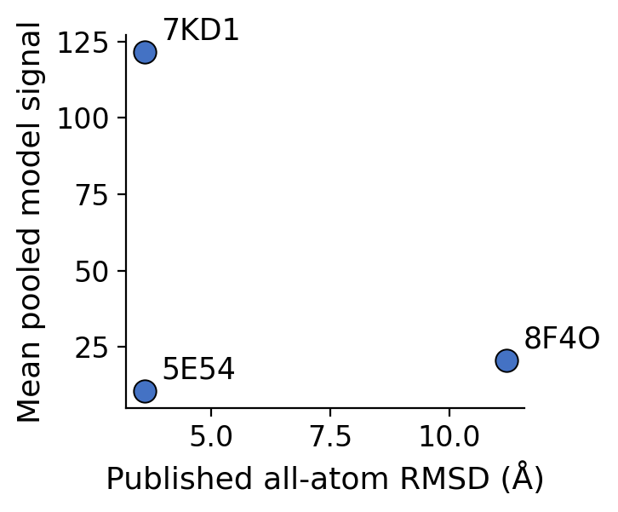
Fig. A1. Published all-atom RMSD versus mean pooled model signal for the three targets with a directly comparable, same-methodology published measurement.

