Colorimetric Testing for Nitrate
- Device: HI781 Marine Nitrate Low Range
- Method: per manufacturer’s instructions
- Results: parts per million (ppm)
- To execute this procedure successfully, we will need the following materials/supplies:
  - Gloves (S, M, L)
  - 10 mL cuvettes
  - HI781A-0 and HI7818-0 reagents

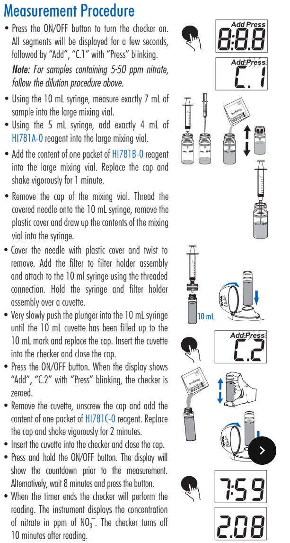
Colorimetric Testing for Nitrate Method

Colorimetric Testing for Nitrite
- Device: HI781 Marine Nitrate Ultra Low Range
- Method: per manufacturer’s instructions
- Results: parts per billion (ppb)
- To execute this procedure successfully, we will need the following materials/supplies:
  - Gloves (S, M, L)
  - 10 mL cuvettes
  - HI764-0 reagents

Colorimetric Testing for Nitrite Method
