Pulse Amplitude Modulation (PAM) fluorometry
- Device: Phyto-Pam-II
- Method: per manufacturer’s instructions
- Results: Maximum quantum yield (F_{v}/F_{m}) (photosynthetic efficiency)
- To execute this procedure successfully, we will need the following materials/supplies:
  - Gloves (S, M, L)
  - Sample
  - Cuvettes
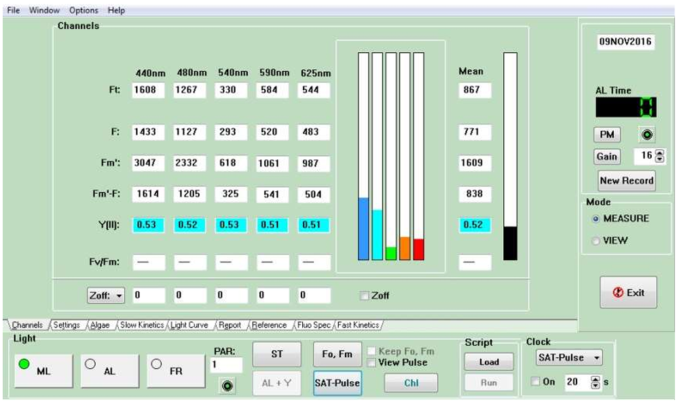
  - RO water
  - 70% EtOH
  - Syringes (6 mL)

PAM Method
Preparation and Cleaning
  - Turn PAM ‘ON’
  - Open Phyto-Winn
  - Clean cuvettes
    - 1x EtoH
    - 3x RO
    - 3x SFSW
Running Sample
  - Homogenize sample
  - Pour (or transfer with pipette) sample into cuvette
  - Click ‘Gain’ and write down custody number (Date turns blue)

  - In a second cuvette, use a syringe to extract 5 mLs of sample, attach 0.22 µM filter, and transfer to cuvette as filtrate
  - Wait for PAR sensor to turn white, check Zoff box
  - Once Zoff is complete, return sample (used for gain - unfiltered) to PAM
  - Wait for PAR sensor to turn white, click ‘SAT-Pulse’ and record mean YII
  - Light Curve
    - Turn ‘ON’ the “AL” light
    - Wait for PAR sensor to turn white, press ‘Start’ (10 steps: 18 s each)
    - Once complete, press ‘Fit’, then ‘Calculator’
    - Click ‘export’, and record the reference # between the parenthesis “()”
  - Final Report

    - Select ‘report’ tab at the bottom, and switch to ‘View Mode’
    - Select ALL parameters (listed on the right >>>)
    - Click (last record) (shown on the right >>>>)
    - Click ‘Export’ (at top)
    - Switch back to ‘Measure Mode’
  - Fast Kinetics
    - Select ‘fast kinetics’ tab on bottom
    - Click ‘Averaging’, Wait for PAR sensor to turn white, then press ‘Start’
      - Repeat 2 more times (total 3 times, waiting for PAR sensor each time)
    - Once complete, press ‘Calc’ at the top
    - When next screen appears, click ‘Start fit’, then ‘Export’ file

- If you are running more samples within the same treatment, turn ‘OFF’ the “AL” button, then select ‘Channels’ tab to return to reading YII
- If starting a new treatment completely, close the application and reopen

References:
- PHYTO-PAM-II

