% //Yizuo Chen
% Clean ref8.png so that all non-white pixels become pure black.
% Output: ref8_clean.png (binary mask)
function clean_ref8()
% --- Load image ---
I = imread('ref4.png');
% Convert to grayscale if needed
if size(I,3) == 3
I = rgb2gray(I);
end
% --- Convert to binary mask ---
% White (255) → 255
% Anything else → 0
mask = I == 255; % logical mask of pure white pixels
out = uint8(mask) * 255;
% --- Save cleaned version ---
imwrite(out, 'ref8_clean.png');
% --- Optional debug display ---
figure;
subplot(1,2,1); imshow(I, []); title('Original ref8.png');
subplot(1,2,2); imshow(out,[]); title('Cleaned ref8 mask');
fprintf('Saved cleaned mask as ref8_clean.png\n');
end
Saved cleaned mask as ref8_clean.png
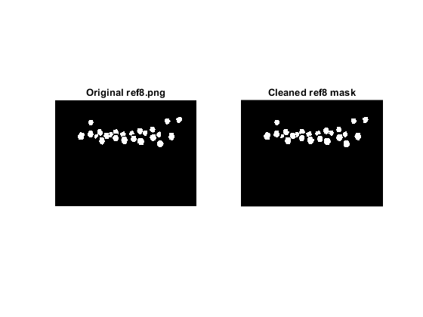
Published with MATLAB® R2024a

