------------------------------------------------------------------------ 7
------------------------------------------------------------------------ 12
------------------------------------------------------------------------ 13
% //Yizuo Chen
function faces = detect_faces_image(imgFile, model)
% Detect faces using:
% • RGB+HSV skin model (trained)
% • Morphological cleanup
% • Strong first-pass classification + template matching
% • Automatic row-band estimation
% • Rescue pass for missed faces
% • Duplicate-merging (neck/logo removal)
% Final output: list of face bounding boxes + centers.
I = imread(imgFile);
if size(I,3) == 1
I = repmat(I,[1 1 3]); % handle grayscale input
end
Igray = im2double(rgb2gray(I));
[H, W, ~] = size(I);
% -------------------------------------------------------------
% 1. Skin segmentation using trained RGB+HSV likelihood model
% -------------------------------------------------------------
% produces:
% (a) skinMask — thresholded bright skin-likelihood
% (b) logRimg — visualization of log-likelihood
[skinMask, logRimg] = apply_skin_model(I, model);
debug_show(logRimg, 'DEBUG: logR image');
% -------------------------------------------------------------
% 1a. Morphology: merge patches, fill holes, remove noise
% -------------------------------------------------------------
% rely on training stats for minimal blob size
minPix = max(round(model.areaStats.min * 0.20), 60);
skinMask = bwareaopen(skinMask, minPix); % remove tiny blobs
skinMask = imclose(skinMask, strel('disk', 6)); % merge forehead/cheek regions
skinMask = imfill(skinMask, 'holes'); % remove holes from eyes/mouth
skinMask = imopen(skinMask, strel('disk', 2)); % knock off thin noise
skinMask = bwareaopen(skinMask, minPix); % final size filter
debug_show(skinMask, 'DEBUG: final skin mask');
% -------------------------------------------------------------
% 2. Connected component analysis
% -------------------------------------------------------------
% Extract geometric properties for all blobs.
L = bwlabel(skinMask);
stats = regionprops(L, 'Area', 'BoundingBox', 'Centroid');
% Debug display of all raw blobs
if ~isempty(stats)
imgBlobs = insertShape(I, 'Rectangle', cat(1,stats.BoundingBox), ...
'Color','cyan','LineWidth',2);
else
imgBlobs = I;
end
debug_show(imgBlobs, 'DEBUG: connected components');
% Empty output if nothing detected
faces = struct('BoundingBox', {}, 'Center', {}, 'Score', {});
if isempty(stats)
return;
end
% -------------------------------------------------------------
% Load trained priors (area, vertical distribution, template)
% -------------------------------------------------------------
meanA = model.areaStats.mean;
minA = 0.35 * meanA; % conservative lower bound
maxA = 2.5 * meanA; % reject very large artifacts
yCenters = model.yPosHist.centers;
yHist = model.yPosHist.hist;
tpl = model.tpl;
tplMask = model.tplMask;
tplSize = model.tplSize;
strongIdx = [];
% -------------------------------------------------------------
% 3. FIRST PASS — strong face candidates
% Filters:
% • size, aspect ratio, fill ratio
% • vertical prior from training
% • skin intensity ratio
% • template correlation score
% These survive as high-confidence faces.
% -------------------------------------------------------------
for i = 1:numel(stats)
a = stats(i).Area;
bb = stats(i).BoundingBox;
c = stats(i).Centroid;
w = bb(3);
h = bb(4);
ratio = h / w;
% --- geometric constraints ---
if a < minA || a > maxA
continue;
end
if ratio < 0.8 || ratio > 2.0
continue;
end
fillRatio = a / (w*h);
if fillRatio < 0.30 || fillRatio > 0.90
continue;
end
% --- vertical position prior ---
yNorm = c(2) / H;
if yNorm < 0.10 || yNorm > 0.70
continue;
end
[~, idxY] = min(abs(yCenters - yNorm));
if yHist(idxY) < 0.01
continue;
end
% --- template correlation check ---
pad = 0.25;
x = bb(1); y = bb(2);
x1 = max(1, floor(x - pad*w));
y1 = max(1, floor(y - pad*h));
x2 = min(W, ceil(x + w + pad*w));
y2 = min(H, ceil(y + h + pad*h));
% skin density in region
patchLogR = logRimg(y1:y2, x1:x2);
hardRatio = nnz(patchLogR > 0) / numel(patchLogR);
if hardRatio < 0.07
continue;
end
% correlation with template
patch = Igray(y1:y2, x1:x2);
patchR = imresize(patch, tplSize);
patchR(~tplMask) = 0;
if var(patchR(:)) < 0.003
continue;
end
tplVec = tpl(:) - mean(tpl(:));
patchVec = patchR(:) - mean(patchR(:));
score = (tplVec' * patchVec) / (norm(tplVec)*norm(patchVec) + eps);
if score < 0.40
continue;
end
% --- accept strong candidate ---
cx = x1 + (x2 - x1)/2;
cy = y1 + (y2 - y1)/2;
faces(end+1).BoundingBox = [x1 y1 (x2-x1+1) (y2-y1+1)];
faces(end).Center = [cx cy];
faces(end).Score = score;
strongIdx(end+1) = i;
end
nStrong = numel(faces);
% -------------------------------------------------------------
% 4. Determine likely vertical row-band from strong detections
% Used to rescue missed faces and eliminate table noise.
% -------------------------------------------------------------
if ~isempty(strongIdx)
yStrongNorm = arrayfun(@(k) stats(k).Centroid(2) / H, strongIdx);
margin = 0.05;
rowBandMinNorm = max(0, min(yStrongNorm) - margin);
rowBandMaxNorm = min(1, max(yStrongNorm) + margin);
else
% fallback if no strong detections
rowBandMinNorm = 0.10;
rowBandMaxNorm = 0.70;
end
% convert to pixel indices
rowBandMinPix = max(1, floor(rowBandMinNorm * H));
rowBandMaxPix = min(H, ceil(rowBandMaxNorm * H));
% debug visualization of allowed rescue region
bandMask = false(H,W);
bandMask(rowBandMinPix:rowBandMaxPix, :) = true;
debug_show(bandMask & skinMask, ...
sprintf('DEBUG: face row band [%.2f, %.2f]', ...
rowBandMinNorm, rowBandMaxNorm));
% -------------------------------------------------------------
% 4b. Adaptive LOWER bounds for rescued faces
% Prevents tiny noise from entering second pass, but allows
% large faces (edges of group) to be kept.
% -------------------------------------------------------------
if ~isempty(strongIdx)
strongAreas = [stats(strongIdx).Area];
strongBB = cat(1, stats(strongIdx).BoundingBox);
strongHeights = strongBB(:,4);
medA = median(strongAreas);
medH = median(strongHeights);
rescueMinA = 0.35 * medA; % minimal area
rescueMinH = 0.40 * medH; % minimal height
else
rescueMinA = minA;
rescueMinH = 0;
end
% -------------------------------------------------------------
% 5. SECOND PASS — rescue plausible blobs inside row band
% Used to recover faces missed in first pass.
% -------------------------------------------------------------
allIdx = 1:numel(stats);
extraIdx = setdiff(allIdx, strongIdx);
for ii = extraIdx
bb = stats(ii).BoundingBox;
c = stats(ii).Centroid;
a = stats(ii).Area;
% must fall inside row band
yNorm = c(2) / H;
if yNorm < rowBandMinNorm || yNorm > rowBandMaxNorm
continue;
end
% adaptive geometric filters
w = bb(3);
h = bb(4);
ratio = h / w;
fillRatio = a / (w*h);
if a < rescueMinA, continue; end
if h < rescueMinH, continue; end
if ratio < 0.6 || ratio > 2.5, continue; end
if fillRatio < 0.25 || fillRatio > 0.95, continue; end
% accept rescued detection
pad = 0.25;
x = bb(1); y = bb(2);
x1 = max(1, floor(x - pad*w));
y1 = max(1, floor(y - pad*h));
x2 = min(W, ceil(x + w + pad*w));
y2 = min(H, ceil(y + h + pad*h));
cx = x1 + (x2 - x1)/2;
cy = y1 + (y2 - y1)/2;
faces(end+1).BoundingBox = [x1 y1 (x2-x1+1) (y2-y1+1)];
faces(end).Center = [cx cy];
faces(end).Score = NaN;
end
% -------------------------------------------------------------
% 6. Merge vertically stacked duplicates (logo + chin + head)
% Removes doubled detections for same person.
% -------------------------------------------------------------
if numel(faces) > 1
keep = true(1, numel(faces));
for i = 1:numel(faces)
if ~keep(i), continue; end
b1 = faces(i).BoundingBox;
c1 = faces(i).Center;
w1 = b1(3); h1 = b1(4);
for j = i+1:numel(faces)
if ~keep(j), continue; end
b2 = faces(j).BoundingBox;
c2 = faces(j).Center;
w2 = b2(3); h2 = b2(4);
% horizontal similarity + vertical proximity
wAvg = 0.5*(w1 + w2);
dx = abs(c1(1) - c2(1));
dy = abs(c1(2) - c2(2));
if dx < 0.45*wAvg && dy < 1.4*max(h1,h2)
% pick stronger score as base
s1 = faces(i).Score; if isnan(s1), s1 = -Inf; end
s2 = faces(j).Score; if isnan(s2), s2 = -Inf; end
if s2 > s1
base = j; other = i; bbBase = b2; bbOther = b1;
else
base = i; other = j; bbBase = b1; bbOther = b2;
end
% merge bounding boxes
xMin = min(bbBase(1), bbOther(1));
yMin = min(bbBase(2), bbOther(2));
xMax = max(bbBase(1)+bbBase(3), bbOther(1)+bbOther(3));
yMax = max(bbBase(2)+bbBase(4), bbOther(2)+bbOther(4));
bbNew = [xMin, yMin, xMax-xMin, yMax-yMin];
faces(base).BoundingBox = bbNew;
faces(base).Center = [bbNew(1)+bbNew(3)/2, ...
bbNew(2)+bbNew(4)/2];
keep(other) = false;
end
end
end
faces = faces(keep);
end
% -------------------------------------------------------------
% 7. Visualization of final detections
% -------------------------------------------------------------
outImg = I;
for k = 1:numel(faces)
outImg = insertShape(outImg,'Rectangle',faces(k).BoundingBox, ...
'Color','yellow','LineWidth',3);
end
debug_show(outImg, 'DEBUG: final detected faces');
end

------------------------------------------------------------------------
//Yizuo Chen
function [mask, logRimg] = apply_skin_model(I, model)
% Apply RGB+HSV log-likelihood model:
% • compute skin probability using trained histograms
% • convert to log-likelihood image
% • apply bright-pixel threshold (~195–255)
% • apply HSV gate to remove false positives
I_rgb = im2uint8(I);
[H, W, ~] = size(I_rgb);
nbinsRGB = model.nbinsRGB;
nbinsHSV = model.nbinsHSV;
% ----------------- RGB flattening + binning -----------------
R = double(reshape(I_rgb(:,:,1), [], 1));
G = double(reshape(I_rgb(:,:,2), [], 1));
B = double(reshape(I_rgb(:,:,3), [], 1));
binR = floor(R / 256 * nbinsRGB) + 1;
binG = floor(G / 256 * nbinsRGB) + 1;
binB = floor(B / 256 * nbinsRGB) + 1;
binR = min(max(binR,1), nbinsRGB);
binG = min(max(binG,1), nbinsRGB);
binB = min(max(binB,1), nbinsRGB);
idxRGB = sub2ind([nbinsRGB nbinsRGB nbinsRGB], binR, binG, binB);
% ----------------- HSV flattening + binning -----------------
I_hsv = rgb2hsv(im2double(I_rgb));
Hh = reshape(I_hsv(:,:,1), [], 1);
Ss = reshape(I_hsv(:,:,2), [], 1);
Vv = reshape(I_hsv(:,:,3), [], 1);
binH = floor(Hh * nbinsHSV) + 1;
binS = floor(Ss * nbinsHSV) + 1;
binV = floor(Vv * nbinsHSV) + 1;
binH = min(max(binH,1), nbinsHSV);
binS = min(max(binS,1), nbinsHSV);
binV = min(max(binV,1), nbinsHSV);
idxHSV = sub2ind([nbinsHSV nbinsHSV nbinsHSV], binH, binS, binV);
% ----------------- Combined log-likelihood -----------------
scores = model.logR_rgb(idxRGB) + model.logR_hsv(idxHSV) + model.alpha;
logRimg = reshape(scores, H, W);
% normalize to 0–255
logRnorm = mat2gray(logRimg);
logR8 = uint8(255 * logRnorm);
% brightness thresholding (your measured skin limit)
brightMask = logR8 >= 195;
% HSV gate to reject bright non-skin (lights, shirts, monitors)
Simg = reshape(Ss, H, W);
Vimg = reshape(Vv, H, W);
hsvGate = (Simg > 0.08) & (Simg < 0.95) & ...
(Vimg > 0.05) & (Vimg < 0.98);
mask = brightMask & hsvGate;
end
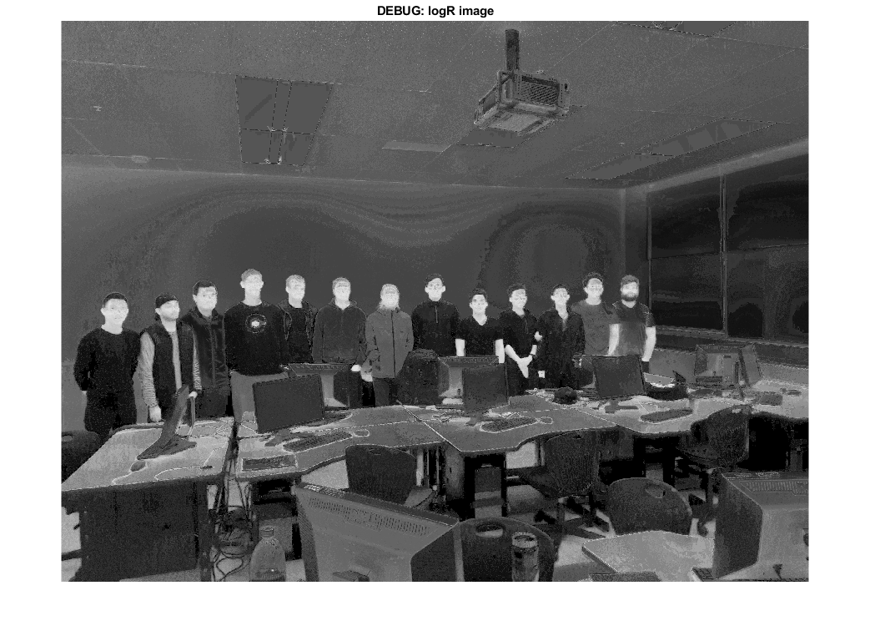
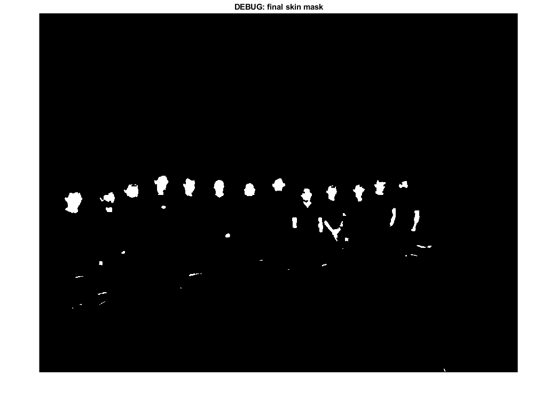
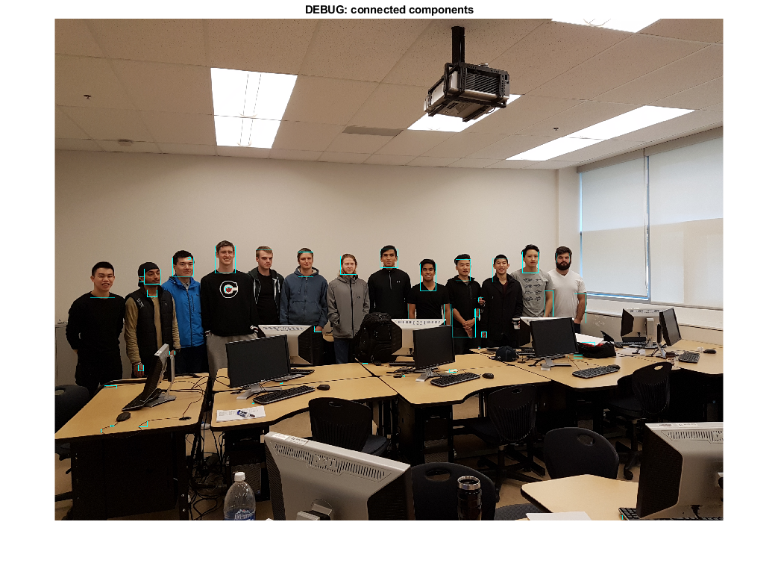
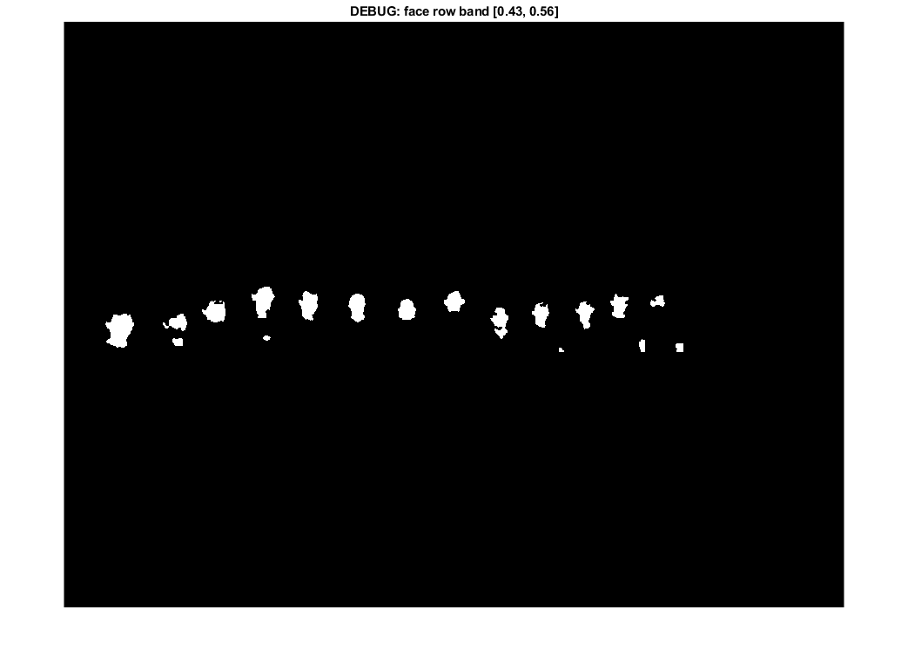
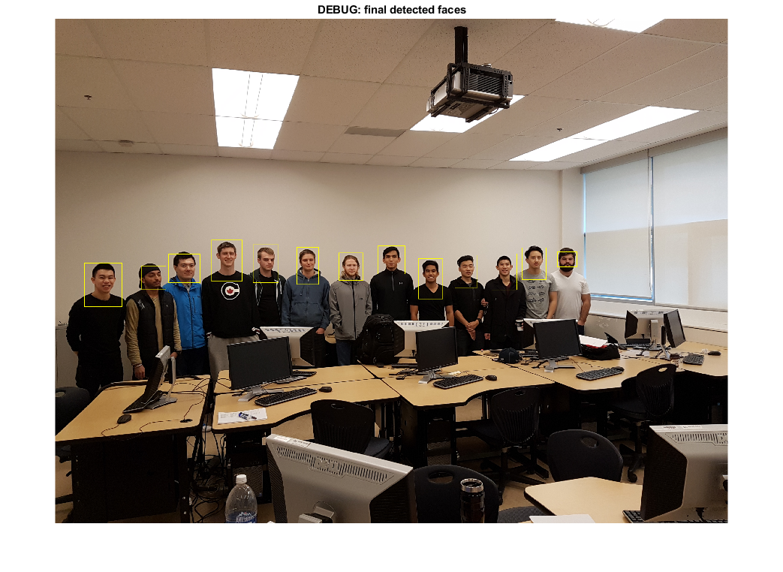

------------------------------------------------------------------------
//Yizuo Chen
function show_faces(imgFile, faces)
% Display detected faces with bounding boxes and center points.
I = imread(imgFile);
figure; imshow(I); hold on;
for i = 1:numel(faces)
bb = faces(i).BoundingBox;
rectangle('Position', bb, 'EdgeColor', 'y', 'LineWidth', 2);
plot(faces(i).Center(1), faces(i).Center(2), 'r+', ...
'MarkerSize', 8, 'LineWidth', 2);
end
title(sprintf('Detected faces: %d', numel(faces)));
end
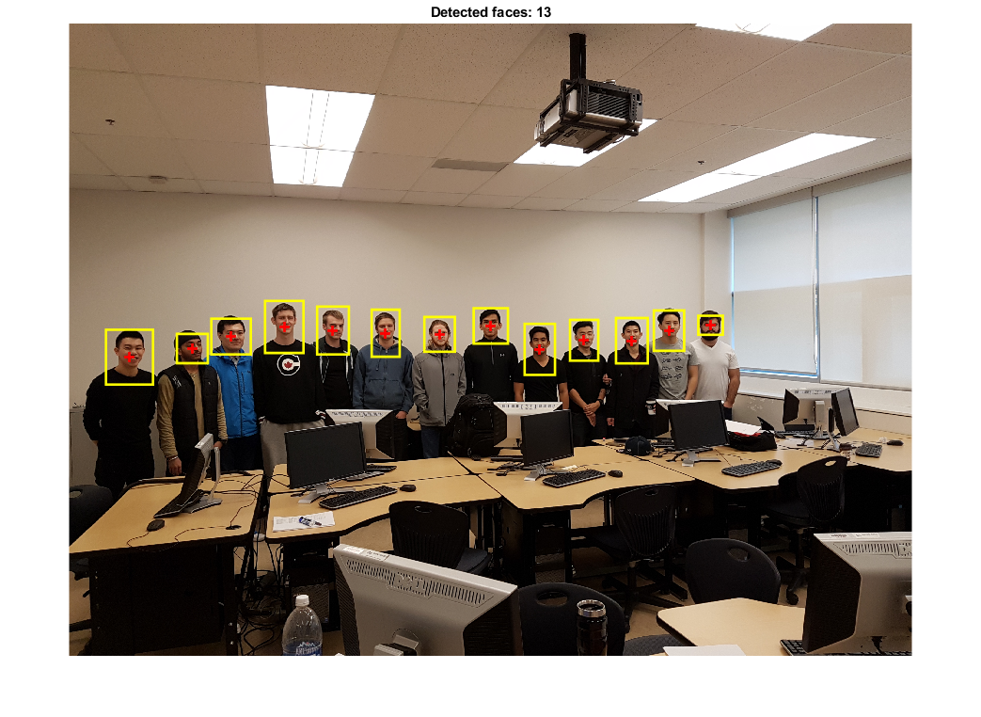

------------------------------------------------------------------------
//Yizuo Chen
function debug_show(img, titleText)
% Helper to show intermediate results with pause.
figure('Name', titleText);
imshow(img, []);
title(titleText,'Interpreter','none');
drawnow;
uiwait(msgbox('OK to continue','DEBUG','modal'));
end
load face_model.mat
faces = detect_faces_image("person2.jpg", model);
show_faces("person2.jpg", faces);
Published with MATLAB® R2024a

