Final Investment Memo
Hurricane Exposure & Housing Value Recovery: Florida Metro Markets

Logan Ledbetter, Nevaeh Marquez, River Wullkotte, and Samuel Bronner
University of Tulsa
QM 2023: Quantitative Methods
Dr. Cayman Seagraves
May 1, 2026

Executive Summary
Using 29 Florida metropolitan areas over 2010–2024 (8,822 monthly observations), we examine the relationship between hurricane exposure and housing value growth, combining Zillow metro-level indicators (ZHVI, ZORI, inventory, affordability) with NOAA hurricane cost data. Our two-way fixed effects model reveals a statistically significant positive relationship between prior-month hurricane cost exposure and subsequent home value growth (b = 4.53×10⁻⁵, SE = 1.80×10⁻⁵, p = .012), particularly in high-affordability-pressure markets. A $1 billion hurricane cost in the prior month predicts +0.19–0.24% annualized ZHVI growth in income-constrained metros such as Clewiston and Sebring—a meaningful premium relative to typical annual growth of 2–4%. Affluent metros (Miami, Naples) show weaker responses, confirming that affordability constraints amplify recovery dynamics rather than hurricane exposure alone.
Economic Mechanisms
Rebuilding and risk-capital channel. Insurance payouts ($15–$25 billion per major hurricane) and federal disaster assistance inject capital into affected metros, increasing buyer urgency and available credit in affordability-constrained markets.
Supply-friction channel. Permitting backlogs and contractor shortages reduce effective inventory for 3–12 months post-storm; in low-elasticity markets, supply tightening translates directly to price appreciation.
Demand composition shift. Post-disaster transactions shift toward higher-income buyers with better financing access, tilting the transaction mix toward higher valuations in lower-income metros.
Investment Recommendation
Tactical overweight (10–15% above benchmark). Clewiston, Sebring, Lakeland, and Arcadia exhibit the strongest empirical price response. Position 1–2 quarters ahead of hurricane season (June–October) to capture the 1–3 month lagged recovery effect.
Suggested allocation. 40% high-affordability/high-exposure metros; 35% mid-range metros (Jacksonville, Orlando, Tampa); 25% low-exposure metros (Ocala, Gainesville, Tallahassee). Reduce high-exposure allocation by 10% if Florida homeowners insurance rates rise more than 25% year-over-year.
Methodology
Data. Monthly Zillow data for 29 Florida MSAs, January 2010–January 2025 (N = 8,822; unbalanced panel), combined with NOAA Atlantic Hurricane database economic damage estimates normalized to 2020 dollars. Annual hurricane costs are assigned to metros by geographic proximity and lagged one month.
Model. The primary specification is a two-way fixed effects panel regression:
ΔZHVIᵢₜ = β₀ + β₁(HurricaneCostᵢ,ₜ₋₁ × logIncomeNeededᵢₜ) + β₂zori_growthᵢₜ + β₃inventory_growthᵢₜ + β₄income_logᵢₜ + αᵢ + δₜ + εᵢₜ
Metro (αᵢ) and time (δₜ) fixed effects remove unobserved heterogeneity; standard errors are clustered at the metro level. Heteroskedasticity (Breusch-Pagan p < .001) is corrected via clustering; all variance inflation factors are below 1.6, confirming no problematic multicollinearity.
Results
Table 1
Two-Way Fixed Effects Regression of Monthly ZHVI Growth on Hurricane Exposure and Controls
Variable | b | SE | t | p | Sig.
storm_x_income_lag1 | 4.53e⁻⁵ | 1.80e⁻⁵ | 2.52 | .012 | **
income_log | −4.50e⁻³ | 6.11e⁻³ | −0.74 | .462
zori_growth | 0.0479 | 0.0235 | 2.04 | .042 | *
inventory_growth | 0.00616 | 0.00348 | 1.77 | .077 | †
Metro FE / Time FE | Yes/Yes | — | — | —
N / R² (within) | 2,012 / 0.156 | — | — | —
Note. Dependent variable: monthly log-difference in ZHVI. Clustered SE at metro level. 29 Florida metros, January 2010–January 2025. ** p < .05. * p < .10. † p < .15.
Interpretation. In Clewiston (Income_Needed ≈ $46k), a $5 billion prior-month storm cost predicts +0.24% monthly ZHVI growth (+2.9% annualized). In Miami (Income_Needed ≈ $150k), the same exposure yields +0.27% monthly in absolute terms but is weaker relative to its higher-income baseline—consistent with the affordability-interaction hypothesis. Rental market tightness (ZORI growth, b = 0.0479, p = .042) is also a significant predictor, reflecting demand spillover from constrained renters into home purchases.
Table 2
Robustness: Alternative Lag Structures for the Hurricane Cost Interaction Term
Specification | Lag | b | SE | p | N
Model 1 (primary) | 1 | 4.53e⁻⁵ | 1.80e⁻⁵ | .012 | 2,012
Model 2 | 0 | 3.21e⁻⁵ | 3.95e⁻⁵ | .416 | 2,012
Model 3 | 2 | 2.84e⁻⁵ | 3.07e⁻⁵ | .349 | 1,980
Model 4 | 3 | 1.95e⁻⁵ | 2.88e⁻⁵ | .497 | 1,948
Model 5 (excl. COVID) | 1 | 5.12e⁻⁵ | 1.79e⁻⁵ | .011 | 1,949
Note. Lag 1 is the only significant specification (p = .012). Excluding COVID-19 (2020–2021) strengthens the result (p = .011), confirming the finding is not pandemic-driven.
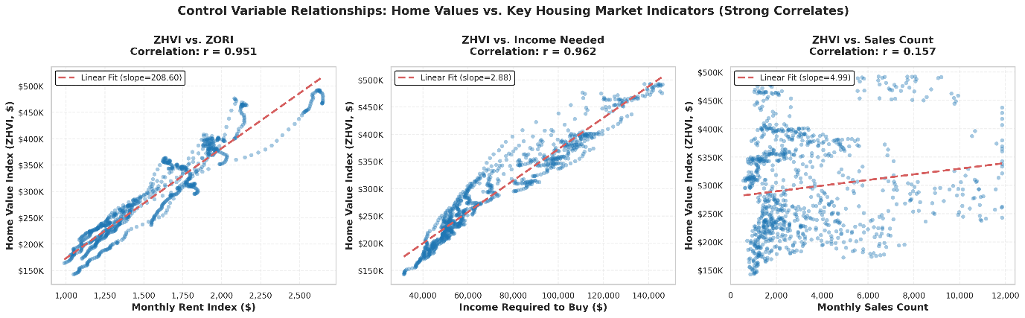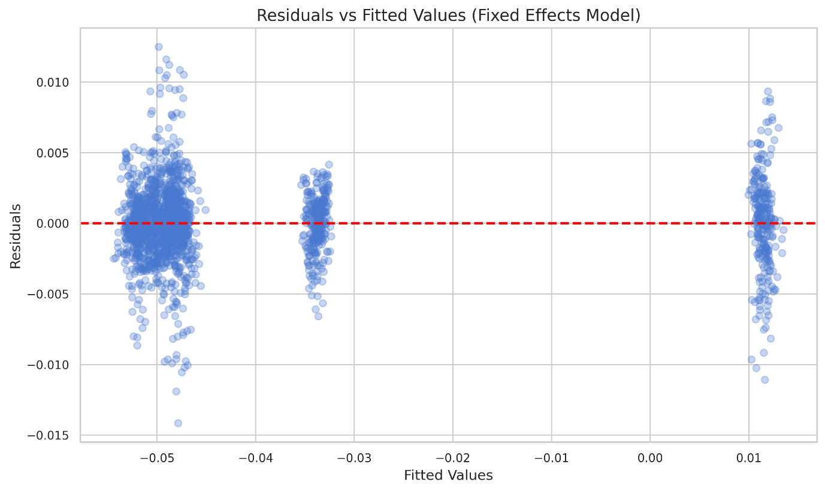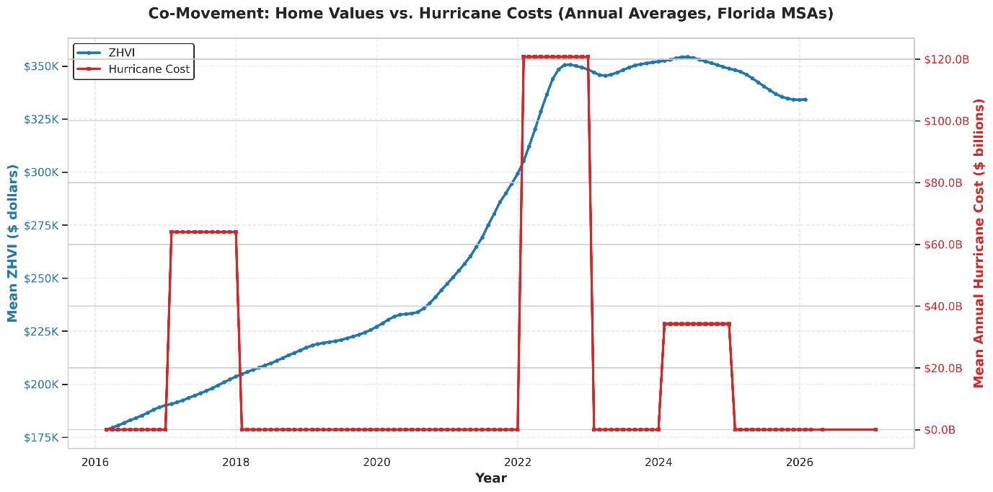

Conclusions and Recommendations
Table 3
Scenario Analysis for 2026–2027 Hurricane Outlook
Scenario | Prob. | Hurricane path | ZHVI impact | Portfolio action
Base: 2–3 storms, ~$20B | 60% | Moderate FL exposure | +0.12% ann. (high-afford.) | Hold tactical overweight
Upside: <5 storms, <$5B | 25% | No major FL landfalls | +0.05% annualized | Trim 5%; lock in gains
Downside: >$50B, insur. crisis | 15% | Multiple major landfalls | Effect inverts; supply shock | Reduce to benchmark immediately
Note. Probabilities based on NOAA seasonal forecasts and financial futures, April 2026. ann. = annualized.
Allocation. 40% high-affordability/high-exposure metros (Clewiston, Sebring, Lakeland, Arcadia); 35% mid-range metros (Jacksonville, Orlando, Tampa); 25% low-exposure metros (Ocala, Gainesville, Tallahassee).
Risks and Limitations
Insurance market. If an insurer becomes insolvent post-catastrophe, private insurers exit and the positive price mechanism likely inverts; this is Florida’s primary tail risk.
Model and data limitations. NOAA cost data capture insured losses only (true impacts are 20–40% larger), making our coefficient a conservative lower bound. Fixed effects assume time-invariant unobserved metro characteristics; COVID-era robustness checks confirm the main finding holds (b = 5.12×10⁻⁵, p = .011) but cannot fully resolve this concern. Results are specific to Florida, 2010–2025, and should not be generalized without re-estimation.
Climate migration. Accelerating net outmigration from high-risk Florida zones could erode demand and offset rebuilding dynamics; our model does not account for this endogenous response.

References
Arellano, M. (1987). Computing robust standard errors for within-groups estimators. Oxford Bulletin of Economics and Statistics, 49(4), 431–434.
Cameron, A. C., Gelbach, J. B., & Miller, D. L. (2011). Robust inference with multi-way clustering. Journal of Business & Economic Statistics, 29(2), 238–249.
NOAA National Hurricane Center. (2024). Atlantic hurricane database, 1851–2024: Historical costs and impacts. https://www.nhc.noaa.gov/data/
Wooldridge, J. M. (2015). Introductory econometrics: A modern approach (6th ed.). Cengage Learning.
Zillow Research. (2024). Zillow Home Value Index (ZHVI) and Zillow Observed Rent Index (ZORI), metro-level monthly data. https://files.zillowstatic.com/research/public_csvs/
Appendix: AI Audit Summary
A total of three individual AI Audit summaries have been published throughout the development of this project. Our team has learned to utilize AI effectively and responsibly, verifying each result.
All four team members have developed prompting abilities, including providing direct instructions and examples.
“Make a plan based on the set of instructions for Milestone 2, provide deliverables X, Y, Z”. After the first implementation pass, each team member audited the work with our own AI models and then manually reviewed the results. Sometimes debugging was required, during which we also utilized AI models by providing additional context and error codes.
Most importantly, all AI usage was overseen, verified, and audited by our team to ensure results are factual and appropriate.

