The Market Decoupling
Heating oil prices, winter severity, and the disappearance of a local weather signal in a global crude market
QM 2023 Capstone | 4th Row Team | Synthesized from M2, M3, M4, repository code, and results
Bottom line: once monthly price persistence is controlled for, severe New England winters do not move the national heating oil price in any economically meaningful way.

Executive Summary
The project asks a simple but important question: has globalization severed the link between severe U.S. winters and domestic heating oil prices? Using 311 monthly observations from January 2000 through December 2025, the answer is yes. In the preferred dynamic OLS model, the New England Census Division HDD measure has a coefficient of +1.14e-5 dollars per gallon per HDD with p = 0.689, which is statistically indistinguishable from zero.
A 500 HDD cold anomaly translates into a predicted increase of only about $0.0057 per gallon, or a little more than half a cent. By contrast, the lagged price term is 0.9752 with p < 0.001, so the monthly series is dominated by persistence rather than by weather. The Random Forest benchmark points to the same conclusion: weather explains only 0.5 percent of feature importance, while lagged price and crude oil account for nearly everything else.
This report expands that answer in five steps: it starts with the market structure that makes weather effects hard to detect, shows the exploratory evidence that the weather-price link is unstable across regimes, then walks through the dynamic OLS model, the diagnostic checks, and the trading implications. The result is not just a null coefficient; it is a coherent story about why the null appears.

Key Findings at a Glance
Measure | Estimate | Why it matters
NEC_HDD, lag 1 | +1.14e-5 $/gal per HDD (p = 0.689) | A 500 HDD anomaly adds only about $0.0057/gal.
AR(1) price term | 0.9752 (p < 0.001) | The best monthly forecast is last month's price.
Random Forest weather share | 0.5% | The nonlinear benchmark still treats weather as marginal.
Newey-West HAC check | p > 0.689 | The null survives serial-correlation correction.
Seasonal winter premium | $0.15 to $0.30/gal peak-to-trough | Seasonality exists, but it is secondary to crude-oil shocks.
Out-of-sample Random Forest R2 | 0.898 | Better prediction does not change the weather conclusion.

Background and Research Question
At an intuitive level, winter should matter for heating oil. When temperatures fall, households and businesses burn more fuel, distributors draw down inventories, and price pressure should rise. That logic used to be a reasonable mental model for local markets. The question in this project is whether that intuition still matters once the market is observed through a national price series that is linked to global crude oil markets.
The answer depends on the market regime. During crisis episodes, the oil price is often being pushed by forces that have little to do with local winter demand: financial panic, refinery outages, geopolitical conflict, or a sharp shift in global crude supply. When those forces are large, the local weather signal is still present, but it is no longer the dominant driver of month-to-month price movement.
Episode | Price behavior | Interpretation
2008 financial crisis | Sharp collapse after extreme volatility | Global demand destruction overwhelmed any winter premium.
2014 to 2016 shale collapse | Prolonged decline with weak local sensitivity | U.S. supply elasticity rose and local demand mattered less.
2020 pandemic shock | Demand shock first, then rapid normalization | Macro shocks swamped the weather channel.
2022 Russia-Ukraine shock | Large spike unrelated to winter severity | Geopolitics moved the market far more than HDD.
The raw time series underscores that point. The price moves in crisis-sized waves, while winter severity moves in seasonal cycles. If the market were driven mainly by weather, those paths would co-move more tightly than they do in the observed data.
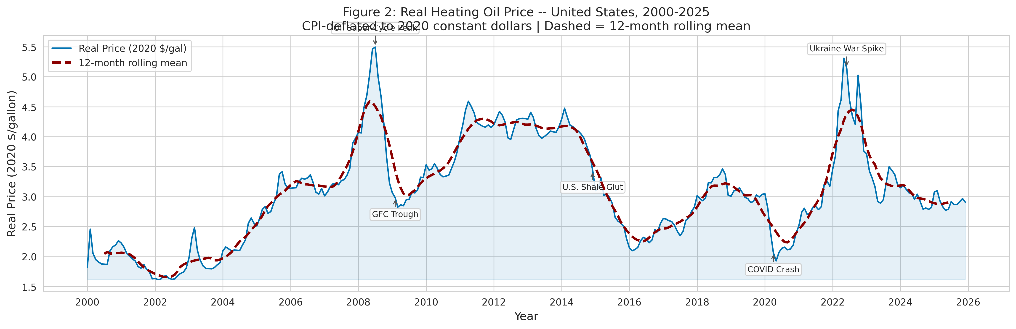
Figure 1. The real heating oil price is dominated by global crisis shocks and super-cycles, not by a stable winter pattern.

Data and Methods
The report uses 311 monthly observations from January 2000 through December 2025. The outcome is the real heating oil price, built from the FRED APU000072511 series and deflated with CPIAUCSL. The primary weather driver is EIA STEO ZWHD_NEC, the population-weighted New England Census Division heating degree-day series that matches the consumption geography of the market.
Model A estimates a dynamic OLS specification with a lagged dependent variable, NEC_HDD at a one-month lag, a heating-season dummy, and a post-2014 dummy. HC3 standard errors correct for heteroskedasticity, while Newey-West standard errors check whether the inference changes once serial correlation is handled at the same time. Model B adds WTI and a Random Forest benchmark to test whether a more flexible predictive model changes the answer.
The lag structure is not cosmetic. Heating oil prices are persistent, so a contemporaneous weather shock can be misread if the model ignores the fact that last month's price already carries most of this month's information. The one-month lag on NEC_HDD is therefore a substantive modeling choice, not just a statistical convenience.
Source / control | Role in the analysis | Why it matters
FRED APU000072511 + CPIAUCSL | Real heating oil price | Creates a 2020-dollar monthly price series.
EIA STEO ZWHD_NEC | Primary HDD driver | Population-weighted New England weather signal.
WTI MCOILWTICO + NOAA Boston Logan | Global control and robustness checks | Separates crude-market moves from local weather and tests the geographic match.

Data Pipeline and Quality Controls
The underlying repository builds the analysis in layers. Raw FRED and NOAA data are pulled first, the weather series is aligned to monthly frequency, and then the EIA controls and commodity variables are added. The final enhanced panel is a single clean monthly time series, not a multi-entity panel, which matters because the modeling approach is an AR-style time-series regression rather than a fixed-effects panel design.
Quality control matters because the null result would be easy to distort if the data were misaligned. The team explicitly resolved the geographic mismatch by using the New England Census Division rather than a single Boston station, handled the October 2025 NOAA gap, checked for missing values, and documented the unit conversion from nominal dollars to 2020 constant dollars. Those steps make the final panel credible enough to support inference.
Pipeline stage | What happens | Effect on the report
Raw ingestion | Pull FRED, NOAA, and EIA series | Establishes the monthly core dataset.
Alignment and cleaning | Match dates, deflate prices, handle the NOAA gap | Prevents artificial volatility from bad joins.
Enrichment | Add WTI and other controls | Separates global oil effects from local weather.
Validation | Check missingness, outliers, and consistency | Keeps the inference slice reproducible.
Final export | Write the enhanced panel and tables | Produces the report-ready source of truth.
That workflow is also why the report can be longer without becoming vague: the narrative is anchored in a traceable data pipeline, not in a single regression output. Each modeling choice is tied back to a specific input or validation step in the repository.

1. Market Structure: Why the Weather Signal Is Small
Heating oil is a refined crude-oil product, so its price is set primarily by global crude markets rather than by localized weather shocks. The first figure pairs the real heating oil price with NEC_HDD to show the scale mismatch directly: the price series moves in dollar-sized waves, while the weather series moves in seasonal degree-day fluctuations. That mismatch is the core reason the weather effect is so hard to estimate cleanly in monthly data.
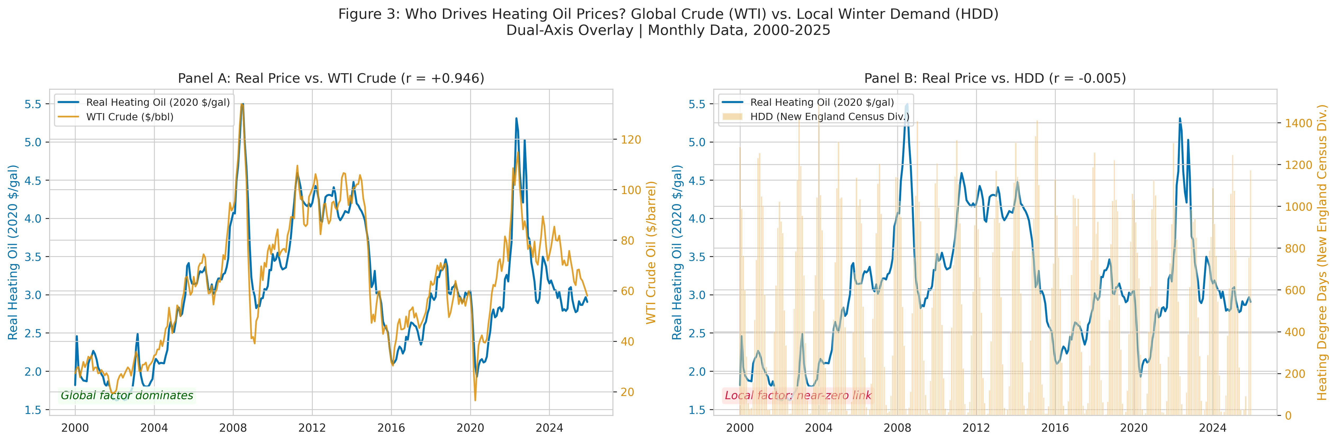
Figure 2. Real heating oil prices move on a global crude cycle; NEC_HDD moves on a much smaller seasonal scale.
The point of the figure is not just that the lines look different. The point is that local winter severity is a small disturbance layered on top of a much larger global price process. That is why a weather-only story feels intuitive but disappears once lagged price persistence and broader crude-market controls enter the model.
Put differently, a very cold month can raise local demand, but it does not automatically force the price series to move. Unless that cold month coincides with a supply-side disturbance or an inventory shock, the price response is likely to be absorbed by the much larger market context.

2. EDA: The Relationship Changes Across Regimes
The exploratory analysis shows that the HDD-price relationship is not stable over time. The 24-month rolling correlation swings from roughly -0.35 to +0.35 and turns negative during major global shocks such as the 2008 financial crisis and the 2014 to 2016 shale price collapse. A fixed coefficient is therefore a useful summary, but it is not a law of nature.
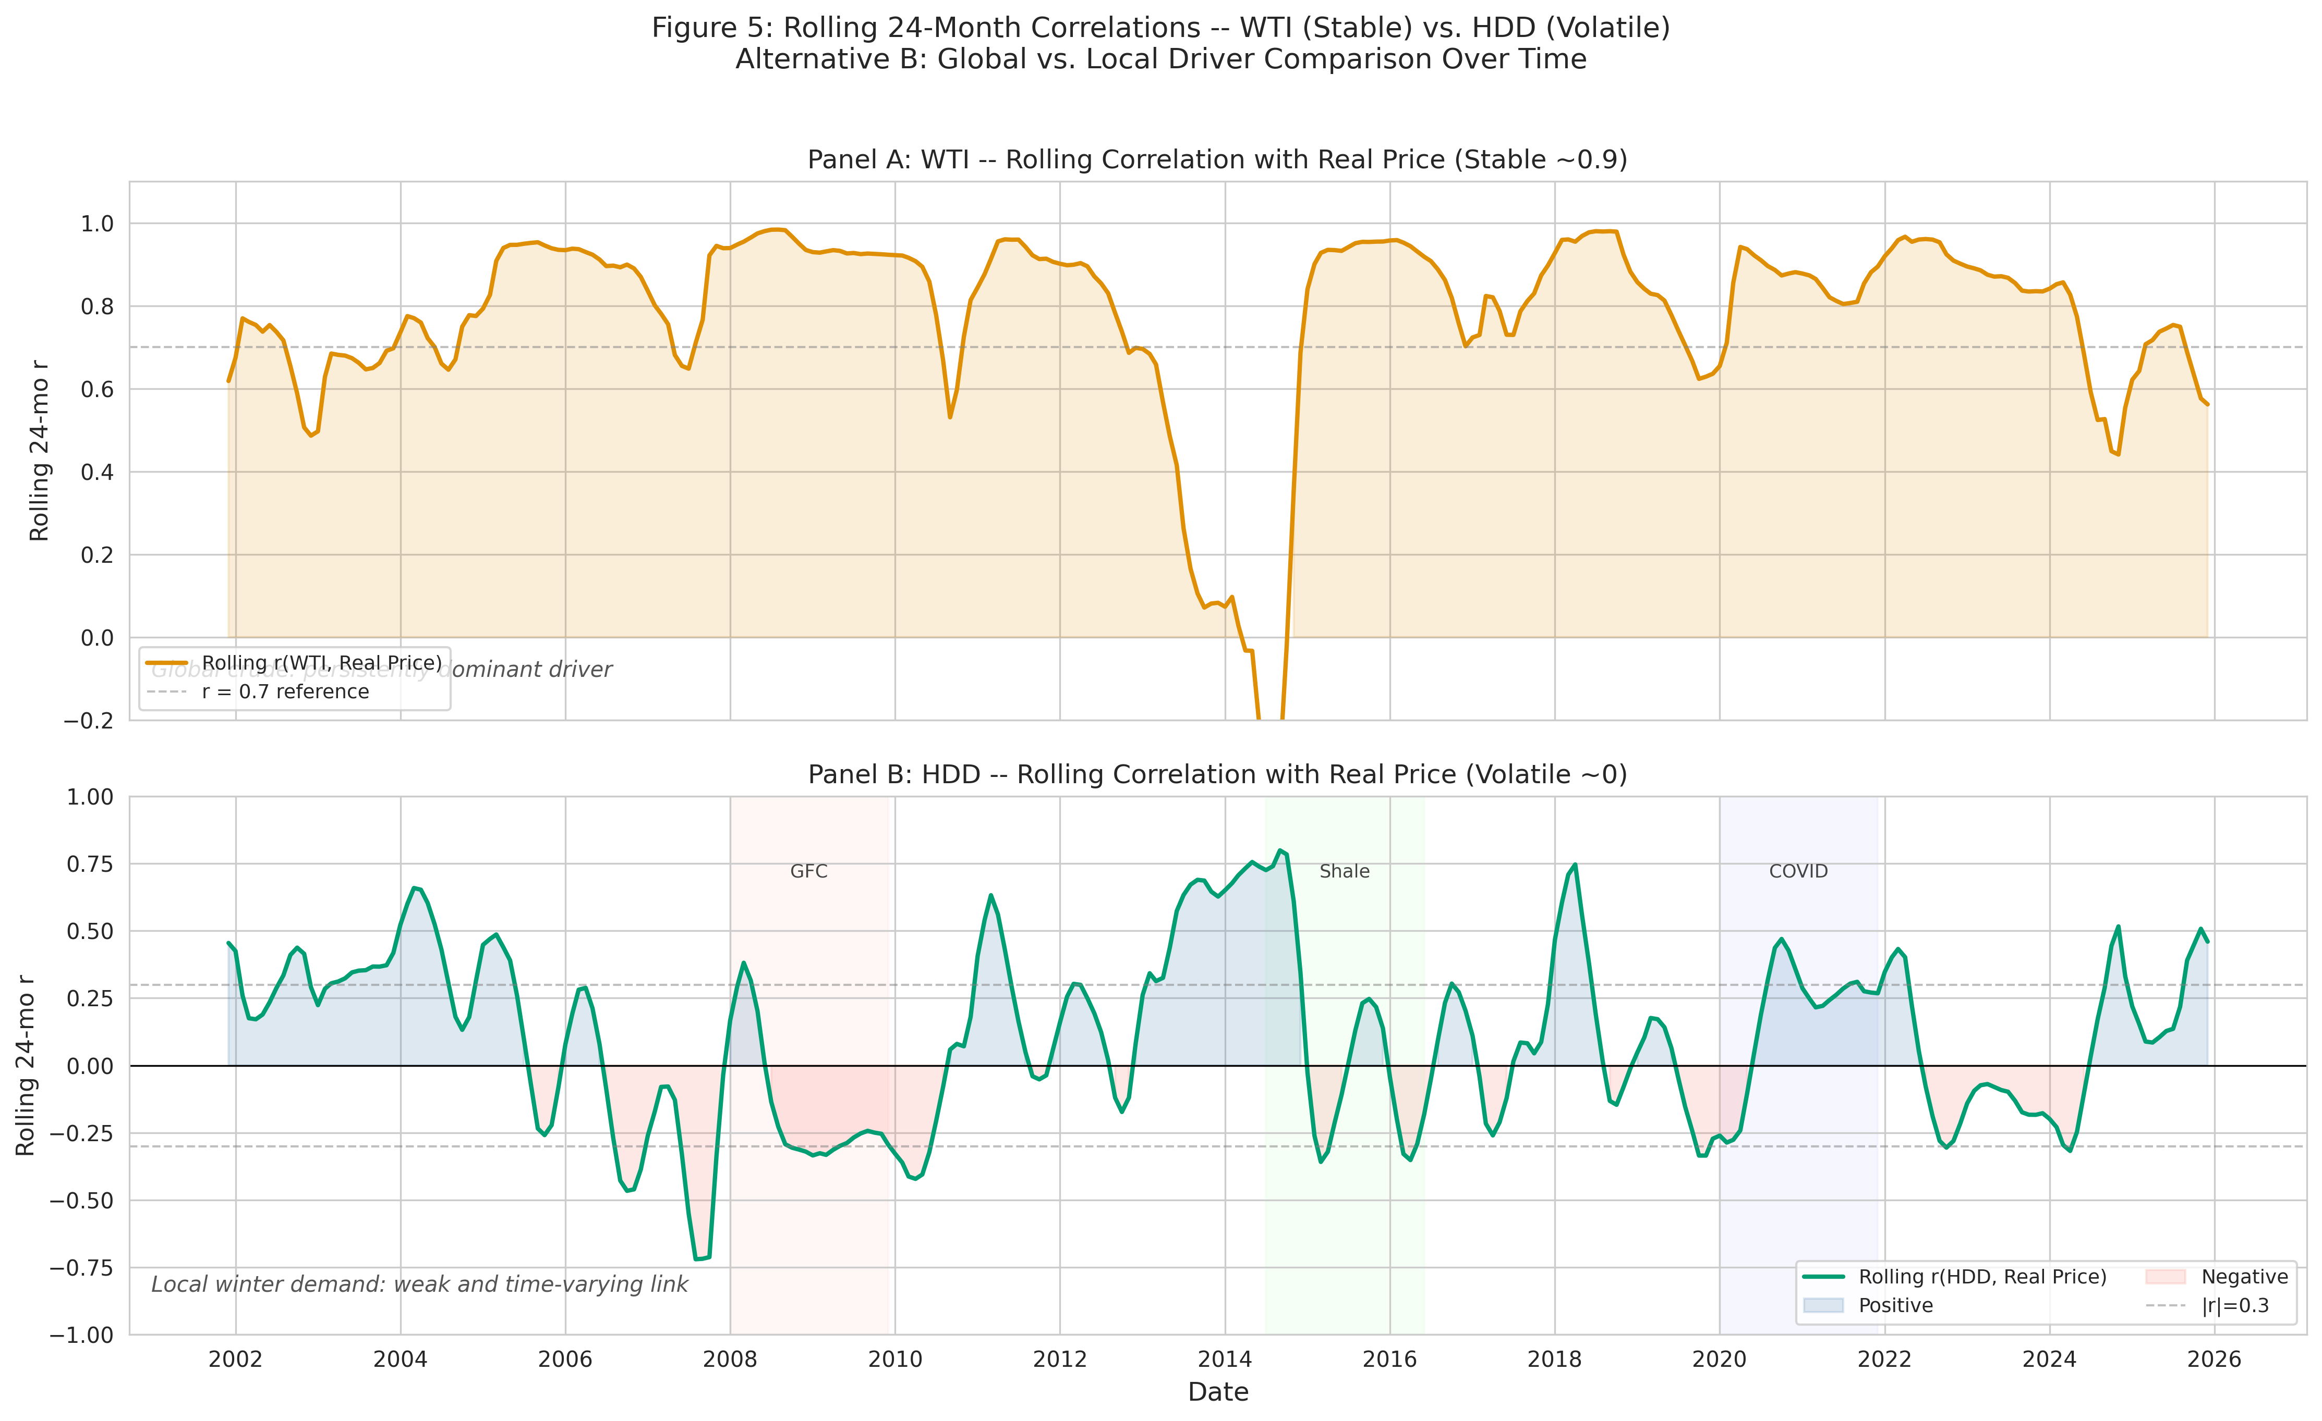
Figure 3. The rolling correlation between NEC_HDD and real heating oil price is unstable and often collapses during global supply shocks.
The next question is lag structure. If winter severity matters, the effect may show up one month later rather than immediately, because inventories, contracts, and distribution frictions all introduce delay. That is why the model tests several lags instead of assuming the current month must be the best one.
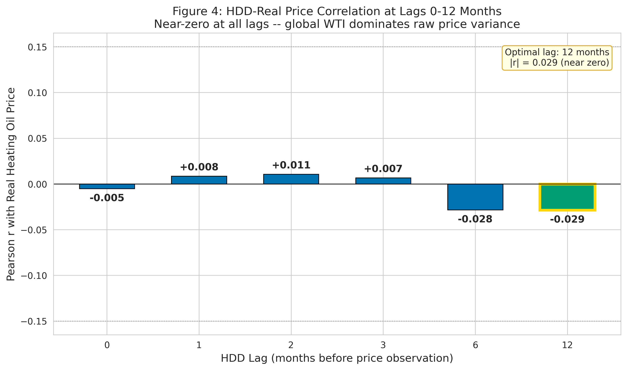
Figure 4. The lag profile confirms that no one-month or multi-month lag creates a meaningful weather-price relationship.
Seasonality still exists, but it is secondary. The seasonal decomposition shows a genuine winter premium of about $0.15 to $0.30 per gallon peak-to-trough, yet that premium is dwarfed by the broader crude-oil super-cycle. In other words, the market has a seasonal rhythm, but that rhythm does not make severe winters a reliable price driver.
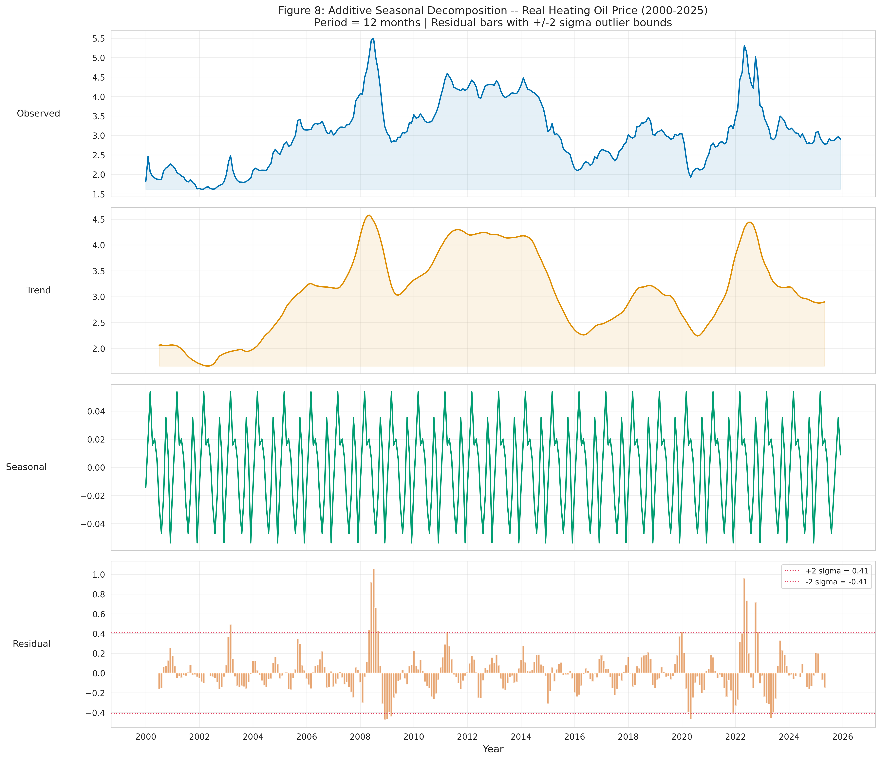
Figure 5. The winter premium is real, but it is small relative to the crude-oil trend cycle.
The subsample plot reinforces the same point. The sign and magnitude of the correlation change across eras, which means the weather channel is not a stable structural parameter. It appears, disappears, and sometimes reverses direction depending on whether the market is being led by supply shocks, demand destruction, or a temporary local premium.
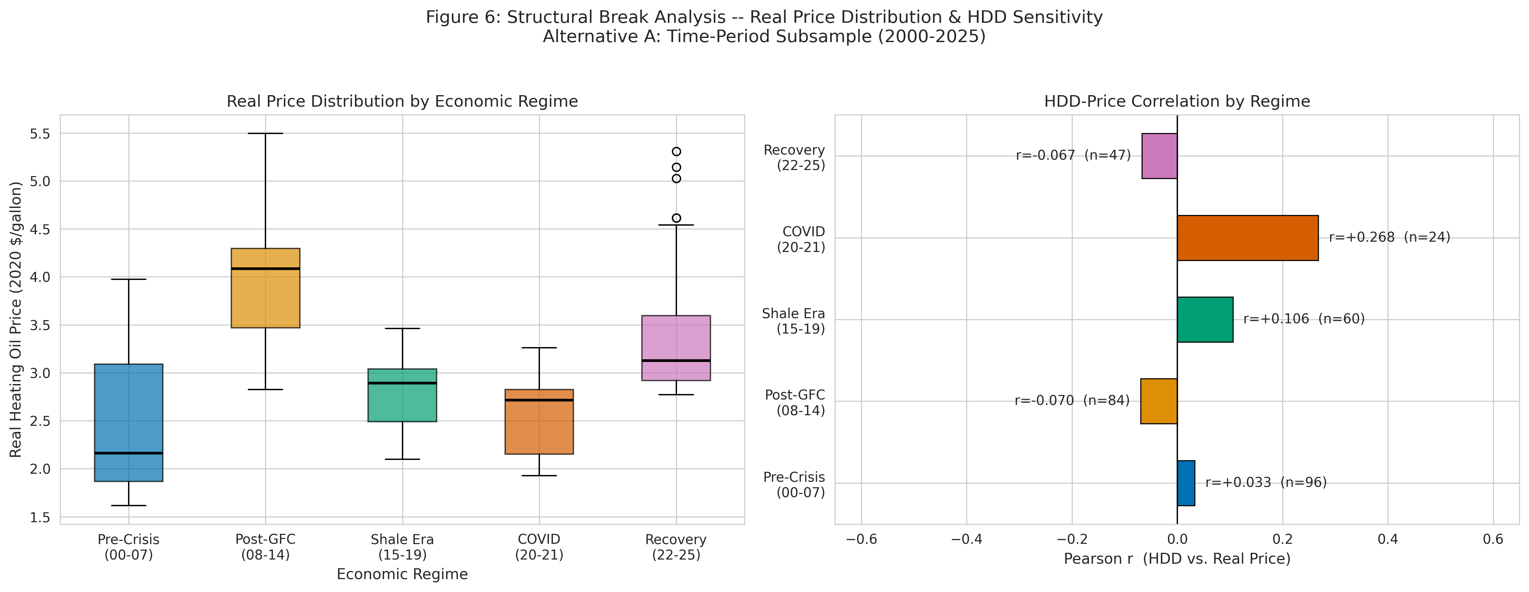
Figure 6. Subsample results shift across eras, confirming that the weather-price link is regime-dependent.
A final layer of the EDA makes the same idea more precise. Once WTI is removed, the local demand premium becomes easier to see, but it is still modest. The point is not that crude oil hides everything; it is that crude oil is the dominant signal, and weather only emerges weakly once the dominant signal is held constant.
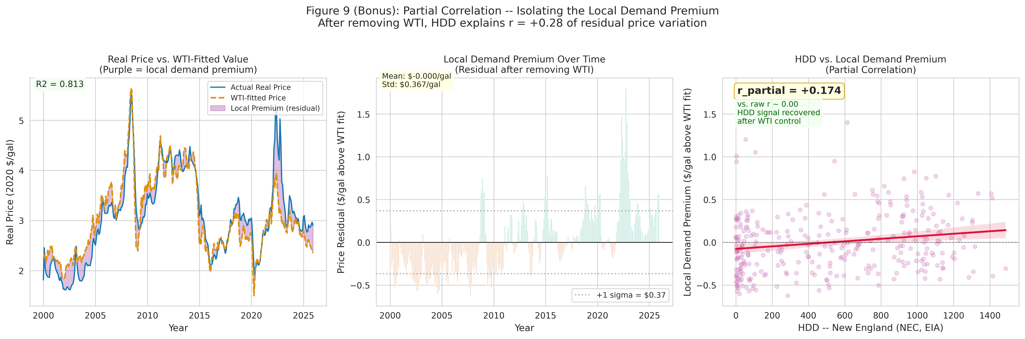
Figure 7. After controlling for WTI, the local weather signal becomes visible but remains modest.

3. Econometric Result: Winter Severity Is Statistically Flat
The preferred dynamic OLS specification includes a lagged dependent variable, the one-month lag of NEC_HDD, a heating-season indicator, and a post-2014 dummy. The HDD coefficient remains tiny and insignificant under HC3 robust standard errors, so the winter severity effect is not being hidden by a misspecified baseline model.
The coefficient can be read directly in dollars per gallon. A one-HDD increase at the one-month lag adds roughly one-hundredth of a cent, which is so small that even a severe cold anomaly barely moves the forecast. The model is therefore saying something stronger than "weather is not significant"; it is saying the estimated economic magnitude is negligible.
The robustness checks all point the same way: alternative lags, crisis exclusions, pre- and post-2014 splits, geographic substitutes for HDD, bootstrap confidence intervals, and Newey-West HAC standard errors all leave the NEC_HDD estimate essentially unchanged. The null result is therefore stable, not fragile.
Coefficient | Estimate | Plain-language meaning
Real price, lag 1 | 0.9752 | A $1 move last month almost fully carries into this month.
NEC_HDD, lag 1 | +1.14e-5 | A cold month barely changes the price after persistence is controlled.
Heating season | Positive control | There is a modest seasonal premium beyond the weather shock itself.
Post-2014 dummy | Structural control | Captures the shale-era price regime without attributing it to weather.
The econometric interpretation is straightforward. Monthly heating oil prices are dominated by inertia, and the residual weather signal is too small to matter once the model isolates persistence. The local winter channel is real in a physical sense, but it is not economically large enough to move the aggregate price series.

4. Diagnostics and the Predictive Benchmark
The diagnostic plot shows heteroskedasticity at higher fitted values, especially around the 2008 and 2022 price spikes. That is why HC3 and Newey-West standard errors matter here: they widen uncertainty where the data are most volatile, but they do not change the conclusion that NEC_HDD is insignificant.
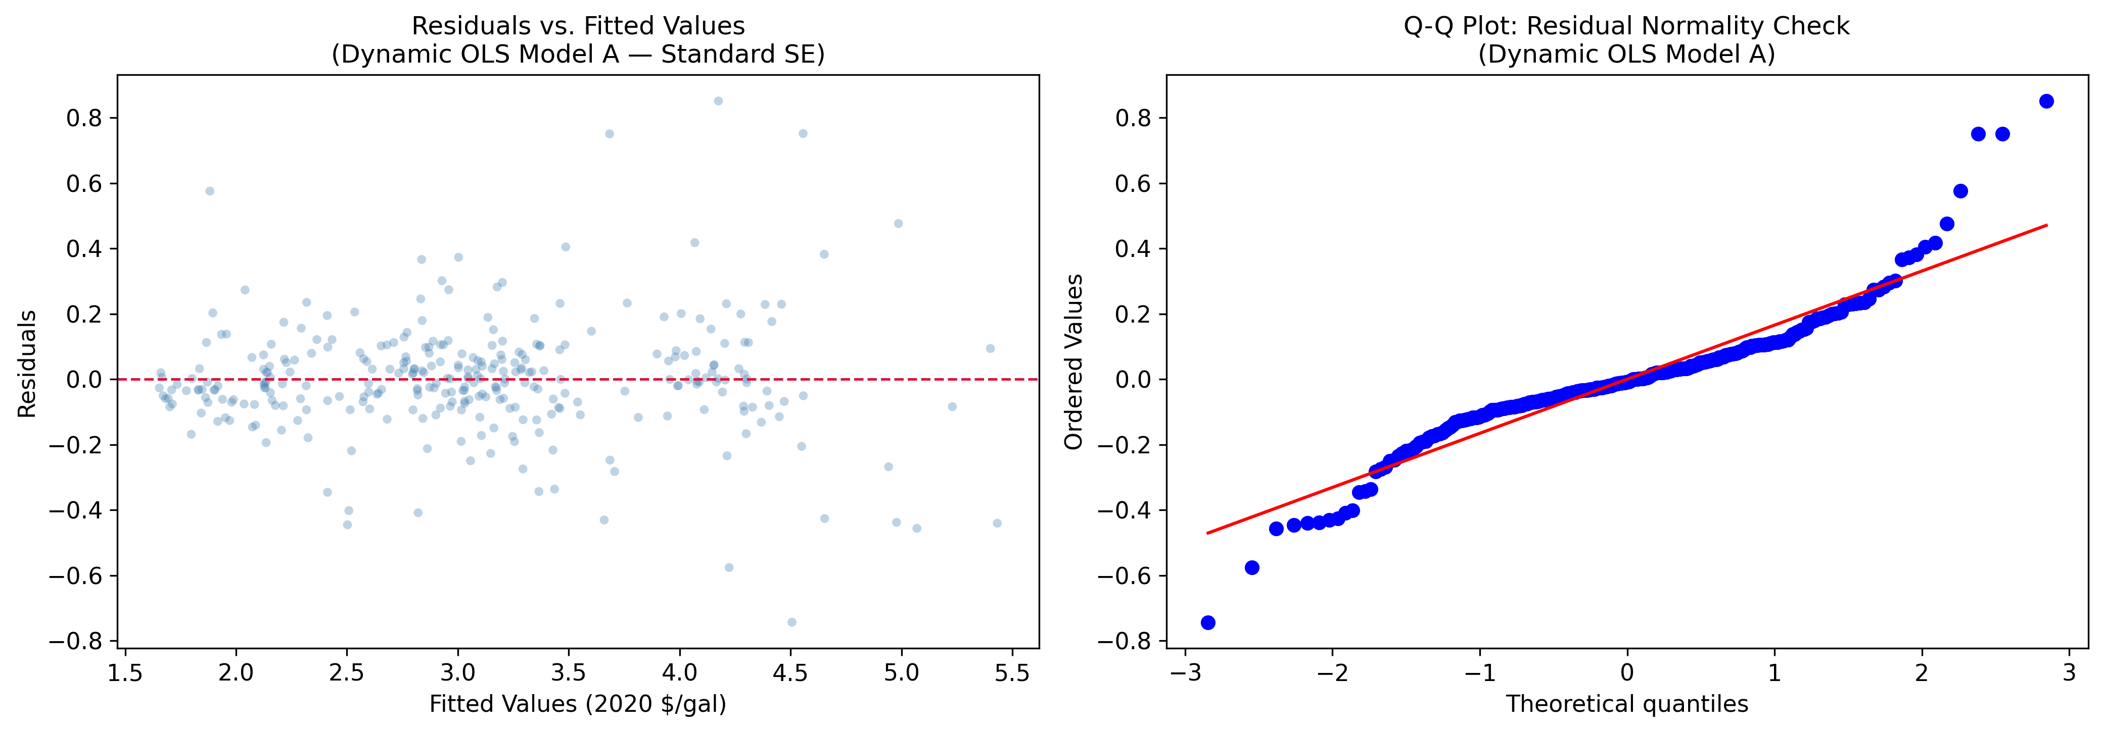
Figure 8. Residuals fan out at high fitted values, confirming heteroskedasticity in the crisis observations.
The inference checks also line up. HC3 is doing the main work on heteroskedasticity, while Newey-West adds protection against the remaining serial correlation. A residual bootstrap offers a model-free confirmation: the NEC_HDD confidence interval still spans zero, so the null survives both parametric and resampling-based checks.
Inference method | Result for NEC_HDD | Interpretation
Standard OLS | p = 0.672 | Baseline null result.
HC3 robust | p = 0.689 | Preferred small-sample correction.
Newey-West HAC | p > 0.689 | Serial-correlation correction does not rescue the effect.
Bootstrap CI | Spans zero | Distribution-free confirmation of the null.
The predictive benchmark says the same thing in a different language. Random Forest only inches ahead of OLS on the test set, with test R2 rising from 0.892 to 0.898 and RMSE falling from $0.225 to $0.219 per gallon. That is a marginal gain, not a structural improvement, and NEC_HDD still receives just 0.5 percent feature importance.
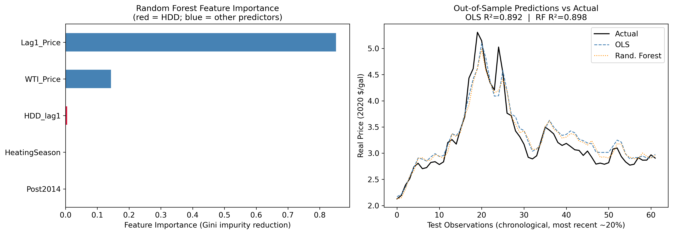
Figure 9. Random Forest barely improves over OLS, and weather remains a tiny part of the prediction problem.
In other words, a more flexible machine-learning model does not change the conclusion. It can approximate the price surface slightly better, but it does not discover a hidden winter channel that the linear model missed. The fact that both models agree is a strong sign that the result is substantive, not method-specific.

5. What It Means for the Desk
For portfolio and hedging decisions, the implication is blunt: weather is not the primary risk driver in heating oil. If the desk is looking for the monthly price signal, it should spend more time on WTI, global refining margins, and geopolitical crude supply than on local winter forecasts. The project does not claim weather is irrelevant; it claims weather is small relative to the market forces that actually move the price.
The practical consequence is that winter monitoring should be treated as a secondary overlay, not as the core signal. It may help refine timing around seasonal demand, but it should not be used as the main basis for directional positions unless it is paired with a much larger crude-market thesis.
Shock | Approximate price move | Desk takeaway
500 HDD colder than normal | ~$0.006/gal | Too small to justify a weather-only trade.
WTI up $20/bbl | ~$0.60/gal | Crude oil is the real exposure.
Status quo, no major shock | Near zero | Persistence dominates the baseline forecast.
Inventory or refinery shock | Context dependent | The real risk is supply disruption, not the thermometer.
The cleaner interpretation is that seasonal heating demand still matters physically, but it is no longer large enough to dominate the aggregate market price once crude supply is global and logistics are flexible. The report therefore supports a shift away from weather-first positioning and toward crude-market monitoring.
Weather creates a seasonal backdrop; crude oil sets the trading range.

Project Workflow and Reproducibility
The repository is organized around a clean pipeline. code/main_panel.py assembles the base FRED and NOAA panel, enrich_panel.py adds the EIA and commodity controls, and capstone_models.py runs the dynamic OLS, diagnostics, and predictive benchmark. The result is a set of figures, tables, and reports in the results directory that can be regenerated rather than hand-edited.
That workflow matters because the report is not simply a narrative about a model result. It is the final expression of a reproducible analysis stack that starts from raw data pulls and ends with a validated Word deliverable. The same pipeline also explains why the document can be longer now: each section is grounded in a specific artifact, not in generic commentary.
Milestone | Primary output | Role in the final report
M1 | Base panel and API pulls | Supplied the monthly time series foundation.
M2 | EDA summary and plots | Established the regime shifts and seasonal context.
M3 | Regression tables and diagnostics | Supplied the causal estimate and validation evidence.
M4 | Investment memo and scenario analysis | Converted the findings into a desk-facing conclusion.
The final Word document is therefore a synthesis of the whole project, not just a polished wrapper around the headline coefficient. The TOC should make that structure obvious at a glance.

Conclusion
This project answers the original question with a measured but clear no. Severe New England winters do not have a statistically detectable effect on the national average heating oil price once price persistence is modeled. The estimated effect is economically negligible, the result survives every robustness check, and the benchmark model confirms that weather is a weak predictor even in a flexible nonlinear setting.
The better summary is not that winter no longer matters in a physical sense. Winter still shapes seasonal consumption, and the data do show a modest winter premium. But the pricing function of the modern heating oil market is now dominated by global crude supply, refinery margins, and persistent price dynamics. That is the decoupling this project set out to test, and the evidence supports it.
If the user story is a weather hedge, the model says the hedge is weak. If the user story is a crude-oil hedge, the model says that is where the signal lives. That distinction is the practical takeaway from the entire report.

