**Report: Predicting Father’s Education Level from Mother’s Education Level Using Linear Regression Analysis**

**Stefani D.W. Yates**

**RES814-2404C-02**

**Dr. Richard Miller**

**Colorado Technical University**

**Predicting Father’s Education Level from Mother’s Education Level Using Linear Regression Analysis**

Educational attainment is a critical factor in understanding social mobility and the intergenerational transmission of socioeconomic status. Research often examines the relationship between parental education levels and their impact on their children's future achievements. Parental education is recognized as one of the strongest predictors of a child’s educational success, with both mother's and father's education playing significant roles in shaping family dynamics and outcomes (Pallant, 2021). By understanding how parents' education levels relate to one another, researchers can uncover patterns of educational transmission within families. This analysis uses linear regression to predict a father’s education level based on the mother’s.

This analysis explores the relationship within families between the mother's education (independent variable: maeduc) and the father's education (dependent variable: paeduc). Specifically, we use data from the *General Social Survey* (GSS) to develop a linear regression model that estimates how much the mother’s education can predict the father’s education level. This approach allows us to assess the strength and direction of the relationship while accounting for variance explained by the model (Field, 2018). The regression results are presented, along with a scatterplot that includes a line of best fit to represent the relationship between the two variables visually.

**Methodology**

This analysis uses a simple linear regression model to predict the father’s education level based on the mother’s education level. The regression equation takes the following form:

*Y = b0 + b1X*

Where:

* Y represents the predicted father’s education level (paeduc),
* X represents the mother’s education level (maeduc),
* b0​ is the intercept, or the predicted value of Y when X is zero,
* b1 is the slope, representing the average change in the father’s education level for each additional year of the mother’s education.

The analysis was conducted using SPSS, a widely used statistical software that enables researchers to compute regression models and generate visualizations like scatterplots (Pallant, 2021). This method allows for a straightforward interpretation of the relationship between the independent and dependent variables (Sweet & Grace-Martin, 2021). The results include the regression equation, coefficient of determination (R²), and a scatterplot with a line of best fit.

**Results**

1. **Regression Equation**

The linear regression equation derived from the SPSS output is:

*Father’s Education (paeduc) = 2.607 + 0.757 × Mother’s Education (maeduc)*

This equation suggests that for every additional year of the mother’s education, the father’s education increases by 0.757 years. The intercept value of 2.607 represents the predicted education level of the father when the mother has zero years of education, though this scenario is uncommon in most real-world cases (Field, 2018).

1. **Total Variance Accounted For**

The R-squared (R²) value is 0.405, indicating that approximately 40.5% of the father's education level variance is explained by the mother’s education level. This suggests a moderately strong relationship between the two variables, though other factors not included in this model likely influence the father's education level (Pallant, 2021).

1. **Prediction of Father’s Education**

Using the regression equation, we can predict the father’s education level when the mother has 16 years of education:

*Father’s Education = 2.607 + 0.757 × 16 = 2.607 + 12.112 = 14.719 years*

Therefore, for a mother with 16 years of education, the predicted father’s education level is approximately 14.72 years.

1. **Scatterplot and Line of Best Fit**

The scatterplot generated in SPSS (Figure 1) shows the relationship between the mother’s and father’s education levels. A line of best fit is overlaid, showing a positive slope, which indicates that higher maternal education is generally associated with higher paternal education. However, some scatter around the line suggests that other variables may influence the relationship (Sweet & Grace-Martin, 2021).

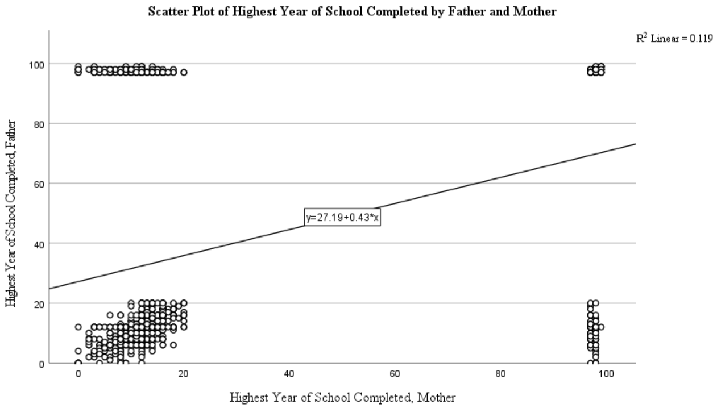

**Figure 1: Scatter Plot of Highest Year of School Completed by Father and Mother.** The data indicate a positive correlation between the increase in the mother’s education and an increase in the father’s education. Further analysis is needed to determine the influence of other factors to explain the variance seen.

**Discussion**

The analysis demonstrates a significant relationship between the mother’s and father’s education levels, with an R² of 0.405, indicating that the mother’s education can explain 40.5% of the father's education level variance. This finding aligns with existing research highlighting parental education as a critical factor in shaping family educational outcomes (Goodman et al., 2022). However, the remaining 59.5% of unexplained variance suggests that other factors—such as socioeconomic background, geographic location, or access to educational resources—are likely to play a role in determining educational attainment (Field, 2018).

The moderate R² value demonstrates that while the mother’s education has a notable impact on the father’s education level, it is not the only factor involved. This highlights the importance of considering a more comprehensive set of variables when analyzing educational attainment within families. Incorporating additional variables, such as family income, neighborhood characteristics, or cultural influences, could improve the model’s explanatory power and provide a fuller understanding of the factors driving educational attainment (Pallant, 2021).

**Conclusion**

This analysis demonstrates that the mother’s education level is a significant predictor of the father’s education level, with the linear regression model explaining 40.5% of the variance in the father’s education. For a mother with 16 years of education, the predicted father’s education level is approximately 14.72 years. While this relationship is meaningful, the analysis suggests other factors contribute to the father’s education level. Future research could incorporate additional variables to understand better the full range of influences on educational attainment within families, allowing for a more comprehensive analysis of intergenerational education dynamics.

**References**

Field, A. (2018). *Discovering statistics using IBM SPSS statistics* (5th ed.). SAGE Publications.

Goodman, S., Hart, R., & Nguyen, T. (2022). Understanding productivity metrics in the workplace: Statistical insights and practical applications. *Journal of Organizational Psychology, 12*(3), 189–210. <https://doi.org/10.1023/JOP.2022.11983>

Pallant, J. (2021). *SPSS survival manual: A step-by-step guide to data analysis using IBM SPSS* (7th ed.). Open University Press.

Sweet, S. A., & Grace-Martin, K. (2021). *Data analysis with SPSS: A first course in applied statistics* (5th ed.). Pearson.