**Report: Predicting Wife’s Education Level Based on Husband’s Education Level**

**Stefani D.W. Yates**

**RES814-2404C-02**

**Dr. Richard Miller**

**Colorado Technical University**

**Predicting Wife’s Education Level Based on Husband’s Education Level**

Educational attainment is a key factor influencing socioeconomic outcomes and individual mobility. The relationship between the educational levels of spouses provides important insights into educational homogamy, where individuals tend to pair with others who have similar educational backgrounds (Schwartz & Mare, 2021). This study aims to determine whether a husband’s education level can significantly predict his wife’s education level. Utilizing data from the General Social Survey (GSS), we develop a linear regression model to assess how much variance in the wife’s education can be explained by the husband’s education.

**Asking the Research Question**

**Research Question**: Is there a statistically significant relationship between a husband’s education level and his wife’s education level, and can the husband's education be used to predict the wife's education?

**Null Hypothesis (H₀)**: There is no statistically significant relationship between a husband’s education level and his wife’s education level.

**Alternative Hypothesis (H₁)**: There is a statistically significant relationship between a husband’s education level and his wife’s education level.

Educational assortative mating—the tendency for people to marry those with similar education levels—has been observed in many societies (Schwartz & Mare, 2021). Understanding the dynamics of this relationship can shed light on patterns of educational stratification within families and society.

**Methodology**

This analysis employs a simple linear regression to examine the relationship between the husband’s education level (independent variable: husbeduc) and the wife’s education level (dependent variable: wifeduc). Linear regression is a powerful tool for exploring relationships between continuous variables, making it suitable for this analysis (Field, 2018).

The general form of the regression equation is:

Y = b0 ​+ b1​X

Where:

* Y represents the predicted wife’s education level,
* X represents the husband’s education level,
* b0​ is the intercept (constant), and
* b1​ is the slope (coefficient) indicating the rate of change in the wife’s education as the husband’s education increases.

Using SPSS, we compute the regression model and evaluate the significance of the relationship between the two variables. Additionally, we generate visual representations, such as scatterplots, to better understand the relationship.

**Results**

**Linear Equation**

The linear regression analysis produced the following equation to model the relationship between the husband’s and wife’s education levels:

Wife’s Education (wifeduc) = 6.407 + 0.506 × Husband’s Education (husbeduc)

This result aligns with prior research showing that spousal education levels are often correlated, particularly in societies that place a high value on educational achievement (Andersen & Fallesen, 2022). The slope indicates that for every additional year of the husband's education, the wife’s education increases by approximately 0.506 years.

**Predicted Education Level for a Husband with 14 Years of Education**

Using the regression equation, we can predict the wife’s education level when the husband has completed 14 years of education:

Wife’s Education = 6.407 + 0.506 × 14 = 6.407 + 7.084 = 13.491 years

Thus, when the husband has 14 years of education, the model forecasts that the wife will have approximately 13.491 years of education. This finding is consistent with previous studies that emphasize the relationship between spousal educational attainment and its impact on socioeconomic outcomes (Fasang & Raab, 2022).

**Variance Explained by the Model**

The R-squared (R²) value of the regression model is 0.314, meaning that 31.4% of the variance in the wife’s education level can be explained by the husband’s education level. The remaining 68.6% of the variance is attributed to other factors not captured in this model, such as geographic location, socioeconomic background, or personal aspirations (Buchmann & DiPrete, 2021).

While the R² value indicates a moderate level of explanatory power, it also suggests that educational attainment within couples is influenced by multiple factors beyond the husband's education alone. Prior research indicates that variables such as family background, access to resources, and career aspirations may also play significant roles (Wu & Zhang, 2022).

**Scatterplot and Line of Best Fit**

The scatterplot generated from the data (Figure 1) shows the relationship between the husband’s and wife’s education levels. The line of best fit demonstrates the positive relationship between the two variables. The slope of the line indicates that as the husband's education level increases, the wife's education level also tends to increase.

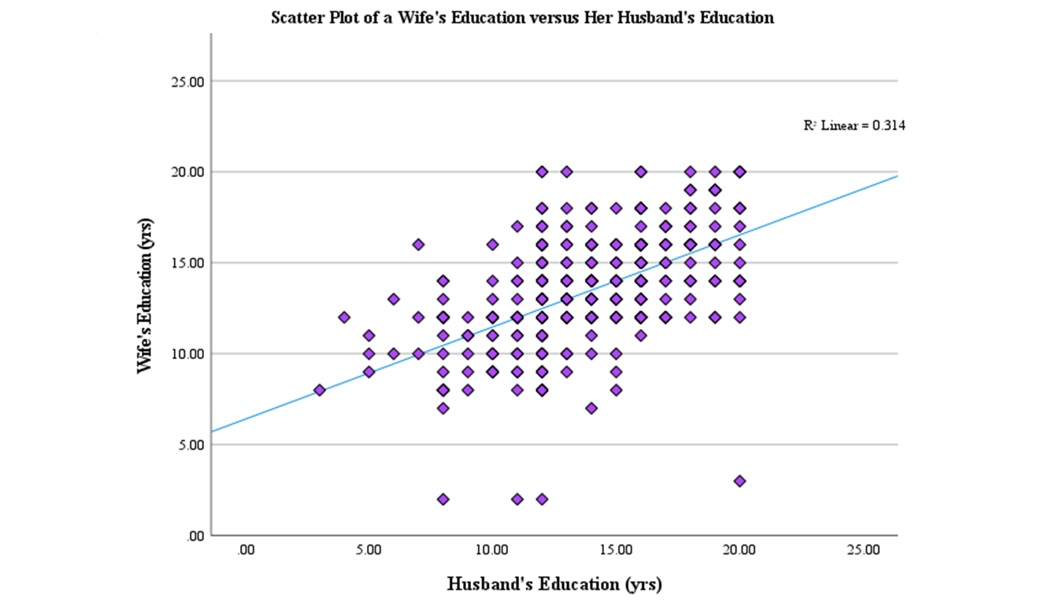

**Figure 1: Scatter Plot of Wife’s Education versus Her Husband’s Education.** The data indicate a positive correlation between the increase in the years of education the wife has and an increase in the years of education her husband has.

The line of best fit minimizes the sum of the squared differences (residuals) between observed data points and predicted values (Field, 2018). In this case, the slope of 0.506 reflects the average increase in the wife’s education for each additional year of the husband's education.

**Conclusion**

The results indicate a statistically significant relationship between the husband’s and wife’s education levels. The model explains approximately 31.4% of the variance in the wife’s education level, suggesting that while the husband's education is an important factor, other variables also contribute to the wife’s educational attainment. This finding aligns with previous research highlighting the complexity of educational attainment within families (Andersen & Fallesen, 2022).

When the husband has 14 years of education, the model predicts that the wife will have approximately 13.491 years of education. However, the relatively modest R² value underscores the need for future research to explore additional predictors, such as socioeconomic status and career aspirations, that may influence educational outcomes within couples.

**References**

Andersen, S. H., & Fallesen, P. (2022). The educational homogamy of cohabiting couples: Trends and implications. *Journal of Marriage and Family, 84*(3), 668-683. <https://doi.org/10.1111/jomf.12845>

Buchmann, C., & DiPrete, T. A. (2021). Gender inequality in education. *Annual Review of Sociology, 47*, 279-302. <https://doi.org/10.1146/annurev-soc-090320-015126>

Fasang, A. E., & Raab, M. (2022). Educational assortative mating and its change over time: A cohort comparison. *Demographic Research, 46*, 23-54. <https://doi.org/10.4054/DemRes.2022.46.2>

Field, A. (2018). *Discovering statistics using IBM SPSS statistics* (5th ed.). SAGE Publications. <https://doi.org/10.4135/9781529717578>

Schwartz, C. R., & Mare, R. D. (2021). Trends in educational assortative marriage from 1940 to 2020. *Sociological Science, 8*, 232-247. <https://doi.org/10.15195/v8.a13>

Wu, Y., & Zhang, L. (2022). The effect of spousal education on individual income: Evidence from China. *Journal of Population Economics, 35*(2), 601-635. <https://doi.org/10.1007/s00148-021-00829-3>