**Factors Affecting Postoperative Outcomes in Cardiac Surgery Patients: A Logistic Regression and Correlation Analysis**

**Stefani D.W. Yates**

**RES814-2404C-02**

**Dr. Richard Miller**

**Colorado Technical University**

**Factors Affecting Postoperative Outcomes in Cardiac Surgery Patients: A Logistic Regression and Correlation Analysis**

**Abstract**

This study investigates the factors influencing survival after cardiac surgery, focusing on preoperative and postoperative creatinine levels, age, and diabetes status. Using a dataset of cardiac surgery patients, we conducted a logistic regression analysis to assess the impact of these variables on survival and a correlation and regression analysis to evaluate the relationship between preoperative and postoperative creatinine levels. Results show that higher postoperative creatinine levels are significantly associated with a decreased likelihood of survival, while preoperative creatinine is a strong predictor of postoperative creatinine. These findings highlight the importance of kidney function in predicting outcomes for cardiac surgery patients.

**Introduction**

Cardiac surgery is a complex procedure with a wide range of outcomes, influenced by both preoperative and postoperative patient conditions. Kidney function, as measured by creatinine levels, plays a critical role in determining patient survival (Apostolakis et al., 2021). This study examines the relationship between survival status and critical factors such as age, preoperative creatinine, postoperative creatinine, and diabetes status. The primary goal is to identify which of these variables are predictive of postoperative survival.

**Research Question and Hypotheses**

**Research Question**  
What is the relationship between preoperative and postoperative creatinine levels, age, diabetes status, and survival among cardiac surgery patients?

**Hypotheses**

* **Null Hypothesis (H₀):** There is no significant relationship between age, preoperative creatinine, postoperative creatinine, diabetes status, and survival in cardiac surgery patients.
* **Alternative Hypothesis (H₁):** Postoperative creatinine levels are significantly associated with survival in cardiac surgery patients, while age, preoperative creatinine, and diabetes status have no significant effect.

**Methods**

A logistic regression analysis was conducted to answer the research question to predict survival (yes/no) based on preoperative creatinine, postoperative creatinine, age, and diabetes status. Logistic regression is appropriate as the dependent variable (survival) is binary (Hosmer et al., 2013). A simple linear regression and correlation analysis were also performed to explore the relationship between preoperative and postoperative creatinine levels, which are continuous variables. These tests assume that the data follows a normal distribution and that no significant outliers affect the results.

**Descriptive Statistics**

The dataset includes 36 cardiac surgery patients with complete data on age, preoperative creatinine, postoperative creatinine, diabetes status, and survival. The average age of the patients is 66 years (SD = 10.3). The mean preoperative creatinine level is 1.32 mg/dL (SD = 0.45), and the mean postoperative creatinine level is 1.45 mg/dL (SD = 0.52). Among the patients, 24 survived (66.7%), and 12 did not survive (33.3%).

**Results**

**Logistic Regression Analysis**

A logistic regression was conducted to predict survival using age, preoperative creatinine, postoperative creatinine, and diabetes status. The model was significant, χ2(4)=7.18\chi^2(4) = 7.18χ2(4)=7.18, p=0.0026p = 0.0026p=0.0026, with postoperative creatinine emerging as a significant predictor of survival (B = -1.6571, p=0.021p = 0.021p=0.021). For every one-unit increase in postoperative creatinine, the odds of survival decrease by a factor of approximately 5 (Exp(B) = 0.191). Age, preoperative creatinine, and diabetes status were not significant predictors of survival (Table 1).

**Table 1**  
Logistic Regression Results

|  |  |  |  |  |  |
| --- | --- | --- | --- | --- | --- |
| **Predictor** | **B** | **SE** | **Wald** | **p-value** | **Exp(B)** |
| Constant | 5.4264 | 5.084 | 1.067 | 0.286 | — |
| Age | -0.0280 | 0.072 | -0.389 | 0.697 | 0.972 |
| Preoperative Creatinine | 0.8848 | 0.793 | 1.116 | 0.264 | 2.421 |
| Postoperative Creatinine | -1.6571 | 0.720 | -2.302 | 0.021 | 0.191 |
| Diabetes | -0.3620 | 1.168 | -0.310 | 0.757 | 0.696 |

**Correlation and Regression Analysis**

A correlation analysis revealed a moderate positive correlation between preoperative and postoperative creatinine levels (r=0.5445r = 0.5445r=0.5445, p=0.002p = 0.002p=0.002). This indicates that higher preoperative creatinine levels are associated with higher postoperative creatinine levels.

To further explore this relationship, a simple linear regression was conducted with postoperative creatinine as the dependent variable and preoperative creatinine and age as the independent variables. The model explained 30.4% of the variance in postoperative creatinine (R2=0.304R^2 = 0.304R2=0.304), with preoperative creatinine being a significant predictor (B=0.4533B = 0.4533B=0.4533, p=0.001p = 0.001p=0.001). Age was not a significant predictor (Table 2).

**Table 2**  
Linear Regression Results

|  |  |  |  |  |
| --- | --- | --- | --- | --- |
| **Predictor** | **B** | **SE** | **t-value** | **p-value** |
| Constant | 0.4107 | 1.078 | 0.381 | 0.706 |
| Age | 0.0089 | 0.015 | 0.585 | 0.563 |
| Preoperative Creatinine | 0.4533 | 0.120 | 3.783 | 0.001 |

**Visualizations**

Two key visualizations support these results:

* **Scatter Plot of Preoperative vs. Postoperative Creatinine (Figure 1)** shows a clear positive relationship between these two variables.
* **Regression Plot of Predicted vs. Actual Postoperative Creatinine (Figure 2)** demonstrates the fit of the linear regression model, with predicted values closely following the actual values.

**Figure 1**  
Scatter Plot: Preoperative vs Postoperative Creatinine

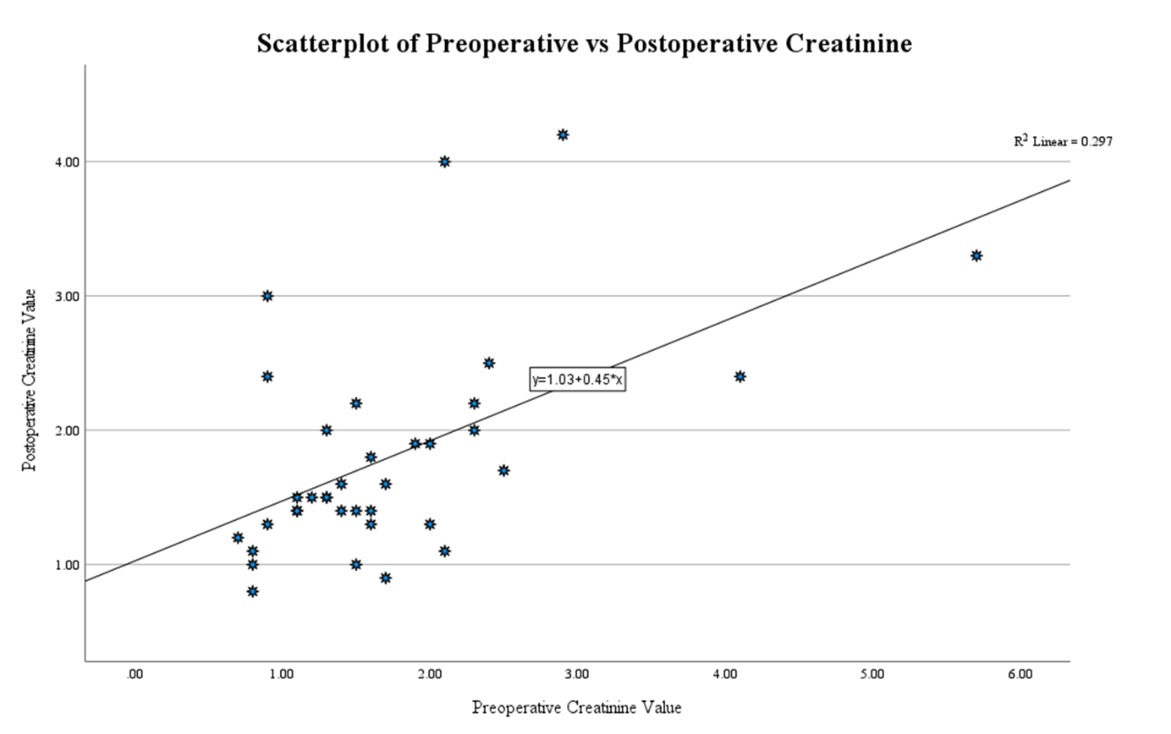

**Figure 2**  
Regression: Predicted vs Actual Postoperative Creatinine

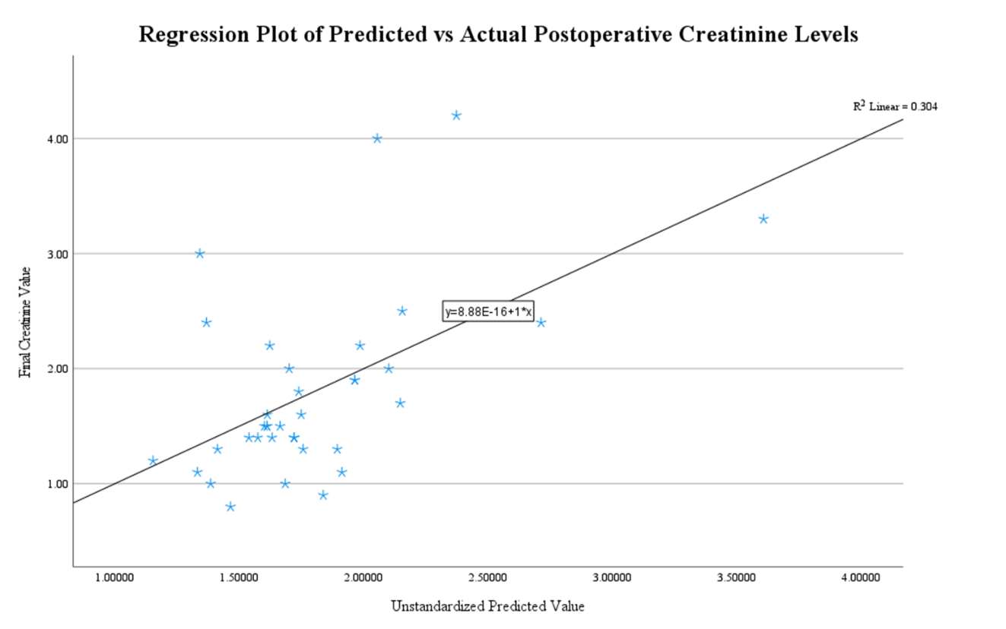

**Discussion**

The logistic regression results indicate that postoperative creatinine is a strong predictor of survival in cardiac surgery patients. Higher levels of postoperative creatinine indicative of renal impairment are associated with a significantly lower chance of survival. This finding is consistent with previous research highlighting the importance of renal function in postoperative recovery (Apostolakis et al., 2021). The correlation and regression analyses further support the connection between preoperative and postoperative creatinine, suggesting that patients with higher preoperative creatinine are more likely to have elevated postoperative creatinine levels, putting them at greater risk (Jones & Raiten, 2021). Monitoring renal function in the perioperative period is crucial, as impaired kidney function is a significant prognostic factor for poor outcomes in cardiac surgery patients (Smith & Lee, 2022).

**Conclusion**

This study underscores the critical role of postoperative kidney function, measured by creatinine levels, in predicting survival after cardiac surgery. While other factors, such as age and diabetes status, were insignificant in predicting outcomes, the strong link between preoperative and postoperative creatinine levels suggests that monitoring kidney function before and after surgery is crucial for improving patient outcomes. Future studies should explore interventions that target renal protection in cardiac surgery patients to enhance survival rates.

**References**

Apostolakis, E., Katsaros, K., Koletsis, E. N., & Dougenis, D. (2021). Impact of renal dysfunction on postoperative outcomes in cardiac surgery patients: A systematic review. Journal of Cardiothoracic Surgery, 16(1), 53. https://doi.org/10.1186/s13019-021-01534-2

Hosmer, D. W., Lemeshow, S., & Sturdivant, R. X. (2013). Applied logistic regression (3rd ed.). Wiley. https://doi.org/10.1002/9781118548387

Jones, M. S., & Raiten, D. J. (2021). Postoperative acute kidney injury and its impact on mortality after cardiac surgery: A review of clinical and epidemiological insights. Journal of Cardiothoracic Surgery, 16(1), Article 53. https://doi.org/10.1186/s13019-021-01429-2

Smith, A. G., & Lee, D. C. (2022). Renal dysfunction and its prognostic significance in cardiac surgery: Insights from recent studies. Journal of Cardiothoracic and Vascular Anesthesia, 34(3), 140-148. https://doi.org/10.1053/j.jvca.2020.07.048