Tutorial 1 – Getting acquainted with R

Why use R?
R is a free and powerful software that can assist with all kinds of data analysis and the production of very nice graphs, figures and tables.

Where can I get R?
You can use R through a command window, but most prefer to use through Rstudio. The latter implement R into a environment that looks a bit more like a windows or an apple environment. It also facilitates the separation of script writing from running environment, as well as helping with the uploading and looking at your data. So, downloading both R and R studio is strongly recommended, and in the following tutorials it will be assumed you are using R studio.

For R studio to work, R has to be installed and working, so let’s start by installing R:

Main R website: https://www.r-project.org - in this page you will find instructions for downloading and installing for your system. Instructions are slightly different if you use a windows, apple or linux computer.

If you have everything ready to go, you should see a window like this when you start R :

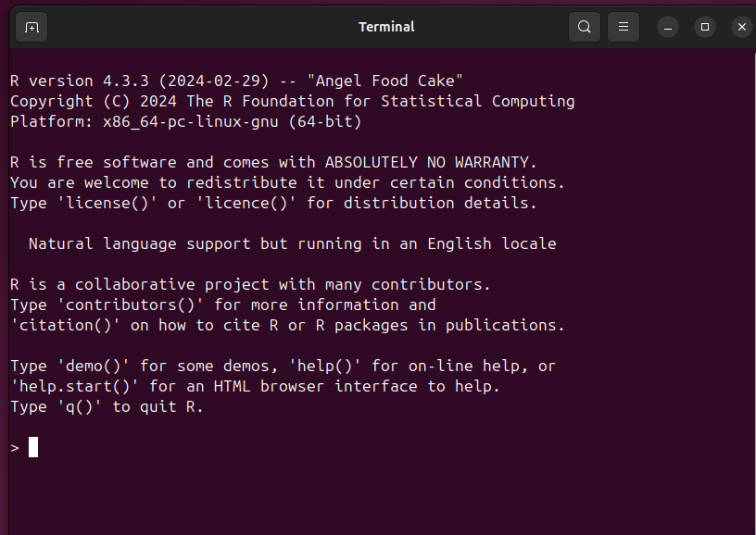

To use it, you just start to type where the cursor is blinking

What is R?
R was created as as a programming language to teach introductory statistics by two professors at the University of Auckland. When you download R from its main website it will only have its basic functions (also referred as BaseR). One of the reason why R is so widely used, is because it is open source (i.e. anyone can write scripts that work with R). Consequently, a very large number of add-on packages can be downloaded and used for very specific tasks.

R is also described as an “object-oriented language”. An easy way to test whether R is working and to understand what “object-oriented” means, is by opening R and comparing what happened when you just type:

> 1+1

versus

> value = 1+1

In the first case, you would see the response in the screen as 2 (R can serve as a very over specified calculator….). When you type the latter, it will look like nothing has happened. But go ahead and type:

>value

It should now say 2. That is because the second command told R to create an object, called value, which contains the sum of the addition 1+ 1. You can ask R to show what is in that object by typing its name. R can create many kind of objects, and do different functions with them, as we will see in the other tutorials.

This is a good time to make a couple of important points:

In the tutorials “>” indicates the R prompt (do not type it in), and what is actually typed is in red.

R will only do what it is told, it does not have a brain to reason…. So if you type Value, with a capital V (go ahead, try it), it would say it does not recognize it. That is because what was created is the object value (with a lower case v). In other words, R is “capital-aware”.

To make life easier, is a good idea to always name objects without capitals (so no need to remember later whether it is capitalized or not), with no spaces (because R will not understand that two words go together as the name of one object). If you must, you can use single quotes around the variable name, as in ‘my variable’, but that is so cumbersome! my_variable is ok.

If R opened up and did the actions described above, it is installed and working. So we can move onto R studio.

Installing and testing R studio

To download R studio go here: https://posit.co/download/rstudio-desktop/

If the installation went well, when you opened R studio it will look like this, with 4 panes:

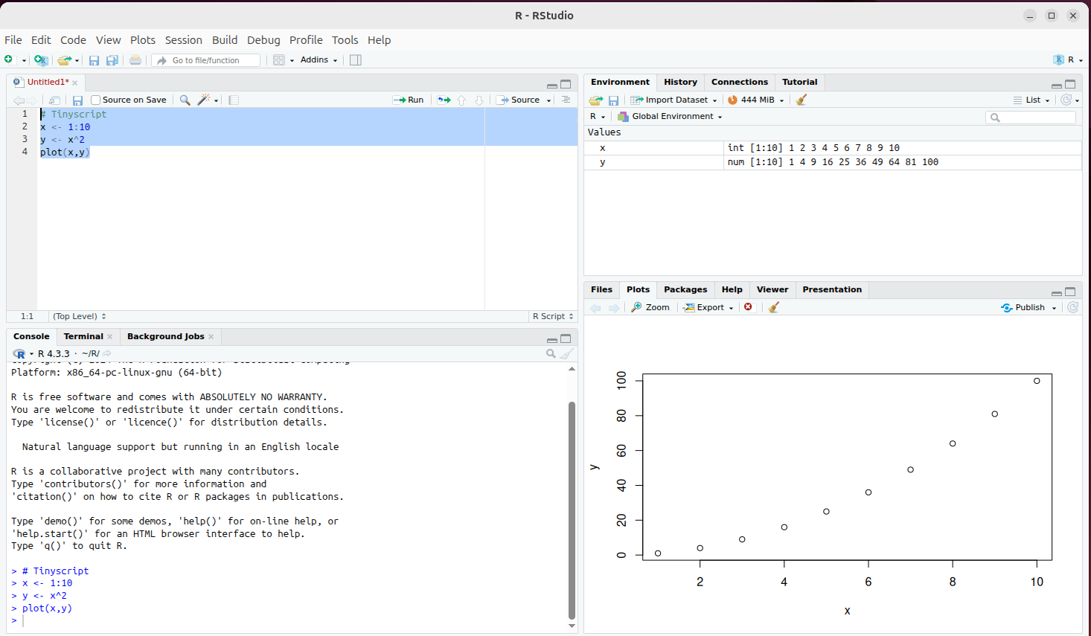
Pane 1
Pane 2
Pane 3
Pane 4
1. Source Pane (Top-left)
This is where you write and edit R scripts and R Notebooks. In other words, you can write a series of commands and try them and edit as necessary. By doing this you can also run the exact same steps on a different dataset, by just changing the file names in a script you have saved before.
2. Console Pane (Bottom-left)
This pane behaves like the base R console. It’s where commands are run and results are printed.
Code from the Source pane appears here when executed. You can also type directly into it.
3. Environment/History Pane (Top-right)
This pane has two tabs at the top. Environment tab shows your objects: variables, data frames, functions, etc. History tab shows a record of commands you’ve entered.
You can click on items to view or rerun them, or remove objects using the broom icon.
4. Files/Plots/Packages/Help/Viewer Pane (Bottom-right)
This pane also has multiple tabs at the top
By default this pane is in the Files tab. This tab shows which directory R studio is working with, and allows you to change the directory or open files by clicking on it.
This pane is also where plots will show up when running commands that produce plots (Plots tab)
The Packages tab is super useful to see what packages are installed and allows you to load or update them. It can also be used to install new packages.
Help tab: Shows documentation using ?function_name or help().
Viewer tab: Displays HTML widgets or Shiny apps when run locally.
A very simple script to try:
1. Write this script in the “source pane”.
# Tinyscript
x = 1:10
y = x^2
plot(x,y)

Nothing should happen after you write this in the source pane. To run this script, highlight all the lines with the mouse and press the little button in the right corner that say “run” If it ran, lines 2 to 4 will show up in the console pane. The variables x and y and their values will show in the environment pane, and the graph in the Plot pane. It should look like the figure above.

What happened?

R read your script!

R ignores any line in a script that starts with #, so we use these lines to annotate our script. It is really helpful to do this. Annotate away, your future self will thank you for it. Let your future self know what this is script was about, what was the assumptions that went into writing it, etc. Anything after # will be ignored so this script could also be written like this to help it out:

#tiny script to help me understand how R works
x = 1:10 #creating object x, which has values 1 to 10
y = x^2 # creating object y, which would take each x and square it (power of 2)
plot(x,y) # creating a plot with a point for each combination of x and y

Go ahead and try typing this script and running it….it should give you exactly the same result!
You will notice that all your annotation show up in green in the script pane. This is handy to help you scrutinize your script.

When something goes wrong….

R is incredibly powerful, and honestly you can start running many scripts right now. However, R can also be a pain and not do what you want due to small formatting issues…. So here is a couple of tips:

- you can highlight a single line of code at a time, to see where things go wrong.
- you can check the environment pane and see if the objects you expect have been created, and whether they have the values you expected
- most of the time that R does not run properly it is because the name of an object was misspelled, or a parenthesis or comma has been forgotten. Frustrating, but easy to solve. Take your time to look through your command to spot these small typos.
- Search the error codes R gives back to you in the internet. Most of the time, someone else had the same problem and there will be some suggestions of what has gone wrong.

