INTRODUCTION:

1. First of all, we need to train yolov3 model on all classes (in the current case 3 classes i.e. car person and cat).
2. Now to implement incremental training we split the classes into two categories i) (in this case car and person): ii) cat. you trained yolov3 on car and person, Fine
3. Now to implement incremental learning we introduced distillation loss and trained the yolov3 on Cat class (using only the labels of cat class not person and car). Now that we have used only cat labels we want to use these weights and detect all the 3 classes i.e. class, person and cat.

In the code I found that you have read all the class labels. Such that:

trainset = Dataset('train', NEW_CLASSES_TO_LEARN, MODEL_OBJECTS_AFTER_INCRE)

The NEW_CLASSES_TO_LEARN = CAT However the MODEL_OBJECTS_AFTER_INCRE=person, car and cat

My only concern is that you have not used the labels of CAR and PERSON while 2nd training on only CAT. Right?

PROGRESS:

1). We need to train and find AP for test set the yolov3 on Pascal VOC 2007 dataset for 1st training on 19 classes and incrementing 1 class and 20 classes without incremental.

2). We need to train yolov3 and find average precision (AP) on test set for 5 classes 1st training and then 5 classes for 2nd training and then 5 classes 3rd training and 4th training 5 classes and 20 classes without incremental.

3) Also we need to train incremental and without incremental on COCO dataset which have 80 classes and 80 classes without incremental.

4) Also we need to check the runtime (fps) for yolov3 after every incrimination of classes.

5) we need to have the class AP for each class similar like in the following table

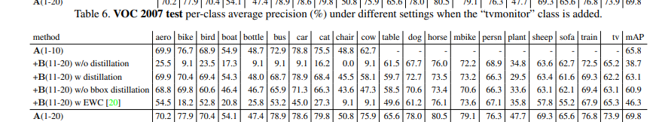

6). If you know there is lambda in the loss function can you find the influence of lambda in the loss function and make a figure of it. As similar to explained in the FRCNN paper and shown in the following graph.

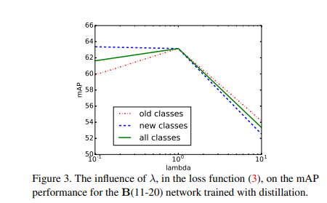

7). Please keep the graphs of training and validation losses and/or accuracy. We need to have a lot f figures to put in the ppt. if you save it would make things easy for us.

8).