SMD challenge instructions

solder the missing SMD components
(LEDs, R) fully assembled, the LEDs
will blink in sequence

two LEDs per size,
alternating polarity,
start with green
marking on the right
LEDs
R
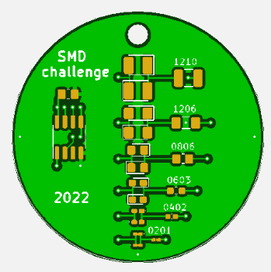

https://github.com/Dr-schobi/smd-challenge/

Version 2022-09

