Name: Basant Raj Kadel
ID: 80117739
Lab-8:Connecting Disparate Networks using Static Routing on Cisco Routers

1. Objective
To establish connectivity between two remote networks (192.168.1.0/24 and 192.168.2.0/24) by configuring static routes on two Cisco routers connected via a serial link (10.1.1.0/8).

2. Theory
Routers use a routing table to determine the best path for forwarding packets to their destination. By default, a router only knows about networks that are directly connected to its interfaces.

Static Routing: A network administrator manually configures the routing table, specifying the path for traffic to reach a specific network. This is done using the ip route command.
  - Use Case: Ideal for small networks with few paths, or for defining a specific exit path for traffic (e.g., a default route).
- Next-Hop Address: This is the IP address of the neighboring router's interface that a packet should be sent to in order to reach a remote network.
3. Diagram, Procedures, and Commands
Network Topology

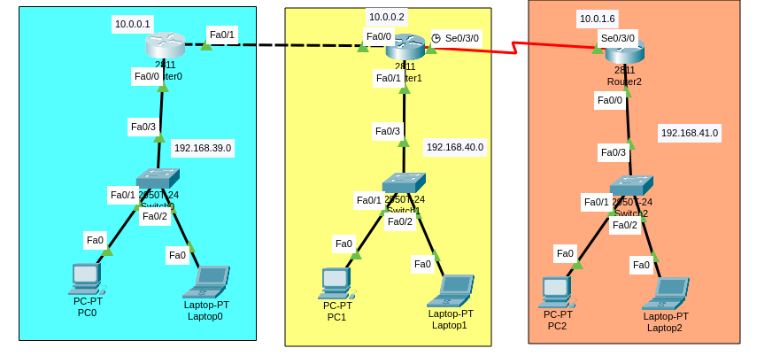
Configuring Router0 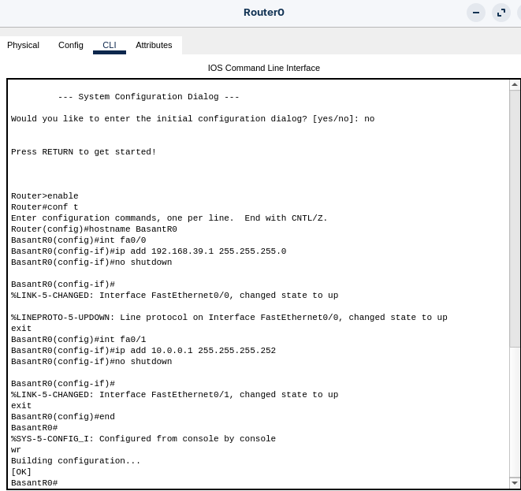
Configuring Router1
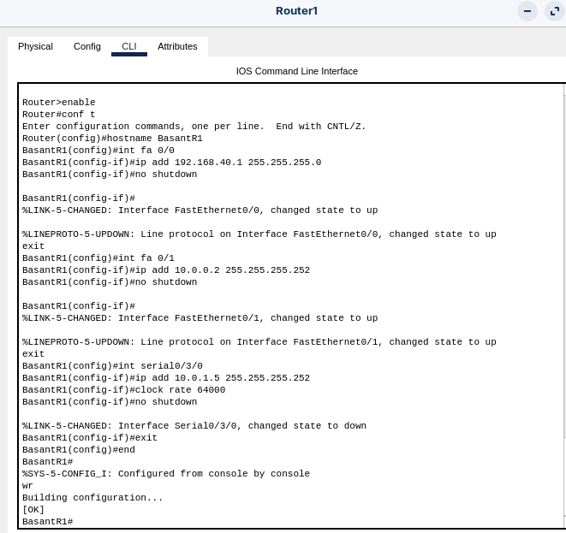
(small modification because my route setup was a error.)
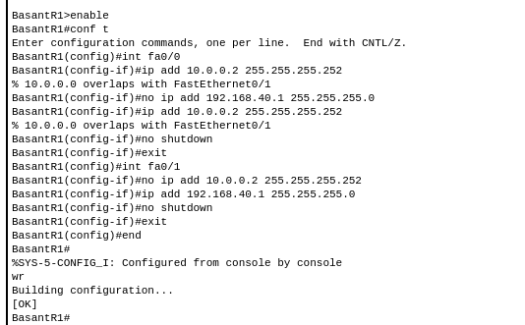
Configuring Router2
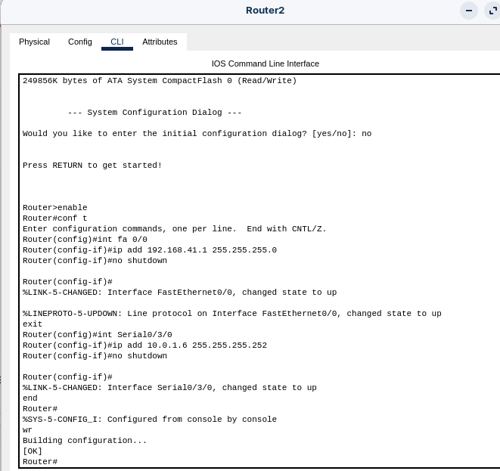
Configuring the Static Routes
On Router0:
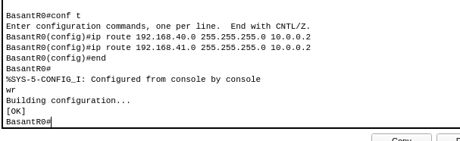
On Router1:
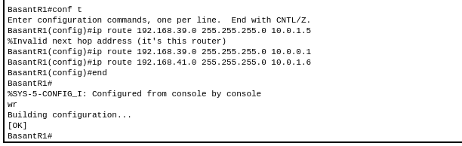
On Router2:
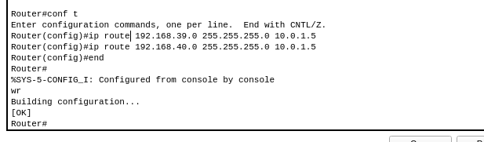
Configuring the PCs
- PC0 (same for all PCs in Network 1):
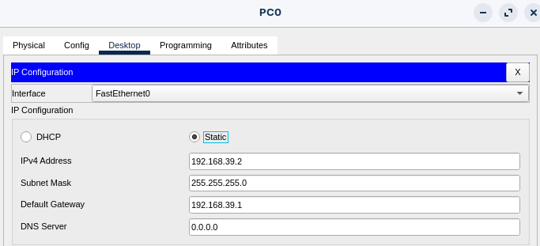
- PC1 (same for all the PCs in Network 2): 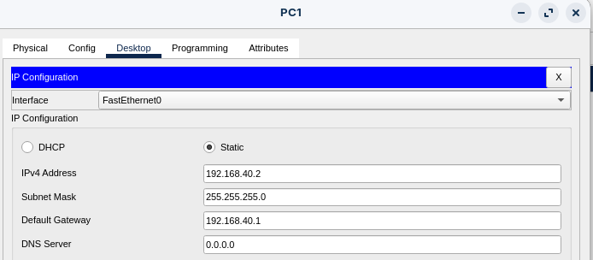
- PC2 (same for all the PCs in Network 3): 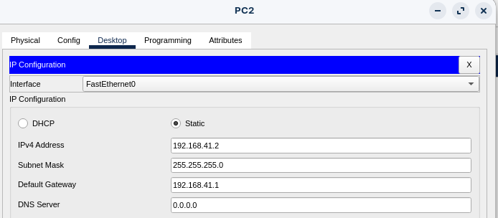

4. Testing and Verification
- Verifying Routing Tables:
  - On each router, running show ip route. We should see a line with an S (Static) pointing to the remote network.
  - On Router0: 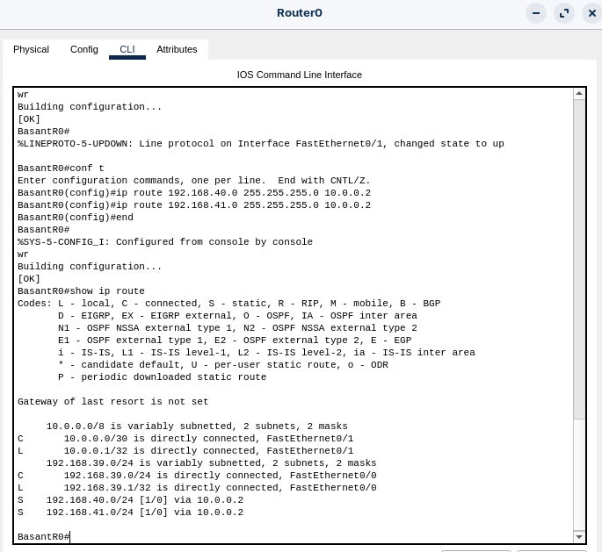
  - On Router1: 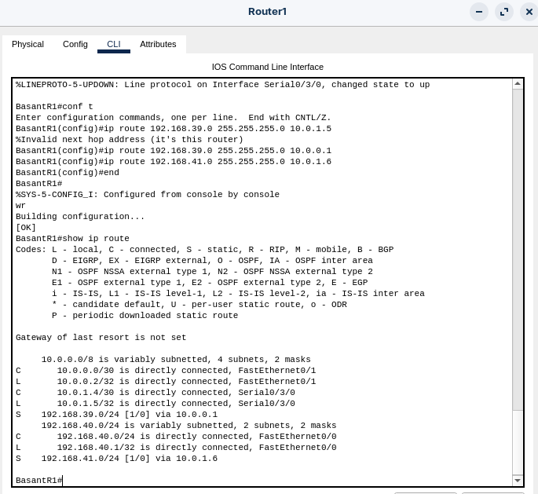
  - On Router2: 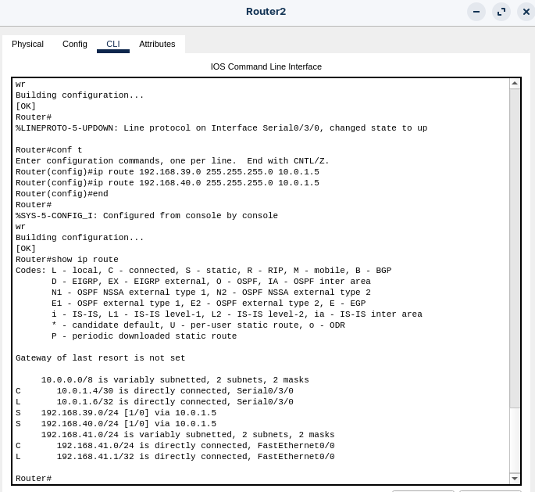
This proves the static routes are working correctly and the routers know how to forward packets to each other's networks.

5. Conclusion
The lab successfully demonstrated the principle and configuration of static routing. Initially, the routers were only aware of their directly connected networks. By manually adding static routes using the ip route command, each router was informed of the path to the remote network. The successful ping from PC1 to PC2 confirmed that the routers could now correctly forward traffic between the disparate networks, enabling end-to-end connectivity. This method provides precise control over routing paths in a network.

