Lab-1

Title: INTRODUCTION TO BASIC LINUX COMMANDS

Objective:
To show the use case and functions of the following Linux Commands used for file and directory management and their relevant options.

Theory:
Linux is a powerful, open-source operating system where most system administration and file management tasks are performed through terminal commands. The fundamental commands covered in this lab form the building blocks of Linux operations:
- man (Manual Pages)
Use Case: View documentation for Linux commands, system calls, and configuration files.
Functions: Displays the manual page of a command.
Provides syntax, options, examples, and descriptions.
Relevant Options:
man ls → Shows the manual for the ls command.
man -k <keyword> → Searches manual pages for a keyword (e.g., man -k "list files").
man -f <command> → Displays a brief description of the command.
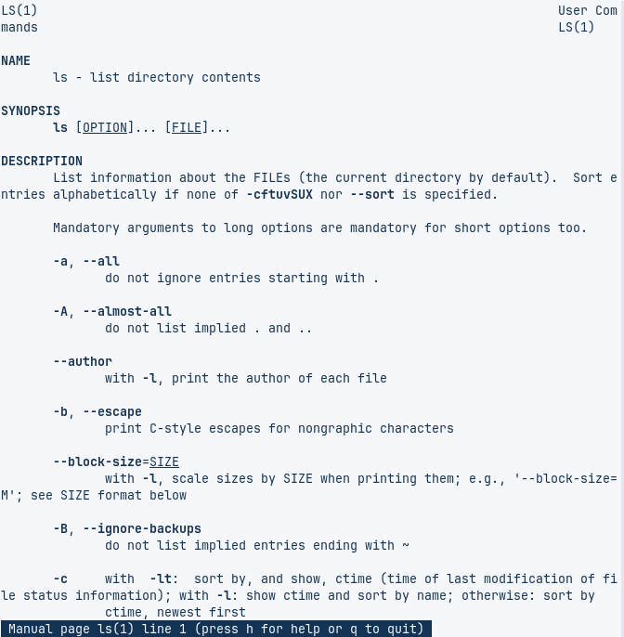
- ls (List Directory Contents)
Use Case: List files and directories in a folder.
Functions: Displays names, permissions, sizes, and modification dates.
Relevant Options:
ls -l → Long listing format (detailed view).
ls -a → Shows hidden files (starts with .).
ls -h → Human-readable file sizes (e.g., KB, MB).
ls -t → Sorts by modification time (newest first).
ls -R → Recursively lists subdirectories.
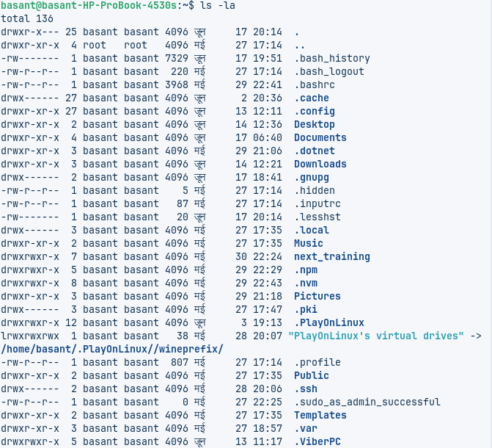
- dir (Alternative to ls)
Use Case: Similar to ls, but less commonly used.
Functions: Lists directory contents (mostly for compatibility).
Relevant Options: Same as ls (e.g., dir -l, dir -a).
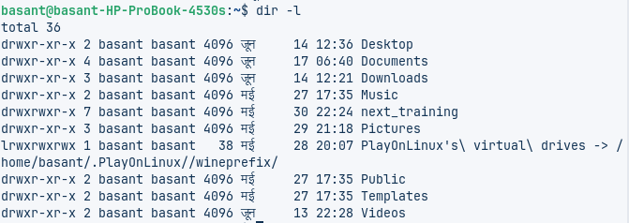
- pwd (Print Working Directory)
Use Case: Shows the current directory path.
Functions: Displays the absolute path of the current directory.
Relevant Options:
pwd -P → Prints the physical path (resolves symlinks).
- cd (Change Directory)
Use Case: Navigate between directories.
Functions: Changes the current working directory.
Relevant Options:
cd ~ → Goes to the home directory.
cd .. → Moves up one directory.
cd - → Switches to the previous directory.
cd /path/to/dir → Moves to an absolute path.
- mkdir (Make Directory)
Use Case: Create new directories.
Functions: Creates one or multiple directories.
Relevant Options:
mkdir dir1 → Creates dir1.
mkdir -p dir1/dir2 → Creates nested directories (no error if parent exists).
mkdir -m 755 dir1 → Sets permissions while creating.
- touch (Create Empty File / Update Timestamp)
Use Case: Create new files or update timestamps.
Functions: Creates an empty file if it doesn’t exist.
Updates access/modification time if the file exists.
Relevant Options:
touch file.txt → Creates file.txt.
touch -a file.txt → Updates only access time.
touch -m file.txt → Updates only modification time.
- vim (Text Editor)
Use Case: Edit text files in a terminal.
Functions: Opens a file in Vim (modal editor: insert, command, visual modes).
Relevant Options:
vim file.txt → Opens file.txt for editing.
vim +10 file.txt → Opens at line 10.
:wq → Save and quit.
:q! → Quit without saving.
- cat (Concatenate Files)
Use Case: Display, combine, or create files.
Functions: Prints file contents to the terminal.
Concatenates multiple files.
Relevant Options:
cat file.txt → Displays content.
cat file1.txt file2.txt > merged.txt → Combines files.
cat -n file.txt → Shows line numbers.
cat > newfile.txt → Creates a new file (Ctrl+D to save).
- cp (Copy Files/Directories)
Use Case: Copy files or directories.
Functions: Duplicates files/dirs to a new location.
Relevant Options:
cp file.txt /backup/ → Copies to /backup/.
cp -r dir1 dir2 → Recursively copies directories.
cp -i file.txt dest/ → Prompts before overwriting.
cp -u src.txt dest/ → Copies only if source is newer.
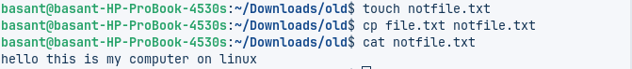
- mv (Move/Rename Files/Dirs)
Use Case: Move or rename files/dirs.
Functions: Moves files/dirs to a new location.
Renames files/dirs.
Relevant Options:
mv old.txt new.txt → Renames old.txt to new.txt.
mv file.txt /target/ → Moves to /target/.
mv -i file.txt dest/ → Prompts before overwriting.
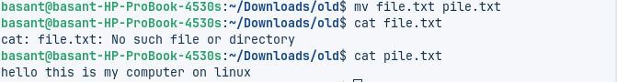
- rm (Remove Files/Dirs)
Use Case: Delete files/dirs permanently.
Functions: Removes files/dirs (use with caution!).
Relevant Options:
rm file.txt → Deletes file.txt.
rm -r dir1 → Recursively deletes a directory.
rm -f file.txt → Forces deletion (no prompt).
rm -i file.txt → Prompts before deleting.
- rmdir (Remove Empty Directory)
Use Case: Delete empty directories.
Functions: Removes only empty directories (safer than rm -r).
Relevant Options:
rmdir dir1 → Deletes if empty.
rmdir -p dir1/dir2 → Removes parent dirs if empty.
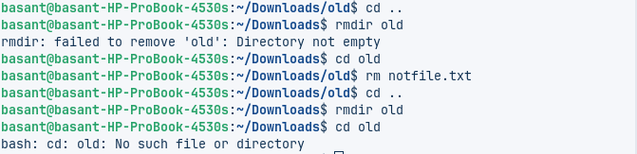

Conclusion :
Linux commands are the backbone of system administration, scripting, and daily file management in Unix-based systems. Mastering commands like ls, cd, cp, mv, and rm is essential for navigating and manipulating the file system efficiently.The man command serves as a vital help resource, while mkdir, touch, and rmdir handle file and directory operations.Text editors like vim and file viewers like cat allow users to create and inspect file contents.File manipulation commands (cp, mv, rm) help in organizing, relocating, and deleting data safely.

