Lab-2

Title : INTRODUCTION TO LINUX COMMANDS
Objective: To learn and practice essential Linux commands for system monitoring, hardware detection, storage management, and software administration to gain hands-on experience in Linux system operations.
Theory:
Linux commands are essential tools for interacting with the operating system, allowing users to manage hardware, files, processes, and software efficiently. Commands like:
- lscpu
Function: Displays CPU architecture information
Use Case: Checking processor details like number of cores, threads, architecture, etc.
Options:
-e or --extended: Show extended CPU information
-p or --parse: Show parseable output format
-s or --sysroot: Use specified directory as system root
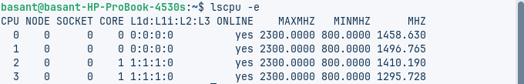
- lshw
Function: Lists detailed hardware information
Use Case: Comprehensive hardware inventory for troubleshooting or documentation
Options:
-short: Show brief hardware listing
-class <class>: Show only specified hardware class (e.g., network,
storage)
-html or -xml: Output in HTML or XML format
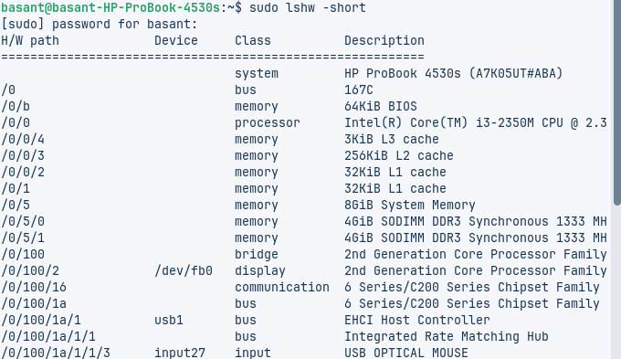

- hwinfo
Function: Provides detailed hardware information (not installed by default on all distros)
Use Case: Advanced hardware diagnostics and troubleshooting
Options:
--short: Brief summary
--<hardware>: Show specific hardware (e.g., --cpu, --memory)
--log: Save output to fileExample: hwinfo –cpu
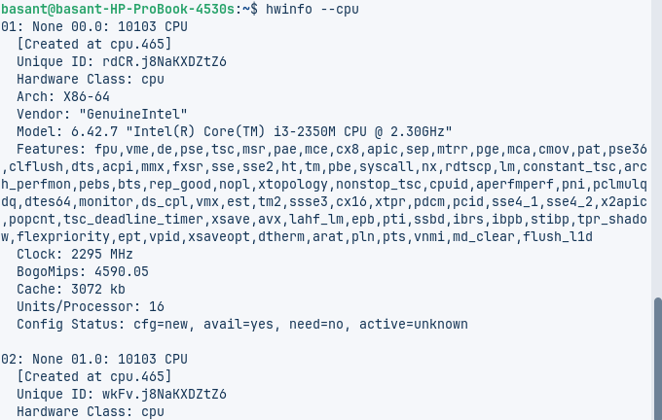
- lspci
Function: Lists all PCI devices
Use Case: Checking installed PCI devices like graphics cards, network controllers
Options:
-v: Verbose output
-vv or -vvv: Very/extra verbose
-k: Show kernel drivers handling each device
-t: Show as tree view
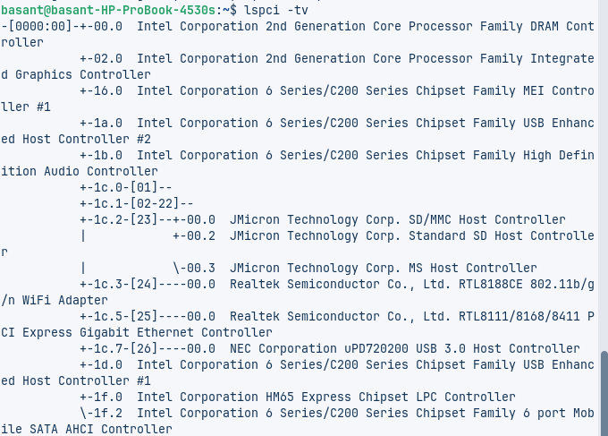
- lsscsi
Function: Lists SCSI devices (and SATA, USB storage)
Use Case: Identifying storage devices and their attributes
Options:
-l: Show additional information
-v: Verbose output
-g: Show generic SCSI devices
- lsusb
Function: Lists USB devices and buses
Use Case: Troubleshooting USB devices, checking connections
Options:
-v: Verbose output
-t: Show as tree view
-s [[bus]:][devnum]: Show specific device
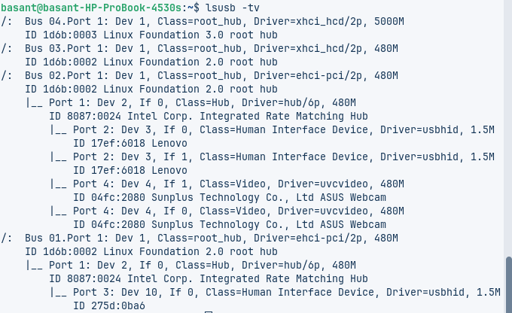
- inxi
Function: Full system information tool (needs installation)
Use Case: Comprehensive system overview for support requests
Options:
-F: Full output (CPU, GPU, RAM, etc.)
-b: Basic information
-G: Graphics information
-m: Memory information
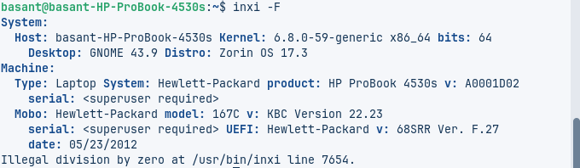
- lsblk
Function: Lists block devices (disks, partitions)
Use Case: Disk management, checking storage layout
Options:
-a: Show all devices
-f: Show filesystems
-o: Specify output columns
-m: Show owner, group and mode
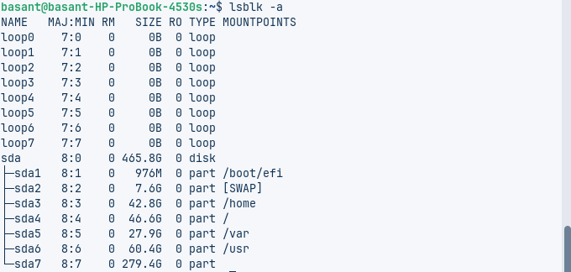
- df
Function: Shows disk filesystem usage
Use Case: Checking available disk space
Options:
-h: Human-readable format
-T: Show filesystem type
-i: Show inode information
--total: Show summary total
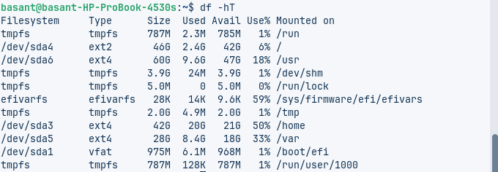
- fdisk
Function: Disk partitioning utility
Use Case: Creating, deleting, modifying partitions
Options:
-l: List partitions
-s <partition>: Show partition size
-v: Show version
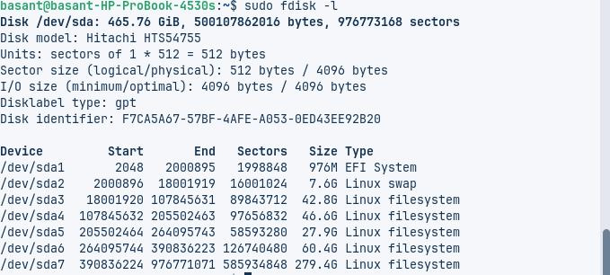
- free
Function: Shows memory usage (RAM and swap)
Use Case: Monitoring system memory utilization
Options:
-h: Human-readable format
-s <seconds>: Continuous update
-t: Show total line
-w: Wide output
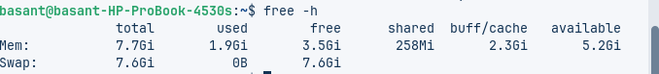
- top
Function: Dynamic real-time process viewer
Use Case: Monitoring system resource usage by processes
Options:
-d <delay>: Update delay in seconds
-p <PID>: Monitor specific process
-u <user>: Show only user's processes
-n <iterations>: Number of iterations before exiting
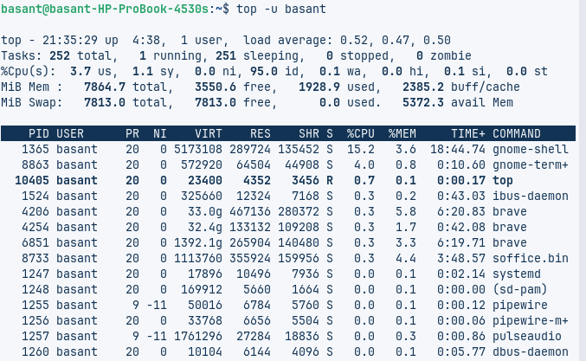
- /proc/cpuinfo
Function: Virtual file showing CPU details
Use Case: Checking detailed processor information
Usage: cat /proc/cpuinfo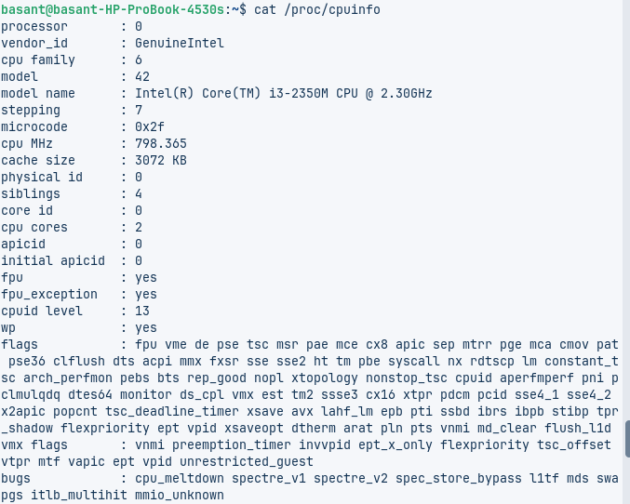
- /proc/meminfo
Function: Virtual file showing memory details
Use Case: Checking detailed memory information
Usage: cat /proc/meminfo
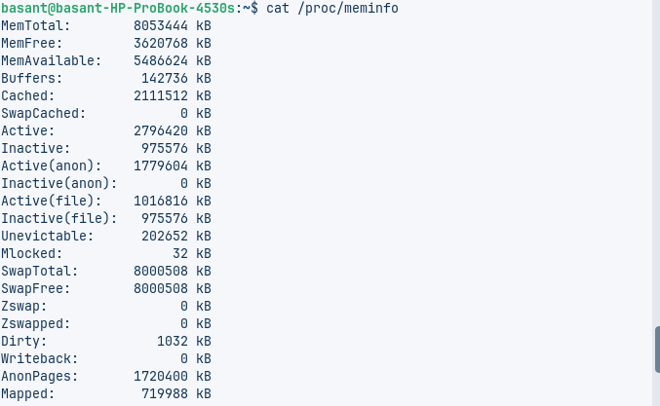
- uname
Function: Shows system information
Use Case: Checking kernel version, system architecture
Options:
-a: All information
-s: Kernel name
-r: Kernel release
-m: Machine hardware name
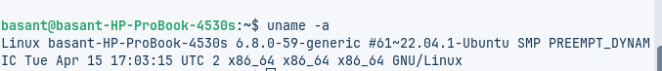
- id
Function: Shows user and group information
Use Case: Checking user privileges, group membership
Options:
-u: Show only user ID
-g: Show only primary group ID
-G: Show all group IDs
-n: Show names instead of numbers
- init
Function: Parent of all processes (systemd in modern systems)
Use Case: System initialization and run level management
Options:
0: Halt
1: Single-user mode
3: Multi-user mode
5: Graphical mode
6: Reboot

- apt
Function: High-level package management (Debian/Ubuntu)
Use Case: Installing, removing, updating packages
Options:
install <package>: Install package
remove <package>: Remove package
update: Update package lists
upgrade: Upgrade installed packages
search <term>: Search for packages
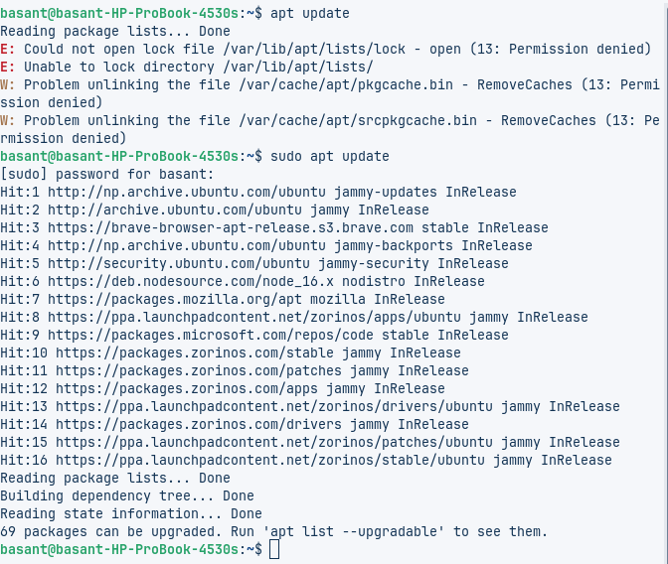
- apt-get
Function: Lower-level package management (older alternative to apt)
Use Case: More control over package management
Options:
install <package>: Install package
remove <package>: Remove package
update: Update package lists
upgrade: Upgrade installed packages
dist-upgrade: Smart upgrade handling dependencies
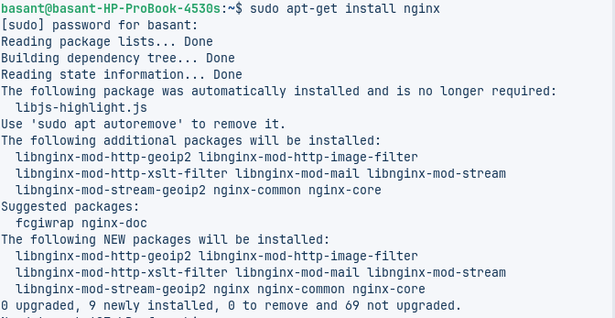
- sudo
Function: Execute commands as superuser
Use Case: Performing administrative tasks
Options:
-i: Run interactive shell as root
-u <user>: Run as specified user
-l: List allowed commands
-v: Extend sudo timeout
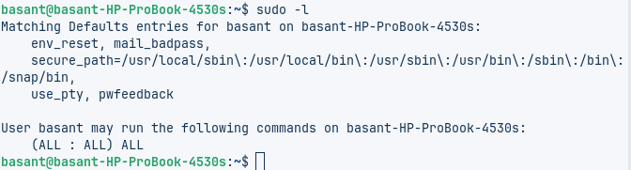
Conclusion:
This lab helped us master essential Linux commands for system monitoring, hardware analysis, storage management, and software administration. By using tools like lscpu, lsblk, top, and apt, we learned to check system resources, manage disks, control processes, and handle packages efficiently. These practical skills are vital for troubleshooting and maintaining Linux systems, giving us a solid foundation for real-world system administration tasks.

