Name: Basant Raj Kadel
ID: 80117739
Lab-10: Configuring Static NAT on a Cisco Router

1. Objective
To configure Static Network Address Translation (NAT) on a Cisco router, allowing a host on a private internal network (192.168.1.0/24) to be reachable from a public external network (1.0.0.0/8) using a mapped public IP address.

2. Theory
NAT (Network Address Translation) is a method used to map private (internal) IP addresses to public (external) IP addresses. This conserves public IP address space and provides a layer of security by hiding internal network structure.
- Inside Network: The private, internal local network (e.g., 192.168.1.0/24).
- Outside Network: The public, external global network (e.g., the internet, 1.0.0.0/8 in this lab).
- Static NAT: Creates a permanent, one-to-one mapping between a specific private local IP address and a public global IP address. This is used for servers that need to be accessible from the outside world.

3. Diagram, Procedures, and Commands
Network Topology
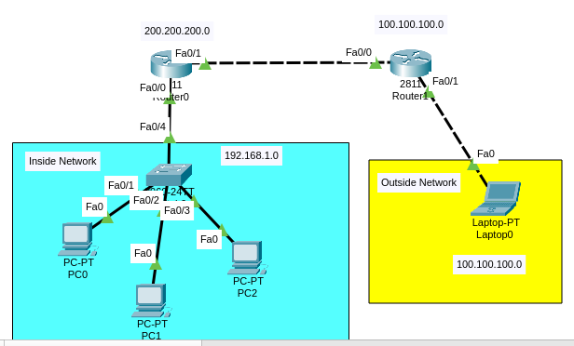
Configuring Router1's Interfaces
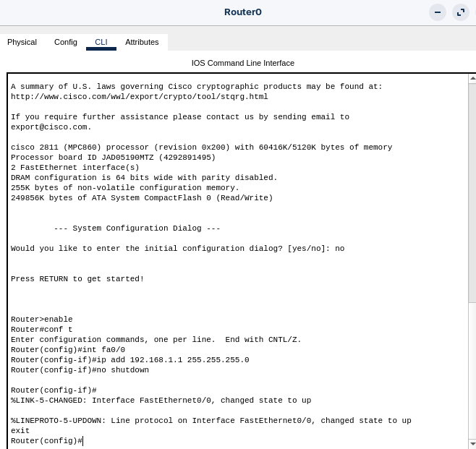
Configuring Router2
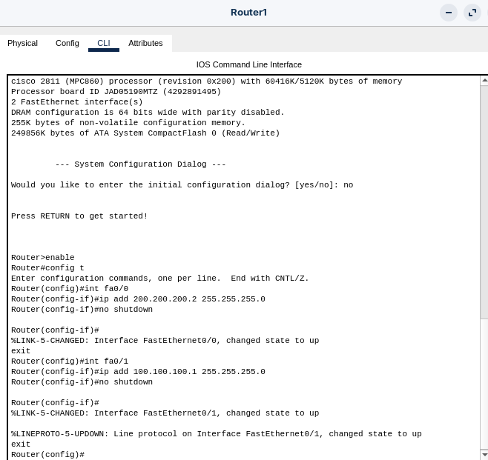
Configuring Static NAT on Router1
This is the core NAT configuration. It maps the inside local address to an inside global address.
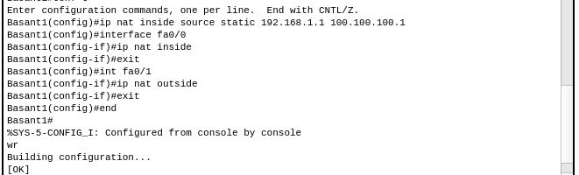
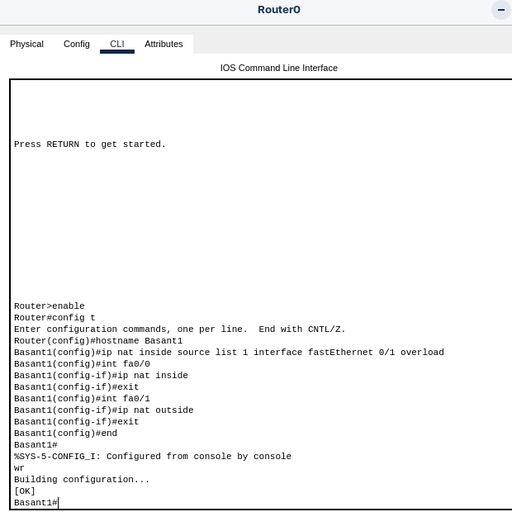
Configuring the PCs
- PC0 :
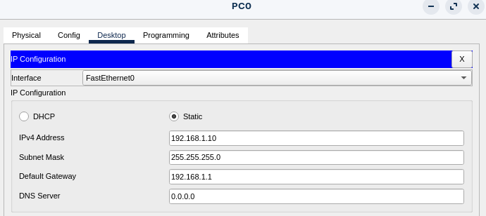
- PC1 :
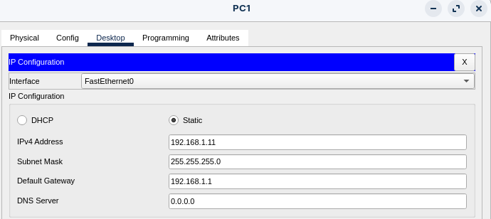
- PC2 :
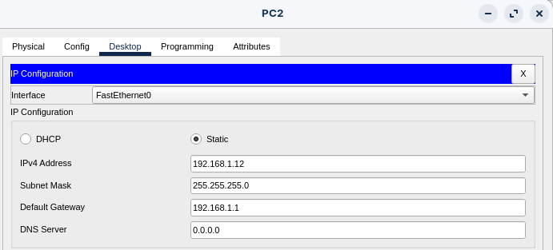

Adding Routes:
On Router1:
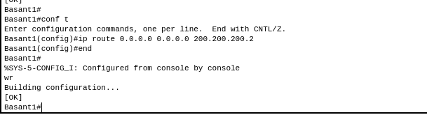
On Router2:
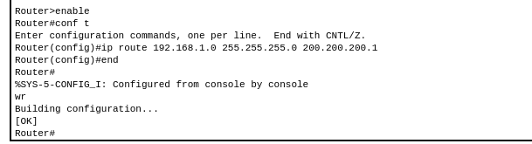

4. Testing and Verification
1. Verifying NAT Translation:
On Router1, use the following command to see the active NAT translation:
show ip nat translations
Output:
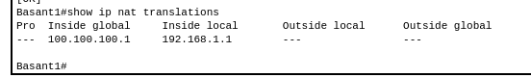
This confirms that the private IP 192.168.1.2 is permanently mapped to the public IP 1.1.1.10.
2. Test Connectivity:
- From Router2 , ping the mapped public IP address:
ping 100.100.100.100
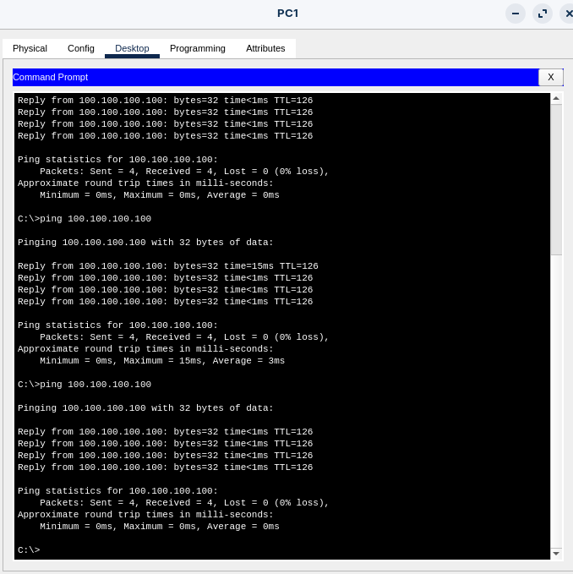
- The ping should be successful. This proves that Router2 can reach the internal PC0 (192.168.1.10) through its public NAT address (100.100.100.100).

5. Conclusion
The lab successfully demonstrated the configuration and operation of Static NAT. A permanent one-to-one mapping was created between the inside local address (192.168.1.2) and the inside global address (1.1.1.10). The successful ping from the external ISP router to the mapped public IP address verified that the NAT translation is working correctly. This technique is essential for allowing external access to specific servers (e.g., web, email) housed within a private network.

