Name: Basant Raj Kadel
ID: 80117739
Lab-7: Automating IP Address Assignment using a DHCP Server on a Cisco Router

1. Objective
To configure a Cisco router to act as a DHCP server for the network 192.168.39.0/24, automatically providing IP addresses to end devices.

2. Theory
DHCP (Dynamic Host Configuration Protocol) is a network management protocol used to automate the process of configuring devices on IP networks. A DHCP server dynamically assigns an IP address and other network configuration parameters (like the subnet mask and default gateway) to each device on the network, allowing them to communicate with other IP networks. This eliminates the need for a network administrator to manually configure each device.

3. Diagram, Procedures, and Commands
Network Diagram :
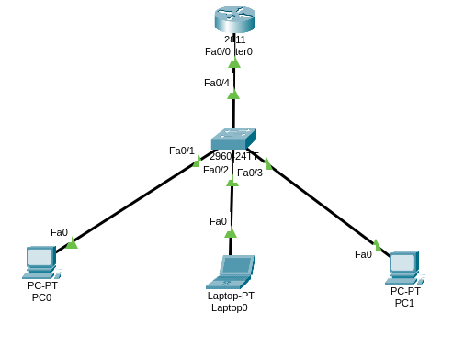
Configuring the Router's Interface
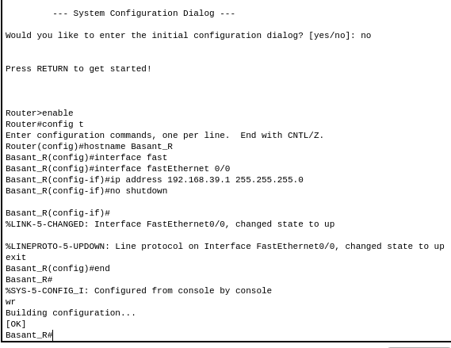
Configuring the DHCP Server Pool
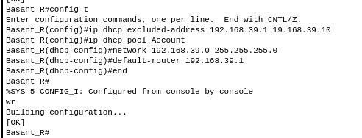
Configuring PCs for DHCP
On each PC:
Go to Desktop > IP Configuration. And Select DHCP.
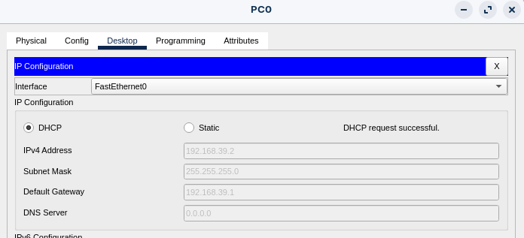
Verifying DHCP Assignment
On the PC, open Command Prompt and run: ipconfig
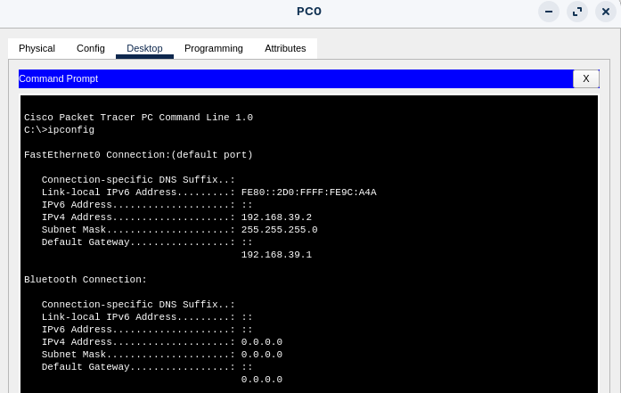

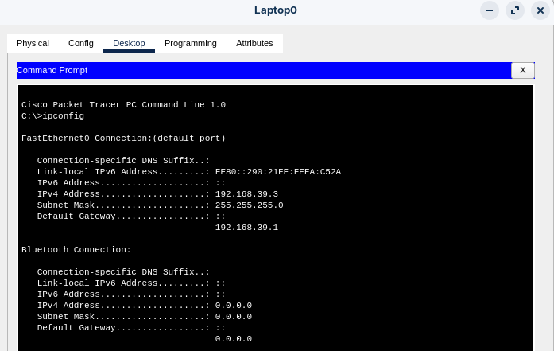

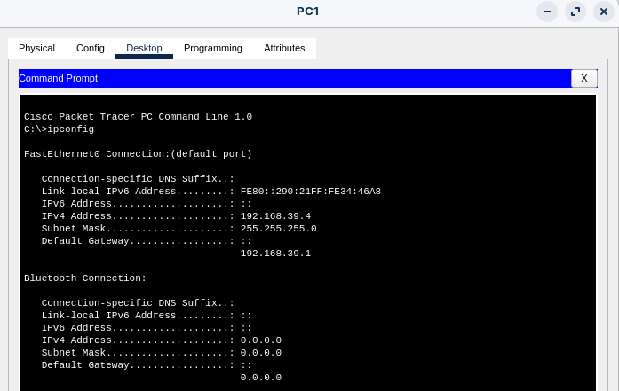

4. Testing
Here, the test is successful as each PC receives an IP address in the range 192.168.39.11 to 192.168.39.254 and can ping the gateway (192.168.39.1).

5. Conclusion
The router was successfully configured as a DHCP server for the 192.168.39.0/24 network. End devices automatically obtained their IP configuration, confirming the functionality of DHCP in simplifying network management.

