Name: Basant Raj Kadel
ID: 80117739
Lab-9: Implementing Reachability in a Ring Topology using RIP and OSPF

1. Objective
To configure dynamic routing protocols (RIP and OSPF) on a network of three routers in a ring topology, enabling automatic learning and propagation of routes so that all networks (10.0.0.0/24, 10.1.1.0/24, 10.2.2.0/24) are reachable from any point in the network.

2. Theory
In a ring topology with multiple paths, static routing becomes inefficient and cannot automatically adapt to link failures. Dynamic routing protocols solve this by allowing routers to automatically advertise their connected networks to neighboring routers.
- RIP (Routing Information Protocol): A distance-vector protocol. Routers broadcast their entire routing table to neighbors periodically. RIP uses hop count as its metric (cost). The maximum hop count is 15, making it suitable for smaller networks.
- OSPF (Open Shortest Path First): A link-state protocol. Routers multi-cast information about the state of their own links to all other routers in the area. Each router builds a complete map of the network topology and uses the SPF (Shortest Path First) algorithm to calculate the best path based on cost (typically derived from bandwidth). It is faster converging and more scalable than RIP.

3. Diagram, Procedures, and Commands

Network Topology
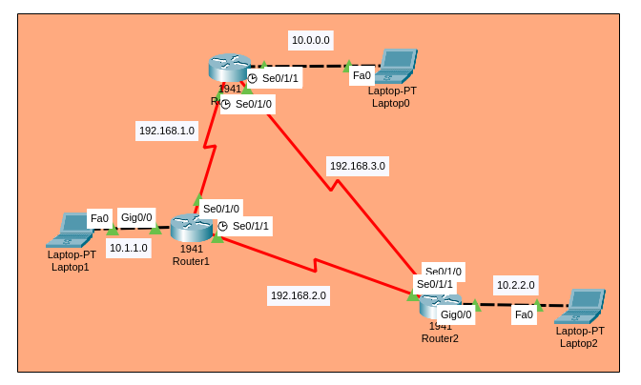

Basic Router Configuration (IP Addressing)

Router1 Configuration:
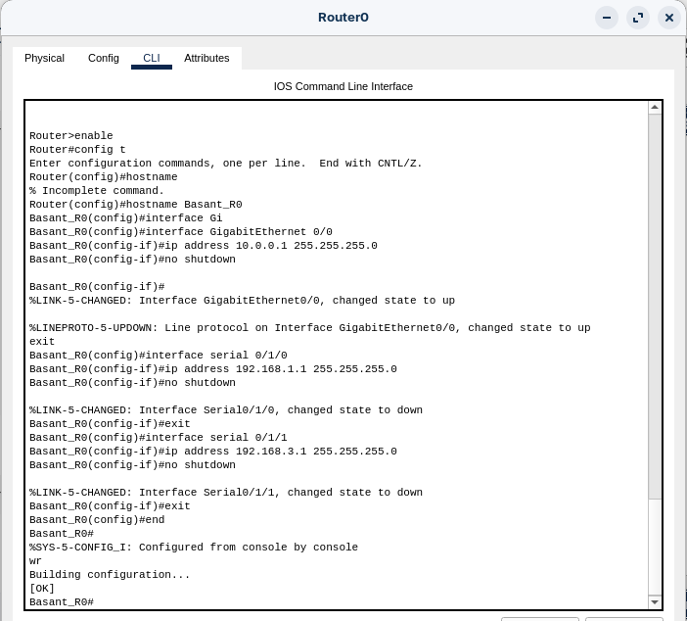

Repeating this process for Router2
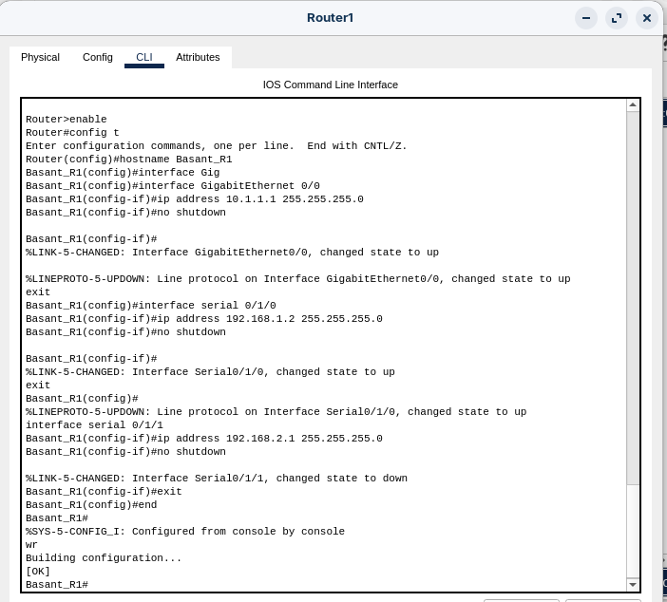

and Router3
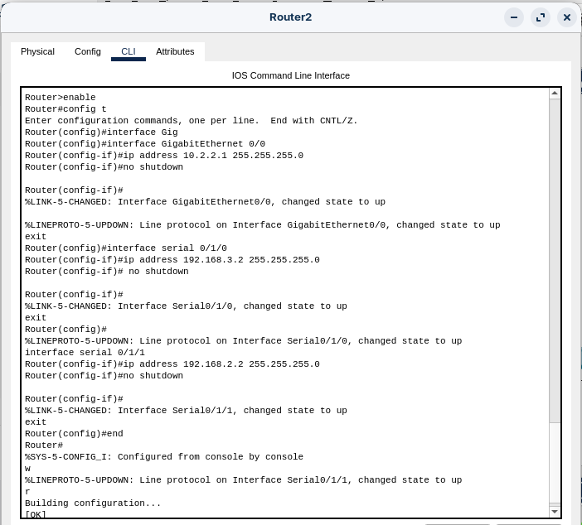
assigning the correct IPs to their interfaces.

Configuring Dynamic Routing Protocol – RIP
Enable RIP on all routers and advertise the networks that are directly connected to them.
Configuration on ALL Routers (Router1, Router2, Router3):
Router-1
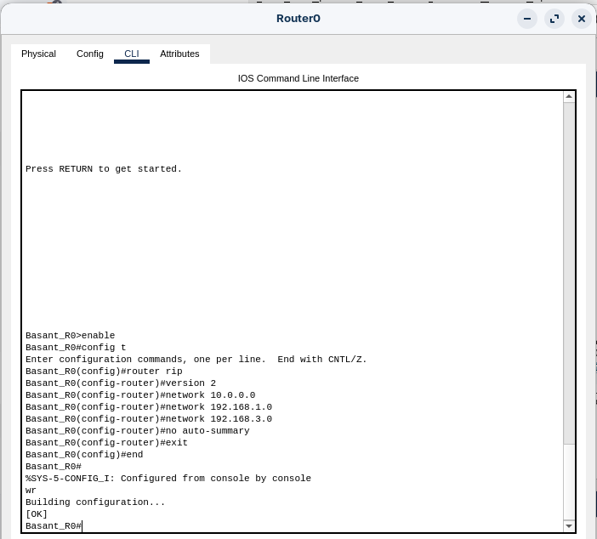
Router-2:
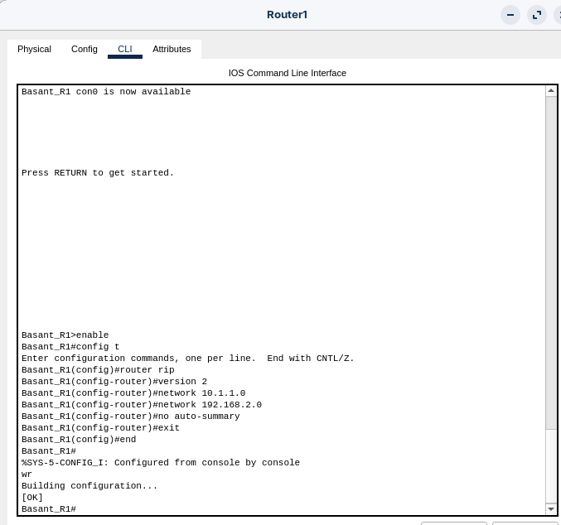
Router-3:
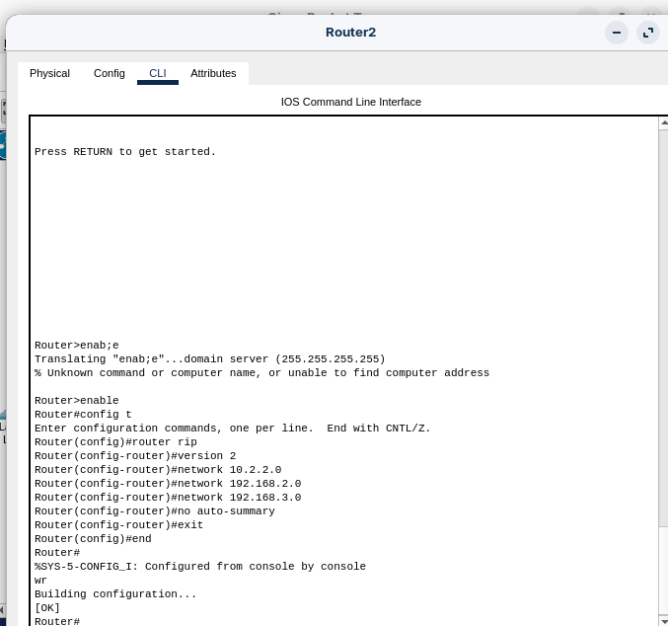

Configuring Dynamic Routing Protocol – OSPF
Alternatively, configure OSPF. This is generally preferred over RIP.
Configuration on ALL Routers (Router1, Router2, Router3):
Router-1:
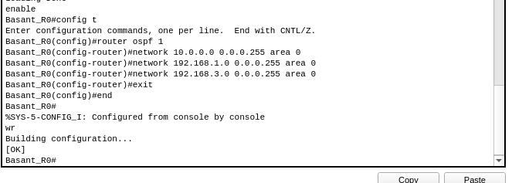
Router-2:
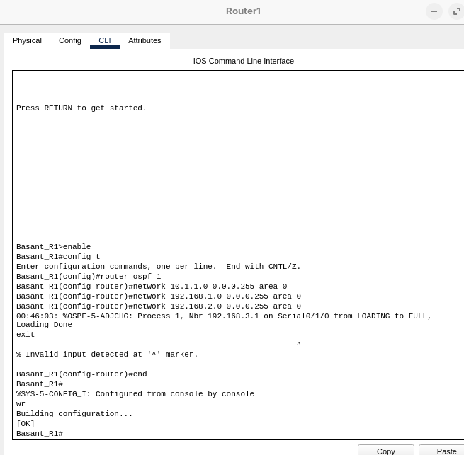
Router-3:
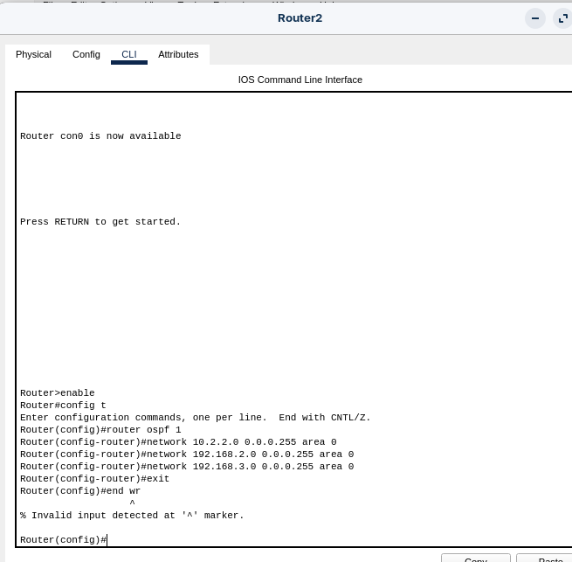

Configuring PCs
Configuring each PC with an IP address and the router's LAN interface as its default gateway.
- Laptop0 (on 10.0.0.0/24): IP: 10.0.0.10, Gateway: 10.0.0.1 (Router1)
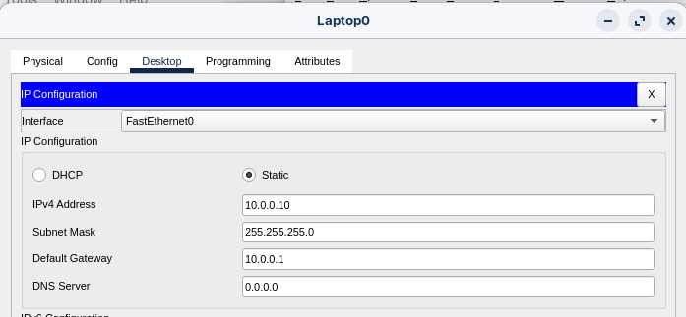
- Laptop1 (on 10.1.1.0/24): IP: 10.1.1.10, Gateway: 10.1.1.1 (Router2)
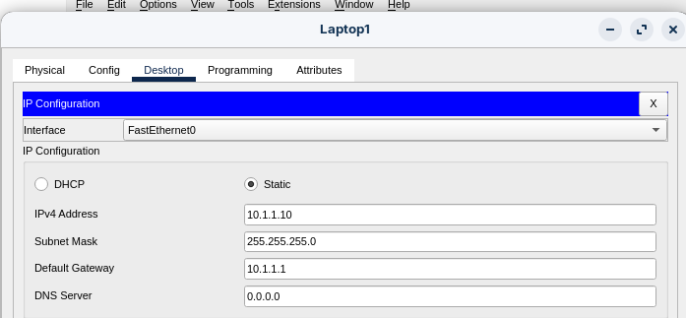
- Laptop2 (on 10.2.2.0/24): IP: 10.2.2.10, Gateway: 10.2.2.1 (Router3)
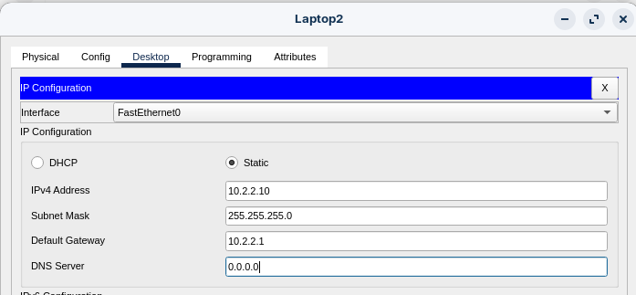

4. Testing and Verification
- Checking Routing Tables: On any router, run show ip route. We should see routes marked with:
  - R for RIP-learned routes.
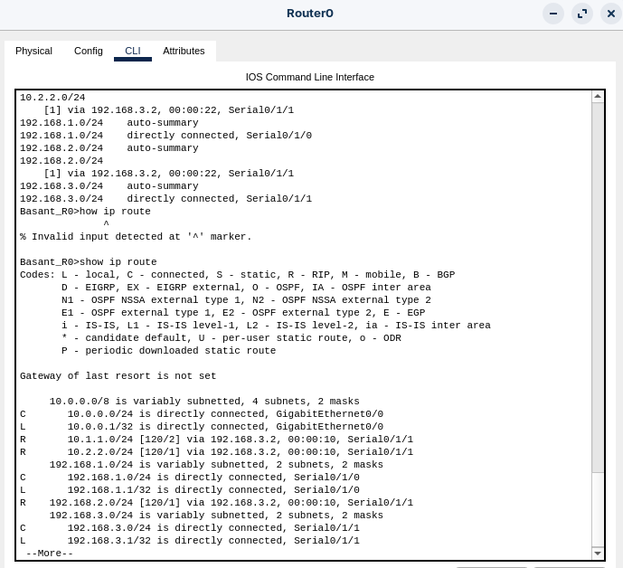
  - O for OSPF-learned routes.
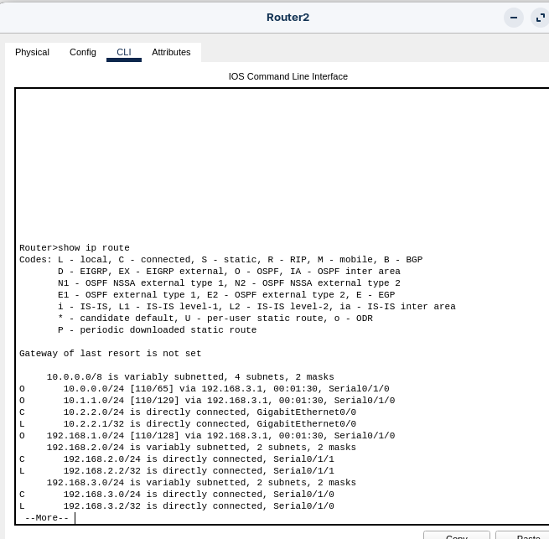

  - This confirms the routers are dynamically learning about the remote networks.

- Test End-to-End Connectivity: From any PC, ping a PC on a different LAN.
  - pinging 10.1.1.10 (from Laptop0 During RIP)
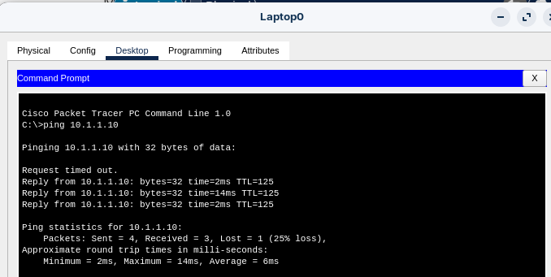
  - pinging 10.2.2.10 (from laptop 1 During OSPF)
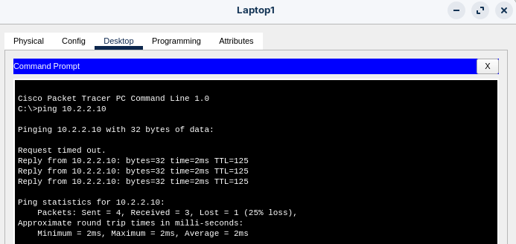
  - Result: SUCCESS. This proves the dynamic routing protocol is working correctly, and all networks are reachable.

5. Conclusion
The lab successfully demonstrated the implementation of dynamic routing protocols (RIP and OSPF) in a ring topology. Unlike static routing, these protocols automatically propagated network routes to all routers, creating redundant paths. The successful pings between all PCs confirmed that the routers dynamically learned the best paths to all networks, ensuring full connectivity. OSPF is generally the more modern and scalable choice due to its faster convergence and use of cost rather than simple hop count.

