Lab-2

Title: Introduction to Basic Networking Tools and Commands

Objective: To get familiar with essential networking tools and commands used for troubleshooting, diagnosing, and managing network configurations.

Theory:
Networking tools are software utilities or commands used to configure, monitor, troubleshoot, and analyze computer networks. They help diagnose connectivity issues, test performance, secure connections, and manage network resources. Common examples include:
- ipconfig/ifconfig
Networking tools like ipconfig/ifconfig display a device’s IP address, subnet mask, and default gateway, helping verify basic network settings.
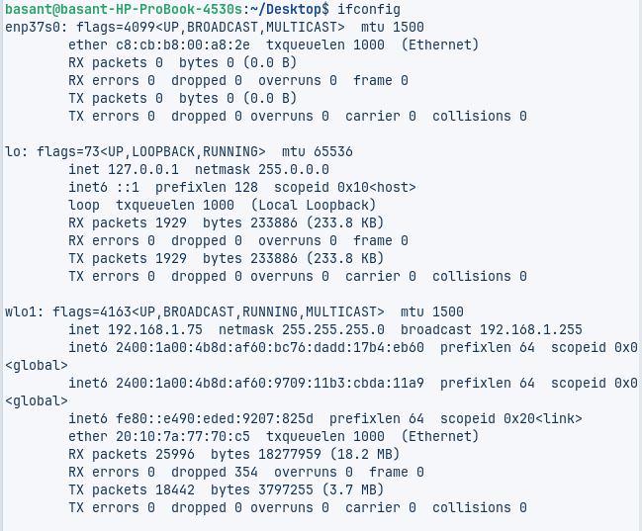
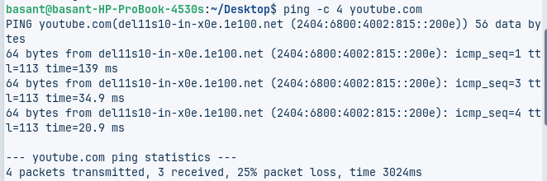
- ping
The ping command tests connectivity by sending ICMP packets to a host, revealing response times and potential packet loss.
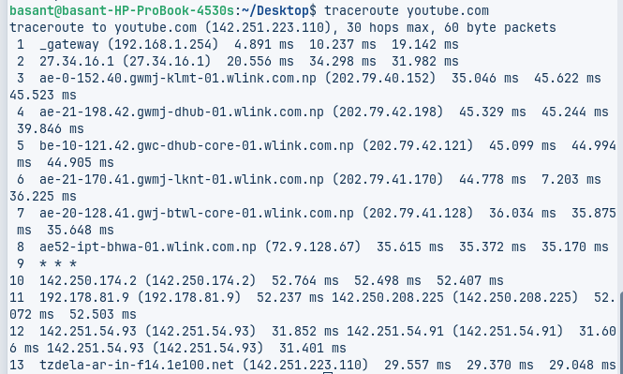
- tracert/traceroute
For path analysis, tracert/traceroute maps the route data takes across networks, identifying delays or failures at specific hops.
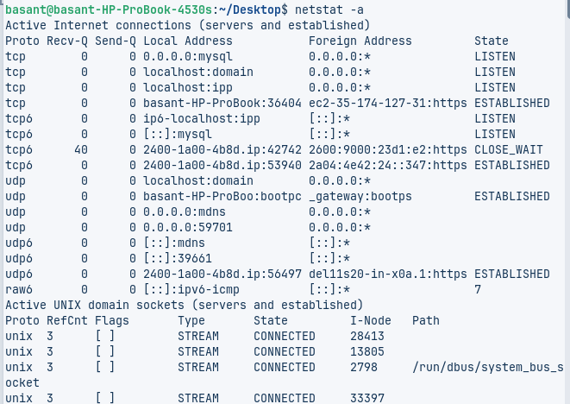
- netstat
Netstat lists active connections and open ports, useful for monitoring traffic and detecting suspicious activity.
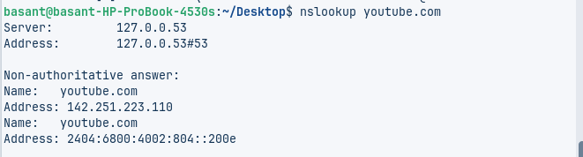
- nslookup
Nslookup queries DNS servers to resolve domain names into IP addresses, aiding in DNS troubleshooting.
- arp
The arp command shows IP-to-MAC address mappings on a local network, helping detect unauthorized devices.
- hostname
Hostname simply reveals the system’s network identifier.
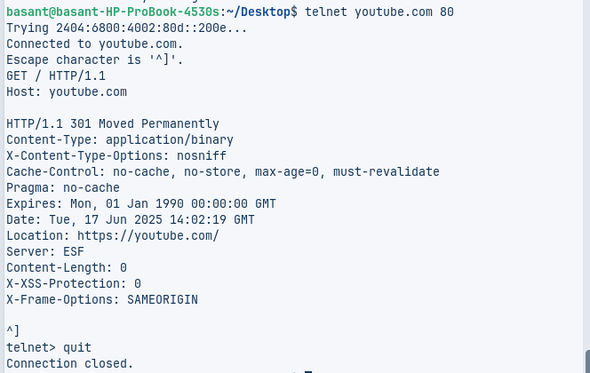
- telnet
Telnet tests whether a remote port is open and accessible, often used to verify service availability.
Conclusion:
This lab covered key networking commands (ipconfig, ping, tracert, etc.) for troubleshooting connectivity, analyzing traffic, and diagnosing DNS or port issues. Mastering these tools helps quickly identify and resolve common network problems, making them essential for IT professionals. Regular practice ensures efficient network management and security monitoring.

