Moriah Holland, Chris Vaughn, Ian Biggs, Dalton Finch

PURDUE GLOBAL IT473 Capstone ASSIGNMENT PROFESSOR STEPHEN SAVAGE | 12-15-2024

Wireframe and Planning Documentation

GotNoChill Website and App Development.

**GotNoChill Website Development: Wireframe Planning and Implementation**

The purpose of this documentation is to outline the wireframes, prototypes, and the overall planning for the GotNoChill/PrimePath Provisions project. This document will guide the team through the visual and functional layout of the website and app to ensure a seamless development process.

**1. Wireframe Objectives**

The wireframe serves as the first visual guide to the project. The goals include:

* Establishing a clear user journey for both desktop and mobile users.
* Defining page structure, navigation flow, and content placement.
* Providing a foundation for responsive design.

**2. Wireframe Generations**

**2.1 First-Generation Wireframes**

* **Desktop Login Page**:  
  A simple layout showcasing the login form with placeholders for:
  + Email/Username input
  + Password input
  + Login button
  + "Forgot Password" link
* **Desktop Checkout Page**:  
  Includes:
  + Cart item list
  + Billing information form
  + Payment method selection
  + "Place Order" button

**2.2 Second-Generation Wireframes**

* Enhanced layouts improving usability with responsive elements.
* Focus areas include:
  + **Consistent header/navigation** for seamless flow.
  + **Highlighted call-to-action buttons** to improve conversions.

**3. App Wireframe**

**3.1 App Login Page**

* Includes simplified fields for:
  + Email/Username
  + Password
  + "Login" button

**3.2 App Checkout Page**

* Focuses on mobile-friendly elements such as:
  + Scrollable cart items
  + Autofill-enabled input forms
  + Touch-friendly payment options

**4. Tools and Resources**

The following tools were utilized during the development process:

1. **Figma**: Used to create detailed wireframes for desktop and app layouts.
2. **GitHub**: For version control, collaboration, and repository management.
3. **Glitch.com**: A platform to develop and test the functional website in a live environment.
4. **Node.js/Express.js**: Frameworks used to handle the backend server and routing.
5. **HTML/CSS/JavaScript**: Core technologies for the front-end interface and interactive features.

**5. Functional Website Development**

After wireframe approval, the functional website was developed using **Glitch.com**.

* **Purpose**: Enabled real-time testing, debugging, and collaborative editing.
* **Features Implemented**:
  + Smooth navigation across sections (e.g., Menu, About, Cart).
  + Responsive design optimized for desktop and mobile.
  + Interactive components such as the "Order Now" button.
  + Integration of JavaScript for dynamic behavior like smooth scrolling and content toggles.

**Functional Links**

* **Live Website**: <https://gotnochill.glitch.me/PrimePathProvisions/>
* **Code Repository on Glitch**: <https://glitch.com/edit/#!/gotnochill>

**6. Design and Development Decisions**

* **Responsive Design**: Ensured the site works seamlessly across devices.
* **Color Scheme**: Green tones to reflect freshness and align with the food delivery theme.
* **Minimal UI**: Clean and modern layout to provide an intuitive user experience.

GotNoChill.com's planning and development included wireframes, iterative design, and real-time testing applied with tools like Figma, Glitch.com, and GitHub. The resulting design guarantees easy ordering experience and user-friendly navigation, thereby supporting the objective of the project, that it provides fresh food effectively.

Wireframe 1st.

Wireframe 2nd. Gen prototype webpage

Desktop Login Page:

Desktop Checkout Page:

App WireFrame:

App Login Page:

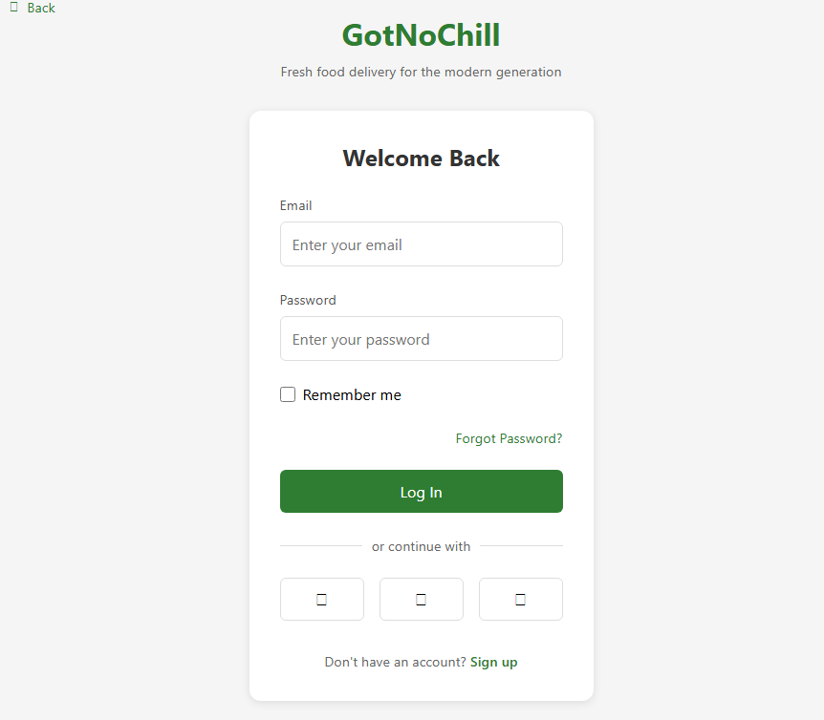

App Checkout Page :



