**PlaceboPharma**

**Cyber Security Team Blue Team 07**

**Recipient**: PlaceboPharma Cyber Operations Team

**Date**: 2/1/2025

**Subject:** Response to Request Inject Q01

Dear <malou>,

Thank you for reaching out to our team. We were asked to conduct a comprehensive network inventory to identify all active subnets, devices, and configurations. This task included distinguishing between public and private subnets along with devices in the network. The detailed report and findings are provided below.

Sincerely,

Blue Team 07

Executive Summary

This document provides a network topology, device inventory and broad areas of risk in the network. Our team performed an extensive network inventory to find all active subnets devices, and their configurations. During the assessment, we differentiated between public and private subnets and categorized all devices. During the evaluation we uncovered several network misconfigurations as well as potential risk that could have substantial impact on security and business continuity. The key areas of risk are provided in the next section. This is a broad overview of risk found in this first analysis. Further examination and hardening will be executed on each device immediately.

Areas Of Risk Found

* The devices blank, blank and blank have public facing ports 23 which run the telnet service (telnet transmits all data in clear text with no encryption)

Network Topology

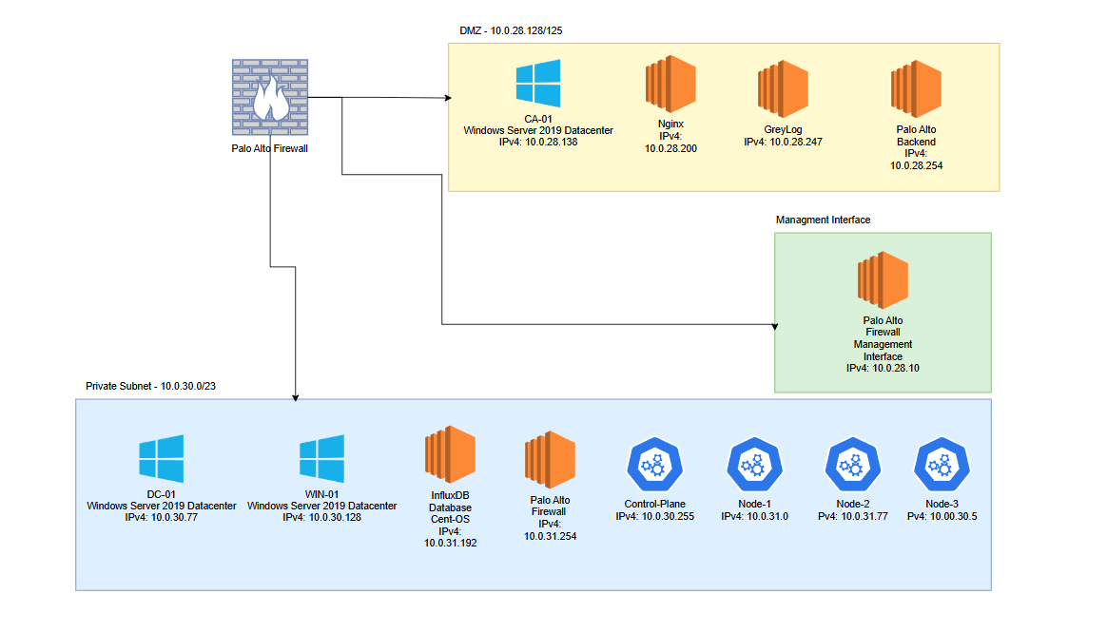

Network Device Inventory

DMZ Subnet: 10.0.28.128/25

|  |  |  |  |  |  |
| --- | --- | --- | --- | --- | --- |
| **Hostname** | **IPv4** | **Mac Address** | **Operating System/Version** | **Open Ports** | **Notes** |
| CA-01 |  |  | Windows Server 2019 Datacenter |  |  |
| Nginx |  |  |  |  |  |
| Greylog |  |  |  |  |  |
| pfSense |  |  |  |  |  |

Management Subnet:

|  |  |  |  |  |  |
| --- | --- | --- | --- | --- | --- |
| **Hostname** | **IPv4** | **Mac Address** | **Operating System/Version** | **Open Ports** | **Notes** |
| pfSense |  |  |  |  |  |
|  |  |  |  |  |  |

Private Subnet: 10.0.30.0/23

|  |  |  |  |  |  |
| --- | --- | --- | --- | --- | --- |
| **Hostname** | **IPv4** | **Mac Address** | **Operating System/Version** | **Open Ports** | **Notes** |
| DC-01 |  |  | Windows Server 2019 Datacenter |  |  |
| FILE-01 |  |  | Windows Server 2019 Datacenter |  |  |
| WIN-01 |  |  | Windows 10 |  |  |
| pfSense |  |  |  |  |  |
| InfluxDB |  |  |  |  |  |
| cntr-Plane |  |  |  |  |  |
| node-1 |  |  |  |  |  |
| node-2 |  |  |  |  |  |
| node-3 |  |  |  |  |  |