University of Virginia Data Science  
DS 5110 Big Data Systems

**Amazon S3: Retrieving Root Access Keys**  
Last updated: September 28, 2021

**Purpose**  
Root Access Keys give you the ability to do many things with AWS.

For our purposes here, we will use the keys to work with file upload and download from Python using the *boto* package.

Boto3 is the Amazon Web Services (AWS) Software Development Kit (SDK)  
<https://pypi.org/project/boto3/>

**Note**: Be very careful with your access keys, as they provide access to your AWS account. Do not share them with others.

The steps for retrieving access keys are based on this [tutorial](https://www.msp360.com/resources/blog/how-to-find-your-aws-access-key-id-and-secret-access-key/).

1) Log in to the AWS Management Console

2) Go to user name at top right, select My Security Credentials

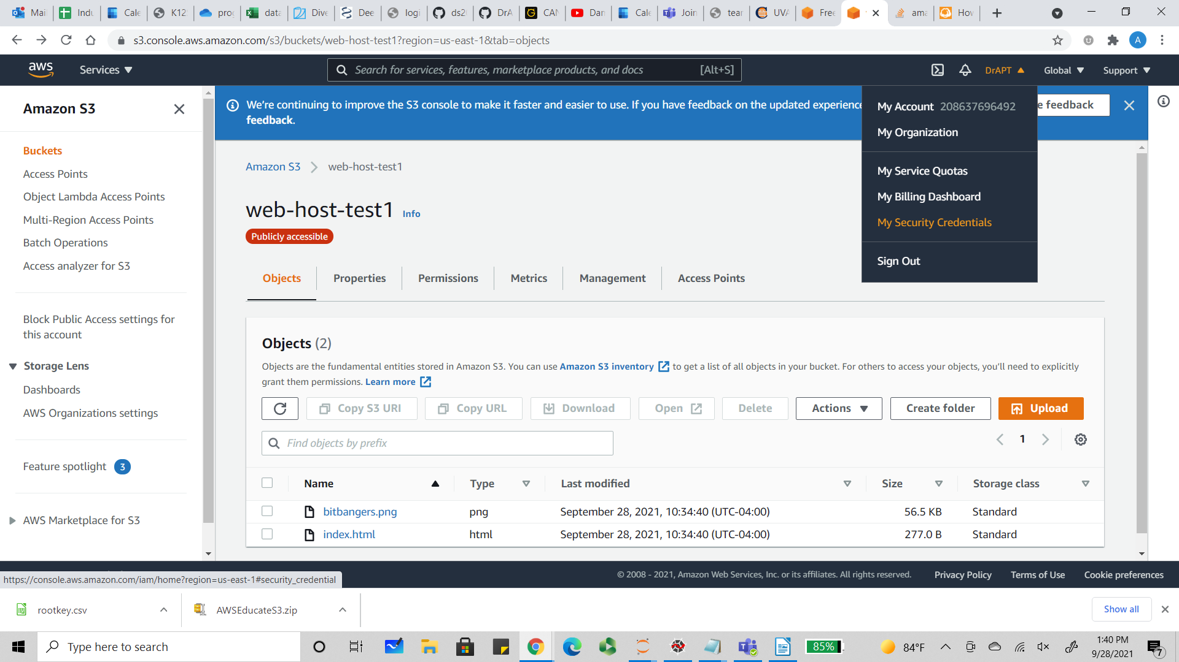

2) Click Access keys

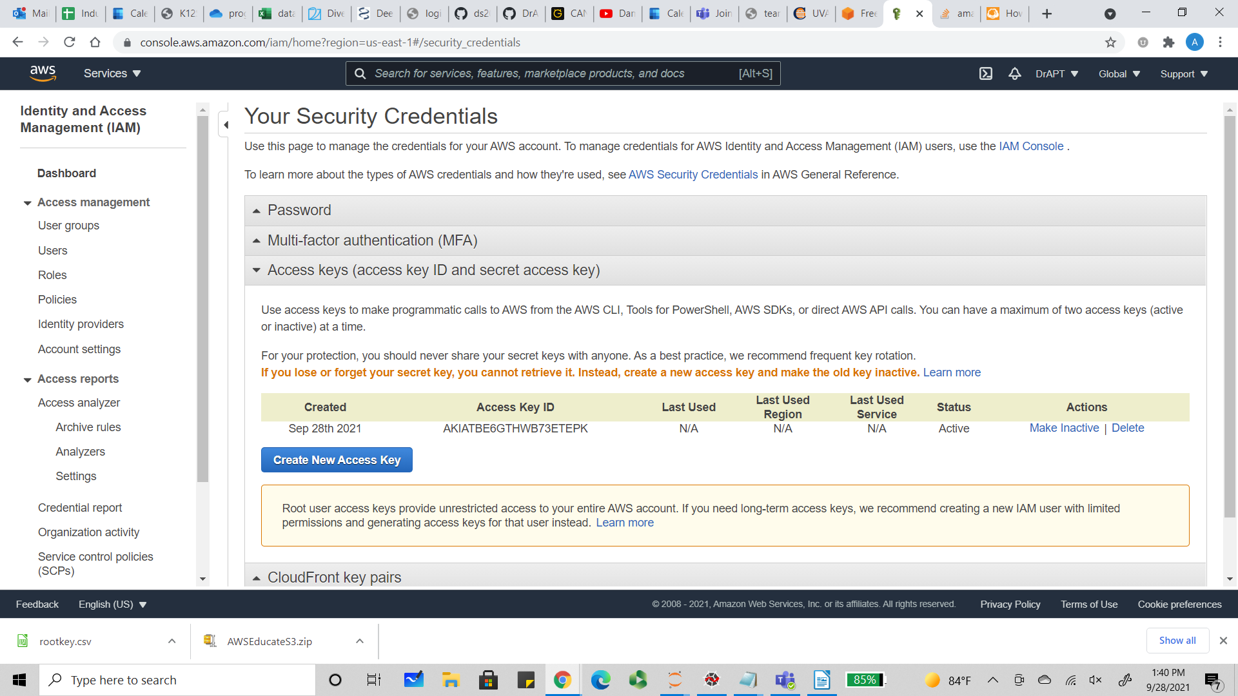

3) Create Access Key and then Download Key File.

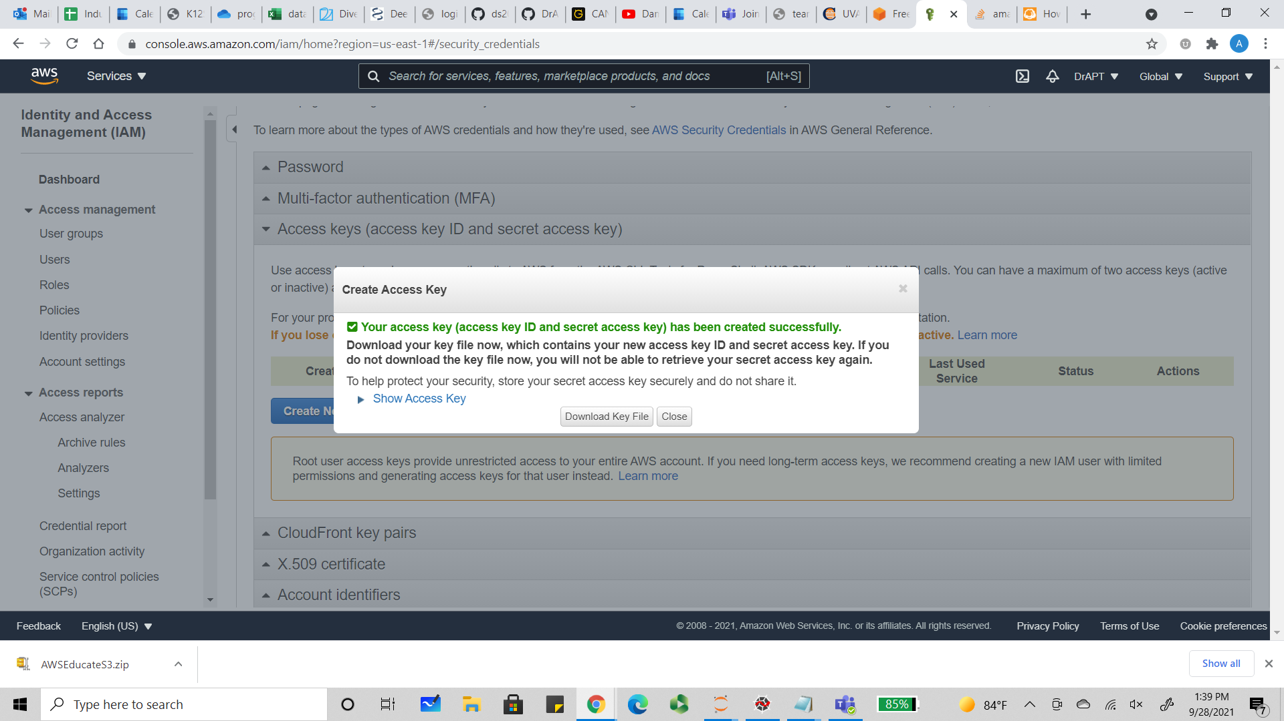

4) This file contains *aws_access_key_id* and *aws_secret_access_key*

When you wish to use boto3 to connect to an S3 bucket, you submit this Python code.  
A separate tutorial will review S3 bucket upload and download operations.

import boto3

s3_client = boto3.client(

's3',

aws_access_key_id='YOUR_AWS_ACCESS_KEY_ID_AS_STRING',

aws_secret_access_key='YOUR_AWS_SECRET_ACCESS_KEY_AS_STRING'

)