NAME : SATYAM SAURAV AGE: 17 Y/ M DATE: 29 November 2025
Refd. By.: DR SANJAY KUMAR MBBS
==============================================================================
This Scan has been Proudly done on Brand New, Most Advanced 3 Tesla MRI

CE M.R.I. STUDY OF BRAIN

Technique
Multiplanar, multisequence MRI of the brain performed, including T1, T2, FLAIR, DWI/ADC, GRE/SWI.

Findings
- Parenchyma:
  - Multiple scattered FLAIR hyperintensities are seen diffusely across the cerebral parenchyma. Mild DWI hyperintensity with corresponding ADC hypointensity is noted in some of these lesions, suggesting restricted diffusion.
  - Lesions are non-territorial.
  - No hemorrhage or calcification on GRE/SWI.
- Gray and White Matter:
  - Patchy cortical and subcortical involvement noted. Basal ganglia and thalami appear preserved.
- Ventricles & CSF Spaces:
  - Normal in size and configuration. No hydrocephalus or midline shift.
- Meninges:
  - No abnormal meningeal enhancement detected on post-contrast sequences.
  - No evidence of pachymeningeal or leptomeningeal thickening.
- Enhancement: No abnormal parenchymal enhancement.
- Other Structures:
  - Brainstem and cerebellum appear unremarkable.

Impression
- Diffuse scattered FLAIR hyperintensities across the brain parenchyma, with mild DWI hyperintensity and corresponding ADC hypointensity in some lesions, indicating restricted diffusion.
- Findings are more suggestive of encephalitic/inflammatory parenchymal process (viral encephalitis, post-infectious demyelination/ADEM).
- Isolated meningitis is less likely in the absence of meningeal enhancement, though very early meningitis cannot be excluded clinically.

Recommendations
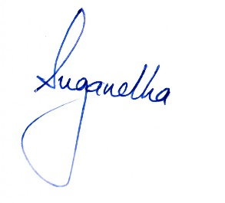
- Correlate with CSF (cell count, protein, glucose, culture/PCR) and serological studies.
- Clinical correlation essential for differentiation between encephalitis and meningitis.
- Follow-up MRI with contrast may be considered if symptoms persist or worsen.

