|  |  |  |
| --- | --- | --- |
| /Users/moah/Desktop/university/ZU/Robotics/lecturesLaTeX/figures/zuLogo.jpg | Zagazig University  Faculty of Engineering  Computer and Systems Engineering Dept. | /Users/moah/Desktop/university/ZU/Robotics/lecturesLaTeX/figures/engLogo.png |

**Project Title**

*Project Subtitle*

**Group Name** (if none, leave blank)

This document is the report concerning the project done in the winter semester 2015 by our group. The group was composed of six students who studied Computer and Systems Engineering on the 4th year at Zagazig University, Faculty of Engineering.

Zagazig, Tuesday, December 8, 2015.

**Participant(s)**:

|  |  |  |  |
| --- | --- | --- | --- |
| **Name** | **ID** | **Task(s)** | **Signature** |
| 1. Aa Name Name Name Name   Name in Arabic | ID.No. | task1, task2, … |  |
| 1. Bb Name Name Name Name   Name in Arabic | ID.No. | task1, task2, … |  |
| 1. Cc Name Name Name Name   Name in Arabic | ID.No. | task1, task2, … |  |
| 1. Dd Name Name Name Name   Name in Arabic | ID.No. | task1, task2, … |  |
| 1. Ee Name Name Name Name   Name in Arabic | ID.No. | task1, task2, … |  |
| 1. Ff Name Name Name Name   Name in Arabic | ID.No. | task1, task2, … |  |

**Abstract**:

Here is the abstract. **Maximum 280 words** or the fill of this box.

An abstract is a concise description of the report including its purpose and most important results. An abstract must not be longer than half a page and must not contain figures or make reference to them. The results may be summarized in the abstract but qualitatively, not quantitatively.

No specific technical jargon, abbreviations, or acronyms should be used.

**Keywords**:

Robotics, Mechatronics, Embedded Systems, Control, Simulation, …

This document specifies the recommended format to be used when submitting the project report. Also, this manual can be used as a guide to compose a formal technical report in a variety of disciplines and purposes and/or less formal reports, such as lab reports, that may consist of a subset of the items presented here. It is a useful general guide from which faculty can specify the particular requirements for reports in their courses.

The purpose of the project technical report is to completely and clearly describe your project work, why it was done, results obtained and implications of those results. The technical report serves as a means of communicating the work to others and possibly providing useful information about that work at some later date. A well‐written report allows the reader to quickly understand what has been accomplished. The report also provides sufficient detail to allow the reader to recreate the results although the level of detail provided depends heavily on the report’s audience and any proprietary nature of the work.

Clear presentation of results is at least as important as the results themselves; therefore, writing a report is an exercise in effective communication of technical information. Results, such as numerical values, designed systems or graphs by themselves are not very useful. To be meaningful to others, results must be supported by a written explanation describing how results were obtained and what significance they hold, or how a designed system actually functions. Although the person reading the report may have a technical background, the author should assume unfamiliarity with related theory and procedures. The author must therefore supply details that may appear obvious or unnecessary. With practice, the technical report writer learns which details to include.

The key to a well‐written report is organization. A report that is divided into several sections, occurring in a logical sequence, makes it easy for the reader to quickly obtain an overview of the contents as well as locate specific information. This document provides guidelines for producing a well‐written technical report.

The formal technical report contains a complete, concise, and well‐organized description of the work performed and the results obtained. Any given report may contain all of the sections described herein or a subset, depending upon the report requirements. These requirements are decided by the author(s) and are based on the audience and expected use of the report.

Project/Formal Technical Report Template

Author: *Dr.Ing.* **Mohammed** Nour Abdelgwad **Ahmed** (mnahmed@zu.edu.eg)

Last Revision: 21.02.2016

|  |  |  |
| --- | --- | --- |
| /Users/moah/Desktop/university/ZU/Robotics/lecturesLaTeX/figures/zuLogo.jpg | Zagazig University  Faculty of Engineering  Computer and Systems Engineering Dept. | /Users/moah/Desktop/university/ZU/Robotics/lecturesLaTeX/figures/engLogo.png |

**Project Title Here**

*Subtitle Goes Here*

Project Report

by

Aa Name

Bb Name

Cc Name

Dd Name

Ee Name

Ff Name

|  |  |  |  |
| --- | --- | --- | --- |
| Zagazig University | Faculty of Engineering | Computer and Systems Engineering Dept. | 2016 |

Where otherwise noted, this work is licensed under the Creative Commons Attribution-NonCommercial 4.0 International License. To view a copy of this license, visit http://creativecommons.org/licenses/by-nc/4.0/.

Copyright © 2015 *Dr.Ing.* **Mohammed** Nour Abdelgwad **Ahmed** as part of the course work and learning material. All Rights Reserved.

Here you can write something about which tools and software you have used for typesetting the document, running simulations and creating figures. If you do not know what to write, either leave this block blank or have a look at the colophon in some of your books.

Dr.Ing. Mohammed Ahmed

mnourgwad@gmail.com

**Title**:

Project Title: Project Subtitle

**Keywords**:

Robotics, Mechatronics, Embedded Systems, Control, Simulation

**Project Period**:

Winter Semester 2015

**Project Group**:

Group Name

**Participant(s)**:

|  |  |  |
| --- | --- | --- |
| 1. Aa Name Name Name Name | ID.No. | task1, task2, … |
| 1. Bb Name Name Name Name | ID.No. | task1, task2, … |
| 1. Cc Name Name Name Name | ID.No. | task1, task2, … |
| 1. Dd Name Name Name Name | ID.No. | task1, task2, … |
| 1. Ee Name Name Name Name | ID.No. | task1, task2, … |
| 1. Ff Name Name Name Name | ID.No. | task1, task2, … |

**Supervisor(s)**:

Dr.Ing. Mohammed Ahmed

**Numbers of Pages**: **15**

**Date of Completion**:

Tuesday, December 8, 2015

**Abstract**:

Here is the abstract. Maximum 280 words or the fill of this box.

An abstract is a concise description of the report including its purpose and most important results. An abstract must not be longer than half a page and must not contain figures or make reference to them. The results may be summarized in the abstract but qualitatively, not quantitatively.

No specific technical jargon, abbreviations, or acronyms should be used.

The content of this report is freely available, but publication (with reference) may only be pursued

due to agreement with the author *Dr.Ing.* Mohammed Ahmed. For a *LATEX* version of this document, please contact the author.

Table of Contents

1. Introduction 1

2. Background Theory 2

3. Design and Analysis 3

4. Implementation 4

4.1 Procedure Writing Guidelines 4

5. Results and Discussion 5

6. Conclusion 6

7. References 7

7.1. Citing an Article in a Periodical 7

7.2. Citing a Book 7

7.3. Citing World Wide Web Documents 7

A. Appendix 8

7.4. Guidelines for Graphs 8

B. Writing Tips for Results and Discussion Section 9

B.1. Percent Difference/Error 9

List of Figures

**Figure 2.1.** Example of a figure.All figures must have captions. The figure and its Caption are centered on page 7

List of Tables

**Table 4.1** Example of a table. The table caption is above the table. 9

List of Algorithms

List of Symbols and Abbreviations

|  |  |
| --- | --- |
|  |  |
|  |  |

# **Introduction**

Give the objective of the work, a brief description of the problem, and how it is to be attacked. This section should provide the reader with an overview of why the work was performed, how the work was performed, and the most interesting results. This can usually be accomplished with ease if the work has clearly stated objectives. After introducing the problem, indicate how those objectives are met. The length of this section depends on the purpose but the author should strive for brevity, clarity, and interest.

Be careful not to use specific technical jargon or abbreviations such as using the term “oscope” instead of “oscilloscope”. Also, make sure to define any acronyms or abbreviations prior to using them. For example, in a surveying lab report a student might want to refer to the electronic distance measuring (EDM) device. The first time the device is referred to, the student must spell out what the acronym stands for before using the acronym as demonstrated in the previous sentence. This practice should be applied throughout the report when the author wants to use an acronym that has not yet been defined within the report. Do not assume that the reader is familiar with all the acronyms that are familiar to the author.

# **Background Theory**

Include, if necessary, a discussion of relevant background theory. For example, if the phase shift of an RC circuit is to be measured, give the derivation of the theoretical phase shift. Include any preparation specified in the lab manual. In deciding what should or not should be included as background theory, consider presenting any material specific to the project that you had to learn prior to performing the project. This section may be divided into subsections if appropriate. Keep the discussion brief and refer the reader to outside sources of information where appropriate. The proper method of providing references and making citations within the report is provided in Appendix A.

**Figure 2.1.** Example of a figure.All figures must have captions. The figure and its Caption are centered on page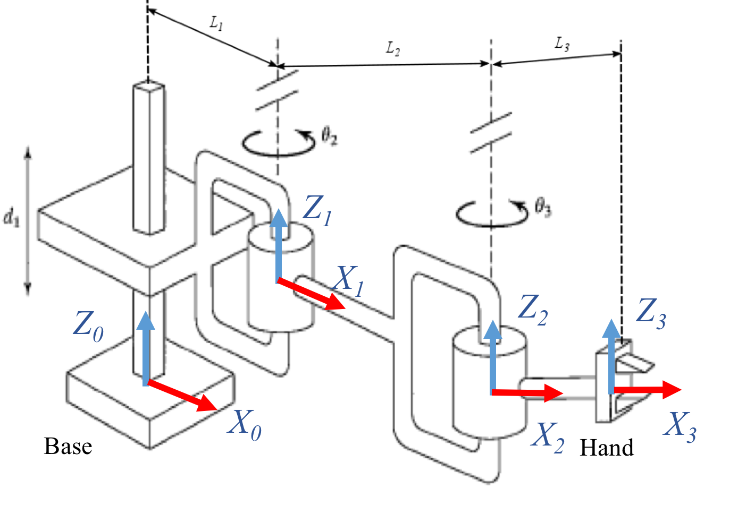

# **Design and Analysis**

Give the details of your design procedure. Be sure to introduce and describe your design work using sentences, equations alone are not sufficient. Use citations if you wish to refer the reader to reference material. Divide this section into subsections where appropriate. For example, a robot design may consist of designing several modules that are subsequently interconnected; you may choose to treat each module design in its own subsection. Keep this section as general as possible, only applying specific numbers after the design is explained.

If there is no design but strictly analysis, then provide the important details of all the analysis performed. It is necessary to show every step; sentences can be used to describe the intermediate steps. Furthermore, if there are many steps to the analysis, the reader should be directed to the appendix for complete details.

# **Implementation**

This section varies depending on requirements of the project. At a minimum, the author *discusses* the procedure by describing the method used to test a theory, verify a design or conduct a process. Presentation of the procedure may vary significantly for different projects, however, for all projects, **the author should BE BRIEF and get to the point**. Like with any written work, if it is unnecessarily wordy, the reader becomes bored and the author no longer has an audience. Also, the procedure section should **never** include specific measurements/results, discussion of results, or explanation of possible error sources. Make sure all diagrams provided are numbered, titled, and clearly labeled.

Depending on the situation, the procedure section must provide a detailed description of the implementation steps. In another case, it might be the author’s job to provide all the detail so the work can be duplicated.

## **Procedure Writing Guidelines**

The writing guidelines for the possible procedure section are provided below. Use these guidelines so you can supply a detailed description of the steps required to complete the work.

* Describe in detail all necessary steps or processes required to complete the work. This may include, but is *not limited to*, the following:
* Equipment use
* Define terms specific to the technology
* Measurement techniques and/or calibration
* The description, as detailed above, should be sufficiently clear so that the reader could duplicate the work.
* Do not assume that the reader has prior knowledge or access to prior reports, textbooks, or handouts.
* If part of the procedure was successfully described in a previous report, either repeat the procedure or include that report in the appendix and refer the reader to it.
* Where appropriate, provide diagrams and/or pictures to assist the reader in understanding the procedure.

**Table 4.1** Example of a table. The table caption is above the table.

|  |  |  |  |  |
| --- | --- | --- | --- | --- |
| **Link** | ***a*** | ***α*** | ***θ*** | ***d*** |
| **1** | *L1* | *0* | *0* | *d1* |
| **2** | *L2* | *0* | *θ2* | *0* |
| **3** | *L3* | *0* | *θ3* | *0* |

# **Results and Discussion**

Present the results of the work performed using neatly organized and completely labeled tables and/or graphs whenever possible. When comparative data is available, present the data in a way that facilitates the comparison. For example, if theoretical and experimental values are available, present the values alongside one another accompanied by percent error. If it would help the reader understand the results, include a few sample calculations but put lengthy calculations in an appendix.

**ALWAYS** accompany results with a meaningful discussion. The discussion explains what the results mean and points out trends. In some cases, the results speak mostly for themselves and the discussion may be brief, i.e., “Table 2 shows that the designed variable modulus counter works as expected”. In other cases, the meaning of the results may not be as clear requiring more detailed discussion.

**ALWAYS** discuss the possible sources of error and how accurate the results need to be in order to be meaningful. Do not include a discussion of possible sources of error that would not add significantly to the observed error. What counts as significant depends on the situation. For example, if the components used have a tolerance of 5% and the accuracy of the equipment is within 0.1% of the measured value, then the equipment does not add any significant error. In general, it is impossible to obtain error‐free results, however, attention to detail when conducting procedures should minimize the error. Errors are different from mistakes. It is **unacceptable** to report mistakes. If a mistake was made in the work, the work must be repeated until acceptable tolerances are achieved before submitting a report.

When working in the industry, it is imperative to know how accurate the results need to be. It is worth your time and effort (and in the best interest of your boss or client) to provide the appropriate level of accuracy. If that means repetitive measurements to check for accuracy within tolerance, then do it. If it means performing a detailed analysis prior to making measurements, then do it. In the academic setting, the result of laziness or lack of effort may only be a bad grade. In the workplace, you may get fired!

Other information pertaining to writing the Results and Discussion section can be found in Appendix B. This information includes

# **Conclusion**

In this final section of the body of the report, the author should briefly bring everything together. It is similar to the abstract except that now the results are concluded upon in a quantitative way. Therefore, the conclusion should be a concise description of the report including its purpose and most important results providing specific quantitative information. The conclusion should not contain figures or make reference to them. As with the abstract, the reader should be able to read this section on its own which means that there should be no specific technical jargon, abbreviations, or acronyms used.

# **References**

List all works cited in the report, include all the important bibliographical information. The Works Cited should begin on a new page, not on the same page with the conclusion. Refer to Appendix A for information on preparing the Works Cited section.

## **Citing an Article in a Periodical**

When citing an article in a periodical, you must include:

* The author(s) last name(s), followed by a comma, and first initial (s), followed by a period.
* The year of publication and date, in parentheses, followed by a period.
* The article title followed by a period. Capitalize only the first word and any proper nouns (names, places, etc).
* The title of journal, in italics, followed by a comma.
* The volume number in italics.
* The issue number (if available) in parenthesis, followed by comma.
* The pages followed by a period.

## **Citing a Book**

When citing a book, you must include:

* The author(s) last name(s), followed by a comma and first initial (s), followed by a period.
* The year the book was copyrighted in parentheses, followed by a period.
* The title of the book, in italics and followed by a period. Capitalize only the first word and any proper nouns (names, places, etc).
* The place of publication, followed by a colon.
* The publisher followed by a period.

## **Citing World Wide Web Documents**

When citing information that was retrieved from a website, you must include:

* The author(s) last name(s) (if available) followed a comma and first initial.
* The year of publication (if available) in parentheses. If no date is available, use (n.d.)
* The title of the document in italics followed by a period. Capitalize only the first word and any
* proper nouns (names, places, etc).
* The phrase “Retrieved” followed by the date you found the document on the Web followed by
* the word “from” and a comma.
* If a government or academic site, the name of the host organization followed by a colon.
* The Web address (URL), followed by a period.

# **Appendix**

This section may not always be present. Materials included in an appendix may include data sheets, parts list, diagrams, extensive calculations, error analyses, and lengthy computer programs. Introduce numbered appendices rather than putting different items in one appendix.

## **Guidelines for Graphs**

Always refer to graphs and tables when discussing results. Construct graphs using the following guidelines:

1. Create the graph using a computer software package such as Microsoft Excel.
2. Clearly label axes, including **names** of quantity plotted and its **units**.
3. Use a smoothed line to produce the best‐fit curve.
4. Clearly indicate data points using a circle, triangle, or square. Use different shapes for different curves plotted on the same axes.
5. Label different curves plotted on the same axes.
6. Number and title every graph. “Figure 1: V vs. R” is NOT an acceptable title whereas “Figure 1: Measurement of voltage (V) as a function of varying resistance (R)” is.
7. Place all graphs in the report so that the bottom of the graph is either along the bottom of the paper or centered on the paper.

# **Writing Tips for Results and Discussion Section**

This information includes:

* How to calculate percent difference/error.
* Typical magnitudes of percent error for courses where circuits are constructed.
* What to consider writing about based on the project requirements.
* Guidelines for graphs provided in a report.

## **Percent Difference/Error**

Always calculate meaningful percent difference where percent difference is commonly understood to be:

(1)

where: is the difference in percentage, is measured value, and is the theoretical.

The measured value is the same as the experimental value. This value is determined through experimentation. The theoretical value is determined from an analysis and does not depend on any measured value.