Test File

Nick

20 June 2016

## Using RMarkdown

### Text

Text can be decorated with **bold** or *italics*. It is also possible to

* create [links](http://rmarkdown.rstudio.com/)
* include mathematics like $e=mc^{2}$ or

$$y=β_{0}+β_{1}x_{1}+β_{2}x_{2}$$

Be sure to put a space after the * when you are creating bullets and a space after # when creating section headers, but **not** between $ and the mathematical formulas.

### Graphics

If the code of an R chunk produces a plot, this plot can be displayed in the resulting file.

xyplot(births ~ date, data=Births78)

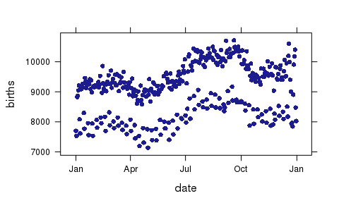

### R output

Other forms of R output are also displayed as they are produced.

favstats(~ births, data=Births78)

## min Q1 median Q3 max mean sd n missing  
## 7135 8554 9218 9705 10711 9132.162 817.8821 365 0

### Destination formats

This file can be knit to HTML, PDF, or Word. In RStudio, just select the desired output file type and click on Knit HTML, Knit PDF, or Knit Word. Use the dropdown menu next to that to change the desired file type.

### Documenting file creation

It's useful to record some information about how your file was created.

* File creation date: 2016-06-20
* R version 3.2.3 (2015-12-10)
* R version (short form): 3.2.3
* mosaic package version: 0.14.2
* Additional session information

## R version 3.2.3 (2015-12-10)  
## Platform: x86_64-redhat-linux-gnu (64-bit)  
## Running under: CentOS Linux 7 (Core)  
##   
## locale:  
## [1] LC_CTYPE=en_US.UTF-8 LC_NUMERIC=C   
## [3] LC_TIME=en_US.UTF-8 LC_COLLATE=en_US.UTF-8   
## [5] LC_MONETARY=en_US.UTF-8 LC_MESSAGES=en_US.UTF-8   
## [7] LC_PAPER=en_US.UTF-8 LC_NAME=C   
## [9] LC_ADDRESS=C LC_TELEPHONE=C   
## [11] LC_MEASUREMENT=en_US.UTF-8 LC_IDENTIFICATION=C   
##   
## attached base packages:  
## [1] graphics grDevices utils datasets stats methods base   
##   
## other attached packages:  
## [1] mosaic_0.14.2 Matrix_1.2-6 mosaicData_0.14.0 ggplot2_2.1.0   
## [5] lattice_0.20-33 dplyr_0.4.3.9000   
##   
## loaded via a namespace (and not attached):  
## [1] Rcpp_0.12.5 knitr_1.13 magrittr_1.5   
## [4] splines_3.2.3 MASS_7.3-45 munsell_0.4.3   
## [7] colorspace_1.2-6 R6_2.1.2 ggdendro_0.1-20   
## [10] stringr_1.0.0 plyr_1.8.4 tools_3.2.3   
## [13] parallel_3.2.3 grid_3.2.3 gtable_0.2.0   
## [16] DBI_0.4-1 htmltools_0.3.5 yaml_2.1.13   
## [19] digest_0.6.9 lazyeval_0.2.0 assertthat_0.1   
## [22] gridExtra_2.2.1 formatR_1.4 reshape2_1.4.1   
## [25] evaluate_0.9 rmarkdown_0.9.6.14 stringi_1.1.1   
## [28] scales_0.4.0