Title page
DELAY-RISK IDENTIFICATION AND PRIORITISATION FOR BRICK MASONRY WORK IN INDIAN BUILDING PROJECTS: AN EVIDENCE-TRACEABLE DECISION-SUPPORT TOOL
(Registered project title: “Framework for Brickwork Labor-Productivity and Delay-Risk Prediction Using Managerial Factors in Selected Indian Building Projects”. Section 1.6 explains how the work reported here relates to the registered title.)
A Final Year Project Report submitted in partial fulfilment of the requirements for the degree of
Bachelor of Technology in Civil Engineering
by
Name | Roll / enrolment number
[Team member 1: full name] | [number]
[Team member 2: full name] | [number]
[Team member 3: full name] | [number]
Under the guidance of
[Name and designation of project guide]
[School / department name] [Full institution name and campus, to be confirmed by the team: NICMAR, Pune]
[Month and year of submission]

Certificate
This is to certify that the project report entitled “Delay-Risk Identification and Prioritisation for Brick Masonry Work in Indian Building Projects: An Evidence-Traceable Decision-Support Tool” (registered title: “Framework for Brickwork Labor-Productivity and Delay-Risk Prediction Using Managerial Factors in Selected Indian Building Projects”) is a record of the work carried out by
- [Name of team member 1], [number]
- [Name of team member 2], [number]
- [Name of team member 3], [number]
under my guidance, in partial fulfilment of the requirements for the award of the degree of Bachelor of Technology in Civil Engineering at [institution name]. To the best of my knowledge the work has not been submitted to any other institution for the award of a degree or diploma.
Place: [place]
Date: [date]
[Signature] | [Signature]
[Name, designation of project guide] | [Name, designation of Head of Department / Programme Chair]

Declaration
We declare that this report is our own account of the project. Where we have used the work of others, we have named it and listed it in the References. Every numerical value in the report is either (a) copied from a cited published source, (b) computed from such values by a script or calculation that is named next to the result, (c) entered by a user of the tool as a labelled example, or (d) stated as an assumption of the tool and labelled as one. We have not collected, fabricated or altered any site data or survey responses. No site data and no expert survey were collected for this report, and the example case in the report is illustrative only.
We understand that any misrepresentation of the above is a breach of academic integrity.
Name | Signature | Date
[Team member 1]
[Team member 2]
[Team member 3]

Declaration on the use of AI assistants
This project was carried out with substantial help from AI coding and writing assistants (Claude models from Anthropic, run as coding agents and chat sessions). We state what they did, what they did not do, and what the team is responsible for.

What AI agents did
Table 0.1. Tasks performed with AI assistance, and the check the team is asked to record for each.
Area | What the AI agents did | Check recorded by the team
Software | Wrote and edited most of the Python code of the tool (rules engine, risk matrix, register, exports, local web interface, PySide6 desktop wrapper, optional decision layer in app/analysis.py) and the automated tests. | [Team member, date: code read and tests run]
Literature search and notes | Ran keyword searches against open metadata sources, screened the resulting records by title and abstract, and wrote the research notes in Research_Notes/. The screening judgements are model output and were not independently re-read in full by a human (see Chapter 3 and docs/Literature_Database_Report.md). | [Team member, date: sample of records checked]
Data transcription | Transcribed relative importance index (RII) values from published papers into data/literature_seed.json. A later audit by AI agents compared all 182 rows with the printed tables and found the values matched; it also found and corrected metadata errors. | [Team member, date: rows spot-checked against the PDFs]
Audits and reviews | Ran a research-methods audit, an engine audit and four simulated committee reviews (engineering/UX, domain expert, methods, external examiner). These produced the list of withdrawn claims and corrected wording in docs/Audit_Corrections_2026-10-08.md and docs/Project_Handoff_Summary.md. They are not a substitute for review by the supervisor or an external examiner. | [Guide, date: reviewed]
Statistics | Wrote the scripts that compute the cross-study agreement statistics and sensitivity analyses (scripts/, analysis/). | [Team member, date: results re-computed]
Drafting | Drafted the text of this report from the repository files, with each number traced to a file or script output. | [Team member, date: report read in full]

What AI did not do
The AI assistants did not supply any probability, delay duration, cost, productivity rate, survey response or site observation. All probabilities, delays and costs that appear in the tool are typed in by a user and carry a Source label. The numbers taken from the literature are RII values copied from the published papers. The AI-suggestion feature of the tool can propose risk names, mechanisms and identifiers of evidence records only, and the tool rejects numeric fields in its output (guard rules described in Chapter 5). The example case in this report was written by the team for illustration and is labelled ILLUSTRATIVE wherever it appears.

What the team must verify
The team remains responsible for the content. Before submission the team should confirm, and record in Table 0.1, that: (1) the transcribed RII values and the factor-to-risk mapping have been checked by a human against the source papers; (2) the references exist and say what the report attributes to them, in particular the items listed as unverified in the reference assembly notes; (3) the statistics have been re-run by a team member; (4) the wording in the report about what was and was not done matches the real project history; and (5) the declaration above is accurate for each team member.

Acknowledgements
[To be written by the team. Suggested content: the project guide and any co-guide; the Head of Department; the faculty and practitioners who will be asked to rate risks in the expert-survey phase, if that phase goes ahead; family and friends. Do not name anyone who has not agreed to be named.]

Abstract
Delays in brick and block masonry recur in Indian building projects, and published delay-cause studies rank factors by relative importance index (RII) without carrying the ranking into a site-level risk register. This report describes an offline decision-support tool for delay risk in one activity, brick or blockwork masonry. The registered title promised labour-productivity and delay prediction from managerial factors in selected Indian projects. Because no site access was available, the scope was reduced to risk identification, a source-labelled risk register and a five-by-five probability-impact matrix, and the report states this change openly.
The tool holds 46 masonry delay risks, 22 rules that flag risks from site facts, and a register in which every number carries a Source label (Literature, Historical Data, User Input, Expert Judgment, Derived Calculation or Assumption). For 30 of the 46 risks an ordinal starting position is derived from 182 RII values transcribed from 11 published studies; five studies form the seed and six are held out. An RII measures importance, not probability or days, so this starting position is an assumption of the tool and is labelled as one. An optional Monte Carlo and expected-monetary-value layer uses only numbers the user enters.
Agreement between the published rankings is weak. Cross-prediction between seed studies gave Spearman correlations of 0.09 to 0.64, none significant, and agreement with three held-out surveys (0.28, 0.63 and -0.18) did not survive correction for multiple testing. No site data were collected and no expert survey was run, so the tool is verified as software but not validated on real projects, and the example case is illustrative. Site validation and expert elicitation are defined as future work.

Keywords
brick masonry; construction delay; risk register; probability-impact matrix; relative importance index; decision support; India

Contents
Title page 1
Certificate 1
Declaration 1
Declaration on the use of AI assistants 2
What AI agents did 2
What AI did not do 2
What the team must verify 2
Acknowledgements 2
Abstract 7
Keywords 7
List of abbreviations 7
Chapter 1. Introduction 7
Background 7
Problem statement 7
Aim 8
Objectives 8
Scope 8
Scope revision relative to the registered title 9
Research gap 10
Contribution 10
Structure of the report 11
Chapter 2. Literature Review 11
Purpose and approach 11
Delay causes in building construction 13
The relative importance index and its limits 17
Risk management standards 18
Risk matrices and their critique 19
Quantitative schedule risk analysis: context 19
Labour productivity norms (context only; out of scope) 20
Elicitation, verification and validation 21
Decision-support tools for delay risk 22
Summary and the research gap 22
Chapter 3. Methodology 23
3.1 Research design and scope 23
3.2 The evidence corpus and the corpus count 23
3.3 Study selection for the RII data 24
3.4 Extraction and verification protocol 26
3.5 Mapping protocol 26
3.6 Seed construction 27
3.7 Matrix definitions and thresholds 28
3.8 Analysis plan 30
3.9 Software verification method 32
3.10 Future expert survey and second-coder design 32
3.11 Ethics 34
3.12 Threats to validity 34
3.13 Integrity rules and source labels 35
Chapter 4. Secondary-Data Analysis 35
4.1 What was run 35
4.2 The 30-risk literature seed 36
4.3 Behaviour of the bands and of the 5x5 rule 38
4.4 Example-case sensitivity (S1) 39
4.5 Edge and threshold sensitivity (S2) 41
4.6 Seed-band sensitivity (S3) 44
4.7 Bootstrap and jackknife tiers (S3) 46
4.8 Non-circular inter-study agreement (S4) 49
4.9 RII uncertainty (S5) 52
4.10 Summary of results 54
4.11 What this analysis does not show 54
Chapter 5. System Design and Implementation 54
5.1 Requirements 55
5.2 Architecture 56
5.3 Data model: the case file 58
5.4 The risk library 58
5.5 The rule engine 60
5.6 Register and matrix logic 63
5.7 Literature tier and source labels 64
5.8 AI evidence layer and guard rules 65
5.9 Exports 66
5.10 The interface 67
5.11 Desktop wrapper, build and continuous integration 73
5.12 Optional decision layer 74
5.13 Summary 78
Chapter 6. Verification and Testing 78
6.1 Verification approach 78
6.2 The automated test suite 78
6.3 The relevance guard tests 81
6.4 Hand calculation against the tool: the matrix 82
6.5 Independent check of the decision layer 83
6.6 Reproducibility and determinism 84
6.7 Robustness and fuzz testing (QA report) 84
6.8 Audit findings and what was corrected 86
6.9 Known defects and deferred items 88
6.10 What was not done 88
6.11 Summary 89
Chapter 7. Discussion 89
What was found, and how strongly 89
Reading the weak agreement between surveys 90
What the matrix level means 91
Comparison with other ways of keeping a register 92
Implications for site engineers 93
Threats to validity 93
What can and cannot be claimed 94
Chapter 8. Conclusions, Limitations and Future Work 94
Conclusions 94
Limitations 95
Recommendations 96
Future work 96
Closing statement 98
References 98
Appendix A. Literature seed table: all 182 rows 103
Appendix B. Risk library: all 46 risks 109
Appendix C. The 22 site-fact rules 112
Appendix D. Case file schema and interface endpoints 114
D.1 Case JSON schema, summary 114
D.2 Interface endpoints 116
Appendix E. Software test log 117
E.1 Relevance and consistency guards 118
E.2 Known defects not covered by the suite 119
Appendix F. Proposed expert-survey instrument 119
F.1 Purpose and design 119
F.2 Introduction shown to respondents (proposed text) 120
F.3 Section A: respondent profile (all choices from a list; no free text except where stated) 120
F.4 Section B: the 15 items, two ratings each 120
F.5 Section C: closing items 121
F.6 Bias controls 121
F.7 Pre-specified analysis plan 121
F.8 Sample-size honesty 122
Appendix G. Second-coder protocol for the factor-to-risk mapping 122
G.1 What is coded 122
G.2 Procedure 122
G.3 Output files (proposed layout) 123
G.4 What the result can and cannot show 123
Appendix H. Assumption register 123
H.1 How to read the sensitivity column 125
H.2 Items that are decisions, not assumptions 125
Appendix I. User guide 125
I.1 What the tool does and does not do 125
I.2 Install and start 125
I.3 Step by step on the ILLUSTRATIVE example 126
I.4 Working with a real activity 127
I.5 Optional cost, options and decision analysis 127
I.6 Known limits to keep in mind 128
Appendix J. Glossary and abbreviations 128

List of abbreviations
Table 0.2. Abbreviations used in this report.
Abbreviation | Meaning
AAC | Autoclaved aerated concrete (block)
AI | Artificial intelligence
APA | American Psychological Association (citation style, 7th edition)
BIS | Bureau of Indian Standards
CPWD | Central Public Works Department (India)
CSV | Comma-separated values (file format)
DSS | Decision-support system
EMV | Expected monetary value
FYP | Final year project
GUI | Graphical user interface
IEC | International Electrotechnical Commission
ISO | International Organization for Standardization
LLM | Large language model
LOSO | Leave-one-study-out
MC | Monte Carlo (simulation)
NICMAR | The institution at which the project was carried out (see title page)
P-I | Probability-impact (as in P-I matrix)
PERT | Programme evaluation and review technique (three-point estimate)
RII | Relative importance index
SE | Standard error
WBS | Work breakdown structure
Seed | The default ordinal starting position of a library risk derived from RII values of the seed studies
Held-out study | A published survey whose RII values are not used to build the seed and are used only for comparison
ILLUSTRATIVE | Label for example numbers that are not evidence

Chapter 1. Introduction

Background

Brick masonry in Indian building construction
Brick and block masonry is labour-intensive hand work. In a framed residential or commercial building the walls are laid by gangs of masons and helpers after the structural frame is cast, and plastering, services and finishing trades cannot proceed in a room until its walls are up. A delay in masonry therefore delays the activities that follow it. The activity depends on the daily availability of skilled labour, on bricks or blocks and mortar materials arriving and being staged near the working face, on access and scaffolding, on weather, and on payment and supervision arrangements that determine whether a gang turns up and stays.
Three strands of published evidence, read for this project, describe how this work behaves on Indian sites. They are small studies and none of them is a representative sample of India, so they are used here only to describe the kind of problem, not to size it.
- Reddy and Chambrelin (2021) video-recorded brickwork at seven residential sites in Andhra Pradesh. Each site was observed once for roughly one to two hours, and the reported work efficiency ranged from 62.57% to 90.62% (Source: Literature; Research_Notes/A_masonry_india.md, card A01). The authors attribute low efficiency to lack of work targets, poor planning and monitoring, material shortage and equipment breakdown. The sample is seven short observations and the area-based productivity column of the paper is not usable, as discussed in the research notes.
- Ponmalar et al. (2018) recorded the brick masonry activity on two three-storey residential buildings in Chennai. Both activities were planned as 20 working days. The authors report 6.14% and 8.17% work-hour overrun and that 7 and 8 of the 20 days respectively were ineffective (Source: Literature; card A02). The definitions are the authors’ own and the sample is two projects.
- Loganathan and Kalidindi (2015) report, from the abstract of a pilot study on one project in Tamil Nadu, a 20% to 40% production variation between masonry crews (Source: Literature; card A03; the abstract does not define the variation measure, and the full text was not accessible).
The same research notes record a second set of studies that name the drivers of workforce unavailability in India. Loganathan and Kalidindi (2016) interviewed project managers and labour sub-contractors on 15 projects in six states and report illness, injury, lack of basic facilities and payment delays as significant contributors to absenteeism and turnover among migrant construction workers. Guha and Biswas (2008) used Monte Carlo simulation on a housing project in Kolkata and report that the monsoon increased project duration by about 5% and cost by about 12% (Source: Literature; abstract only).

Delay research in India and elsewhere
Most of the published work on construction delay asks practitioners to rate a list of candidate causes and then ranks the causes by an index, most often the relative importance index (RII). Chapter 2 reviews these studies in detail. Two features of this literature matter for the problem stated below. First, most surveys cover building or infrastructure construction in general, not one activity. Second, the output of a survey is a ranking of importance, whereas a site engineer who has to decide what to do on Monday morning needs to know which of the listed risks is present on the site, how likely it is to cause loss of working days, and what the loss would be. The ranking does not state these.

Risk registers and matrices in practice
Risk management standards describe a cycle of identifying, analysing, evaluating and treating risk (International Organization for Standardization [ISO], n.d.). In project practice this cycle is commonly recorded in a risk register and summarised on a probability-impact (P-I) matrix, in which each risk is placed by a probability class and an impact class and given a level. A matrix is easy to read and to produce, but it is a coarse device with known weaknesses (Cox, 2008), which Chapter 2 discusses because they shape several design decisions in this project.

Problem statement
A site engineer or planning engineer who wants to keep a risk register for the masonry activity of a building faces three practical problems.
- Identification is unaided. There is no short, referenced list of the delay risks that are specific enough to masonry to be checked against a site, and general lists of delay causes mix project-level, contractual and activity-level items.
- Numbers have no source. A register needs a probability and an impact for each risk. Practitioners can enter them, but a number typed into a spreadsheet usually carries no record of whether it came from past records, a published study, a colleague’s opinion or a guess. A reviewer cannot tell which numbers are evidence and which are assumptions.
- Published rankings are not usable as probabilities. Importance indices from delay surveys are the most accessible quantitative literature, but an RII is a rating of how important respondents consider a factor. It is neither a probability that the factor occurs nor a number of days lost. Using it as either, which is tempting because it is a number between 0 and 1, would present an opinion rating as a measurement.
The project therefore asks what a tool can honestly do for the masonry activity when the user has, at best, partial project data and the published literature offers rankings but not probabilities, and how far such a tool can be checked without site data.

Aim
To develop and verify an offline tool that helps site engineers identify, register and prioritise delay risks in a brick/block masonry activity, with every value traceable to its source and published survey evidence used only as a labelled ordinal starting point.

Objectives
- Compile and verify a masonry delay-risk library from published delay/productivity surveys, with a documented and inter-coder-checked factor-to-risk mapping.
- Implement site-condition rules, a source-labelled risk register and a 5x5 probability-impact matrix with all assumptions stated.
- Analyse how consistent published RII rankings are (cross-study agreement, held-out comparison, sensitivity of matrix placement) to establish how far literature can stand in for project data.
- Verify the software and evaluate it with practitioners (expert likelihood/impact ratings, face validity, usability), defining site validation as future work.
Two of these objectives are only partly met in the work reported here, and the report says so in the chapters concerned. For Objective 1, the mapping was done by a single coder, so the inter-coder check has not been carried out. For Objective 4, the software was verified by automated tests and by a hand-worked calculation, but no practitioner evaluation (expert rating or usability session) has been run. Table 1.1 records the status of each objective.
Table 1.1. Status of the objectives at the time of writing.
Objective | Status | Where reported
1. Library and mapping | Library of 46 risks built; 182 RII rows transcribed from 11 studies and compared with the printed tables; mapping done by one coder, second-coder check not done | Chapters 3 and 4
2. Rules, register, matrix | Implemented, with 22 site-fact rules; assumptions listed in an Assumption register | Chapter 5
3. Consistency of rankings | Cross-study agreement, leave-one-study-out cross-prediction, held-out comparison and sensitivity analyses done; results weak and not significant after correction | Chapter 4
4. Verification and evaluation | Software verification done; practitioner evaluation not done; site validation defined as future work | Chapters 6 and 8
Source: counts from README.md and docs/Project_Handoff_Summary.md section 9 (Literature / Derived Calculation from repository files); status entries are the authors’ statement of work done.

Scope
In scope.
- One construction activity: brick or block masonry in building projects in India.
- Identification of delay risks from a literature-derived library and from rules applied to site facts that the user enters.
- A register in which each risk can carry a probability, a delay range, a Source label for each number, an owner, an early-warning trigger, a response type (avoid, reduce, transfer, accept), an action and a review date.
- A five-by-five probability-impact matrix with stated edges and level thresholds, and exports (HTML report, image, CSV, Markdown, case file).
- An ordinal literature starting position, labelled as an Assumption, for the 30 of 46 library risks that have a survey value in the seed studies.
- An optional quantitative layer (Monte Carlo schedule simulation, delay-cost and expected-monetary-value comparison of responses) that uses only numbers entered by the user, each with a Source.
- A secondary-data analysis of the 11 published surveys held in the repository.
Out of scope.
- Any prediction of labour productivity, and any use of CPWD or BIS labour output norms in the tool. Legacy code for these exists in the repository, is not connected to the interface and is not used in any result in this report.
- Collection of site data, and any claim about the accuracy of the tool on real sites.
- An expert survey (a form is described in the project records; it has not been administered) and a usability study.
- Other activities (plastering, concreting), project-level scheduling, and cloud or mobile versions.
- Any probability, delay or cost supplied by an AI model.
Limitations that apply to the whole report. No site data were collected and no expert survey was run. The example case used to demonstrate the tool is illustrative and its numbers are not evidence. The RII values come from general building-construction surveys in India and Sri Lanka, not masonry-specific surveys, and the transcription covers only a subset of the factors in several of the papers. These limits are repeated where they bear on a result.

Scope revision relative to the registered title
The registered title of the project is “Framework for Brickwork Labor-Productivity and Delay-Risk Prediction Using Managerial Factors in Selected Indian Building Projects”. The first project plan described a desktop application that would take daily site conditions, look up a delay probability and a mitigation cost in a rules matrix, run a Monte Carlo simulation of the schedule using a work breakdown structure held in a database, and output a financial command based on expected monetary value. On 28 September 2026 the scope was cut to identification, register and matrix, The project records give the date of the decision but no written rationale. The reasons on which this report relies are that no site data were available, and that the probabilities, delays and costs the larger design needs could not be taken from the literature, since the survey rankings the project holds are importance ratings and cannot supply them. The code of the larger version was kept on disk. On 8 October 2026, at the team’s request, a quantitative layer was reconnected that uses only user-entered numbers (Handoff section 8.14). The title has not been changed in the project records. Table 1.2 maps each term of the registered title and of the first plan to what was done, and why.
Table 1.2. Scope revision: registered title terms and first-plan features against what was done and what was deferred.
Term or feature | Status in this report | What was done | Why, and what would be needed
“Framework” | Done (as a process) | A risk-management process of identify, analyse, evaluate and record, following the cycle described in ISO 31000, implemented as library, rules, register, matrix and exports | No change of meaning; it is a procedure and a tool, not a new theory
“Brickwork” | Done | Library, rules and the register are written for a brick/block masonry activity. The survey seed is not masonry-specific (see Chapter 4) | The surveys are general building-construction surveys; masonry-specific ratings would need an expert survey
“Labor-Productivity” | Deferred | Not modelled. Legacy productivity models and an India labour-norms file exist in the repository and are not used in any result | Needs measured output data from sites; a known defect in the legacy norms file was found in the audit; CPWD norms are planning norms, not measured productivity
“Delay-Risk” | Done (identification and prioritisation) | Risks are identified, registered and placed on a 5x5 matrix; an optional layer can simulate delay from entered numbers | Probabilities and delays for real sites need project records or expert elicitation
“Prediction” | Not done; wording withdrawn | The tool orders risks; it does not predict delays | An RII is importance, not likelihood, and no site outcome data exist to test a predictive claim
“Managerial Factors” | Partly done | The library contains management-type risks (for example poor planning, supervision, site management, communication, labour discipline) and some site facts relate to them. They are not analysed as a separate group of factors | A managerial-factor analysis needs project-level data on supervision hours, crew ratios and material staging
“Selected Indian Building Projects” | Not done | No projects were selected or studied. The seed uses published surveys from India and Sri Lanka | Needs site access and permission; a site data-collection form is described in the project records but was not used
Desktop application (PySide6) | Done, with a qualification | A local web interface runs offline in a browser and inside a PySide6 desktop window | The PySide6 window hosts the same local interface; it is not a separate native interface
Rules matrix of 27 states giving delay probability and mitigation cost | Replaced | 22 rules flag risks from site facts and give no numbers; the 5x5 matrix uses user-entered or labelled values | A lookup of probability and cost needs a source for each cell
Monte Carlo (10,000 runs), P90 delay, work breakdown database | Optional layer only | A Monte Carlo schedule simulation exists in the optional layer and runs on entered numbers. The database-based work breakdown is not used | No default distributions are supplied; results are only as good as the entered ranges
Expected monetary value and the “authorize mitigation / accept risk” command | Optional layer only | The layer compares entered response costs and effects with delay cost and returns a command worded as “preferred under the stated criterion” | No cost or effect size is supplied by the tool; real values need quotations and site records
CPWD labour norms | Not in the product | Context only, in Chapter 2 | Legacy norms file has a documented defect; out of scope
Daily dynamic risk from site conditions | Partly done | Site facts entered by the user trigger rules that flag risks | Rules are logical conditions labelled Assumption; practitioner endorsement not yet collected
Publication in a Scopus-indexed journal | Not supported by the present work | Not claimed | See Chapter 8 for routes that the work could support
Sources: registered title and first-plan description from the project statement; scope history from docs/Project_Handoff_Summary.md sections 1, 8.13, 8.14 and 9; status of each item from README.md and the repository.
The decision on whether to change the registered title has not been recorded in the project files; a title that matches the work is proposed on the cover of this report, and the choice rests with the guide.

Research gap
The review in Chapter 2 supports the following statement of the gap, stated as modestly as the evidence allows. Indian delay-cause studies rank factors by RII but stop at a ranking that does not carry into site risk registers. General risk tools and templates require the user to enter probabilities and impacts and do not tie them to evidence. Within the search reported in Chapter 2 we did not find an activity-level tool for masonry in which site conditions feed a register and every value carries a source label. Absence from a keyword search of titles and abstracts is weak evidence, and the corpus was not searched in full text. The gap is therefore a practical one that this project addresses, and not a claim that no such tool exists.

Contribution
The contributions of the work are practical and modest.
- A referenced library of 46 masonry delay risks, with the survey factors that support each one, and a documented rule for mapping survey factors to risks.
- A verified secondary dataset of 182 RII rows from 11 studies, with a recorded source location and a list of the errors and omissions found in the transcription.
- An offline tool in which every number in a register carries one of six Source labels, and in which assumptions of the tool (class edges, level thresholds, the equal-count bands, the one-class step for a rule flag) are named, listed and printed on every export.
- An analysis, from published data only, of how far survey rankings agree with each other, which shows that the agreement is weak and so limits how much weight the literature starting position can bear.
- A set of withdrawn claims, recorded with the reason, as a guide for later work that uses RII data in a risk register.
The project does not propose a new risk-analysis method. The probability-impact matrix, RII, Monte Carlo simulation and expected-value comparison are all established, and Chapter 2 cites published work that already combines several of them for construction schedules. The report makes no claim that the tool predicts delays, that it is accurate on real sites, or that it is the first of its kind.

Structure of the report
Chapter 2 reviews the literature on delay causes, the RII method and its limits, risk-management standards, the critique of risk matrices, quantitative schedule risk analysis as context, labour productivity norms (briefly, as out of scope) and decision-support tools, and ends with a summary of the gap. Chapter 3 describes the methodology: design approach, literature search and screening, data extraction and verification, the factor-to-risk mapping, the construction of the seed and the statistical plan. Chapter 4 presents the secondary-data analysis of the 11 surveys, including what it does not show. Chapter 5 describes the system design: requirements, architecture, case schema, library, rules, matrix logic, the Assumption register and the guard on AI output. Chapter 6 reports software verification, a worked example labelled illustrative, sensitivity of the matrix and the known defects. Chapter 7 discusses what can and cannot be claimed and the threats to validity. Chapter 8 gives conclusions, limitations and future work, including the data that the productivity, Monte Carlo and expected-value parts of the registered title would need. References and appendices follow, including the 182-row seed table, the risk library and the rule table.
A note on numbers. Every number in the report is labelled with its Source (Literature, Historical Data, User Input, Expert Judgment, Derived Calculation or Assumption) in the sentence, table note or caption where it appears. No value labelled Historical Data appears in this report, because no site records were obtained.

Chapter 2. Literature Review

Purpose and approach
This chapter reviews the published work that bears on one question: what can a risk register for brick masonry draw from the literature, and what must it leave to the user? The review covers delay-cause studies in India and elsewhere, the relative importance index (RII) that most of them use, the risk-management standards and the probability-impact matrix on which registers rest, quantitative schedule risk analysis as context, labour productivity norms (briefly, because they are out of scope), and decision-support tools. It ends with a table of the gap that the project addresses.
The review rests on the evidence corpus held in the project repository: the 11 RII surveys transcribed into data/literature_seed.json, the research notes in Research_Notes/ (topic groups A to F and the P1 to P3 notes), a screened metadata database of open bibliographic records, and a set of references on risk matrices and statistics named in the project’s methods review. Each paper cited below was read at one of three depths, and the depth limits what the review says about it: full text; abstract only; or, for a few items, title and metadata only. Where only an abstract was read, the text says so. Papers that the research notes list as unread leads are not cited for their findings.

The screened corpus
The project built a database of open bibliographic records (OpenAlex metadata) by keyword search and screening on titles and abstracts. The database report records 17,788 harvested records and 3,975 retained after screening (rules version 2026-10-07.1). Two other documents in the repository give different sizes (11,599 input and 3,550 included in the screening report; 21,902 harvested and 5,214 kept in the handoff summary), and the three have not been reconciled. Chapter 3 reports one reconciled count and explains the difference. The figures used here are those of the database report, and they describe the database only. The keyword rules are the authors’ own, the screening used titles and abstracts, and the relevance judgements on 4,981 records were made by model reviewers and not checked by a human, so the corpus is a map of what the search found and not a census of the literature.
Table 2.1. Composition of the screened corpus (N = 3,975 works).
Theme (a work may have several) | Works | Share of 3,975
Delay causes and factors | 2,035 | 51.2%
Risk identification and assessment (RII, probability-impact, matrix) | 1,557 | 39.2%
Labour productivity and masonry work | 1,121 | 28.2%
Rule-based, expert-system and AI risk tools | 512 | 12.9%
Source: counts from docs/Corpus_Statistical_Analysis.md and docs/Literature_Database_Report.md (Derived Calculation by regular-expression matching of title and abstract; shares are the counts divided by 3,975 and are not additive). Regular-expression matching measures how many abstracts mention a theme term, not how many studies used a method.
The corpus shows where the literature sits. About half of the works address delay causes, and fewer than 30% mention labour productivity or masonry. Themes overlap little: only 150 works carry both a delay-cause and a productivity-or-masonry tag, and the pairing of delay causes with rule-based or AI tools is also rare (204 works), partly because a title tags one theme (Source: docs/Corpus_Statistical_Analysis.md, section 3, with the caveat given there that the negative association is partly built into the tagging). Figure 2.1 shows the share of abstracts that mention each of several methods. Questionnaire surveys appear in 46.9% of abstracts and RII in 10.6% (423 works), whereas large language models appear in 0.4% (14 works) and machine learning in 5.7%; the machine-learning share rises from about 2% of abstracts in 1995 to 2009 to 10.4% in 2023 to 2026. India appears in 6.7% of abstracts (268 works), Sri Lanka in 1.2% and the Middle East in 6.8%.
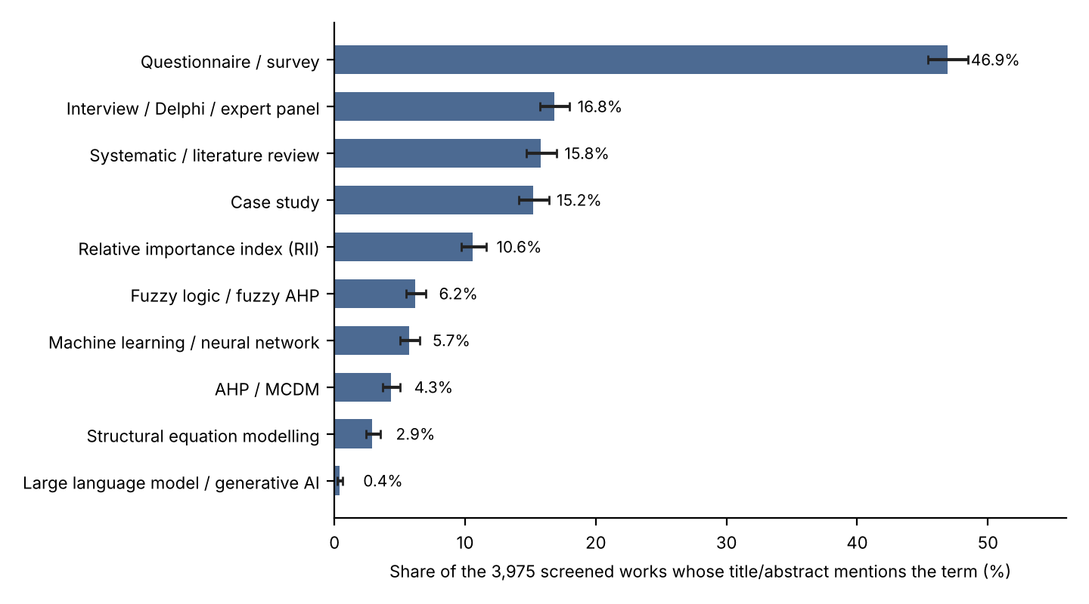
Figure 2.1. Share of screened works whose title or abstract mentions each method, with 95% intervals. Source: docs/Corpus_Statistical_Analysis.md section 6a (Derived Calculation, keyword matching; mentions are not evidence that the method was used).

Delay causes in building construction

What a delay-cause survey does
A typical delay-cause study compiles a list of candidate causes from earlier papers and interviews, asks a sample of contractors, consultants, clients or workers to rate each cause on a five-point or four-point scale, and ranks the causes by an index computed from the ratings. The RII is the most common index in the corpus and in the studies read here. The ranking identifies which causes respondents consider most important in general. It does not identify which cause occurred on a given project, how often, or how many days it cost.

Studies in India
Studies carried out in India and read for this project are of three kinds: RII surveys that enter the seed (Karthik & Rao, 2019a; Ponmalar et al., 2018; Dixit et al., 2019), RII surveys held out of the seed (Pinky Devi & Sindhu, 2025), and a larger group read at lower depth, collected in Table 2.2.
Karthik and Rao (2019a) surveyed 44 respondents from building firms in Telangana on factors affecting labour productivity. The ranked factors with RII of 0.700 or more include unsafe working conditions (0.809), poor planning and unrealistic scheduling (0.791 each), material shortage (0.777), payment delay (0.773) and work at height (0.764) (Source: Literature; data/literature_seed.json, M01). Only the 28 of 38 factors at or above 0.700 are listed in the paper’s table, so lower-rated factors are absent, and the field case study in the paper concerns walls built from autoclaved aerated concrete (AAC) blocks, not bricks. Ponmalar et al. (2018) surveyed supervisors, project engineers and labourers on two residential buildings in Chennai; respondent numbers are not reported. Lack of experience (0.787), lack of construction material (0.780), lack of tools (0.760), absenteeism (0.751) and payment delays (0.7758) all rate highly, and weather is 0.700 (Source: Literature; M01 and A02 rows in the seed file; the paper’s index uses weights of 1 to 4). Dixit et al. (2019) used 201 respondents across consultants, contractors, developers and academia in the Indian construction industry, with RII computed as total score divided by 5 x 201; the paper prints one factor twice with different values (Source: Literature, M06 note).
Pinky Devi and Sindhu (2025) surveyed 72 construction management professionals about delays in infrastructure (roads and bridges), not buildings, and ranked material-related issues first as a group (group mean 0.562), ahead of construction-site factors (0.555) and contractor-related factors (0.506) (Source: Literature; seed-file note for A10). This study is held out of the seed because it is not about buildings, and a repository audit recorded that about ten library risks overlap with its table, although those rows were not entered.
Table 2.2. Other Indian studies read for this project and not entered in the RII seed.
Study | Design and sample | Finding relevant to masonry | Depth read
Reddy & Chambrelin (2021) | Video time-and-motion study, seven residential sites in Andhra Pradesh; one observation of about 1 to 2 hours per site; crews of 2 to 4 | Work efficiency 62.57% to 90.62%; causes named: lack of targets, poor planning and monitoring, material shortage, equipment breakdown | Full text
Loganathan & Kalidindi (2015) | Pilot on one project in Tamil Nadu | 20% to 40% production variation between masonry crews (measure not defined in the abstract) | Abstract only
Loganathan & Kalidindi (2016) | Interviews on 15 projects in six states | Illness, injury, lack of facilities and payment delays are significant contributors to absenteeism and turnover of migrant workers | Abstract only
Guha & Biswas (2008) | Monte Carlo study of a housing project in Kolkata, contractor time and cost data | Monsoon increased project duration by about 5% and cost by about 12% | Abstract only
Soundarya et al. (2025) | Six residential sites in Chennai; frequency, severity and importance indices | Overall lag in schedule has frequency index 0.861 and severity index 0.819; rework (importance index 0.55) and inadequate skilled labour (0.53) rank next | Full text (summarised by fetch tool)
Mehta & Gaikwad (2017) | Questionnaire to 100 stakeholders; importance index, principal component analysis | Finance-related and labour-related problems dominate (values not in the abstract) | Abstract only
Tankkar & Wanjari (2015) | 85 respondents (33 clients, 10 consultants, 42 contractors) | Lack of human resources, poor site management and insufficient coordination are the top three | Abstract only
Noushad et al. (2023) | Delphi and RII, high-rise buildings in Kerala, 76 delay causes | No numbers in the preview read | Abstract only
Source: Research_Notes/A_masonry_india.md, cards A01, A03, A08, A09, A11, A12, A13 and A19 (Literature). The number of respondents in Soundarya et al. (2025) was not recorded in the notes.
These studies point the same way as the surveys: labour availability and skill, material supply, planning and management, payment and site conditions recur, and weather is cited but not always among the top factors. The masonry records are small. Reddy and Chambrelin’s efficiencies come from seven short observations, Ponmalar et al.’s overrun figures from two projects, and Loganathan and Kalidindi’s crew variation from one project, so none supports a probability or a delay distribution for a new site.

Studies outside India
Six further RII studies in the corpus are from outside India, and two of the five seed studies are from Sri Lanka. Abeysinghe and Jayathilaka (2022) received 163 responses to a questionnaire of 39 delay factors in Sri Lankan construction; shortage of labourers (0.8245), delay in delivering materials (0.8098) and fluctuation of material prices (0.7890) are among the top factors and bad weather conditions is 0.6528 (rank 30 of 39). About 26% of respondents worked on road projects, so the sample is not only buildings (Source: Literature; seed-file note for A14). Manoharan et al. (2022) surveyed 90 upper-grade contractor firms on labour-related factors in Sri Lankan building projects; of 32 factors, 21 exceed an RII of 0.7, with skills shortage first (0.82).
Adebowale and Agumba (2023) pooled RII values of 35 productivity factors from ten surveys in a meta-analysis labelled by the authors as Middle East, although the paper itself includes Malaysia and Vietnam among them. Almeida et al. (2021) surveyed 47 directors, managers and engineers of private building companies in Brasilia on delay causes. Loekito et al. (2026) surveyed 83 construction workers in East Java, Indonesia, on productivity factors. Ouansrimeang and Wisaeang (2024) analysed 30 delayed public projects in Thailand with RII from 380 respondents and ranked contractor financial issues (0.777) and labour issues (0.733 in the results; the abstract prints 0.773) near the top. Hassoon et al. (2025) is the only study in the corpus whose subject is brickwork specifically: its abstract, the only part read, reports RII of 0.874 for planning and 0.856 for team size for brickwork and housing skeleton tasks in Iraq (Source: Literature; Research_Notes/D_mitigation.md, abstract only).

The 11 studies in the seed file
Table 2.3 lists the 11 studies from which the project transcribed RII values. Five serve as seed studies, and six are held out and used only to compare the ranking they imply with the seed order. Figure 2.2 shows the number of rows entered per study.
Table 2.3. The 11 RII studies in the seed file: location, sample, scale, method and role.
ID | Study | Location | Sample | Scale | Index / method | Masonry-specific | Role | Rows entered
M01 | Karthik & Rao (2019a) | India (Telangana) | 44 respondents | 1-5 | RII; field case on AAC walls | No | Seed | 28
A02 | Ponmalar et al. (2018) | India (Chennai) | Not reported | 1-4 | RII; separate masonry site record | No | Seed | 14
M06 | Dixit et al. (2019) | India | 201 respondents | 1-5 (inferred) | RII | No | Seed | 40
A14 | Abeysinghe & Jayathilaka (2022) | Sri Lanka | 163 respondents | 1-5 | RII | No | Seed | 5
A15 | Manoharan et al. (2022) | Sri Lanka | 90 firms | Not recorded | RII | No | Seed | 5
M10 | Adebowale & Agumba (2023) | Middle East (10 studies) | 10 studies | Pooled RII | Meta-analysis, random model | No | Held out | 33
M15 | Almeida et al. (2021) | Brazil (Brasilia) | 47 respondents | 1-4 | RII | No | Held out | 24
M14 | Loekito et al. (2026) | Indonesia (East Java) | 83 workers | 1-4 stated | RII printed as W/(5N) | No | Held out | 23
A10 | Pinky Devi & Sindhu (2025) | India (infrastructure) | 72 respondents | 1-5 | RII | No | Held out | 6
A21 | Ouansrimeang & Wisaeang (2024) | Thailand (public projects) | 30 projects; 380 respondents | 1-5 | RII with machine learning | No | Held out | 2
HAS25 | Hassoon et al. (2025) | Iraq | Not recorded | Not recorded | RII (abstract only) | Yes (brickwork) | Held out | 2
Source: data/literature_seed.json, fields studies and rows (Literature for the study attributes; row counts are a Derived Calculation by counting rows; total 182, of which 92 are in seed studies and 90 in held-out studies). Dixit et al. (2019) state no scale in the text; 1-5 is inferred from the RII denominator. For Loekito et al. (2026) the printed index equals total score divided by 5N although the text gives A = 4.
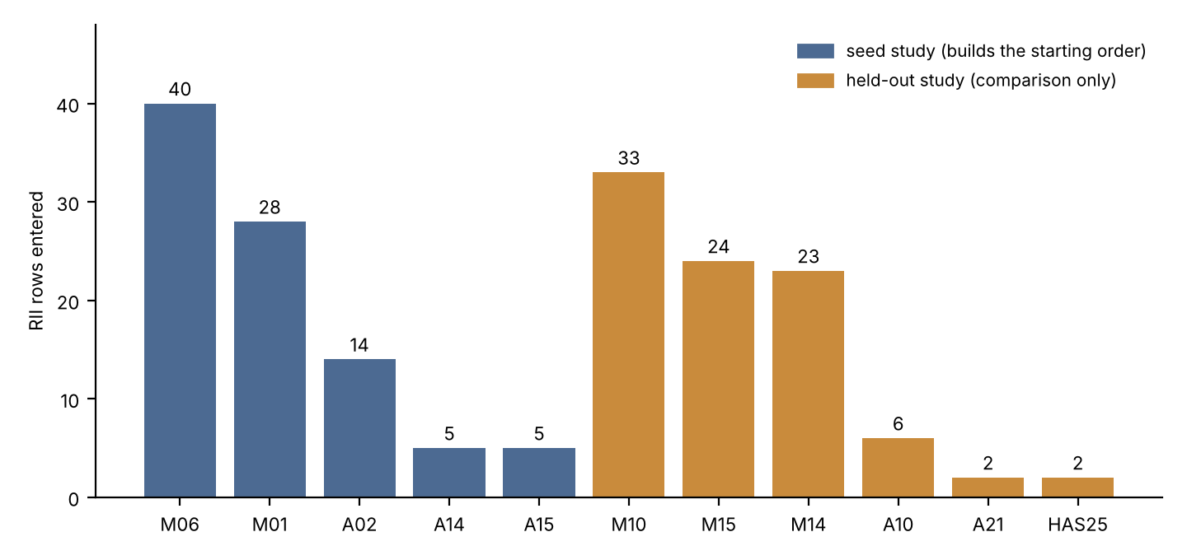
Figure 2.2. RII rows entered per study (182 rows from 11 studies). Source: data/literature_seed.json (Derived Calculation).
Three features of Table 2.3 limit how the studies can be used. First, none of the five seed studies is a masonry survey: M01 and A02 are general building labour-productivity surveys whose masonry content is a separate field record, and the two Sri Lankan studies include non-building respondents or only the top-ranked factors. Second, the transcription is a subset. A14 contributes 5 of its 39 factors, A15 5 of 32, A02 14 of 35, and M01 lists only the 28 factors at or above 0.700. A repository audit recorded that the omitted factors include some that rank higher than those entered (for example, financial difficulties of contractors, 0.8233, rank 3 in A14). Third, the studies use different scales and sample types, so absolute RII values are not comparable. M14, for example, prints an index that equals W/(5N) on a scale the text describes as 1 to 4.

Masonry-specific productivity and delay literature
Direct evidence on masonry is thinner than on delay in general. The research notes record the following, mostly at abstract depth.
- Nepal: Lawaju et al. (2021) observed 35 sets of brick masonry output at seven sites in the Kathmandu Valley, chose 13 inputs from an RII survey of 44 factors and fitted an artificial neural network (a test set of five cases); Rana et al. (2023) used a Likert questionnaire with RII and neural-network sensitivity for bricklaying in Surkhet and report that material-related factors form the highest-ranked group (Cronbach’s alpha 0.976). Numbers other than these were not seen (abstract only).
- Turkey: Gerek et al. (2015) modelled the productivity of 147 masonry crews with two neural-network techniques using crew size, experience, hours, wall type and mortar type as inputs, with test mean absolute percentage error of about 14.3% to 15.0% (full text). The paper does not report descriptive statistics of crew productivity, so it cannot supply a distribution for an Indian crew.
- Indonesia: Djohim et al. (2024) simulated the schedule of a modest house type and report that wall work was the most influential activity for delay (abstract only; Source: Literature).
- Iraq: Hassoon et al. (2025), as above.
These studies identify which inputs and factors matter for masonry output. They do not provide India-specific, measured daily outputs or delay frequencies that a risk register could use as probabilities. One research note records that the area-based productivity column of Reddy and Chambrelin (2021) is physically implausible and must not be used; only its efficiency percentages are used here, as context.

Consolidating the factors
Across the seed studies, the same families of factors recur: labour availability, absenteeism and skill; material shortage and delivery; planning and scheduling; payment; site and equipment conditions; weather. The values differ by study. Weather, for instance, takes the values 0.700 (A02), 0.6528 (A14, rank 30 of 39), 0.764 (M01) and 0.6567 (M06) among the four seed studies that rate it, and labour shortage takes 0.751 (A02 absenteeism), 0.8245 (A14) and 0.723 (M01) (Source: Literature; docs/Project_Handoff_Summary.md section 8.2). An earlier statement of the project that weather is rated lower than other factors was a post-hoc finding on a ten-risk set, and the audit withdrew it (docs/Project_Handoff_Summary.md, section 8.6); it is not made in this report. The review draws only the weaker conclusion that the same families of factor appear in studies from different places, without agreement on their order.

From factor families to the risk library
The project’s risk library groups the factor families into 11 categories. Table 2.4 shows how many of the 46 library risks fall in each category, how many have a survey value in the seed studies, and how many are tagged as project-level and not activity-level. A risk with no seed value stays off the matrix until a user enters numbers.
Table 2.4. The 46 library risks by category: total, with a survey (seed) value, and tagged project-level.
Category | Risks | With seed value | Without seed value | Tagged project-level
Labour | 13 | 9 | 4 | 0
Material | 6 | 4 | 2 | 0
Management | 6 | 4 | 2 | 2
Design | 4 | 3 | 1 | 1
Equipment | 3 | 1 | 2 | 0
Financial | 3 | 2 | 1 | 2
External | 3 | 2 | 1 | 3
Safety | 2 | 2 | 0 | 0
Weather | 2 | 1 | 1 | 0
Quality | 2 | 1 | 1 | 0
Site | 2 | 1 | 1 | 0
Total | 46 | 30 | 16 | 8
Source: data/risk_library_masonry.json (Derived Calculation by counting records by category, seed_status and scope). The 38 original risks were built from the factors transcribed from the 11 studies; the 8 added on 2026-10-08 cite evidence records and carry a masonry-specific form labelled Expert Judgment, to be confirmed by an expert survey.
The table shows the effect of the literature on the library: the seeded risks are the ones that surveys happen to ask about, so labour, material and management risks are well covered by survey values, while masonry-specific conditions such as vertical transport, scaffolding, mortar supply and work-front availability have no survey value and depend entirely on what the user enters.

Reviews of delay causes
Review papers in the corpus summarise this literature. Romzi and Doh (2022) review causes of project delay and list slow decision making, poor site management and supervision, labour shortage, scope change and late design approval, with number of studies and method not reported in the abstract. Abu Hasan et al. (2025) review 90 publications from 2007 to 2024, identify 93 common conflict factors, add 18 interviews and propose a conflict-delay model. Abd Aziz et al. (2022) review delay mitigation strategies in a systematic review. Ghaeb and Mahjoob (2023), reviewing 38 studies published from 1997 to 2020, observe that most work addresses risk identification and assessment and call for more work on risk response (the journal is modest and the review’s method is thin). The reviews support a general point: identification and ranking of delay causes is well covered, and what is done with the ranking at the level of a single activity on a site is less so.

The relative importance index and its limits

Definition and a worked example
For a factor rated by N respondents on a scale from 1 to A, the relative importance index is
RII = (sum of the ratings given by all respondents) / (A x N),
so an RII of 1 would mean every respondent gave the top rating. The studies in the seed state this formula in various ways; Dixit et al. (2019), for example, define RII as total score divided by 5 x 201.
Worked example. In Karthik and Rao (2019a) the factor “bad leadership skill” received 1, 5, 5, 27 and 6 respondents at ratings 1 to 5 (N = 44). The total score is 1 x 1 + 2 x 5 + 3 x 5 + 4 x 27 + 5 x 6 = 164, so RII = 164 / (5 x 44) = 0.7455 (Derived Calculation from the counts in data/literature_seed.json, note on M01). The paper prints 165 and 0.750 for this row; the repository keeps the printed value and records the inconsistency. The sample standard deviation of the 44 ratings is 0.92, so the standard error of the mean rating is 0.92 / sqrt(44) = 0.139 and the standard error of the RII is 0.139 / 5 = 0.028 (Derived Calculation, treating the ratings as independent). An approximate 95% interval is therefore about 0.745 +/- 0.055. A single respondent changing one rating by one point moves the index by 1 / (5 x 44) = 0.0045.
This example shows how much of the RII scale the sampling error of one survey item occupies. In the seed table of the project, the first six risks lie within 0.019 of each other and 24 of 30 risks lie within 0.096, while the standard error of one M01 item is about 0.03 (Source: docs/Project_Handoff_Summary.md section 8.2, audit estimate). Differences of less than about 0.05 between two RII values from one survey of this size should not be read as differences in importance.

Importance is not probability or days
An RII answers the question “how important do respondents think this factor is?” It was designed to rank factors within a study. Three features separate it from a probability or a duration.
- It is a rating, not a count. A factor can be rated important because its effect would be severe, because it occurs often, or because respondents have recently experienced it. The index does not separate frequency from severity. Soundarya et al. (2025) are unusual in reporting frequency and severity indices separately and combining them into an importance index: for the overall lag in schedule their frequency index is 0.861 and severity index 0.819, and the product of these two, 0.705, matches the reported importance index of 0.71 (Derived Calculation from values in Research_Notes/A_masonry_india.md). An RII on a single question cannot be decomposed this way.
- It is ordinal in use. Moving from RII to a probability needs a mapping, and no validated mapping from importance to likelihood exists in the sources read. Research on elicitation records precedents for mapping qualitative levels to probability bands in project risk (Curto et al., 2022; Acebes et al., 2024) but not a validation of any mapping from survey importance.
- It depends on the respondent group and the scale. Loekito et al. (2026) surveyed workers, whereas most of the other studies surveyed managers, engineers or consultants. The agreement check in Chapter 4 found a weak negative correlation between the worker survey and the seed order (rho = -0.18, 13 risks, p = 0.55, not significant); this is consistent with workers and managers rating factors differently but cannot be distinguished from noise with these data. Scales of 1 to 4 and 1 to 5 give different absolute RII values for the same opinions.

Other limits recorded in the project’s audit
Beyond the points above, the project’s audit recorded the following limits of the secondary data. Truncation: M01 reports only factors with RII of at least 0.700 (28 of 38). Selection: the seed transcribes only a subset of factors from several papers. Single-study support: 14 of the 30 seeded risks rest on one study. Instability: when the ranking built from the other seed studies is compared with a left-out seed study’s own order, the Spearman correlations are 0.09 (M01, n = 13), 0.37 (A02, n = 10), 0.64 (M06, n = 9) and 0.60 (A14, n = 4), none significant, and A15 cannot be tested with n = 2 (Source: docs/Project_Handoff_Summary.md section 8.4; Derived Calculation). Agreement with held-out studies is weak and not significant after correction for multiple testing (section 8.5 of the same document). Chapter 4 gives the method and numbers; they are summarised here because they determine how the RII may be used in a tool. It may order risks coarsely when nothing else is known; it cannot stand in for site data.

Risk management standards

ISO 31000
ISO 31000 is the international standard that gives principles and guidelines for risk management and describes a process in which risk is identified, analysed, evaluated and treated, with communication, monitoring and review throughout (ISO, n.d.). The standard is used here as the organising frame of the tool and not as a source of numbers. The wording of the process stages follows the project’s own methodology description (docs/Project_Handoff_Summary.md, section 2) and should be checked against the current edition of the standard before submission (the edition year is not recorded in the repository).

IEC 31010
IEC 31010 is the companion standard on techniques for risk assessment (International Electrotechnical Commission [IEC], n.d.). It is cited because the techniques of this project, a consequence-and-likelihood matrix, a register, and (optionally) Monte Carlo simulation, are among the kinds of technique that such standards catalogue. The content of the standard has not been reviewed in detail for this report, and the claim that it lists these techniques should be checked against the standard text.

Mapping the tool onto the process
Table 2.5 shows which part of the tool serves each stage of the ISO 31000 process, and what the tool does not do.
Table 2.5. Stages of the risk-management process and the corresponding parts of the tool.
Process stage | Part of the tool | What the tool does not do
Establish context | Case record: project, activity, planned duration, site facts | Does not set the organisation’s risk appetite
Identify | Library of 46 risks; 22 site-fact rules; evidence-cited AI suggestions of names and mechanisms | Does not discover risks outside the library unless the user adds them
Analyse | User-entered probability and delay range with Source label; ordinal literature tier for 30 risks without entered numbers | Does not supply probabilities or delays
Evaluate | 5x5 probability-impact matrix with stated edges and thresholds (Assumptions); prioritisation by score | Does not decide which level is acceptable
Treat | Register fields for owner, trigger, response type, action, review date; optional comparison of responses using entered costs | Does not recommend a response or supply effect sizes
Monitor and review | Review date field; exports for the review meeting | Does not collect actual outcomes
Source: README.md, docs/Project_Handoff_Summary.md sections 2, 8.14 and 9 (descriptive).

Risk matrices and their critique

Use of the matrix
A probability-impact matrix assigns each risk to a probability class and an impact class and reads a level from the cell. In the tool, the classes run from 1 to 5, the score is the product of the two class numbers, and the level is Low for a score up to 5, Moderate for 6 to 10, High for 11 to 15 and Extreme for 16 or more. These thresholds are Assumptions of the tool, not values from a source. Table 2.6 shows the resulting scores and levels.
Table 2.6. Score (probability class x impact class) and level in the tool’s 5x5 matrix.
Probability class Impact class | 1 | 2 | 3 | 4 | 5
5 | 5 Low | 10 Moderate | 15 High | 20 Extreme | 25 Extreme
4 | 4 Low | 8 Moderate | 12 High | 16 Extreme | 20 Extreme
3 | 3 Low | 6 Moderate | 9 Moderate | 12 High | 15 High
2 | 2 Low | 4 Low | 6 Moderate | 8 Moderate | 10 Moderate
1 | 1 Low | 2 Low | 3 Low | 4 Low | 5 Low
Source: Derived Calculation from the thresholds in docs/Project_Handoff_Summary.md section 4 (Assumption). Counting cells gives 10 Low, 7 Moderate, 4 High and 4 Extreme of 25.

Cox (2008) and Duijm (2015)
Cox (2008) examined risk matrices and concluded that they have four problems: poor resolution, errors (a matrix can rate a quantitatively smaller risk higher than a larger one), suboptimal resource allocation and ambiguous inputs and outputs, and that they should be used with caution and with careful explanation of the embedded judgements (this review read the abstract only). Duijm (2015) gives recommendations on the use and design of risk matrices (this review read the reference details only; the paper’s detailed recommendations should be reviewed before the chapter is finalised).
Table 2.6 illustrates the range-compression point that follows from Cox’s critique. Because the level is a function of the product, the whole first row and first column are Low whatever the other class is: a risk in probability class 1 and impact class 5 scores 5 and is Low, and so is a risk in probability class 5 and impact class 1. Only 8 of 25 cells are High or Extreme. The thresholds are a design choice: a different cut at 4 or 6 would move cells between levels. Chapter 6 reports a sensitivity analysis on how many risks of the example case change level when the class edges and thresholds change. Two consequences are drawn for the design.
- The matrix is presented as an aid to ordering, and the thresholds are printed on every export as Assumptions.
- Risks with impact class 5 and an entered probability are also listed separately, as a filter and not as a score, so that a rare, severe risk is not hidden in the Low band.

Beyond the matrix
Several papers in the corpus compare or combine matrices with simulation. Acebes et al. (2024) propose a quantitative methodology for risk prioritisation as an alternative to probability-impact matrices; the research notes record that rankings from a matrix and from Monte Carlo analysis differ in their example. Koulinas et al. (2021) use a risk matrix to set probability and impact for each activity and then run Monte Carlo simulation for an artificial-lake project in Greece, with a qualitative mitigation loop. Starczyk-Kolbyk and Jedras (2025) compare a matrix and Monte Carlo on cost for twelve risks of a high-rise office and report a high level of consistency between the methods (abstract only). Canesi et al. (2025) integrate a probabilistic risk matrix with Bayesian Monte Carlo simulation for cost overruns in infrastructure (abstract only). The papers show that matrix and simulation are used together, and that the relation between their rankings depends on the case.

Quantitative schedule risk analysis: context

Monte Carlo and three-point estimates
Monte Carlo schedule risk analysis samples activity durations and risk events many times and reports the distribution of the project finish. Activity durations are often given as three-point (optimistic, most likely, pessimistic) estimates under a beta-PERT assumption. The literature read for this project is critical of the assumptions behind that choice: the PERT variance is fixed by the range alone (Hahn, 2008), the mean and variance formulas do not correspond to a beta whose mode is the elicited value (Herrerias-Velasco et al., 2011), and Trietsch et al. (2012) argue for a lognormal core and report a Parkinson effect in recorded activity times. Flyvbjerg (2006) documents optimism bias in forecasts for large infrastructure projects, which implies that three-point estimates elicited from project teams may be too narrow. Song and Vanhoucke (2025) treat the interaction between risks in schedule risk analysis.

Risk-event simulation in construction schedules
Monte Carlo simulation with risk events and mitigation has been applied to construction projects, including in India. Gheewala et al. (2025) simulated an elevated metro rail project with a baseline schedule of 711 days, 17 risks prioritised by a probability-impact approach and 1,000 simulations; all risks together gave a mean duration of 842 days, and a mitigation plan costing Rs 3.32 million reduced the mean and maximum durations by 26 and 76 days (abstract only). Ichsan et al. (2025) simulated the schedule of the Jakarta Central Railway Station project at the level of nine critical activities and compared pre- and post-mitigation (residual) risk, with response effects from a focus group of five panel members. Guha and Biswas (2008) applied Monte Carlo to monsoon effects on a Kolkata housing project. Koulinas et al. (2020) built a simulation-based expert system for delay risk in a hotel renovation. Hadad and Keren (2025) combine Monte Carlo simulation with budget-constrained selection of risk responses on an office building. Prins et al. (2022) model risk occurrence as a binary variable with a probability and apply Beta-PERT to durations in a mitigation-planning method for a tunnel project; this is a preprint. Table 2.7 sets these studies beside the present project.
Table 2.7. Closest published work combining risk events, simulation and mitigation, and how this project differs.
Study | Level | What it does | Difference from this project
Prins et al. (2022) | Project (tunnel) | Binary risk occurrence, Beta-PERT, mitigation optimisation | No single-activity masonry focus; inputs from a project risk register
Ichsan et al. (2025) | Nine critical activities (railway station) | Pre- and post-mitigation schedule simulation | Response effects from a five-person focus group; not masonry
Gheewala et al. (2025) | Project (metro, India) | Matrix-prioritised risks, simulation, mitigation plan cost versus days saved | Project level; mitigation modelled as one plan, not as alternatives
Hadad & Keren (2025) | Project (office building) | Simulation with response budgeting | Dollar-based, project level, no schedule network
Koulinas et al. (2021) | Activity (lake project) | Risk matrix, simulation, qualitative mitigation loop | Not masonry; mitigation is a qualitative loop without residual quantification
Djohim et al. (2024) | Activity-level schedule of a house | Simulation identifies wall work as most influential | No mitigation
Source: Research_Notes/F_novelty_validation.md, items F01, F03, F04, F05, F11 and F12 (Literature; abstracts or full text as marked in the notes).
The same research notes conclude that the individual mechanics of risk-event simulation with mitigation are published and not new, and the project therefore makes no claim to novelty in them. Two conditions apply to the simulation studies above. Their inputs (probabilities, ranges, response effects) come from project registers, contractor records, expert panels or focus groups, and the research notes found no construction paper that reports a calibration or back-test of a simulated range against actual outcomes (the closest, Ichsan et al., 2025, claims an accuracy figure in its abstract without a back-test in the text read). Khodabakhshian et al. (2023), in a systematic review of 48 papers on deterministic and probabilistic risk management approaches, note that experience, prior knowledge and historical data are required and often not documented or easily accessible. This is the data-scarcity problem that confronts a user of the optional layer in this project: the simulation can run, but the numbers it needs must be entered by the user and carry their own Source labels.

Labour productivity norms (context only; out of scope)
The registered title mentions labour productivity. This section records what the research notes found, briefly, to show why productivity was not modelled.
India’s planning norms for masonry labour are published as labour output constants. IS 7272 (Part 1), adopted in 1974 and reaffirmed in 2010, gives labour-days per unit of work for building works in north India, derived by the Central Building Research Institute from work-measurement observations on sites in Delhi and Roorkee (Bureau of Indian Standards, 1974). For brickwork in walls thicker than one brick the constant is 0.94 mason-days per cubic metre (with 1.80 labourer-days and 0.20 water-carrier-days). The CPWD Analysis of Rates for Delhi 2007 gives the same mason labour quantity for brickwork in superstructure, 0.47 plus 0.47 mason-days per cubic metre (Central Public Works Department, 2008). The research notes record that the CPWD brick masonry labour constants are identical across the 2007, 2012 and 2014 editions read and equal the 1974 constants, so they are long-standing planning norms and not fresh measurements. A state schedule read (Works Department, Government of Odisha, 2006) gives a mason total about 1.5 to 1.9 times the CPWD figure, with larger bricks, so published norms differ between sources by a large factor. The reading of the unit of the one-brick-wall row of IS 7272 is an inference from a low-resolution scan (Source: Literature; Research_Notes/P3_india_norms.md, records P3-01 to P3-04).
A norm is a planning constant with allowances built in; it is not a measurement of what a crew achieves on a given day, and it gives no distribution. Measured productivity studies read for this project are small (Reddy & Chambrelin, 2021; Loganathan & Kalidindi, 2015) or come from other countries (Gerek et al., 2015). A productivity model would need measured daily output by crew on Indian sites, which the project does not have. A defect in the legacy norms file in the repository was also recorded in the audit. Productivity is therefore listed in Chapter 8 as future work with its data prerequisites, and no CPWD number is used in any result in this report.

Elicitation, verification and validation
The tool leaves probabilities and delays to the user. Where they come from experts, the elicitation literature applies, and where the tool itself is to be judged, so does the literature on verification and validation. This section records the sources the project draws on for its future-work plan (Chapter 8); none of them has been applied in the work reported here.
Elicitation. Bedford et al. (2006) review expert elicitation for reliability design and state that accurate subjective probabilities are not obtained by simply asking for a number, naming four standard biases (motivational, cognitive, anchoring and availability) and recommending structured elicitation with feedback. Williams et al. (2021) compare aggregation methods on a clinical example with three experts and ten seed questions and find that all three aggregation methods outperformed the individual experts, with equal weights a defensible default when experts and calibration questions are few. Dharmarathne et al. (2022) point out that tests of expert calibration on a modest number of questions have poor power. Ameyaw et al. (2016) reviewed 88 Delphi papers in construction engineering and management: panel sizes ranged from 3 to 93 with 8 to 20 the most common, rounds from 2 to 6, and a Likert scale was used in 41 papers; Delphi output is ordinal, and the review says nothing about converting Likert scores to probabilities. Curto et al. (2022) and Acebes et al. (2024) attach a probability range to each qualitative level (for example, “High” as a uniform range of 20% to 35% in one project) and simulate within the range; the ranges are set by each project’s expert committee and are not transferable. These sources imply that, in this project, any mapping from a rating to a probability would be an explicit Assumption with a sensitivity check, and that an expert survey should report its sample size and agreement, not only a mean.
Verification and validation. Sargent (2013) describes approaches to deciding model validity, conceptual model validity, model verification, operational validity and data validity, and a procedure for documenting validation (the research notes record a discrepancy in the venue metadata of this item, which should be checked before submission). Verification, meaning that the software computes what its specification says, is possible without site data and is what Chapter 6 reports. Operational validity, meaning that outputs are accurate enough for their purpose on real cases, needs site outcomes, and is not claimed. Fowler et al. (2024) offer a template for face validity of a decision-support tool by surveying subject-matter experts (in a cybersecurity setting, not construction); a similar trial with site engineers is the nearest evaluation step available to this project and is proposed in Chapter 8.

Decision-support tools for delay risk

Tools in the literature
The tools reported in the corpus fall into three groups. The first is schedule risk software used in case studies, such as Primavera P6 with Risk Analyzer in Gheewala et al. (2025) and @RISK in Ichsan et al. (2025), which run simulation on a schedule and rely on the user to supply the distributions and probabilities. The second is expert systems and data-driven models: Koulinas et al. (2020) describe a simulation-based expert system for delay risk, and Zorrilla et al. (2026) report a decision-support system that applies clustering, anomaly detection and explainable machine learning to a dataset of construction documents, with an F1 score of 0.73 in bottleneck detection (abstract; no simulation of mitigation). The third is the use of large language models for risk identification and classification.

Large language models
Vilibic et al. (2026) applied several large language models to risk identification in one project and conclude that human expertise remains crucial for prioritisation, contextual interpretation and mitigation. Erfani and Khanjar (2025) compare configurations for risk classification and report that few-shot GPT-4 reaches an F1 of 0.81 against 0.86 for the best classical model (BERT with a support vector machine). Martin et al. (2025) examine ChatGPT limitations in risk identification, mitigation strategies and user experience (the notes record the title only). A systematic review of large language models in smart construction (Gao et al., 2026) lists hallucination control and domain adaptation among persisting challenges. In the corpus, large language models appear in 14 abstracts, 0.4% of 3,975 works (Figure 2.1). The use in this project is limited to proposing risk names, mechanisms and evidence identifiers, and the design rejects numeric output (Chapter 5); the literature supports caution about letting such models supply numbers.

What the tools do not provide
Within the corpus read, the tools take probabilities and durations as user input and do not record, for each number, where it came from. They are project-level more often than activity-level. The papers above also say little about how the tool user, a site engineer, would see which risk conditions are present on a particular day. A register kept as a plain spreadsheet has only the columns its author gives it; whether it carries a source for each number depends on the author. These observations are about the studies read and are not a survey of commercial software, which this project did not carry out. Chapter 7 compares features of the tool with the tools that could be checked.

Summary and the research gap
Table 2.8. Summary of what the literature provides, what it lacks, and how this project responds.
Need of a site engineer | What the literature provides | What it lacks | How this project responds
Know which delay risks to check for masonry | Many delay-cause surveys; ranked lists; reviews | Few masonry-specific surveys; most are general building or infrastructure; mixed project-level and activity-level items | A library of 46 risks, each with supporting survey factors, tagged by scope; 22 site-fact rules
Tell how important a risk is when nothing is entered | RII values from India and Sri Lanka | RII is importance, not probability or days; studies disagree weakly; one study per risk for 14 of 30 | An ordinal starting position labelled as an Assumption and replaced by entered values; the weak agreement reported
Record a probability and impact with their source | Matrix and register practice; Cox (2008) on matrix weaknesses | No recorded source for each number in the tools reviewed | Six Source labels on every number; assumptions printed on every export
Quantify schedule effect | Published simulation methods and Indian and international case studies | Inputs from teams or panels; no back-test on masonry activities | Optional layer using only entered numbers; no defaults
Use AI assistance safely | Studies of language models for identification and classification | Risk of hallucination; numbers from models unverified | AI may propose names and evidence identifiers only; numeric output rejected
Judge whether the tool works | Verification and validation guidance | No site data and no practitioner evaluation in this project | Software verification now; expert rating, usability and site validation defined as future work
Source: synthesis of sections 2.2 to 2.9 of this chapter and the cited sources (descriptive).
The gap, in the form given in Chapter 1, is practical: published rankings do not carry into site risk registers, general tools ask for probabilities and impacts without tying them to evidence, and within this search we did not find an activity-level masonry tool in which each value carries its source. The search was by keyword on titles and abstracts, and the finding is not a statement that no such tool exists. The review also shows what the project cannot rely on: the survey rankings are weak and unstable as a base for probabilities, masonry-specific measured data are scarce, and simulation and matrix methods are established and not new. The project therefore limits itself to identification, a source-labelled register and prioritisation, with simulation as an optional layer that depends entirely on what the user enters.

Chapter 3. Methodology
This chapter states how the evidence was gathered and checked, how the literature seed and the risk matrix are defined, which statistics are used and why, how the software was verified, and what a future expert survey and second-coder check would involve. It describes what was done, not what was hoped for. No site data have been collected and no expert survey has been run; every analysis in Chapter 4 therefore uses published survey values (Literature) or an illustrative example case whose inputs are placeholders (Assumption). Chapter 4 reports the results; this chapter fixes the rules before they are applied.

3.1 Research design and scope
The work is a tool-development project with a secondary-data analysis attached to it. The tool is an offline register for delay risks in one activity, brick and block masonry. It supports risk identification from a library, a risk register, and an ordinal probability-impact matrix. The secondary-data analysis asks how much weight the published survey values can carry when they are used as the starting position of a risk on that matrix. The design follows the stages of the ISO 31000 risk-management process in a reduced form: identification (risk library and site-fact rules), analysis (ordinal classes and a score), evaluation (matrix levels) and recording (register and exports). The risk-matrix technique itself is one of the assessment techniques catalogued in IEC 31010. Communication, treatment and monitoring are outside what this project can evaluate without site users.
Five questions guide the analysis. They are questions about the order of risks and about the behaviour of the software’s classification rule, not about delay in days or probability of occurrence.
- How is a risk’s seed class obtained from the survey values, and with which assumptions?
- How much does a risk’s class change when the banding rule, the data variant or the set of seed studies changes?
- Which risks keep a high or low class under study resampling, and which cannot be assessed because they rest on one study?
- Do the surveys agree with each other on the order of the risks they share, and by how much could a check of this kind detect agreement?
- How does the matrix level of a risk with entered numbers react to its inputs and to the assumed edges and thresholds?
The design deliberately excludes four things. Monte Carlo schedule simulation, expected monetary value and the productivity models exist in the repository as optional or legacy code (the decision layer was re-connected on 2026-10-08 and uses only numbers the user enters). They are not analysed here because no input for them has a source: no delay distribution, cost or mitigation effect has been measured. A survey importance index is never converted into a probability or a number of days. The original project title promised labour-productivity and delay-risk prediction; Chapter 1 explains the scope revision, and nothing in this chapter or the next claims prediction.

3.2 The evidence corpus and the corpus count
Three documents in the repository give three different corpus sizes, and the repository also contains a fourth number, the count of curated evidence records that the application loads. The audit logged the conflict as finding F08 and left it as a decision for the supervisor (Audit Corrections, 2026-10-08, F08 and Section 5). This report does not reconcile the figures and does not choose one. Table 3.1 lists all four with their sources.
Table 3.1. Corpus and record counts found in the repository (Literature-search bookkeeping; n as stated per row; source labels: counts copied from the files named, not recomputed except the last row)
Version | Harvested or input | Kept | Where it is stated
1 | 21,902 harvested | 5,214 construction-relevant | docs/Project_Handoff_Summary.md Section 5 and 8.9 (data/openalex_corpus.jsonl, not in the repository)
2 | 17,788 harvested | 3,975 in the database | docs/Literature_Database_Report.md, docs/Corpus_Statistical_Analysis.md (data/literature.db, not in the repository; screening rules 2026-10-07.1)
3 | 11,599 input | 3,550 included | data/screening_report.json (screening rules 2026-10-07.1)
4 | not applicable | 472 curated evidence records | Derived Calculation: build_full_store() in app/ai_layer/corpus.py, run on 2026-10-08 on this checkout; it reports “TOTAL: 472 evidence records”
Source: the files named in the last column; row 4 re-run for this report. The same figure (472) was seen in the application’s health check during the committee review.
Three points matter for how the corpus is used in this report.
First, the 472 records are not a screened search result. They are the records the application can retrieve: 48 from Literature_Evidence_Package.xlsx, records parsed from the research notes in Research_Notes/, benchmark and model registries, and 54 full-text review files. The OpenAlex bulk file (data/openalex_corpus.jsonl) and the screening database are excluded from version control by .gitignore, so a fresh clone loads 472 records and not thousands. The relationship between the 472 records and versions 1 to 3 has not been documented, and no relationship is assumed here.
Second, none of the three screening counts can be turned into a single PRISMA flow with confidence. Versions 2 and 3 carry the same rule version label (2026-10-07.1) but differ by 6,189 records in input and 425 in records kept, and no script output in the repository explains the difference. A PRISMA-style flow diagram would require re-running the harvest and screening scripts against one frozen input, which has not been done. The counts are therefore reported as a conflict and the corpus is treated as a source of background reading, not as the evidence base of any statistic in this report.
Third, the corpus statistics in docs/Corpus_Statistical_Analysis.md describe a database of N = 3,975 records (version 2) and use regular-expression matching on titles and abstracts. They show how many abstracts mention a term, not how many studies used a method, and the “sufficiency” bootstrap in that document is a subsample illustration of a census, not evidence that the corpus is large enough (audit correction, F19). Where Chapter 2 quotes those figures it must carry the same limit. The statistics that matter for this report are computed on a much smaller object: the 182 rows of data/literature_seed.json, described next.

3.3 Study selection for the RII data
The quantitative evidence is the relative importance index (RII) values that published surveys report for delay or productivity-loss factors. RII, as defined in these papers, is the sum of the respondents’ ratings divided by the highest possible rating times the number of respondents:
$$RII=\frac{\sum_{i=1}^{A}{w_{i}}n_{i}}{A⋅N}$$
where $w_{i}$ is the rating weight, $n_{i}$ the number of respondents giving it, $A$ the highest weight and $N$ the number of respondents. It lies between $1/A$ and 1 and measures how important respondents rated a factor. It is not a probability of occurrence and not a number of days.
Eleven studies are in the dataset. The seed file records no formal inclusion criteria, so none is claimed. What the entries show is that each study reports RII (or an RII-like importance index on a stated scale) for factors that map to at least one library risk, and that the team had its full text or abstract; the PDF folders named in the file (5_Masonry_Productivity_Delay, 6_Ranking_Studies_OpenAccess) are collections the team assembled, not the output of a systematic screen. Two further sources were recorded but not used: Soundarya et al. (2025), because it reports a frequency-times-severity index, not RII, and Karthik and Rao (2022 or 2019, the year differs between sources), for which only a factor-group average of 0.784 is available from the abstract and which may report the same survey as M01 (other_indices in the seed file).
Each study carries a role in the dataset: five are seed studies (M01, A02, M06, A14, A15) and six are held-out studies (M10, M15, M14, A10, A21, HAS25). The seed file stores the held-out role under the older label validation; this report uses “held-out” because the check is an agreement check, not a validation (Audit Corrections, F05). Seed studies are Indian or Sri Lankan surveys; held-out studies come from the Middle East (pooled), Brazil, Indonesia, India (infrastructure), Thailand and Iraq. Only seed studies feed the placement of a risk. Held-out studies are used only to compare orders.
The date at which these roles were assigned relative to the first agreement calculation is not recorded. The earliest committed version of the seed file (commit ed97aab, 2026-10-07) already contains the roles, but the handoff summary records agreement results on a ten-risk set dated 2026-10-06 and 2026-10-07, and the library was widened from 10 to 38 risks after that first look. The role assignment therefore cannot be shown to precede all analysis, and the agreement results in Chapter 4 are labelled exploratory for that reason. Table 3.2 lists the studies.
Table 3.2. The 11 studies in data/literature_seed.json (Literature; n = 11 studies, 182 rows)
ID | Study (as recorded in the seed file) | Country | N respondents | Scale | Masonry-specific? | Role | Rows | Entered subset
M01 | Karthik and Rao (2019a) | India (Telangana) | 44 | 1-5 | No (field case: AAC blocks) | seed | 28 | only factors with RII >= 0.700 are printed (28 of 38); truncated list
A02 | Ponmalar et al. (2018) | India (Chennai) | not reported | 1-4 | No | seed | 14 | 14 of 35 factors
M06 | Dixit et al. (2019) | India | 201 (206 in text) | 1-5 | No | seed | 40 | 40 table rows
A14 | Abeysinghe and Jayathilaka (2022) | Sri Lanka | 163 | 1-5 | No (26.4% of respondents on road projects) | seed | 5 | 5 of 39 factors
A15 | Manoharan et al. (2022) | Sri Lanka | 90 firms | not recorded | No | seed | 5 | 5 of 32 factors; two-decimal summary values
M10 | Adebowale and Agumba (2023) | Middle East, pooled | 10 studies | pooled RII | No | held-out | 33 | Table 7, 33 rows
M15 | Almeida et al. (2021) | Brazil | 47 | 1-4 | No | held-out | 24 | not stated
M14 | Loekito et al. (2026) | Indonesia | 83 (workers) | 1-4 stated; printed RII = W/(5N) | No | held-out | 23 | not stated
A10 | Pinky Devi and Sindhu (2025) | India (infrastructure) | 72 | 1-5 | No (roads, bridges) | held-out | 6 | subset; about 10 tool risks overlap
A21 | Ouansrimeang and Wisaeang (2024) | Thailand | 380 (30 projects) | 1-5 | No | held-out | 2 | subset; more items overlap
HAS25 | Hassoon et al. (2025) | Iraq | not recorded | not recorded | Yes (abstract only) | held-out | 2 | abstract
Source: data/literature_seed.json (study fields, corrected 2026-10-08) and docs/Audit_Corrections_2026-10-08.md, Sections 3. Row counts: Derived Calculation from the file (n = 182). N for M06: 201 in the abstract and Table 3, 206 in Section 3.1 of the paper.
Three features of this table limit what the seed can mean. Only one study (HAS25) is masonry-specific, and it contributes two rows from an abstract. M01 and A02 are general building-construction surveys; masonry appears only in their field observations. Scales differ (1-4, 1-5, pooled, not recorded), and M14 prints RII as $W/\left(5N\right)$ although its text states $A=4$, so its absolute RII level is not comparable with other studies. Ranks within M14 are unaffected.

3.4 Extraction and verification protocol
Each RII value was copied by the team from the published table into one row of the seed file with the fields study, factor, RII, printed rank, mapped risk and mapping strength (direct, related or none). The source location is recorded per study, not per row (for example “Table 3, p.61” for M01), so the claim that every value carries its table and page is withdrawn; the accurate statement is 182 rows (178 factor values mapped to a risk, four unmapped or group-level rows), each with a study-level source location (Audit Corrections, F25).
The audit then compared the rows with the papers. Its summary states that all 182 rii and rank values match the printed papers, that no seed row is absent from its paper, and that the 182 rows were identical before and after the audit’s edits (only metadata and notes changed). A test, test_g3_seed_rows_are_frozen, pins a SHA-256 hash of the study, factor, RII and rank fields so that a later edit cannot change a value silently.
One discrepancy must be stated. The audit’s description of its source list names eight studies for the row-level check against PDFs: M01, M06, A14, M10, M15, M14, A10 and A21. Those eight studies hold 161 of the 182 rows. The seed file records A02 (14 rows) and A15 (5 rows) as taken from research notes, with the PDF not in the project folder, and HAS25 (2 rows) as taken from an abstract. This report therefore treats 161 rows as checked against PDFs and 21 rows as checked only against notes or an abstract, until the audit’s author confirms otherwise. A02 and A15 matter: A02 contributes 13 direct values to the seed and A15 four. Table 3.3 gives the position study by study.
Table 3.3. Provenance of the 182 seed rows (Derived Calculation from the seed file’s obtained field; n = 182 rows)
Provenance recorded in the seed file | Studies | Rows
Read from the PDF | M01 (28), M06 (40), A14 (5), M10 (33), M15 (24), M14 (23), A10 (6), A21 (2) | 161
From research notes (PDF not in project folder) | A02 (14), A15 (5) | 19
From the abstract only | HAS25 (2) | 2
Known inconsistencies inside the papers were kept as printed and noted in the seed file. Examples: M01 “Bad leadership skill” prints a sum of 165 and RII 0.750, while the paper’s own counts $\left[1,5,5,27,6\right]$ over $N=44$ give $1⋅1+2⋅5+3⋅5+4⋅27+5⋅6=164$ and $164/\left(5×44\right)=0.745$; M06 gives $N$ as 201 and 206 in different places; M15 prints two DOIs; M10’s Table 7 has 33 rows and two further items appear only in text. None of these changes a seed value by more than 0.005 where it can be quantified. The values of A11 and of the group average P1-23 were not verified and are not used.
The seed file is a deliberate subset of its papers. A14 enters 5 of 39 factors, and the omitted ones include financial difficulties of contractors (RII 0.8233, rank 3) and Covid-19 (0.7902, rank 5); the audit estimated that adding the omitted A14 rows would move 14 of 35 classes. The statement that the library was “built from every factor in the 11 studies” is withdrawn; the accurate statement is “from the factors transcribed so far”.

3.5 Mapping protocol
Each factor was assigned by the team to a library risk with a strength: direct (the factor is the risk or a clear synonym), related (an overlapping concept), or none (group-level or unmappable). The library holds 46 risks, of which 30 have at least one direct value in a seed study; 16 have none and stay off the matrix until numbers are entered (eight of the original 38 and the eight added on 2026-10-08). Only direct mappings from seed studies enter the seed: 66 values (M01 25, A02 13, M06 20, A14 4, A15 4), which combine into 30 per-risk means.
The mapping is one coder’s judgment (Expert Judgment, single coder). The audit found inconsistent decisions, for example for “poor site management” in M10, “training” in M06, “age” in A02 and “changing jobs” in M14 (finding F12), and recommended a second-coder check before any mapping value changes. That check has not been run. Until it is, every statistic that depends on the mapping carries the label “single coder, agreement not measured”. The planned protocol is in Section 3.10.

3.6 Seed construction
The procedure is the one implemented in app/literature_seed.py. Figure 3.1 summarises it and the following steps state it exactly.
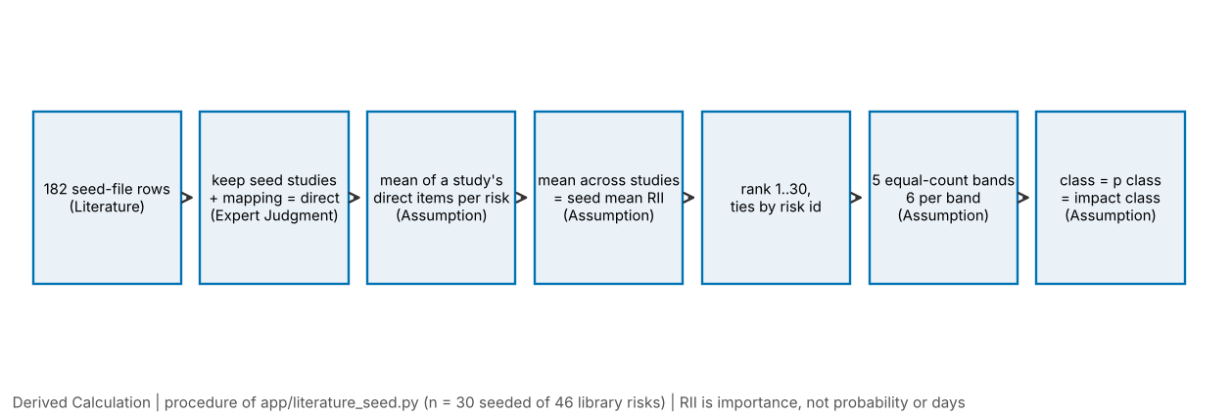
Figure 3.1. Steps from the 182 seed-file rows to a seed class (Derived Calculation; n = 30 seeded of 46 library risks; labels show the source label of each step).
- Select rows. Keep rows whose study has role seed and whose mapping is direct and which carry a risk id. This gives 66 rows.
- Average within a study. For each risk and each seed study, take the arithmetic mean of that study’s direct items. A study then counts once for the risk, however many of its items map to it (Assumption, AS-9 below).
- Average across studies. The seed mean RII of a risk is the arithmetic mean of its study means, with equal weight for each study (Assumption, AS-8).
- Rank. Order the 30 seeded risks by seed mean RII, highest first. Ties are broken by risk id in alphabetical order (Assumption, AS-12). Exactly one tie exists, R-MTH and R-STO at 0.7000.
- Band. For rank $r$ among $n=30$ risks the class is
$$\text{class}=5−\left\lfloor \frac{\left(r−1\right)⋅5}{n}\right\rfloor$$
- so ranks 1 to 6 are class 5, ranks 7 to 12 class 4, and so on down to class 1 (ranks 25 to 30): five equal-count bands of six (Assumption, AS-5). The number of bands, five, is chosen to match the five classes of the matrix axes.
- Place. The class is used as both the probability class and the impact class of the matrix, because a survey importance index measures neither probability nor days (Assumption, AS-6). A rule flag marked “elevated” raises the probability class by one, capped at 5 (Assumption, AS-7). A seeded placement is an ordinal starting position. A user who enters both a probability and a delay for the risk replaces it.
Two worked examples follow. The first shows the RII definition applied to counts. The second applies steps 2 to 5 to one risk.
Worked example 3.1: RII from counts (Literature counts, Derived Calculation). M01 “Bad leadership skill”: 44 respondents on a 1-5 scale with counts 1, 5, 5, 27 and 6 for ratings 1 to 5. The weighted sum is $1\left(1\right)+2\left(5\right)+3\left(5\right)+4\left(27\right)+5\left(6\right)=164$, the maximum possible sum is $5×44=220$, so RII $=164/220=0.7455$. The paper prints 165 and 0.750; the seed uses the printed 0.750.
Worked example 3.2: from RII to class for R-LAB (labour absenteeism or shortage). Direct items: A02 “Absenteeism” 0.751; A14 “Shortage of labourers (skilled, semi-skilled, unskilled)” 0.8245; M01 “High workforce absenteeism” 0.723. Each study has one direct item, so the study means are 0.751, 0.8245 and 0.723. The seed mean RII is $\left(0.751+0.8245+0.723\right)/3=0.7662$ (code: 0.7662). In the order of 30 means, 6 risks have a higher mean, so the rank is 7. Then class $=5−⌊6⋅5/30⌋=5−1=4$. The code returns rank 7 and class 4. The same calculation for a risk with several items in one study, R-SUP in M01 (0.759, 0.759, 0.714), gives a study mean of $2.232/3=0.744$, which equals the value in the seed table. The check was run by report/scripts/ch34_build.py, which asserts both results against seed_table().

3.7 Matrix definitions and thresholds
The matrix classifies each risk on two axes with five classes each and combines them into a level. The definitions, all from app/engine/matrix.py, are:
- Probability class from a probability $p$ with edges 0.2, 0.4, 0.6, 0.8: class = 1 + the number of edges that $p$ has reached. A value on an edge goes to the higher class (lower-edge-inclusive), with a relative tolerance of ${10}^{−9}$ so that binary rounding does not move a value that is meant to lie on an edge. The edges are equal-width bins (Assumption, AS-1).
- Impact class from the conditional expected delay divided by the planned activity duration, with four ascending edges entered by the user. The tool has no default, and the example case uses 0.02, 0.05, 0.10 and 0.20 (Assumption, ILLUSTRATIVE, AS-3). The same lower-edge-inclusive convention and tolerance apply (AS-4).
- Score is the product of the two classes.
- Level is Low for scores up to 5, Moderate for 6 to 10, High for 11 to 15 and Extreme for 16 and above (thresholds 5, 10, 15, Assumption, AS-2).
Table 3.4 and Figure 3.2 show the level of all 25 cells. The structure follows from the rule and is a property of the chosen scoring rule, not a finding about risk. Row 1 and column 1 are always Low, because the largest score on them is $1×5=5$. High needs both classes of at least 3. The score is symmetric, so the rule treats probability and impact as interchangeable. Cox (2008) discusses these properties of multiplicative matrices (poor resolution and range compression), and Duijm (2015) gives recommendations for matrix design; the choices here follow neither as a standard, and the sensitivity analyses of Chapter 4 test how far the thresholds matter.
Table 3.4. Score and level of each cell of the 5x5 rule (Derived Calculation from matrix_level; n = 25 cells; L = Low, M = Moderate, H = High, E = Extreme)
 | i class 1 | i class 2 | i class 3 | i class 4 | i class 5
p class 5 | 5 L | 10 M | 15 H | 20 E | 25 E
p class 4 | 4 L | 8 M | 12 H | 16 E | 20 E
p class 3 | 3 L | 6 M | 9 M | 12 H | 15 H
p class 2 | 2 L | 4 L | 6 M | 8 M | 10 M
p class 1 | 1 L | 2 L | 3 L | 4 L | 5 L
Source: app.engine.matrix.matrix_level, thresholds 5/10/15 (Assumption).
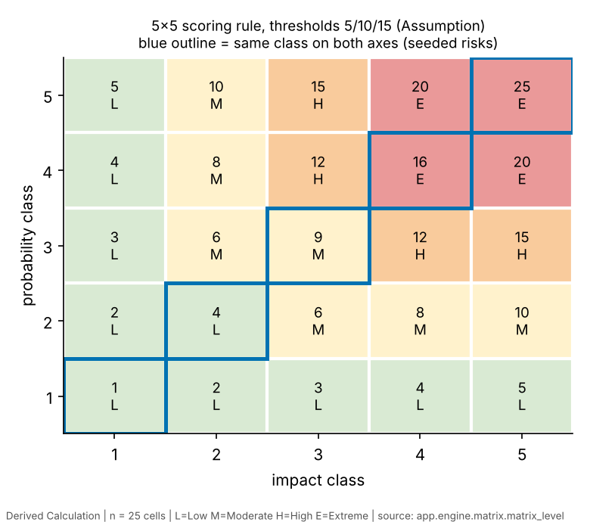
Figure 3.2. Level map of the 5x5 scoring rule; the blue outline marks the cells a seeded risk can occupy (Derived Calculation; n = 25 cells; thresholds are an Assumption).
With the same class on both axes, a seeded risk can only land on the diagonal: scores 1, 4, 9, 16 and 25, hence levels Low, Low, Moderate, Extreme and Extreme. Six risks in each class give 12 Low, 6 Moderate, 0 High and 12 Extreme (counted in Chapter 4). The effect is that the rank is effectively squared and given an absolute-sounding label, which the audit raised as finding F02. The application now labels seeded placements as “literature tier (Assumption)”, draws them as grey dashed chips and excludes them from the level totals; whether to hide the level colour entirely remains a supervisor decision.

The Assumption register
The labels AS-1 to AS-16 are local to this chapter and Chapter 4; the full register in Appendix H uses its own numbering (AS-01 to AS-18), and the two are not the same list. Table 3.5 lists every assumption that changes a number in this report, where it is used, why it was made, and which analysis tests it. Items AS-1 to AS-7 define the tool; AS-8 to AS-13 define how literature values are combined; AS-14 to AS-16 concern the analysis itself.
Table 3.5. Assumption register (Source label of every row: Assumption)
ID | Assumption | Where used | Reason | Tested by
AS-1 | Probability edges 0.2/0.4/0.6/0.8 (equal width) | probability class of risks with entered p | simplest neutral bins; no source | S2 (example case)
AS-2 | Level thresholds 5/10/15 on the product of classes | matrix level | no source | S2 (example), A1 extra (seeded, 969 triples)
AS-3 | Impact = expected delay / planned duration with four user-entered edges (example 0.02/0.05/0.10/0.20, ILLUSTRATIVE) | impact class of risks with entered delay | puts delay on a duration-relative scale | S2
AS-4 | Lower-edge-inclusive classes, relative tolerance ${10}^{−9}$ | both class functions | removes float artefacts at an edge | S0 probes; S1 break-even (R-WX)
AS-5 | Five equal-count bands, six risks per band | seed class | five classes on the axes | S3 band variants
AS-6 | Same class on both axes | seeded placements | RII is neither probability nor days | structural analysis (Chapter 4); not testable with these data
AS-7 | A rule flag adds one probability class, cap 5 | seeded risks with an elevated rule | lets site facts move a seeded risk; no source for the step size | structural analysis (Chapter 4); not testable with these data
AS-8 | Each seed study has equal weight | seed mean RII | avoids weighting by N across unequal designs | S3 (study bootstrap, drop-one-study)
AS-9 | A study’s direct items are averaged first | seed mean RII | one study counts once for a risk | not varied
AS-10 | Only direct mappings enter the seed | seed rows | related rows are weaker matches | S3 (direct + related)
AS-11 | Raw RII from 1-4 and 1-5 scales is averaged | seed mean RII | no common scale is available | S3 (rescaled; percentile rank)
AS-12 | Ties are ordered by risk id | rank | needs a deterministic rule | one tie (R-MTH, R-STO), reported
AS-13 | Seed and held-out roles as listed in the seed file | agreement analysis | see Section 3.3 | S4 (non-circular comparison)
AS-14 | Sensitivity ranges (x0.5 to x2, edge shifts, cut-off triples), the 80% tier rule, B = 2000, seed 20261008 | all of Chapter 4 | analysis design; fixed before reporting | all variants reported
AS-15 | Planning SD of one Likert point for survey precision | Section 3.10 | M01’s counts give about 0.96 | not applicable (planning only)
AS-16 | Every probability, delay and the planned duration of the example case | S1, S2 | placeholders for a demonstration | S1, S2

3.8 Analysis plan
The committee’s methods review fixed one family of analyses, A1 to A7, before the results of the final scripts were produced. The scripts are in analysis/ (S0 to S5) and one further script, report/scripts/ch34_build.py, adds the structural counts of A1, the cut-off analysis for the seeded placements, the tier rule, the critical correlations and the worked-example checks. Table 3.6 maps the plan to the scripts.
Table 3.6. Analysis family A1 to A7 and where each is implemented (Source: methods plan of 2026-10-08 and analysis/README.md)
ID | Question | Method | Implemented in | Input label
A1 | What does the 5x5 rule imply by itself? | enumerate 25 cells; count levels; apply to the seeded diagonal | ch34_build.py; S0 probes | Assumption
A2 | How does the level of a risk with entered numbers respond to its inputs? | one-at-a-time and joint scaling (x0.5, 0.8, 1.2, 1.5), 5x5 joint grid, 5000 random joint draws, break-even multipliers | S1 | Assumption (ILLUSTRATIVE)
A3 | How do edges and thresholds matter? | shift each probability edge, scale impact edges, alternative sets, 5000 random edge draws, cut-off triples | S2 (example); ch34_build.py (seeded: 969 triples) | Assumption
A4 | How stable are seed classes under banding and data variants? | 14 variants, drop-one-study, boundary gaps | S3 | Literature
A5 | Which risks keep a coarse tier under study resampling? | study-level bootstrap (2000), exact jackknife, tier rule | S3; tier rule in ch34_build.py; spread in S5 | Literature
A6 | Do studies agree on order, without circularity? | pairwise Spearman with n, permutation p, Holm; study vs seed from the other studies; Kendall W blocks | S4 | Literature
A7 | Are the RII values comparable across studies? | scale and selection checks reported as limits | S3 (rescaled, percentile, drop-one), S5; Table 3.2 | Literature
Statistics used.
- Spearman’s rho between two orders over the risks that both orders contain. Every correlation is reported with its n. A correlation with fewer than five shared risks is not tested.
- Permutation p-values. For n up to 8 the two-sided p is exact, by enumeration of all n! permutations. For larger n, 20,000 random permutations are drawn and p = (count + 1)/(20,000 + 1), where count is the number of permutations with $\left|ρ^{*}\right|≥\left|ρ\right|$. Monte Carlo error is about $±0.003$. Permutation tests are preferred to the t-approximation because n is small and the ranks contain ties.
- Kendall’s W (Kendall & Babington Smith, 1939) for m studies ranking n risks that all of them contain, with a tie correction. The test statistic is $W=12S/\left[m^{2}\left(n^{3}−n\right)−m∑T\right]$, where $S$ is the sum of squared deviations of the risk rank sums and $T$ the tie term. The p-value is a permutation p (20,000 permutations, one-sided, with the +1 correction), because the chi-square approximation is unreliable at n of 5 to 10. W measures consensus about order, not reliability.
- Holm’s step-down correction (Holm, 1979) within each family of tests: the sorted p-values are multiplied by $k,k−1,…,1$ and made monotone. Three separate families are used: the 13 pairwise correlations with n of at least 5; the leave-one-study-out comparisons; and the 14 Kendall W blocks. The W blocks share studies and risks, so their adjusted p-values are descriptive.
- Study-level bootstrap. The five seed studies are resampled with replacement 2000 times, a study drawn twice has weight 2, and the seed is rebuilt each time. A risk is absent from a resample if all its studies were left out; class shares are therefore conditional on presence, and the share of resamples in which a risk is present is reported. Bands are cut over the risks present in the resample. With five clusters a percentile bootstrap is crude, so the exact leave-one-study-out (jackknife) is reported beside it, and the bootstrap is descriptive.
- Tier rule (Assumption, AS-14). A risk is in Tier 1 if it is in class 5 in at least 80% of the resamples in which it is present and it rests on at least two seed studies; “Tier lower” is the same with classes 1 and 2; a risk that meets a threshold but rests on one study is flagged “not assessable”; all others are “unresolved”.
- Critical correlations. For each n the smallest $\left|ρ\right|$ whose two-sided permutation p is at most 0.05, so that the reader knows what a check of that size could detect.
All random draws use one generator seed, numpy.random.default_rng(20261008). All variants named in the plan are reported, whether or not they look favourable. Software: Python 3.13.16, NumPy 2.5.3, SciPy 1.18.1, Matplotlib 3.11.2 (versions read from the interpreter used for this report). The command PYTHONPATH=/usr/local/lib/python3.13/dist-packages python analysis/run_all.py clears analysis/out/, reruns S0 to S5 in about 32 seconds, asserts that every output carries the label “Derived Calculation” and an n, and writes a manifest of SHA-256 hashes. The command was run twice for this report and the two manifests were identical. Because analysis/out/ is excluded from version control, the result could not be compared with an earlier run of the same files; the check that remains is the identical second run and agreement with the figures of the committee plan where those are quoted.
What was and was not pre-specified. The family was written down in the committee plan on 2026-10-08, after the ten-risk analyses and after the library was widened to 38 risks. It is therefore a specification made after the data were known, not a pre-registration. Its protection against forking paths is that the variants are enumerated, none is dropped and every one is reported. The 38-risk run is a second look at data first examined on 10 risks and is exploratory.
Excluded on purpose. The earlier scripts computed a number of statistics that this report does not repeat: item-level Kruskal-Wallis and Mann-Whitney tests (pseudo-replication and post hoc), any pooled order that contains the seed studies compared with the seed (circular), “mean pairwise rho” as an agreement statistic, a two-way model whose headline p depends on single-study risks, and any conversion of RII into a probability. The audit’s findings F01, F05, F09 and F10 list them.

3.9 Software verification method
Verification asks whether the software does what its specification says. Validation would ask whether its output helps a site manager or matches site reality, and no validation has been done. The verification used four methods.
- Automated tests. The pytest suite covers the engine, matrix, rules, service, exports, AI guard and the optional analysis layer. On 2026-10-08, with the command python -m pytest -q, it reported 513 passed and 3 skipped in about 29 seconds; the three skips need the screening database, which is not in the repository. This count is reported as read at that time, not as a fixed property: other counts (46 library risks, 30 seeded, 182 seed rows, 11 studies, 5 seed studies, 22 site-fact rules) are pinned through tests/test_relevance_guard.py, which reads each count from the data files and fails when a document or data file changes without a conscious update.
- Guard tests. Ten guards G-1 to G-10 check that counts agree across data and documents, that the seed rows are frozen (a hash), that withdrawn wording is absent from current documents, that every exported number has a source, that the example stays labelled ILLUSTRATIVE, and that unseeded risks carry a status and no seed rows and the AI path carries no numbers.
- Hand calculation against the tool. Chapter 6 compares hand calculations with tool output for a worked case. Within this report, Worked examples 3.2 and 4.1 recompute a seed class and a matrix placement by hand and compare them with the code’s output.
- Cross-implementation checks inside the analysis package. S3 re-implements the RII-to-class rule and asserts equality with seed_table() for all 30 seeded risks. S1 and S2 use a faster path through the matrix functions and assert equality with run_case on all 84 one-at-a-time runs, on 100 random draws, on the baseline and on every impact-edge variant. No mismatch occurred (fast_path_vs_run_case_mismatches is 0).
S0 probes small behaviours of the repository code. Results relevant here: run_case does not expose the probability edges (classification uses the default edges, although a docstring suggests otherwise), so S2 varies them through the matrix functions and asserts agreement at the defaults; the example case’s R-WX, with p = 0.20, lies exactly on the first probability edge; and switching the seed basis to “all” (held-out studies and related mappings pooled) changes the class of 24 of the 30 common risks. The S0 output also stores a finding text about a missing probability tolerance, which is stale: the tolerance was added after the committee review (Audit Corrections, Section 6), and the probe’s recorded class for 0.1 + 0.7 is 5, as the tolerant rule expects.
Engine defects found by the audit (H1, M1 to M10, L1 to L14) were partly fixed on 2026-10-08. Those still open are listed in the audit and in Chapter 6; NaN and boolean inputs are now rejected by the case validator. None of them affects the seed or the analyses reported here.

3.10 Future expert survey and second-coder design
Neither of the following has been done. They are described so that the analysis can be pre-registered before any data arrive.

3.10.1 Expert survey
The design is a short questionnaire of 15 neutral-worded causes of masonry delay (for example bricks or blocks not on site, masons absent, hoist unavailable, rain stopping external masonry), each rated for frequency (1 never or almost never to 5 on almost every masonry activity) and for severity (1 no noticeable slip to 5 holds up following trades), with “not applicable” and “don’t know” options. The anchor wording is the team’s own (Assumption) and is never converted to days or probability. Item order is randomised, the literature ranks and the tool’s matrix are not shown, one attention-check item is included, team members do not respond, and a three-cause ranking question gives a check independent of the rating scales. The respondent profile records role, years of masonry supervision, building types, unit types, region and employer type, without names. A pilot with two or three site engineers tests wording.
Pre-registration. A dated file in the repository, written before data arrive, will fix the items, the item-to-library mapping, the exclusion rules (failed attention check, under one year of masonry supervision), the handling of N/A (pairwise, never imputed) and the analysis list below.
Analysis list.
- Per item: n answering, median, IQR, frequency index (FI) and severity index (SI) by the RII formula, importance FI x SI, with a respondent-bootstrap 95% interval (B = 5000), and ranks with bootstrap rank intervals.
- Kendall’s W across respondents on complete cases, separately for frequency and severity, and by group (contractor-side, client or consultant side) when a group has at least 8 respondents.
- Reliability of the item order, not only Cronbach’s alpha (Cronbach, 1951): random split-half of respondents, Spearman of the two halves’ FI orders corrected by the Spearman-Brown formula, averaged over 1000 splits; alpha is reported for convention only, because the 15 causes are a checklist and not one reflective construct.
- Group differences per item by Mann-Whitney with Holm over 15 items and a rank-biserial effect size, only if each group has at least 10 respondents.
- Comparison with the seed by Spearman rho on the items that have a pre-registered one-to-one mapping (about 10 expected), exact p; labelled “agreement check, exploratory”.
Precision and sample size. The sample will be purposive or snowball, so no population margin of error is claimed. With a planning SD of one Likert point (Assumption; M01’s counts give about 0.96), the standard error of one item’s index is about $SD/\left(5\sqrt{n}\right)$: Table 3.7 gives the values and the half-width of a 95% interval. The gaps between neighbouring seed risks are 0.001 to 0.02, so an expert sample of 10 to 15 is a pilot and cannot resolve order inside a band. A target of at least 30, with response rate and respondent profile reported, is stated in advance. With n = 10 shared items, the smallest $\left|ρ\right|$ that would reach p of 0.05 is 0.648 (Table 3.8), so the detectable agreement is stated before the survey, not after.
Table 3.7. Planning precision of one importance index (Derived Calculation from the Assumption SD = 1 Likert point; formula $SE=SD/\left(5\sqrt{n}\right)$)
n respondents | SE of one index | Half-width of 95% interval (1.96 x SE)
15 | 0.052 | 0.101
30 | 0.037 | 0.072
44 (M01’s N) | 0.030 | 0.059
Table 3.8. Smallest absolute Spearman correlation reaching two-sided permutation p <= 0.05 (Derived Calculation; exact for n up to 9, 200,000 random permutations with seed 20261008 above that; n = number of shared items or risks)
n shared risks | Smallest absolute rho with two-sided permutation p <= 0.05
5 | 1.000
6 | 0.886
7 | 0.786
8 | 0.738
9 | 0.700
10 | 0.648
11 | 0.618
13 | 0.566
15 | 0.521
19 | 0.460
Source: report/scripts/ch34_build.py. Values are discrete for small n; n = 5 admits only a perfect rank agreement.
Frequency answers and the optional “out of the last 10 activities” counts will not be converted into probabilities in the analysis. They can be entered later, risk by risk, as Expert Judgment with n stated.

3.10.2 Second-coder protocol for the mapping
- Freeze a coding manual first: the risk definitions (name, scope, inclusion and exclusion examples), the decision rule for direct, related and none, and a rule for “unmappable”.
- The second coder is a person who did not build the mapping (a team member who did not code, or a faculty member). The coder is blind to the first coder’s assignments and to the RII and rank columns; only the factor text and study context are exported.
- Calibrate on 15 to 20 rows from a study that is not in the agreement sample (for example A10 or A21 items not yet entered), discuss, amend the manual once and freeze it.
- Code all 178 mapped factor rows and any newly entered rows.
- Statistics: Cohen’s kappa (Cohen, 1960) for risk assignment across the library categories plus none, with percent agreement and a bootstrap 95% interval over rows; linearly weighted kappa for strength (direct, related, none); and the same for the subset that feeds the seed (seed studies, direct). Report prevalence. Landis and Koch (1977) descriptors are used only as labels.
- Pre-committed rule: kappa below 0.60 means revise the manual and recode a fresh sample; otherwise resolve disagreements by discussion and log every change (row, old, new, reason).
- Re-run A4 to A6 once on the reconciled mapping and report original and reconciled results side by side.

3.11 Ethics
No human participants have been involved in the work reported here. All data are published survey values, and the example case is made up. The planned expert survey will involve adults who volunteer information about their own professional experience. Before it starts, the team will: obtain whatever institutional approval or exemption NICMAR requires for a questionnaire study (the requirement has not been confirmed with the supervisor and no approval number exists); show an information sheet stating purpose, voluntary participation, the right to stop, the anonymity of responses and the uses of the data; obtain informed consent as the first item of the form; collect no names, employer names or contact details in the response file (invitations are sent separately); store the response file on institutional or team-controlled storage and share only aggregated results; and report n, response rate and respondent profile truthfully. A site data collection phase would need a separate approval and the consent of the site owner. The AI evidence layer of the tool is not used to produce numbers.

3.12 Threats to validity
Table 3.9 collects the threats by type, with what has been done and what remains open. Chapter 7 returns to them.
Table 3.9. Threats to validity (Assumption and Literature labels as in the text)
Type | Threat | Handling in this report | Status
Construct | RII measures importance, not likelihood or days; the same band is used on both matrix axes; multiplicative matrices compress range (Cox, 2008) | seed labelled ordinal and Assumption; A1 and S2 show what the rule implies; no RII-to-probability conversion | open by design
Internal | One coder for the mapping | kappa protocol designed | open
Internal | Analysis choices after seeing the ten-risk data; many variants | one enumerated family, all reported, 38-risk run called exploratory | mitigated, not removed
Internal | M01 prints only RII >= 0.70; A14 and A15 give top factors only; selection on outcome pulls these risks up | dropping A14 and A15 together is one variant in S3 | reported
Internal | Mixed scales, M14 printed basis, A15 scale not recorded | rescaling and percentile-rank variants | reported
Statistical conclusion | 5 seed studies; 14 of 30 seeded risks rest on one study; overlaps of 1 to 19 risks give low power; multiple testing | exact or permutation p, Holm, n for every statistic, critical rho | reported
Statistical conclusion | Intervals ignore mapping and scale uncertainty, so they understate it | stated with each interval | open
External | General building surveys, not masonry-specific; two Sri Lankan studies; road projects in A14; manager-dominated respondents; dated surveys | study table and limits stated | open
Reliability of the tool | Engine defects (NaN, booleans, edge rounding) | partly fixed, tests, S0 probes | partly open (NaN, booleans, edge rounding fixed)
Ecological | No site data; example is ILLUSTRATIVE; no user evaluation | no claim of accuracy on real sites | open
Corpus | Three corpus counts and a fourth record count unreconciled | reported, not resolved | open (supervisor decision)

3.13 Integrity rules and source labels
Every number in this report has a source label: Literature (as printed in a published study), Expert Judgment (the team’s single-coder mapping, and, in future, survey ratings with n), Derived Calculation (computed from inputs of the other kinds, which are named; a value derived from Assumption inputs inherits the label ILLUSTRATIVE) and Assumption (a choice made by the team and listed in Table 3.5). Historical Data and User Input do not occur in this report, because no site data or user entries exist. Tables and figures of Chapter 4 carry the label and the n in their captions. RII is described as importance and never as probability or days; the seed as an ordinal starting position; the held-out comparison as an agreement check that is weak, low-powered and inconclusive. The wording withdrawn in the audit (Handoff Section 8.11) is not used.

Chapter 4. Secondary-Data Analysis
This chapter reports every analysis defined in Section 3.8, with the numbers as the scripts produced them. All tables and figures are Derived Calculations: their inputs are Literature values (the 182 seed rows) or the Assumption inputs of the illustrative example case, as each caption states, and every caption gives n. The scripts are in analysis/ and report/scripts/; the outputs are in analysis/out/; the figures are copies of the files there, with chapter-based names. Two rules govern how the results are worded. RII is an importance rating, so every analysis concerns the order of risks and never a probability or a number of days. The surveys are few and overlap little, so a result that is not significant is described as low-powered and inconclusive, not as evidence that agreement is absent.

4.1 What was run
Table 4.1 gives the inventory. The rows follow the order of the sections below, which is the order of the question set in Section 3.1.
Table 4.1. Analyses reported in this chapter (Derived Calculation; counts of risks, runs, draws or resamples as shown)
Section | Analysis | Inputs | n
4.2 | Seed table and two worked examples | 66 direct seed values | 30 seeded risks
4.3 | Behaviour of the bands and of the 5x5 rule | seed classes; thresholds | 30 risks; 969 cut-off triples
4.4 | Example-case sensitivity (S1) | ILLUSTRATIVE example, Assumption inputs | 7 risks; 84 one-at-a-time runs; 25 grid cells; 5000 draws
4.5 | Edge and threshold sensitivity (S2) | same example | 7 risks; 55 scenarios; 5000 draws
4.6 | Seed-band sensitivity (S3) | Literature | 30 risks; 14 variants
4.7 | Bootstrap and jackknife tiers (S3) | Literature | 30 risks; 5 seed studies; 2000 resamples
4.8 | Non-circular inter-study agreement (S4) | Literature | 11 studies; 55 pairs; 13 tested
4.9 | RII uncertainty (S5) | Literature | 30 seeded risks; 11 studies

4.2 The 30-risk literature seed
Table 4.2 is the seed as app.literature_seed.seed_table() returns it, with the library name of each risk. The study means are the per-study averages of Step 2 of Section 3.6. The “Level” column applies the 5x5 rule to a risk whose probability class and impact class are both equal to its seed class (Assumption, AS-6); it is shown to document what the tool does and is not a finding about the risk.
Table 4.2. The literature seed, 30 seeded risks (Derived Calculation from Literature values; n = 30 risks, 66 direct values from 5 seed studies; classes and levels are Assumptions of the tool)
Rank | Risk | Library name | Seed studies (n) | Seed mean RII | Class | Level if p-class = i-class | Study means (Literature, averaged per study)
1 | R-MAT | Brick / block / mortar material shortage or late delivery | 3 | 0.7889 | 5 | Extreme | A02 0.7800, A14 0.8098, M01 0.7770
2 | R-SAFE | Unsafe conditions or work at height | 1 | 0.7865 | 5 | Extreme | M01 0.7865
3 | R-SKILL | Unskilled or unqualified labour | 3 | 0.7831 | 5 | Extreme | A02 0.7870, A15 0.8033, M01 0.7590
4 | R-PLAN | Poor planning or unrealistic scheduling | 2 | 0.7771 | 5 | Extreme | M01 0.7910, M06 0.7632
5 | R-PAY | Payment delay | 3 | 0.7733 | 5 | Extreme | A02 0.7758, M01 0.7730, M06 0.7711
6 | R-DIS | Poor labour discipline or weak site leadership | 2 | 0.7700 | 5 | Extreme | A15 0.7900, M01 0.7500
7 | R-LAB | Labour absenteeism or shortage | 3 | 0.7662 | 4 | Extreme | A02 0.7510, A14 0.8245, M01 0.7230
8 | R-SCP | Unclear scope or inadequate project formulation | 1 | 0.7642 | 4 | Extreme | M06 0.7642
9 | R-SITE | Poor site access, clearance or conditions | 2 | 0.7611 | 4 | Extreme | A02 0.7510, M06 0.7711
10 | R-DES | Design changes or incomplete documentation | 2 | 0.7585 | 4 | Extreme | M01 0.7320, M06 0.7851
11 | R-RWK | Rework due to workmanship or defects | 2 | 0.7561 | 4 | Extreme | M01 0.7360, M06 0.7761
12 | R-TOOL | Tools and equipment delay | 2 | 0.7528 | 4 | Extreme | A02 0.7600, M01 0.7455
13 | R-INC | Inadequate wages or incentives | 1 | 0.7520 | 3 | Moderate | M01 0.7520
14 | R-STR | Labour strikes or disputes | 1 | 0.7493 | 3 | Moderate | M06 0.7493
15 | R-CTR | Contractual disputes and claims | 1 | 0.7468 | 3 | Moderate | M06 0.7468
16 | R-SUP | Inadequate supervision or monitoring of workers | 1 | 0.7440 | 3 | Moderate | M01 0.7440
17 | R-MOT | Low motivation, morale or labour turnover | 1 | 0.7360 | 3 | Moderate | M01 0.7360
18 | R-MGT | Poor site management and coordination | 2 | 0.7331 | 3 | Moderate | M01 0.7090, M06 0.7572
19 | R-CST | Cost control and budget updating problems | 1 | 0.7184 | 2 | Low | M06 0.7184
20 | R-OVT | Overtime and long working hours | 2 | 0.7063 | 2 | Low | M01 0.7250, M06 0.6876
21 | R-ACC | Accidents and injuries on site | 2 | 0.7045 | 2 | Low | A02 0.6500, M01 0.7590
22 | R-MTH | Construction method or design complexity | 1 | 0.7000 | 2 | Low | M01 0.7000
23 | R-STO | Poor material storage or handling | 1 | 0.7000 | 2 | Low | A02 0.7000
24 | R-WX | Rain / monsoon stoppage | 4 | 0.6934 | 2 | Low | A02 0.7000, A14 0.6528, M01 0.7640, M06 0.6567
25 | R-COM | Poor communication or misunderstanding on site | 2 | 0.6793 | 1 | Low | A02 0.6800, M06 0.6786
26 | R-PRC | Material price escalation | 2 | 0.6695 | 1 | Low | A02 0.5500, A14 0.7890
27 | R-ECO | Economic conditions, inflation or interest rates | 1 | 0.6612 | 1 | Low | M06 0.6612
28 | R-WAT | Water shortage | 1 | 0.6500 | 1 | Low | A02 0.6500
29 | R-FAT | Worker fatigue, age or personal problems | 1 | 0.6100 | 1 | Low | A02 0.6100
30 | R-SOC | Social or community environment | 1 | 0.5940 | 1 | Low | M06 0.5940
Source: app.literature_seed.seed_table() (basis “seed”); data/literature_seed.json; risk names from data/risk_library_masonry.json. R-MTH and R-STO tie at 0.7000 and are ordered by id.
Six features of the table matter for everything that follows.
The spread is small. The seed means run from 0.594 (R-SOC) to 0.789 (R-MAT), a range of 0.195. Ranks 1 to 6 lie within 0.019 of each other (0.7889 to 0.7700), and ranks 1 to 24 within 0.096. The median gap between adjacent ranks is 0.0034 (S5). The class of a risk therefore depends on small differences in a mean of at most four numbers.
Fourteen of the 30 risks rest on a single study: R-CST, R-CTR, R-ECO, R-FAT, R-INC, R-MOT, R-MTH, R-SAFE, R-SCP, R-SOC, R-STO, R-STR, R-SUP and R-WAT (S0). For those the “average across studies” is one study’s number.
Sixteen library risks have no seed. R-CLI, R-DEF, R-FIN, R-GOV, R-PRD, R-QLT, R-SUB and R-TRN have no direct value in the seed studies, and eight further risks added on 2026-10-08 (R-FRONT, R-VT, R-MORT, R-GPAY, R-OPEN, R-SCAF, R-FEST, R-HEAT) were written without seed rows. They stay off the matrix until numbers are entered. Several of the omitted risks (work-front release, scaffolding, the hoist) are the ones a site manager might most expect, and no seed study has a direct value for them.
Six per class is a rule, not a result. Equal-count banding puts exactly six risks in each class whatever the data (S0 confirms 6, 6, 6, 6, 6).
Seed studies differ in kind. M01 lists only items rated 0.70 or higher; A14 and A15 contribute four values each; A02 is on a 1-4 scale. The class of a risk reflects which of these studies happened to report it.
One tie exists (R-MTH and R-STO at 0.7000), broken alphabetically.
Worked example 4.1: one risk placed on the matrix by hand. R-LAB has seed class 4 (Worked example 3.2). Both axes take the class: probability class 4, impact class 4. The score is $4×4=16$. The level thresholds are 5, 10 and 15; a score of 16 exceeds 15, so the level is Extreme (the code takes bisect_right([5,10,15], 16 - 1), which is 3, the fourth name). If a site-fact rule marks R-LAB as elevated, the probability class becomes $min\left(5,4+1\right)=5$, the score $5×4=20$, and the level stays Extreme. The returned placement agrees: seed_for("R-LAB") gives p class 4, impact class 4, and seed_for("R-LAB", elevated=True) gives p class 5, impact class 4, with raised_by_rule true. For contrast, a risk with entered numbers is placed from its inputs. In the illustrative example R-MAT has p = 0.5 and a PERT delay with minimum 1, most likely 3 and maximum 8 days, so the expected delay if it occurs is $\left(1+4⋅3+8\right)/6=3.5$ days. The planned duration is 16 days, so the ratio is $3.5/16=0.21875$. With impact edges 0.02, 0.05, 0.10 and 0.20, the ratio has reached all four, so the impact class is 5. With probability edges 0.2, 0.4, 0.6 and 0.8, p = 0.5 has reached two, so the probability class is 3. The score is 15, which is High. The tool returns p class 3, impact class 5, score 15, High (S1, base case). All inputs of the second calculation are Assumptions (ILLUSTRATIVE); the first uses Literature values and the assumed rule.

4.3 Behaviour of the bands and of the 5x5 rule
Section 3.7 showed that the rule has 10 Low, 7 Moderate, 4 High and 4 Extreme cells (Derived Calculation, n = 25 cells; ch34_build.py recounts them from matrix_level). Applied to the seeded risks, with the same class on both axes, the effect is stark (Table 4.3).
Table 4.3. Levels of the 30 seeded risks under the repo rule (Derived Calculation; n = 30 risks; classes from Table 4.2; same class on both axes is an Assumption)
Case | Low | Moderate | High | Extreme
Placed as the tool does, no rule flag | 12 | 6 | 0 | 12
Hypothetical: every seeded risk carries an “elevated” flag (probability class + 1, cap 5) | 6 | 6 | 6 | 12
Source: ch34_build.py (facts in report/scripts/out/facts.json). The second row is a structural illustration of Assumption AS-7, not a scenario that occurs in the example case.
With no flag, no seeded risk can be High, and risks in classes 4 and 5 are all Extreme, so the twelve most important risks by seed rank are all “Extreme” although their seed means differ by at most 0.0361 (R-MAT 0.7889 to R-TOOL 0.7528). The boundary between ranks 12 and 13 shows the label’s arbitrariness: R-TOOL (0.7528, class 4, Extreme) and R-INC (0.7520, class 3, Moderate) differ by 0.00075 in mean RII, which is smaller than the change in an M01 RII caused by one respondent moving one Likert point (0.0045 at N = 44; Handoff Section 8.2). One flag lifts a class 3 risk from Moderate to High and a class 2 risk from Low to Moderate, so in the flagged row six risks are High.
The levels also depend on the cut-offs. Table 4.4 gives the effect of six named alternatives on the seeded placements, and Figure 4.1 shows the distribution over all 969 admissible triples $t_{1}<t_{2}<t_{3}$ in 2 to 20.
Table 4.4. Levels of the 30 seeded risks under alternative level cut-offs (Derived Calculation; n = 30 risks per row; cut-offs are the upper score of Low, Moderate and High; same class on both axes is an Assumption)
Cut-offs (Low/Mod/High upper score) | Risks changing level (of 30) | Low | Moderate | High | Extreme
5/10/15 (repo) | 0 | 12 | 6 | 0 | 12
4/9/15 | 0 | 12 | 6 | 0 | 12
4/9/16 | 6 | 12 | 6 | 6 | 6
4/8/12 | 6 | 12 | 0 | 6 | 12
6/12/16 | 6 | 12 | 6 | 6 | 6
3/8/14 | 12 | 6 | 6 | 6 | 12
5/10/20 | 6 | 12 | 6 | 6 | 6
Source: ch34_build.py.
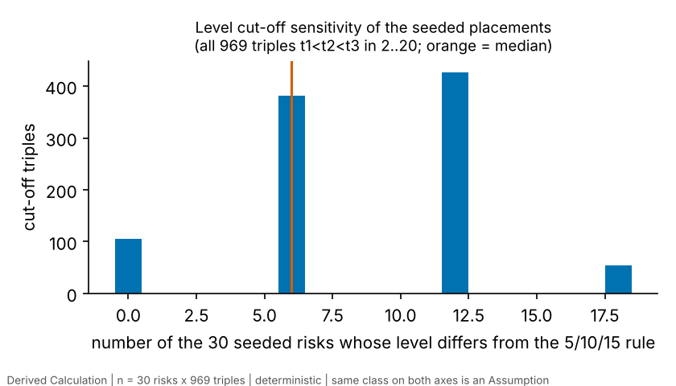
Figure 4.1. Number of the 30 seeded risks whose level changes when the cut-offs change, over all 969 triples (Derived Calculation; n = 30 risks x 969 triples).
Over the 969 triples the median number of changed levels is 6 of 30 (interquartile range 6 to 12, range 0 to 18); in 10.8% of triples no seeded level changes. Because six risks share each diagonal score, a cut-off that moves past one diagonal score changes six labels at once. The levels of seeded placements are therefore a function of the assumed thresholds as much as of the evidence, which is consistent with the application’s decision to draw them as an ordinal tier and exclude them from level totals.

4.4 Example-case sensitivity (S1)
S1 uses the illustrative example case, which has 7 risks, a planned duration of 16 days, probabilities from 0.10 to 0.50 and PERT delays of 1 to 8 days, all placeholders (Assumption, ILLUSTRATIVE; Table 4.5). It tests how the classification rule responds to its inputs. It says nothing about how a real site behaves. With 7 risks, the counts below are descriptions of one small case, not a sample.
Table 4.5. The example case as classified (Derived Calculation from Assumption inputs, ILLUSTRATIVE; n = 7 risks; planned duration 16 days; impact edges 0.02/0.05/0.10/0.20 of planned duration)
Risk | p (Assumption) | Distance of p to nearest p edge | Expected delay / planned duration | Distance of ratio to nearest impact edge | p class | Impact class | Level
R-MAT | 0.5 | 0.1 | 0.2188 | 0.0938 | 3 | 5 | High
R-LAB | 0.35 | 0.05 | 0.1562 | 0.2188 | 2 | 4 | Moderate
R-RWK | 0.25 | 0.05 | 0.1458 | 0.2708 | 2 | 4 | Moderate
R-WX | 0.2 | 0.0 | 0.1667 | 0.1667 | 2 | 4 | Moderate
R-PLAN | 0.1 | 0.1 | 0.0833 | 0.1667 | 1 | 3 | Low
R-SAFE | 0.3 | 0.1 | 0.1562 | 0.2188 | 2 | 4 | Moderate
R-SKILL | 0.22 | 0.02 | 0.1458 | 0.2708 | 2 | 4 | Moderate
Source: analysis/out/s2_edge_margins.csv; inputs from examples/example_case.json. Expected delay is the mean of the PERT delay (a + 4m + b)/6.
Five risks (R-LAB, R-RWK, R-WX, R-SAFE, R-SKILL) are probability class 2 and impact class 4 and are Moderate (score 8). R-MAT is High (score 15) and R-PLAN Low (score 3). R-WX has p = 0.20, exactly on the first probability edge, so under the lower-edge-inclusive rule it is class 2 and any shift of that edge or of p flips it. This single placeholder drives many of the counts below.
One at a time. Each risk’s p, its delay days (a, m, b together) or both were multiplied by 0.5, 0.8, 1.2 and 1.5 (p capped at 1), with the other six risks unchanged. 84 runs were made. No run changed the level of any other risk (oat_other_risks_ever_changed is 0): the matrix is per-risk and independent.
Table 4.6. Number of the 7 risks whose level changes when one input is scaled, one risk at a time summed over risks (Derived Calculation from Assumption inputs, ILLUSTRATIVE; n = 7 risks x 4 factors per input; 84 runs in all)
Input changed | x0.5 | x0.8 | x1.2 | x1.5
p | 6 | 2 | 2 | 3
delay | 0 | 0 | 0 | 0
p+delay | 6 | 2 | 2 | 3
Source: analysis/out/s1_summary.json. Each cell counts risks, 7 at most, whose own level changed when that risk alone was scaled by the factor shown.
The level responds to probability and not to delay. Scaling every risk’s delay by 0.5 to 1.5 changes no level, because the probability class caps the score: a risk of probability class 2 scores at most $2×5=10$, still Moderate. Delay changes the impact class (for example R-MAT drops from impact class 5 to 4 at 0.91 times its delay) but not the level. Table 4.7 gives the break-even multiplier, the smallest scaling of one input within 0.30 to 2.00 (step 0.01) at which a class or level first changes.
Table 4.7. Break-even multipliers, one input of one risk at a time (Derived Calculation from Assumption inputs, ILLUSTRATIVE; n = 7 risks; grid 0.30 to 2.00 in steps of 0.01)
Risk | Input | Up: first multiplier changing class | Down: first multiplier changing class | Up: first multiplier changing level | Down: first multiplier changing level
R-MAT | p | 1.2 | 0.79 | 1.2 | 0.79
R-MAT | delay | none in 0.30-2.00 | 0.91 | none in 0.30-2.00 | 0.45
R-LAB | p | 1.15 | 0.57 | 1.15 | 0.57
R-LAB | delay | 1.28 | 0.63 | none in 0.30-2.00 | 0.31
R-RWK | p | 1.6 | 0.79 | 1.6 | 0.79
R-RWK | delay | 1.38 | 0.68 | none in 0.30-2.00 | 0.34
R-WX | p | 2.0 | 0.99 | 2.0 | 0.99
R-WX | delay | 1.2 | 0.59 | none in 0.30-2.00 | none in 0.30-2.00
R-PLAN | p | 2.0 | none in 0.30-2.00 | 2.0 | none in 0.30-2.00
R-PLAN | delay | 1.2 | 0.59 | none in 0.30-2.00 | none in 0.30-2.00
R-SAFE | p | 1.34 | 0.66 | 1.34 | 0.66
R-SAFE | delay | 1.28 | 0.63 | none in 0.30-2.00 | 0.31
R-SKILL | p | 1.82 | 0.9 | 1.82 | 0.9
R-SKILL | delay | 1.38 | 0.68 | none in 0.30-2.00 | 0.34
Source: analysis/out/s1_breakeven.csv. “none in 0.30-2.00” means no change anywhere on the grid.
Probability changes a level at multipliers between 0.57 and 2.0, risk by risk: R-MAT at +20% or -21%, R-LAB at +15%, R-SAFE at +34%. R-WX flips down at 0.99, because it sits on the edge. Delay changes a level only for decreases of 55% to 69% (multipliers 0.31 to 0.45), and not at all within the grid for R-WX and R-PLAN. Delay increases up to double change no level.
Joint changes. Scaling all probabilities and all delays together on a 5x5 grid (25 cells) and drawing each input’s factor independently from U(0.5, 1.5) 5000 times (seed 20261008) give the same picture as the single-input runs (Figure 4.3; grid and per-risk shares in analysis/out/s1_joint_grid_summary.csv and s1_joint_random_by_risk.csv). On average 2.48 of the 7 levels change per draw, and in 4% of draws none does.
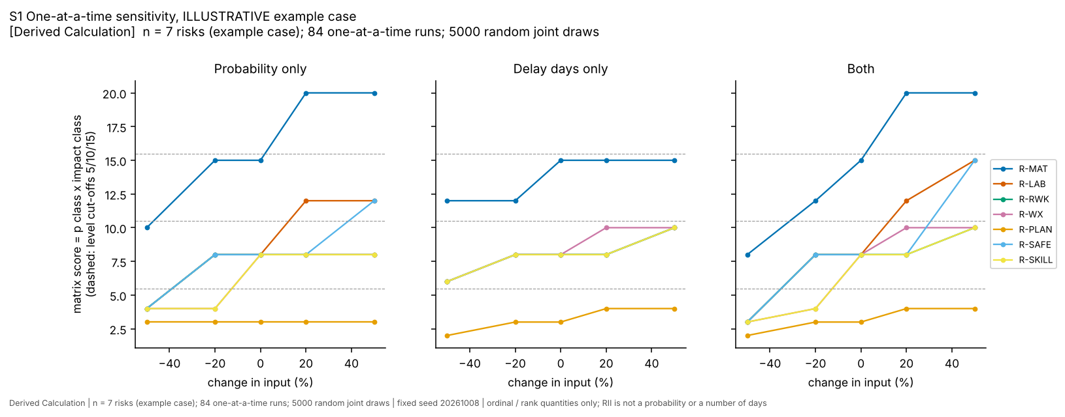
Figure 4.2. One-at-a-time sensitivity of the matrix score (Derived Calculation from Assumption inputs, ILLUSTRATIVE; n = 7 risks; 84 runs). Dashed lines are the level cut-offs.
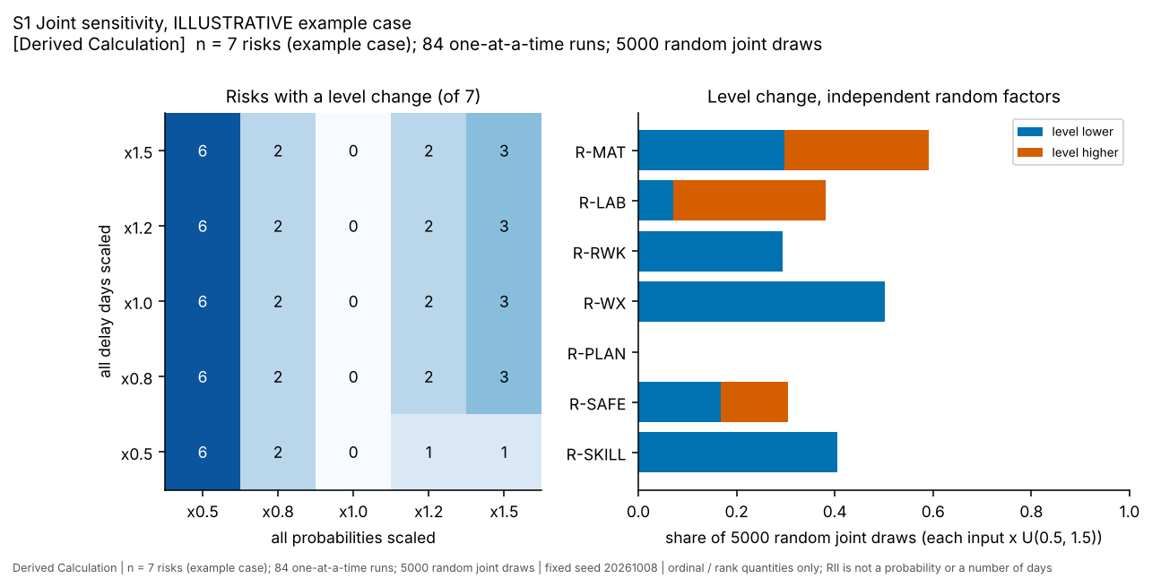
Figure 4.3. Joint sensitivity: risks with a level change on the 5x5 grid (left) and share of random draws with a level change by risk (right) (Derived Calculation from Assumption inputs, ILLUSTRATIVE; n = 7 risks; 25 cells; 5000 draws).
The grid and the draws agree with the single-input results. Scaling all probabilities by 0.5 changes 6 of 7 levels whatever the delay factor; by 0.8, 2; by 1.2, 2 (1 at a delay factor of 0.5); by 1.5, 3 (1 at a delay factor of 0.5). Delay only matters at the margins of the grid: a probability factor of 1.2 or 1.5 together with a delay factor of 0.5 gives 1 changed level instead of 2 or 3, because the shorter delay offsets the higher probability for one risk. In the random draws, R-PLAN never changes level (p = 0.10 and a short delay keep it Low), R-MAT changes in 59% of draws, R-WX in 50% (its edge position), and R-LAB and R-SAFE can move up or down.
What this shows is how the rule responds to inputs: the ordinal level is governed by the probability class, and a change of the assumed probabilities by 20 to 50% changes the level of between 2 and 6 of 7 risks. It does not show that any real risk is sensitive to probability, and the example’s numbers are placeholders.

4.5 Edge and threshold sensitivity (S2)
S2 varies the classification edges and thresholds on the same example, in 55 named scenarios and 5000 random edge draws. For each scenario it counts how many of the 7 risks change class and how many change level. Both counts are reported, because counting levels alone hides class changes (Table 4.8).
Table 4.8. Level changes under edge and threshold scenarios (Derived Calculation from Assumption inputs, ILLUSTRATIVE; n = 7 risks per scenario; 55 scenarios in 7 groups)
Scenario group (ILLUSTRATIVE example, 7 risks) | Scenarios | Levels changed: min-median-max (of 7) | Max p classes changed | Max impact classes changed
One p edge shifted by -0.10, -0.05, +0.05 or +0.10 | 16 | 0-0-3 | 3 | 0
All four p edges shifted together by the same amounts | 4 | 1-2.5-4 | 4 | 0
Alternative p-edge sets (4) | 4 | 2-4.5-7 | 7 | 0
One impact edge scaled (x0.5 to x2) | 16 | 0-0-0 | 0 | 3
All four impact edges scaled (x0.5 to x2) | 5 | 0-0-0 | 0 | 7
Alternative impact-edge sets (3) | 3 | 0-0-6 | 0 | 7
Alternative level cut-offs (7 named triples) | 7 | 0-0-1 | 0 | 0
Source: analysis/out/s2_summary.json and s2_threshold_scenarios.csv. Median of the single-edge group is 0.
Probability edges. Shifting all four edges by -0.10 changes four levels (R-MAT, R-LAB, R-PLAN, R-SAFE); by +0.10, three (R-RWK, R-WX, R-SKILL). A low-skewed alternative set (0.05, 0.15, 0.35, 0.65) changes all seven. Shifting a single edge matters only when a risk sits near it: the first edge (0.2) at -0.10 flips R-PLAN (p = 0.10) and at +0.05 flips R-WX and R-SKILL (p = 0.20 and 0.22). The fourth edge (0.8) never matters here because no example risk has p above 0.5.
Impact edges. Scaling the impact edges changes the impact class of up to all seven risks (six at x0.5, seven at x2), but changes no level. Again the probability class caps the score: with probability class 2 or lower, even impact class 5 gives at most 10, Moderate, and probability class 1 gives at most 5, Low. Only one alternative changes levels, equal-width impact edges (0.2, 0.4, 0.6, 0.8), which put six risks in a lower level because every impact class falls to 1 or 2 (the delay ratios, 0.08 to 0.22, mostly lie below the first edge of 0.2: six of the seven are 0.17 or lower and only R-MAT, at 0.22, is above it). The statement “the matrix is robust to the impact edges” would therefore be wrong in general: it holds here because the placeholder probabilities are low.
Level cut-offs. Of seven named triples, two change one level (R-MAT, at 4/8/12 and 3/8/14), and five change none. Over all 2,024 admissible triples with cut-offs between 1 and 24 (S2) the median is 5 of 7 risks changing level (interquartile range 1 to 6). The seeded placements in Section 4.3 are more exposed, with a median of 6 of 30.
Random edges. Jittering each probability edge independently by up to 0.05 changes at least one level in 48% of 5000 draws (mean 0.77 changed levels, maximum 2); jittering impact edges by up to 50% changes none; jittering both gives the same as probability jitter. By risk, the levels that move are R-WX (48% of draws) and R-SKILL (29%), the two risks whose p lies within 0.02 of an edge (Table 4.5, column 3).
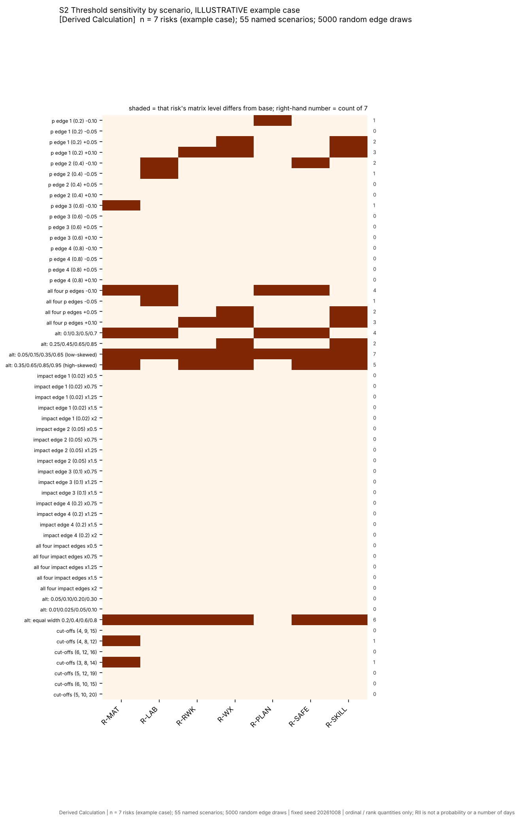
Figure 4.4. Level and class changes across the 55 named edge and threshold scenarios (Derived Calculation from Assumption inputs, ILLUSTRATIVE; n = 7 risks; 55 scenarios).
The result is a description of how fragile the level label is near an edge. The margin table (Table 4.5) shows which placeholders sit close to an edge: R-WX at 0.00 and R-SKILL at 0.02 from a probability edge, the rest at 0.05 to 0.10. A real user’s numbers will have their own margins.

4.6 Seed-band sensitivity (S3)
S3 asks how many seeded risks change class when the banding rule or the data are changed. The 14 variants of Table 4.9 were fixed in advance and are all reported. Percentages are of the risks common to the variant and the base rule (30 unless the variant drops a risk). Spearman’s rho is between the variant’s per-risk means and the base means; Kendall’s tau between the classes.
Table 4.9. Class changes under banding and data variants (Derived Calculation from Literature values; n = 30 seeded risks, 5 seed studies; one row per variant)
Variant | Risks | Changed class | % changed | Spearman of mean RII vs base | Kendall tau of classes | Class counts (class:risks) | Dropped | Added
repo rule: 5 equal-count bands (6 per band) | 30 | 0 | 0.0 | 1.00 | 1.00 | 1:6 2:6 3:6 4:6 5:6 | - | -
3 equal-count bands (tertiles), mapped to classes 1/3/5 | 30 | 12 | 40.0 | 1.00 | 0.86 | 1:10 3:10 5:10 | - | -
4 equal-count bands, mapped to 1-5 | 30 | 9 | 30.0 | 1.00 | 0.90 | 1:7 2:8 4:7 5:8 | - | -
5 equal-width bands on mean RII | 30 | 22 | 73.3 | 1.00 | 0.89 | 1:2 2:3 3:6 4:6 5:13 | - | -
fixed RII cut-offs 0.2/0.4/0.6/0.8 | 30 | 24 | 80.0 | 1.00 | 0.23 | 3:1 4:29 | - | -
fixed RII cut-offs 0.60/0.65/0.70/0.75 | 30 | 23 | 76.7 | 1.00 | 0.86 | 1:1 2:1 3:5 4:10 5:13 | - | -
direct + related mappings | 32 | 8 | 26.7 | 0.96 | 0.88 | 1:6 2:6 3:7 4:6 5:7 | - | R-CLI R-QLT
>= 2 seed studies per risk (re-banded) | 16 | 6 | 37.5 | 1.00 | 0.91 | 1:3 2:3 3:3 4:3 5:4 | R-CST R-CTR R-ECO R-FAT R-INC R-MOT R-MTH R-SAFE R-SCP R-SOC R-STO R-STR R-SUP R-WAT | -
scale-rescaled (RII-1/k)/(1-1/k) | 30 | 2 | 6.7 | 0.99 | 0.97 | 1:6 2:6 3:6 4:6 5:6 | - | -
within-study percentile rank (studies with >= 3 risks) | 30 | 11 | 36.7 | 0.92 | 0.80 | 1:6 2:6 3:6 4:6 5:6 | - | -
drop seed study A02 | 27 | 13 | 48.1 | 0.78 | 0.67 | 1:5 2:5 3:6 4:5 5:6 | R-FAT R-STO R-WAT | -
drop seed study A14 | 30 | 2 | 6.7 | 0.97 | 0.97 | 1:6 2:6 3:6 4:6 5:6 | - | -
drop seed study A15 | 30 | 3 | 10.0 | 0.99 | 0.92 | 1:6 2:6 3:6 4:6 5:6 | - | -
drop seed study M01 | 25 | 9 | 36.0 | 0.95 | 0.83 | 1:5 2:5 3:5 4:5 5:5 | R-INC R-MOT R-MTH R-SAFE R-SUP | -
drop seed study M06 | 24 | 6 | 25.0 | 0.96 | 0.89 | 1:4 2:5 3:5 4:5 5:5 | R-CST R-CTR R-ECO R-SCP R-SOC R-STR | -
Source: analysis/out/s3_band_variants.csv. Variants with fewer risks list the risks dropped or added.
Three groups of variants differ in meaning.
Banding rules change which risks share a class even though the order of the risks is unchanged (Spearman 1.00 in every row). With tertiles mapped to classes 1, 3 and 5, 12 of 30 classes change; with four equal-count bands, 9; with five equal-width bands on mean RII, 22, because 13 risks fall in the top band; with fixed RII cut-offs of 0.2, 0.4, 0.6 and 0.8, 24, because 29 of 30 risks fall in class 4 (all means lie between 0.59 and 0.79). A probability-like fixed scale applied to RII is not informative here. Fixed cut-offs of 0.60, 0.65, 0.70 and 0.75 change 23. These changes are by construction: they show that a class belongs to the rule, not to the risk.
Data variants. Adding related mappings (32 risks, adding R-CLI and R-QLT) changes 8 of 30 classes (Spearman 0.96, largest rank shift 10). Restricting to risks with at least two seed studies re-bands 16 risks and changes 6 of them. Rescaling each study’s RII as $\left(RII−1/k\right)/\left(1−1/k\right)$ for scale points k changes 2 (Spearman 0.99): mixing 1-4 and 1-5 scales has a small effect on the order. Replacing RII by within-study percentile rank changes 11 of 30 (Spearman 0.92, largest rank shift 8). Switching the repository’s seed basis to “all” (held-out studies and related mappings pooled; S0) changes the class of 24 of the 30 common risks.
Dropping a seed study. Dropping A02 changes 13 of the 27 remaining risks (48%; Spearman 0.78, largest rank shift 23) and removes R-FAT, R-STO and R-WAT. Dropping M01 changes 9 of 25, M06 6 of 24, A15 3 of 30 and A14 2 of 30. The class of a seeded risk depends on which studies are present, and most on A02, a study whose N is not reported, whose scale is 1-4 and whose values come from the research notes.
Across all 14 variants between 2 and 24 of the common risks change class (6.7% to 80%); the data variants that keep five bands change between 2 and 13 risks. The order of the means is more stable than the classes: every banding variant keeps Spearman 1.00, and the data variants keep 0.78 to 1.00.
Table 4.10. Gaps in seed mean RII at the four band boundaries of the repo rule (Derived Calculation from Literature values; n = 30 risks)
Band boundary (ranks) | Upper risk | Lower risk | Gap in seed mean RII
6-7 | R-DIS | R-LAB | 0.00383
12-13 | R-TOOL | R-INC | 0.00075
18-19 | R-MGT | R-CST | 0.01470
24-25 | R-WX | R-COM | 0.01408
Source: analysis/out/s3_band_boundary_gaps.csv.
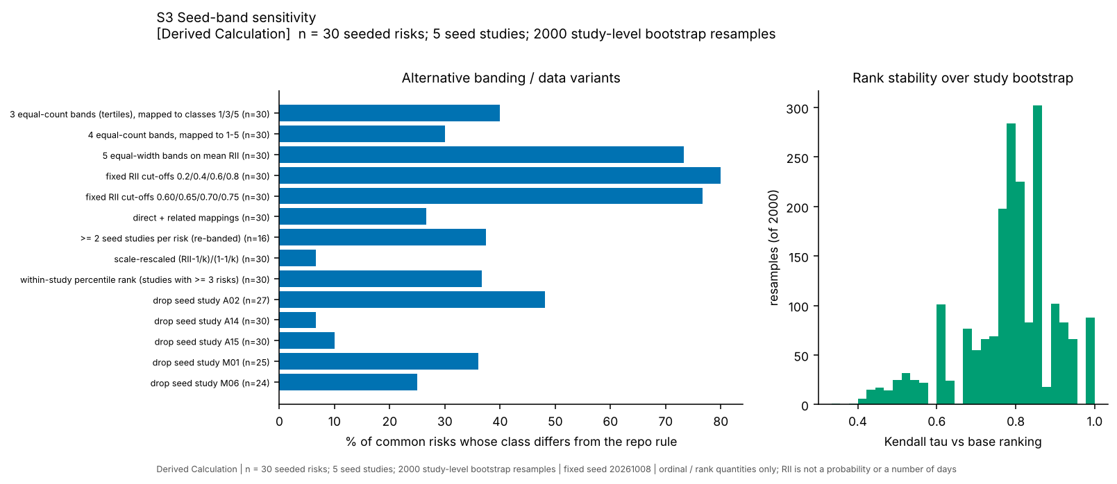
Figure 4.5. Percentage of risks changing class under each variant (left) and Kendall tau of the study-bootstrap ranking against the base ranking (right) (Derived Calculation from Literature values; n = 30 seeded risks; 5 seed studies; 2000 resamples).
The boundary between ranks 6 and 7 (R-DIS to R-LAB) is 0.0038 wide; between 12 and 13 it is 0.00075; the two outer boundaries are about 0.014 wide. Two risks on either side of the narrower boundaries differ by less than the effect of one respondent in the smallest-N seed survey with a printed N.

4.7 Bootstrap and jackknife tiers (S3)
The seed was rebuilt 2000 times from five studies drawn with replacement. The Kendall tau between the resampled mean ordering and the base ordering averages 0.784 (2.5th to 97.5th percentile 0.476 to 1.000) and Spearman’s rho 0.884 (0.60 to 1.00). On average 24.5 of the 30 risks are present in a resample (range 14 to 30), and the share of present risks keeping their base class averages 0.664 (0.316 to 1.000). Five risks keep their base class in fewer than half of the resamples where they are present: R-LAB, R-DES, R-RWK, R-INC and R-DIS. Table 4.11 gives every risk, and Figure 4.6 shows the class distribution.
Table 4.11. Class stability of each seeded risk under study resampling (Derived Calculation from Literature values; n = 30 risks, 5 seed studies, 2000 resamples; shares are conditional on the risk being present in the resample)
Rank | Risk | Base class | Seed studies | Present | P(same class) | P(class 5) | P(top 10) | Rank in resamples (2.5%-median-97.5%)
1 | R-MAT | 5 | 3 | 0.99 | 1.00 | 1.00 | 1.00 | 1-2-4
2 | R-SAFE | 5 | 1 | 0.67 | 0.97 | 0.97 | 1.00 | 1-2-5
3 | R-SKILL | 5 | 3 | 0.99 | 0.87 | 0.87 | 0.94 | 1-3-10
4 | R-PLAN | 5 | 2 | 0.91 | 0.72 | 0.72 | 0.89 | 1-4-11
5 | R-PAY | 5 | 3 | 0.99 | 0.51 | 0.51 | 0.93 | 4-5-8
6 | R-DIS | 5 | 2 | 0.92 | 0.43 | 0.43 | 0.72 | 2-6-14
7 | R-LAB | 4 | 3 | 0.99 | 0.34 | 0.35 | 0.64 | 1-7-19
8 | R-SCP | 4 | 1 | 0.67 | 0.79 | 0.14 | 0.79 | 6-8-11
9 | R-SITE | 4 | 2 | 0.93 | 0.77 | 0.07 | 0.57 | 6-8-11
10 | R-DES | 4 | 2 | 0.91 | 0.38 | 0.27 | 0.52 | 3-10-15
11 | R-RWK | 4 | 2 | 0.91 | 0.43 | 0.14 | 0.44 | 4-11-14
12 | R-TOOL | 4 | 2 | 0.93 | 0.68 | 0.00 | 0.27 | 6-10-17
13 | R-INC | 3 | 1 | 0.67 | 0.37 | 0.00 | 0.30 | 7-10-14
14 | R-STR | 3 | 1 | 0.67 | 0.91 | 0.00 | 0.01 | 11-13-15
15 | R-CTR | 3 | 1 | 0.67 | 0.90 | 0.00 | 0.00 | 12-14-16
16 | R-SUP | 3 | 1 | 0.67 | 0.74 | 0.00 | 0.00 | 10-15-18
17 | R-MOT | 3 | 1 | 0.67 | 0.64 | 0.00 | 0.00 | 12-17-20
18 | R-MGT | 3 | 2 | 0.91 | 0.51 | 0.00 | 0.00 | 10-17-20
19 | R-CST | 2 | 1 | 0.67 | 0.73 | 0.00 | 0.00 | 13-19-21
20 | R-OVT | 2 | 2 | 0.91 | 0.79 | 0.00 | 0.00 | 15-17-22
21 | R-ACC | 2 | 2 | 0.93 | 0.54 | 0.00 | 0.09 | 8-19-24
22 | R-MTH | 2 | 1 | 0.67 | 0.66 | 0.00 | 0.00 | 18-22-24
23 | R-STO | 2 | 1 | 0.69 | 0.80 | 0.00 | 0.00 | 8-20-24
24 | R-WX | 2 | 4 | 1.00 | 0.61 | 0.00 | 0.00 | 9-19-25
25 | R-COM | 1 | 2 | 0.93 | 0.68 | 0.00 | 0.00 | 9-21-25
26 | R-PRC | 1 | 2 | 0.93 | 0.53 | 0.20 | 0.25 | 1-20-30
27 | R-ECO | 1 | 1 | 0.67 | 0.81 | 0.00 | 0.00 | 16-26-27
28 | R-WAT | 1 | 1 | 0.69 | 0.95 | 0.00 | 0.00 | 12-23-28
29 | R-FAT | 1 | 1 | 0.69 | 1.00 | 0.00 | 0.00 | 13-24-29
30 | R-SOC | 1 | 1 | 0.67 | 1.00 | 0.00 | 0.00 | 18-27-30
Source: analysis/out/s3_bootstrap_tier_membership.csv. “Present” is the share of resamples that contain at least one study reporting the risk. “Top 10” is membership of the top third.
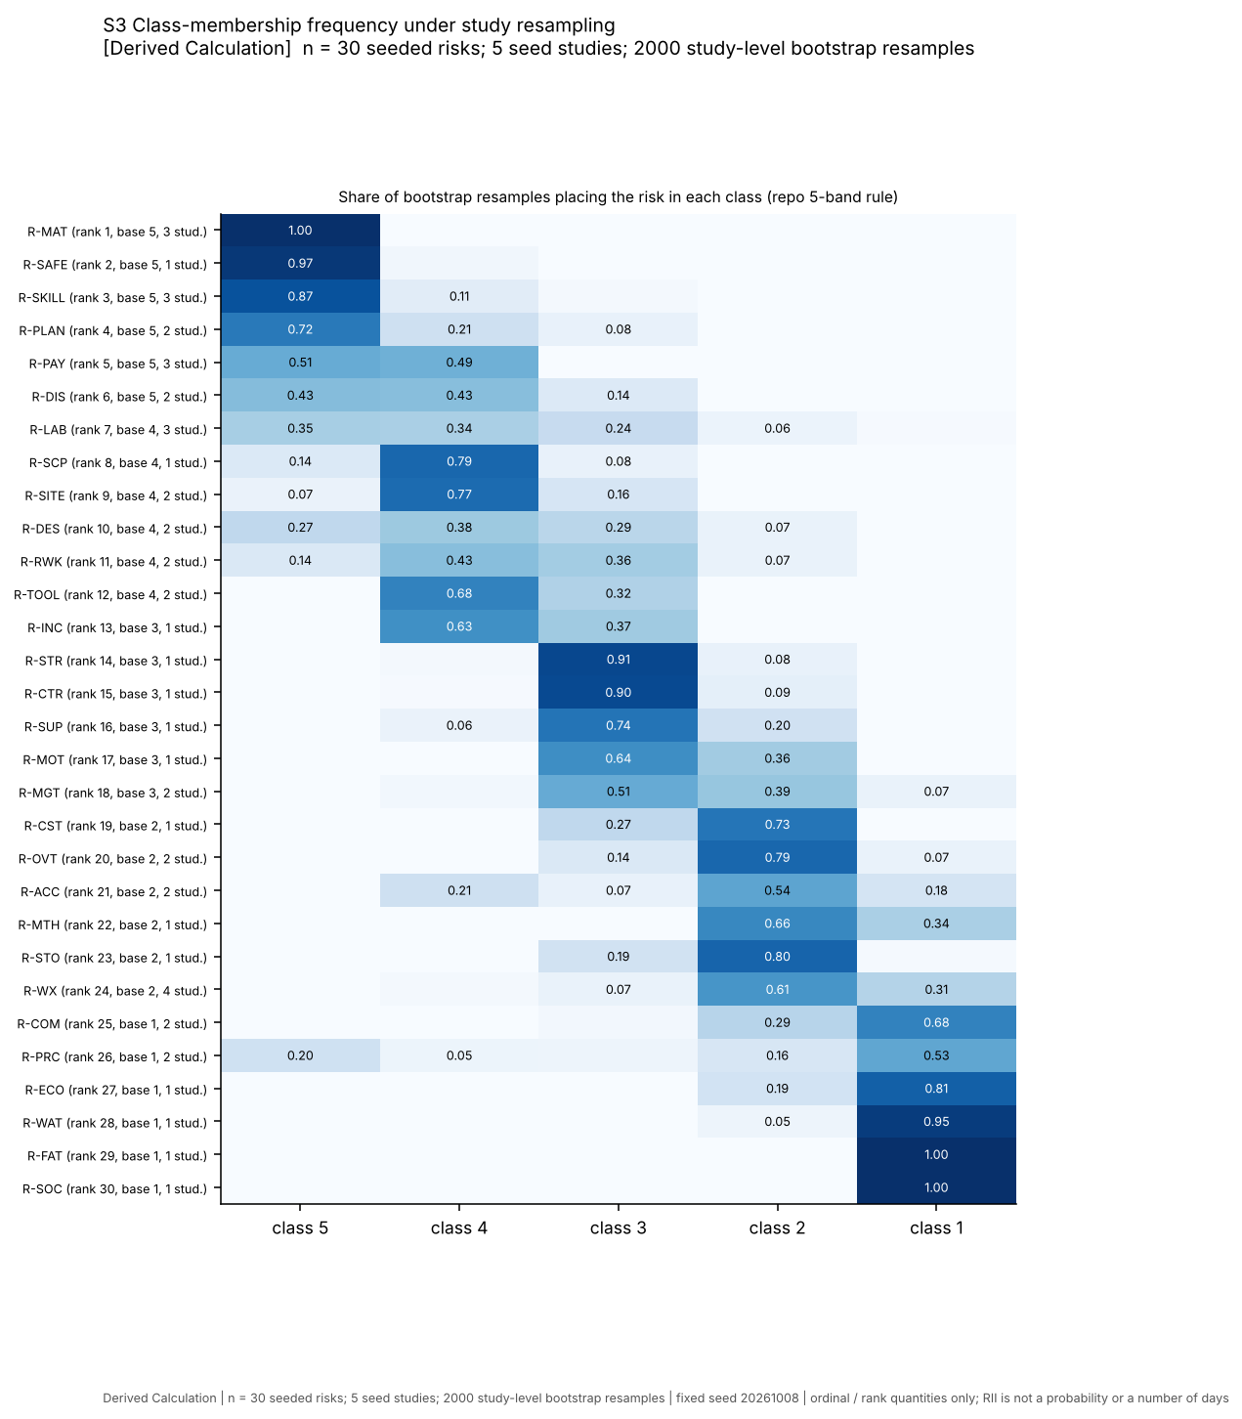
Figure 4.6. Share of resamples placing each risk in each class (Derived Calculation from Literature values; n = 30 seeded risks; 5 seed studies; 2000 study-level bootstrap resamples).
Reading the table: R-MAT is in class 5 in 99.7% of resamples where present and in rank 1 to 4 in 95% of them, and rests on three studies. R-SAFE is class 5 in 96.8% of resamples but is present in only about 67% of them, because it rests on M01 alone. R-LAB, class 4 at rank 7, is class 5 in 34.5% of resamples, class 4 in 33.9% and ranges over ranks 1 to 19. R-PRC (two studies, 0.55 in A02 and 0.789 in A14) is class 5 in 20% of resamples and class 1 in 53%.
Because five clusters are too few for a reliable percentile interval, the exact leave-one-study-out (jackknife) results are given beside it.
Table 4.12. Exact leave-one-study-out rank stability of the seed (Derived Calculation from Literature values; n = 30 risks; five rebuilds)
Seed study dropped | Risks still seeded | Spearman vs full seed order | Kendall tau | Risks changing class (of 30)
A02 | 27 | 0.78 | 0.77 | 13
A14 | 30 | 0.97 | 0.91 | 2
A15 | 30 | 0.99 | 0.96 | 3
M01 | 25 | 0.95 | 0.84 | 9
M06 | 24 | 0.96 | 0.87 | 6
Source: analysis/out/s3_leave_one_study_out_rank_stability.csv.
Applying the tier rule of Section 3.8 (class 5 or class 1 to 2 in at least 80% of present resamples, and at least two seed studies) gives Table 4.13, which lists the risks that are not “unresolved”.
Table 4.13. Tier assignments under the 80% rule, risks that meet a threshold (Derived Calculation from Literature values; n = 30 risks, 2000 resamples; the rule is an Assumption)
Risk | Base rank | Seed studies (n) | Present in resamples | P(class 5), when present | P(class 1-2), when present | Tier by rule
R-MAT | 1 | 3 | 0.993 | 0.997 | 0.000 | Tier 1 (high)
R-SAFE | 2 | 1 | 0.665 | 0.968 | 0.000 | high-class but single study (not assessable)
R-SKILL | 3 | 3 | 0.988 | 0.868 | 0.000 | Tier 1 (high)
R-OVT | 20 | 2 | 0.912 | 0.000 | 0.856 | Tier lower
R-MTH | 22 | 1 | 0.665 | 0.000 | 1.000 | low-class but single study (not assessable)
R-STO | 23 | 1 | 0.685 | 0.000 | 0.812 | low-class but single study (not assessable)
R-WX | 24 | 4 | 1.000 | 0.000 | 0.916 | Tier lower
R-COM | 25 | 2 | 0.932 | 0.000 | 0.976 | Tier lower
R-ECO | 27 | 1 | 0.668 | 0.000 | 1.000 | low-class but single study (not assessable)
R-WAT | 28 | 1 | 0.685 | 0.000 | 1.000 | low-class but single study (not assessable)
R-FAT | 29 | 1 | 0.685 | 0.000 | 1.000 | low-class but single study (not assessable)
R-SOC | 30 | 1 | 0.668 | 0.000 | 1.000 | low-class but single study (not assessable)
Source: ch34_build.py applied to s3_bootstrap_tier_membership.csv.
Only two risks, R-MAT and R-SKILL, meet the rule for the top tier with at least two studies. R-SAFE meets the 80% threshold but rests on one study and so cannot be assessed. Three risks (R-OVT, R-WX, R-COM) meet the rule for the lower tier, and six single-study risks (R-MTH, R-STO, R-ECO, R-WAT, R-FAT, R-SOC) are low but not assessable. The remaining 18 are unresolved. Two cautions apply to the lower tier. R-WX is in class 1 or 2 in 92% of resamples, yet its four seed studies range from 0.653 to 0.764 (M01 ranks “weather conditions” 8th of 28 printed items, A14 30th, M06 37th). The tier states where the mean of the studies falls in the order of the 30 risks, not that weather is unimportant, and the earlier claim that weather is rated lower than the rest was withdrawn (Audit Corrections, F09). Second, the rule ignores mapping uncertainty and scale differences, so it understates uncertainty.
The data therefore support, at most, coarse tiers: two risks in a high tier, a few in a low tier, and an unresolved middle in which the order is not determined by these studies.

4.8 Non-circular inter-study agreement (S4)
S4 compares studies without letting a study into the reference it is compared with. For a seed study X the reference is the seed built from the other four seed studies; for a held-out study it is the full five-study seed. A correlation needs at least five shared risks to be tested at all.
Coverage. Little overlap exists (analysis/out/s4_study_coverage.csv). Of 55 study pairs, 13 share five or more risks; the other 42 share four or fewer (13 pairs share none, 15 share one, 9 share two, 2 share three, 3 share four). The studies contribute these numbers of risks with a direct mapping (items in brackets): M01 18 (25), A02 13 (13), M06 15 (20), A14 4 (4), A15 2 (4), M10 23 (27), M15 13 (18), M14 15 (18), A10 2 (3), A21 2 (2) and HAS25 1 (1).
Pairwise agreement. Table 4.14 gives the 13 testable pairs with n, rho, the two-sided permutation p and the Holm-adjusted p over the 13 tests.
Table 4.14. Spearman agreement between studies on shared risks, pairs with n >= 5 (Derived Calculation from Literature values; n = 5 to 15 shared risks per pair; 13 tests; exact p for n <= 8, otherwise 20,000 permutations)
Pair | Roles | n shared risks | Spearman rho | Two-sided p | p method | Holm p (13 tests)
M01 - A02 | seed / seed | 7 | 0.32 | 0.482 | exact | 1.000
M01 - M06 | seed / seed | 7 | 0.11 | 0.840 | exact | 1.000
M01 - M10 | seed / held-out | 15 | 0.25 | 0.383 | 20000 permutations | 1.000
M01 - M15 | seed / held-out | 10 | 0.15 | 0.679 | 20000 permutations | 1.000
M01 - M14 | seed / held-out | 11 | -0.16 | 0.634 | 20000 permutations | 1.000
A02 - M10 | seed / held-out | 10 | 0.62 | 0.063 | 20000 permutations | 0.694
A02 - M15 | seed / held-out | 5 | 0.70 | 0.233 | exact | 1.000
A02 - M14 | seed / held-out | 7 | -0.18 | 0.713 | exact | 1.000
M06 - M10 | seed / held-out | 8 | 0.29 | 0.501 | exact | 1.000
M06 - M15 | seed / held-out | 6 | 0.89 | 0.033 | exact | 0.400
M10 - M15 | held-out / held-out | 9 | 0.77 | 0.021 | 20000 permutations | 0.270
M10 - M14 | held-out / held-out | 13 | 0.45 | 0.129 | 20000 permutations | 1.000
M15 - M14 | held-out / held-out | 6 | -0.43 | 0.419 | exact | 1.000
Source: analysis/out/s4_pairwise_spearman.csv. Values within +-0.003 for permutation p.
The median rho over the 13 tested pairs is 0.29 (range -0.43 to 0.89). Only two pairs have a raw p below 0.05, M10 with M15 (rho 0.77, n = 9, p = 0.021) and M06 with M15 (rho 0.89, n = 6, p = 0.033); after Holm the smallest adjusted p is 0.270 and none is significant. The two seed-seed pairs that can be tested are weak: M01 with A02 0.32 (n = 7) and M01 with M06 0.11 (n = 7). Of the untestable seed pairs, A02 with M06 and A02 with A14 show 0.74 and 0.60 on four shared risks each, which a test could not distinguish from chance, and M01 with A14 shows -0.50 on three. The M15-M14 pair is negative (-0.43, n = 6), consistent with the manager-versus-worker explanation that has been offered post hoc, which this data set cannot test.
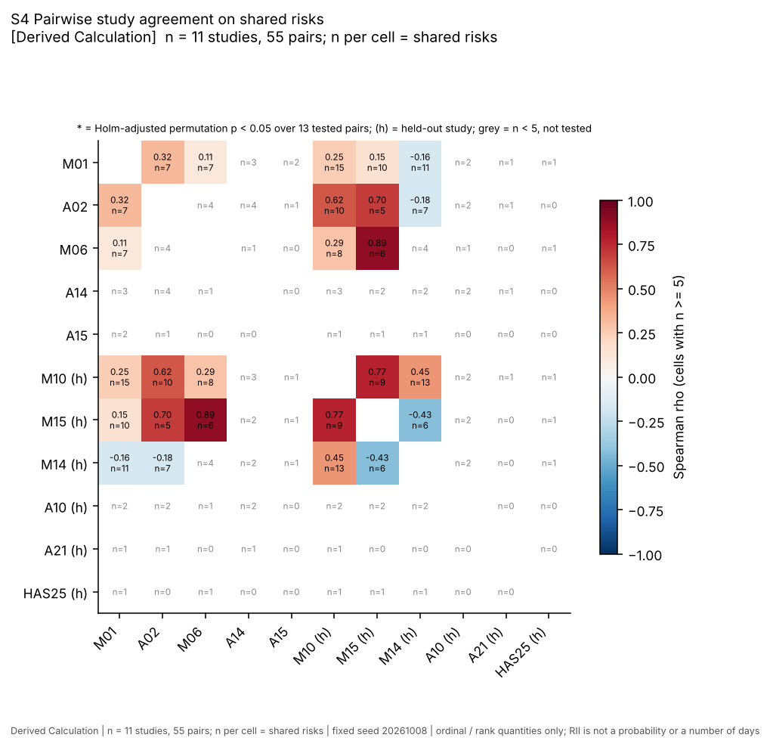
Figure 4.7. Pairwise Spearman agreement (cell text: rho and number of shared risks; grey = n below 5, not tested) (Derived Calculation from Literature values; n = 11 studies, 55 pairs; 13 tested).
Study against a seed built without it. Table 4.15 compares each study with a seed that does not contain it. The last two columns show what would have been reported had the study been left inside its own seed (circular): 0.54, 0.91 and 0.87 for M01, A02 and M06, against 0.09, 0.37 and 0.64 without them. The inflation is why the earlier “leave-one-study-out” figures of 0.78 to 0.99 were withdrawn.
Table 4.15. Agreement of each study with a seed built without it (Derived Calculation from Literature values; n = 1 to 19 shared risks per study; 6 tests in the Holm family)
Study X | Role | n shared risks (X vs seed built from the other 4) | Spearman rho | Two-sided p | Holm p | n (circular) | rho if X is inside its own seed (circular, shown only as a warning)
M01 | seed | 13 | 0.09 | 0.765 | 1.000 | 18 | 0.54
A02 | seed | 10 | 0.37 | 0.290 | 0.959 | 13 | 0.91
M06 | seed | 9 | 0.64 | 0.066 | 0.329 | 15 | 0.87
A14 | seed | 4 | 0.60 | not tested | - | 4 | 0.60
A15 | seed | 2 |  | not tested | - | 2 | -
M10 | held-out | 19 | 0.28 | 0.240 | 0.959 | 19 | -
M15 | held-out | 11 | 0.63 | 0.045 | 0.267 | 11 | -
M14 | held-out | 13 | -0.18 | 0.549 | 1.000 | 13 | -
A10 | held-out | 2 |  | not tested | - | 2 | -
A21 | held-out | 1 |  | not tested | - | 1 | -
HAS25 | held-out | 1 |  | not tested | - | 1 | -
Source: analysis/out/s4_leave_one_study_out.csv. For held-out studies the reference is the five-study seed, which does not contain them, so there is no circular column.
None of the six testable comparisons is significant after Holm correction over the six (smallest adjusted p 0.267, M15). M15’s raw permutation p is 0.045 (the t-approximation in earlier documents gave 0.039); M06 is 0.066. Restricting the family to the three held-out studies, as the handoff did, the adjusted values computed from the printed raw p-values are 0.134 (M15), 0.479 (M10) and 0.549 (M14), still none below 0.05. A15 (n = 2), A10 (2), A21 (1) and HAS25 (1) share too few risks to test. The agreement of the three held-out surveys with the seed is therefore rho 0.28, 0.63 and -0.18: weak, low-powered and inconclusive. M14 is negative, and its basis, W/(5N), is not comparable in level with the others.
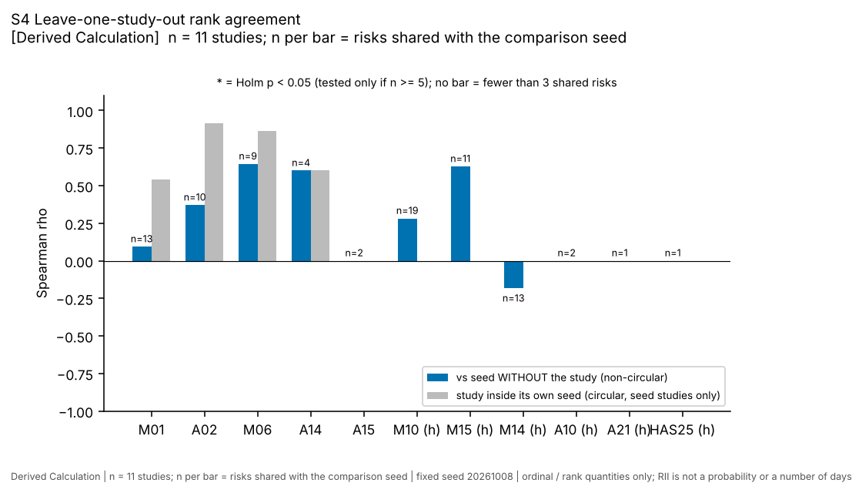
Figure 4.8. Agreement with the seed built without the study (blue) and the circular value (grey) (Derived Calculation from Literature values; n = 11 studies; the n above each bar is the number of shared risks).
Detectable agreement. With 5 to 19 shared risks only large correlations could have been detected. The smallest absolute rho that reaches a two-sided permutation p of 0.05 is 0.52 at n = 15, 0.57 at 13, 0.62 at 11, 0.65 at 10, 0.70 at 9, 0.74 at 8, 0.79 at 7, 0.89 at 6 and only a perfect 1.00 at 5, and 0.46 at 19 (Table 3.8). Most overlaps in Table 4.14 are at or below 10, so only a rho of about 0.65 or more could have been called significant for a typical pair. The check is low-powered, and a non-significant result is neither evidence for nor against agreement.
Kendall W. Table 4.16 gives W for every complete block of at least three studies and at least five risks, 14 blocks in all.
Table 4.16. Kendall W over complete study-by-risk blocks (Derived Calculation from Literature values; m = 3 or 4 studies, n = 5 to 10 risks per block; 14 blocks; one-sided permutation p, 20,000 permutations; Holm over the 14 blocks, descriptive because blocks overlap)
Studies (m) | Complete risks (n) | Kendall W | Permutation p | Holm p (14 blocks)
M01 M10 M14 | 10 | 0.488 | 0.126 | 1.000
M01 M10 M15 | 9 | 0.539 | 0.079 | 0.871
A02 M10 M14 | 7 | 0.429 | 0.278 | 1.000
M01 A02 M10 | 7 | 0.733 | 0.010 | 0.122
M01 M06 M10 | 6 | 0.467 | 0.231 | 1.000
M01 M15 M14 | 6 | 0.289 | 0.571 | 1.000
M10 M15 M14 | 6 | 0.441 | 0.275 | 1.000
A02 M10 M15 | 5 | 0.889 | 0.004 | 0.059
M01 A02 M14 | 5 | 0.200 | 0.717 | 1.000
M01 A02 M15 | 5 | 0.638 | 0.083 | 0.871
M01 M06 M15 | 5 | 0.467 | 0.252 | 1.000
M01 M10 M15 M14 | 6 | 0.400 | 0.153 | 1.000
M01 A02 M10 M14 | 5 | 0.263 | 0.411 | 1.000
M01 A02 M10 M15 | 5 | 0.699 | 0.009 | 0.112
Source: analysis/out/s4_kendall_w.csv.
The block that the earlier analysis reported, M01, M10, M15 and M14 on six risks, gives W = 0.400 with permutation p = 0.153, the same conclusion as the chi-square p of 0.156: not distinguishable from chance. Two blocks that include A02 and M10 reach raw permutation p of 0.004 (A02, M10, M15; five risks; W = 0.889) and 0.009 (M01, A02, M10, M15; five risks; W = 0.699), but their Holm-adjusted p-values are 0.059 and 0.112, and the highest W values come from the blocks with the fewest risks, where a large W is easiest to obtain by chance and the 14 blocks use the same studies repeatedly. No block is significant after correction. W describes consensus on order among the studies in the block; it is not reliability.
Summary of agreement. The non-circular evidence is: agreement between studies on shared risks is weak (median rho 0.29), the raw p-values below 0.05 (two pairs, M10 with M15 and M06 with M15, and M15 against the seed) do not survive correction, and the held-out comparison is weak and inconclusive. The agreement that the earlier, circular calculations suggested (pooled rank against the seed 0.73; z order against the seed 0.40 and 0.53) does not appear when the seed studies are excluded from the reference: the held-out-only values are 0.08 and 0.09 (Handoff Section 8.3, quoted, not recomputed here).

4.9 RII uncertainty (S5)
S5 compares the spread of RII for the same risk across studies with the gaps between adjacent ranks. The spread is between-study, on unequal scales; it is not the sampling error of any survey.
Table 4.17. Spread of RII across studies, seeded risks with at least two seed studies (Derived Calculation from Literature values; n = 16 risks of 30; RII as printed, scales differ)
Seed rank | Risk | Seed studies | Seed mean RII | Range of seed study means | All studies reporting | Min RII (all) | Max RII (all) | Range (all)
1 | R-MAT | 3 | 0.7889 | 0.0328 | 7 | 0.508 | 0.810 | 0.302
3 | R-SKILL | 3 | 0.7831 | 0.0443 | 6 | 0.523 | 0.803 | 0.280
4 | R-PLAN | 2 | 0.7771 | 0.0278 | 6 | 0.475 | 0.874 | 0.399
5 | R-PAY | 3 | 0.7733 | 0.0047 | 5 | 0.716 | 0.776 | 0.060
6 | R-DIS | 2 | 0.7700 | 0.0400 | 2 | 0.750 | 0.790 | 0.040
7 | R-LAB | 3 | 0.7662 | 0.1015 | 5 | 0.660 | 0.825 | 0.165
9 | R-SITE | 2 | 0.7611 | 0.0201 | 2 | 0.751 | 0.771 | 0.020
10 | R-DES | 2 | 0.7585 | 0.0531 | 4 | 0.693 | 0.785 | 0.093
11 | R-RWK | 2 | 0.7561 | 0.0401 | 4 | 0.736 | 0.776 | 0.040
12 | R-TOOL | 2 | 0.7528 | 0.0145 | 5 | 0.435 | 0.760 | 0.325
18 | R-MGT | 2 | 0.7331 | 0.0482 | 3 | 0.520 | 0.757 | 0.237
20 | R-OVT | 2 | 0.7063 | 0.0374 | 3 | 0.688 | 0.725 | 0.037
21 | R-ACC | 2 | 0.7045 | 0.1090 | 4 | 0.455 | 0.759 | 0.304
24 | R-WX | 4 | 0.6934 | 0.1112 | 8 | 0.475 | 0.764 | 0.289
25 | R-COM | 2 | 0.6793 | 0.0014 | 4 | 0.518 | 0.682 | 0.164
26 | R-PRC | 2 | 0.6695 | 0.2390 | 2 | 0.550 | 0.789 | 0.239
Source: analysis/out/s5_rii_spread_by_risk.csv.
The median gap between adjacent seed ranks is 0.0034. For the 16 risks with two or more seed studies the median range of the study means is 0.040, and 15 of the 16 (94%) have a range larger than the median adjacent gap. The widest seed ranges are R-PRC 0.239 (A02 0.55, A14 0.789), R-WX 0.111 (four studies), R-ACC 0.109, R-LAB 0.101 and R-DES 0.053. Using all 11 studies, the median between-study standard deviation over the 26 risks reported by at least two studies is 0.082. The order inside the middle of the list, where the gaps are thousandths, is therefore finer than the studies disagree with each other.
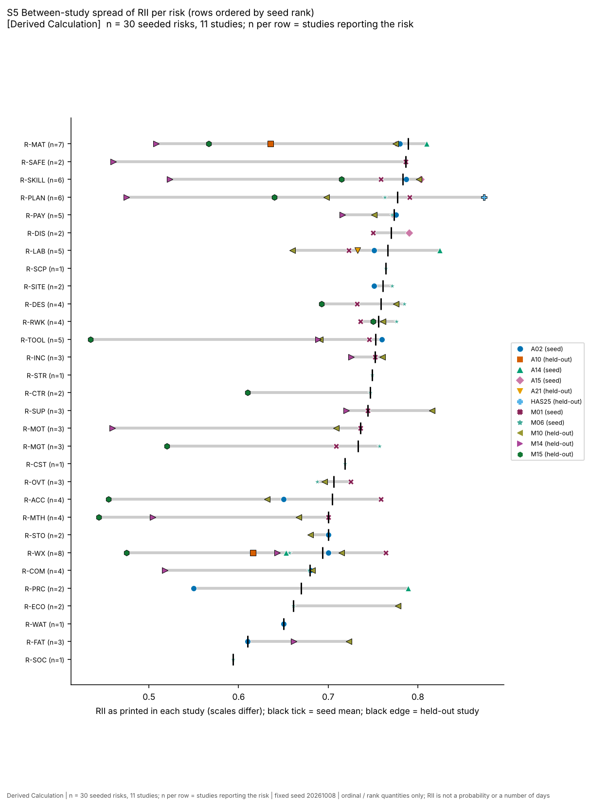
Figure 4.9. RII of each seeded risk in every study that reports it (marker per study, black tick = seed mean; scales differ) (Derived Calculation from Literature values; n = 30 seeded risks, 11 studies).
Sampling error within a study is a separate and smaller component. The audit estimated about 0.03 for one M01 RII from that study’s own counts, and the planning arithmetic of Table 3.7 gives 0.030 at N = 44 for an SD of one Likert point (Assumption). Against a median adjacent gap of 0.0034, that is roughly nine times larger. No standard error was computed for A02 and A15 (no counts or SDs) or for the other studies in this report; a within-study error draw (analysis A5, part ii) was planned but is not implemented in the analysis package, so the tiers above carry between-study uncertainty only.

4.10 Summary of results
Table 4.18. What each analysis shows, in the words the evidence allows (Derived Calculation; n as in each section)
Section | Result | Wording to use
4.2 | 30 seeded risks, 14 on one study, 16 unseeded; top six within 0.019 | the seed is an ordinal starting position
4.3 | 12 Low, 6 Moderate, 0 High, 12 Extreme with the same class on both axes; median 6 of 30 levels change over 969 cut-off triples | level labels of seeded risks are artefacts of the rule and thresholds
4.4 | level driven by p, not by delay; p x0.5 changes 6 of 7 levels | shows the rule’s response, not site behaviour
4.5 | impact edges change 0 levels but up to 7 classes; p edges change up to 7 levels | level labels depend on assumed edges
4.6 | 2 to 24 of 30 classes change across variants; order of means more stable (Spearman 0.78 to 1.00) | the class depends on banding and on which studies are present
4.7 | tau 0.78 under resampling; only R-MAT and R-SKILL are Tier 1 | at most coarse tiers; middle unresolved
4.8 | median pairwise rho 0.29; none significant after Holm; held-out 0.28, 0.63, -0.18; W 0.40, p 0.15 | weak, low-powered, inconclusive
4.9 | between-study range exceeds the adjacent gap for 15 of 16 risks | order inside the middle is finer than the data

4.11 What this analysis does not show
- It does not validate the seed or show that it predicts anything. RII is importance, not probability or days, and no site data were used.
- It does not show that the seed order is wrong. The agreement check is low-powered; a non-significant correlation on 5 to 19 shared risks is compatible with real agreement and with none.
- It does not give independent evidence that the seed is corroborated. The only independent comparisons are the held-out studies (rho 0.28, 0.63, -0.18) and none survives correction.
- It does not show what drives delay in masonry on Indian sites. Ten of the eleven studies are not masonry-specific, the seed studies are general building or construction surveys, and one held-out study (A10) is infrastructure.
- It does not show that the matrix level of any real risk is stable or unstable. S1 and S2 use one illustrative case of seven risks with placeholder numbers; their counts describe that case and are not a sample.
- It does not make the bootstrap tiers confidence statements. Five clusters, uneven coverage (14 risks on one study), mapping uncertainty ignored and scale differences ignored mean the tiers understate uncertainty.
- It does not measure within-study sampling error beyond the M01 estimate; the third source of error, the single-coder mapping, has not been measured.
- It does not support the withdrawn claims: that weather is rated lower than the rest, that studies agree modestly, or that the pooled order agrees with the seed.
- It is a second look at data first examined on ten risks, so it is exploratory; the 38-risk library was defined after the first look.
- The planned expert survey, second-coder check and site data are the next evidence. Until they exist, the seed is a transparent default ordering and nothing more.

Chapter 5. System Design and Implementation
This chapter describes the tool as it exists in the repository on 8 October 2026. Everything stated here can be checked against a file in the repository; where a statement rests on a test, the test is named. Section 5.1 sets out the requirements the design answers, Sections 5.2 to 5.4 the architecture, data model and risk library, Sections 5.5 to 5.7 the rule engine, the register and matrix logic and the literature-tier display, Sections 5.8 and 5.9 the AI evidence layer and the exports, Section 5.10 the interface, Section 5.11 the desktop wrapper and the build, and Section 5.12 the optional decision layer. Chapter 6 reports how the tool was verified.
Two points frame the chapter. First, the tool does not predict delay. It organises delay risks for one activity (brick or block masonry), places them on a probability-impact matrix as an ordinal aid, and keeps every number it shows tied to a Source label. Second, no site data and no expert survey were collected for this project, so every probability, delay, cost and planned duration shown in the screenshots below is an ILLUSTRATIVE placeholder labelled Assumption. The scope change from the original project title is explained in Chapter 1.

5.1 Requirements

5.1.1 How the requirements were obtained
The requirements below were reconstructed from the project’s own design documents (README.md, docs/Project_Handoff_Summary.md, docs/case_schema.md), from the integrity rules the team adopted (Handoff section 3), and from four review passes carried out on 8 October 2026 (engineering and usability, domain, research methods, examiner). They were not elicited from site managers. No requirements interview, site visit or usability session was held, and the requirements therefore express what the team decided the tool should do, not what practitioners asked for. This is a limitation of the work and is repeated in Chapter 6.

5.1.2 Functional requirements
Table 5.1. Functional requirements and where each is implemented. Source: repository files named in the last column.
ID | Requirement | Implemented in
FR1 | Describe one masonry activity: project details, activity name, planned duration in working days with a Source | gui/static/js/screens/case.js; app/service.py (parse_case)
FR2 | Accept site facts (Yes / No / Unknown, or a number) and evaluate rules on them; a missing fact must never be guessed | app/engine/rules.py; gui/static/js/screens/rules.js
FR3 | Offer a curated library of masonry delay risks, each with the evidence record IDs that show the risk exists | data/risk_library_masonry.json; register screen side panel
FR4 | Keep a risk register: probability and a delay range per risk, each with a Source, plus status and text-only owner, early-warning sign, response type, action and review date | app/service.py; gui/static/js/screens/risks.js
FR5 | Place risks that have entered numbers on a 5 x 5 probability-impact matrix and state the level | app/engine/matrix.py; gui/static/js/screens/matrix.js
FR6 | Place risks without entered numbers at a labelled literature tier, never as a probability | app/literature_seed.py; app/service.py (run_case)
FR7 | Search a cited evidence corpus and show the record behind each citation | app/ai_layer/evidence.py, corpus.py; evidence screen
FR8 | Propose candidate risks from the corpus (offline retrieval, optionally an LLM) without any number coming from the model | app/ai_layer/guard.py; gui/api.py (/api/suggest-risks)
FR9 | Export the register and matrix as register.md, register.csv, report.html, matrix.svg, matrix.png, and save and reopen the case as JSON | app/reporting/*; gui/api.py
FR10 | Reject wrong input with a plain message and keep the last valid result on screen | app/service.py; gui/static/js/problems.js
FR11 | Optional: compare responses by simulated schedule and cost using only user-entered numbers | app/analysis.py, app/engine/*
FR12 | Run offline on a site laptop, as a browser page or a desktop window, with a Windows build | gui/__main__.py, gui/qt_app.py, .github/workflows/build-exe.yml

5.1.3 Non-functional requirements and integrity constraints
Table 5.2. Non-functional requirements and constraints. Source: docs/Project_Handoff_Summary.md sections 3 and 9; gui/README_GUI.md. RG-n refers to the relevance guard test test_gn_* in tests/test_relevance_guard.py (Section 6.3).
ID | Requirement | How it is met
NFR1 | Every number carries a Source label (Literature, Historical Data, User Input, Expert Judgment, Derived Calculation, Assumption) | Source enumeration in app/engine/models.py; a number without a Source is a problem; guard test RG-5 checks that every number in the exports has its Source
NFR2 | A survey importance index (RII) is never presented as a probability or as days | literature tier labelled Assumption; excluded from level totals; no p or delay shown for it
NFR3 | AI never supplies a probability, delay, cost or effect size | guard rules G2, G7, G9 (Section 5.8); guard test RG-10
NFR4 | Deterministic and reproducible: same case, same output | determinism checked in the QA run (Section 6.7); Monte Carlo uses a fixed seed
NFR5 | Offline for the core path; nothing leaves the machine unless the user adds an AI key | server binds 127.0.0.1 only; host-header check; key stored outside the project folder
NFR6 | Calm failure: no stack trace to the user, no silent defaults | CaseError problems list; JSON error handlers in gui/api.py
NFR7 | Readable at 1280 px and 800 px, light and dark theme, no horizontal page scroll | checked by screenshots on 8 October 2026 (Handoff section 9, item 7)
NFR8 | Wording stays within what the work supports (no “validated”, “predicts”, “optimal”) | guard tests RG-4 and the analysis test on optimality wording

5.2 Architecture

5.2.1 Layers
The tool is a single Python package with a small local web interface. Figure 5.1 shows the layers. The interface (HTML, CSS and JavaScript in gui/static) is served by a Flask application (gui/api.py) bound to 127.0.0.1. The interface holds the case in the browser, and on every edit it posts the case to the server, which returns the register and the matrix. The interface computes nothing of its own: the service function app.service.run_case produces every figure on screen (gui/README_GUI.md).
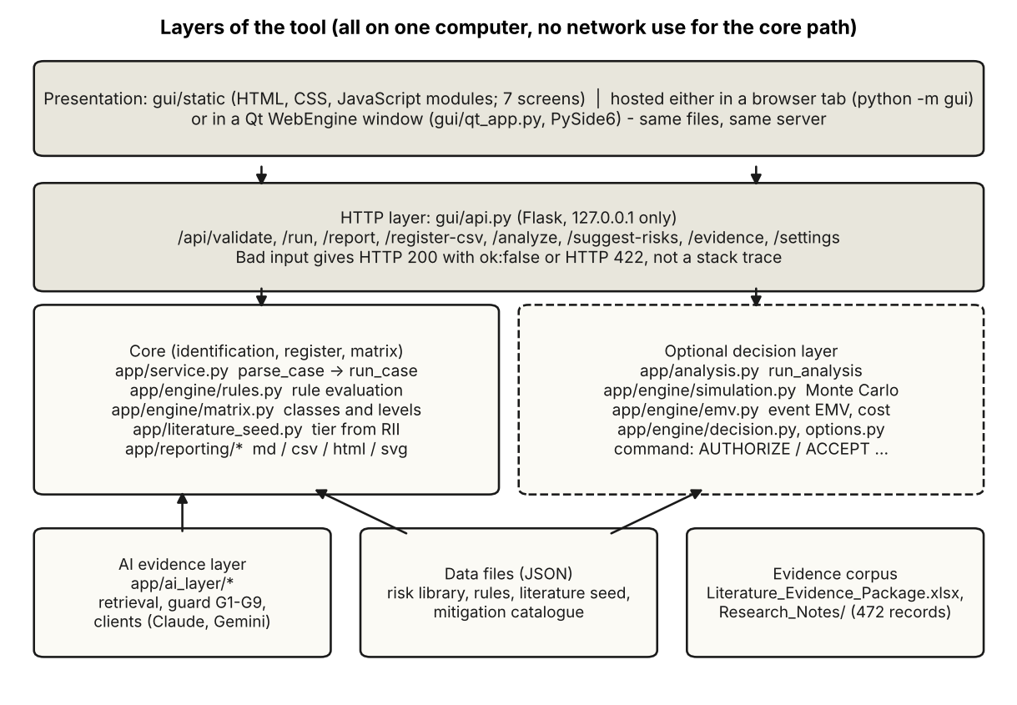
Figure 5.1. Layers of the tool. Dashed box: optional decision layer. Drawn by report/scripts/make_ch5_diagrams.py from the module structure of the repository.
This arrangement was chosen so that the same code is exercised by the command-line tool (python -m app.cli), the browser version, the desktop window and the tests. It keeps the engine testable without a browser and the interface free of numeric logic that could disagree with the engine.
Table 5.3. Size of the code base, counted with wc -l on 8 October 2026 over .py, .js, .css and .html files (pycache excluded). Source: command run for this report.
Part | Lines
app/ (engine, service, AI layer, reporting, decision layer, legacy productivity models) | 5,060
of which app/productivity/ (legacy, not used by the interface) | 420
gui/ Python (server, entry point, Qt wrapper) | 761
gui/static/ (interface: HTML, CSS, JavaScript) | 3,928
tests/ | 3,297
Line counts say nothing about quality; they are given so the reader can judge the size of what was verified.

5.2.2 Data flow of one edit
Figure 5.2 follows one edit through the service. parse_case checks types and the presence of a Source on every number and builds a list of problems. If there are problems, the run stops and the interface keeps the last valid result on screen, marked as stale. Otherwise the rule engine evaluates the site facts, the matrix classifies every risk that has entered numbers, and the literature seed places the remaining library risks that have a seed value. The result object carries the register rows, the matrix rows, the summary counts, the matrix settings with their Source, the rule outcomes, the warnings, and the rendered Markdown and SVG.
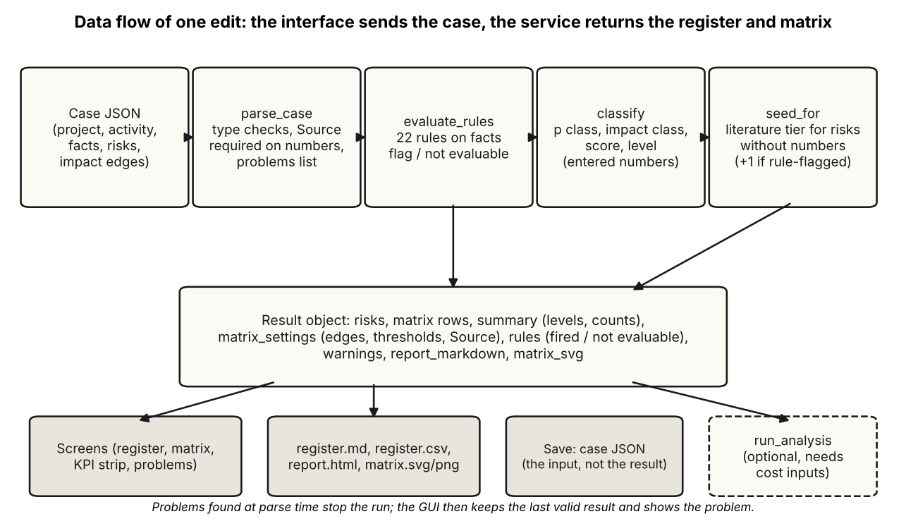
Figure 5.2. Data flow of run_case (app/service.py). Dashed box: the optional decision layer takes the same case plus cost inputs.

5.2.3 Module map
Table 5.4. Main modules. Source: repository tree.
Module | Role
app/service.py | Parsing and validation of the case, run_case, example and template cases, evidence lookup, suggestion entry point
app/engine/models.py | Source, Param, DelayDist (PERT, triangular, uniform, fixed), Risk, Mitigation, CostModel
app/engine/rules.py | Rule objects, typed evaluation, rule-base consistency check, priority and conflict resolution
app/engine/matrix.py | Probability class, impact class, score and level
app/literature_seed.py | Literature tier from the seed file
app/ai_layer/ | Evidence store, retrieval, guard, LLM clients, settings store
app/reporting/ | register.md, register.csv, report.html, matrix.svg writers
app/analysis.py, app/engine/{simulation,emv,decision,options}.py | Optional decision layer
gui/api.py, gui/__main__.py, gui/qt_app.py | Local server, entry points, desktop wrapper
data/*.json | Risk library, rules, literature seed, mitigation catalogue
app/productivity/, data/productivity_models.json, data/india_labour_norms.json | Earlier labour-productivity models; out of scope, not used by the interface (guard test RG-6)
The productivity models belong to the original project scope. They remain in the repository because their removal needs a supervisor decision (Handoff section 9), and a guard test confirms that neither the live application nor the interface loads them.

5.3 Data model: the case file
A case is one JSON object (docs/case_schema.md). It is the only input to the engine, and it is what the interface saves and opens. Every numeric input other than a plain count is an object {"value", "source", "evidence_ids", "note"}, and time is in working days.
Table 5.5. Blocks of the case file. Source: docs/case_schema.md; app/service.py (template_case).
Block | Content | Notes
project | name, location, construction type, notes | descriptive only
activity | id, name, planned_duration_days {value, source}; optional deadline_days | impact class is measured against the planned duration
facts | key-value pairs: numbers, true/false | inputs to the 22 rules; planned_duration_days is added automatically
risks[] | id, name, category, status, p {value, source}, delay {kind, a, m, b, source}, evidence IDs; text-only owner, trigger, response type, action, review date | p is the probability that the risk occurs at least once during the activity; delay is the extra delay in days if it occurs
impact_bin_edges_fraction, impact_bin_edges_source | four ascending fractions of the planned duration, with a Source | user input, no default
use_literature_seed, seed_basis | switch for the literature tier; seed (default) or all | all also uses held-out studies, so no held-out comparison applies to it
cost, mitigations[], options[], constraints, simulation | optional decision layer | Section 5.12
Three design choices in the data model are worth stating.
- Source is part of the number. A probability without a Source is rejected as a problem rather than defaulted, and a delay distribution carries its own Source. The six values of Source are those listed in the project’s integrity rules.
- Delay is conditional. The delay is the extra delay in working days given that the risk occurs, and p is the probability of occurrence during the activity. This is the same Bernoulli-times-delay structure used for risk events in the schedule-risk literature recorded in the research notes (for example the Beta-PERT times Bernoulli construction of Prins et al., 2022, a preprint that was not peer reviewed). The structure is a modelling choice of this tool, stated as such.
- Wrong is not the same as missing. A value that is present but invalid (p outside 0 to 1, minimum above maximum, a number with no Source, a boolean or non-finite value where a number is needed) is a problem and the register keeps its last valid state. A value that is simply not entered leaves the risk in the register without a placement or with a literature tier.
A blank template is produced by python -m app.cli template and the ILLUSTRATIVE example by python -m app.cli example. The example has seven risks; Section 5.10 shows it in the interface and Chapter 6 recomputes it by hand.

5.4 The risk library
The library (data/risk_library_masonry.json) holds 46 risks. Thirty-eight were built on 7 October 2026 from the factors transcribed from the eleven studies of the literature seed, and eight were added on 8 October 2026 after the domain review (R-FRONT, R-VT, R-MORT, R-GPAY, R-OPEN, R-SCAF, R-FEST, R-HEAT). Each entry has an identifier, a name, a category, a description, the evidence IDs that show the risk exists, an evidence note, and a scope (activity for 38, project for 8). Entries without a survey value carry a seed_status note.
Table 5.6. Library risks by category and by whether the literature seed has a value for them. Generated from the data by report/scripts/gen_ch5_tables.py. Source: data/risk_library_masonry.json, data/literature_seed.json (seed studies, direct mappings).
Category | Risks | With seed value | Without
Labour | 13 | 9 | 4
Management | 6 | 4 | 2
Material | 6 | 4 | 2
Design | 4 | 3 | 1
Equipment | 3 | 1 | 2
External | 3 | 2 | 1
Financial | 3 | 2 | 1
Quality | 2 | 1 | 1
Safety | 2 | 2 | 0
Site | 2 | 1 | 1
Weather | 2 | 1 | 1
Total | 46 | 30 | 16
The evidence IDs on a library entry support only the statement that the risk exists in published studies. They do not support a probability. The evidence note of R-MAT, for instance, records that M01 reports material shortage at RII 0.777 and that survey rankings show importance, not probability.
Sixteen library risks have no survey value in the seed studies. They are listed in Table 5.7. Eight were in the original 38 and have no matching survey item; eight were added later and are written in site language from the domain review. For the eight added risks the masonry-specific form of the risk is labelled Expert Judgment in the library and is to be confirmed by the expert survey, which has not been run.
Table 5.7. The 16 library risks without a seed value, with the rules that flag them. Generated by report/scripts/gen_ch5_tables.py. Source: data/risk_library_masonry.json, data/rules_masonry.json.
Risk | Name | Category | Scope | Added 2026-10-08 | Rules that flag it
R-TRN | Inadequate training of workers | Labour | activity | no | none
R-PRD | Low labour productivity | Labour | activity | no | none
R-SUB | Subcontracting and contract-type problems | Management | activity | no | none
R-CLI | Client decision delay or pressure | Management | project | no | none
R-QLT | Inspection and quality-approval delays | Quality | activity | no | none
R-DEF | Defective or poor-quality material | Material | activity | no | none
R-GOV | Government policies or approvals | External | project | no | none
R-FIN | Contractor financial difficulties | Financial | project | no | none
R-FRONT | Work front not released (slab not de-shuttered, props or debris in place, frame not handed over) | Site | activity | yes | RL-FRONT
R-VT | Hoist or material lift unavailable or broken (bricks and mortar to upper floors) | Equipment | activity | yes | RL-VT
R-MORT | Mortar materials short or poor (cement, sand, or mixer down) | Material | activity | yes | RL-MORT
R-GPAY | Gang wages or labour-contractor running bill overdue | Labour | activity | yes | RL-GPAY
R-OPEN | Openings, lintels, door/window frames and MEP sleeves not coordinated | Design | activity | yes | RL-OPEN
R-SCAF | Scaffolding not available, not erected or not passed safe | Equipment | activity | yes | RL-SCAF
R-FEST | Festival, harvest or election season exodus of the migrant gang | Labour | activity | yes | RL-FEST, RL-FEST2
R-HEAT | Peak-summer heat cuts effective working hours | Weather | activity | yes | RL-HEAT
Two limits follow from the table. Only 18 of the 46 library risks have any rule: the 10 original rule targets plus the 8 added risks. The other 28 enter the register by choice from the library, from an AI suggestion, or as custom risks. And the library is built from general building-construction surveys, with masonry-specific evidence mainly from M01 and A02, so it should not be read as a census of masonry delay causes on Indian sites. The risk of over-reading it is discussed in Chapter 7.

5.5 The rule engine

5.5.1 Purpose and constraints
The rule engine turns declared site facts into qualitative flags. A rule states a logical condition over facts, for example required workers exceed available workers. A rule flags one library risk as elevated or normal (relevant only). The module’s design constraints (app/engine/rules.py) are the following.
- A rule carries no probability and no numeric threshold invented by the software. Where a number appears, it is a fact the user enters (stock days, lead time) or the planned duration.
- A flag never produces a probability or a delay for a risk with entered numbers.
- A fact that is missing, or that has the wrong type for the rule, makes the rule “not evaluable”. It is reported as such and never guessed.
- Every rule has an identifier, a Source, evidence IDs, a rationale and a confidence, and the rule base is checked for consistency before use.

5.5.2 Evaluation
A rule has a list of all_of conditions and an optional list of any_of conditions. Each condition compares a fact with a literal or with another fact, using one of lt, le, gt, ge, eq, ne, in. The rule fires when every all_of condition is true and, if any_of is present, at least one any_of condition is true.
Typing is strict. Numeric comparisons need finite real numbers, and equality tests need the fact to have the same type as the value it is compared with. A string such as “10” or “yes” is not coerced. A rule is “not evaluable” if a needed fact is missing or has the wrong type and no other condition of the rule is already false.
When several rules fire on the same risk, the highest priority wins. If rules of equal priority disagree on the level, the outcome is reported as conflict. The rule base itself is checked for duplicate IDs, unknown facts, unknown levels, missing conditions, literature-sourced rules without evidence IDs, and identical conditions with contradictory levels (check_rule_base). Guard test RG-8 asserts that no pair of rules on one risk can give an equal-priority conflict.

5.5.3 The 22 rules
Table 5.8. The 22 site-fact rules. Generated from data/rules_masonry.json by report/scripts/gen_ch5_tables.py; the “condition in words” is the rule’s own description field. Level elevated marks the risk as elevated; normal marks it as relevant only. Pri. is the priority used when several rules fire on one risk. Source: data/rules_masonry.json.
Rule | Condition (in words) | Formal condition | Risk flagged | Level | Pri. | Source | Conf.
RL-LAB | Required workers exceed workers available | required_workers > available_workers | R-LAB | elevated | 0 | Assumption | Moderate
RL-MAT | Stock on site runs out before a new delivery can arrive (for the material with the longest lead time) | material_stock_days <= material_lead_time_days | R-MAT | elevated | 1 | Assumption | Moderate
RL-MAT2 | Stock on site covers fewer days than the planned duration | material_stock_days < planned_duration_days | R-MAT | normal | 0 | Assumption | Low
RL-TOOL | Tools or equipment shortage expected | tools_shortage = true | R-TOOL | elevated | 0 | Assumption | Low
RL-WX | Activity period overlaps the monsoon / rainy season | monsoon_overlap = true | R-WX | normal | 0 | Assumption | Moderate
RL-HGT | Masonry is done at height and scaffolding is not ready | work_at_height = true AND scaffolding_ready = false | R-SAFE | elevated | 0 | Assumption | Low
RL-PAY | Payment delays occurred previously or are expected | payment_delay_expected = true | R-PAY | elevated | 0 | Assumption | Low
RL-DES | Drawings or details are incomplete | design_incomplete = true | R-DES | elevated | 0 | Assumption | Low
RL-RWK | Rework was frequent in earlier work on this site or crew | prior_rework_history = true | R-RWK | elevated | 0 | Assumption | Low
RL-PLAN | Planner or site engineer judges the programme faster than the gang can achieve | schedule_compressed = true | R-PLAN | elevated | 0 | Assumption | Low
RL-SKILL | Skilled masons are fewer than needed | skilled_masons_short = true | R-SKILL | elevated | 0 | Assumption | Low
RL-WX2 | Monsoon overlaps the activity and external walls are in scope | monsoon_overlap = true AND external_walls_in_scope = true | R-WX | elevated | 1 | Assumption | Low
RL-PACE | Planned daily output is higher than the output achieved last week | planned_daily_output > achieved_daily_output_last_week | R-PLAN | elevated | 0 | Assumption | Low
RL-FRONT | Floors or walls planned for the next 7 days are not de-propped, cleared and handed over | work_front_ready = false | R-FRONT | elevated | 0 | Assumption | Low
RL-VT | Masonry is above the ground floor and no hoist or material lift is available | masonry_floor_level >= 1 AND hoist_available = false | R-VT | elevated | 0 | Assumption | Low
RL-SCAF | Scaffolding is not ready | scaffolding_ready = false | R-SCAF | elevated | 0 | Assumption | Low
RL-MORT | Sand or cement stock runs out before a new delivery can arrive | sand_cement_stock_days <= sand_cement_lead_time_days | R-MORT | elevated | 0 | Assumption | Low
RL-GPAY | The gang’s weekly payment or the labour contractor’s bill is overdue | gang_payment_overdue = true | R-GPAY | elevated | 0 | Assumption | Low
RL-OPEN | Door/window frames, MEP sleeve layout or lintel-level plan is not ready | frames_on_site = false OR mep_sleeve_layout_marked = false OR lintel_level_plan_issued = false | R-OPEN | elevated | 0 | Assumption | Low
RL-FEST | A major festival, harvest or election falls inside the activity window | festival_or_harvest_in_window = true | R-FEST | normal | 0 | Assumption | Low
RL-FEST2 | A festival, harvest or election falls inside the window and the gang is mostly migrant | festival_or_harvest_in_window = true AND gang_mostly_migrant = true | R-FEST | elevated | 1 | Assumption | Low
RL-HEAT | The activity overlaps peak summer | summer_overlap = true | R-HEAT | normal | 0 | Assumption | Low
All 22 rules carry the Source label Assumption, 19 have confidence Low and 3 Moderate (RL-LAB, RL-MAT, RL-WX). The reason is that each rule states a logical condition that the team judged relevant, with evidence IDs showing that the risk exists. None of the rules is an empirical finding about how much a condition raises delay. The rationale text of each rule says this, and the interface shows the Source and the confidence beside each rule. Twenty-nine distinct fact names are used by the rules, one of which (the planned duration) is supplied automatically.
Several rules were changed after the review of 8 October 2026 (Audit_Corrections section 6). RL-MAT now compares stock days with lead time with a tie counted as a stock-out; RL-MAT2, RL-WX, RL-FEST and RL-HEAT are normal only, so that merely overlapping the monsoon does not mark weather as elevated; RL-HGT needs scaffolding not ready as well as work at height; and RL-WX2, RL-PACE and nine other rules were added. Priorities were set so that no pair of rules on one risk conflicts.

5.6 Register and matrix logic

5.6.1 The register
The register holds one card per risk. A card shows the name, category, status, the probability and the delay range with their Source badges, evidence chips, the rule flag if any, the matrix cell if any, and the expected delay if the risk occurs. The status is one of literature-supported, expert/user-provided and AI-suggested-unverified. The text-only fields (owner, early-warning trigger, response type, action, review date) follow the register practice described in the risk-response literature in the research notes (avoid, reduce, transfer, accept; Baker et al., 1999; Dey, 2011). They carry no numbers and take no part in any calculation.

5.6.2 Expected delay
For a risk with entered numbers the matrix uses the conditional expected delay E[D], computed in closed form from the entered range (DelayDist.mean):
$$E{\left[D\right]}_{PERT}=\frac{a+λm+b}{λ+2}, λ=4 E{\left[D\right]}_{tri}=\frac{a+m+b}{3} E{\left[D\right]}_{uni}=\frac{a+b}{2} E{\left[D\right]}_{fixed}=m$$
where a, m and b are the minimum, most likely and maximum delay in working days. With the default shape weight λ = 4 the PERT mean is (a + 4m + b)/6, the classical three-point mean (Herrerias-Velasco et al., 2011; Trietsch et al., 2012). The choice of λ = 4 is the conventional default and carries no site calibration. The notes record that no source supplies a masonry-specific value of λ.

5.6.3 Probability class, impact class, score and level
Let T₀ be the planned duration in working days, p the entered probability, and f₁ < f₂ < f₃ < f₄ the four impact bin edges entered by the user as fractions of T₀. The probability class is
$$c_{p}=1+\sum_{k=1}^{4}{1}\left[ p≥e_{k} \right], \left(e_{1},…,e_{4}\right)=\left(0.2, 0.4, 0.6, 0.8\right)$$
and the impact class is
$$r=\frac{E\left[D\right]}{T_{0}}, c_{i}=1+\sum_{k=1}^{4}{1}\left[ r≥f_{k} \right].$$
Both classes run from 1 to 5. The indicator uses lower-edge-inclusive bins: a value exactly on an edge goes to the higher class. “Exactly on an edge” is judged with a relative tolerance of 10⁻⁹, so that 1.2 days on a 12-day activity, which is 0.09999999999999999 in binary floating point, is still the 0.10 edge. The same tolerance applies on both axes (EDGE_REL_TOL in app/engine/matrix.py); it was added to the probability axis after the audit finding M4. The score and the level are
$$s=c_{p}×c_{i}, \text{level}=\left\{\begin{matrix}\text{Low} & s≤5 \\ \text{Moderate} & 6≤s≤10 \\ \text{High} & 11≤s≤15 \\ \text{Extreme} & s≥16\end{matrix}\right.$$
The probability edges and the score thresholds are equal-width choices of the tool. They are not taken from the literature, and every export prints them labelled Assumption. The impact edges have no default: they are the user’s input with a Source, and without them the matrix is not computed for entered numbers. Because the highest score in probability class 1 is 1 × 5 = 5, a risk in probability class 1 is always Low whatever its impact. This is a consequence of the product rule, and the matrix legend states it and marks the two affected cells. Risks in impact class 5 are also listed separately as a high-consequence filter, so that a severe but unlikely risk is not lost in a “Low” cell. The filter is not a score.
The matrix is an ordinal prioritisation aid. The literature on risk matrices (Cox, 2008; Duijm, 2015) warns that matrices have poor resolution, can rank a quantitatively smaller risk above a larger one, and depend on how the bins are drawn. The tool therefore keeps the continuous p and delay in the register next to the class, labels the thresholds as Assumptions, and calls the output “ordinal prioritisation only” on screen and in every export. The sensitivity of the levels to the thresholds and edges was analysed separately (Chapter 4); the matrix does not remove the limits the literature describes.
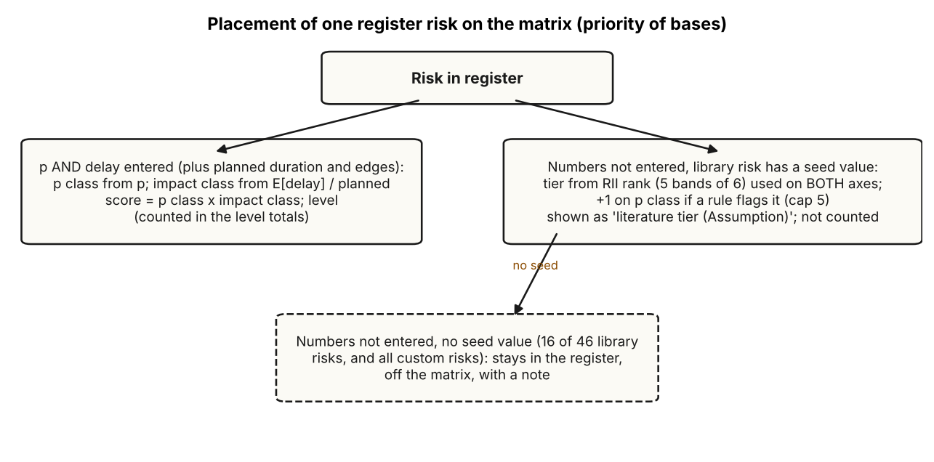
Figure 5.3. Placement of a register risk on the matrix. Drawn by report/scripts/make_ch5_diagrams.py from run_case in app/service.py.

5.7 Literature tier and source labels

5.7.1 What the tier is
A library risk whose probability and delay are not both entered still appears on the matrix if the literature seed has a value for it (30 of the 46 library risks). The placement is computed in app/literature_seed.py. For each risk, the direct-mapped RII values of each seed study are averaged first, so that one study counts once, and the study means are then averaged. The 30 risks are ranked by this mean, rank 1 being the highest, and cut into five equal-count bands of six. For rank ρ among n = 30 seeded risks,
$$\text{tier}=5−\left\lfloor \frac{5 \left(ρ−1\right)}{n}\right\rfloor .$$
The tier is used as both the probability class and the impact class. If a rule flags the risk as elevated, the probability class is raised by one, capped at 5: c_p = min(5, tier + 1). Entering both p and delay replaces the placement.
Both uses of the tier are Assumptions of this tool, and neither is a finding. An RII measures how important respondents rated a factor; it is not a probability and not a number of days. Using one rank on both axes squares it in the score, and the +1 step for a rule flag has no literature source. The seed values themselves match the printed papers (Audit_Corrections, row-level check of all 182 values), but the agreement of the seed with held-out surveys is weak and not statistically significant (Handoff section 8.4, reported in Chapter 4). The seed is therefore an ordinal starting position, to be replaced by expert-survey and site data.

5.7.2 How the tier is displayed
After the committee review of 8 October 2026, a seeded risk is shown differently from a risk with entered numbers, in all outputs.
- The chip on the grid is grey with a dashed outline and the label “literature tier (Assumption)”. The cell colour beneath it is the colour of the cell, not an assessed level for that risk.
- Seeded risks are left out of the level totals (summary.levels, the key-figure strip, and the High, Moderate, Low counts). The strip counts “on matrix (entered numbers)” separately from the seeded count.
- No probability, expected delay or monetary value is displayed or computed for a seeded risk.
- In register.csv the level cell is empty for a seeded row and the tier column holds the text “literature tier (Assumption): tier n”.
- The +1 step is labelled Assumption wherever it applies.
A fuller alternative, showing seeded risks in neutral colour with no level at all and dropping the +1 step, was considered in the review and left to a supervisor decision (Audit_Corrections section 6). The present display is the smaller fallback.

5.7.3 Source labels in the interface
Every numeric field has a Source picker, and the badge (for example ASM for Assumption) is shown beside the value on register cards, in the matrix table and in the exports. Typing a number into an empty field sets the Source to User Input; it never sets Literature automatically. The matrix legend prints the impact edges with their Source and the default probability edges and score thresholds as Assumption. If the impact edges have no Source, the tool gives a warning and the exports print “Source: not given”. A banner on every screen states “ILLUSTRATIVE case: every number is a placeholder, not evidence and not site data” whenever the example is loaded (guard test RG-7 keeps the example labelled in every export).

5.8 AI evidence layer and guard rules

5.8.1 Purpose
The AI layer helps identify candidate risks. It does not estimate anything. The user types an activity and a query; the tool retrieves the best-matching records from the evidence store, sends only those records to a language model, and accepts back candidate risks that name a mechanism and cite record IDs. The layer works without a key in an offline mode that returns matching library risks and evidence records. With a key stored in Settings, either an Anthropic or a Google model can be called; default model identifiers are set in app/ai_layer/clients.py and can be overridden. The Gemini path was checked against the live service during development, and the Anthropic path was not checked because no key was available (gui/README_GUI.md). The key is stored in the user’s application-data folder, outside the project folder, with restricted file permissions, so that zipping the project for submission does not carry it.

5.8.2 Evidence store and retrieval
The store holds the curated records of Literature_Evidence_Package.xlsx and the structured records parsed from Research_Notes/ (app/ai_layer/corpus.py). The running application reports 472 evidence records. Retrieval is lexical, by token overlap, and runs offline. The code comments and the GUI notes state that lexical retrieval is simple and that many harvested records have an abstract only. Retrieval grounding does not by itself prevent unsupported output, which is why the guard follows it.
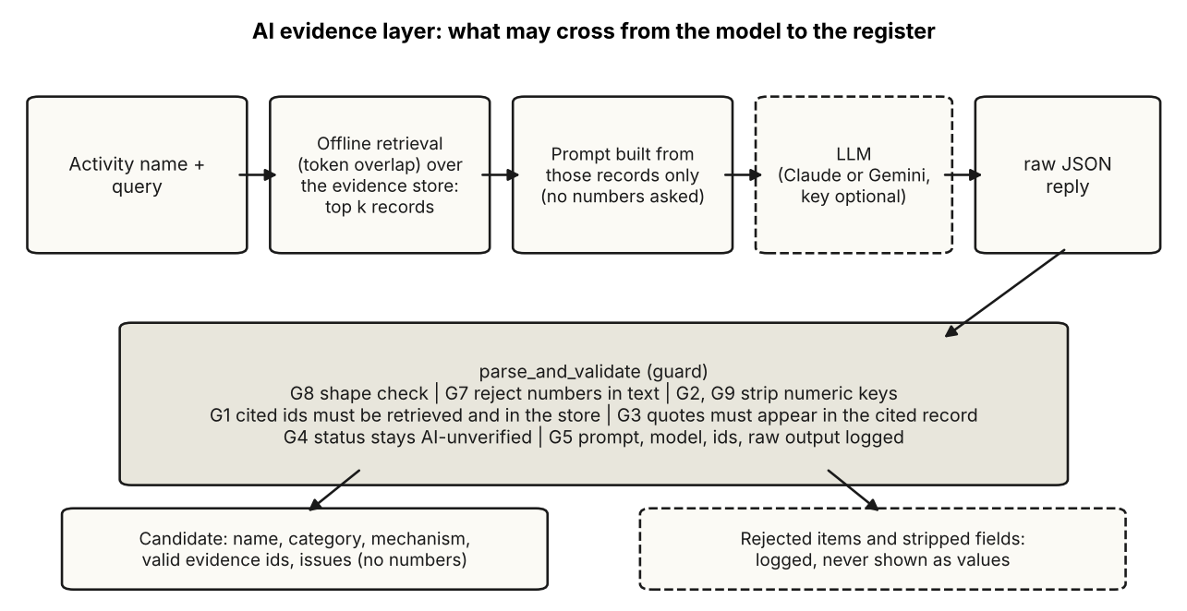
Figure 5.4. Path of an AI suggestion from query to register. Dashed boxes: optional or rejected paths. Drawn from app/ai_layer/guard.py.

5.8.3 Guard rules
The guard (app/ai_layer/guard.py) validates every reply before anything reaches the interface. Table 5.9 lists the rules. Each is enforced in code and exercised in tests/test_ai_guard.py or the relevance guard tests.
Table 5.9. Guard rules G1 to G9 of the AI layer. Source: app/ai_layer/guard.py header and code.
Rule | What it enforces
G1 | Every cited ID must be in the retrieved set and in the store; otherwise it is dropped and the item flagged
G2 | Any numeric field the model returns (probability, delay, cost, effect size and similar listed keys) is stripped and logged as rejected
G3 | A quoted passage must appear in the cited record’s stored text; otherwise the quote is flagged
G4 | Output is always AI-suggested-unverified; only an explicit user confirmation changes the status
G5 | The prompt, model identifier, retrieved IDs and raw output are kept verbatim in an audit log
G6 | Belongs to the explanation module (app/ai_layer/explain.py), which checks numbers in a narrative against the result trace; that module is not exposed by the current interface
G7 | A suggestion whose name, category or mechanism contains a probability, percentage, duration, day count or currency figure is rejected and logged
G8 | Every field is type-checked; one malformed item is dropped and logged and the others survive
G9 | Unknown numeric keys (likelihood, days, impact and similar) are dropped and logged as under G2
The consequence is that the AI path cannot place a number in the register. A candidate carries a name, a category, a mechanism and valid evidence IDs. promote turns a candidate into a risk only when the caller supplies the probability and delay with a Source, refuses a derived value as the source of either, and leaves the status at AI-unverified unless the user confirms. Guard test RG-10 checks that no path from the AI layer to the service can carry a number, and guard test RG-4 checks that the wording of the exports no longer claims “No number here was produced by AI”, a sentence that the audit (finding M7) showed was not enforced at the time. It was replaced by a statement of what the tool does: it does not generate probabilities, delays or costs, each number shown was entered with the Source printed next to it, and the AI feature can propose names, mechanisms and evidence IDs only.

5.8.4 Limits of the guard
The guard is pattern-based. G7 detects figures with regular expressions for percentages, probability phrases, durations and currency; a figure written in a form that none of the patterns matches could pass, and a suggestion with a harmless number in a name could be rejected without need. G3 compares text after whitespace and case normalisation, so a paraphrase is flagged but a quotation of the wrong sense is not. The guard does not judge whether a suggested risk is good: it judges whether it is traceable and number-free. Whether AI suggestions improve identification has not been tested; this would need a comparison with an expert-built list, which was not done.

5.9 Exports
All exports are produced from the result object, so they cannot disagree with the screen.
Table 5.10. Exports. Source: app/reporting/*, gui/api.py.
File | Content
register.md | Settings block (impact edges with Source; probability edges and thresholds as Assumption), the matrix grid, the register table, rule flags, warnings, and the statement of what the tool does and does not do
register.csv | One row per risk, 28 columns including basis (entered or literature tier), p and its Source, delay kind and range, class and level, tier, ILLUSTRATIVE note, and the text-only register fields
report.html | Printable page with the coloured matrix and the register (print to PDF from the browser)
matrix.svg, matrix.png | The 5 x 5 grid as a graphic
case JSON | The input case, for saving and reopening
analysis.md | Optional decision layer report (Section 5.12)
Several output-safety measures were added after the QA run (Chapter 6). The CSV neutralises cells that begin with =, +, -, @, tab or carriage return, so a risk named with a spreadsheet formula is written as text. The Markdown writer escapes the pipe character and replaces newlines. The HTML report escapes all text. The SVG writer escapes its inputs. The CSV is served with a byte-order mark so that Excel on Windows decodes non-ASCII names.

5.10 The interface
The interface has seven screens in the left rail (Table 5.11). A top bar holds the case name, an unsaved-changes indicator, an input-problem counter and the New, Open, Save and Load example buttons, and a theme switch. A strip under the bar summarises the register: risks, complete, on the matrix (entered numbers), levels, and rule-flagged. Shortcuts are Ctrl+S, Ctrl+O and Esc.
Table 5.11. Screens. Source: gui/README_GUI.md; gui/static/js/app.js.
# | Screen | Purpose
1 | Case & Activity | project details, activity, planned duration with Source
2 | Site facts & Rules | declare facts; see which rules fired, which are not evaluable
3 | Risk register | cards with p, delay, Source, status, evidence; library and AI suggestions in a side panel
4 | Risk matrix | impact edges with Source; the grid; the table of classes and levels; the high-consequence list
5 | Cost, options & decision | optional decision layer (Section 5.12)
6 | Evidence | curated records; search across the corpus
7 | Export | downloads
The following figures show each screen with the ILLUSTRATIVE example loaded, at a viewport width of 1280 px in the light theme, captured with Playwright and Chromium on 8 October 2026 by report/scripts/take_screenshots.py. Long pages are cropped at the bottom; no other editing was done. Every number in these figures is an ILLUSTRATIVE placeholder labelled Assumption.
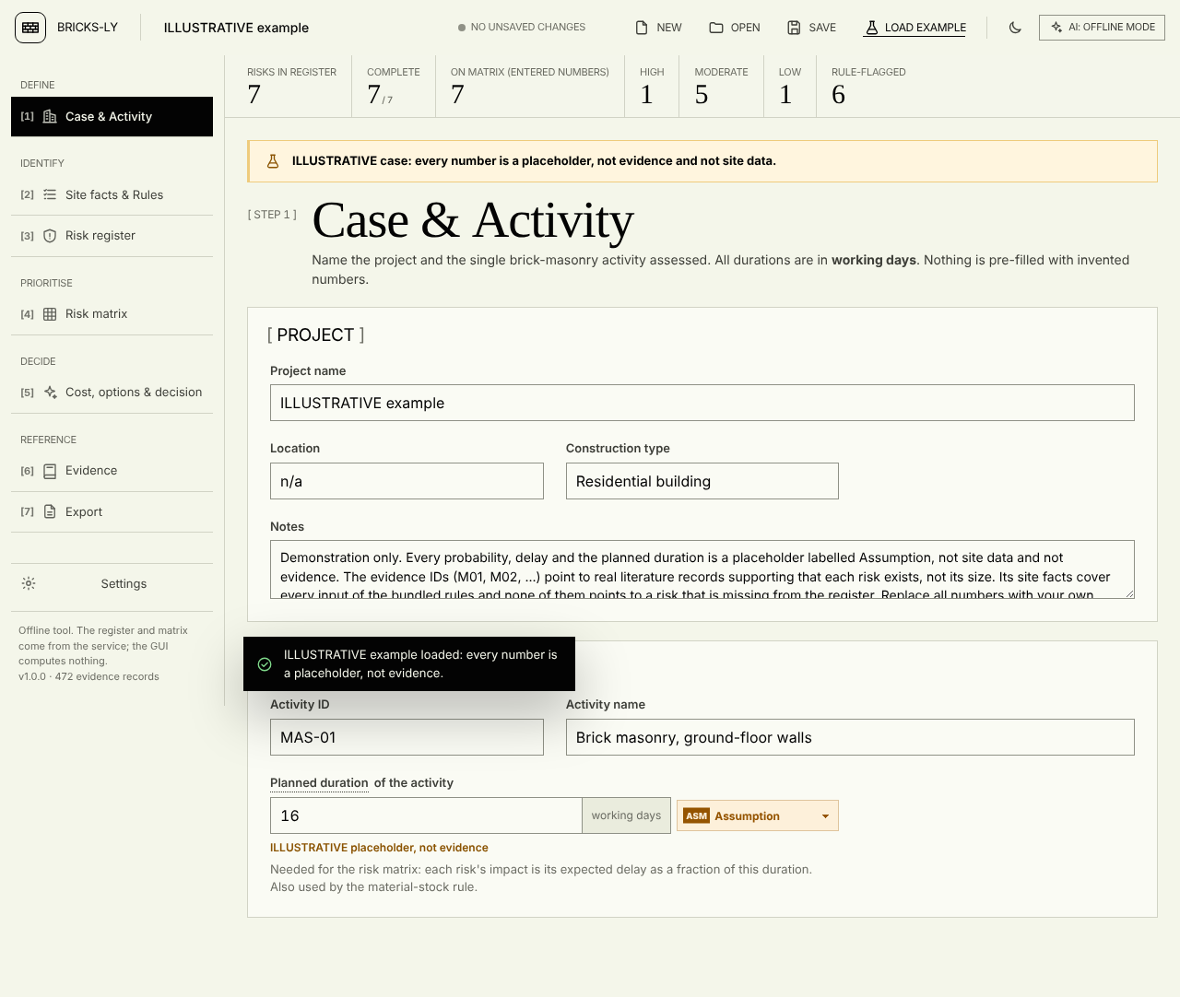
Figure 5.5. Case & Activity screen with the ILLUSTRATIVE example. Planned duration (16 working days) and its Source are on this screen. The values are placeholders, not site data.
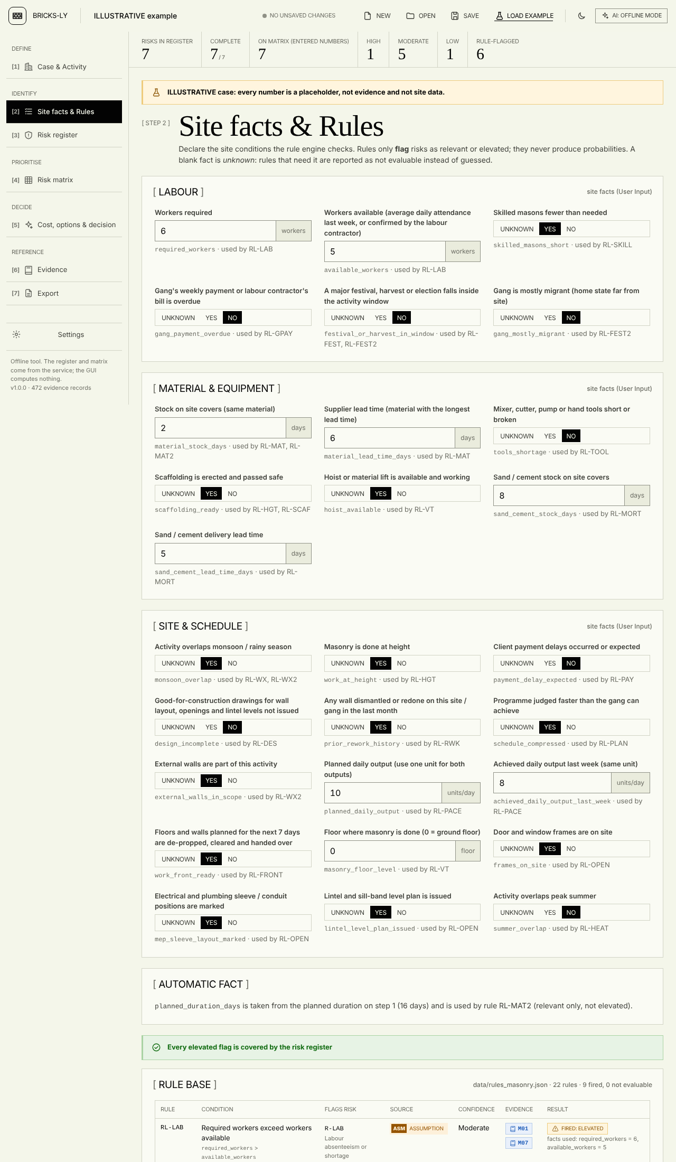
Figure 5.6. Site facts & Rules screen (top part), with the ILLUSTRATIVE example. Each fact is a Yes / No / Unknown control or a number field with its unit, and names the rules that use it. The rule table below the facts is listed in Table 5.8. Cropped.
The facts screen avoids free text on purpose. Every input is a number with a unit, or a three-way Yes / No / Unknown control, so the user cannot type a value the rules cannot read. Unknown is the default and means “not evaluable”, which is different from No.
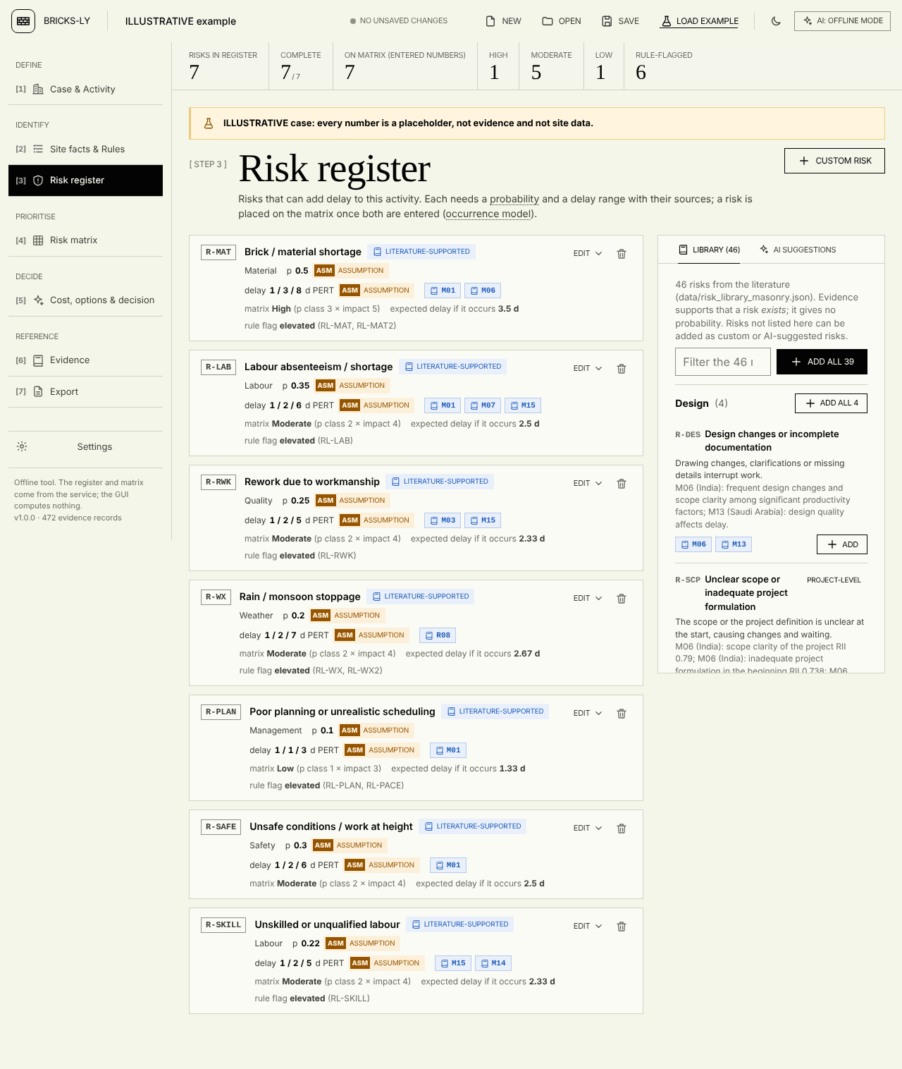
Figure 5.7. Risk register screen with the ILLUSTRATIVE example: seven cards, each with p and delay and their Source badges, evidence chips, rule flag and matrix cell. The side panel offers the 46-risk library and AI suggestions.
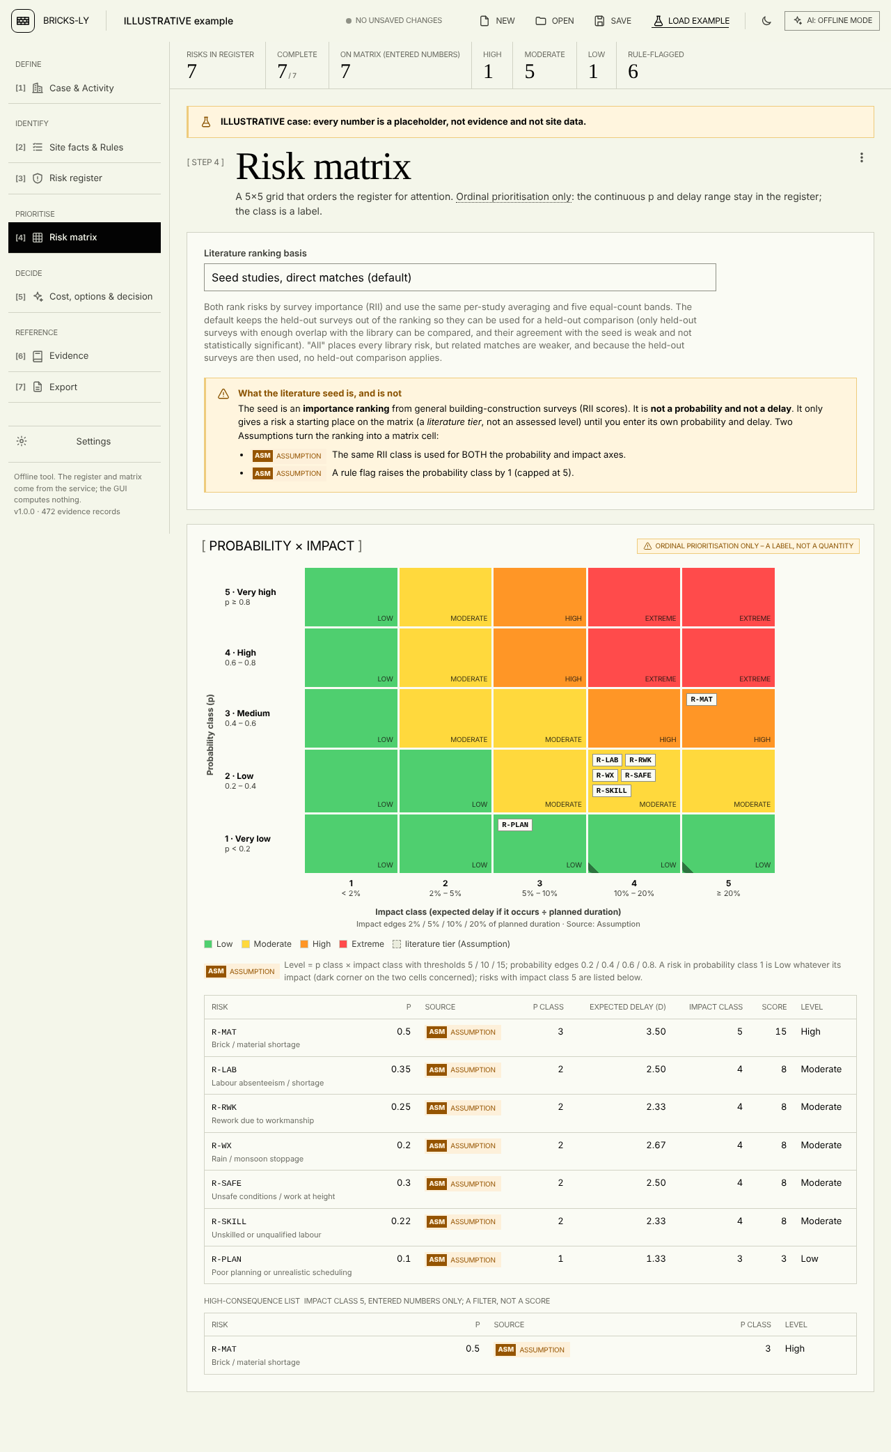
Figure 5.8. Risk matrix screen with the ILLUSTRATIVE example. The grey notice states what the literature seed is and is not. The grid shows the seven risks; the legend states the impact edges and their Source, the probability edges and score thresholds as Assumption, and marks the two probability-class-1 cells where a risk is Low whatever its impact. Below the grid: the table of classes and levels and the high-consequence list.
In the example, R-MAT falls in probability class 3 and impact class 5 (score 15, High) and is the only entry in the high-consequence list; five risks are Moderate and R-PLAN is Low. The hand calculation in Chapter 6 reproduces these cells. The example has no risk placed from the literature tier, so no grey dashed chip appears in this figure; the dashed style is exercised in tests (Chapter 6) and in the legend.
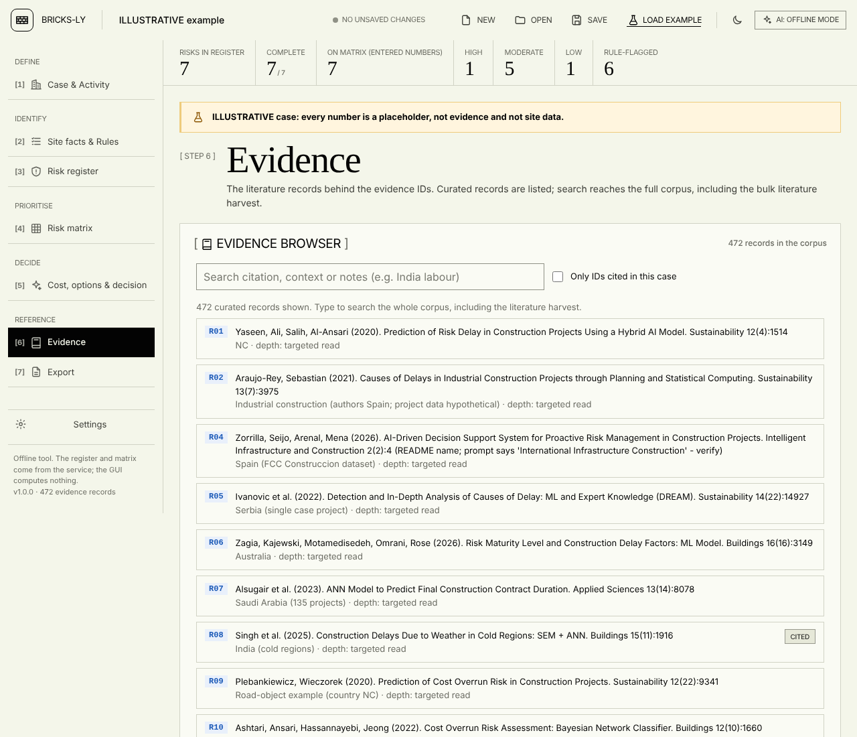
Figure 5.9. Evidence screen (top part, cropped). The search reaches the whole corpus; curated records are listed first.
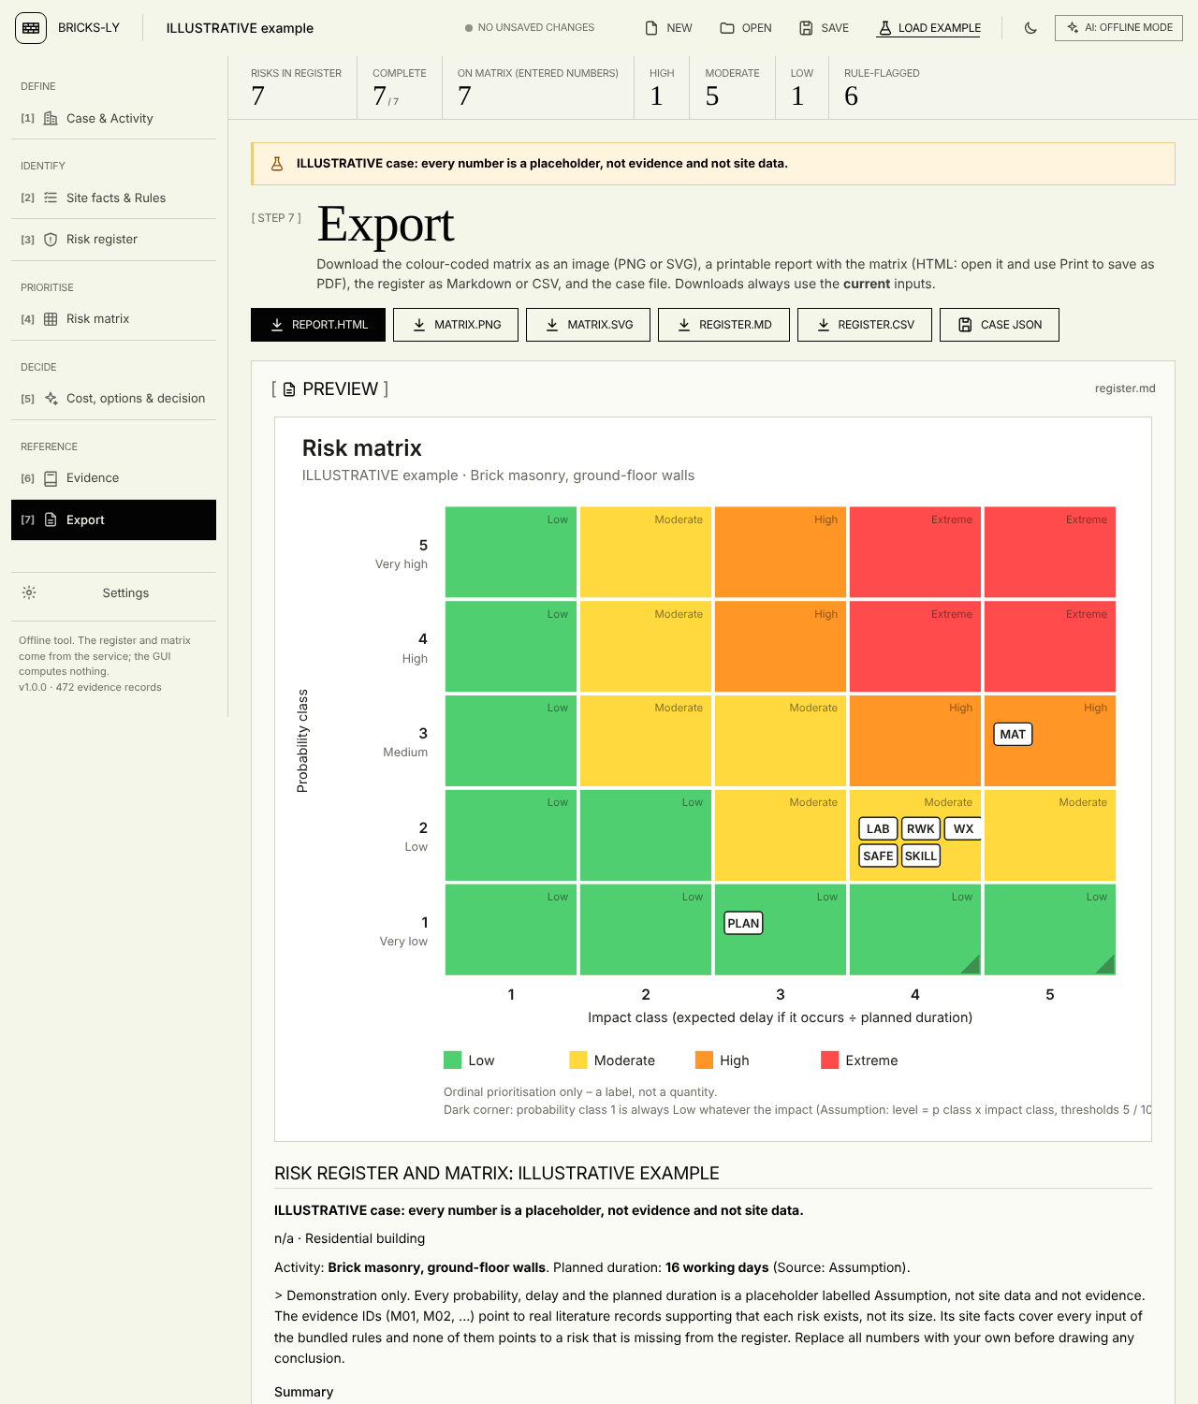
Figure 5.10. Export screen (top part, cropped).
Errors are handled in the same way on every screen. A value that is present but wrong is shown beside the field and in a problem counter in the top bar, with a button that jumps to the screen that holds it. The register and matrix keep their last valid state and are marked stale until the problem is fixed. Opening a saved case restores it exactly: a risk the user deleted is not re-added on open. This was defect 1 of the QA report and is now covered by a test (Chapter 6).

5.11 Desktop wrapper, build and continuous integration

5.11.1 Two ways to run
python -m gui starts the server and opens a browser tab at http://127.0.0.1:8765/; the next free port is used if the preferred one is busy. python -m gui.qt_app opens a PySide6 window that hosts the same interface in Qt WebEngine. The window starts the same Flask server on a free loopback port in a background thread, loads it, opens any external link in the normal browser, and replaces browser downloads with a Save dialog. The desktop window therefore adds no new logic: it is a different container for the same files, and a defect in the engine is the same defect in both.
The project description speaks of a PySide6 desktop application. The implementation is accurate to that description only in this sense: the window is a PySide6 application, but the interface inside it is web content. This is stated so that the wrapper is not mistaken for a native Qt interface.

5.11.2 Build and checks
build_desktop_exe.bat and build_exe.bat build Windows executables with PyInstaller from fyp_desktop.spec and fyp_gui.spec. A GitHub Actions workflow (.github/workflows/build-exe.yml, run on demand or on a version tag) performs the following on a Windows runner: install the requirements, run the test suite, build the browser-version executable, start it and call /api/health, /api/example and /api/run, run the desktop window from source in a headless self-test (--smoke), build the desktop executable, run its self-test, and upload the zipped folders as artifacts. The self-test loads the page, checks that the page has buttons and text and that the server reports loaded evidence records, and writes a JSON result.
What was and was not checked. The workflow is in the repository. In the working session for this report it was not run, because the session is a Linux machine without Windows, PyInstaller or Qt WebEngine, and the QA report states that the Qt wrapper and fyp_desktop.py were not tested in its run. This report therefore makes no claim that the Windows executables were built or run successfully; the workflow is the means by which that is to be checked, and its log is the evidence. Python 3.12 is the version used on the build runner, and the development environment of this report used Python 3.13.

5.11.3 Dependencies and offline use
The runtime requirements are Flask, NumPy, SciPy, Matplotlib and openpyxl; the desktop window adds PySide6. No component of the core path needs a network. The only network use is an AI request, which happens only when the user has stored a key and presses the suggestion button, and the test route for the key. The server answers only requests addressed to 127.0.0.1, localhost or the loopback IPv6 name, which blocks DNS-rebinding access to the settings routes (gui/api.py). The server is the Flask development server, which is adequate for one user on one machine and is not meant to be exposed on a network; the interface README says so.

5.12 Optional decision layer

5.12.1 Scope and status
On 8 October 2026 the team asked for a cost, options and decision screen to be added. It is implemented in app/analysis.py with the engine modules simulation, emv, decision and options, exposed on screen 5 and by python -m app.cli analyze. It is optional. The register and the matrix do not depend on it, and its result never feeds back into the register or the matrix level.
It is not the four-phase pipeline described in the original project description. In particular, it does not use a 27-state matrix to produce a delay probability, it does not produce a mitigation cost, and it does not compute the product of a P90 delay, a daily penalty and a delay probability. It computes the expected total cost of each response option from a simulated schedule, as set out below.

5.12.2 What goes in, and what does not
The layer uses only numbers the user enters, each with a Source: the cost of one delay day (no default), optional liquidated damages per day after a deadline, an optional deadline, per-response costs, and the effect of each response on a risk as a new probability and/or a new delay range. A response with no entered effect is reported and left out; the tool does not supply one. The mitigation catalogue (data/mitigation_catalogue.json, 13 entries) lists candidate actions and what must be elicited for each, and contains no effect sizes and no costs, because the evidence review found no transferable risk-reduction factor for a masonry-specific response (Research_Notes/D_mitigation.md, section 7, as recorded in the catalogue header). The layer never uses a literature-tier (RII) placement as a probability. If a risk has no entered p and delay, it is left out of the simulation with a note.

5.12.3 Method
For each risk i with entered probability p_i and delay distribution F_i, a simulated run draws an occurrence I_i ~ Bernoulli(p_i) and, if the risk occurs, a delay D_i ~ F_i. The duration is
T=T0+i​IiDi,
with independent, additive risks unless correlations are entered. The delay distributions are Beta-PERT with shape weight λ = 4, triangular, uniform or fixed. The draws for each risk come from a random stream keyed on the seed and the risk ID, so a response option that changes p_i or F_i reuses the same underlying draws as the baseline (common random numbers). Differences between options are then driven by the entered changes and not by sampling noise. The default is 10,000 runs and seed 12345, both user-editable (up to 200,000 runs).
The cost of a run is
C=Cdmax0,T−T0+ℓmax0,T−Tdl+i​Ii di,
where C_d is the cost of a delay day, ℓ the liquidated damages per day after the deadline T_dl, and d_i an optional direct cost if risk i occurs. Early finishes earn no credit: negative delay is clipped at zero in the cost. The event expected monetary value of one risk is analytic,
$${EMV}_{i}=p_{i} \left(E\left[D_{i}\right] C_{d}+d_{i}\right),$$
and its sum equals the simulated expected delay cost in expectation for independent additive risks. It does not include liquidated damages, whose term is non-linear in T and cannot be recovered from event EMVs.
For response options, each option is a set of at most one response per risk. The tool evaluates each response alone and combinations of responses that target different risks (at most 40 options), plus the option “accept”. For option j with mitigation cost M_j the total expected cost is
$${TEC}_{j}=M_{j}+E\left[C_{j}^{res}\right],$$
where the residual cost is simulated with the changed p and F. The default criterion is the minimum TEC; minimum probability of exceeding the deadline and minimum P90 duration are also available, with optional constraints on the deadline probability and the mitigation budget. Infeasible responses and options that violate a constraint are removed before ranking. The result is one of the commands AUTHORIZE MITIGATION or ACCEPT RISK, with the figures behind it. The command text says the option is “preferred under the stated criterion among the options evaluated”, never “optimal”, and a test enforces that wording. Two further checks accompany every command: the preferred option under three different seeds, and the preferred option as the cost of a delay day is scaled from 0.25 to 4 times.

5.12.4 Illustrative output
The ILLUSTRATIVE analysis example (python -m app.cli example-analysis) adds to the register example a deadline of 20 working days, a delay-day cost of INR 8,000, liquidated damages of INR 5,000 per day, and six responses with placeholder costs and effects, one of them marked infeasible. All of these numbers are Assumptions of the example and are not evidence, site data or an expert’s estimate. Figure 5.11 shows the entry fields and Figure 5.12 the decision part of the screen after the analysis was run.
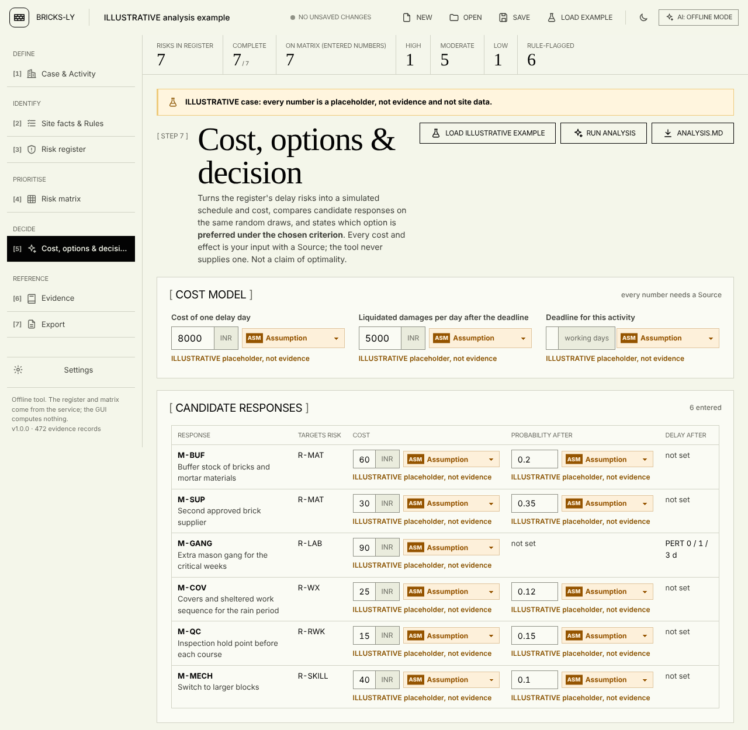
Figure 5.11. Cost, options & decision screen, inputs (cost model and candidate responses), ILLUSTRATIVE analysis example. Cropped. In this capture the narrow number fields clip the entered values: the cost of M-BUF is stored as 6000 but the field shows “60”, and the deadline field (20 days) shows no digits. The data are intact; the display is a defect recorded in Chapter 6.
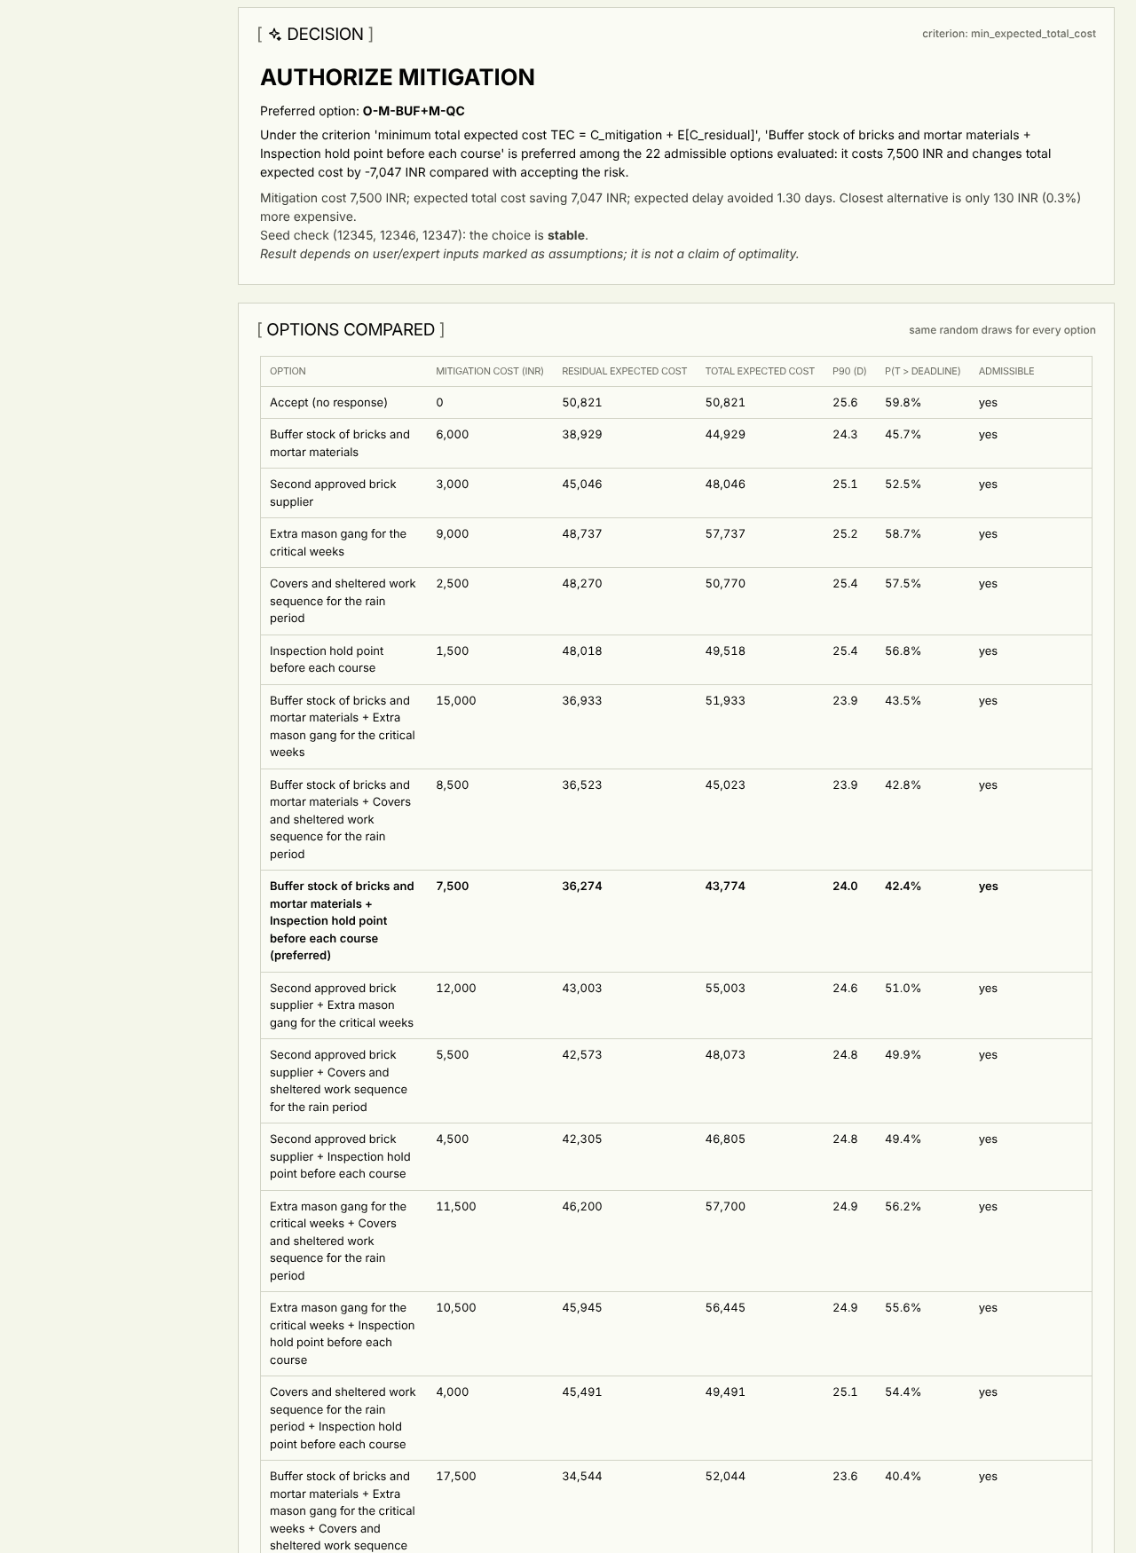
Figure 5.12. Decision part of the same screen after “Run analysis”: the command, the criterion, and the first rows of the table of options compared. Cropped. Every number is derived from ILLUSTRATIVE placeholders.
With those placeholders the tool reports an expected delay of 5.13 days, a probability of 59.8 % of finishing after the deadline, and the command AUTHORIZE MITIGATION for the option “buffer stock plus inspection hold point” (mitigation cost INR 7,500; change in total expected cost INR -7,047 against accepting). The closest alternative is INR 130 more expensive, a gap of 0.3 %, which the tool itself describes as close. The preferred option is the same under three seeds and changes to “accept” when the delay-day cost is scaled to a quarter. This shows how sensitive the command is to its inputs, which are invented. It is not a result about any real project. Section 6.5 compares the first of these figures with an independent calculation.

5.12.5 Limits
The layer is a calculator over user inputs. It is only as good as the probabilities, delay ranges, costs and response effects entered, none of which this project has measured. Independence between risks is the default, though correlations can be entered. A pre-implementation review noted that the evidence base offers no masonry-specific effect sizes for any response, and the layer was therefore built so that it refuses to invent them. The distribution shape (PERT with λ = 4) has no site calibration. Whether a site manager would use the screen, or would trust its command, has not been tested.

5.13 Summary
The tool is a deterministic, offline register-and-matrix aid with a transparent rule base, a labelled literature tier, a guarded AI suggestion path that cannot supply numbers, and an optional cost layer that uses only the user’s own numbers. Its main design decisions are to keep the engine separate from the interface, to attach a Source to every number, to prefer “not evaluable” or “not placed” over a guess, and to word outputs as ordinal or conditional. Its main design weaknesses, carried forward to Chapter 6 and Chapter 7, are the Assumption-laden class edges and thresholds, the use of one RII band on two axes, the thin evidential basis of the rules, and the absence of any evaluation with practitioners.

Chapter 6. Verification and Testing
This chapter reports what was checked, how, and with what result, and then states what was not checked. The checks establish that the software does what Chapter 5 says it does: that it computes the matrix cells it claims to, rejects the input it claims to reject, keeps its wording within limits, and gives the same output for the same input. They do not establish that the tool is useful to a site manager, that its probabilities or thresholds are right, or that it improves any decision. No expert evaluation, no usability study and no site trial were carried out, and Section 6.9 lists what that leaves open.
All counts in this chapter were produced by commands run on 8 October 2026 against commit 9f265f9 of the repository (working tree with the report files untracked), on Linux with Python 3.13.16. Commands and scripts are named so that the reader can repeat them.

6.1 Verification approach
Four kinds of evidence are used, in order of strength for the claim they support.
- Automated tests (Section 6.2 to 6.3) show that specified behaviour holds for the inputs the tests choose. They are only as good as those inputs.
- Independent recomputation (Sections 6.4 to 6.6) shows that the numbers the tool prints for the ILLUSTRATIVE example equal numbers obtained by a separate calculation, by hand in the text and by a second implementation of the arithmetic in report/scripts/hand_check.py.
- Robustness probing (Section 6.7) shows how the tool behaves on malformed and hostile input. It was done by an independent QA pass and repeated for a sample of its findings in this session.
- Audit and review (Section 6.8) shows what independent reviewers found wrong, and what was changed.
The ILLUSTRATIVE example is used for the worked checks because it is the only case with complete numbers. Its probabilities, delays, costs and planned duration are placeholders labelled Assumption. A match between hand calculation and tool therefore shows that the arithmetic is right. It says nothing about whether the placeholders resemble any site.

6.2 The automated test suite

6.2.1 How it was run
pytest is not installed in the system Python of the environment used for this report. It was run from the isolated environment of the pytest tool that was already present, with the project’s dependencies on the path:
PYTHONPATH=/usr/local/lib/python3.13/dist-packages \
/root/.local/share/uv/tools/pytest/bin/python -m pytest -q -rA
PYTHONPATH=... python -m pytest --collect-only -q
The run took 29 seconds. The result was 513 passed, 3 skipped, 0 failed from 516 collected tests in 17 files. The earlier project documents quote 137 passed and 3 skipped on 8 October before the committee changes (Handoff section 8), and 133 before that; the larger number now is mostly parametrised cases of the hardening tests (one test function can generate many cases) and the tests added with the committee upgrades, not 380 new behaviours.
Two further test files, tests/test_explain.py (7 test functions) and tests/test_india_norms.py (6 test functions), are not collected. tests/conftest.py excludes them with collect_ignore because they import service functions (explain_result, india_norms) of the earlier simulation, cost and decision features that the lean application no longer exposes. They are kept on disk until their removal is confirmed. These 13 test functions did not run and are not counted as passed.
The three skipped tests are in tests/test_corpus.py and skip on a missing optional resource: the bulk literature harvest (data/openalex_corpus.jsonl, not in git) and the SQLite database data/literature.db (not in git, built by scripts/build_literature_db.py). The tests that check the database against its screening log and the 3,000-record work target therefore did not run in this environment, and the corpus-size discrepancy noted in the audit (finding F08) is not tested.

6.2.2 Tests per file
Table 6.1. Tests per file: collected, passed, skipped (all failed counts are zero). Collected counts from pytest --collect-only -q; passed and skipped from pytest -rA, both run for this report. A parametrised test counts once per case. Source: command output saved under the session scratch directory; commands as in Section 6.2.1.
File | Collected | Passed | Skipped | What it covers
test_validation_hardening.py | 140 | 140 | 0 | Input validation: non-finite numbers, booleans as numbers, bad shapes, missing Source, probability and impact edge rules, string facts
test_export_api_hardening.py | 129 | 129 | 0 | Exports and HTTP layer: CSV injection, Markdown escaping, BOM, odd bodies on every POST route, host check, guard rules G7 to G9, settings masking
test_service.py | 42 | 42 | 0 | run_case: example reproducibility, matrix rows, literature tier, rules in the service, register fields, exports
test_engine.py | 32 | 32 | 0 | Distribution means and variances, Monte Carlo against analytic moments, reproducibility, EMV, residual risk, constraints, audit hash
test_analysis.py | 29 | 29 | 0 | Decision layer: sections of the result, wording, input errors, deadline criterion, API routes
test_legacy_hardening.py | 26 | 26 | 0 | Earlier simulation, EMV and productivity code: bad values rejected, EMV against hand calculation, Monte Carlo mean within 3 standard errors
test_options.py | 17 | 17 | 0 | Response options: break-even targets, option generation, net benefit, command wording, seed stability, catalogue has no numbers
test_settings.py | 16 | 16 | 0 | AI key storage: outside the project, masked, never echoed, retry behaviour
test_relevance_guard.py | 14 | 14 | 0 | Guards that tie documents, data and wording to the facts (Section 6.3)
test_gui_api.py | 14 | 14 | 0 | HTTP routes of the interface
test_corpus.py | 13 | 10 | 3 | Evidence store and corpus loading; the 3 skips need data not in git
test_productivity.py | 13 | 13 | 0 | Earlier productivity models (out of scope)
test_gui_settings_api.py | 12 | 12 | 0 | Settings routes
test_ai_guard.py | 10 | 10 | 0 | Guard rules G1 to G4, audit log, promotion rules
test_rules.py | 5 | 5 | 0 | Rule firing, missing facts, priority and conflicts, consistency checker
test_gui_static.py | 3 | 3 | 0 | Static files are UTF-8 without garbled characters; opening a case does not auto-add risks; honest wording
test_report.py | 1 | 1 | 0 | Earlier Monte Carlo report
Total | 516 | 513 | 3
Two things stand out. First, the two largest files are hardening tests added after audit and QA findings, so more than half of the suite is a regression guard for defects that were found and fixed (Section 6.8). Second, 40 tests (test_legacy_hardening, test_productivity and test_report) cover earlier code that is out of scope and not used by the interface; they pass but support no claim about the current tool. The same holds in part for test_engine.py and test_options.py, which test the simulation and decision modules; those modules are live only in the optional decision layer.

6.2.3 Test categories
The suite can be read as six kinds of test.
Unit tests of the logic (test_engine, test_rules, parts of test_validation_hardening). Examples: the closed-form mean of each delay distribution equals the mean from a simulation within sampling error; a value exactly on a class edge goes to the higher class; a brute-force check over a one-decimal grid of ratios agrees with exact arithmetic for the impact class (test_m4_brute_force_one_decimal_grid_matches_exact_arithmetic); a rule with a missing fact is not evaluable and never fires; two rules of equal priority and different levels give conflict.
Integration tests of the service (test_service, test_analysis). They run whole cases through run_case or run_analysis and check the result: that the example is reproducible, that every matrix row equals the engine’s classification of the register risk, that an entered number replaces the literature tier, that a rule flag raises the probability class by one for a seeded risk only, that a risk with partial numbers stays in the register, and that every evidence ID cited by the example exists in the corpus.
API and export tests (test_gui_api, test_export_api_hardening, test_gui_settings_api). They call the Flask routes with valid, malformed and hostile bodies, and parse the exports (CSV with the csv module, HTML for unescaped markup, SVG as XML).
Guard tests (test_ai_guard, test_relevance_guard, parts of test_export_api_hardening). They check the AI guard rules and the document and wording guards of Section 6.3.
Regression tests for named defects. The hardening files name the audit item they guard: test_h1_* (non-finite numbers), test_h2_* (delay without Source), test_m1_* to test_m9_*, test_l1_* to test_l5_* and test_qa14_*. Each test was written after the defect was reproduced, so each one is a record that the defect existed.
What the suite does not include. There are no automated tests of the JavaScript interface code: test_gui_static.py checks encoding, wording and one behaviour of the load function by reading the source, but no browser test drives the screens. The browser behaviour was checked manually and with a Playwright pass (Section 6.7), whose scripts are not in the repository. The Qt desktop wrapper has no test in the suite; it has a self-test in the build workflow that was not run here (Section 5.11.2). There is no test of a real LLM reply for the Anthropic path (no key was available), and no coverage measurement was made, so the proportion of lines exercised is not known.

6.3 The relevance guard tests
tests/test_relevance_guard.py holds ten guards added on 8 October 2026 after the committee review. They protect the report and the interface from drifting away from the data. In this report they are cited as RG-1 to RG-10, matching the function names test_g1_* to test_g10_* in the file; they are distinct from the AI guard rules G1 to G9 of Chapter 5.
Table 6.2. The relevance guard tests. Source: tests/test_relevance_guard.py; all 14 test cases (RG-5 has two parametrised cases; RG-4, RG-6 and RG-9 have two functions each) passed in the run of 8 October 2026.
Guard | What it asserts | Why it matters
RG-1 | Counts read from the data are consistent with each other: seeded plus unseeded equals the number of library risks (46), seed plus held-out studies equals the number of studies (11), the unseeded risks are exactly those with a seed_status note, IDs are unique | These counts are quoted throughout the report; they are not typed into the test
RG-2 | README.md, docs/case_schema.md and gui/README_GUI.md state the rule, row, study and risk counts found in the data | Documents cannot silently go stale
RG-3 | The 182 seed rows are frozen: a checksum of the study, factor, rii and rank fields equals the stored value | A change to a transcribed survey value fails the suite
RG-4 | Withdrawn wording (“validated”, “predicts”, “built from every factor” and others listed in Handoff section 8) does not occur in live text; the handoff mentions withdrawn wording only on lines that say it is withdrawn | Keeps the claims within what the work supports
RG-5 | Every number in the exports has its Source printed next to it, for the example and for a case with the whole library added | Integrity rule 2
RG-6 | Legacy modules are not imported by the live application, and the interface does not load the legacy screens | Out-of-scope code cannot influence outputs
RG-7 | The example case stays labelled ILLUSTRATIVE in every export | Placeholders cannot be mistaken for data
RG-8 | Rule-base sanity: every rule is Assumption-sourced or carries evidence IDs; no pair of rules on one risk has different levels at equal priority; every fact used by a rule has a label on the facts screen; every rule targets a library risk | Rule base stays consistent with the interface
RG-9 | Unseeded library risks carry the seed_status note and have no seed rows; evidence IDs of the eight added risks exist in the corpus | The 16 unseeded risks cannot acquire a literature tier by accident
RG-10 | promote refuses a derived (AI) value as the source of p or delay; the response of /api/suggest-risks contains no numeric-looking key | NFR3
These guards test consistency, not truth. RG-3 shows that the seed rows are unchanged since the row-level check against the printed papers; it does not re-check them. RG-4 shows that listed phrases are absent; a new over-claim in different words would pass.

6.4 Hand calculation against the tool: the matrix

6.4.1 The example
The ILLUSTRATIVE example (app.service.example_case, also examples/example_case.json) has a planned duration T₀ = 16 working days, impact edges (0.02, 0.05, 0.10, 0.20), and seven risks with PERT delays. All values are Assumptions. The calculation uses the formulas of Section 5.6: E[D] = (a + 4m + b)/6, r = E[D]/T₀, c_p from the edges 0.2, 0.4, 0.6, 0.8, c_i from the impact edges, s = c_p c_i, and the level thresholds 5, 10, 15.

6.4.2 By hand, for R-MAT
R-MAT has p = 0.50 and a delay range a = 1, m = 3, b = 8 days.
- E[D] = (1 + 4 × 3 + 8)/6 = 21/6 = 3.5 days.
- r = 3.5/16 = 0.21875, which is at least the fourth edge 0.20, so the impact class is c_i = 5.
- p = 0.50 is at least 0.4 and below 0.6, so the probability class is c_p = 3.
- s = 3 × 5 = 15, and 11 ≤ 15 ≤ 15 gives the level High.
For R-LAB (p = 0.35, a/m/b = 1/2/6): E[D] = (1 + 8 + 6)/6 = 2.5; r = 0.15625 lies in [0.10, 0.20), so c_i = 4; p = 0.35 lies in [0.2, 0.4), so c_p = 2; s = 8, Moderate. R-PLAN (p = 0.10, a/m/b = 1/1/3): E[D] = (1 + 4 + 3)/6 = 1.3333; r = 0.08333 lies in [0.05, 0.10), so c_i = 3; p = 0.10 is below 0.2, so c_p = 1; s = 3, Low. The remaining four risks are computed in the same way in Table 6.3.

6.4.3 All seven risks
Table 6.3. Hand calculation and tool output for the seven risks of the ILLUSTRATIVE example. All inputs are placeholders labelled Assumption. “Hand” columns come from the formulas of Section 5.6 applied with a separate script (report/scripts/hand_check.py, which does not call app.engine); “Tool” columns come from app.service.run_case. Source: report/tables/hand_check_output.txt, produced by running the script.
Risk | p | a / m / b (d) | E[D] hand (d) | r = E[D]/16 | c_p | c_i | s | Level (hand) | Tool: E[D], c_p, c_i, s, level
R-MAT | 0.50 | 1 / 3 / 8 | 3.5000 | 0.2188 | 3 | 5 | 15 | High | 3.5000, 3, 5, 15, High
R-LAB | 0.35 | 1 / 2 / 6 | 2.5000 | 0.1562 | 2 | 4 | 8 | Moderate | 2.5000, 2, 4, 8, Moderate
R-RWK | 0.25 | 1 / 2 / 5 | 2.3333 | 0.1458 | 2 | 4 | 8 | Moderate | 2.3333, 2, 4, 8, Moderate
R-WX | 0.20 | 1 / 2 / 7 | 2.6667 | 0.1667 | 2 | 4 | 8 | Moderate | 2.6667, 2, 4, 8, Moderate
R-PLAN | 0.10 | 1 / 1 / 3 | 1.3333 | 0.0833 | 1 | 3 | 3 | Low | 1.3333, 1, 3, 3, Low
R-SAFE | 0.30 | 1 / 2 / 6 | 2.5000 | 0.1562 | 2 | 4 | 8 | Moderate | 2.5000, 2, 4, 8, Moderate
R-SKILL | 0.22 | 1 / 2 / 5 | 2.3333 | 0.1458 | 2 | 4 | 8 | Moderate | 2.3333, 2, 4, 8, Moderate
All seven rows agree: expected delay to within 10⁻⁹ days, and class, score and level exactly. The tool’s summary reports one High, five Moderate and one Low. The p = 0.20 of R-WX is exactly on the edge 0.2 and goes to class 2, which is the lower-edge-inclusive convention of Section 5.6.3; this case is a deliberate check of the convention. The test test_m4_exact_edge_goes_to_the_higher_class guards the same behaviour.
What this check shows is limited. It confirms the arithmetic and the edge convention. The classes and levels depend on the impact edges (0.02 to 0.20), the probability edges and the score thresholds, which are Assumptions; with other edges the same seven risks would be classed differently. The sensitivity of the levels to those choices was examined in Chapter 4 and is not repeated here.

6.4.4 Rules for the example, by hand
The example’s 28 facts (Chapter 5, Figure 5.6) fire nine rules. By hand, with the facts of the example (required workers 6, available 5, material stock 2 days, lead time 6 days, planned duration 16, monsoon overlap Yes, external walls Yes, schedule compressed Yes, planned daily output 10, achieved 8, prior rework Yes, skilled masons short Yes):
- RL-LAB fires (6 > 5), RL-MAT fires (2 ≤ 6) at priority 1, RL-MAT2 fires (2 < 16) as normal, RL-WX fires as normal, RL-RWK fires, RL-PLAN fires, RL-SKILL fires, RL-WX2 fires (monsoon and external walls) at priority 1, RL-PACE fires (10 > 8).
- Thirteen rules do not fire: RL-TOOL (no tools shortage), RL-HGT (work at height but scaffolding is ready), RL-PAY, RL-DES, RL-FRONT (work front ready), RL-VT (floor 0 is below 1), RL-SCAF (scaffolding ready), RL-MORT (8 > 5 days), RL-GPAY, RL-OPEN (all three items ready), RL-FEST, RL-FEST2, RL-HEAT.
On R-MAT, RL-MAT (elevated, priority 1) and RL-MAT2 (normal, priority 0) both fire, and the higher priority wins, so R-MAT is elevated, not conflict. On R-WX, RL-WX (normal, 0) and RL-WX2 (elevated, 1) give elevated. The tool reports the same nine fired rules, no rule not evaluable, and six elevated risks (R-LAB, R-MAT, R-WX, R-RWK, R-PLAN, R-SKILL), matching the “rule-flagged 6” in the key-figure strip of Figure 5.8. R-SAFE has no flag, as its scaffolding is ready.

6.4.5 Literature tier, by hand
The tier is not used by the example, whose risks all have entered numbers. To check the tier arithmetic, a case with R-MAT entered and R-TOOL and R-WX left without numbers was run, with tools_shortage set to true and the other facts as in the example. The seed table (app.literature_seed.seed_table()) gives R-TOOL a mean RII of 0.7528 (study means M01 0.7455 and A02 0.760, the mean of the two study means) at rank 12 of 30, and R-WX a mean RII of 0.6934 (A14 0.6528, M01 0.764, A02 0.700, M06 0.6567) at rank 24.
- R-TOOL: tier = 5 − ⌊5 × 11/30⌋ = 5 − 1 = 4. It is flagged elevated by RL-TOOL, so c_p = min(5, 4 + 1) = 5 and c_i = 4, giving score 20.
- R-WX: tier = 5 − ⌊5 × 23/30⌋ = 5 − 3 = 2. RL-WX2 (elevated, priority 1) beats RL-WX (normal), so c_p = 3 and c_i = 2, giving score 6.
The tool reports exactly these cells and marks both as “literature tier (Assumption)” with raised_by_rule true. Its level totals count only R-MAT (High), as the specification requires: the seeded risks do not enter the High, Moderate or Low counts even though their cells carry a colour. Band membership also holds in the data: the 30 seeded risks fall six into each tier (Counter of tiers 1 to 5: 6, 6, 6, 6, 6). Both the 20 and the 6 are cell positions produced by two Assumptions (one RII band on both axes, +1 for a flag), and not assessments of those risks.

6.5 Independent check of the decision layer
The decision layer is checked on the ILLUSTRATIVE analysis example, again with placeholders. Two kinds of check are possible: closed-form quantities that can be computed by hand, and simulated quantities that need an independent simulation.
Closed-form: expected delay and event EMV. The expected total delay of independent additive risks is the sum of p_i E[D_i]:
0.50 × 3.5 + 0.35 × 2.5 + 0.25 × 2.3333 + 0.20 × 2.6667 + 0.10 × 1.3333 + 0.30 × 2.5 + 0.22 × 2.3333 = 1.75 + 0.875 + 0.5833 + 0.5333 + 0.1333 + 0.75 + 0.5133 = 5.1383 days.
At INR 8,000 per delay day the sum of event EMVs is 5.1383 × 8,000 = INR 41,106.67. The tool’s event EMV rows sum to INR 41,106.67, equal to the cent.
Simulated: expected delay. The tool’s 10,000-run simulation with the default seed gives an expected delay of 5.1323 days with a standard error of 0.0334, which is 0.18 standard errors below the hand value. A second implementation written for this check (hand_check.py, own beta sampler, own random generator) with 4,000,000 runs gives 5.1401 days (standard error 0.0016), 1.1 standard errors above the hand value and consistent with it. The tool with 200,000 runs gives 5.1521.
Simulated: probability of any delay. Every risk, if it occurs, adds at least one day, so the probability that the activity finishes late is 1 − ∏(1 − p_i) = 1 − 0.5 × 0.65 × 0.75 × 0.8 × 0.9 × 0.7 × 0.78 = 0.9042. The tool’s default run reports 0.8975, 0.0067 below, which is 2.3 standard errors of a proportion at 10,000 runs and therefore looks like a sampling fluctuation but needs a check. Six other seeds give 0.9084, 0.9037, 0.9039, 0.9028, 0.9037 and 0.9092, and 200,000 runs give 0.9036, all in agreement with 0.9042. The seed 12345 simply happens to be a low draw for this quantity. This is the reason the tool shows the number of runs, the seed and standard errors, and why a result should not be read to more digits than the sampling error allows.
Deadline and cost. The probability of exceeding the 20-day deadline and the expected cost (which includes the liquidated-damages term) have no closed form here, because they depend on the distribution of the sum. The tool reports P(T > 20) = 0.598 and an expected cost of INR 50,821 at 10,000 runs. The independent 200,000-run simulation gives 0.6025 and INR 50,929. The 200,000-run tool run gives 0.6041. The two simulators agree to within about 0.5 % on the cost and 0.5 percentage points on the probability, which is within the sampling error of the 10,000-run result. As a consistency check on the liquidated-damages term, the expected cost minus 8,000 × 5.1323 = INR 41,058 leaves about INR 9,763, which is the expected liquidated damages 5,000 × E[max(T − 20, 0)], so E[max(T − 20, 0)] is about 1.95 days; this is a derived consistency figure and was not computed independently.
Decision command. The command (AUTHORIZE MITIGATION with “buffer stock plus inspection hold point”) rests on the simulated cost of 22 admissible options and was not recomputed by hand. What was verified is that the preferred option does not change with the seed (three seeds), that the repository’s tests compare the net benefit of a response with the simulated comparison when the cost is linear (test_net_benefit_agrees_with_simulated_comparison_when_cost_is_linear), and that the break-even targets agree with hand checks (test_break_even_targets_hand_checked). The gap between the first and second option is 0.3 % of total expected cost, smaller than a difference that the sampling error of a 10,000-run simulation would make dependable by itself; the tool reports the gap for that reason. The result is a demonstration of the arithmetic on placeholders and not a recommendation about any activity.

6.6 Reproducibility and determinism
Repeating the same case gives the same output. In the QA run, six cases were each sent 96 times concurrently, in forward and reversed order, and the hashes of /api/run and of all four exports were identical across repetitions; no server state carried between requests. The test test_example_case_builds_the_register_and_matrix_and_is_reproducible and test_result_is_reproducible_and_input_is_not_modified give the same check in the suite. The Monte Carlo layer is reproducible for a given seed and number of runs, as the hand check above shows by the stable 12345-seed values, and the result of a change of seed is shown, not hidden.

6.7 Robustness and fuzz testing (QA report)

6.7.1 What the QA pass did
An independent QA pass on 8 October 2026 tested the interface and service with scripted fuzzing and a real Chromium run. The report is at /tmp/claude-0/-home-claude-fyp/b6e485db-2d31-5ab7-a4a5-10d8b255e54b/scratchpad/qa/qa_report.md, and the scripts it names (fuzz.py, fuzz2.py, probe*.py, det.py, b1.py to b4.py) are in the same session directory, not in the repository. The pass covered API fuzzing of every route with empty, malformed, wrongly typed and oversized bodies; export checks; determinism; the settings store; the command line; a Chromium run through all screens, themes and widths with XSS payloads in every text field; and a static review. The suite at that time had 137 passed and 3 skipped.
What it found to be sound is recorded in the report: all POST routes returned 422 or ok:false for empty bodies, bad JSON, wrong content type and list or null bodies (except two routes, defect 6 below); a 30 MB body returned 413; 5,000 risks validated in 0.4 seconds and 1.2 MB names were handled by all five exports; probabilities outside [0, 1] in object form, reversed delay ranges, negative delays, bad planned durations, duplicate IDs and bad impact edges were all rejected with clear messages; CSV parsed with 17 columns on every row at that time; the SVG was well-formed; the HTML report contained no raw script or image tags; path-traversal strings returned 404; the register was identical after save and reopen of the unmodified example; and none of the XSS payloads executed on any screen or in the problem list.

6.7.2 Defects found, and their status
The QA report listed 17 defects. They were reported at a commit before the committee upgrades; the table gives the status found when selected items were re-probed in this session on the current code, with the test that now guards each.
Table 6.4. QA defects and their status. “Re-probed” means the reproduction of the QA report was repeated in this session against the current code (command output not saved to a file); “test” names the guard in the suite. Source: QA report, section “Defects”; probes run on 8 October 2026.
# | Severity | Defect (QA report) | Status on current code
1 | medium | Opening a saved case re-added a rule-flagged risk the user had deleted | Fixed: test_load_case_does_not_auto_add_risks in test_gui_static.py (checks the source of the load function)
2 | medium | Non-string names and non-object activity gave HTTP 500 | Re-probed: now ok:false with “activity.name must be text, not int” and “activity: expected an object”; test_m6_non_string_names, test_validate_never_returns_html_for_odd_case_shapes
3 | medium | CSV formula injection | Re-probed: cell now written as text with a leading apostrophe; test_csv_cells_starting_with_formula_chars_are_neutralised
4 | medium | Invalid bare p (-1, 1.5, “abc”) silently treated as not entered | Re-probed: p = -1 gives “expected an object with value and source”; test_m2_bare_probability_value_rejected
5 | low-med | register.md table broken by \| or newline in names | Re-probed: pipe escaped, newline replaced; test_markdown_table_escapes_pipes_and_newlines
6 | low-med | /api/suggest-risks and /api/settings/test returned HTML 500 for non-object bodies | Re-probed: HTTP 422; test_settings_test_and_suggest_reject_wrong_types
7 | low | Garbled characters (“Â·”, “â€¦”) in app.js | Fixed: test_static_files_are_utf8_without_mojibake
8 | low | NaN, Infinity and booleans accepted as numbers | Re-probed: “must be a finite number”; boolean gives “must be a number, not true”; test_h1_*, test_m1_booleans_are_not_numbers
9 | low | Case with bad types left the screen at “Checking the case…” with the cause hidden | Same validation as 2; screen behaviour not re-probed in a browser
10 | low | Export screen overflowed at 800 px | Handoff section 9 records a screenshot check at 800 px with no overflow; not re-probed here
11 | low | Deeply nested JSON gave HTML 500 | Re-probed: HTTP 422 with a JSON body; test_unhandled_exception_becomes_json_500, test_every_post_route_returns_clean_json_error_for_odd_bodies
12 | low | CLI printed tracebacks for bad files | Re-probed for a missing file: one-line message; test_cli_friendly_errors
13 | low | CSV had no BOM | Fixed: the HTTP route and the CLI encode as utf-8-sig; test_register_csv_endpoint_has_bom_and_is_parseable, test_cli_writes_csv_with_bom
14 | low | Unknown evidence IDs accepted without warning | Re-probed: a warning is given; test_qa14_unknown_evidence_ids_are_warnings_not_errors
15 | info | Masked key revealed short keys; any Host header accepted | Fixed: test_masked_key_never_reveals_a_short_key, test_host_header_is_checked
16 | info | Dead JavaScript screens shipped; dark-theme level colours differ from the specified values | Dead-code part guarded by RG-6; dark-theme colours not re-checked here
17 | low | Label for attributes missing; one select text clipped; toast uses innerHTML for a few server strings | Not re-checked; treat as open
Fourteen of the seventeen were re-probed or have a named guard test that passed; items 9, 10, 16 (dark-theme part) and 17 were not re-checked in this session. A new display defect was found while capturing the screenshots for Chapter 5 and is not in the QA report.

6.7.3 A defect found in this verification
On the “Cost, options & decision” screen at a viewport width of 1280 px, the number fields for the response costs and the deadline are too narrow for their values. A measurement in the page shows the deadline field (value 20) with a client width of 20 px and a content width of 41 px, and the cost fields (value 6000) 37 px wide against 56 px of content, so the digits are cut off (Figure 5.11 shows “60” for 6,000 and an empty-looking deadline). The stored values are correct and are the ones used in the analysis; the display misleads the user about what is entered. This is a usability defect in a part of the tool that decides on money. It is not fixed, and it is listed with the known defects below.

6.8 Audit findings and what was corrected

6.8.1 The audit
Before the committee upgrades, a research-methods audit of the repository (30 findings, F01 to F30), a row-level check of the literature seed against the printed papers (17 findings, V-prefixed), and an engine audit (3 high, 10 medium and 14 low findings, H, M and L) were carried out. docs/Audit_Corrections_2026-10-08.md lists each with its status. The status tags in the file (a finding can carry two) show that, of the 30 research findings, 19 were fixed in documents, 5 in data, 12 needed a code change when the file was written, and 10 were left as decisions for the supervisor.

6.8.2 The main result: the data were right, the claims were not
The row-level check compared all 182 RII values and ranks in data/literature_seed.json with the printed papers and found them all to match. No row transcribed from M01 (28 of 28 table rows), M06 (40 of 40), A14 (as entered) or M10 (33 of 33 Table 7 rows) was missing. What was wrong was metadata, notes and wording. This finding supports the reliability of the transcription; it does not extend to the mapping of survey items to library risks, which is a judgement (finding F12), and for which no second coder or agreement statistic exists. Two further entries, A11 and P1-23 (listed under “other indices” in the seed file, not used in the seed), were not verified against PDFs because the files were not on disk.

6.8.3 Statistical findings that were corrected
The audit found the following problems in what had been said about the literature seed. Each was corrected in the documents; the scripts that generate some of the old figures were not all changed (Audit_Corrections section 5).
- Circular agreement figures (F01). The agreement of the pooled ranking with the seed (rho 0.73) included the seed studies themselves. The held-out-only values are rho 0.08 (n = 22, p = 0.73) for the pooled rank against the seed and 0.09 (p = 0.70) for the standardised pooled score. The circular values are withdrawn.
- Over-claim of validation (F05). “Validation”, “out-of-sample test” and “predicts the order of study X” were withdrawn. The leave-one-study-out comparisons against the seed give rho 0.09 (M01, p 0.76), 0.37 (A02, p 0.29), 0.64 (M06, permutation p 0.066) and 0.60 (A14, n 4); these are seed studies, not held-out ones. For the three held-out studies M15, M10 and M14 the Holm-adjusted p are 0.13, 0.48 and 0.55. The proper description is an agreement check that is weak, low-powered and inconclusive.
- Same band on both axes (F02). Using one class on both axes squares the rank: 12 of the 30 seeded risks fall in the Extreme level and none in High. The use was kept as a labelled Assumption and the seeded cells were demoted to a “literature tier” display (Section 5.7).
- Subset claims (F03). Only 5 of the 39 factors of A14 were entered, so “built from every factor” was withdrawn and the subset stated.
- Post-hoc finding (F09). “Weather is rated lower than the rest” (p = 0.049) was item-level and post hoc; the study-level Kruskal-Wallis p was 0.25. It was withdrawn.
- Kendall W (F10). W = 0.400, permutation p = 0.153 (chi-square approximation 0.156; four studies, six risks) is no evidence of agreement and was reworded.
These are findings about the evidence behind the tier, discussed in Chapter 4. They are included here because the tier is a feature of the tool and its description in the interface changed as a result.

6.8.4 Engine and QA findings fixed in code
After the committee review the code changes in Audit_Corrections section 6 were made and tests added. Re-probing on the current code in this session (Section 6.7 and the checks below) shows that most items listed as “needs code change” in sections 4 and 5 of the audit file are now rejected or handled, although those sections of the file were not updated. The statuses found were:
- H1 non-finite numbers: a NaN planned duration is rejected with “must be a finite number”. The audit’s remaining point, the command line writing invalid JSON for NaN, was not re-probed.
- H2 delay without Source: rejected (“source is required”). Previously it was silently labelled Expert Judgment.
- M1 booleans, M2 out-of-range probability without a delay, M5 string facts, M6 malformed shapes, M9 edge count (six edges now rejected, “exactly four numbers”), L1 (a conflicting planned-duration fact is rejected), L4 (a string use_literature_seed is rejected): re-probed, all handled.
- M3, partly entered numbers: a risk with only p entered stays in the register with the entered p kept, is placed from the literature seed if it has a seed value, and carries a note that the p is not used for placement until the delay is entered. This is a documented design choice and not a defect.
- L5, a uniform distribution without m, is accepted, as intended: uniform uses only a and b.
- M4, rounding of values exactly on an edge: fixed with the 10⁻⁹ relative tolerance on both axes, with the brute-force grid test.
- M7, the unenforced sentence “No number here was produced by AI”: replaced (Section 5.8.3).
The deferred items, which remain open, are in Section 6.9.

6.9 Known defects and deferred items
This section lists what is known to be wrong or unfinished, so that nothing in the earlier sections is read as completeness.
Known defects
- The number fields of the “Cost, options & decision” screen clip their values at 1280 px (Section 6.7.3).
- QA items 9, 10, 16 (dark-theme colours) and 17 (label associations, one clipped select, innerHTML in a few toasts) were not re-checked, and item 17 is treated as open.
- The stale sections 4 and 5 of docs/Audit_Corrections_2026-10-08.md still list items as needing code changes that the code now handles. The document describes a state before the committee changes and was only extended in its section 6. The report does not rely on those sections for status.
- The scripts that generate corpus statistics (scripts/corpus_statistics.py, scripts/stats_corpus.py) still print the old margin-of-error and N sentences, so re-running them overwrites the corrected documents (F19, F20). The statistics scripts still compute the circular agreement figures (F01, F21), and still use the t-based p-value for two studies where a permutation p is recommended (F11).
- The three corpus sizes (21,902 / 5,214; 17,788 / 3,975; 11,599 / 3,550) have not been reconciled (F08), and the test that would compare the database with its screening log is skipped in this environment.
- The Windows executables and the Qt desktop window were not built or run in this verification (Section 5.11.2).
- Retrieval is lexical; no test measures how good the retrieved records are, and the guard is pattern-based (Section 5.8.4).
- The explain module with guard rule G6, and 13 test functions of the earlier decision features, are not exposed or run.
Deferred decisions (Audit_Corrections section 6 and Handoff section 9): an event-or-condition tag on library risks; merging and removing risks (R-TRN into R-SKILL, R-OVT with R-FAT, removal of R-PRD), which would change the seed mapping and every band; renaming risks into site language; the uncoloured-tier display and dropping the +1 step; entering the 34 omitted A14 factors; a second-coder check of the mappings (F12); handling of the truncated M01 table (F13); updating the stale existence_evidence of core risks (F16); recomputing M14 on its stated scale (V-M14); the sensitivity table of thresholds in the interface; the title-versus-scope decision (F07); the real title of HAS25 and the details of A15 (V-A15, V-HAS25).

6.10 What was not done
The verification stops where the evidence stops. The following were not done, and no statement in this report depends on them.
- No expert evaluation. No expert survey was run and no expert reviewed the library, the rules, the thresholds or the response catalogue. The statements that a rule or risk is “relevant” rest on literature records and on the team’s judgement, not on practitioner confirmation. The rules are labelled Assumption with Low or Moderate confidence for this reason.
- No usability study. No site manager or engineer used the tool. The claims about the interface (no free-text fact fields, plain error messages, Source badges) describe its design; whether they work for users is untested. The defect in Section 6.7.3 would probably have been found by even a short session.
- No site data and no calibration. No project data were collected, so nothing in this chapter shows that the tool’s classes or its decision layer agree with what happened on any project. No accuracy figure for any real site exists or is claimed.
- No validation of the thresholds or the tier. The probability edges, score thresholds and tier construction are Assumptions. Their effect was explored by sensitivity analysis (Chapter 4), which shows how much the output depends on them and not that any setting is correct.
- No inter-rater check of the risk mapping, no second coder, no kappa.
- No test of AI usefulness or of the Anthropic path. The guard blocks numbers; whether suggestions improve identification was not tested, and the Anthropic client was not run against the live service.
- No code coverage measurement and no browser test suite in the repository.
- No penetration test or security review beyond the QA probes. The tool is for a single user on one machine and should not be exposed on a network.

6.11 Summary
The automated suite passes (513 passed, 3 skipped for missing optional data, 0 failed, 516 collected), but more than half of it guards defects that were found and fixed, and under a tenth covers out-of-scope code. For the ILLUSTRATIVE example, an independent calculation reproduces every matrix cell, the nine fired rules, the tier arithmetic and the closed-form delay and EMV, and a second simulator agrees with the Monte Carlo layer within sampling error. Fuzz and QA probing found 17 defects, most of which are now fixed and guarded by tests, and this verification found one more, a display defect in the decision screen. The audit confirmed that the transcribed survey values match the papers and corrected a set of over-claims about what the seed shows. The tool has not been evaluated by experts or users, has not been run on any real project, and its Windows builds were not exercised here; those gaps limit what can be concluded about its worth, and they are the main limitations carried into Chapter 7.

Chapter 7. Discussion
This chapter says what the results of Chapters 4 to 6 mean, how far they can be pushed, how the tool compares with the other ways a site engineer could keep a masonry risk register, and what could make the conclusions wrong. It repeats results only where the argument needs them. All numbers carry a Source label; those labelled Derived Calculation come from analysis/out/ or from the scripts in report/scripts/, and those labelled Literature are values printed in the surveys.

What was found, and how strongly
Four findings carry the report. Table 7.1 states each with the evidence behind it and the strength with which it can be said.
Table 7.1. Principal findings and the strength of the evidence. Source: Chapters 4 to 6; analysis/out/ (Derived Calculation); docs/Audit_Corrections_2026-10-08.md; Appendix E.
Finding | Evidence | Strength
The transcribed RII values and ranks match the printed papers; errors found were in metadata and notes | Row-by-row check of 161 of the 182 rows against the PDFs on 2026-10-08, listed in the audit file; the 21 rows from A02, A15 and HAS25 were taken from research notes or an abstract and were not checked against a PDF | Strong for the 161 rows checked. The values of A11 and P1-23 were not re-checked, and the seed is a subset of the factors printed in several papers (A14 5 of 39, A15 5 of 32, A02 14 of 35)
Published RII rankings agree only weakly with one another on the risks they share | Held-out comparison: M10 rho 0.28 (n = 19), M15 0.63 (n = 11), M14 -0.18 (n = 13). Leave-one-study-out cross-prediction among seed studies: M01 0.09 (n = 13), A02 0.37 (n = 10), M06 0.64 (n = 9). Kendall’s W 0.40, permutation p = 0.15 (4 studies, 6 risks) | Weak, low-powered and inconclusive: no comparison is significant after correction, and the overlaps are small enough that only large correlations could be detected
The class a seeded risk receives depends on banding and study choices; the level a risk receives from entered numbers depends more on probability class and thresholds than on the delay range | Seed variants: 6.7% to 80.0% of the 30 classes change across the pre-specified variants; example: no delay multiplier from 0.5 to 1.5 changes any of 7 levels, whereas halving every probability changes 6 of 7 (analyses S3 and S1) | Descriptive of the rules; says nothing about real risks, because the example inputs are placeholders
The software does what the documents say | 513 tests passed, 3 skipped, 0 failed (Appendix E); worked example in Chapter 6 | Verification only. Not validation, and not a guarantee for the defects still listed as open in the audit file
What was not found matters as much. No site data were collected, no expert was asked, and no user has been observed using the tool. The report therefore contains no evidence that the tool improves a decision, that its levels correspond to delay on a real site, or that a site engineer finds it usable. These are the open questions that Chapter 8 turns into future work.

Reading the weak agreement between surveys
The agreement analysis was built to ask how far the literature can stand in for project data. The honest answer is that it cannot be said, and the reasons deserve to be separated, because they lead to different remedies.
Real heterogeneity. The surveys differ in country, in the kind of project, in who answered and in what was asked. Two are Sri Lankan, one pools ten Middle Eastern studies, one is Brazilian, one Indonesian. M14 is the only held-out study to correlate negatively with the seed (rho -0.18), and its authors rated factors with workers only (the managers were consulted on mitigation, not on the ratings); why the order differs is a hypothesis that this project cannot test. If the surveys really rank risks differently because the sites differ, then a pooled ordering describes no particular site, and the case for replacing it with local data is stronger.
Sampling noise. The RII of one item carries sampling error. For M01 (N = 44) an interval of about plus or minus 0.06 around a single RII is reasonable (Derived Calculation, docs/Project_Handoff_Summary.md section 8.12), while neighbouring seed risks differ by far less: the top six risks lie within 0.019 of each other, the top 24 within 0.096, and ranks 12 and 13 (R-TOOL and R-INC) differ by 0.0008 (Derived Calculation, audit file F30 and F02). The order of most risks is therefore not resolved by the data, and the sampling error would produce disagreement between surveys even if the true order were identical.
Different things being rated. An RII measures how important respondents rated a factor on a Likert scale. One survey may ask about causes of delay, another about causes of lost labour productivity (M01, A02, M06, A15 and M14 are productivity surveys; A14, A10, A21 and M15 are about delay). The same word, for example “material shortage”, can then carry different weight in the two lists. Mixing 1 to 4 and 1 to 5 scales also moves values, though rescaling changed only 2 of 30 seeded classes (6.7%, analysis S3), so scale mixing is the smallest of these concerns.
Selection of what is printed. M01 prints only factors with RII of 0.700 or more (28 of 38). A14 and A15 are represented by their top factors (5 of 39 and 5 of 32 entered). A risk whose only evidence comes from a top-factors list is pulled upwards by construction. Dropping A14 changes 6.7% of the classes and dropping A15 10.0% (analysis S3), which is small, but A02 is influential: dropping it changes 13 of the 27 classes of the risks that remain (48.1%).
Low power. With few shared risks, only a large correlation can be distinguished from chance. Figure 7.1 shows the smallest correlation that would be two-sided significant at 5% for each overlap (Derived Calculation, report/scripts/critical_rho.py: 0.62 at n = 11, 0.56 at n = 13, 0.46 at n = 19) together with the observed values. M15’s rho of 0.63 at n = 11 sits just beyond the line (raw permutation p = 0.045), while the others lie well inside. After Holm correction over the three held-out comparisons (Holm, 1979), the adjusted p-values are 0.13 (M15), 0.48 (M10) and 0.55 (M14); over all six testable leave-one-study-out comparisons of analysis S4 the adjusted value for M15 is 0.27. None is significant. A non-significant result with this power is not evidence of disagreement either: it leaves the question open.
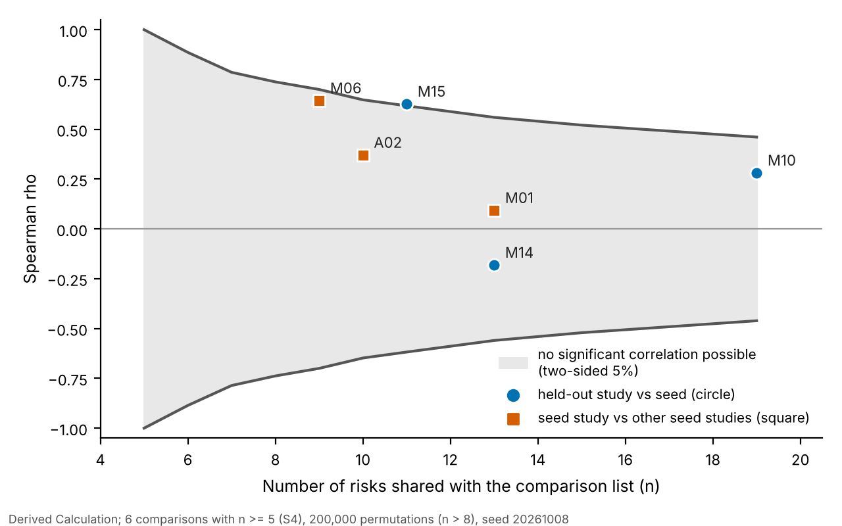
Figure 7.1. Smallest absolute Spearman correlation that could be called significant (two-sided, 5%) at each overlap of shared risks, with the observed leave-one-study-out correlations. Derived Calculation from analysis/out/s4_leave_one_study_out.csv and report/scripts/out/critical_rho.csv.
Taken together, the results support a narrow statement: the literature gives a coarse order, with a few risks (material availability, skilled labour) near the top in several lists and a few (social environment, training, client decisions) clearly lower, but it does not give a stable ranking of the middle. The bootstrap over the five seed studies agrees: three risks reach the top band in at least 80% of the 2,000 resamples (R-MAT, R-SAFE and R-SKILL), and R-SAFE rests on a single study (Derived Calculation, analysis S3). Resamples that omit a study drop its risks, so these shares are conditional on the risk being present. This is the reason the tool shows seeded risks as a labelled, uncounted “literature tier” and asks for entered numbers, instead of treating the seed as an estimate.
The disagreement also has a use. Because the surveys do not converge, the report can offer a methods point that does not depend on any site: rankings of delay factors from a handful of South Asian RII surveys are not stable enough to be copied into a risk register as if they were probabilities. This is a modest, checkable observation and the one the audit trail best supports.

What the matrix level means
The tool multiplies a probability class by an impact class and labels the product Low, Moderate, High or Extreme. This is a conventional device and it has known weaknesses. Cox (2008) lists poor resolution, errors in ranking, suboptimal resource allocation and ambiguous inputs and outputs as problems of risk matrices, and Duijm (2015) gives recommendations on their design; both are cited here for the general critique, and only the abstract of Cox was read in this project. Three of those concerns are visible in the tool.
First, resolution is coarse. Only five classes per axis exist, so risks with quite different entered numbers share a cell. In the ILLUSTRATIVE example, five of seven risks share the cell probability class 2 by impact class 4 (Chapter 6), although their probabilities range from 0.20 to 0.35 and their expected delays from 2.3 to 2.7 days.
Second, the score is symmetric and class 1 on either axis always gives Low. A risk with a probability below 0.2 is Low whatever its consequence, since 1 x 5 = 5. The tool prints this as an Assumption and also lists impact-class-5 risks separately, as a filter and not a score, so that a rare but severe risk is not lost.
Third, the result depends on the edges. In the example, replacing the probability edges with alternative sets changes between 2 and 7 of the 7 levels, and changing the level thresholds over 2,024 admissible triples changes a median of 5 of 7 (IQR 1 to 6; analysis S2). By contrast, scaling the impact edges between 0.5 and 2 changes the impact class of between 1 and 7 of the 7 risks but never a level, because the probability class caps the score. Two things follow. The level is less sensitive to the entered delay than a reader might expect; and the one number that moves the example most is a probability sitting exactly on an edge (R-WX, p = 0.20, which the tool places in class 2 under its lower-edge-inclusive convention). A reader should therefore treat the level as a prompt for discussion, and the probability class edges and thresholds as parameters that deserve a stated reason, which for this tool is that they are Assumptions (Appendix H).
For risks that carry only a literature tier, the weakness is larger. Using one band as both axes squares the rank (diagonal scores 1, 4, 9, 16 and 25), so a risk at the top fifth of an importance list scores 25. That is not a statement about probability or impact, and the earlier version of the tool coloured such placements Extreme, High or Low as if it were. After the committee review these placements are grey, dashed and excluded from the level totals. The more conservative option, removing level colours and the one-class step for rule flags altogether, remains a decision for the supervisor (audit file, F02).

Comparison with other ways of keeping a register
Three alternatives are realistic for a site engineer: a spreadsheet register, a schedule-risk package used by the planning office, and no formal register. The comparison below is limited to what could be established without testing commercial products. The project did not install or evaluate Primavera Risk Analysis or any other package, and the account of schedule-risk software rests on how it is described in the case studies of the corpus: Gheewala et al. (2025) used Primavera P6 with Risk Analyzer and Ichsan et al. (2025) used @RISK, in both cases on project schedules with distributions supplied by the study team. Anything not stated in those papers or visible in the repository is marked “not assessed”.
Table 7.2. Features of the tool compared with a spreadsheet register and with schedule-risk software as used in two cited case studies. Source: tool column from the repository (README.md, docs/case_schema.md, Appendices B to D); software column from Gheewala et al. (2025) and Ichsan et al. (2025) as summarised in Chapter 2; spreadsheet column describes what a plain sheet is, not any particular template. No commercial product was tested.
Capability | This tool | Spreadsheet register | Schedule-risk software (as used in the cited studies)
Masonry-specific risk library with evidence IDs | Yes: 46 risks, 30 with a survey seed value, 16 without | Only if the author builds one | Not assessed; the studies built their risk lists from surveys or focus groups
Source label required on every number | Yes: six labels; a number without one is rejected | Only if the author adds a column and keeps it | Not reported in the papers read
Site facts flag risks | Yes: 22 rules, Source Assumption, no numbers | Possible with formulas written by the author | Not assessed
Probability-impact matrix | Yes, with edges and thresholds printed as Assumptions | Possible; edges are whatever the author chose | Not assessed
Schedule simulation | Optional layer, entered numbers only, no defaults | Not in a plain sheet | Yes in both studies; distributions and probabilities supplied by the user (Chapter 2)
Whole-project schedule network | No: one activity | No | Yes: project-level in both studies
Works offline on one computer | Yes (local server or desktop window) | Yes | Not assessed
Evidence of use on real projects | None: verified by tests only; no user evaluation | Not assessed | Published case studies exist (two cited)
The differences are practical, not methodological. This tool contains no calculation that a competent engineer could not build in a spreadsheet, and it does not contain the project-level scheduling that the packages offer. What it adds is a particular discipline: a referenced list of masonry risks to start from, a prompt from site conditions, and an output that cannot show a number without its source. Whether that discipline helps a site engineer is not known. The closest published prior art for the optional quantitative layer is activity-level residual-risk simulation after mitigation (Ichsan et al., 2025, who took response effects from a five-person focus group); the response types in the register follow the avoid, reduce, transfer, accept classification used in the risk-response literature (Dey, 2011; Baker et al., 1999). No claim of novelty is made for any of these mechanics.

Implications for site engineers
The findings have practical consequences even though the tool has not been evaluated with users.
Use the library and the rules as a checklist, not as a forecast. The 46 risks and the rule prompts are the part most likely to help. A flag such as “stock on site runs out before a new delivery can arrive” asks a question the engineer can answer in a minute. It costs nothing to check and it is derived from facts the engineer entered. The flag says that the condition holds, not that a delay will follow.
Enter your own numbers, and say where they come from. A literature tier is a starting point for a conversation about which risks to look at first. As soon as the engineer has an estimate of a probability and a delay range, the estimate replaces the tier and carries its own Source label. An estimate from the engineer’s own experience is Expert Judgment; a count from the site diary is Historical Data. Both are better than a survey rank, and both are visible as such in the register and its exports.
Do not read the level as a measurement. The example shows that the level can change when a probability moves across an edge, and that the delay range has little influence on it. The ordering inside a level is not meaningful. A high-consequence risk of low probability appears in the separate impact-class-5 list for that reason.
Use the response fields. The register asks for an owner, an early-warning sign, a response type and a review date. These are text fields and carry no numbers, and they are what turns a ranked list into something a site team can act on. Several of the committee’s recommendations concerned exactly these fields, and the report treats them as at least as valuable as the matrix.
Treat the optional cost layer with caution. It compares responses using the engineer’s own costs and effects. If those effects are guesses, the output is a guess presented with a command word. The wording “preferred under the stated criterion” is deliberate, and a stability check across random seeds is built in, but neither guards against poor inputs.
Time and effort were not measured. The tool needs entry of facts and numbers for each activity. How long this takes, and whether a busy engineer would do it daily, is a question for the pilot in Chapter 8.

Threats to validity
Table 7.3. Threats to validity, their likely effect and what has been done or remains to do. Source: methods review of 2026-10-08, audit file, and the authors’ assessment.
Type | Threat | Likely effect | Done so far | Still needed
Construct | An RII is importance, not likelihood or days; the seed puts one band on both axes | A seeded placement has no quantitative meaning | Labelled Assumption everywhere; shown as an uncounted, grey literature tier; wording “starting position” | Expert likelihood and impact ratings on separate axes
Construct | Multiplicative matrix compresses range and depends on edges | Levels differ under other edges or thresholds | Edges and thresholds printed as Assumptions; sensitivity reported (analyses S1, S2) | Practitioner view on edges; option of dropping level colours for seeded risks
Internal | Single coder for the factor-to-risk mapping; some decisions inconsistent (F12) | The seed depends on one person’s judgment | Mapping rule documented; Direct versus Related distinguished | Second coder and Cohen’s kappa (Appendix G)
Internal | Analysis choices made after seeing the 10-risk data; the 38-risk run was a second look | Forking paths | One pre-specified family of variants; all variants reported | Re-run once on a reconciled mapping with the plan fixed in advance
Statistical conclusion | Five seed studies; 14 of 30 seeded risks rest on one; overlaps of 5 to 19 risks | Low power; unstable ranks; intervals understate uncertainty | Exact or permutation p-values; Holm correction; power shown (Figure 7.1) | More studies; complete the omitted A14, A10 and A21 factors and re-run once
Statistical conclusion | Surveys are not independent (M10 pools ten studies); M14 printed RII on a basis that differs from its stated scale | Agreement may be over- or understated | Noted; values kept as printed | Recompute M14 on its stated basis if the supervisor agrees
External | General building-construction surveys, two from Sri Lanka, one road-heavy (A14 26.4% road respondents), manager-dominated | Seed may not describe Indian masonry | Stated in every table note | Masonry-specific expert survey
Reliability of the tool | Defects listed in the engine audit (for example NaN accepted by the command-line writer, booleans accepted as numbers) | Wrong output on malformed input | Several fixed and tested after the review; 513 tests pass | Close the remaining items before any release
Ecological | No site data; example is ILLUSTRATIVE; no user evaluation | No evidence that levels match what happens on site | Claims limited accordingly | Site pilot and usability sessions (Chapter 8)
Corpus | Three corpus sizes appear in the project records (F08) | Reported search coverage uncertain | The three versions are listed with their source files in the audit file | Re-run the corpus statistics once against the database and keep one figure
One threat deserves a sentence of its own. The report was written after the tool, and several of its checks, such as the audit of the seed, the held-out comparison and the guard tests, were produced by reviewers who were asked to find faults. That is a strength for integrity and a weakness for independence: the same team that built the tool prepared the corrections. An outside reader should treat the audit trail as evidence of care, not as an independent evaluation.

What can and cannot be claimed
Table 7.4. Claims, whether the evidence supports them, and the wording to use. Source: docs/Project_Handoff_Summary.md section 8.11 and 8.12 (withdrawn and replacement wording), extended by this report.
Claim | Supported? | Wording to use
The tool predicts delay or labour productivity | No | “orders risks”; “starting position”
The literature seed has been validated | No | “agreement check with held-out surveys: weak, low-powered and inconclusive”
Published rankings agree | Not shown | “weak agreement, not distinguishable from chance”
The seed values are probabilities | No | “an importance rank used as an ordinal tier, an Assumption”
Every number in an export has a source | Yes, by design and by test G-5 | “each number is printed with its Source”
The AI supplies no numbers | By design and guard; fixed after the audit | “the AI can propose names, mechanisms and evidence IDs only; numeric fields are rejected”
The tool is accurate on real sites | No evidence | not claimed
The tool is useful to site engineers | Not evaluated | “intended to help; to be evaluated”
A first or new framework | Not claimed | “an evidence-traceable tool; no new method”
Published agreement shows masonry-specific importance | No; surveys are general | “general building-construction surveys”
The conclusion of this chapter is that the project delivers a transparent, offline, verified tool and an honest account of how little published rankings can carry, and that it stops short of everything that would need data from people or from sites.

Chapter 8. Conclusions, Limitations and Future Work

Conclusions
The project set out to build and verify an offline tool that helps a site engineer identify, register and prioritise delay risks in a brick or block masonry activity, with every value traceable to its source and with published survey evidence used only as a labelled ordinal starting point. Table 8.1 states what was concluded for each objective of Chapter 1, and how far.
Table 8.1. Conclusions mapped to the objectives. Source: Chapters 3 to 7; docs/Audit_Corrections_2026-10-08.md; Appendix E (Derived Calculation and Literature, as labelled in those chapters).
Objective | Conclusion | How far it goes
1. Compile and verify a masonry delay-risk library with a documented, inter-coder-checked mapping | A library of 46 risks (38 original, 8 added on 2026-10-08) was built, 30 of them with a survey seed value and 16 without. 182 RII rows (161 checked against the PDFs) from 11 studies (5 seed, 6 held-out) were transcribed; every one of the 161 rows checked matches the printed papers; the other 21 were not checked against a PDF. The mapping rule and its Direct / Related distinction are documented | Partly met. One coder made all mappings, and some decisions are inconsistent (audit finding F12). The second-coder check and kappa have not been done (Appendix G). The seed is a subset of the printed factors (A14 5 of 39, A15 5 of 32, A02 14 of 35), and the surveys are general building-construction surveys, not masonry surveys
2. Implement site-condition rules, a source-labelled register and a 5 x 5 matrix with assumptions stated | 22 site-fact rules, a register in which each number carries one of six Source labels (and in which text fields record owner, early-warning sign, response type, action and review date), a 5 x 5 matrix, and exports (Markdown, CSV, HTML, SVG, case file) were implemented. The assumptions that shape the output (equal-count bands, one band on both axes, probability edges, level thresholds, the one-class step for a rule flag) are listed in Appendix H and printed on every export | Met as software. The rule conditions and the matrix edges are Assumptions that no practitioner has yet endorsed
3. Analyse how consistent published RII rankings are, to establish how far literature can stand in for project data | Agreement between surveys is weak and not distinguishable from chance: held-out correlations 0.28, 0.63 and -0.18 on 19, 11 and 13 shared risks, none significant after Holm correction; leave-one-study-out cross-prediction 0.09 to 0.64; Kendall’s W 0.40 (permutation p = 0.15). Band and study choices change 6.7% to 80.0% of seeded classes. Only a coarse order can be read from the literature | Met, with a negative result. The check is low-powered, so it cannot show that surveys disagree either. It supports the limited use of the seed as a starting position
4. Verify the software and evaluate it with practitioners; define site validation as future work | The suite passes 513 tests (3 skipped because the literature database is not in the repository) in 17 files; a worked example is given in Chapter 6. Site validation is defined below | Verification met; evaluation not done. No expert rating, usability session or site case exists
Four general conclusions follow.
- The most defensible contribution is the traceability. Every number in a register carries a Source, every assumption is named, and the claims that the audit withdrew are recorded with the reason. A reader can see which numbers are evidence and which are placeholders.
- A survey importance index cannot stand in for a probability. The seed is an ordinal starting position and nothing more. The weak agreement among surveys shows that even the order of the middle of the list is not settled by the data in hand.
- The matrix is a prompt for discussion. Its levels depend on edges and thresholds that are Assumptions and, in the example, depend more on the probability class than on the delay entered. It helps a team look at the same list of risks at the same time; it does not measure them.
- The registered title promised more than was done. Productivity prediction, a rules matrix giving probability and cost, and the financial decision command were not built as described, because no site data existed to feed them. Chapter 1 gives the term-by-term account. The optional quantitative layer added on 2026-10-08 runs only on numbers the user enters and has been verified only as software.

Limitations
The limitations that bear on every result are these.
- No primary data. No site was visited, no site record collected, and no practitioner consulted. No number in this report is Historical Data, and no number is an expert rating.
- The seed is secondary and indirect. The RII surveys are general building-construction surveys from India and Sri Lanka (plus held-out studies from other countries); none is masonry-specific. The transcribed factors are a subset. M01 prints only RII of 0.700 or more. Scales differ between studies and the scale of two is not recorded. Fourteen of the 30 seeded risks rest on one study.
- One coder. The factor-to-risk mapping has no second coder and no agreement statistic.
- The agreement check is low-powered. With 5 to 19 shared risks only a correlation of about 0.46 (19 shared risks) to 1.00 (5 shared risks) could be detected (Figure 7.1). The analysis was first run on a 10-risk set and then on the 38-risk library, so the second run is a second look, and the library has since grown to 46 risks, the 8 new ones having no survey rows.
- Assumptions drive the placement. Equal-count bands, one band on both axes, equal study weights, averaging within a study first, and alphabetical tie-breaking are choices of the team (Appendix H).
- The tool has not been used by anyone but its authors. Usability, time to complete a case and acceptability are unknown. The Anthropic path of the optional AI feature was never run against the live service; the Google path was.
- Open defects. The engine audit lists defects that were fixed and tested after the committee review, and others that still need a code change (Audit Corrections, sections 4 and 6; for example NaN in the command-line JSON writer and booleans accepted as numbers). The corpus-size figure has three versions that are not reconciled (F08). Legacy productivity code with a known norms defect remains in the repository, unused.
- The registered title has not been changed. The decision belongs to the project guide.

Recommendations
For a site engineer who wants to try the tool. Use it on one masonry activity at a time. Start with the site facts and the rule prompts; treat the literature tier as a list of things to think about, not as a ranking of danger; replace it with your own estimates as soon as you have them, with the right Source label; fill in owner, early-warning sign and review date; and keep the exported register with its stated assumptions. Do not use the optional cost layer to justify spending unless the costs and effects entered have a source you can show.
For the project guide (decisions recorded as open). (i) Retitle the work to match what was done, or keep the registered title with the scope-revision table of Chapter 1. (ii) Decide whether to drop the one-class step for rule flags and to show seeded risks with no level colour (F02, F18). (iii) Decide whether to enter the omitted A14, A10 and A21 factors and re-run the statistics once, with the analysis plan fixed in advance (F03); the basis of the seed must not be chosen by which agreement figure looks better. (iv) Decide how to treat the truncated M01 list (F13) and whether to recompute M14 on its stated basis. (v) Approve the second-coder check before any mapping is changed (F12). (vi) Reconcile the corpus count with one re-run (F08).
For the maintainers of the code. Close the open items of the engine audit that touch integrity (the items listed as open in Audit Corrections; NaN, booleans, missing delay Source and malformed input shapes were fixed on 2026-10-08); move the unused productivity, norms and legacy simulation modules to a folder marked as legacy so that no reader mistakes them for the deliverable; and keep the guard tests of Appendix E, which tie the counts and the wording rules in the documents to the data files.

Future work
The next steps are ordered by how much each adds for the effort. The first three need no site access.

1. Expert survey
Administer the 15-item instrument of Appendix F (frequency and severity rated separately, with N/A and Don’t know, neutral wording, randomised order, profile questions) to practitioners who have supervised masonry, with the analysis plan dated before the first reply. The target is at least 30 respondents, because 10 to 15 would be a pilot: with a planning standard deviation of one Likert point (Assumption AS-18) the half-width of one item’s index is about 0.10 at n = 15 and 0.07 at n = 30, while neighbouring seed risks differ by 0.001 to 0.02. Results would be labelled Expert Judgment with n, response rate and respondent profile, never converted to probabilities or days, and compared with the seed by Spearman correlation on the items with a one-to-one mapping, as an exploratory check with the detectable correlation stated in advance. The same survey can ask respondents to endorse the rule conditions and to name causes the library lacks. Institutional ethics approval and consent text must be settled first; neither has been sought.

2. Second coder
Carry out the protocol of Appendix G: freeze the coding manual, have a coder who did not build the mapping code the blinded rows, compute Cohen’s kappa for the risk assignment and a weighted kappa for the strength, apply the pre-committed rule that kappa below 0.60 triggers a revision of the manual (Cohen, 1960; Landis & Koch, 1977), log every change, and re-run the seed table and the statistics once, reporting the original and reconciled results side by side.

3. Face validity and usability session
Ask 5 to 8 site engineers to complete a case on the example activity and then on one of their own, observe where they hesitate, and collect a standard usability questionnaire such as the System Usability Scale (Brooke, 1996). Report the real number of participants and no synthetic ones. This is the only form of tool evaluation possible before site data exist, and it would show whether the rule prompts, the Source labels and the register fields are understood.

4. Site pilot
A site pilot would collect a daily diary for each masonry activity, with cause codes equal to the library risk identifiers: date, masons and helpers present, quantity laid (in one unit chosen at the start), hours lost and cause, rain and heat, hoist, scaffold and mixer status, material received, hold points passed; plus a start-of-activity snapshot of every rule fact. The project records plan three to five completed activities for a first phase. With so few activities only descriptive comparisons are possible, and the report should say so. The four comparisons planned in the project records are: (a) did the tool’s flags include the risks that happened (hit rate); (b) does the order of the matrix match the days lost (Spearman correlation); (c) do entered probabilities match how often risks occurred, which needs many activities; and (d) only if the quantitative layer is used, did the actual delay fall inside the simulated range. All diary numbers would be Historical Data. Site access and permission are the main obstacles.

5. Prerequisites for the parts of the registered title that were not built
Table 8.2. What each deferred part of the registered title would need before it could be built or switched on honestly. Source: docs/Project_Handoff_Summary.md sections 6 and 8; Research_Notes/ (productivity and norms notes); committee reviews of 2026-10-08. Nothing in the third column exists yet.
Part | Needs | Why the present data cannot supply it
Labour-productivity model | Measured output per crew per day on masonry activities (unit chosen in advance), crew size and mason-to-helper ratio, wall height and number of openings, weather and working hours, supervision time | The seed surveys rate importance; they contain no output measurements. CPWD and BIS labour norms are planning norms, not measured productivity, and the legacy norms file has a documented defect
Prediction from managerial factors | Many activities with managerial factors recorded (supervision hours, material staging, crew ratio) and an observed outcome for each, in enough number to fit and test a model out of sample | There are no projects and no outcomes. Fitting a model to survey importance values would produce a number without meaning
Monte Carlo schedule simulation on real risks | For each risk, a frequency from several activities or an elicited probability, and a delay distribution from days lost per event, each with a Source | RII is not a probability or days; the tool refuses to use seed placements in the simulation. The layer already runs on entered numbers, but nothing entered so far is evidence
Expected-monetary-value command | Cost of one delay day from the contract (liquidated damages, site overheads), cost quotations for each response, and an observed or elicited effect of each response on probability or delay | No cost or effect size exists in the project; the tool deliberately supplies none
Rules matrix of 27 states | A source for every cell, or a replacement by rules with practitioner endorsement | The original cells had no source; the present 22 rules carry no numbers
None of these is a coding task. Each is a data-collection task, and the pilot in item 4 is its first step.

6. A single clean re-run of the seed statistics
When the second coder has reported and the omitted factors of A14, A10 and A21 have been entered, re-run the secondary-data analysis once with the family of tests fixed in advance, permutation p-values, Holm correction and held-out studies kept out of any reference they are compared with. Correct the generator text of the corpus scripts (F19, F20) and the circular figures that the older statistics scripts still print (F01), so that a re-run does not reintroduce withdrawn wording.

7. Routes to a paper
The work supports two modest routes, and not a claim of a validated predictive framework. The first is a paper that combines the expert survey (item 1) with a face-validity and usability evaluation of the tool (item 3). The second is a methods note on how unstable RII-based rankings of delay factors are across South Asian surveys, and what that means for seeding a risk register, built on the secondary-data analysis already done and the single clean re-run of item 6. Either needs the corresponding primary data or the re-run first. Publication in a particular indexed journal is not claimed here.

Closing statement
What has been built is a small, careful instrument: a library of masonry delay risks tied to the surveys that support them, a set of site-fact prompts, a register in which no number appears without its Source, and a record of what was checked and what was withdrawn. What it has not done is show that any of this changes a decision on a site. The most useful next step is to put it in front of site engineers and to record, with their permission and with real numbers, what happens on their next masonry activities.

References
References are in APA 7th edition author-date style, assembled from the lists kept by each chapter writer. Only works that appear in the repository evidence corpus or in the project’s methods notes are listed. Where a bibliographic detail (author initials, volume, pages, DOI, edition) is not recorded in the repository it has been left out and not guessed; such entries are marked with a dagger (†) and itemised in report/references_unverified.txt. Standards are listed without an edition year where the year is not recorded.
Abd Aziz, N., Mohd Rahim, F. A., & Aziz, N. M. (2022). Delay mitigation strategies and the implication on the construction industry: A systematic literature review. Planning Malaysia, 20(24). https://doi.org/10.21837/pm.v20i24.1199
Abeysinghe, & Jayathilaka. (2022). Factors influencing the timely completion of construction projects in Sri Lanka. PLoS ONE, 17(12), Article e0278318. https://doi.org/10.1371/journal.pone.0278318 [check: initials]
Abu Hasan, A., Fenn, P., & Aminian, E. (2025). Conflict and delay in construction projects: A systematic literature review. Journal of Engineering and Technology (UTeM), 16(2). https://doi.org/10.54554/jet.2025.16.2.001
Acebes, F., Gonzalez-Varona, J. M., Lopez-Paredes, A., & Pajares, J. (2024). Beyond probability-impact matrices in project risk management: A quantitative methodology for risk prioritisation. Humanities and Social Sciences Communications, 11, Article 670. https://doi.org/10.1057/s41599-024-03180-5
Adebowale, & Agumba. (2023). A meta-analysis of factors affecting construction labour productivity in the Middle East. Journal of Construction in Developing Countries, 28(1), 193-220. https://doi.org/10.21315/jcdc-12-21-0192 [check: initials]
Almeida, E. L. G. de, Feitoza, V. A. S., Carvalho, M. T. M., Piña, A. B. S., Araújo, L. G., & Aidar, L. A. G. (2021). Study of delays in constructions: A managerial point of view of private companies in Brasilia, Brazil. Gestao & Producao, 28(3), Article e5194. https://doi.org/10.1590/1806-9649-2021v28e5194 [check: surname form, journal diacritics, DOI inconsistency inside the PDF (e5194 vs e5120)]
Ameyaw, [initials not recorded], Hu, [initials not recorded], Shan, [initials not recorded], Chan, [initials not recorded], & Le, [initials not recorded]. (2016). Application of Delphi method in construction engineering and management research: A quantitative perspective. Journal of Civil Engineering and Management, 22(8), 991-1000. https://doi.org/10.3846/13923730.2014.945953 [INCOMPLETE: initials] †
Baker, [initials not recorded], Ponniah, [initials not recorded], & Smith, [initials not recorded]. (1999). Risk response techniques employed currently for major projects. Construction Management and Economics. https://doi.org/10.1080/014461999371709 [INCOMPLETE: initials, volume, issue, pages not in repository; Research_Notes/D_mitigation.md record D16, abstract only] †
Bedford, [initials not recorded], Quigley, [initials not recorded], & Walls, [initials not recorded]. (2006). Expert elicitation for reliable system design. Statistical Science, 21(4), 428-450. https://doi.org/10.1214/088342306000000510 [INCOMPLETE: initials] †
Brooke, J. (1996). SUS: A quick and dirty usability scale. †
Bureau of Indian Standards. (1974). IS 7272 (Part 1): Recommendation for labour output constants for building work, Part I: North Zone. Bureau of Indian Standards. [Reaffirmed 2010; Amendment No. 1, 1979. Verify against the standard.]
Canesi, R., Gabrielli, L., Marella, G., & Ruggeri, A. (2025). Probabilistic risk assessment framework for cost overruns predictions in infrastructure projects using randomized simulations. Computer-Aided Civil and Infrastructure Engineering. https://doi.org/10.1111/mice.70100
Central Public Works Department. (2008). Analysis of rates for Delhi 2007 (Vol. 1). Director General (Works), Central Public Works Department, Government of India. [Foreword dated February 2008; verify]
Cohen, J. (1960). A coefficient of agreement for nominal scales. Educational and Psychological Measurement, 20(1), 37-46.
Cox, L. A., Jr. (2008). What’s wrong with risk matrices? Risk Analysis, 28(2), 497-512. https://doi.org/10.1111/j.1539-6924.2008.01030.x
Cronbach, L. J. (1951). Coefficient alpha and the internal structure of tests. Psychometrika, 16(3), 297-334.
Curto, [initials not recorded], Acebes, [initials not recorded], Gonzalez-Varona, [initials not recorded], & Poza, [initials not recorded]. (2022). Impact of aleatoric, stochastic and epistemic uncertainties on project cost contingency reserves. International Journal of Production Economics, 253, Article 108626. https://doi.org/10.1016/j.ijpe.2022.108626 [INCOMPLETE: initials] †
Dey, P. K. (2011). Project risk management using multiple criteria decision-making technique and decision tree analysis: A case study of Indian oil refinery. Production Planning & Control, 23(12), 903-921. https://doi.org/10.1080/09537287.2011.586379
Dharmarathne, G., Hanea, A., & Robinson, A. (2022). Are experts well-calibrated? An equivalence-based hypothesis test. Entropy, 24(6), Article 757. https://doi.org/10.3390/e24060757
Dixit, Mandal, Thanikal, & Saurabh. (2019). Study of significant factors affecting construction productivity using relative importance index in Indian construction industry. E3S Web of Conferences, 140, Article 09010. https://doi.org/10.1051/e3sconf/201914009010 [check: initials]
Djohim, [initials not recorded], Nugroho, [initials not recorded], & Handayani, [initials not recorded]. (2024). Risk analysis of modest housing projects scheduling using Monte Carlo simulation. Civil Engineering Dimension, 26(2), 160-172. https://doi.org/10.9744/ced.26.2.160-172 [INCOMPLETE: initials] †
Duijm, N. J. (2015). Recommendations on the use and design of risk matrices. Safety Science, 76, 21-31. [DOI not in repository]
Erfani, A., & Khanjar, H. (2025). Large language models for construction risk classification: A comparative study. Buildings, 15(18), Article 3379. https://doi.org/10.3390/buildings15183379
Flyvbjerg, B. (2006). From Nobel Prize to project management: Getting risks right. Project Management Journal, 37(3), 5-15. https://doi.org/10.1177/875697280603700302
Fowler, [initials not recorded], Joiner, [initials not recorded], & Ma, [initials not recorded]. (2024). Cyber Evaluation and Management Toolkit (CEMT): Face validity of model-based cybersecurity decision making. Systems, 12(7), Article 238. https://doi.org/10.3390/systems12070238 [INCOMPLETE: initials] †
Gao, Y., Yiu, T. W., Shen, X., & Tam, V. W. Y. (2026). Large language models in smart construction: A systematic review of implementation strategies, applications and future directions. Engineering, Construction and Architectural Management. https://doi.org/10.1108/ecam-10-2025-1668
Gerek, [initials not recorded], Erdis, [initials not recorded], Mistikoglu, [initials not recorded], & Usmen, [initials not recorded]. (2015). Modelling masonry crew productivity using two artificial neural network techniques. Journal of Civil Engineering and Management, 21(2), 231-238. https://doi.org/10.3846/13923730.2013.802741 [INCOMPLETE: initials] †
Ghaeb, H. O., & Mahjoob, A. M. R. (2023). Risk response in construction project: A review study. Journal of Engineering (University of Baghdad), 29(8). https://doi.org/10.31026/j.eng.2023.08.09
Gheewala, D., Chaturvedi, S., & Sarkar, D. (2025). Probabilistic risk analysis for elevated metro rail construction using Monte Carlo simulations. International Journal of Construction Management. https://doi.org/10.1080/15623599.2025.2603423
Guha, [initials not recorded], & Biswas, [initials not recorded]. (2008). Monsoon risks for construction sites in India. In 2008 IEEE International Conference on Industrial Engineering and Engineering Management. IEEE. https://doi.org/10.1109/IEEM.2008.4738167 [INCOMPLETE: initials; DOI from a ResearchGate page, verify] †
Hadad, Y., & Keren, B. (2025). Risk-response budgeting: A financial optimization approach to project risk management. Journal of Risk and Financial Management, 18(3), Article 160. https://doi.org/10.3390/jrfm18030160
Hahn, [initials not recorded]. (2008). Mixture densities for project management activity times: A robust approach to PERT. European Journal of Operational Research, 188(2), 450-459. https://doi.org/10.1016/j.ejor.2007.04.032 [INCOMPLETE: initials] †
Hassoon, [initials not recorded], et al. (2025). [Title not recorded in the repository]. Journal of Infrastructure Preservation and Resilience, 6, Article 3. https://doi.org/10.1186/s43065-025-00116-4 [INCOMPLETE: real title and author list needed; seed file calls the title field a placeholder] †
Herrerias-Velasco, [initials not recorded], Herrerias-Pleguezuelo, [initials not recorded], & van Dorp, [initials not recorded]. (2011). Revisiting the PERT mean and variance. European Journal of Operational Research, 210, 448-451. https://doi.org/10.1016/j.ejor.2010.08.014 [INCOMPLETE: initials, issue; cited for the (a + 4m + b)/6 mean, Research_Notes/B_methods.md B01] †
Holm, S. (1979). A simple sequentially rejective multiple test procedure. Scandinavian Journal of Statistics, 6(2), 65-70.
Ichsan, [initials not recorded], Isvara, [initials not recorded], & Karim, [initials not recorded]. (2025). Monte Carlo simulation for enhancing the schedule completion forecast of Jakarta Central Railway Station construction project. Applied Sciences, 15(13), Article 7464. https://doi.org/10.3390/app15137464 [INCOMPLETE: initials] †
International Organization for Standardization. (2018). ISO 31000:2018. †
International Electrotechnical Commission. (n.d.). IEC 31010: Risk management: Risk assessment techniques. [Edition year not in repository; verify against the standard]
International Organization for Standardization. (n.d.). ISO 31000: Risk management: Guidelines. [Edition year not in repository; verify against the standard]
Karthik, D., & Rao, C. B. K. (2019a). The analysis of essential factors responsible for loss of labour productivity in building construction projects in India. Engineering Journal, 23(2), 55-70. https://doi.org/10.4186/ej.2019.23.2.55
Karthik, D., & Rao, C. B. K. (2019b). Identifying the significant factors affecting masonry labour productivity in India. International Journal of Construction Management, 22(3), 464-472. https://doi.org/10.1080/15623599.2019.1631978 [check: year is 2019 online and 2022 for the issue; the text cites it as “2022 or 2019”; used only as a source not entered in the seed]
Kendall, M. G., & Babington Smith, B. (1939). The problem of m rankings. The Annals of Mathematical Statistics, 10(3), 275-287.
Khodabakhshian, A., Puolitaival, T., & Kestle, L. (2023). Deterministic and probabilistic risk management approaches in construction projects: A systematic literature review and comparative analysis. Buildings, 13(5), Article 1312. https://doi.org/10.3390/buildings13051312
Koulinas, G. K., Xanthopoulos, A. S., Tsilipiras, T. T., & Koulouriotis, D. E. (2020). Schedule delay risk analysis in construction projects with a simulation-based expert system. Buildings, 10(8), Article 134. https://doi.org/10.3390/buildings10080134
Koulinas, G. K., Demesouka, O. E., Sidas, K. A., & Koulouriotis, D. E. (2021). A TOPSIS - risk matrix and Monte Carlo expert system for risk assessment in engineering projects. Sustainability, 13(20), Article 11277. https://doi.org/10.3390/su132011277
Landis, J. R., & Koch, G. G. (1977). The measurement of observer agreement for categorical data. Biometrics, 33(1), 159-174.
Lawaju, N., Parajuli, N., & Shrestha, S. K. (2021). Analysis of labor productivity of brick masonry work in building construction in Kathmandu Valley. Journal of Advanced College of Engineering and Management, 6, 159-175. https://doi.org/10.3126/jacem.v6i0.38356
Loekito, Dani, Zulfikar, Triarso, & Prasetyono. (2026). Factors influencing construction worker productivity in Indonesia and strategies for improvement. Multidisciplinary Science Journal, 8, Article e2026243. https://doi.org/10.31893/multiscience.2026243 [check: initials]
Loganathan, [initials not recorded], & Kalidindi, [initials not recorded]. (2015). Masonry labor construction productivity variation: An Indian case study. Proceedings of the Indian Lean Construction Conference, Mumbai, India (Vol. 1). [INCOMPLETE: initials, DOI, pages] †
Loganathan, [initials not recorded], & Kalidindi, [initials not recorded]. (2016). Absenteeism and turnover of migrant construction workers in Indian projects: A survey-based study. In Construction Research Congress 2016 (pp. 1793-1802). American Society of Civil Engineers. https://doi.org/10.1061/9780784479827.179 [INCOMPLETE: initials] †
Manoharan et al. (2022). Labour-related factors affecting construction productivity in Sri Lankan building projects: Perspectives of engineers and managers. Frontiers in Engineering and Built Environment. https://doi.org/10.1108/FEBE-03-2022-0009 [check: authors, volume, pages]
Martin, H., James, J., & Chadee, A. (2025). Exploring large language model AI tools in construction project risk assessment: ChatGPT limitations in risk identification, mitigation strategies, and user experience. Journal of Construction Engineering and Management, 151(9). https://doi.org/10.1061/JCEMD4.COENG-16658
Mehta, [initials not recorded], & Gaikwad, [initials not recorded]. (2017). Delays and its analysis: Indian residential construction projects. Journal of Construction Engineering and Project Management, 7(4), 20-28. https://doi.org/10.6106/JCEPM.2017.7.4.020 [INCOMPLETE: initials] †
Noushad, [initials not recorded], Saud, [initials not recorded], & Neduvancheri, [initials not recorded]. (2023). Analysis of causes and effects of critical delay factors in high rise building projects of Kerala. In Proceedings of SECON’23 (Lecture Notes in Civil Engineering, Vol. 381). Springer. https://doi.org/10.1007/978-3-031-39663-2_8 [INCOMPLETE: initials, editors, pages] †
Ouansrimeang, & Wisaeang. (2024). Analyzing the critical delay factors for construction projects in the public sector using relative importance index and machine learning techniques. Journal of Infrastructure, Policy and Development, 8(8), Article 6208. https://doi.org/10.24294/jipd.v8i8.6208 [check: initials]
Pinky Devi, & Sindhu. (2025). Delay analysis of infrastructure construction projects in India. Journal of The Institution of Engineers (India): Series A, 106(3), 763-771. https://doi.org/10.1007/s40030-025-00899-5 [check: author name form]
Ponmalar, Aravindraj, & Nandhini. (2018). Study on factors influencing labour productivity in residential buildings in Indian scenario. IJETMR, 5(2), 239-248. https://doi.org/10.29121/ijetmr.v5.i2.2018.168 [check: initials, journal full name]
Prins, [initials not recorded], Kammouh, [initials not recorded], & Wolfert, [initials not recorded]. (2022). Multi-criteria optimization and automated network restructuring to mitigate construction projects delays on-the-run (an extension of the Mitigation Controller). arXiv:2206.09823 [preprint, not peer reviewed; cited only as an example of the Bernoulli x Beta-PERT risk-event structure, Research_Notes/B_methods.md B18; INCOMPLETE: initials]
Project team. (2026a). Audit corrections, 2026-10-08 [Unpublished project document]. FYP repository, docs/Audit_Corrections_2026-10-08.md.
Project team. (2026b). Literature database report [Unpublished project document]. FYP repository, docs/Literature_Database_Report.md.
Project team. (2026c). Project handoff summary, Sections 5, 8 and 9 [Unpublished project document]. FYP repository, docs/Project_Handoff_Summary.md.
Project team. (2026d). Statistical analysis of the literature database [Unpublished project document]. FYP repository, docs/Corpus_Statistical_Analysis.md.
Rana, [initials not recorded], Sharma, [initials not recorded], Neupane, [initials not recorded], & Shrestha, [initials not recorded]. (2023). [Title not recorded in the repository; bricklaying labour productivity in Surkhet]. Advances in Engineering and Technology: An International Journal, 3(1), 103-119. https://doi.org/10.3126/aet.v3i1.60628 [INCOMPLETE: title, initials] †
Reddy, G. V. K., & Chambrelin, K. S. (2021). Application of time and motion study for brickwork activity in residential building. IOP Conference Series: Materials Science and Engineering, 1197, Article 012038. https://doi.org/10.1088/1757-899X/1197/1/012038
Romzi, N. A., & Doh, S. I. (2022). Underlying causes of construction project delay: A review. CONSTRUCTION, 2(2). https://doi.org/10.15282/construction.v2i2.7775
Sargent, R. G. (2013). Verification and validation of simulation models. Journal of Simulation, 7(1), 12-24. https://doi.org/10.1057/jos.2012.20 [venue metadata discrepancy noted in Research_Notes; verify]
Song, Y., & Vanhoucke, M. (2025). Schedule risk analysis for project control with risk interactions. Annals of Operations Research. https://doi.org/10.1007/s10479-025-06668-8
Soundarya et al. (2025). An investigation study on residential buildings for cost overrun. Scientific Reports. https://doi.org/10.1038/s41598-025-95984-x [check: authors, volume, article number]
Starczyk-Kolbyk, [initials not recorded], & Jedras, [initials not recorded]. (2025). [Title not recorded in the repository; matrix versus Monte Carlo risk analysis of a high-rise office building]. Applied Sciences, 15(17), Article 9371. https://doi.org/10.3390/app15179371 [INCOMPLETE: title, initials] †
Tankkar, [initials not recorded], & Wanjari, [initials not recorded]. (2015). Identification of critical delay factors in execution of construction projects in India. Research Journal of Engineering and Technology, 6(4), 389-398. https://doi.org/10.5958/2321-581X.2015.00061.6 [INCOMPLETE: initials] †
Trietsch, [initials not recorded], Mazmanyan, [initials not recorded], Gevorgyan, [initials not recorded], & Baker, [initials not recorded]. (2012). Modeling activity times by the Parkinson distribution with a lognormal core: Theory and validation. European Journal of Operational Research, 216, 386-396. https://doi.org/10.1016/j.ejor.2011.07.054 [INCOMPLETE: initials, issue] †
Vilibic, K., Sigmund, Z., & Zavrski, I. (2026). Intelligent risk identification in construction projects: A case study of an AI-based framework. Buildings, 16(2), Article 409. https://doi.org/10.3390/buildings16020409
Williams, [initials not recorded], Wilson, [initials not recorded], & Wilson, [initials not recorded]. (2021). A comparison of prior elicitation aggregation using the Classical Method and SHELF. Journal of the Royal Statistical Society: Series A (Statistics in Society), 184(3), 920-940. https://doi.org/10.1111/rssa.12691 [INCOMPLETE: initials] †
Works Department, Government of Odisha. (2006). Analysis of rates 2006. https://works.odisha.gov.in/sites/default/files/2022-02/document2013-03-07_29.pdf
Zorrilla, J., Seijo, S., Arenal, U., & Mena, J. R. (2026). AI-driven decision support system for proactive risk management in construction projects. Intelligent Infrastructure and Construction, 2(2), Article 4. https://doi.org/10.3390/iic2020004

Appendix A. Literature seed table: all 182 rows
This appendix reproduces every row of data/literature_seed.json in file order (Source: Literature; transcribed from the printed papers and checked row by row against the PDFs on 2026-10-08, see docs/Audit_Corrections_2026-10-08.md section 3). Generated by report/scripts/gen_appendices.py. No value has been altered. The RII is a survey importance index; it is not a probability and not a number of days. The rank is the rank printed in the source study, within that study’s own list, and is not comparable between studies. “Mapped risk” is the library risk the team assigned (Source: Expert Judgment, single coder; the second-coder check is not done, see Appendix G). Mapping type “direct” means the factor is the same thing as the library risk; “related” means a looser match, and only “direct” rows of seed studies feed the literature seed. 135 rows are direct, 43 related and 4 unmapped (three are group-level rows or are noted as such in the file, one is the M14 item “No consumption”). The seed studies are a subset of the factors printed in several papers (for A14 only 5 of 39 factors were entered, for A15 5 of 32, for A02 14 of 35); M01 prints only factors with RII of 0.700 or more. These selection effects are discussed in Chapters 4 and 7.
Table A.1. The 11 studies in the seed file (5 seed, 6 held-out) and the number of rows each contributes. Source: data/literature_seed.json, field studies; row counts are a Derived Calculation from the file.
Study | Role | Year | Country / context | N | Scale | Rows
M01 | seed | 2019 | India (Telangana) | 44 | 1-5 | 28
A02 | seed | 2018 | India (Chennai) | Not reported | 1-4 | 14
M06 | seed | 2019 | India | 201 | 1-5 | 40
A14 | seed | 2022 | Sri Lanka | 163 | 1-5 (very low to very high significance) | 5
A15 | seed | 2022 | Sri Lanka | 90 firms | Not recorded | 5
M10 | held-out | 2023 | Middle East (10 studies: Malaysia, Palestine, Kuwait, Qatar, Saudi Arabia, Egypt, Bahrain, Oman, Yemen, Vietnam) | 10 studies | Pooled RII | 33
M15 | held-out | 2021 | Brazil (Brasilia) | 47 | 1-4 | 24
M14 | held-out | 2026 | Indonesia (East Java) | 83 | 1-4 | 23
A10 | held-out | 2025 | India | 72 | 1-5 | 6
A21 | held-out | 2024 | Thailand | 30 projects; 380 respondents | 1-5 importance scale | 2
HAS25 | held-out | 2025 | Iraq | Not recorded | Not recorded | 2
Table A.2. The 182 seed rows. “Not printed” means the paper does not print a rank for that row. Source: Literature (data/literature_seed.json, field rows); mapped risk and mapping type: Expert Judgment.
No. | Study (role) | Factor as printed | RII | Rank | Mapped risk | Mapping
1 | M01 (seed) | Unsafe working conditions | 0.809 | 1 | R-SAFE | direct
2 | M01 (seed) | Poor work planning | 0.791 | 2 | R-PLAN | direct
3 | M01 (seed) | Unrealistic scheduling | 0.791 | 3 | R-PLAN | direct
4 | M01 (seed) | Little or no financial rewards | 0.777 | 4 | R-INC | direct
5 | M01 (seed) | Material shortages | 0.777 | 5 | R-MAT | direct
6 | M01 (seed) | Payment delay | 0.773 | 6 | R-PAY | direct
7 | M01 (seed) | Working at heights | 0.764 | 7 | R-SAFE | direct
8 | M01 (seed) | Weather conditions | 0.764 | 8 | R-WX | direct
9 | M01 (seed) | Lack of skill and experience of worker | 0.759 | 9 | R-SKILL | direct
10 | M01 (seed) | Poor or no supervision method | 0.759 | 10 | R-SUP | direct
11 | M01 (seed) | Incompetent supervisors | 0.759 | 11 | R-SUP | direct
12 | M01 (seed) | Accidents | 0.759 | 12 | R-ACC | direct
13 | M01 (seed) | Poor relation between labour and superintendents | 0.755 | 13 | R-COM | related
14 | M01 (seed) | Poor condition of equipment and tools | 0.750 | 14 | R-TOOL | direct
15 | M01 (seed) | Bad leadership skill | 0.750 | 15 | R-DIS | direct
16 | M01 (seed) | Working 7 days per week | 0.741 | 16 | R-OVT | direct
17 | M01 (seed) | Equipment and tools shortages | 0.741 | 17 | R-TOOL | direct
18 | M01 (seed) | Low labour morale/commitment | 0.736 | 18 | R-MOT | direct
19 | M01 (seed) | Rework | 0.736 | 19 | R-RWK | direct
20 | M01 (seed) | Lack of empowerment | 0.732 | 20 | R-MOT | related
21 | M01 (seed) | Change order during execution | 0.732 | 21 | R-DES | direct
22 | M01 (seed) | Low amount of pay | 0.727 | 22 | R-INC | direct
23 | M01 (seed) | High workforce absenteeism | 0.723 | 23 | R-LAB | direct
24 | M01 (seed) | Lack of labour surveillance | 0.714 | 24 | R-SUP | direct
25 | M01 (seed) | Inadequate safety plan | 0.714 | 25 | R-SAFE | related
26 | M01 (seed) | Frequency of working overtime | 0.709 | 26 | R-OVT | direct
27 | M01 (seed) | Effectiveness of management system | 0.709 | 27 | R-MGT | direct
28 | M01 (seed) | Method of construction | 0.700 | 28 | R-MTH | direct
29 | A02 (seed) | Lack of experience (manpower) | 0.787 | 1 | R-SKILL | direct
30 | A02 (seed) | Absenteeism | 0.751 | 2 | R-LAB | direct
31 | A02 (seed) | Age | 0.730 | not printed | R-FAT | related
32 | A02 (seed) | Misunderstanding among labourers | 0.680 | not printed | R-COM | direct
33 | A02 (seed) | Accidents | 0.650 | not printed | R-ACC | direct
34 | A02 (seed) | Personal problems | 0.610 | not printed | R-FAT | direct
35 | A02 (seed) | Lack of required construction material | 0.780 | 1 | R-MAT | direct
36 | A02 (seed) | Lack of tools/equipment | 0.760 | not printed | R-TOOL | direct
37 | A02 (seed) | Poor site condition | 0.751 | not printed | R-SITE | direct
38 | A02 (seed) | Material storage location | 0.700 | not printed | R-STO | direct
39 | A02 (seed) | Increase in price of material | 0.550 | 9 | R-PRC | direct
40 | A02 (seed) | Payment delays | 0.776 | not printed | R-PAY | direct
41 | A02 (seed) | Weather condition | 0.700 | 3 | R-WX | direct
42 | A02 (seed) | Shortage of water | 0.650 | 5 | R-WAT | direct
43 | M06 (seed) | Availability of resources | 0.802 | 1 | R-MAT | related
44 | M06 (seed) | Contractual disputes | 0.799 | 2 | R-CTR | direct
45 | M06 (seed) | Scope clarity of the project | 0.790 | 3 | R-SCP | direct
46 | M06 (seed) | Design capability and frequent design changes | 0.785 | 4 | R-DES | direct
47 | M06 (seed) | Rework | 0.776 | 5 | R-RWK | direct
48 | M06 (seed) | Coordination between all stakeholders | 0.774 | 6 | R-MGT | direct
49 | M06 (seed) | Project manager’s authority to take financial decisions and select key team members | 0.772 | 7 | R-MGT | related
50 | M06 (seed) | Timely payment of completed works | 0.771 | 8 | R-PAY | direct
51 | M06 (seed) | Site clearance/availability | 0.771 | 9 | R-SITE | direct
52 | M06 (seed) | Ability to handle the crisis by the PM | 0.771 | 10 | R-MGT | related
53 | M06 (seed) | Use of inappropriate planning tools and techniques | 0.763 | 11 | R-PLAN | direct
54 | M06 (seed) | Quality | 0.754 | 12 | R-QLT | related
55 | M06 (seed) | Leadership qualities | 0.752 | 13 | R-DIS | related
56 | M06 (seed) | Top management support to PM | 0.752 | 14 | R-MGT | related
57 | M06 (seed) | Human resource and labour strike | 0.749 | 15 | R-STR | direct
58 | M06 (seed) | Cost | 0.744 | 16 | R-CST | direct
59 | M06 (seed) | Project coordination meetings | 0.740 | 17 | R-MGT | direct
60 | M06 (seed) | Inadequate project formulation in the beginning | 0.738 | 18 | R-SCP | direct
61 | M06 (seed) | Obsolete construction equipment, methods and technology | 0.738 | 19 | R-TOOL | related
62 | M06 (seed) | Conflict of interest among team members | 0.737 | 20 | R-CTR | related
63 | M06 (seed) | Customer/client satisfaction | 0.730 | 21 | R-CLI | related
64 | M06 (seed) | Conflict of interest among team members (second entry) | 0.730 | 22 | R-CTR | related
65 | M06 (seed) | Availability of training and development for enhancing skills | 0.727 | 23 | R-SKILL | related
66 | M06 (seed) | Selection of PM with proven track record | 0.724 | 24 | R-MGT | related
67 | M06 (seed) | Supply chain | 0.700 | 25 | R-MAT | related
68 | M06 (seed) | Willingness to adopt change | 0.700 | 26 | R-MGT | related
69 | M06 (seed) | Claim genuineness | 0.695 | 27 | R-CTR | direct
70 | M06 (seed) | Regular budget update | 0.693 | 28 | R-CST | direct
71 | M06 (seed) | Social skills of key team managers | 0.692 | 29 | R-COM | related
72 | M06 (seed) | Working hours | 0.688 | 30 | R-OVT | direct
73 | M06 (seed) | Developing and maintaining a short and informal line of communication | 0.679 | 31 | R-COM | direct
74 | M06 (seed) | Urgency emphasized by the owner while issuing tender | 0.674 | 32 | R-CLI | related
75 | M06 (seed) | Ability to delegate authority | 0.670 | 33 | R-MGT | related
76 | M06 (seed) | Political and economic environment | 0.666 | 34 | R-ECO | direct
77 | M06 (seed) | Exceptional difference between client and architect | 0.666 | 35 | R-CTR | related
78 | M06 (seed) | Interpersonal skills | 0.663 | 36 | R-COM | related
79 | M06 (seed) | Climate conditions | 0.657 | 37 | R-WX | direct
80 | M06 (seed) | Interest and inflation rates | 0.657 | 38 | R-ECO | direct
81 | M06 (seed) | Availability of accurate historical information | 0.642 | 39 | R-SCP | related
82 | M06 (seed) | Social environment | 0.594 | 40 | R-SOC | direct
83 | A14 (seed) | Shortage of skilled subcontractors/suppliers | 0.829 | 1 | R-MAT | related
84 | A14 (seed) | Shortage of labourers (skilled, semi-skilled, unskilled) | 0.825 | 2 | R-LAB | direct
85 | A14 (seed) | Delay of delivering materials to the site | 0.810 | 4 | R-MAT | direct
86 | A14 (seed) | Fluctuation of material prices in the market | 0.789 | 6 | R-PRC | direct
87 | A14 (seed) | Bad weather conditions | 0.653 | 30 | R-WX | direct
88 | A15 (seed) | Skills shortage | 0.820 | 1 | R-SKILL | direct
89 | A15 (seed) | Lack of thinking abilities | 0.810 | 2 | R-SKILL | related
90 | A15 (seed) | Lack of work experience | 0.800 | 3 | R-SKILL | direct
91 | A15 (seed) | Lack of knowledge in construction works | 0.790 | 4 | R-SKILL | direct
92 | A15 (seed) | Poor labour discipline | 0.790 | 5 | R-DIS | direct
93 | M10 (held-out) | Inadequate workers’ supervision | 0.816 | 2 | R-SUP | direct
94 | M10 (held-out) | A shortage of skilled labour | 0.801 | 3 | R-SKILL | direct
95 | M10 (held-out) | Extent of change orders | 0.793 | 4 | R-DES | direct
96 | M10 (held-out) | Clarity of technical specifications | 0.791 | 5 | R-DES | related
97 | M10 (held-out) | Coordination among design disciplines | 0.785 | 6 | R-DES | related
98 | M10 (held-out) | Lack of incentive schemes | 0.783 | 7 | R-INC | direct
99 | M10 (held-out) | Economic conditions | 0.778 | 8 | R-ECO | direct
100 | M10 (held-out) | Material shortage at project site | 0.775 | 9 | R-MAT | direct
101 | M10 (held-out) | Proportion of work subcontracted | 0.761 | 10 | R-SUB | direct
102 | M10 (held-out) | Rework | 0.761 | 10 | R-RWK | direct
103 | M10 (held-out) | Quality and availability of drawings | 0.758 | 12 | R-DES | direct
104 | M10 (held-out) | Payment delay | 0.751 | 13 | R-PAY | direct
105 | M10 (held-out) | Remuneration scale | 0.738 | 14 | R-INC | direct
106 | M10 (held-out) | Stringent inspections | 0.732 | 15 | R-QLT | direct
107 | M10 (held-out) | Physical fatigue | 0.723 | 16 | R-FAT | direct
108 | M10 (held-out) | Inclement weather conditions | 0.715 | 17 | R-WX | direct
109 | M10 (held-out) | Poor workers’ motivation | 0.709 | 18 | R-MOT | direct
110 | M10 (held-out) | Unrealistic deadline for project completion | 0.698 | 19 | R-PLAN | direct
111 | M10 (held-out) | Government policies | 0.698 | 19 | R-GOV | direct
112 | M10 (held-out) | Poor site management | 0.696 | 21 | R-PLAN | related
113 | M10 (held-out) | Working overtime | 0.696 | 21 | R-OVT | direct
114 | M10 (held-out) | Unavailability of suitable tools and equipment | 0.691 | 23 | R-TOOL | direct
115 | M10 (held-out) | Problem of communication | 0.682 | 24 | R-COM | direct
116 | M10 (held-out) | Unsuitability of storage location | 0.680 | 25 | R-STO | direct
117 | M10 (held-out) | Design complexity | 0.668 | 26 | R-MTH | direct
118 | M10 (held-out) | Construction method | 0.666 | 27 | R-MTH | direct
119 | M10 (held-out) | Absenteeism | 0.660 | 28 | R-LAB | direct
120 | M10 (held-out) | Working within a confined space | 0.659 | 29 | R-SITE | related
121 | M10 (held-out) | Inspection delay | 0.638 | 30 | R-QLT | direct
122 | M10 (held-out) | Accident | 0.632 | 31 | R-ACC | direct
123 | M10 (held-out) | Lack of labour recognition programmes | 0.555 | 33 | R-MOT | related
124 | M10 (held-out) | Project location | 0.555 | 33 | R-SITE | related
125 | M10 (held-out) | Inadequate training | 0.459 | 35 | R-TRN | direct
126 | M15 (held-out) | Rework | 0.750 | 1 | R-RWK | direct
127 | M15 (held-out) | Low labor productivity | 0.730 | 2 | R-PRD | direct
128 | M15 (held-out) | Lack of skilled labor | 0.725 | 3 | R-SKILL | direct
129 | M15 (held-out) | Low qualification of labor | 0.705 | 4 | R-SKILL | direct
130 | M15 (held-out) | Modifications to the project | 0.695 | 5 | R-DES | direct
131 | M15 (held-out) | Failure to manage deadlines | 0.690 | 6 | R-PLAN | related
132 | M15 (held-out) | Poor specification or lack of definition of the project | 0.690 | 6 | R-DES | direct
133 | M15 (held-out) | Incompatibility of projects | 0.670 | 8 | R-DES | related
134 | M15 (held-out) | Poor qualification in the contractor’s technical staff | 0.650 | 9 | R-MGT | related
135 | M15 (held-out) | Delay in delivery of material | 0.650 | 9 | R-MAT | direct
136 | M15 (held-out) | Unrealistic schedule | 0.640 | 11 | R-PLAN | direct
137 | M15 (held-out) | Timing failures due to overestimation of productivity | 0.630 | 12 | R-PLAN | related
138 | M15 (held-out) | Delay in ordering materials | 0.615 | 13 | R-MAT | direct
139 | M15 (held-out) | Conflict between parties (contractor and contractor) | 0.610 | 14 | R-CTR | direct
140 | M15 (held-out) | Delay in delivery of material at the front of service (site handling) | 0.590 | 15 | R-MAT | related
141 | M15 (held-out) | Delay in the mobilization of the work | 0.520 | 16 | R-MGT | direct
142 | M15 (held-out) | Low efficiency and productivity of equipment | 0.510 | 17 | R-TOOL | related
143 | M15 (held-out) | Delay for defective material | 0.485 | 18 | R-DEF | direct
144 | M15 (held-out) | Effects of climate on construction (heat, rain) | 0.475 | 19 | R-WX | direct
145 | M15 (held-out) | Equipment shortage | 0.455 | 20 | R-TOOL | direct
146 | M15 (held-out) | Accident during construction | 0.455 | 20 | R-ACC | direct
147 | M15 (held-out) | Complexity of the project | 0.444 | 22 | R-MTH | direct
148 | M15 (held-out) | Scarcity of building materials on the market | 0.435 | 23 | R-MAT | direct
149 | M15 (held-out) | Equipment defects | 0.415 | 24 | R-TOOL | direct
150 | M14 (held-out) | Low salary | 0.735 | 1 | R-INC | direct
151 | M14 (held-out) | Lack of supervision | 0.720 | 2 | R-SUP | direct
152 | M14 (held-out) | No incentives | 0.716 | 3 | R-INC | direct
153 | M14 (held-out) | Late payment | 0.716 | 4 | R-PAY | direct
154 | M14 (held-out) | Personal problems | 0.711 | 5 | R-FAT | direct
155 | M14 (held-out) | Changing jobs | 0.701 | 6 | R-MOT | related
156 | M14 (held-out) | Inadequate tools | 0.689 | 7 | R-TOOL | direct
157 | M14 (held-out) | Project scale | 0.660 | 8 | R-MTH | related
158 | M14 (held-out) | Types of work contracts | 0.660 | 9 | R-SUB | direct
159 | M14 (held-out) | Weather | 0.643 | 10 | R-WX | direct
160 | M14 (held-out) | Fatigue | 0.612 | 11 | R-FAT | direct
161 | M14 (held-out) | No consumption | 0.598 | 12 | none (unmapped) | none
162 | M14 (held-out) | Lack of skills | 0.523 | 13 | R-SKILL | direct
163 | M14 (held-out) | Poor communication | 0.518 | 14 | R-COM | direct
164 | M14 (held-out) | Late material | 0.508 | 15 | R-MAT | direct
165 | M14 (held-out) | Project location | 0.508 | 16 | R-SITE | related
166 | M14 (held-out) | Job scheduling | 0.504 | 17 | R-PLAN | related
167 | M14 (held-out) | Work method | 0.504 | 18 | R-MTH | direct
168 | M14 (held-out) | Compressed time | 0.475 | 19 | R-PLAN | direct
169 | M14 (held-out) | Worker dissatisfaction | 0.460 | 20 | R-MOT | direct
170 | M14 (held-out) | Inadequate safety | 0.460 | 21 | R-SAFE | direct
171 | M14 (held-out) | Lack of motivation | 0.458 | 22 | R-MOT | direct
172 | M14 (held-out) | The owner/supervisor cannot decide | 0.412 | 23 | R-CLI | direct
173 | A10 (held-out) | Late material deliveries | 0.652 | not printed | R-MAT | direct
174 | A10 (held-out) | Material shortages | 0.619 | not printed | R-MAT | direct
175 | A10 (held-out) | Weather conditions (external) | 0.616 | not printed | R-WX | direct
176 | A10 (held-out) | Material-related issues (group) | 0.562 | 1 | none (unmapped) | none
177 | A10 (held-out) | Construction-site factors (group) | 0.555 | not printed | none (unmapped) | none
178 | A10 (held-out) | Contractor-related (group) | 0.506 | not printed | none (unmapped) | none
179 | A21 (held-out) | Contractor financial issues | 0.777 | 1 | R-FIN | direct
180 | A21 (held-out) | Labour issues (shortage during harvest season or festivals) | 0.733 | 2 | R-LAB | direct
181 | HAS25 (held-out) | Planning | 0.874 | not printed | R-PLAN | direct
182 | HAS25 (held-out) | Team size | 0.856 | not printed | R-LAB | related

Appendix B. Risk library: all 46 risks
The risk library (data/risk_library_masonry.json) holds 46 candidate delay risks for one brick or block masonry activity: 38 from the original compilation and 8 added on 2026-10-08 (R-FRONT, R-VT, R-MORT, R-GPAY, R-OPEN, R-SCAF, R-FEST, R-HEAT). 38 are scoped to the activity and 8 to the project as a whole. “Seeded” means at least one direct survey row of a seed study maps to the risk, so the literature seed can place it at an ordinal tier; rank and class are those of app.literature_seed.seed_table() on the five seed studies (Derived Calculation, Assumption: five equal-count bands). “Unseeded” risks have no survey value; they stay off the matrix until probability and delay are entered, and carry the seed_status text from the library. Evidence IDs point to records in the evidence corpus (Literature_Evidence_Package.xlsx, Research_Notes/) and support that the risk exists, never its size. The masonry-specific form of the 8 added risks is labelled Expert Judgment, to be confirmed by the expert survey (Appendix F).
Table B.1. Library risks by category. Source: Derived Calculation from data/risk_library_masonry.json.
Category | Risks
Labour | 13
Management | 6
Material | 6
Design | 4
Equipment | 3
External | 3
Financial | 3
Quality | 2
Safety | 2
Site | 2
Weather | 2
Table B.2. The 46 library risks. Source: data/risk_library_masonry.json (name, category, scope, evidence IDs: Literature); seed status: Derived Calculation from data/literature_seed.json.
ID | Name | Category | Scope | Seed status | Evidence IDs
R-MAT | Brick / block / mortar material shortage or late delivery | Material | activity | seeded: rank 1 of 30, class 5, 3 studies | M01, M06
R-TOOL | Tools and equipment delay | Equipment | activity | seeded: rank 12 of 30, class 4, 2 studies | M01
R-LAB | Labour absenteeism or shortage | Labour | activity | seeded: rank 7 of 30, class 4, 3 studies | M01, M07, M15
R-SKILL | Unskilled or unqualified labour | Labour | activity | seeded: rank 3 of 30, class 5, 3 studies | M15, M14
R-PLAN | Poor planning or unrealistic scheduling | Management | activity | seeded: rank 4 of 30, class 5, 2 studies | M01
R-SAFE | Unsafe conditions or work at height | Safety | activity | seeded: rank 2 of 30, class 5, 1 study | M01
R-WX | Rain / monsoon stoppage | Weather | activity | seeded: rank 24 of 30, class 2, 4 studies | R08, M01
R-RWK | Rework due to workmanship or defects | Quality | activity | seeded: rank 11 of 30, class 4, 2 studies | M03, M15
R-PAY | Payment delay | Financial | activity | seeded: rank 5 of 30, class 5, 3 studies | M01
R-DES | Design changes or incomplete documentation | Design | activity | seeded: rank 10 of 30, class 4, 2 studies | M06, M13
R-SUP | Inadequate supervision or monitoring of workers | Labour | activity | seeded: rank 16 of 30, class 3, 1 study | M01, M10, M14
R-MOT | Low motivation, morale or labour turnover | Labour | activity | seeded: rank 17 of 30, class 3, 1 study | M01, M10, M14
R-INC | Inadequate wages or incentives | Labour | activity | seeded: rank 13 of 30, class 3, 1 study | M01, M10, M14
R-OVT | Overtime and long working hours | Labour | activity | seeded: rank 20 of 30, class 2, 2 studies | M01, M06, M10
R-FAT | Worker fatigue, age or personal problems | Labour | activity | seeded: rank 29 of 30, class 1, 1 study | A02, M10, M14
R-COM | Poor communication or misunderstanding on site | Labour | activity | seeded: rank 25 of 30, class 1, 2 studies | A02, M01, M06, M10, M14
R-DIS | Poor labour discipline or weak site leadership | Management | activity | seeded: rank 6 of 30, class 5, 2 studies | A15, M01, M06
R-TRN | Inadequate training of workers | Labour | activity | unseeded: no survey RII value; enter probability and delay | M10
R-PRD | Low labour productivity | Labour | activity | unseeded: no survey RII value; enter probability and delay | M15
R-STR | Labour strikes or disputes | Labour | activity | seeded: rank 14 of 30, class 3, 1 study | M06
R-ACC | Accidents and injuries on site | Safety | activity | seeded: rank 21 of 30, class 2, 2 studies | A02, M01, M10, M15
R-MGT | Poor site management and coordination | Management | activity | seeded: rank 18 of 30, class 3, 2 studies | M01, M06, M15
R-SUB | Subcontracting and contract-type problems | Management | activity | unseeded: no survey RII value; enter probability and delay | M10, M14
R-CTR | Contractual disputes and claims | Management | project | seeded: rank 15 of 30, class 3, 1 study | M06, M15
R-SCP | Unclear scope or inadequate project formulation | Design | project | seeded: rank 8 of 30, class 4, 1 study | M06
R-CLI | Client decision delay or pressure | Management | project | unseeded: no survey RII value; enter probability and delay | M06, M14
R-CST | Cost control and budget updating problems | Financial | project | seeded: rank 19 of 30, class 2, 1 study | M06
R-QLT | Inspection and quality-approval delays | Quality | activity | unseeded: no survey RII value; enter probability and delay | M06, M10
R-DEF | Defective or poor-quality material | Material | activity | unseeded: no survey RII value; enter probability and delay | M15
R-SITE | Poor site access, clearance or conditions | Site | activity | seeded: rank 9 of 30, class 4, 2 studies | A02, M06, M10, M14
R-STO | Poor material storage or handling | Material | activity | seeded: rank 23 of 30, class 2, 1 study | A02, M10
R-PRC | Material price escalation | Material | activity | seeded: rank 26 of 30, class 1, 2 studies | A02, A14
R-WAT | Water shortage | Material | activity | seeded: rank 28 of 30, class 1, 1 study | A02
R-MTH | Construction method or design complexity | Design | activity | seeded: rank 22 of 30, class 2, 1 study | M01, M10, M14, M15
R-ECO | Economic conditions, inflation or interest rates | External | project | seeded: rank 27 of 30, class 1, 1 study | M06, M10
R-GOV | Government policies or approvals | External | project | unseeded: no survey RII value; enter probability and delay | M10
R-SOC | Social or community environment | External | project | seeded: rank 30 of 30, class 1, 1 study | M06
R-FIN | Contractor financial difficulties | Financial | project | unseeded: no survey RII value; enter probability and delay | A21
R-FRONT | Work front not released (slab not de-shuttered, props or debris in place, frame not handed over) | Site | activity | unseeded: no survey RII value; enter probability and delay | D01, P1-05
R-VT | Hoist or material lift unavailable or broken (bricks and mortar to upper floors) | Equipment | activity | unseeded: no survey RII value; enter probability and delay | P1-02, P3-02
R-MORT | Mortar materials short or poor (cement, sand, or mixer down) | Material | activity | unseeded: no survey RII value; enter probability and delay | A02, D01
R-GPAY | Gang wages or labour-contractor running bill overdue | Labour | activity | unseeded: no survey RII value; enter probability and delay | A08, D21
R-OPEN | Openings, lintels, door/window frames and MEP sleeves not coordinated | Design | activity | unseeded: no survey RII value; enter probability and delay | M10, M06
R-SCAF | Scaffolding not available, not erected or not passed safe | Equipment | activity | unseeded: no survey RII value; enter probability and delay | P1-05, P3-01
R-FEST | Festival, harvest or election season exodus of the migrant gang | Labour | activity | unseeded: no survey RII value; enter probability and delay | A21, A03, A08
R-HEAT | Peak-summer heat cuts effective working hours | Weather | activity | unseeded: no survey RII value; enter probability and delay | P2-08, M15, P2-06
Unseeded risks (16): R-TRN, R-PRD, R-SUB, R-CLI, R-QLT, R-DEF, R-GOV, R-FIN, R-FRONT, R-VT, R-MORT, R-GPAY, R-OPEN, R-SCAF, R-FEST, R-HEAT.

Appendix C. The 22 site-fact rules
The rule base (data/rules_masonry.json) turns site facts the engineer already knows (Yes / No / Unknown, or a number entered by the user) into a flag on a library risk. A rule is a logical condition on facts. It contains no probability, no delay and no numeric threshold other than comparisons between two entered facts or a Yes/No fact. All 22 rules carry Source = Assumption (a logical condition proposed by the team); the evidence IDs support that the risk exists, not the rule’s size or trigger. Level “elevated” marks an observed shortfall; level “normal” marks the risk as relevant only. Where several rules fire on one risk the highest priority wins; equal priority with different levels is reported as a conflict (guard test G-8). A rule whose facts are missing is shown as “not evaluable”, never guessed. For a risk placed from the literature seed, an “elevated” flag raises its probability class by one (cap 5); that step is an Assumption of the tool (register item AS-11, Appendix H). Rule levels: 18 elevated, 4 normal.
Table C.1. The 22 rules: condition, flagged risk, level, priority and evidence. Source: data/rules_masonry.json. Conditions are rendered from the rule’s all_of / any_of fields; “= yes” is a Boolean fact set to true.
Rule | Flags risk | Condition | Level | Priority | Source | Evidence IDs | Confidence
RL-LAB | R-LAB | required_workers > available_workers | elevated | 0 | Assumption | M01, M07 | Moderate
RL-MAT | R-MAT | material_stock_days <= material_lead_time_days | elevated | 1 | Assumption | M01, M06 | Moderate
RL-MAT2 | R-MAT | material_stock_days < planned_duration_days | normal | 0 | Assumption | M01 | Low
RL-TOOL | R-TOOL | tools_shortage = yes | elevated | 0 | Assumption | M01 | Low
RL-WX | R-WX | monsoon_overlap = yes | normal | 0 | Assumption | R08, M01 | Moderate
RL-HGT | R-SAFE | work_at_height = yes AND scaffolding_ready = no | elevated | 0 | Assumption | M01 | Low
RL-PAY | R-PAY | payment_delay_expected = yes | elevated | 0 | Assumption | M01 | Low
RL-DES | R-DES | design_incomplete = yes | elevated | 0 | Assumption | M06, M13 | Low
RL-RWK | R-RWK | prior_rework_history = yes | elevated | 0 | Assumption | M03, M15 | Low
RL-PLAN | R-PLAN | schedule_compressed = yes | elevated | 0 | Assumption | M01 | Low
RL-SKILL | R-SKILL | skilled_masons_short = yes | elevated | 0 | Assumption | M15 | Low
RL-WX2 | R-WX | monsoon_overlap = yes AND external_walls_in_scope = yes | elevated | 1 | Assumption | A09, P1-05 | Low
RL-PACE | R-PLAN | planned_daily_output > achieved_daily_output_last_week | elevated | 0 | Assumption | M01 | Low
RL-FRONT | R-FRONT | work_front_ready = no | elevated | 0 | Assumption | D01, P1-05 | Low
RL-VT | R-VT | masonry_floor_level >= 1 AND hoist_available = no | elevated | 0 | Assumption | P1-02, P3-02 | Low
RL-SCAF | R-SCAF | scaffolding_ready = no | elevated | 0 | Assumption | P1-05, P3-01 | Low
RL-MORT | R-MORT | sand_cement_stock_days <= sand_cement_lead_time_days | elevated | 0 | Assumption | A02, D01 | Low
RL-GPAY | R-GPAY | gang_payment_overdue = yes | elevated | 0 | Assumption | A08, D21 | Low
RL-OPEN | R-OPEN | any of: frames_on_site = no OR mep_sleeve_layout_marked = no OR lintel_level_plan_issued = no | elevated | 0 | Assumption | M10, M06 | Low
RL-FEST | R-FEST | festival_or_harvest_in_window = yes | normal | 0 | Assumption | A21, A03, A08 | Low
RL-FEST2 | R-FEST | festival_or_harvest_in_window = yes AND gang_mostly_migrant = yes | elevated | 1 | Assumption | A21, A03, A08 | Low
RL-HEAT | R-HEAT | summer_overlap = yes | normal | 0 | Assumption | P2-08, M15 | Low
Table C.2. Description and rationale text of each rule as stored in the file. Source: data/rules_masonry.json.
Rule | Description | Rationale (as stored)
RL-LAB | Required workers exceed workers available | Logical shortfall condition; carries no numeric threshold. Risk existence: M01, M07.
RL-MAT | Stock on site runs out before a new delivery can arrive (for the material with the longest lead time) | Logical stock-out condition: stock days at or below the lead time leave no margin (a tie is a stock-out risk). Carries no numeric threshold. Risk existence: M01, M06.
RL-MAT2 | Stock on site covers fewer days than the planned duration | Restocking is required during the activity, so the risk is relevant; it is not raised to elevated by this fact alone. Whether it fails depends on lead time (see RL-MAT, which wins when both fire).
RL-TOOL | Tools or equipment shortage expected | User-declared condition.
RL-WX | Activity period overlaps the monsoon / rainy season | Calendar overlap declared by the user. Internal walls can continue in rain, so monsoon alone marks the risk as relevant only (see RL-WX2 for external walls).
RL-HGT | Masonry is done at height and scaffolding is not ready | Work at height alone applies to almost every superstructure wall, so it is raised only when scaffolding is not ready. M01 ranks working at heights among the listed factors.
RL-PAY | Payment delays occurred previously or are expected | User-declared condition.
RL-DES | Drawings or details are incomplete | User-declared condition.
RL-RWK | Rework was frequent in earlier work on this site or crew | User-declared condition.
RL-PLAN | Planner or site engineer judges the programme faster than the gang can achieve | User-declared (subjective) condition. See RL-PACE for the checkable form.
RL-SKILL | Skilled masons are fewer than needed | User-declared condition.
RL-WX2 | Monsoon overlaps the activity and external walls are in scope | Logical condition declared by the user; external walls are the work that rain stops. Risk existence: A09 (Kolkata monsoon), P1-05.
RL-PACE | Planned daily output is higher than the output achieved last week | Checkable form of RL-PLAN: both facts are User Input in the same unit (the user chooses it once); no norm is used.
RL-FRONT | Floors or walls planned for the next 7 days are not de-propped, cleared and handed over | User-declared condition. Risk existence: D01, P1-05. Masonry-specific form: Expert Judgment, to be confirmed by the expert survey.
RL-VT | Masonry is above the ground floor and no hoist or material lift is available | Floor 0 is the ground floor, so the only number is the floor index 1. Risk existence (related): P1-02, P3-02. Expert Judgment, to be confirmed by the expert survey.
RL-SCAF | Scaffolding is not ready | User-declared condition. Risk existence: P1-05, P3-01. Expert Judgment, to be confirmed by the expert survey.
RL-MORT | Sand or cement stock runs out before a new delivery can arrive | Same logical stock-out condition as RL-MAT, for mortar materials. Risk existence: A02, D01.
RL-GPAY | The gang’s weekly payment or the labour contractor’s bill is overdue | User-declared condition. Risk existence: A08 (abstract only), D21.
RL-OPEN | Door/window frames, MEP sleeve layout or lintel-level plan is not ready | Any one of the three being ‘No’ fires the rule. If one is left blank and the others are ‘Yes’, the rule is reported as not evaluable. Risk existence (related): M10, M06.
RL-FEST | A major festival, harvest or election falls inside the activity window | Calendar fact declared by the user: the risk is relevant only. Expert Judgment (to be confirmed by the expert survey) for the Indian form.
RL-FEST2 | A festival, harvest or election falls inside the window and the gang is mostly migrant | Raised above RL-FEST (priority 1) when the gang is mostly migrant. Expert Judgment, to be confirmed by the expert survey.
RL-HEAT | The activity overlaps peak summer | Calendar fact declared by the user: the risk is relevant only. Heat figures from brick-making (P2-06) are not used.

Appendix D. Case file schema and interface endpoints

D.1 Case JSON schema, summary
A case is one JSON object that describes one masonry activity. python -m app.cli template prints a blank case and python -m app.cli example prints the ILLUSTRATIVE one. Every numeric input that is not a plain count is an object {"value": ..., "source": ..., "evidence_ids": [...], "note": "..."}. The source must be one of Literature, Historical Data, User Input, Expert Judgment, Derived Calculation or Assumption; a number without a source is rejected. Time is in working days. The full definition is docs/case_schema.md; this appendix summarises it.
Table D.1. Top-level blocks of the case file. Source: docs/case_schema.md (summarised).
Block | Fields | Notes
project | name, location, construction_type, notes | Descriptive text.
activity | id, name, planned_duration_days {value, source} | The planned duration is the denominator of the impact fraction for risks with entered numbers and an input to rule RL-MAT2. Risks placed from the literature seed do not need it.
facts | free key / value pairs | Inputs to the rules, for example required_workers, available_workers, material_stock_days, material_lead_time_days, scaffolding_ready, monsoon_overlap. Every fact used by the 22 rules is listed in data/rules_masonry.json. A missing fact makes a rule “not evaluable”.
rules | optional list | Default is data/rules_masonry.json. A rule flags a library risk as relevant or elevated; a flag never produces a probability or a delay for a risk with entered numbers.
risks | id, name, category, description, status, p {value, source, note}, delay {kind, a, m, b, lam, source, note}, evidence_ids; optional text fields owner, trigger, response_type (avoid, reduce, transfer, accept), response_action, review_date (YYYY-MM-DD) | p is the probability that the risk occurs at least once during the activity. delay is the extra delay in days if it occurs, as PERT, triangular, uniform or fixed. A risk with p or delay missing stays in the register; if the literature seed has a value for it, it is placed at a labelled literature tier, otherwise it is left off the matrix with a note. The register text fields carry no numbers.
use_literature_seed, seed_basis | optional | use_literature_seed is true by default. seed_basis is seed by default (the 5 seed studies, direct mappings); all also uses held-out studies and related mappings, so the held-out agreement check no longer applies to it.
impact_bin_edges_fraction | four ascending fractions of the planned duration | User input, no default. A value exactly on an edge goes to the higher class (relative tolerance 1e-9, both axes).
impact_bin_edges_source | optional {source, note} | Source of the four edges. If missing, a warning is issued and the exports print “Source: not given”.
Results returned by run_case (Appendix I shows an example) are: project, activity, risks (one row per register entry with a completeness flag and any rule flag), matrix (probability class, impact class, score, level and expected delay if it occurs, for every placed risk; literature-tier rows carry basis: literature-seed and no expected delay), summary (counts and level totals; literature-tier rows are not counted in the level totals), rules (fired, not evaluable, flags), matrix_settings (impact edges with Source; probability edges and level thresholds, both Assumption), high_consequence (entered-number risks in impact class 5; a filter, not a score), warnings and report_markdown. The command line writes register.md, register.csv and result.json. The register CSV appends delay_note, expected_delay_source, tier, owner, trigger, response_type, response_action and review_date; its level column is empty for literature-tier rows.
Table D.2. Optional analysis blocks of the decision layer (app/analysis.py, python -m app.cli analyze). Every number is a {"value", "source"} object and nothing has a default value except the simulation settings. Source: docs/case_schema.md (summarised).
Block | Content
activity.deadline_days | Optional deadline, needed for liquidated damages and the probability of exceeding the deadline.
risks[].direct_cost_if_occurs | Optional money lost if the risk occurs, on top of the cost of its delay days.
cost | cost_per_delay_day (required), ld_per_day_after_deadline (optional), currency (default INR).
mitigations[] | id, risk_id, action, strategy, cost (required), p_after and / or delay_after (entered, with a source, normally Expert Judgment), secondary risks, feasibility. A response with no modelled effect is reported and left out.
options[], constraints | Optional option sets (blank = generated: each response alone, combinations that target different risks, and Accept); optional maximum probability of exceeding the deadline and maximum budget.
simulation | n (default 10,000, at most 200,000), seed (default 12345), criterion, correlations.
The command is one of AUTHORIZE MITIGATION, ACCEPT RISK, NO ADMISSIBLE OPTION or NO RESPONSE EVALUATED. It is worded as “preferred under the stated criterion among the options evaluated”, never as optimal, and it is not produced from literature-tier placements.

D.2 Interface endpoints
The local interface (python -m gui) is a Flask application that serves a single page on 127.0.0.1 only. gui/api.py registers 23 routes, 21 of them under /api/. The table below is parsed from the source file by report/scripts/gen_appendices.py; the purposes are summarised from gui/README_GUI.md and docs/case_schema.md. The interface computes nothing itself: every figure on screen comes from app.service.run_case (or run_analysis), which runs on every edit.
Table D.3. Routes registered in gui/api.py. Source: gui/api.py (route paths); purposes summarised from the repository documents.
Method | Path | Purpose
GET | / | Serves the single-page interface
GET | /favicon.ico | Icon
GET | /api/health | Liveness check; reports whether AI is offline and the number of curated evidence records
GET | /api/meta | Version, counts and run settings for the interface
GET | /api/template | Blank case JSON
GET | /api/example | The ILLUSTRATIVE example case (placeholders, labelled Assumption)
GET | /api/risk-library | The risk library (Appendix B) with seed placement
GET | /api/rules | The site-fact rules (Appendix C)
GET | /api/evidence | Evidence records (curated list, by ids, or search with ?q=)
GET | /api/settings | Whether an AI key is configured (never returns the key)
POST | /api/settings | Store the AI provider and key outside the project folder
POST | /api/settings/test | One small real request to the provider to check the key
POST | /api/validate | Check a case; always HTTP 200 with ok true/false and a problem list
POST | /api/run | Run the register, rules and matrix on a case (HTTP 422 on problems)
POST | /api/analyze | Optional decision layer: Monte Carlo schedule, delay cost / EMV, response comparison on user-entered numbers
POST | /api/analysis-report | Markdown report of the optional decision layer
GET | /api/mitigation-catalogue | Catalogue of candidate responses (text only, no effect sizes)
GET | /api/example-analysis | ILLUSTRATIVE case with cost model, deadline and responses
POST | /api/suggest-risks | Guarded AI suggestions: risk names, mechanisms and evidence IDs only
POST | /api/report | register.md
POST | /api/register-csv | register.csv
POST | /api/matrix-svg | matrix.svg download
POST | /api/report-html | report.html download
Errors on /api/ paths return JSON. POST /api/validate always answers HTTP 200 with {"ok": true, "result": ...} or {"ok": false, "problems": [...]}; POST /api/run answers 422 when the case has problems. The desktop version (python -m gui.qt_app) hosts the same interface in a Qt WebEngine window; it is a wrapper, not a separate implementation.

Appendix E. Software test log
The automated test suite was run for this appendix on 2026-10-08 13:10 UTC with pytest -v (Python 3.13.16, pytest 9.1.1) from the repository root, using report/scripts/gen_appendices.py. The raw output is saved as report/scripts/out/pytest_log.txt. Result line: 513 passed, 3 skipped in 30.21 s. That is 516 tests in 17 files: 513 passed, 3 skipped, 0 failed or errored.
The tests verify software behaviour (that the code does what the documents say it does). They do not validate the tool against real sites and say nothing about the accuracy of any risk level (Chapter 6). The counts are a Derived Calculation from the log; the module docstring column is the first line of each test module’s own docstring, where one exists.
Two further files, tests/test_explain.py and tests/test_india_norms.py, are excluded from collection by tests/conftest.py (they exercise legacy modules); they are not part of the counts below.
Table E.1. Test results by file. Source: pytest -v run of 2026-10-08 13:10 UTC; docstrings from the test modules.
Test file | Tests | Passed | Skipped | Failed | Module docstring (first line)
test_ai_guard.py | 10 | 10 | 0 | 0
test_analysis.py | 29 | 29 | 0 | 0 | Tests for the quantitative analysis flow (app/analysis.py), its service wrappers, report and HTTP routes.
test_corpus.py | 13 | 10 | 3 | 0
test_engine.py | 32 | 32 | 0 | 0
test_export_api_hardening.py | 129 | 129 | 0 | 0 | Regression tests for export / HTTP API / CLI / AI-guard hardening.
test_gui_api.py | 14 | 14 | 0 | 0 | Tests for the GUI’s HTTP layer (gui/api.py) using Flask’s built-in test client.
test_gui_settings_api.py | 12 | 12 | 0 | 0 | Tests for the /api/settings routes. Isolated from the real machine: APPDATA/XDG_CONFIG_HOME are
test_gui_static.py | 3 | 3 | 0 | 0 | Static-content checks for the GUI front end (no browser needed).
test_legacy_hardening.py | 26 | 26 | 0 | 0 | Regression tests for the legacy quantitative modules (simulation, EMV, productivity, India norms).
test_options.py | 17 | 17 | 0 | 0 | Tests for option generation and the decision command (app/engine/options.py) and the memoised Beta quantile.
test_productivity.py | 13 | 13 | 0 | 0
test_relevance_guard.py | 14 | 14 | 0 | 0 | Relevance / consistency guards G-1 .. G-10 (committee 2026-10-08).
test_report.py | 1 | 1 | 0 | 0
test_rules.py | 5 | 5 | 0 | 0
test_service.py | 42 | 42 | 0 | 0
test_settings.py | 16 | 16 | 0 | 0
test_validation_hardening.py | 140 | 140 | 0 | 0 | Regression tests for the validation hardening of app.service / app.engine (audit 2026-10-08).
Total | 516 | 513 | 3 | 0
Table E.2. Skipped tests and the reason printed by pytest. Source: pytest -rs section of the same run.
Reason location | Count | Reason
tests/test_corpus.py:118 | 1 | bulk harvest not run yet
tests/test_corpus.py:128 | 1 | literature.db not built
tests/test_corpus.py:134 | 1 | literature.db not built (scripts/build_literature_db.py)

E.1 Relevance and consistency guards
tests/test_relevance_guard.py pins the counts and the wording rules used in this report. It reads the numbers from the data files and compares them with the documents, so a change to the library, the rules or the seed that is not reflected in the documents fails the suite. Its 14 tests in this run are listed below; the guard numbering G-1 to G-10 follows docs/Project_Handoff_Summary.md section 9.
- test_g1_counts_are_consistent_with_each_other
- test_g2_current_docs_state_the_counts_in_the_data
- test_g3_seed_rows_are_frozen
- test_g4_withdrawn_wording_does_not_occur
- test_g4_handoff_only_mentions_withdrawn_wording_on_lines_that_say_so
- test_g5_every_exported_number_has_a_source[example_case]
- test_g5_every_exported_number_has_a_source[_full_library_case]
- test_g6_legacy_modules_are_not_imported_by_the_live_app
- test_g6_front_end_does_not_load_legacy_screens
- test_g7_the_example_stays_illustrative_everywhere
- test_g8_rule_base_sanity
- test_g9_unseeded_library_risks_are_labelled_and_have_no_seed_rows
- test_g9_new_risk_evidence_ids_exist_in_the_corpus
- test_g10_ai_path_cannot_carry_numbers

E.2 Known defects not covered by the suite
The engine audit of 2026-10-08 (docs/Audit_Corrections_2026-10-08.md, section 4) lists defects that were reported and, for the items marked FIXED in section 6 of that file, repaired and tested after the committee review. Items still marked “needs code change” there (for example H1, the CLI JSON writer accepting NaN; M1, booleans accepted as numbers; M2, M3, M5, M6, M8, M9 and L1 to L14 except those listed as fixed) are not guaranteed by this test log. Several of the test files named above (for example test_validation_hardening.py) were written after the audit and pin the repaired behaviour. This list is the one to re-check before any release of the tool.

Appendix F. Proposed expert-survey instrument
PROPOSED, NOT ADMINISTERED. This instrument has not been sent to anyone. No response exists, no result in this report comes from it, and no number in this report should be read as survey evidence. It is the instrument the team proposes to use in the next phase (Chapter 8). Item wording and scales follow the committee’s domain-expert review (2026-10-08, “Expert survey and site data form”); the statistical plan follows the methods review of the same date. Both are the team’s own working documents. Ethics approval and the institution’s consent requirements must be confirmed before any distribution (not yet sought).

F.1 Purpose and design
The aim is to obtain the team’s own, masonry-specific evidence on how often each of 15 delay causes slows brick or block masonry on Indian sites and how severe the slip is when it happens. Frequency and severity are asked separately because a published RII mixes them, and neither is a probability or a number of days. The results would be labelled Expert Judgment, with n stated, and would sit beside the literature seed; they would not be converted into probabilities or days. The 15 items were chosen to cover the library’s activity-level risks that a site engineer can recognise and that the committee judged most likely to stop a masonry gang. A 46-item survey would invite fatigue and was rejected.
Table F.1. The 15 items, in the order of the working document (the order is randomised for each respondent). The last two columns show the nearest library risk; 6 of the 15 map to a risk that has a literature seed value and 9 to a risk without one. Source: Expert Judgment (committee review, proposed); library names from data/risk_library_masonry.json.
Item | Wording shown to respondents | Nearest library risk | Library name
1 | Bricks or blocks not on site when needed. | R-MAT | Brick / block / mortar material shortage or late delivery
2 | Sand or cement short, or mortar mixer not working. | R-MORT | Mortar materials short or poor (cement, sand, or mixer down)
3 | Masons or helpers absent or fewer than planned on the day. | R-LAB | Labour absenteeism or shortage
4 | Skilled masons short, helpers doing mason work. | R-SKILL | Unskilled or unqualified labour
5 | Masons leave around festivals, harvest or elections. | R-FEST | Festival, harvest or election season exodus of the migrant gang
6 | Gang’s weekly payment or labour contractor’s bill paid late. | R-GPAY | Gang wages or labour-contractor running bill overdue
7 | Work front not released by the RCC/shuttering team (props, debris, slab not handed over). | R-FRONT | Work front not released (slab not de-shuttered, props or debris in place, frame not handed over)
8 | Hoist or material lift not available or broken. | R-VT | Hoist or material lift unavailable or broken (bricks and mortar to upper floors)
9 | Scaffolding not available or not safe. | R-SCAF | Scaffolding not available, not erected or not passed safe
10 | Door/window frames, lintel casting or electrical/plumbing positions not ready when masonry reaches that level. | R-OPEN | Openings, lintels, door/window frames and MEP sleeves not coordinated
11 | Rain stopping external masonry. | R-WX | Rain / monsoon stoppage
12 | Extreme summer heat reducing working hours. | R-HEAT | Peak-summer heat cuts effective working hours
13 | Walls redone because of line, level, plumb, bond or opening errors. | R-RWK | Rework due to workmanship or defects
14 | Inspection or approval (consultant, QA) delayed before masonry can continue or be plastered. | R-QLT | Inspection and quality-approval delays
15 | Drawings for wall layout/openings not final or changed after start. | R-DES | Design changes or incomplete documentation

F.2 Introduction shown to respondents (proposed text)
“This survey is part of a student final-year project at [institution] on delay risks in brick and block masonry. It takes about 10 minutes. Participation is voluntary and anonymous: we do not ask for your name, your employer’s name or any project name, and you may stop at any time. Answers are used only in the project report and any paper derived from it, and are reported in groups. Please think of the masonry (brick or block wall) activities that you personally supervised or managed in the last 3 years. There are no right or wrong answers.”

F.3 Section A: respondent profile (all choices from a list; no free text except where stated)
- Current role: site / project engineer; project manager; contractor or proprietor; labour or masonry sub-contractor; QA/QC; client or project-management consultant; faculty with site experience.
- Total years in construction (bands).
- Years directly supervising masonry (bands). Respondents with less than 1 year of masonry supervision are excluded from the analysis (pre-specified).
- Number of building projects with masonry supervised (bands).
- Building types (multiple choice): low-rise residential; high-rise residential; commercial; institutional or government.
- Unit types used (multiple choice): burnt clay brick; fly-ash brick; AAC; concrete block.
- State(s) or region of the sites.
- Employer type: developer; general contractor; labour contractor; government / PWD; consultant.
- How masons were mostly employed: through a labour contractor / piece-rate; daily wage directly.

F.4 Section B: the 15 items, two ratings each
For every item the respondent sees the same two questions. The frame above the section reads: “Think of the masonry activities you personally supervised or managed in the last 3 years.”
Frequency (how often it caused delay to masonry):
Code | Label
1 | Never or almost never
2 | Occasionally
3 | Sometimes
4 | Often
5 | On almost every masonry activity
N/A | Not applicable / no experience
Severity (when it occurs, its effect on the masonry finish date):
Code | Label
1 | No noticeable slip
2 | Absorbed within the week
3 | Finish date slips a little
4 | Finish date slips noticeably
5 | Holds up following trades (plaster, flooring) as well
DK | Don’t know
The anchor wording is the team’s own scale and is an Assumption. It is never converted to days or to a probability in the report.

F.5 Section C: closing items
- “From the list, pick the three causes that most often delayed masonry on your sites.” This gives a ranking check that is independent of the Likert items.
- Open text: “Any other cause of masonry delay you have seen?” This feeds the completeness of the library and is the only free-text field.
- Optional, for items 1, 3, 7 and 8 only: “Of the last 10 masonry activities you supervised, in about how many did this happen?” A count may later be entered for a risk as Expert Judgment with n stated; it is never labelled Literature.
- One instructed-response (attention-check) item placed inside Section B: “For this row, please select ‘Occasionally’ for frequency.” Respondents who fail it are excluded (pre-specified).

F.6 Bias controls
- Literature ranks, the tool and its matrix are not shown before or during the survey.
- Item order is randomised per respondent; frequency and severity are separate questions.
- “Not applicable” and “Don’t know” are offered; they are never imputed (pairwise deletion).
- Item wording is neutral (no blame words such as “indiscipline”); recall is anchored to a time window and to activities the respondent personally supervised.
- Contractor-side and client / consultant-side respondents are both recruited and reported separately (each side tends to rate the other side’s causes higher; this is a hypothesis, Expert Judgment).
- Anonymity; team members do not answer; the wording is piloted with 2 to 3 site engineers before release.

F.7 Pre-specified analysis plan
The plan is to be dated and saved in the repository before any response arrives. All items below are Derived Calculations from Expert Judgment ratings and would be reported with n.
- Per item: number answering, median and interquartile range; frequency index (FI) and severity index (SI) with the same RII formula as the seed studies on the 1 to 5 scale; importance index FI x SI (the structure used by A11, an index the seed excludes); respondent-bootstrap 95% intervals (5,000 resamples) and bootstrap rank intervals.
- Kendall’s W across respondents (complete cases, tie-corrected) for frequency and for severity, and per group when a group has at least 8 respondents, with a permutation p-value. W measures consensus on the order, not the reliability of the instrument.
- Reliability: Cronbach’s alpha (Cronbach, 1951) with a confidence interval for convention only (the 15 causes are a checklist, not one construct, so a high alpha mostly reflects respondents who rate everything high); split-half reliability of the item order (1,000 random splits of respondents, Spearman-Brown corrected) is the reliability that matters.
- Group differences per item (contractor side vs client / consultant side) by Mann-Whitney with Holm correction over the 15 items, with a rank-biserial effect size, only if each group has at least 10 respondents.
- Comparison with the literature seed by Spearman correlation on the items with a pre-registered one-to-one mapping (about 10 of 15), exact p-value, described as exploratory. At n = 10 only a correlation of about 0.65 or more (two-sided 5%) could be detected, which is stated in advance.
- Optional short extra section, kept separate from the 15 items so that the main survey stays at about 10 minutes: respondents are shown the 22 site-fact rule conditions (Appendix C) and say for each whether it is a sensible warning sign (yes / no / unsure). This would endorse the conditions only; it would produce no thresholds and no numbers.

F.8 Sample-size honesty
The sample would be purposive and snowball (faculty, alumni, contractor contacts), so no population margin of error is claimed. With a planning standard deviation of one Likert point (Assumption AS-18, close to the 0.96 that M01’s printed counts give), the half-width of one item’s index is about 0.10 at n = 15 and 0.07 at n = 30, whereas adjacent seed risks differ by 0.001 to 0.02. Ten to fifteen responses are therefore a pilot; the target is at least 30, with the response rate (invited versus completed) and the respondent profile reported. For comparison, the seed surveys had N = 44 (M01), 201 (M06) and 163 (A14).

Appendix G. Second-coder protocol for the factor-to-risk mapping
PROPOSED, NOT YET CARRIED OUT. Every mapping of a survey factor to a library risk in Appendix A was made by one coder (Source: Expert Judgment). No second coder has been used, no agreement statistic exists, and the audit of 2026-10-08 found mapping decisions that are not consistent (finding F12; examples: M10 “poor site management”, M06 “training”, A02 “age”, M14 “changing jobs”). No mapping or risk value has been changed since. This appendix is the protocol that the methods review proposed; it is to be executed before any mapping is altered and before the statistics are re-run.

G.1 What is coded
The 178 factor rows of data/literature_seed.json (135 direct, 43 related; the 4 unmapped rows are group-level or have no matching library risk). The current rows use 38 of the 46 library risks; the 8 risks added on 2026-10-08 have no rows yet. Any rows entered later (for example the 34 omitted A14 factors, or the omitted A10 and A21 items) are coded by the same procedure before entry.

G.2 Procedure
- Freeze the coding manual first. For each of the 46 risks: name, scope, a one-sentence definition, two inclusion and two exclusion examples; the decision rule for “direct” (the factor is the same thing as the risk), “related” (the factor is a cause, consequence or part of the risk) and “none”; a rule for factors that are outcomes (for example “low productivity”) and for factors that fit two risks.
- Choose coder 2. A person who did not build the mapping: a team member who did not code, or a faculty member with masonry experience.
- Blind the sheet. Export only the factor wording and the study context (country, building type) in random order. Hide coder 1’s codes, the RII and the rank columns, so the coding cannot be driven by values.
- Calibrate. Both coders code 15 to 20 rows from a study that is not in the agreement sample, discuss differences, amend the manual once, and freeze it again.
- Code all rows independently.
- Compute agreement. (a) Risk assignment: Cohen’s kappa over 46 risks plus “none” (a total of 47 categories), with percent agreement and a bootstrap 95% interval over rows (Cohen, 1960). (b) Strength (direct / related / none): linearly weighted kappa. (c) The subset that actually feeds the seed (seed studies, direct rows): kappa and percent agreement on their own. Report the prevalence of each category, because kappa depends on it. Landis and Koch (1977) descriptors may be used as labels only.
- Apply the pre-committed rule. If kappa is below 0.60 the manual is revised and a fresh sample is recoded; otherwise disagreements are resolved by discussion and every change is logged (row, old code, new code, reason, date).
- Re-run once. The seed table and the statistics of Chapter 4 are recomputed once on the reconciled mapping, and the original and reconciled results are reported side by side. The choice of mapping is not to be made by which result looks better.

G.3 Output files (proposed layout)
File | Content
coding_manual_v1.md | The frozen manual (step 1), with a version and date.
coder2_sheet.csv | Blinded sheet: row id, factor wording, study context.
coder_codes.csv | Row id, coder 1 risk, coder 1 strength, coder 2 risk, coder 2 strength, reconciled risk, reconciled strength.
change_log.csv | Row id, old, new, reason, date, who.
kappa_report.md | Statistics of step 6 with n, prevalence and intervals.

G.4 What the result can and cannot show
A high kappa would show that a second person applying the same manual reaches the same codes; it would not show that the mapping is correct, because both coders share the manual. A low kappa would show that the manual, not only the coder, is ambiguous. Neither result changes the fact that the surveys are general building-construction surveys and not masonry-specific (Chapter 7).

Appendix H. Assumption register
Every value or rule in the tool that is chosen by the project team without supporting data is an Assumption (Source label “Assumption”) and is listed here, with where it is used, why it was made and which analysis, if any, shows how much the outputs depend on it. The register has 18 entries. It is deliberately longer than a typical assumptions list because the integrity rule of the project is that no placeholder may look like evidence. Sensitivity figures are Derived Calculations from analysis/out/ (scripts analysis/s1 to s5, one fixed random seed, all variants reported); they describe how the scoring rule and the seed bands respond to their inputs, not how any real site behaves. Where the figure comes from the ILLUSTRATIVE example it is itself ILLUSTRATIVE.
The factor-to-risk mapping is not listed as an Assumption because it is Expert Judgment (single coder, kappa pending; Appendix G). The Source labels used in this report are Literature, Historical Data, User Input, Expert Judgment, Derived Calculation and Assumption.
Table H.1. Assumption register. Source: tool code and data files named in the “Where used” column; sensitivity: analysis/out/s1_summary.json, s2_summary.json, s3_summary.json (Derived Calculation).
ID | Assumption | Where used | Why it was made | Sensitivity or check
AS-01 | The seed’s equal-count class (1 to 5) is used as BOTH the probability class and the impact class of a risk with no entered numbers. | app/literature_seed.py; every literature-tier chip | A survey importance index measures neither probability nor days; a placement needs some rule, and this is the simplest labelled one. It squares the rank (diagonal scores 1, 4, 9, 16, 25). | Banding alternatives change 30.0% (4 bands) to 80.0% (fixed RII cut-offs) of the 30 seeded classes (analysis S3).
AS-02 | Five equal-count bands of six risks each over the 30 seeded risks (class 5 = most important). | app/literature_seed.py | Avoids absolute RII cut-offs that put almost all risks in one band; equal counts are a display convention. | 3 equal-count bands change 40.0%, 5 equal-width bands 73.3%, fixed cut-offs 0.2/0.4/0.6/0.8 80.0% of classes (analysis S3).
AS-03 | Items of one study that map directly to a risk are averaged first; the per-study means are then averaged with equal study weight. | app/literature_seed.py | Counts each study once; ignores sample size and between-study heterogeneity. | Dropping one seed study changes 6.7% to 48.1% of the classes of the risks that remain (analysis S3).
AS-04 | Only ‘direct’ mappings of seed studies feed the seed; ‘related’ mappings and held-out studies are excluded (default basis ‘seed’). | app/literature_seed.py | Related rows are weaker matches; held-out studies are kept for the agreement check. | Adding related mappings changes 26.7% of classes (analysis S3).
AS-05 | Ties in mean RII are broken alphabetically by risk ID (R-MTH and R-STO tie at 0.7000). | app/literature_seed.py | A rank must be a total order for equal-count bands. | Affects ranks of two risks only; not separately tested.
AS-06 | Raw RII values from 1-4 and 1-5 scales (and one pooled index) are averaged without rescaling. | app/literature_seed.py | Scale details are not recorded for every study; rescaling needs the scale of each. | Rescaling (RII - 1/k)/(1 - 1/k) changes 6.7% of classes (analysis S3); within-study percentile rank changes 36.7%.
AS-07 | Probability-class edges 0.2 / 0.4 / 0.6 / 0.8 (equal-width bins) for entered probabilities. | app/engine/matrix.py DEFAULT_P_EDGES | A conventional equal split of 0 to 1; not derived from data. | On the ILLUSTRATIVE example, alternative edge sets change 2 to 7 of 7 levels (analysis S2).
AS-08 | Impact is the expected delay if the risk occurs divided by the planned duration, binned by four user-entered edges (no default). | app/engine/matrix.py | Makes impact comparable across activities of different length. The edges are User Input with their own Source; the example’s edges (0.02 / 0.05 / 0.10 / 0.20) are ILLUSTRATIVE. | On the example, scaling all four impact edges by 0.5 to 2 changes the impact class of 1 to 7 of 7 risks but changes no level; the alternative edge set 0.2 / 0.4 / 0.6 / 0.8 changes 6 of 7 levels (analysis S2).
AS-09 | Score = probability class x impact class; level thresholds 5 / 10 / 15 give Low (up to 5), Moderate (6 to 10), High (11 to 15), Extreme (16 and above). | app/engine/matrix.py matrix_level | A common multiplicative convention; its known weaknesses are discussed in Chapter 7 (Cox, 2008). | Over 2024 alternative threshold triples the median number of the example’s 7 levels that change is 5 (IQR 1 to 6) (analysis S2).
AS-10 | The score is symmetric: probability class and impact class are interchangeable. | app/engine/matrix.py | Consequence of the product; not a statement about risk. | Structural property of the rule (analysis S0/S1).
AS-11 | A rule flag at level ‘elevated’ raises the probability class of a literature-tier risk by one, capped at 5. | app/service.py; labelled Assumption in all exports | Lets site facts move a seeded risk up the list; there is no source for the size of the step. | Not tested; option of dropping the step is a supervisor decision (Audit Corrections, F02 / F18).
AS-12 | The rule conditions themselves (for example stock days at or below lead time) are logical conditions proposed by the team. | data/rules_masonry.json (all 22 rules carry Source = Assumption) | Observed shortfalls are the conditions a site engineer can check; practitioner endorsement has not been collected. | Not tested; planned in the expert survey (Chapter 8).
AS-13 | A value exactly on an edge goes to the higher class; a relative tolerance of 1e-9 absorbs floating-point rounding (both axes). | app/engine/matrix.py EDGE_REL_TOL | Makes classification deterministic on decimal inputs such as 0.2. | Verified by tests (Appendix E). The example risk R-WX (p = 0.20) sits exactly on the first edge, which drives many sensitivity counts.
AS-14 | Probability class 1 always gives level Low whatever the impact (1 x 5 = 5). | app/engine/matrix.py | Consequence of AS-09; the report lists impact-class-5 risks separately as a filter, not a score. | Structural property of the rule.
AS-15 | Analysis design choices: sensitivity multipliers 0.5 to 1.5, 2,000 bootstrap resamples over 5 seed studies, permutation tests with 20,000 permutations, Holm correction, one fixed random seed (20261008). | analysis/*.py | Pre-specified so that no variant is chosen after seeing results; all variants are reported. | Not applicable; these are analysis settings, not tool behaviour.
AS-16 | Example case inputs (probabilities, delay ranges, planned duration 16 days, site facts) are placeholders. | examples, app/service.py example_case() | A demonstration needs numbers; they are labelled ILLUSTRATIVE and are not evidence. | Sensitivity of the example is reported in Chapter 6 (analysis S1/S2).
AS-17 | Optional decision layer: 10,000 simulation runs and random seed 12345 by default; no default cost, effect size, probability or delay. | app/analysis.py | Run count and seed are tool defaults; every economic number must be entered with a Source. | Decision stability under three seeds and cost-per-day sensitivity are produced by the tool itself.
AS-18 | For planning the proposed expert survey, the standard deviation of one Likert item is taken as 1 point. | Appendix F | M01’s printed response counts give about 0.96 (methods review); used only to state the precision to expect. | Planning figure only.

H.1 How to read the sensitivity column
The seed-band sensitivity shows that the class of a seeded risk depends on the banding rule and on which studies are included, which is why the tool shows seeded risks only as a labelled, uncounted literature tier. The example sensitivity shows that, in the example, the level responds to the probability class and to the thresholds far more than to the entered delay range, because the probability class caps the score. Neither result says that a real risk behaves in this way.

H.2 Items that are decisions, not assumptions
Some open points are decisions for the supervisor rather than assumptions: whether to drop the “+1 class for a rule flag” step and to show seeded risks without any level colour (finding F02 / F18), whether to enter the omitted A14, A10 and A21 factors and re-run the statistics (F03), whether to treat the M01 truncated list differently (F13), which corpus count to report (F08), and whether the registered title or the scope is to be changed (F07). They are recorded in docs/Audit_Corrections_2026-10-08.md.

Appendix I. User guide
This guide is for a site engineer or student who wants to install the tool and work through a case. It is summarised from README.md and gui/README_GUI.md and uses the ILLUSTRATIVE example case shipped with the tool. Every number in the example is a placeholder labelled Assumption; do not read it as site data or as evidence. The step results shown here were produced by running app.service.run_case on the example on 2026-10-08 and agree with python -m app.cli run; the screen layout is described from the GUI documentation and was not re-photographed for this guide.

I.1 What the tool does and does not do
The tool helps one engineer identify, register and rank delay risks for one brick or block masonry activity. It offers a library of 46 risks, 22 rules that read site facts you declare, a risk register in which each number carries a Source, and a 5 x 5 probability-impact matrix. It runs offline on your computer. It does not predict delays or productivity, it does not know anything about your site until you enter it, and it never turns a survey rank into a probability or a number of days. Risks you have not given numbers appear at a labelled “literature tier”, which is an ordinal starting position, not an assessment. An optional cost and decision screen works only from numbers you enter.

I.2 Install and start
Windows. Double-click setup_windows.bat. It creates a .venv folder, installs the requirements and starts the interface. Next time use gui\run_gui.bat. A built desktop program can be produced with build_desktop_exe.bat (a Windows executable that needs no Python on the target computer); building it was not part of this report’s verification.
Any platform.
pip install -r requirements.txt
python -m gui # opens http://127.0.0.1:8765/
python -m gui --port 9000 # another preferred port
python -m gui --no-browser # do not open a browser
python -m gui.qt_app # PySide6 window instead of the browser
Stop the browser version with Ctrl+C in the terminal. The server listens on 127.0.0.1 only; do not expose it on a network. Command-line use without the interface:
python -m app.cli example > case.json
python -m app.cli run case.json --out out # writes register.md, register.csv, result.json
python -m app.cli example-analysis > a.json # optional decision layer, ILLUSTRATIVE
python -m app.cli analyze a.json --out out # writes analysis.md
To run the tests: pip install -r requirements-dev.txt, then python -m pytest (Appendix E).
AI suggestions work offline (evidence retrieval and matching library risks). If you add an Anthropic or Google key in Settings, the tool returns guarded candidate risks with evidence IDs; the key is stored outside the project folder. The AI may propose risk names and cite evidence. It never supplies a probability, a delay, a cost or a matrix placement, and numeric fields in its answers are rejected.

I.3 Step by step on the ILLUSTRATIVE example
Click Load example in the top bar (or open a case file with Open). A banner on every screen says ILLUSTRATIVE. The left rail has six screens.
- Case & Activity. Project details, the activity name and the planned duration in working days with its Source. The example uses a planned duration of 16 working days (Assumption, ILLUSTRATIVE). Impact on the matrix is measured as a fraction of this duration, so enter your own value with its Source.
- Site facts & Rules. Declare each fact as Yes, No, Unknown or a number. The 22 rules flag risks as relevant or elevated; a rule that lacks a fact is shown as not evaluable and is never guessed. Changing a fact adds any flagged risk that is missing from the register, with probability and delay left empty. Opening or loading a case adds nothing: a saved case is restored exactly. In the example, six risks are flagged elevated or relevant by the rules that fired (table below).
- Risk register. One card per risk, with probability, delay range (PERT, triangular, uniform or fixed), a Source for each, status, evidence chips, and the text fields owner, early-warning sign, response type (avoid / reduce / transfer / accept), action and review date. The side panel lists the library and the AI suggestions. A risk with a missing number stays in the register, off the matrix, with a note, unless the literature seed can place it, in which case it appears as a grey dashed chip labelled “literature tier (Assumption)”.
- Risk matrix. Enter the four impact bin edges (fractions of the planned duration) and their Source. The 5 x 5 grid places every complete risk and a table lists probability class, expected delay if it occurs, impact class, score and level. This is ordinal prioritisation only. The example has 7 risks.
- Evidence. The curated evidence records; the search reaches the whole corpus including the bulk literature harvest.
- Export. Download register.md, register.csv, the case JSON, the matrix (matrix.svg) and report.html.
Top bar: case name, unsaved-changes indicator, input-problem counter, New, Open, Save, Load example, light / dark theme. Shortcuts: Ctrl+S save, Ctrl+O open, Esc closes pop-ups. A value that is present but wrong (probability outside 0 to 1, a delay with minimum above maximum, a number with no Source) is shown as a problem and the register keeps its last valid state until it is fixed.

Result of the example (as produced by the tool)
Table I.1. Matrix rows for the ILLUSTRATIVE example: planned duration 16 days (Assumption), impact edges 0.02 / 0.05 / 0.10 / 0.20 of the planned duration (Assumption, ILLUSTRATIVE), probability edges 0.2 / 0.4 / 0.6 / 0.8 (Assumption, tool default), thresholds 5 / 10 / 15 (Assumption, tool default). Expected delay is the mean of the entered PERT range, (a + 4m + b) / 6. Level counts: 1 High, 5 Moderate, 1 Low. Source: app.service.run_case on the example case (Derived Calculation from Assumption inputs, ILLUSTRATIVE).
Risk | p (as entered) | p class | Expected delay if it occurs (days) | Impact class | Score | Level
R-MAT | 0.5 | 3 | 3.50 | 5 | 15 | High
R-LAB | 0.35 | 2 | 2.50 | 4 | 8 | Moderate
R-RWK | 0.25 | 2 | 2.33 | 4 | 8 | Moderate
R-WX | 0.2 | 2 | 2.67 | 4 | 8 | Moderate
R-PLAN | 0.1 | 1 | 1.33 | 3 | 3 | Low
R-SAFE | 0.3 | 2 | 2.50 | 4 | 8 | Moderate
R-SKILL | 0.22 | 2 | 2.33 | 4 | 8 | Moderate
Table I.2. Rules that fired on the example’s declared facts. Source: app.service.run_case (rules from data/rules_masonry.json, Assumption).
Rule | Flags risk | Level
RL-LAB | R-LAB | elevated
RL-MAT | R-MAT | elevated
RL-MAT2 | R-MAT | normal
RL-WX | R-WX | normal
RL-RWK | R-RWK | elevated
RL-PLAN | R-PLAN | elevated
RL-SKILL | R-SKILL | elevated
RL-WX2 | R-WX | elevated
RL-PACE | R-PLAN | elevated
Reading the table: R-MAT has the highest level (High, p class 3 x impact class 5 = 15) because its entered probability and its expected delay of 3.5 days (a fifth of the planned duration or more) are the largest; the five Moderate risks all share the cell p class 2 x impact class 4. Several of those classes depend on a value sitting exactly on a class edge (R-WX has p = 0.20, which is on the first probability edge and so falls in class 2); a tiny change would move it. This is one reason the level is a prioritisation aid and not a measurement (Chapter 6).

I.4 Working with a real activity
- Enter your own planned duration, impact edges and Sources before anything else; replace every ILLUSTRATIVE value, and delete the example’s banner text from the notes.
- Declare the facts you know; leave “Unknown” where you do not. Rules never guess.
- Review each flagged risk. Add risks from the library or from the AI suggestions that fit the activity; remove any that do not.
- For every risk you care about, enter probability and delay with a Source. Use “Expert Judgment” for your own estimate, “Historical Data” for numbers from your own past activities, “User Input” for a measured or contractual value. The tool does not check that a number is sensible.
- Fill in owner, early-warning sign, response type, action and review date. These are text and are part of the register.
- Export the register and keep the case JSON. The exports print each number with its Source, and print the matrix settings as Assumptions.

I.5 Optional cost, options and decision analysis
The command python -m app.cli analyze (and POST /api/analyze) runs a Monte Carlo schedule simulation, delay-cost and EMV analysis and a comparison of the responses you enter, with a command of AUTHORIZE MITIGATION, ACCEPT RISK, NO ADMISSIBLE OPTION or NO RESPONSE EVALUATED. It needs the cost of one delay day, a cost for each response and the effect of each response, all entered by you with a Source; it has no default costs or effect sizes, never uses literature-tier placements as probabilities, and words its output as “preferred under the stated criterion”, never as optimal. It was added on 2026-10-08, is not in the navigation of the interface, and has been verified only as software, not against real projects. The earlier labour-productivity models are not used by the interface.

I.6 Known limits to keep in mind
- The tool is a single-user, local program on a development-grade server.
- The probability-class edges and level thresholds are fixed assumptions; the impact edges are yours and have no default.
- The literature seed comes from general building-construction surveys; it is a starting position only. Replace it with your own numbers or with expert-survey results.
- Retrieval of evidence is lexical (word overlap), not semantic; many harvested records have only an abstract.
- The Google (Gemini) AI path was checked against the live service; the Anthropic path was not (no key was available).
- Defects listed as “needs code change” in docs/Audit_Corrections_2026-10-08.md section 4 may still be present.

Appendix J. Glossary and abbreviations
Table J.1. Terms used in this report. Definitions follow the use in this project, not necessarily a standard.
Term | Meaning in this report
Activity | One masonry work package (brick or block walls of a floor or part of a building), the unit for which a case is built.
Agreement check | A comparison of the order of risks in one survey with the order of the literature seed, using rank correlation on the risks both have. It is exploratory and low-powered; it is not validation.
AAC | Autoclaved aerated concrete (block).
Assumption | A Source label for a value or rule chosen by the project team with no supporting data. Every assumption is listed in Appendix H.
Band, class | One of five ordinal groups (1 to 5). The seed puts the 30 seeded risks into five bands of six by mean RII. Probability and impact are also classified 1 to 5.
Case | The JSON file that holds one activity, its site facts, risks, entered numbers and sources (Appendix D).
CPWD | Central Public Works Department (India); its labour norms are cited in the legacy productivity code, which is out of scope.
Delay (in the tool) | Extra working days of delay if the risk occurs, entered by the user as a range (PERT, triangular, uniform or fixed).
Derived Calculation | A Source label for a number computed from other labelled numbers; it inherits ILLUSTRATIVE if its inputs do.
EMV | Expected monetary value: the probability-weighted cost of an outcome. Used only in the optional decision layer, on user-entered numbers.
Expert Judgment | A Source label for a value or mapping that comes from a person’s professional judgment. The factor-to-risk mapping is Expert Judgment by one coder.
Fact | A site condition entered as Yes / No / Unknown or as a number; the input of a rule.
Held-out study | One of the 6 surveys in the seed file that does not feed the seed and is used only for the agreement check (M10, M15, M14, A10, A21, HAS25).
Holm correction | A step-down adjustment of p-values for several tests, controlling the chance of any false positive (Holm, 1979).
Historical Data | A Source label for numbers from the organisation’s own past projects. None has been collected.
ILLUSTRATIVE | Marker on the example case: every number is a placeholder, not evidence and not site data.
Kappa (Cohen’s) | Chance-corrected agreement of two coders on categories (Cohen, 1960). Planned for the factor-to-risk mapping (Appendix G); not computed.
Kendall’s W | Coefficient of concordance of several rankings (0 = no agreement, 1 = complete).
Library | The 46 candidate masonry delay risks (Appendix B).
Literature | A Source label for a value taken from a published paper.
Literature tier | The labelled ordinal position (1 to 5) given to a risk from the literature seed when no numbers are entered; an Assumption, shown as a grey dashed chip, not counted in level totals.
Mapping | The assignment of a survey factor to a library risk: direct, related or none.
Matrix (5 x 5) | A grid of probability class by impact class whose cells are given a level by the product of the classes.
Monte Carlo | Repeated random sampling of risk occurrence and delay to build a distribution of project duration. Offered only as an optional layer on entered numbers; it is not used on survey values.
P90 | The duration not exceeded in 90% of simulated runs (decision layer only).
PERT | A three-point delay distribution (minimum a, most likely m, maximum b) with mean (a + 4m + b) / 6.
Planned duration | The planned working days of the activity; the denominator of the impact fraction.
Register | The list of risks of one activity with their numbers, sources, status and (as text) owner, early-warning sign, response type, action and review date.
RII | Relative importance index: sum of respondents’ weights divided by (highest weight x number of respondents). It measures how important respondents rated a factor, not its probability or days of delay.
Rule | A logical condition on facts that flags a library risk as relevant or elevated (Appendix C).
Seed (literature seed) | The default ordering of library risks by mean RII from the 5 seed studies; an ordinal starting position and an Assumption, to be replaced by expert and site data.
Seed study | One of the 5 surveys (M01, A02, M06, A14, A15) that feed the seed.
Source label | The tag on every number: Literature, Historical Data, User Input, Expert Judgment, Derived Calculation or Assumption.
User Input | A Source label for a number typed in by the user for the case at hand.
WBS | Work breakdown structure; used in the earlier, larger scope (Chapter 1, scope revision), not in the current tool.

