MSc in Data Science for Health and Social Care

Applied Research Design in Data Science for Health and Social Care assignment: Research Proposal

Exam Number: B248593

Word Count: 2494

1. Study title
How can AI-based posture recognition using Convolutional Neural Networks (CNNs) be applied to detect and analyze habitual patterns of human movement and posture in relation to the concept of ‘use of the self’ in the Alexander Technique?

2. Lay summary
This research explores how computer programs can be used to find patterns in how people move and hold themselves in everyday life, based on the idea of ‘the use of the self’ from the Alexander Technique. The Alexander Technique is a method that helps people become more aware of their posture and movement habits, which can affect overall wellbeing, tension, and coordination. By using advanced posture recognition powered by artificial intelligence—specifically Convolutional Neural Networks (CNNs)—this study aims to detect these patterns from videos of participants during natural movement tasks.
This project will analyze existing video data from Palermo et al. (2021) called the Multi-View Gait and Posture Dataset, which is available on. The dataset includes recordings of individuals walking and standing, captured from multiple angles under controlled conditions. The aim is to explore whether AI can identify physical habits and changes related to posture, informed by the principles of the Alexander Technique.
This could contribute to efforts aimed at improving movement awareness and developing accessible methods for preventing musculoskeletal issues. The secondary data will be used in compliance with the dataset’s licensing terms and associated ethical guidelines to ensure responsible and privacy-conscious research conduct.

3. Background and rationale for the study
The Alexander Technique (AT) is an educational method aimed at improving movement, posture, and the conscious ‘use of the self’ to reduce harmful habitual patterns. Invented by Frederick Matthias Alexander, an Australian actor and author, he found the importance of the balance of the head on the body in motion, referred to in AT as primary control, as a key free movement (Little et al., 2008). Widely applied in fields such as performing arts (Cacciatore et al., 2005), also the disciplines of rehabilitation, and the treatment of chronic pain can address common issues related to muscular tension, poor coordination, and postural imbalance (Little et al., 2008). These problems affect a large portion of the general population, often contributing to discomfort, injury, and reduced physical performance in daily and professional life. Zaucker P. (2010) states, that the foundations for advanced motor skills depend heavily on kinesthetic differentiation ability
- Precision of Movement: Ability to make fine, controlled adjustments in force, speed, and direction.
- Tactile and Proprioceptive Sensitivity: Awareness of body position and movement without visual input.
- Force Regulation: Applying the exact amount of muscular effort required (e.g., gripping a glass vs. lifting a weight).
- Timing and Coordination: Adjusting the timing of movements for smooth and efficient execution.
- Movement Economy Using minimal effort for maximal effect-important in sports, dance, therapy.
which correlates strongly with the concept of “use of self” as Cole (2022) describes Marjorie’s Barstow, one of Frederique Mathias Alexander earliest students, concept of ease and freedom of movement.
Despite its broad application, the effectiveness of the Alexander Technique is often assessed through subjective or qualitative means, such as self-reporting or practitioner observation. This limits the ability to objectively measure progress or evaluate subtle changes in movement behavior over time. Çalışkan (2023) states that recent advances in computer vision and machine learning offer new opportunities to develop objective, data-driven methods for posture and movement analysis of 3D video data. Convolutional Neural Networks (CNNs), a type of deep learning model, have demonstrated high accuracy in recognizing patterns in visual data and are widely used in clinical and sports contexts for posture assessment, gait analysis, and motion tracking. Jiang et al. (2023) describes different motion analysis technologies
- Sensor-based detection
- Image-based detection
- RF-based detection
where this approach combines technologies 1 and 2. However, the application of CNNs to detect and analyze the nuanced, habitual movement patterns central to the Alexander Technique remains underexplored, as mostly posture and expressions (body, hand, face) were analyzed by such technology before (Jiang et al., 2023; Pisharady et al., 2014). A more rigorous, automated approach to capturing these patterns could provide valuable feedback for practitioners and learners, complementing traditional qualitative assessments and supporting more consistent and reliable outcomes. This project will explore how AI-based posture recognition using CNNs can be applied to detect and interpret habitual movement and posture in the context of the Alexander Technique.
The data for this study comes from a secondary data source from Palermo et al. (2021) under the Creative Commons Attribution 4.0 International Public license. With this data, elected Alexander Technique principles will be applied to annotate the video streams in “good” and “bad” use of it-self. By combining insights from movement science, computer vision, and artificial intelligence, this approach aims to contribute to the development of objective, scalable tools for embodied awareness, posture training, and personalized feedback in health, education, and performance contexts. As shown in Fig. 1, the data includes
- Head-neck-back relationship (regarding the primary control principle): Complete spine tracking (head, neck, t8, t12, l3, l5, pelvis)
- Postural coordination: Full body joint tracking for analyzing “use of self”

4. Aims & objectives
The aim of this project is to explore how posture recognition using Convolutional Neural Networks (CNNs) can be applied to detect and analyze habitual movement and posture patterns in via deep learning algorithms with reference to the principles of the Alexander Technique.
Objectives
- Train and evaluate CNN-based models to identify and classify habitual postural and movement patterns from video recordings.
- Investigate the potential of AI-based posture recognition to provide objective insights into the ‘use of the self’ and early postural habits.
- Identification of specific patterns of imbalance between the head and body to indicate poor ‘use of self’.
- Lay the foundation for developing feedback or educational tools to support movement awareness and postural learning.

5. Methods
Study Design
This study is a secondary data analysis exploring posture and movement patterns using artificial intelligence, informed by the principles of the Alexander Technique. The project applies a quantitative, observational design, analysing existing multi-angle video recordings using supervised machine learning, specifically Convolutional Neural Networks (CNNs). The aim is to evaluate whether AI can detect postural habits and coordination patterns relevant to Alexander Technique principles from controlled recordings of natural human movement.
Setting
The study will be conducted remotely using publicly available secondary data. All data analysis will be carried out on secured infrastructure provided by the University of Edinburgh. No new data collection or participant interaction is planned. The computing environment will consist of local and/or university-hosted machines configured with the necessary software packages for machine learning and video analysis.
Participants
Participants in this study are 14 healthy subjects (10 males and 4 females; body mass: 69.7±11.4 kg; body height: 172±10.2 cm; age: 25.4±2.31 years-old), who voluntarily participated in the original data collection. Participants who had submitted a written consent form were selected based on specific inclusion criteria:
- healthy locomotion without clinical history of abnormalities.
- total postural control.
- body height between 150 and 190 cm.
- age of 18 years or older.
Data collection was conducted following ethical approval from the Ethics Committee in Life and Health Sciences (CEICVS 063/2021), adhering to the Helsinki Declaration and the Oviedo Convention. Participants’ rights were preserved, and personal information remained confidential and is not provided in this dataset. As this is a secondary analysis, no recruitment, consent collection, or contact with participants will take place. The research will comply with the original dataset’s ethical use terms and licensing agreement.
Data Sources, Collection and Quality
The Multi-View Gait and Posture Dataset provides synchronized video recordings from multiple camera angles (front, side, back, and oblique views) for each participant. These recordings were captured under controlled laboratory conditions during predefined tasks including static posture, slow walking, and quick walking.
Data Dictionary
Overview of the dataset structure, including variable names, types, and descriptions: 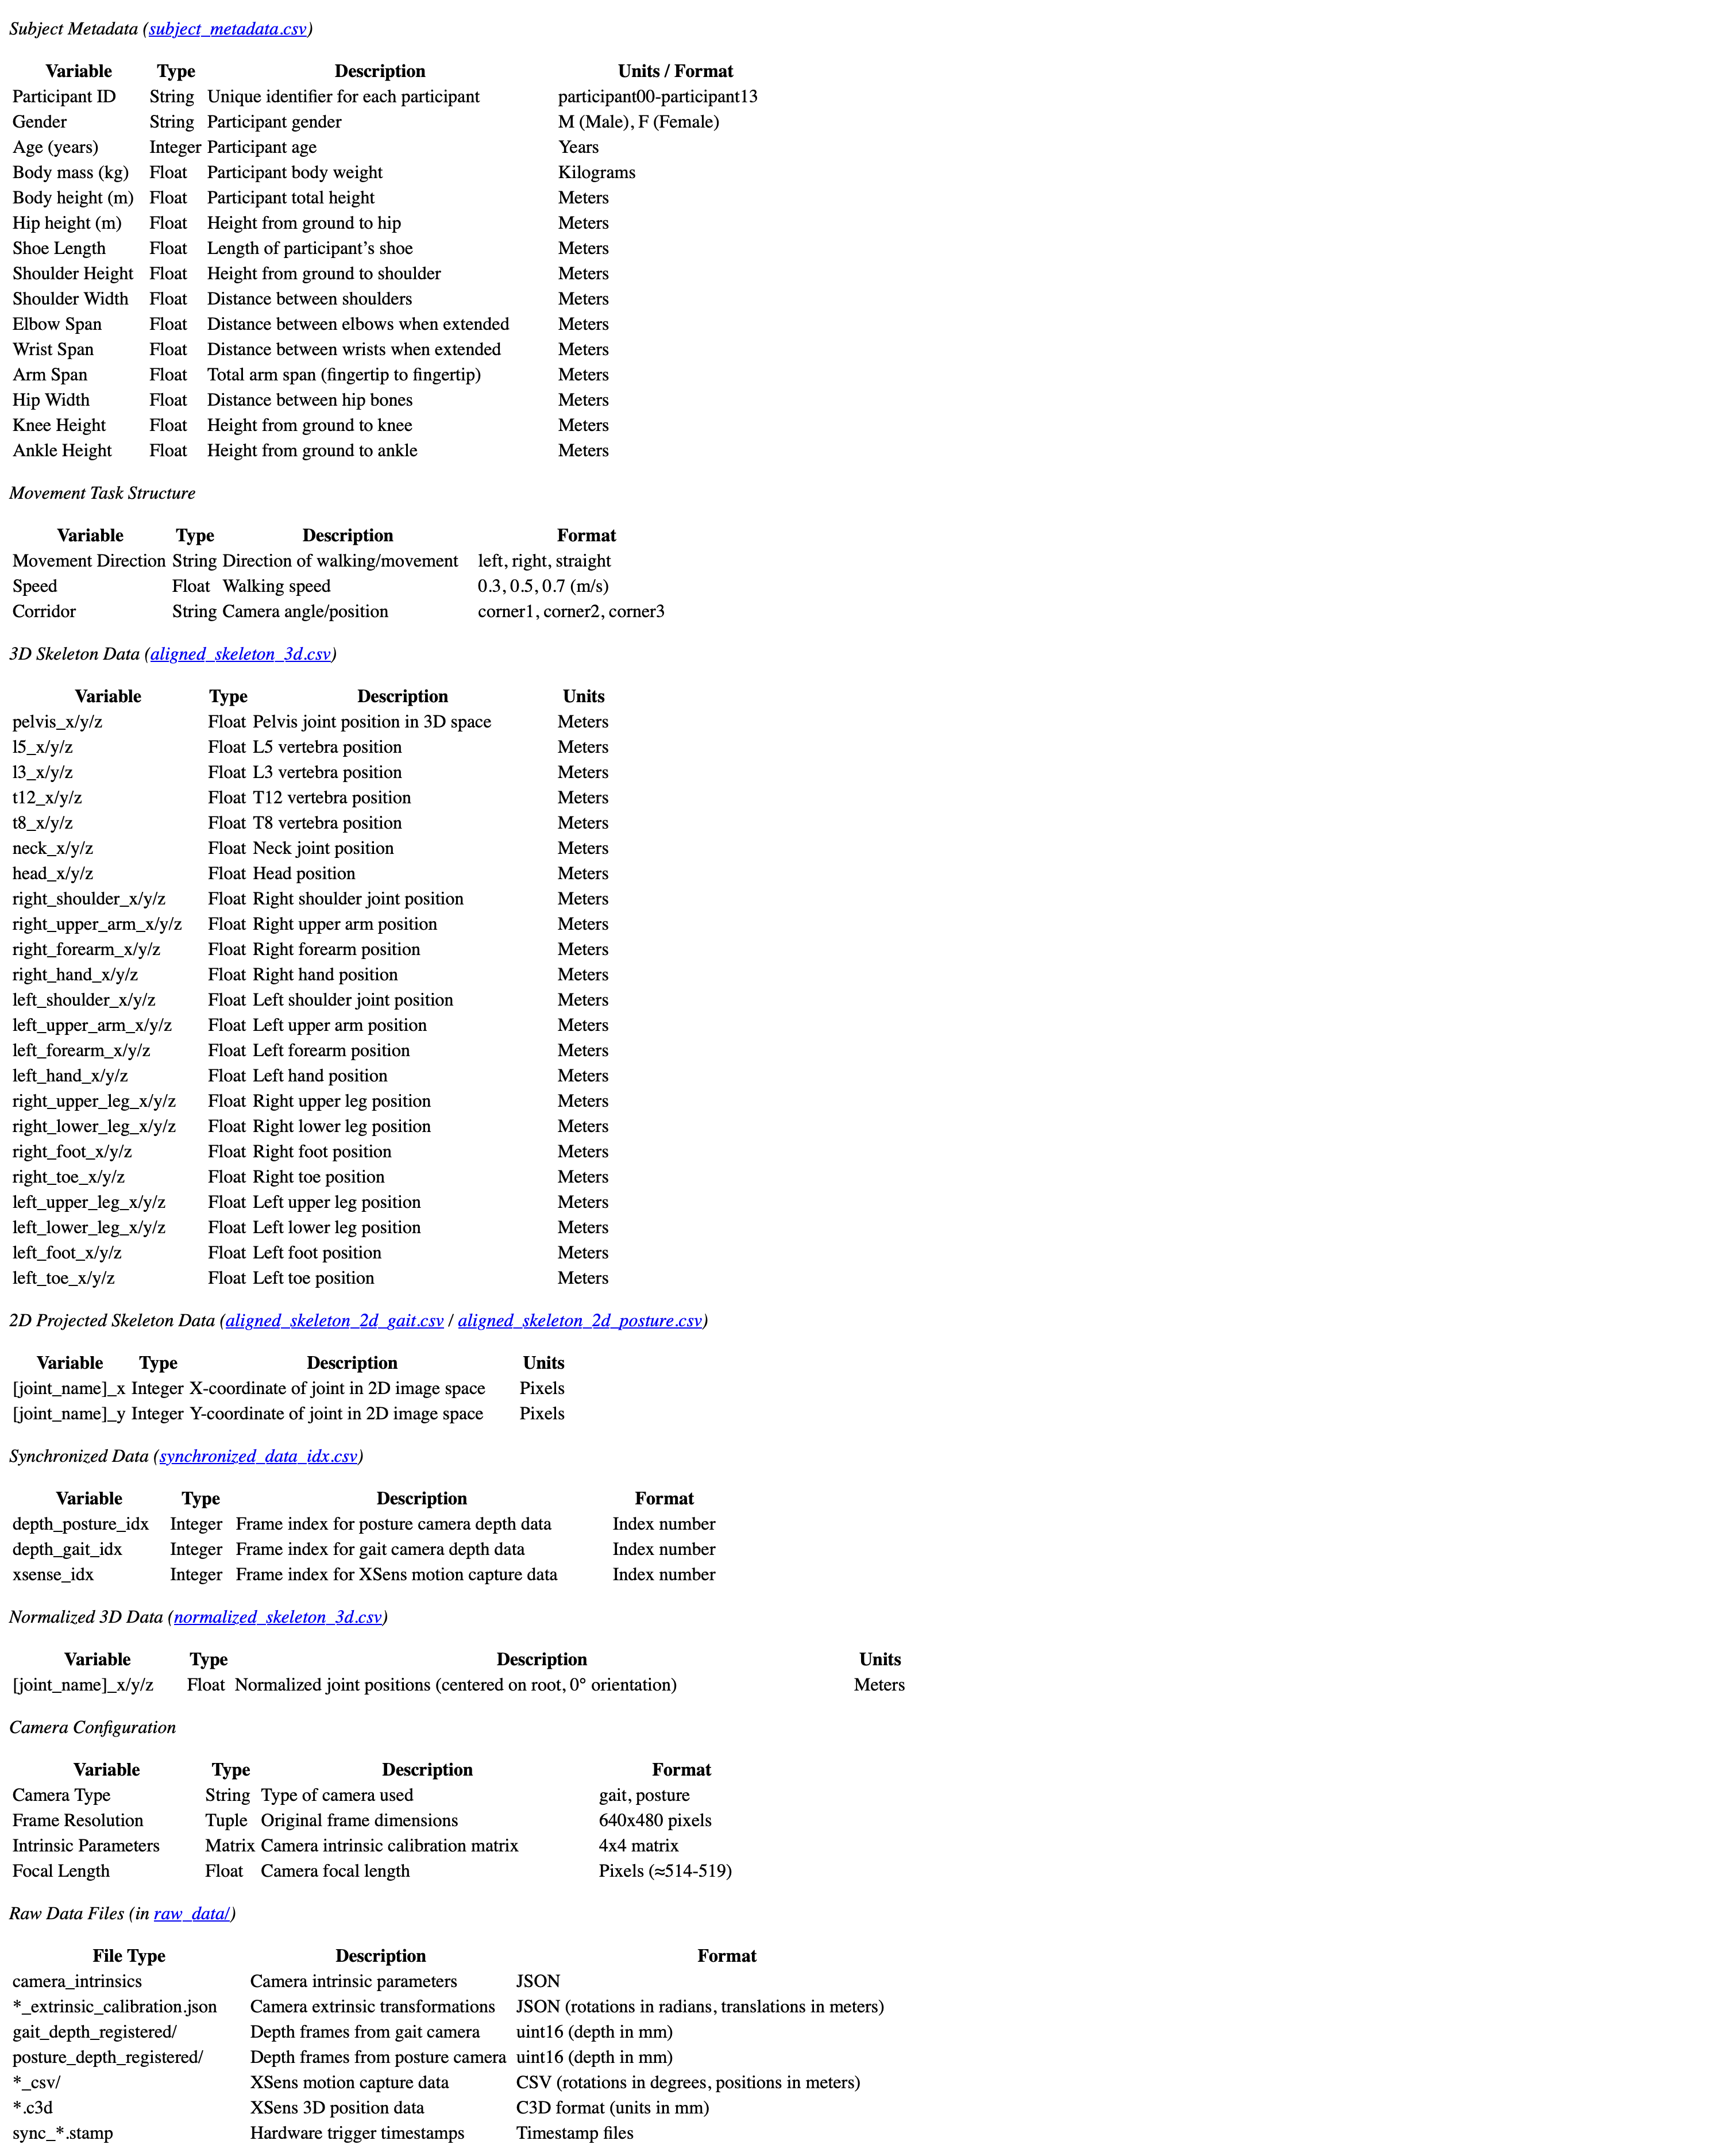
Source: Self-generated based on the dataset
Study measures e.g. exposures, outcomes, covariates, features
The study will focus on extracting and analyzing key biomechanical measures relevant to Alexander Technique principles:
Primary Outcomes:
- Head-neck-back alignment: Angular relationships between head, cervical spine, and thoracic regions as indicators of “primary control”
- Postural coordination patterns: Full-body joint coordination during static and dynamic tasks
- Movement quality indices: Smoothness, efficiency, and habitual tension patterns derived from pose estimation
Exposures/Independent Variables:
- Movement task type: Static posture, slow walking (0.3 m/s), normal walking (0.5 m/s), fast walking (0.7 m/s)
- Walking direction: Straight, left turn, right turn
- Camera angle: Front, side, back, oblique views for multi-perspective analysis
Covariates:
- Participant demographics: Age, sex, body mass, height
- Temporal and spatial features: Movement duration, gait cycle timing, joint angles, limb orientations, center of mass trajectories
Extracted Features:
- Skeletal key points: 25-point body pose estimation including head, shoulders, elbows, wrists, hips, knees, ankles, and spine segments
- Kinematic variables: Joint velocities, accelerations, and angular displacements
- Alexander Technique-specific metrics: Head-forward posture, shoulder elevation, pelvic tilt, and coordination patterns
All measures will be extracted using computer vision techniques and validated against established biomechanical principles to ensure clinical relevance.
Data Cleaning, Processing, and Software
All raw video data will undergo preprocessing prior to model training including standardization to uniform resolution and frame rate, key frame extraction for posture classification, and pose estimation using OpenPose or Mediapipe. Data augmentation techniques (rotation, flipping, cropping) may be applied to expand training data and reduce overfitting. Missing data handling will exclude or interpolate frames where pose estimation fails.
All data processing and modelling will be conducted using Python (v3.11) with OpenCV for video handling, NumPy and Pandas for data manipulation, TensorFlow/Keras or PyTorch for CNN implementation, and Matplotlib/Seaborn for visualization. Publicly available version-controlled scripts will ensure reproducibility.
Proposed Analysis
The analysis will proceed in two main phases:
- Descriptive Analysis:
  - Distribution of participants across movement tasks and camera angles
  - Summary statistics on pose features (e.g. joint trajectories, postural sway)
  - Visualisation of body key points and derived metrics
- AI-based Classification and Pattern Recognition:
  - Develop and train CNN models to classify movement types and detect posture-related features
  - Evaluate model performance using accuracy, precision, recall, and F1 score on a hold-out validation set
  - Exploratory clustering of movement patterns to identify latent postural “types”
  - Compare detected patterns against Alexander Technique principles to assess alignment with concepts such as head-neck-back coordination and habitual tension release
All results will be interpreted considering movement education theory, with special attention to the feasibility of AI in detecting subtle postural cues relevant for prevention and awareness.

6. Ethics and information governance
This study will exclusively use secondary video data from the publicly available Multi-View Gait and Posture Dataset hosted on PhysioNet. No new data will be collected from human participants.
The dataset was collected under established ethical protocols, and all recordings were shared with appropriate consent and anonymisation procedures as stated by the data providers. No attempt will be made to re-identify individuals from the dataset.
The project will adhere to the University of Edinburgh’s data governance and ethical research standards. As no identifiable personal data will be processed by the researcher, and no direct interaction with participants occurs, the use of this dataset qualifies as secondary data research. Ethical self-assessment and documentation will be submitted through the University of Edinburgh’s UMREG process to confirm compliance.
All data will be stored securely on university-approved systems and used solely for research purposes under the terms of the data license.

7. Plan for data management and adhering to principles of open research
This project uses secondary data from the publicly available Multi-View Gait and Posture Dataset (PhysioNet). All data will be stored securely on access-controlled systems, in compliance with GDPR and institutional data governance policies. Raw data will be preserved in read-only format; processed data and derived outputs will be versioned and documented.
A complete data dictionary and preprocessing documentation will accompany the analysis. Python (v3.11) and open-source libraries such as OpenCV, Pandas, and TensorFlow/PyTorch will be used for all processing and modelling tasks. Code will be maintained using Git and hosted in a public repository (e.g. GitHub), with an open license (MIT or GPL), in line with FAIR principles.
Although no new data will be collected, metadata, preprocessing scripts, and model architectures will be openly shared to ensure transparency and reproducibility. The project aligns with the University of Edinburgh’s Open Research principles, committing to:
- Open sharing of code and workflows
- Clear documentation of data use and sources
- Submission of findings to open-access platforms or institutional repositories
Upon project completion, relevant materials will be archived in a trusted repository (e.g. Zenodo or OSF), with DOIs to support citation and reuse. Data and code will be retained for a minimum of five years in accordance with university policies.

8. Public involvement and engagement
Although this study uses secondary data and does not involve direct interaction with participants, the findings have potential public value in promoting posture awareness and digital health literacy. To support engagement, key insights will be shared in accessible formats — such as short videos, blog posts, or infographics — targeted at educators, movement practitioners, and the general public.

9. Expected outputs, impact and dissemination plan
The primary output of this project will be a proof of concept (PoC) AI model that uses Convolutional Neural Networks (CNNs) to identify posture and movement patterns based on principles of the Alexander Technique. Supporting outputs will include annotated code, workflow documentation, and visual examples (e.g. key point overlays) demonstrating model performance and applicability.
No academic publication is planned, as the PoC will be used to develop a commercial eHealth product focused on real-time posture analysis and movement feedback. However, selected findings may inform publicly accessible documentation illustrating the application of CNNs in detecting postural habits.
The intended impact is to contribute to the development of low-cost, non-invasive tools for early identification of poor postural habits, with potential benefits for musculoskeletal health promotion in educational and workplace settings. This aligns with growing public health needs for scalable, preventive approaches to movement-related conditions.
Dissemination will focus on non-academic channels. Key findings and basic model will be shared through a public GitHub repository and discussed with practitioner networks in physiotherapy, movement education (AT and others), and digital health in general. A lay summary, visual demonstrations, and blog posts will make the findings accessible to educators, Alexander Technique practitioners, and potential users.

10. Project plan and timeline
The project will begin on 15 September following a structured timeline across nine months. Key milestones include research proposal submission (October 27th), ethics application (mid-November), and final 10,000-word dissertation submission (15 June). Data analysis will be conducted in early 2026 following ethics approval.

11. References
Cacciatore, T. W., Horak, F. B., & Henry, S. M. (2005). Improvement in Automatic Postural Coordination Following Alexander Technique Lessons in a Person With Low Back Pain.
Çalışkan, A. (2023). Detecting human activity types from 3D posture data using deep learning models. Biomedical Signal Processing and Control, 81, 104479. https://doi.org/10.1016/J.BSPC.2022.104479
Cole, A. (2022). Marjorie Barstow and the Alexander Technique: Critical Thinking in Performing Arts Pedagogy. Marjorie Barstow and the Alexander Technique: Critical Thinking in Performing Arts Pedagogy, 1–329. https://doi.org/10.1007/978-981-16-5256-1/COVER
Jiang, X., Hu, Z., Wang, S., & Zhang, Y. (2023). A Survey on Artificial Intelligence in Posture Recognition. Computer Modeling in Engineering & Sciences, 137, 35–82. https://doi.org/10.32604/cmes.2023.027676
Little, P., Lewith, G., Webley, F., Evans, M., Beattie, A., Middleton, K., Barnett, J., Ballard, K., Oxford, F., Smith, P., Yardley, L., Hollinghurst, S., & Sharp, D. (2008). Randomised controlled trial of Alexander technique lessons, exercise, and massage (ATEAM) for chronic and recurrent back pain. BMJ, 337(7667), 438–441. https://doi.org/10.1136/bmj.a884
Palermo, M., Mendes Lopes, J., André, J., Cerqueira, J., & Santos, C. (2021, November 1). A multi-camera and multimodal dataset for posture and gait analysis v1.0.0. Https://Physionet.Org/Content/Multi-Gait-Posture/1.0.0/Raw_data/. https://physionet.org/content/multi-gait-posture/1.0.0/raw_data/
Pisharady, P. K., Vadakkepat, P., & Poh, L. A. (2014). Computational intelligence in multi-feature visual pattern recognition: Hand posture and face recognition using biologically inspired approaches. Studies in Computational Intelligence, 556. https://doi.org/10.1007/978-981-287-056-8
Zaucker P. (2010). Ballkoordination bei Schülern mit unterschiedlicher Sporterfahrung.

12. Figures
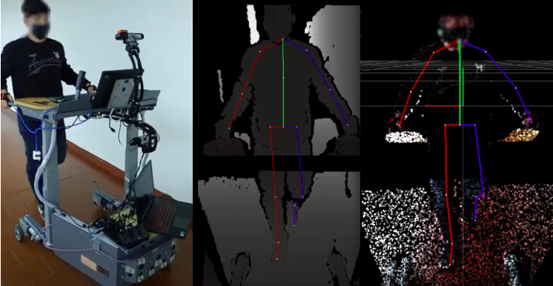
DatabaseData.png
Fig 1: Smart Walker with the mobile recording setup; Depth image overlaid with projected 2D skeleton; Point-cloud overlaid with aligned 3D skeleton. Source: Palermo et al. (2021)
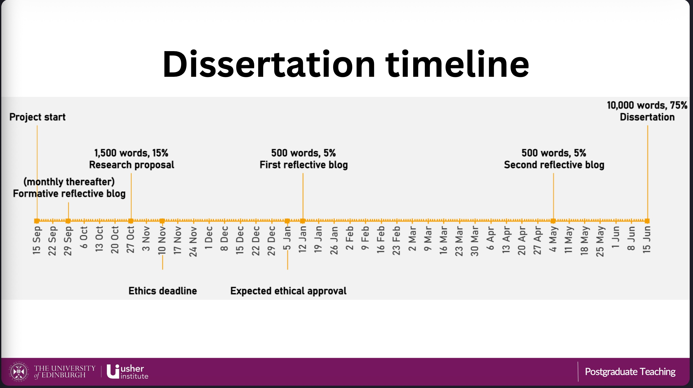
Timeline.png
Fig 2: Project timeline outlining key milestones and deliverables. Source: University of Edinburgh MSc in Data Science for Health and Social Care program

