Dissertation Project
  - Data Science for Health and Social Care (M. Sc.)
© Benjamin Gross
03.06.2026 14:41
Last commit on https://github.com/DrBenjamin/Dissertation: finalized methods chapter
Abstract
This dissertation explores the application of deep learning to detect and analyse habitual patterns of human movement and posture. The work focuses on transfer learning for identifying head-neck-torso imbalances.

Contribution
The development of this dissertation incorporated the selective use of generative artificial intelligence (AI) tools as supportive research and technical assistance instruments. Github Copilot and Posit Assistant were utilized to assist in troubleshooting Python dependency conflicts, resolving Continuous Integration / Continuous Development configuration issues involving Jenkins and Docker, and supporting administrative setup tasks related to RStudio Server. In addition, Perplexity was used for targeted literature discovery and contextual identification of relevant academic sources and references. DeepL was selectively used as language support tool to translate particular technical terminology from German into English, in cases the the author was not readily knowing it.
All critical analysis, interpretation, methodological decisions, and written academic content were independently evaluated, verified, and finalized by the author. This was achieved through systematic inspection of model outputs, including accuracy, loss trajectories, precision/recall metrics, and confusion matrices across training runs, as well as consistency checks between expected and observed model behaviour.
For deeper understanding of Convolutional Neural Network and Tensorflow two LinkedIn Learning courses were attended “Deep Learning with Python: Convolutional Neural Networks” and “Deep Learning with TensorFlow: Insights and Innovations” . Also, the author received valuable guidance and support from my two supervisor, Dr. Syed Ahmar Shah and John Wilson, who gave me many recommendations during the whole process to conduct the project as well reviewed the draft of the paper once and gave me meaningful feedback.

Abstract

Background
Postural abnormalities and impaired motor coordination are associated with musculoskeletal disorder, whilst their assessment in clinical practice often relies on subjective observations and the clinician’s expertise. At the same time, increasing pressure on healthcare systems highlights the need for scalable, cost-effective and objective screening tools that can also be used outside highly specialised laboratory settings. Recent advances in deep learning have enabled automated posture and pose analysis. However, existing research focuses predominantly on general pose estimation or biomechanical tracking, whilst comparatively few studies have investigated clinically grounded models for posture classification based on existing physiotherapy frameworks, such as the Klein-Vogelbach concept of normal, curved (hypotonic) and tense (hypertonic) postural patterns. This study therefore investigates whether transfer learning on compact CNN architectures can support practical, cost-effective and device-based posture screening through the classification of clinically relevant postural states.

Aim & objectives
Finetuning and evaluation of a deep learning model for posture and movement quality assessment that detects and interprets imbalances in the head, neck torso to finetune an pre-trained Google MediaPipe image classification model for posture and movement imbalance detection; and to evaluate the performance of the finetuned classification model.

Methods
Quantitative, observational secondary data analysis evaluating transfer learning on lightweight convolutional neural networks using a curated Kaggle image dataset (n=300) according to clinically informed criteria derived from the physiotherapeutic Klein-Vogelbach framework to yield approximately 1,900 training images with validation and test splits. Transfer learning fine‑tuned classification layers on EfficientNet‑Lite0/2/4 and MobileNet‑V2 backbones; preprocessing included resizing/normalization and clinically conservative augmentations. Models were exported fully as well as quantized TFLite artifacts and evaluated using accuracy, precision, recall, F1, confusion matrices, and balanced accuracy. A binary “normal vs non‑normal” task was also trained to probe clinical interpretability and potential performance gains.

Results
Across the two-class experiments, the binary classification task achieved a balanced accuracy of 0.552 (with landmark overlays) and 0.536 (without overlays), compared to a 0.50 chance level.
Reformulating as a three-class experiment the EfficientNet‑Lite4 model architecture achieved the highest balanced test accuracy (41.7%), followed by EfficientNet‑Lite2 (39.8%). Confusion patterns showed over‑prediction of “slumped” and frequent misclassification of “normal,” consistent with class overlap and subtle boundary cases. This approach indicates modest gains against 0.33 chance level and clearer clinical framing.

Conclusion
Transfer learning on compact convolutional neural networks within the used MediaPipe stack is feasible for posture imbalance screening, but current performance is limited potentially constrained by a small sample size, class ambiguity, and domain subtlety. Therefore targeted data growth (especially boundary and “normal” exemplars), refined labels, posture‑aware augmentation, calibration/thresholding, and fairness checks are recommended.

Introduction
Liu et al. (2025) states that there is an increasing pressure on healthcare systems through musculoskeletal disorders with projected rise to 2.161 billion people in 2035. Therefore, healthcare is progressively recognizing the importance of movement quality and postural balance in preventing injury, managing chronic conditions, and optimizing physical performance (Whittaker et al., 2017). Wijekulasuriya et al. (2025) found in an extensive recent meta analysis that traditional methods for assessing posture and movement often rely on subjective clinical observations, limiting their accessibility and consistency. Deep learning and computer vision offer promising avenues for developing such objective tools that are scalable and run on consumer hardware that is widely available (Bazarevsky & Grishchenko, 2020; Google, 2024). This dissertation explores the development of a deep Learning algorithm for supporting the objective assessment of human posture.
Deep learning is a subset of machine learning based on multi-layered artificial neural networks that learn hierarchical feature representations directly from raw data such as images or motion sequences. Unlike traditional approaches that rely on manually engineered features, deep learning models automatically extract complex, non-linear patterns like edges in images. This enables state-of-the-art performance in domains such as monitoring physical activities of patients . Transfer learning is used to simplify adoption, allowing the reuse of learned visual representations for domain-specific posture classification, extending this paradigm by reusing knowledge from pretrained models. These models often learned from large-scale datasets with wider focus. So, instead of training models from scratch, pretrained networks, for instance image classification or pose estimation models (PEMs) are fine-tuned on domain-specific data such as clinical posture datasets. This significantly reduces data requirements and improves generalization, particularly in settings where labelled clinical data are limited or expensive to obtain (Ray & Kolekar, 2024).
This thesis employs a deep learning method—specifically, a transfer learning approach—to develop a resource-efficient, operational system for posture analysis that can run on standard hardware. Pretrained feature extractors are adapted to classify clinically defined posture categories, leveraging prior knowledge from large-scale vision models to compensate for limited domain-specific data. This combination enables a transition from subjective visual assessment toward scalable, data-driven posture evaluation suitable for healthcare screening, rehabilitation, and movement analysis applications.
Human posture and coordination are central to both health and performance. Impairments such as muscular tension, poor motor control, or postural imbalance contribute significantly to discomfort, injury, and reduced physical performance in daily and professional life (Kubalek-Schröder & Dehler, 2013). Advanced motor skills rely on precise kinaesthetic differentiation, including fine motor control, proprioceptive sensitivity, accurate force regulation, coordinated timing, and the economy of movement. These elements form the basis of effective movement in sports, rehabilitation, and everyday function (Zaucker, 2010). Recent research highlights that chronic low back pain and other movement system impairments are closely associated with sustained postural deviations and maladaptive movement patterns that often develop gradually and may not be apparent during isolated clinical assessments (Ge et al., 2022; Sahrmann et al., 2017).
Traditional approaches to assessing posture and coordination rely on subjective evaluations, clinical observation, expensive motion analysis systems, or extensive practitioner expertise. While commercial software for posture assessment exists, these solutions often require professional oversight and remain limited in their ability to capture subtle or habitual patterns of imbalance consistently (Badhe & Kulkarni, 2018). This highlights a clear gap between the qualitative nature of clinical assessments and the potential for more objective, data-driven methods enabled by modern deep learning techniques.
Recent advances in computer vision and deep learning algorithms provide opportunities to bridge these limitations. Convolutional Neural Networks (CNNs) have demonstrated high accuracy in identifying patterns within image and video data and are increasingly applied in gait analysis, posture detection, and motion tracking (Jiang et al., 2023). Among available frameworks, the Google MediaPipe framework brings a lightweight approach that can be run in the browser or on mobile devices, utilizing a statistical 3D human shape modelling pipeline offered as a trainable and modular deep learning framework. It can accurately represent full-body details to detect pose and posture (Bazarevsky & Grishchenko, 2020; Xu et al., 2020).
This project uses transfer learning (Kakuta et al., 2022) to adapt a pre-trained Google MediaPipe CNN model, originally trained on extensive image data, to a new small Kaggle dataset but with more relevant and higher-quality images for posture imbalance detection. By utilizing pre-learned feature representations, the model can achieve faster convergence and improved accuracy even with a comparatively smaller or domain-specific dataset. Overall the selected technology provides a reproducible and cross-platform environment for prototyping and experimenting model development as it integrates pre-existing perception components and offers consistent performance evaluation across different devices and platforms.
As a physiotherapist with focus on movement quality, I found these gaps were not purely academic but deeply practical in my clinical practice. To reach a level of good understanding of movement (patterns) it required years of training and clinical experience to develop. For instance the ability to accurately assess the quality of movement based on key indicators such as the passive rotatory mobility of the fifth thoracic vertebra (Th5) and adjacent vertebrae (Tachihara & Hamada, 2019).

Research question
How can transfer learning on a pre-existing TensorFlow Lite model for pose estimation and image classification be used to detect and analyze posture and movement imbalances?

Aim
Finetuning and evaluation of a deep learning model for posture and movement quality assessment that detects and interprets imbalances in the head, neck torso and to make it suitable for the clinical context.

Objectives
- To finetune an pre-trained Google MediaPipe image classification model for posture and movement imbalance classification.
- To evaluate the performance of the finetuned classification model.

Dissertation structure
The present work is structured as follows:
The Literature Review chapter provides a comprehensive literature review of the current state of the art posture and movement analysis. A focus on the capabilities and limitations of existing pose estimation frameworks such as Google MediaPipe will be given as well a comparison to commercial products.
The Methodology chapter outlines the methods used, including the study design, data sources, variable definitions, model development approach, and performance evaluation strategies.
The Implementation chapter details the implementation of the training and inference pipelines with a complex continuous development and integration setup.
The Results chapter presents the results of model performance and error analysis and shows the challenges of training a custom CNN model.
The Discussion chapter addresses the findings in relation to existing literature, strengths and limitations, and clinical implications.
The Conclusion chapter outlines the expected impact and dissemination plans, while
Whereby the final chapter concludes with a summary of contributions and future work directions.

Literature Review
This chapter reviews the scientific and technological foundations relevant to deep learning based posture and movement analysis. First, current research on deep learning, computer vision, and PEMs is examined to identify methodological capabilities and limitations in clinical posture assessment. Subsequently, existing commercial motion capture systems are reviewed to contextualize current state of the art technological solutions and identify practical gaps motivating the present study.

Deep learning and PEMs
Cao et al. (2024) describe the detection of human postures undertaken by artificial intelligence as a process in which machines mimic the human visual system and learning behaviour by extracting distinctive features from sensor or image data and subsequently using these features to classify or track postures over time. Furthermore they divide into static and dynamic posture recognition, whereas the static posture recognition treats each input (image or single frame) as a standalone instance. Models for these purposes are trained and perform inference on individual frames, using image-based classifiers such as such as scale-invariant feature transform, histogram of oriented gradients, support vector machine, Gaussian mixture model, dynamic time warping, hidden Markov model, lightweight network and convolutional neural networks (Jiang et al., 2023). Cao et al. (2024) describe the dynamic pose detection as processing a continuous image sequence (video), with models capturing temporal evolution via recurrent structures such as BiGRUs or similar time-aware networks. As they explain, CNNs perform this capturing or, more precisely, feature extraction through the use of a deep convolutional neural network that locates skeletal keypoints and derives a multidimensional set of pose features, much like the human eye recognises edges, shapes and joints. The extracted pose features are then learned as spatial features (body configuration in each individual frame) and temporal features (how the pose changes across successive frames), allowing these PEMs to capture both instantaneous postural configurations and movement dynamics over time. A widely used open-source example of a PEM is Google’s MediaPipe framework for real-time pose estimation (Lugaresi et al., 2019).
Machine learning and deep learning studies are typically defined as retrospective observational studies (Barash et al., 2024; Wei et al., 2025). The online article “What Is a Retrospective Observational Study? - California Learning Resource Network” (2025) describes them further as a research methodology that leverages pre-existing data to investigate potential relationships between variables. This reuse of existing data is classified as secondary data analysis (Baek et al., 2025). Therefore, these studies analyze existing data to identify patterns and relationships, without assigning a specific interventions to collect the information itself. This increases opportunities for medical research, as it eliminates the need for costly data collection, the preparation and administration of clinical assessments and the recruitment and evaluation of participants.
Medical image processing studies can be divided into supervised and unsupervised deep learning. Aljuaid & Anwar (2022) shows in a survey, that supervised learning has achieved exceptional results, with performance comparable to that of medical service providers. It requires a training dataset and prior knowledge of the dataset. The aim is to understand the relationships and structures of the input dataset in order to accurately predict the output.
Recent validation of such studies, comparing the introduced MediaPipe technology with gold-standard motion capture systems, reveal measurable discrepancies in landmark accuracy, particularly for subtle postural features, highlighting the need for domain-specific refinement for clinical use (Kakuta et al., 2022). Here, “subtle” means inappropriate muscular tension with small or no movement of (the) body(-parts). More broadly, current PEMs remain limited by sensitivity to noise and 2D–3D estimation gaps, reducing their reliability for detecting the named tensions and asymmetries critical to movement and pose imbalance analysis (Kakuta et al., 2022; Lachance et al., 2023). Fairness and representativeness in pose estimation systems are also important concerns: current PEMs exhibit performance disparities across demographic groups, with reduced accuracy for under-represented populations in training datasets (Lachance et al., 2023). Available datasets frequently focus on male and predominantly white participants between the ages of 19 and 50, while under-representing females, older adults, and individuals with darker skin tones, thereby increasing the risk of systematic bias and reduced generalizability in movement and posture analysis.”
Consequently, while MediaPipe Pose serves as a robust foundation for pose detection, in its standard configuration of training it does not inherently capture the fine-grained symmetry metrics, sagittal and coronal balance indicators, or compensatory movement patterns that rely on hyper- and hypo-tension that are essential for clinical postural and even more for movement analysis. Computer-vision-based deep learning markerless systems nonetheless represent an important step towards closing the gap between theoretical research, that can be even a century old like the principle of primary control of human movement by F.M. Alexander (2017), and practical implementation in remote clinical assessment (Ultralytics, 2025; Wagh et al., 2024).

Market research on motion capture systems
Modern video analysis with the purpose of detecting pose, movement, and specific markers in sports activities has undergone a paradigm shift, moving from subjective clinical intuition to high-fidelity, data-driven kinematic quantification. Commercial ecosystems like RUNRIGHT 3D (2026) leverage dual-camera 3D reconstruction to analyze over 40 biomechanical metrics without intrusive markers, targeting retail efficiency and rapid, evidence-based footwear recommendations. Similarly, RunDNA (2026) employs advanced motion capture to track kinetic and kinematic variables from foot strike to toe-off, providing practitioners with a granular, 3D anatomical breakdown of movement asymmetries. For integrated clinical environments, the TecnoBody Walker View (2026) combines 3D camera technology with a sensorized, load-cell-equipped treadmill to provide real-time biofeedback and synchronized gait analysis. Supplementing these laboratory-grade tools, ViMove2 (2026) utilizes wearable inertial measurement units (IMUs) to provide continuous, longitudinal monitoring of temporal outcomes like ground contact time and cadence, albeit with sensitivity to speed-dependent discrepancies. At the vanguard of performance capture, Move AI (2026) offers sophisticated, markerless motion capture solutions that utilize computer vision to extract high-fidelity skeletal data from multi-camera footage, facilitating biomechanical analysis outside of traditional studio settings as shown in Figure 1.
Figure 1: Move AI advertising accurate markerless motion capturing on their website.
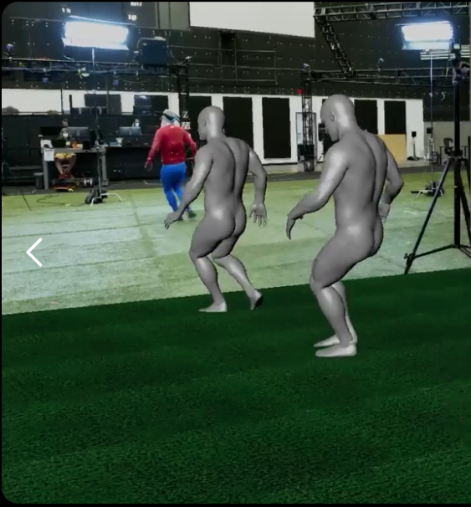
Legend: Participant (left) • 1st virtual avatar (middle) • 2nd virtual avatar (right)
The overarching advantage of these commercial approaches lies in their ability to translate complex, high-frequency spatial data into actionable clinical diagnostics. They reduce inter-rater variability, the differences between multiple assessors, and enable objective longitudinal tracking. Such standardization of classification, may improve the reliability of qualitative (and quantitative) movement assessments in evidence-based rehabilitation settings. Conversely, the disadvantages often involve high capital expenditure for extensive equipment as seen in Figure 1, the requirement for controlled capture environments, and often a reliance on proprietary pipelines that can be difficult to consistently integrate into existing clinical (analytical) workflows.
When evaluated against image classification models, the advantages of the latter become apparent: low-cost, low-latency identification of specific postural states and movement patterns, albeit at the expense of the quantitative kinematic precision provided by advanced motion-capture and biomechanical analysis systems.

Methodology
In this work, deep learning techniques are applied through transfer learning on a pre-trained TensorFlow Lite PEM for posture and movement imbalance detection, with a particular focus on evaluating the performance like accuracy of a fine-tuned CNN model within the Google MediaPipe framework (Lugaresi et al., 2019).

Study design and setting
This study is a retrospective observational secondary data analysis exploring postural and movement imbalance detection using deep learning algorithms. The project applies a quantitative, observational design, analyzing existing image data through supervised deep learning, specifically CNNs implemented via TensorFlow Lite within the Google MediaPipe framework. It can be classed as supervised, as the author manually classified the images into classes, relying on specific knowledge of posture and movement quality.
The aim of this supervised deep learning project is to evaluate whether lightweight AI models can detect subtle patterns of imbalance in posture and coordination and to adapt them for potential clinical use through transfer learning on a posture-specific dataset.
The study will be conducted remotely using a preexisting dataset. All data analysis will be performed on secured infrastructure provided by the author (see Implementation). No new data collection or participant interaction will be conducted.

Data source, preprocessing and class definition
The training image dataset contained 300 original images, distributed across training and test images. These two folders were unified, as a later Extract Transform Load (ETL) - pipeline is splitting the images dynamically by configurable settings. The photographs of the individuals were taken from the side, although their postures and the parts of the body shown (full-body shots, partial shots such as the upper body) varied considerably.
For the experiments, two and three class transfer learning, the images were manually classified through expert-informed visual posture analysis by the author. The present supervised learning approach lacks the principle of dual rater verification. For all, but the first 2-class training, the number from 300 original images were synthetically expanded to between 1500 up to 1800 images, depending on whether extra annotated images with body landmark overlay were used or not. The landmark overlays were generated with the Google MediaPipe Pose framework to incorporate explicit skeletal structure information. As this study uses secondary image data of an openly available “Posture Keypoints Detection – Photos & Labels” dataset on Kaggle only, there was no possibility to increase the amount of samples other than augmenting the existing image data. The original dataset consists of 300 images in static side view in different positions with image resolutions of up to around 1.6 MP and an overall high quality look.
Unlike large-scale, general-purpose image datasets, this Kaggle dataset was specifically curated for posture analysis. It focuses on side-view images suitable for assessing sagittal-plane alignment and often only upper-body posture, in sitting position, in many cases missing the limbs and feet. Makhmudov (2025b), states his work was the final project of the Deep Learning School course at MIPT. On Kaggle he describes the dataset as a collection of people living a sedentary lifestyle. Furthermore, on the corresponding GitHub repository page, he explains, that an implemented Streamlit software for posture recognition was receiving user video also from an side angle (Makhmudov, 2025a). The relatively small dataset size, focus on sitting positions as well as potential demographic limitations may constrain performance, generalizability and fairness of the trained models.
To lower the impact of the small dataset size, various augmentation techniques were applied to increase the number of images:
- First, the images were duplicated several times and processed via random image editing utilizing the OpenCV framework. For instance, the color-theme or background color were changed, images were cropped or tilted. For each augmented image, 2 changes were applied.
- Second, a subset of duplicated 300 images with body landmarks as overlay were added to specific runs as it can be seen in Figure 7. This was achieved by an existing MediaPipe Pose model which was adding these annotations. As this process was automated (described in Automation orchestration (n8n)), also partially misaligned overlay could be found in these images (see Figure 8). On the existing image dataset with only side-view images, the visible landmarks from are listed in Table 1:
Table 1: MediaPipe body landmarks visible from a side view, by contrast to fully available landmarks in the front view Figure 6.
Body part | Left view | Right view
Nose | 0 | 0
Eye | 1–3 | 4–6
Ear | 7 | 8
Mouth corner | 9 | 10
Shoulder | 11 | 12
Elbow | 13 | 14
Wrist | 15 | 16
Hand | 17, 19, 21 | 18, 20, 22
Hip | 23 | 24
Knee | 25 | 26
Ankle | 27 | 28
Heel | 29 | 30
Foot index | 31 | 32
Legend: Body part (left) • Left view (middle) • Right view (right)
Preprocessing was applied consistently for all runs (same processed image data set) to maintain comparability between two and three class runs and the two different base architectures:
- MobileNet-V2: compactness, but at the cost of limited ability to capture complex features
- EfficientNet-Lite0: lightest-weight architecture (see below for details)
- EfficientNet-Lite2: medium-weight architecture (see below for details)
- EfficientNet-Lite4: heaviest-weight architecture, EffcientNet was released 2019 by GoogleAI with a new method of compound scaling (scaling all dimensions of the network architecture in a balanced way, instead of only one), which is described in Table 2:
Table 2: Compound scaling and how the dimensions contribute to model performance and limitations of scaling dimension independently.
Scaling dimension | Meaning | Benefit | Limitation when scaled alone
Deeper | More layers (starting from edges - body parts - full posture) in the network. | Learns more complex and hierarchical features. | Optimization becomes more difficult, training time increases, and performance gains often diminish after a certain depth.
Wider | More channels/filters (like head tilt and other assymetries) per layer. | Captures a greater variety of features at each level. | Computational and memory costs increase substantially, while the model may still lack sufficient hierarchical feature extraction.
Higher Resolution | Larger input images (e.g. 1024×1024 resolution). | Preserves finer spatial details and small visual patterns. | Computational cost grows rapidly, and the network may be unable to fully exploit the additional information if depth and width remain unchanged.
Legend: Scaling Dimensions (left) • Benefits and Limitations (left-middle) • Benefits (right-middle) • Limitations (right)
The objective for the transfer learning is to reach an accuracy of approximately 80–90%, which is generally considered strong performance for practical detection tasks for the Google MediaPipe model architecture. For the first experiment, the images will be annotated into normal and non-normal classes to define a 2-class problem. Both classes were populated from the previously classified 3-class problem - which follows in the next paragraph - with the `slumped posture` and `tensed posture` classes being assigned to the `non-normal` class. As the first training run consisted of only 300 images in total, which were further divided into training, validation and testing subsets, the largest available architecture class, EfficientNet-Lite4, was selected to maximize feature extraction capacity despite limited dataset size. EfficientNet-Lite4 was also retained for training run no. 2 and no. 3, although dataset sizes increased substantially via the described two augmentation techniques, to maintain comparability across experiments.
The posture classification for the 3-class problem follows three types of poses regarding posture classifications by Klein-Vogelbach (1990), a physiotherapeutic postural notation system, as illustrated in Figure 2.
Figure 2: Three types of posture types defined by Klein-Vogelbach, the underlying functional movement concept was developed between 1955-1975.
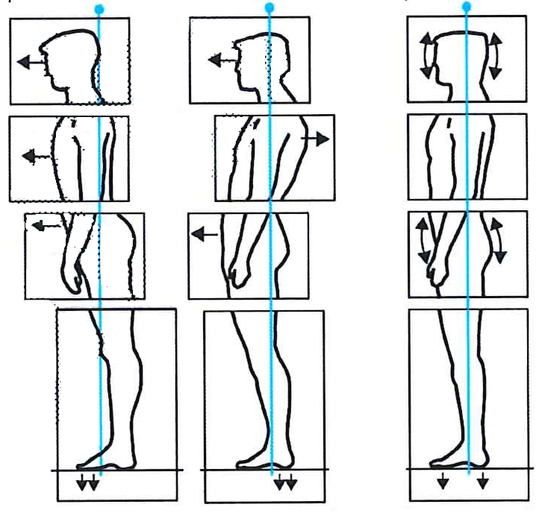
Legend: tensed (left) • slumped (middle) • normal (right)
The author manually annotated and assigned the 300 images to one of these three classes according to his clinical experience in the field of orthopaedics and functional movement therapy. In the initial annotation round, the dataset was artificially balanced by assigning 100 images to each class (normal, slumped, and tensed posture). While this ensured equal class distribution for training, it also introduced ambiguous and potentially misclassified samples near class boundaries in pre-test runs. Therefore, a second annotation procedure was conducted using a slightly imbalanced but clinically more consistent class distribution, resulting in improved class separation and overall classification performance. To achieve pose detection defined by Klein-Vogelbach, three image classes were defined:
- normal posture
- slumped posture
- tensed posture
These three classes represent distinct qualitative posture states used in clinical movement analysis. The normal posture class represents an aligned and functionally efficient baseline posture. The slumped posture class captures flexed, collapsed, or reduced postural normal tone patterns, typically associated with decreased axial extension like the “hunchback”. The tensed posture class represents increased muscular tone and excessive postural rigidity and overly extended joints. This can be for instance the declined neck (slight extension of the axis vertebrae), or elevated shoulder girdle, and in general the impression of reduced movement fluidity in the (thoracic-)spine and hips.
This three-class formulation enables the CNN to distinguish between physiologically neutral, hypoactive (slumped), and hyperactive (tensed) postural states, aligning the computational labels with clinically meaningful categories from the physiotherapeutic Klein-Vogelbach framework.

Variables, features, and preprocessing

Primary outcome
Head/neck-torso-pelvis alignment: Angular relationships and relative positioning of the head/cervical spine, torso and pelvis regarding the 3-class model by Klein-Vogelbach will lead towards model classification:
- normal posture
- slumped posture
- tensed posture

Exposures/independent variables
- Image category/context: Static posture images in standardized side view.
- Camera/view angle: Minor variation in pose estimation accuracy depending on exact lateral positioning as well as the different body parts visible for each individual.

Covariates/control features
- Image characteristics: Resolution, background and lighting, which may influence model performance.
- Posture variation: Degree of anterior head translation, extension or kyphosis of the thoracic-spine, anterior pelvic tilt and other sagittal-plane deviations.
All selected images from the Kaggle dataset undergo data augmentation (e.g., small rotations, cropping, brightness adjustments) before transfer learning is applied to increase sample size and improve generalization while preserving clinically meaningful posture characteristics and avoid overfitting. Ogundokun et al. (2022) were using image augmentation techniques on a comparable posture recognition study, to increase the number of images and to reduce the chance of overfitting the model towards the ingested image data for instance by learning irrelevant features.

Model development and transfer learning
This study employs a transfer learning approach to reduce training time and make it possbile to use consumer hardware as Kakuta et al. (2022) described it. A domain-specific TensorFlow Lite model from Google suitable for clinical posture and movement analysis was chosen, a so called PEM. Transfer learning enables the adaptation of pre-trained CNN architectures—such as those used within MediaPipe and trained on large-scale datasets like ImageNet for vision-based recognition (Jiang et al., 2023). In practice, base model weights are kept frozen like described by (Haris et al., 2021), while classification and selected high-level layers are retrained using the Kaggle posture dataset. In this scenario base weights stand for the pre-trained parameters of the lower and middle layers in the CNN that have learned generic visual features such as edges, textures, and shapes.
Deploying the resulting model as a quantized (reduced the numerical precision) TensorFlow Lite artifact supports real-time, on-device inference on mobile and edge devices and reducing latency which is standard in medical imaging (Rivera-Guzmán et al., 2026). MediaPipe Model Maker is particularly well suited for this task, as it fine-tunes lightweight CNN backbones optimized for Tensorflow Lite within the same ecosystem as MediaPipe Pose. With the pre-trained backbone, only the task-specific classification head is regenerated. In doing so, the family of feature extractors optimized for mobile devices that underpins MediaPipe’s vision solutions is retained; this describes the transfer learning approach.
Thereby on-device efficiency, quantization compatibility and seamless export to .tflite file format is ensured. Although the pose landmarker are not modified, the pose stack keeps it architectural continuity with its low-latency backbone design, and pose-aware augmentation. So they can be used as PEM and as classification models at the same time. Concluding, that the earlier introduced strategy, to add annotated images with body landmark overlay may lead to higher accuracy in the classification model training.

Analysis and performance evaluation
The analysis was undertaken in two phases:
- Descriptive analysis of dataset composition, annotation completeness, and posture-related metrics.
- Classification and pattern recognition using transfer learning on a deep learning network.
The model performance was assessed on the basis of
- Accuracy: The proportion of correctly classified examples out of all predictions
- Precision: The proportion of correctly predicted positive examples out of all examples predicted as positive
- Recall: The proportion of correctly identified positive examples out of all actual positive examples
- F1 score: The harmonic mean of precision and recall, which balances both metrics.
Therefore, in the Results chapter, confusion matrices were created to investigate class-specific error patterns. All hyperparameters, data splits and pre-processing steps were documented to ensure reproducibility.

Implementation
To utilize the Google MediaPipe framework in the described means, an extended continuous integration and development pipeline, also known as CI/CD, was developed to train and evaluate models, and produce deployable artifacts. CI/CD is an established industry standard for automating software integration, testing and reproducible generation of deployable artifacts. Also in the data science sphere, this approach becomes often used (Rzig et al., 2024).
Additionally, an automation workflow was configured to support data preparation and preprocessing steps. To this end n8n, a platform with a visual, node-based editor was used. This fair-code (source-available software licensing model) tool, widely used in machine learning projects as it allows a no-code configuration and easy integration of Advanced Programming Interfaces (APIs), which are used in this work (Pol, n.d.).
The research environment, together with the reproducible procedures for constructing the training pipeline and maintaining a ready-to-use data engineering setup, is described in this chapter.

Research setup
The research setup is describing the four components for realizing this research: the core systems executing that the deep learning (training and inference), the software layer providing application services, the reproducible execution environments, and user-facing interfaces for interaction and experimentation.

Hardware and runtime
The development was mostly performed on a remote virtual machine with Ubuntu Linux and specs of 8GB RAM and 4 available CPU Cores. For editing Python scripts and notebooks, the Jupyter Notebook was used. The transfer learning script was usually run for training a custom model locally on a MacBook Pro due to its superior performance.
For editing the Quarto dissertation project file a RStudio Server was utilized. Next to this, a Streamlit WebApp was developed and used to test re-trained models manually, working as a graphical user interface. Both the Jupyter notebook and the WebApp were deployed via a Docker container on the remote server to manage heavy Python library dependencies of MediaPipe Model Maker (Python 3.10) respective of MediaPipe / TensorFlow Lite (Python 3.13) for the interface app.

Software/framework/service stack
Table 3: Software, Framework and Service Stack used for the development, training, deployment, and automation of the system.
Category | Technologies / Services
Conda programming environments | Python 3.10 (Model Maker), Python 3.13 (Inference)
Core deep learning frameworks | MediaPipe Pose 0.10.20, MediaPipe Model Maker 0.2.1.3, TensorFlow (+Lite, bundled) 2.19.1, Keras 3.12.1
Supporting Python libraries | OpenCV, NumPy, Pandas, Matplotlib, FastAPI
Development and authoring tools | RStudio Server, Jupyter Notebook, Quarto
Deployment and containerized services | Docker, Streamlit WebApp, MediaPipe API
CI/CD and automation | Jenkins, GitHub Actions, n8n
Legend: Category (left) • Technologies / Services (right)

Environment manifests used in this project (congested by Dockerfiles)
Listing 1: Environment manifest files used for local development and containerization.
code/
├── environment.yml
├── environment_model-maker.yml
├── requirements.txt
└── requirements_model-maker.txt

Example reproducible local environment
All scripts, notebooks and the web app can also be run locally; to do this, a Conda environment needs to be created:
Listing 2: Creation of Conda environment for local experimentation.
# MediaPipe Model Maker environment
conda env create -f code/environment_model-maker.yml
conda activate dissertation-3.10
# MediaPipe Pose and TensorFlow Lite environment
conda env create -f code/environment.yml
conda activate dissertation-3.13

Streamlit Web App Interface
Streamlit is an open-source Python framework that was used to build a graphical user interface (code/mediapipe_pose.py). The framework is widely used in the data science sphere, to build interactive data apps, often with AI-centred purposes (Rajput, 2025). As a low-code approach, it was used to build an interface for testing pre-existing models and the classification models build within the project and allowed quick implementation of needed features. Streamlit has a client-server architecture allowing Python code to act like a classical backend and the graphical user interface shown in the browser as the frontend layer.
The Web App can utilize two different kind of CNN models. The first supported type of models are the existing MediaPipe Pose landmarker models, which is a open source PEM, to create the 33 3-dimensional pose mapping overlay. The pretrained models come in three different bundle variants (Lite, Full, Heavy), which differ in model complexity, computational requirements, and performance (accuracy) (Google, 2026). They can be chosen from the sidebar under ‘Model complexity’. As inference is not performed directly in the browser on the user computer or mobile device, this web application could be used on any device, even devices like older smartphones without high computational resources.
Second, the Interface was used to test the build classification models, as you can see with some example images in Figure 3. The model(s) can be bundled statically within the deployed container or dynamically provided via Browser user upload. The loaded model is then invoked via the MediaPipe API (as the former inference for pose models) and performs the inferences, sending the prediction results back to the frontend.
Figure 3: Streamlit Web App with classification of postures using the build quantized model from Training 4 (Table 16).
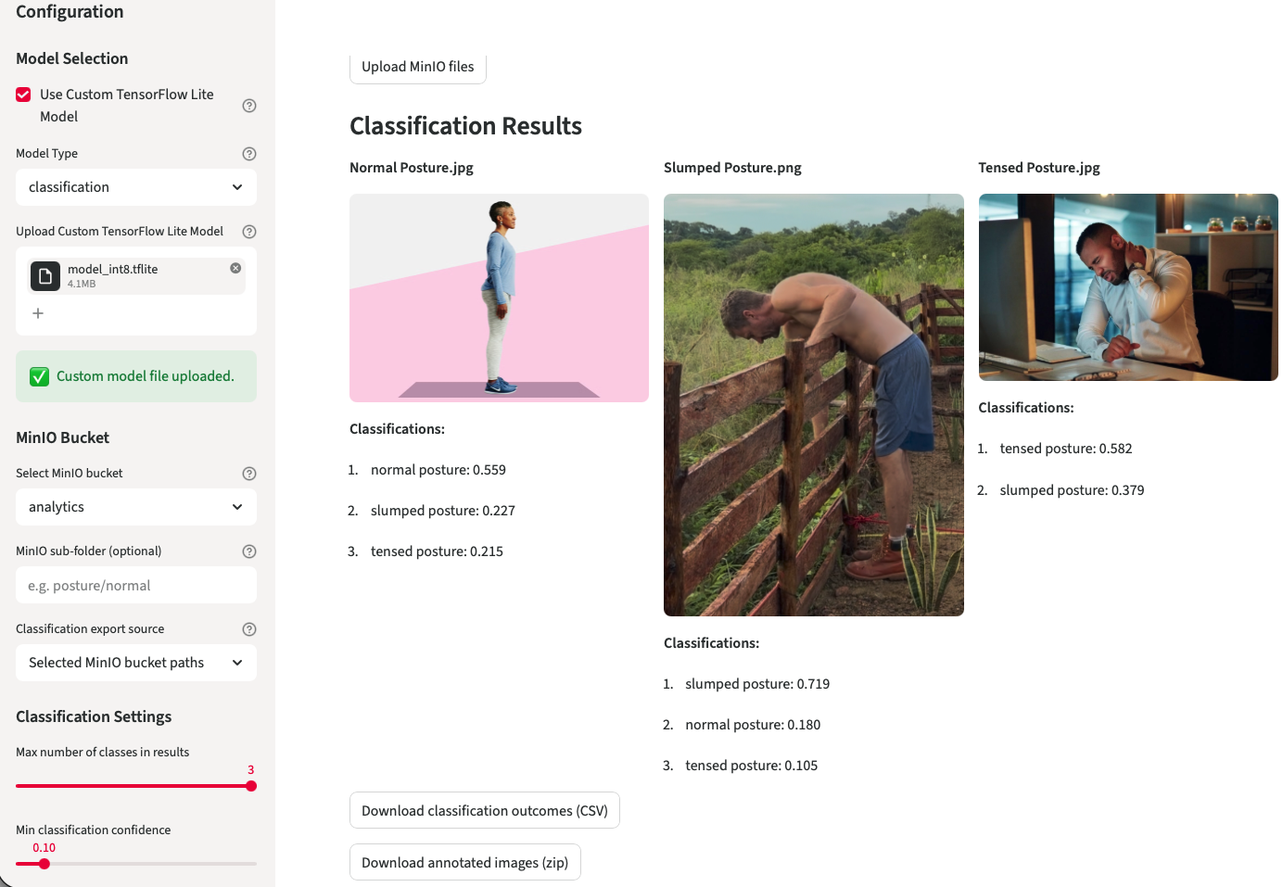
Legend: Sidebar settings (left) • Inference Results (right)
The web app can digest images from the Browser as user uploads or from the self-hosted MinIO server - ladder one can be configured via the inbuild secrets management (code/.streamlit/secrets.toml), to use self-hosted or public MinIO instances.

Training pipeline and data engineering
Overview - The training pipeline follows an ETL pattern: ingest → validate → augment → split → train → evaluate → archive. Steps are implemented in the repository as Jupyter notebooks and scripts to allow both interactive experimentation and non-interactive CI execution.
Automated augmentation (n8n + MediaPipe API) - To expand the original 300 images, the repository uses an n8n workflow to produce duplicates with MediaPipe keypoint overlays and controlled image edits (rotations, crops, brightness adjustments). - The exported n8n workflow is available at code/n8n/Dissertation_Posture_Analysis.json. The high-level workflow:
- Read a list of source images (the initial 300).
- For each image, call a MediaPipe inference endpoint (either the containerized FastAPI MediaPipe API) using an HTTP Request node.
- Receive keypoint coordinates and render overlay images server-side.
- Save augmented images to MinIO bucket.
Training execution - Training can be run locally via the hosted Jupyter notebook on custom_image_classifier_model_training.ipynb.

Augmentation & split policy
Augmentations used brightness/contrast jitter, cropping, tilting. small rotations, and MediaPipe body landmark overlays. Splits are deterministic and saved into sub-folders in data/ for reproducibility.
Artifacts and model storage - Model artifacts (.h5 and .tflite), logs and run figures are stored under data/models/ and runs/. Each run directory includes metadata.

Research client scripts, Inference pipeline, containerization and CI/CD
Inference research client scripts live in code code/scripts/ (for example custom_tflite_image_classifier.py and human_posture_analysis.py) and operate against quantized .tflite models exported to data/models/.
Listing 3: Example usage of the custom TFLite image classifier script for testing a trained model locally on an example image.
# Example usage of the custom TFLite image classifier script
python code/scripts/custom_tflite_image_classifier.py \
--model data/models/model.tflite --image data/images/test.png

Listing 4: As a counterpart to the Streamlit Web App there is also a command line tool for testing, utilizing the API.
# Example usage of the human posture analysis script in image mode
python code/scripts/human_posture_analysis.py --mode image \
--api-base-url http://seriousbenentertainment.org:8000 \
--input-image ./data/images/test.png --output-image ./data/images/output.png

Containerization and compose
The project maintains two primary Dockerfile artifacts:
Listing 5: Dockerfiles for containerization of the training environment.
code/
├── Dockerfile — training and utilities image.
└── Dockerfile_mediapipe
The MediaPipe runtime used for keypoint extraction and overlay rendering. Multi-service development is defined in code/docker-compose.yml.
To start development services docker compose was used:
Listing 6: Development environment with Docker Compose, building the necessary images and running the defined services (e.g., MediaPipe API, Streamlit Web App).
# Development environment with Docker Compose, building the necessary docker
# images and running the defined services (e.g., MediaPipe API)
docker compose -f code/docker-compose.yml up --build

CI/CD
Jenkins is used for build a Jupyter environment on a server to run model training and also builds a Streamlit WebApp for inference testing of previously build models.
Github Actions of a Github Pages repository is trigged to render the Quarto artifacts:
- Checkout repository - Installs Quarto and LaTeX (for PDF rendering).
- Deploys the dissertation project as HTML on https://drbenjamin.github.io/dissertation.html

Automation orchestration (n8n)
A n8n server, run as a containerized service (two container), was used to hosts the augmentation workflows. n8nis a visual, node-based workflow automation tool that allows for the orchestration of complex data processing pipelines without extensive coding. In this project, n8n was configured to automate the augmentation of the original image dataset by integrating with the MediaPipe API for pose estimation and leveraging MinIO for file storage. The responsibilities and functionality include:
- n8n Canvas for editing the workflow (Docker container number one) as seen in Figure 5.
- MediaPipe API (Docker container number two) for inference calls.
- MinIO file storage file retrieval (original images).
- MinIO file storage file writing (augmented images). which is accessed via code/n8n/Dissertation_Posture_Analysis_Images.json.
The n8n automation processes these images, digesting them from a MinIO bucket. The App uses the same MediaPipe API as the Web App, to annotate images with the Google PEM. Reusing the API for all inferences lead to a more efficient development, as only on source of truth for the image classification and detection/processing code was needed. After the inference, the overlay images are saved back to a second bucket.
Figure 4 visualizes the complex implementation setup and the dependencies.
Figure 4: Implementation map illustrates the pipelines, automation and containerization.
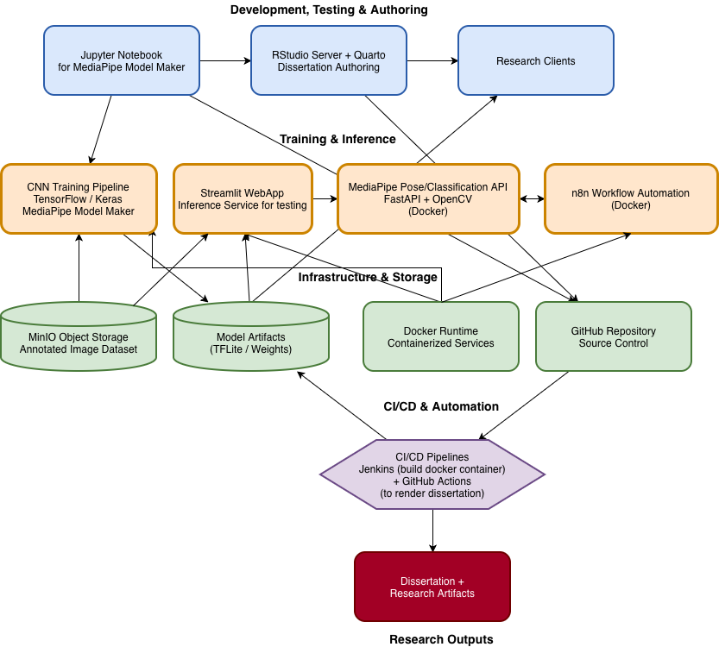
Legend: Creation layer (blue) • Computation layer (orange) • Infrastructure layer (green) • Build layer (purple) • Consume layer (red)

Results
Results were measured for seven model trainings in total, three for 2-class problem solving and four for 3-class approach.

2-Class Training Model performance
The same base dataset was used for all three training runs. To address the class imbalance identified in the test runs prior to the training (runs 2 and 3), data augmentation was performed, increasing the number of images with normal body postures by a factor of 8 and those with abnormal body postures by a factor of 4. This resulted in a more balanced dataset comprising 1,580 synthetically augmented images.
The third run was extended by an additional 300 images, which were augmented using body landmark overlays, which lead to a total of 1880 images.

Training 1
Prediction-derived overall accuracy: 0.6000
Model evaluate() loss/accuracy on dataset_obj: 0.546806/0.733333
Confusion matrix (rows=True class, cols=Predicted class)
Table 4: Confusion matrix for 2-class training 1 showing class imbalance and preference for non-normal posture.
True $∖$ Predicted | non-normal | normal
non-normal | 16 | 8
normal | 4 | 2
Legend: True positives per class non-normal posture 16 (66,6%) • normal posture 2 (33,3%)
Per-class support:
- non-normal posture: 24
- normal posture: 6
Balanced accuracy (macro recall): 0.5000
Classification report
Table 5: Classification results for 2-class training 1 showing on a highly imbalanced class distribution.
Class | Precision | Recall | F1-score | Support
non-normal posture | 0.8000 | 0.6667 | 0.7273 | 24
normal posture | 0.2000 | 0.3333 | 0.2500 | 6
Accuracy |  |  | 0.6000 | 30
macro avg. | 0.5000 | 0.5000 | 0.4886 | 30
weighted avg. | 0.6800 | 0.6000 | 0.6318 | 30
Legend: Accuracy of 60% • balanced accuracy of 50%

Training 2
Prediction-derived overall accuracy: 0.5316
Model evaluate() loss/accuracy on dataset_obj: 0.421809/0.854430
Confusion matrix (rows=True class, cols=Predicted class)
Table 6: Confusion matrix for 2-class training 2 showing class imbalance and preference for normal posture.
True $∖$ Predicted | non-normal | normal
non-normal | 35 | 47
normal | 27 | 49
Legend: True positives per class non-normal posture 35 (42,68%) • normal posture 49 (64,47%)
Per-class support:
- non-normal posture: 82
- normal posture: 76
Balanced accuracy (macro recall): 0.5358
Classification report
Table 7: Classification results for 2-class training 2 showing on a more balanced class distribution, but still with a preference for normal posture.
Class | Precision | Recall | F1-score | Support
non-normal posture | 0.5645 | 0.4268 | 0.4861 | 82
normal posture | 0.5104 | 0.6447 | 0.5698 | 76
Accuracy |  |  | 0.5316 | 158
macro avg. | 0.5375 | 0.5358 | 0.5279 | 158
weighted avg. | 0.5385 | 0.5316 | 0.5264 | 158
Legend: Accuracy of 53.16% • balanced accuracy of 53.58%

Training 3 (extra body landmark overlay)
Prediction-derived overall accuracy: 0.5585
Model evaluate() loss/accuracy on dataset_obj: 0.454466/0.840426
Confusion matrix (rows=True class, cols=Predicted class)
Table 8: Confusion matrix for 2-class training 3 showing class imbalance and preference for normal posture.
True $∖$ Predicted | non-normal | normal
non-normal | 44 | 47
normal | 36 | 61
Legend: True positives per class non-normal posture 44 (48,35%) • normal posture 61 (62,89%)
Per-class support:
- non-normal posture: 91
- normal posture: 97
Balanced accuracy (macro recall): 0.5562
Classification report
Table 9: Classification results for 2-class training 3 showing on a more balanced class distribution, but still with a preference for normal posture and a slight improvement in balanced accuracy compared to Table 9.
Class | Precision | Recall | F1-score | Support
non-normal posture | 0.5500 | 0.4835 | 0.5146 | 91
normal posture | 0.5648 | 0.6289 | 0.5951 | 97
Accuracy |  |  | 0.5585 | 188
macro avg. | 0.5574 | 0.5562 | 0.5549 | 188
weighted avg. | 0.5576 | 0.5585 | 0.5562 | 188
Legend: Accuracy of 55.85% • balanced accuracy of 55.62%

Error analysis
Table 5 achieves the highest accuracy of 0.60. The confusion matrix using the test-image subset shows that performance is uneven across classes: out of 24 non-normal posture cases, 16 are correctly classified and 8 are misclassified as normal, resulting in a recall of 0.6667. In contrast, only 2 out of 6 normal posture cases are correctly identified, while 4 are misclassified as non-normal, yielding a recall of 0.3333. This indicates a clear bias towards correctly predicting non-normal posture while under-detecting normal posture.
As the normal posture class contains only 6 test images, the recall estimate for this class is highly sensitive to single misclassifications and therefore unstable. Consequently, using accuracy as the primary performance indicator is misleading due to both the small sample size and the strong class-wise imbalance. Therefore, balanced accuracy (macro recall) is introduced as the primary evaluation metric, as it assigns equal weight to each class and directly reflects class-wise sensitivity (recall). This strategy will provide a more reliable assessment of model performance across posture categories.
Secondly two annotation strategies to increase the total number of images are used for following runs:
- noise: Several OpenCV image processing routines where applied to multiply the original 300 images to changed duplicates. Techniques used are:
  - Random flip (Horizontal or vertical flipping)
  - Affine transform (Rotating, scaling, translating, and shearing)
  - Random crop + resize (Cropping a random window then resizing back to original size)
  - HSV jitter (Random hue, saturation, and value shifts in HSV space)
  - Intensity adjust (Changing contrast/brightness)
  - Gaussian noise (Additive Gaussian noise per pixel)
  - Random erasing (Erasing a random rectangle region)
- overlay: With a pre-trained Google MediaPipe Pose model, which estimates 33 body landmarks to create a skeletal pose representation, the original 300 images were processed into augmented copies with landmark overlays and color coding (white/red) to indicate posture angles and quality (see Fig. A1).
Table 7 with no overlays but total 1500 images after annotation, achieves an accuracy of 0.5316 and a balanced accuracy of 0.5358, slightly higher than the first Training run with only 300. The confusion matrix shows an uneven class-wise performance: out of 82 non-normal posture cases, 35 are correctly classified as non-normal, while 47 are misclassified as normal, resulting in a recall of 0.4268. In contrast, out of 76 normal posture cases, 49 are correctly identified, while 27 are misclassified as non-normal, yielding a recall of 0.6447.
Table 9 with additional landmark overlay images (>1800 images) achieves an accuracy of 0.5585 and a balanced accuracy of 0.5562. Compared to run 2, class-wise performance becomes more balanced: recall for non-normal cases decreases slightly, while recall for normal cases increases, reducing the class imbalance in sensitivity. This indicates that landmark overlays shift the decision boundary towards improved representation of the minority class, resulting in a more even distribution of classification errors across classes.
Overall, both ladder models still perform only marginally above the 50% chance level, but the overlay-based model provides a measurable improvement in class-balanced performance rather than accuracy alone.

3-Class Training Model performance
For the 3-class problem, in total four training runs were performed using all four available base architectures (from light to heavy computational wise). Each run reports their metrics derived from evaluation on the same held-out on the test split.

Training 1 (MobileNet-V2 architecture)
Prediction-derived overall accuracy: 0.3065
Model evaluate(internal performance metric) loss/accuracy on dataset_obj: 0.736599/0.748744
Confusion matrix (rows=True class, cols=Predicted class)
Table 10: Confusion matrix for 3-class training 1 showing slight under-representation of tensed posture class.
True $∖$ Predicted | normal | slumped | tensed
normal | 24 | 21 | 18
slumped | 26 | 20 | 16
tensed | 23 | 34 | 17
Legend: True positives per class normal posture 24 (38,10%) • slumped posture 61 (32,25%) • tensed posture 17 (22,97%)
Per-class support:
- normal posture: 63
- slumped posture: 62
- tensed posture: 74
Balanced accuracy (macro recall): 0.3111
Classification report
Table 11: Classification results for 3-class training 1 showing a under-representation of tensed posture.
Class | Precision | Recall | F1-score | Support
normal posture | 0.3288 | 0.3810 | 0.3529 | 63
slumped posture | 0.2667 | 0.3226 | 0.2920 | 62
tensed posture | 0.3333 | 0.2297 | 0.2720 | 74
Accuracy |  |  | 0.3065 | 199
Macro avg. | 0.3096 | 0.3111 | 0.3056 | 199
Weighted avg. | 0.3111 | 0.3065 | 0.3038 | 199
Legend: Accuracy of 30.65% • balanced accuracy of 31.11%

Training 2 (EfficientNet-Lite0 architecture)
Prediction-derived overall accuracy: 0.3216
Model evaluate(internal performance metric) loss/accuracy on dataset_obj: 0.638240/0.824121
Confusion matrix (rows=True class, cols=Predicted class)
Table 12: Confusion matrix for 3-class training 2 showing under-representation of normal posture class and a preference for slumped posture.
True $∖$ Predicted | normal | slumped | tensed
normal | 4 | 38 | 21
slumped | 2 | 40 | 20
tensed | 3 | 51 | 20
Legend: True positives per class normal posture 4 (6,35%) • slumped posture 40 (64,52%) • tensed posture 20 (27,03%)
Per-class support:
- normal posture: 63
- slumped posture: 62
- tensed posture: 74
Balanced accuracy (macro recall): 0.3263
Classification report
Table 13: Classification results for 3-class training 2 showing a strong under-representation of normal posture class and a preference for slumped posture.
Class | Precision | Recall | F1-score | Support
normal posture | 0.4444 | 0.0635 | 0.1111 | 63
slumped posture | 0.3101 | 0.6452 | 0.4188 | 62
tensed posture | 0.3279 | 0.2703 | 0.2963 | 74
Accuracy |  |  | 0.3216 | 199
Macro avg. | 0.3608 | 0.3263 | 0.2754 | 199
Weighted avg. | 0.3592 | 0.3216 | 0.2759 | 199
Legend: Accuracy of 32.16% • balanced accuracy of 32.63%

Training 3 (EfficientNet-Lite2 architecture)
Prediction-derived overall accuracy: 0.3920
Model evaluate(internal performance metric) loss/accuracy on dataset_obj: 0.645087/0.849246
Confusion matrix (rows=True class, cols=Predicted class)
Table 14: Confusion matrix for 3-class training 3 showing preference for slumped posture class.
True $∖$ Predicted | normal | slumped | tensed
normal | 16 | 36 | 11
slumped | 10 | 39 | 13
tensed | 12 | 39 | 23
Legend: True positives per class normal posture 16 (25,40%) • slumped posture 39 (62,90%) • tensed posture 23 (31,08%)
Per-class support:
- normal posture: 63
- slumped posture: 62
- tensed posture: 74
Balanced accuracy (macro recall): 0.3979
Classification report
Table 15: Classification results for 3-class training 3 showing a preference for slumped posture class and a slight improvement in balanced accuracy compared to Table 13.
Class | Precision | Recall | F1-score | Support
normal posture | 0.4211 | 0.2540 | 0.3168 | 63
slumped posture | 0.3421 | 0.6290 | 0.4432 | 62
tensed posture | 0.4894 | 0.3108 | 0.3802 | 74
Accuracy |  |  | 0.3920 | 199
Macro avg. | 0.4175 | 0.3979 | 0.3801 | 199
Weighted avg. | 0.4219 | 0.3920 | 0.3797 | 199
Legend: Accuracy of 39.20% • balanced accuracy of 39.79%

Training 4 (EfficientNet-Lite4 architecture)
Prediction-derived overall accuracy: 0.4121
Model evaluate(internal performance metric) loss/accuracy on dataset_obj: 0.703537/0.758794
Confusion matrix (rows=True class, cols=Predicted class)
Table 16: Confusion matrix for 3-class training 4 showing preference for slumped posture class.
True $∖$ Predicted | normal | slumped | tensed
normal | 18 | 33 | 12
slumped | 12 | 38 | 12
tensed | 15 | 33 | 26
Legend: True positives per class normal posture 18 (28,57%) • slumped posture 38 (61,29%) • tensed posture 26 (35,14%)
Per-class support:
- normal posture: 63
- slumped posture: 62
- tensed posture: 74
Balanced accuracy (macro recall): 0.4167
Classification report
Table 17: Classification results for 3-class training 4 showing a preference for slumped posture class and a slight improvement in balanced accuracy compared to Table 15.
Class | Precision | Recall | F1-score | Support
normal posture | 0.4000 | 0.2857 | 0.3333 | 63
slumped posture | 0.3654 | 0.6129 | 0.4578 | 62
tensed posture | 0.5200 | 0.3514 | 0.4194 | 74
Accuracy |  |  | 0.4121 | 199
Macro avg. | 0.4285 | 0.4167 | 0.4035 | 199
Weighted avg. | 0.4338 | 0.4121 | 0.4041 | 199
Legend: Accuracy of 41.21% • balanced accuracy of 41.67%

Error analysis
Across all experiments a consistent pattern of misclassification is apparent. The models show relatively high recall for the slumped posture class but lower precision, indicating a tendency to predict slumped for a wide range of inputs exemplified visible in Table 14. Normal posture is frequently misclassified (low recall in several runs), and tensed posture predictions vary by architecture: deeper Lite variants tended to improve overall discrimination.
- Best overall accuracy and balanced recall were achieved by EfficientNet-Lite4 (accuracy 0.4121, balanced accuracy 0.4167) - Table 16.
- EfficientNet-Lite2 performed second best (accuracy 0.3920, balanced accuracy 0.3979) - Table 14.
- EfficientNet-Lite0 and MobileNet-V2 produced lower overall accuracy (0.3216 and 0.3065 respectively) and lower balanced accuracy - Table 10 and Table 12.

Common failure modes observed in confusion matrices
- Confusion between normal and slumped: many normal examples are predicted as slumped, suggesting the model is sensitive to subtle postural variations or that the dataset contains ambiguous examples near class boundaries.
- Over-prediction of slumped: reflected in row-normalized confusion matrices where the middle column (predicted slumped) is large across runs.
- Lower discrimination for tensed vs. other classes in the smaller architectures, improved modestly in larger EfficientNet-Lite variants.

Comparison of results to 2-class training
Chance levels for the 3-class are 1/3 or 33.3%, for the 2-class 1/2 or 50%. Because of this difference, a chance-balanced accuracy will be calculated.
- Best 3-class model: balanced accuracy =0.4167.
  - κ∗=0.4167−1/31−1/3=0.08340.6667≈0.125κ∗=1−1/30.4167−1/3​=0.66670.0834 ​≈ 0.125.
- Best 2-class model: balanced accuracy =0.562.
  - κ∗=0.562−0.51−0.5=0.0620.5=0.124κ∗=1−0.50.562−0.5​=0.50.062 = 0.124.
Adjusted for chance, 3-class and 2-class models perform essentially on the same performance level. The 3-class model is marginally higher (0.125 vs 0.124), a difference that’s practically negligible and likely not statistically significant with these sample sizes. In raw terms, binary shows higher accuracy (≈56% vs 41%), but that’s expected given its higher chance baseline.

Discussion
This study demonstrates that compact CNNs within the MediaPipe/TFLite stack can learn posture‑relevant features, but current discrimination is limited.

Interpretation of findings
The strongest three‑class model (EfficientNet‑Lite4) reached 41.2% accuracy (41.7% balanced accuracy). Reformulating the task as binary improved raw accuracy to 55.9% (55.6% balanced) with landmark overlays, indicating that explicit skeletal cues modestly aid detection.To compare the results of the 3-class and 2-class training, we can look at the overall accuracy and balanced accuracy (macro recall) for each model. This 3-class model achieved an overall accuracy of 41.21% and a balanced accuracy of 41.67%, while the 2-class model with landmark overlays achieved an overall accuracy of 55.85% and a balanced accuracy of 55.62%. Also the overall low performances of both CNN model training approaches (2-class as well as 3-class only slightly above chance) suggest that the task is challenging and that further improvements in data quality, model architecture, or training strategy may be needed to achieve clinically useful performance.

Implications and next steps
- The results indicate that the models can capture some posture-related features but that class overlap and limited dataset size constrain discriminative performance. Better class balance, additional labelled data for edge cases, and further augmentation tailored to posture variations should be considered.
- Model calibration and threshold tuning (or use of ensemble methods) may improve precision for the slumped and tensed classes.
- Further work should include qualitative review of misclassified examples to identify systematic annotation or dataset issues and targeted augmentation or re-labelling where necessary.

Strengths and limitations
This study demonstrates that transfer learning on compact CNN architectures within the MediaPipe/TFLite stack is applicable to clinically oriented posture classification. The highest-performing three-class model (@tbl-report-training-3class-4 – EfficientNet-Lite4) achieved an accuracy of 41.2% (41.7% balanced accuracy), whilst the binary formulation achieved an accuracy of 55.9% (55.6% balanced accuracy) when landmark overlays were incorporated. The improved performance with overlays suggests that explicit skeletal features can modestly enhance the discrimination of postures.
A further strength lies in the practical and scalable implementation approach. The use of lightweight TensorFlow Lite models enables low-latency inference on off-the-shelf consumer hardware and mobile devices, thereby supporting potential future deployment in the fields of digital health and rehabilitation. Furthermore, the study established a reproducible CI/CD and containerised research pipeline that supports systematic experimentation, reproducibility and deployment readiness.
Another strength is the clinically grounded framework for posture classification, which is based on Klein-Vogelbach. Rather than focusing exclusively on generic pose estimation, the study sought to align the results of deep learning with clinically meaningful posture categories, thereby increasing interpretability and practical relevance.
Despite these strengths, the models performed only marginally above chance when the task complexity was taken into account. As the binary chance level is inherently higher (1/2 versus 1/3), part of the observed performance gain reflects a simplification of the classification problem rather than a substantially improved discriminatory power.
Persistent misclassifications – in particular the frequent misclassification of the ‘normal’ posture as ‘bent’ – point to significant class overlaps and probable label noise within the dataset. The relatively small size of the dataset and in addition, to ensure that the images can be clearly classified regarding the Klein-Vogelbach method, subjetcs shown in non-standing or full body (feet to head) focus, lowered training success. As this dataset only partially met these criteria, for example, many images showed people in different sitting positions or only the upper body, which may have introduced additional variability and compromised the reliability of the classification. These factors increased the risk of subjective bias and inconsistent class boundaries.
The dataset may also lack demographic diversity, which could limit fairness and external validity across different populations. Furthermore, whilst the use of synthetically augmented images is necessary to increase the sample size, it may not fully reflect the variability of posture in the real world. Consequently, the results support the feasibility of a proof-of-concept rather than readiness for clinical use.

Clinical and practical implications
Given current performance (balanced accuracy ≈41% for three‑class), the model’s most appropriate near‑term role is as a clinician‑in‑the‑loop decision support tool rather than a standalone diagnostic. Keeping in mind that n=300, further annotation and data expansion are needed to train the model to a better overall performance. In practice, the system can assist screening by flagging potentially “non‑normal” cases for closer review, standardize documentation via landmark/angle overlays, and track an individual’s progress over time under consistent capture conditions. To ensure reliable use, the probabilities predicted by the model must be compared with the actual correctness. An “abstain/needs review” state, would prevent false classification. In the Figure 3 threshold tuning for confidence of classification is one way, also a clear presentation of uncertainty and a request for a user in the loop. To enhance reliability and equity, future work should expand and re‑balance labelled data—particularly at class boundaries—adopt multi‑rater labelling, incorporate interpretable posture‑aware features (e.g., craniovertebral angle), and validate externally across sites, devices, and demographic subgroups. On‑device TFLite inference supports privacy and low latency, but any clinical use should be governed by explicit intended‑use documentation, bias and robustness monitoring.

Conclusion and Future Work
This dissertation demonstrates that transfer learning on compact CNNs within the MediaPipe/TFLite stack is feasible for static upper‑body posture assessment, but current performance does not yet meet clinical decision thresholds. The strongest three‑class model (EfficientNet‑Lite4) achieved 41.2% accuracy (41.7% balanced accuracy). Persistent confusions—particularly over‑prediction of “slumped” and low recall for “normal”—likely reflect subtle class boundaries, label noise, and the small, static dataset. Practically, the present system is best positioned as clinician‑in‑the‑loop decision support for screening, standardized documentation (landmark/angle overlays), and within‑subject progress tracking under a consistent capture protocol. On‑device TFLite supports privacy and low latency, but safe use requires calibrated confidence, explicit uncertainty, and clear guardrails around intended use.
Priorities for future work will center on prospective clinical image collection, expert annotation, improving the MediaPipe Pose detection, develop a 4-body-block detection model (Klein-Vogelbach) as well as retraining the three‑class model to improve discrimination and equity.

Clinical data collection
To acquire a larger, prospectively collected side-view image dataset in real clinical settings, a strictly standardized acquisition protocol should be implemented, including fixed camera height at approximately shoulder level, constant camera-to-subject distance, standardized lateral stance, neutral footwear, uncluttered background, and controlled, even lighting conditions. A fixed full-body and standing-position capturing should achieve clinically meaningful sensitivity and specificity.
Demographic representativeness across relevant population groups should be ensured as well informed consent and ethics approvals should be obtained. In addition, metadata such as device type, viewing angle, and lighting conditions could be systematically recorded to enable reproducibility and avoid bias assessment and ensuring robust model validation.

Expert annotation
For expert annotation, future work should implement a multi-rater labeling protocol with at least two independent clinicians to ensure annotation reliability, in contrast to the present study where annotations were performed by a single rater (the author). All annotations should follow a clearly defined rubric aligned with the Klein-Vogelbach posture classes (normal, slumped/hypotonic, tensed/hypertonic), including explicit decision criteria to reduce subjective variability. Disagreements between raters should be resolved through a structured adjudication process, ideally involving a third expert reviewer.
Inter-rater agreement should be quantified using metrics such as Cohen’s κ to monitor consistency and identify ambiguous cases. In addition, a stable gold-standard subset should be maintained and periodically reused for model calibration and regression testing to ensure annotation quality and temporal consistency across dataset iterations.

Retraining the 3‑class model
To retrain the model using class-balanced sampling to mitigate class imbalance and apply posture-aware augmentation, boundary cases between normal, slumped, and tensed postures should be carefully handled rather than inadvertently reinforced. Training should incorporate more discriminative and clinically consistent examples, with targeted augmentation that preserves posture semantics while increasing variability in non-ambiguous cases.
In addition, interpretable posture-derived features extracted from landmarks (e.g., craniovertebral angle and thoracic kyphosis proxies) could be integrated to complement image-based learning with clinically meaningful structure. A multi-task architecture, jointly predicting posture class and continuous postural angles, may further improve both classification performance and interpretability by enforcing consistency between categorical and geometric representations of posture. Finally, probability calibration should be applied, and operating thresholds should be explicitly defined for a screening use case to prioritize sensitivity for non-normal postures while controlling false-positive rates.

Evaluation and fairness
Future work should include external validation on a held-out site or device to assess generalisability beyond the current data source test data-set. In addition, model performance should be reported across relevant subgroups (e.g., sex, age bands, and skin tone), including an analysis of confusion patterns to identify systematic biases or failure modes. Learning-curve analyses should further be conducted to quantify data requirements and inform targeted data collection for improving model robustness and fairness.

Example Milestones
To define a concrete milestone, like a on-site pilot study, a small-scale feasibility study to extend the current work, primarily to assess data quality and pipeline robustness under clinical conditions, could be conducted. If so, it should try to create approximately 1,000 newly class-balanced clinical images with the earlier mentioned criteria (standing, full-body-view, side-view). Model performance should be evaluated on an external test split to test for clinically meaningful classification performance.
Further future work could also prioritize the transition to a structured four-body-block pose detection approach aligned with Klein-Vogelbach’s framework. This involves training models to estimate the relative position and orientation of the head, thorax, pelvis, and lower extremities, enabling direct modelling of inter-segment relationships rather than relying on high-dimensional joint inputs. Such an approach may improve robustness and interpretability. Model development should be accompanied by clinically informed annotation protocols and validated against expert-labelled reference data to ensure alignment with functional movement assessment standards.
For deployment readiness, inference could be performed on-device to preserve user privacy within the authors E-Health SaaS service Serious Ben Entertainment for the German health market, where posture detection is embedded in a digital serious back school game. To enhance reliability in this preventive context, the system could implement confidence gating, allowing the model to abstain or flag cases as “needs review” when prediction certainty is low. In addition, datasets and model versions should be systematically tracked to ensure reproducibility and regulatory transparency. Post-deployment, continuous monitoring for data drift would be required, with periodic recalibration to maintain performance as usage conditions, devices, and user populations evolve.
Last but not least, a dedicated iOS application could be developed to deploy the trained models on Apple’s A-series chip architecture, leveraging the integrated Neural Engine for efficient on-device inference. This would enable real-time posture analysis with low latency, reduced energy consumption, and enhanced privacy through local processing, while also supporting scalable deployment within mobile E-Health and serious gaming applications.

Appendix

A. Figures
Figure 1: Move AI advertising accurate markerless motion capturing on their website.
Figure 2: 3 types of posture types defined by Klein-Vogelbach, the underlying functional movement concept was developed between 1955-1975.
Figure 3: Streamlit Web App with classification of postures using the build quantized model from Training 4.
Figure 4: Implementation map illustrates the pipelines, automation and containerization.
Figure 5: Canvas for editing the automation workflow.
Figure 5: n8n automation Canvas.
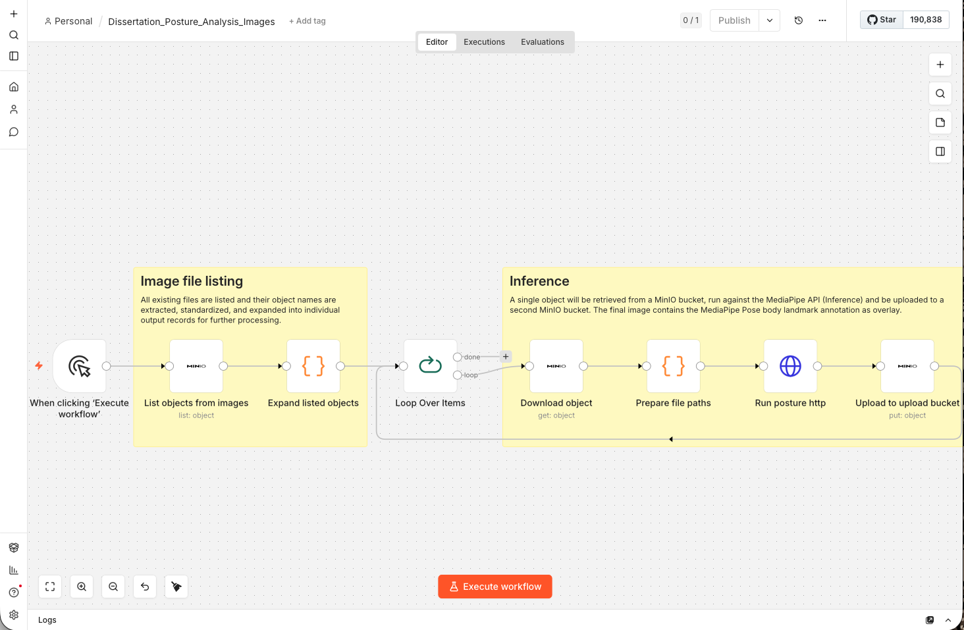
Figure 6: Google MediaPipe Pose landmark model with 33 3-dimensional pose mapping.
Figure 6: Google MediaPipe Pose landmark mapping.
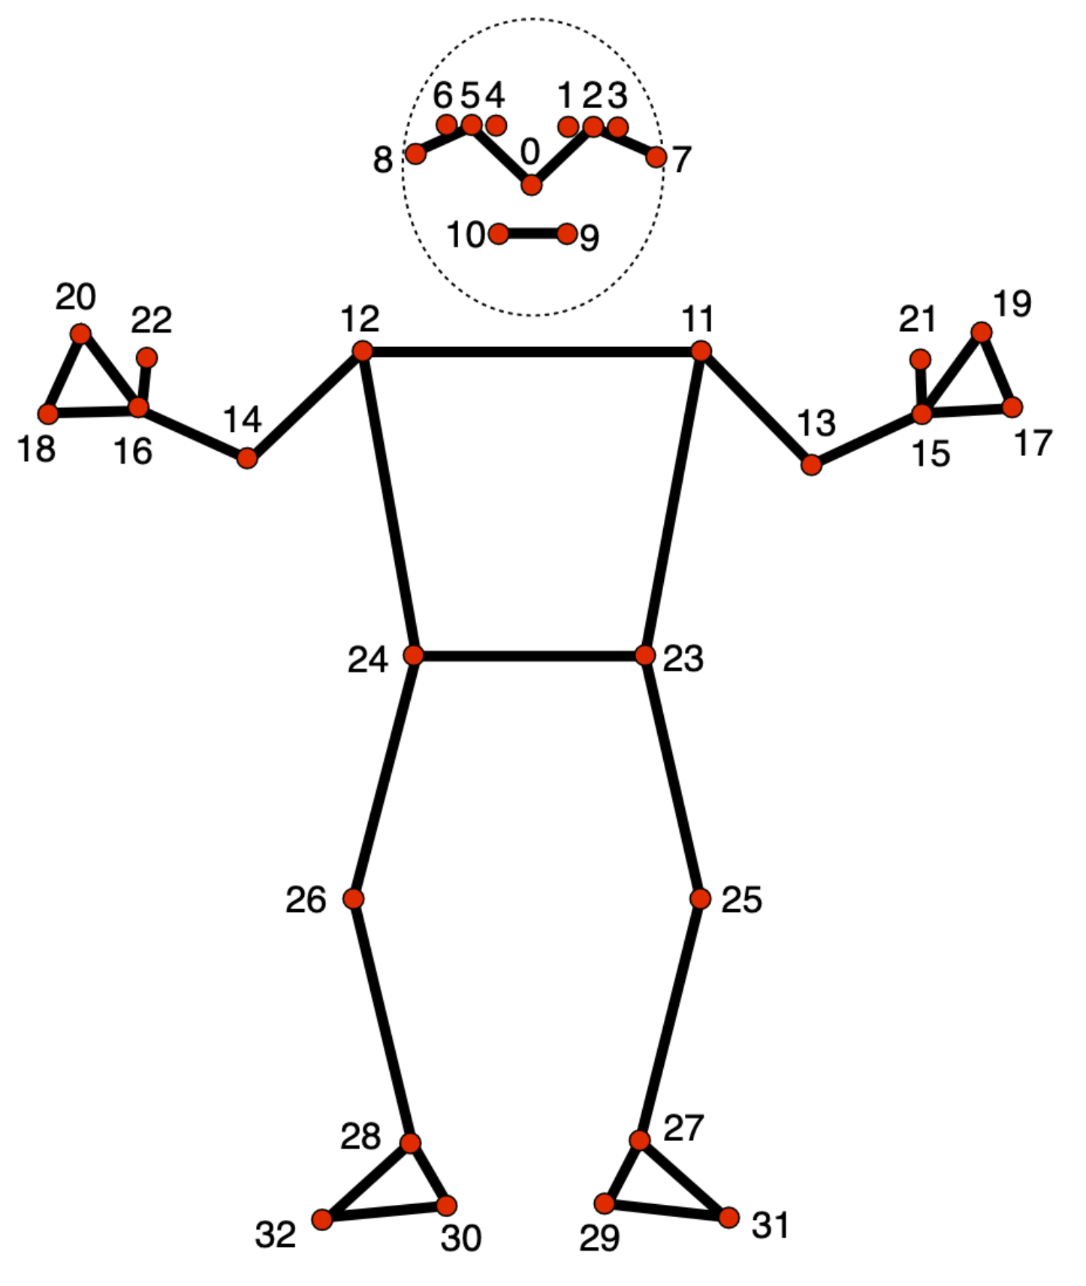
Figure 7: Example of Google MediaPipe Pose landmarker model overlay whichs show angles of head/neck and torso.
Figure 7: Google MediaPipe Pose landmarker model overlay #1.
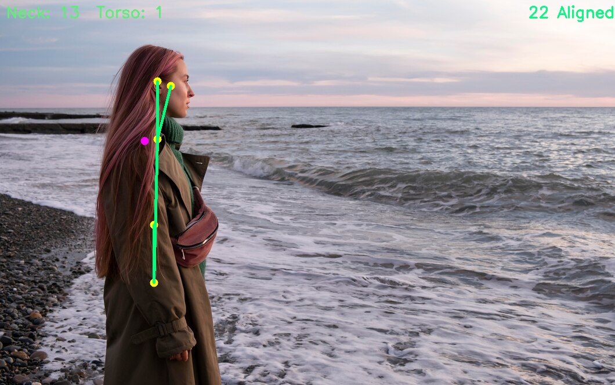
Figure 8: Another example of Google MediaPipe Pose landmarker model overlay showing annotation errors.
Figure 8: Google MediaPipe Pose landmarker model overlay #2.
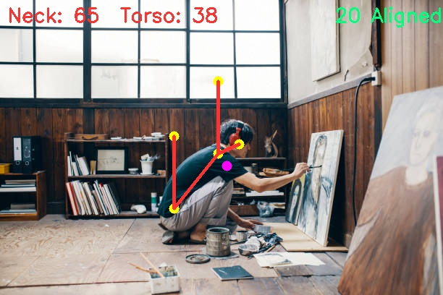

B. List of Abbreviations
Table 18: Abbreviations used in this dissertation.
Abbrevation | Term
API | Advanced Programming Interface
CI/CD | Continuous Integration / Continuous Development
CNN | Convolutional Neural Network
ETL | Extract Transform Load
PEM | Pose Estimation Model

C. Ethics Approval
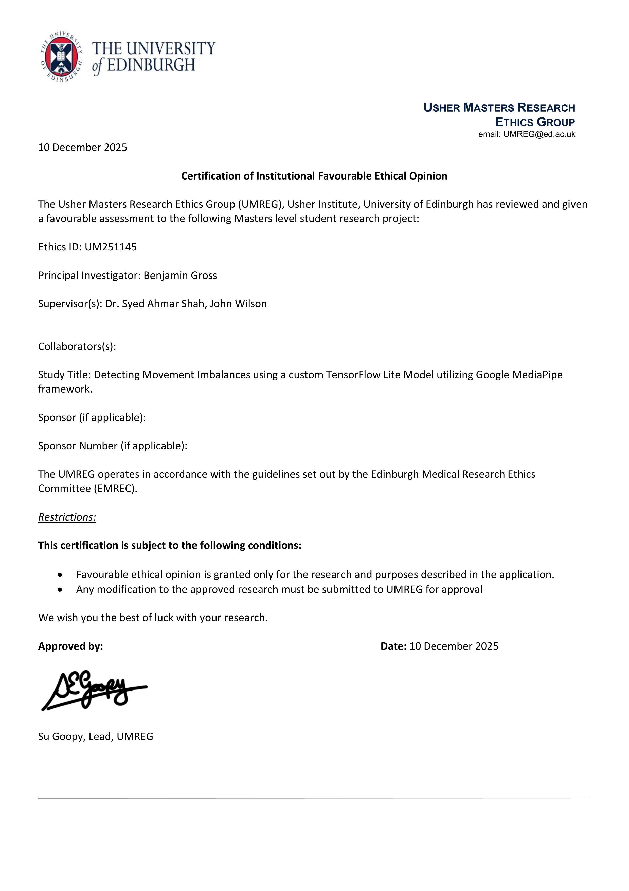

D. Declaration of Originality
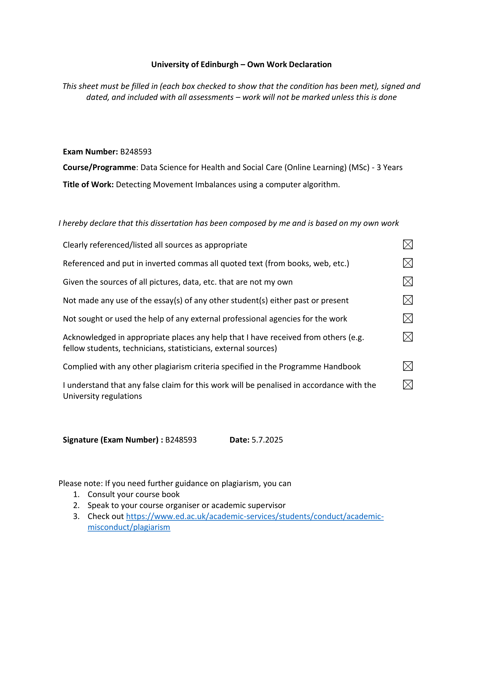

References
Aljuaid, A., & Anwar, M. (2022). Survey of supervised learning for medical image processing. Sn Computer Science, 3, 292. https://doi.org/10.1007/S42979-022-01166-1
Badhe, P. C., & Kulkarni, V. (2018). A review on posture assessment. In https://www.iosrjournals.org/iosr-jspe/papers/Vol-5Issue5/Version-1/B05050815.pdf. https://www.researchgate.net/publication/328981577_A_Review_on_Posture_Assessment
Baek, Y., Han, K., Jeon, E., & Yoo, H. Y. (2025). Prediction of nursing need proxies using vital signs and biomarkers data: Application of deep learning models. Journal of Clinical Nursing, 34, 4121–4131. https://doi.org/10.1111/JOCN.17612
Barash, Y., Sorin, V., Cohen, I., Khaitovich, B., Raskin, D., & Livne, A. (2024). Artificial intelligence in identification of upper GI bleeds. In https://www.unitecollaborative.com/post/artificial-intelligence-in-identification-of-upper-gi-bleeds?utm_source=perplexity. https://www.unitecollaborative.com/post/artificial-intelligence-in-identification-of-upper-gi-bleeds?utm_source=perplexity
Bazarevsky, V., & Grishchenko, I. (2020). On-device, real-time body pose tracking with MediaPipe BlazePose. https://research.google/blog/on-device-real-time-body-pose-tracking-with-mediapipe-blazepose/
Cao, X., Wang, X., Geng, X., Wu, D., & An, H. (2024). An approach for human posture recognition based on the fusion PSE-CNN-BiGRU model. CMES - Computer Modeling in Engineering and Sciences, 140, 385–408. https://doi.org/10.32604/CMES.2024.046752
F.M. Alexander. (2017). Methode mit großem betriebsmedizinischem potential eigene, die berufsfähigkeit existentieller bedrohende probleme mit der stimme führten. Institut Für Arbeits-, Sozial- Und Umweltmedizin. https://doi.org/10.'2017
Ge, L., Pereira, M. J., Yap, C. W., & Heng, B. H. (2022). Chronic low back pain and its impact on physical function, mental health, and health-related quality of life: A cross-sectional study in singapore. Scientific Reports, 12. https://doi.org/10.1038/S41598-022-24703-7
Google. (2024). Pose detection | ML kit | google for developers. https://developers.google.com/ml-kit/vision/pose-detection
Google. (2026). Pose landmark detection guide | google AI edge | google AI for developers. https://ai.google.dev/edge/mediapipe/solutions/vision/pose_landmarker#configurations_options
Haris, M., Khel, K., Kadir, K., Albattah, W., Khan, S., Noor, M., Nasir, H., Habib, S., Islam, M., & Khan, A. (2021). Emerging science journal real-time monitoring of COVID-19 SOP in public gathering using deep learning technique. https://doi.org/10.28991/esj-2021-SPER-14
Jiang, X., Hu, Z., Wang, S., & Zhang, Y. (2023). A survey on artificial intelligence in posture recognition. Computer Modeling in Engineering & Sciences : CMES, 137, 35. https://doi.org/10.32604/CMES.2023.027676
Kakuta, K. C., Kikawa, T., Kumagai, Y., Gupta, J., Pathak, S., & Kumar, G. (2022). Deep learning (CNN) and transfer learning: A review. Journal of Physics: Conference Series, 2273, 012029. https://doi.org/10.1088/1742-6596/2273/1/012029
Klein-Vogelbach, S. (1990). Functional kinetics. Functional Kinetics. https://doi.org/10.1007/978-3-642-95470-2
Kubalek-Schröder, S., & Dehler, F. (2013). Funktionsabhängige beschwerdebilder des bewegungssystems. Funktionsabhängige Beschwerdebilder Des Bewegungssystems. https://doi.org/10.1007/978-3-642-35151-8
Lachance, J. M., Thong, W., Shruti, N., & Xiang, A. (2023). A case study in fairness evaluation: Current limitations and challenges for human pose estimation. Sony. https://r2hcai.github.io/AAAI-23/files/CameraReadys/21.pdf
Liu, M., Rong, J., An, X., Li, Y., Min, Y., Yuan, G., Yang, Y., & Li, M. (2025). Global, regional, and national burden of musculoskeletal disorders, 1990–2021: An analysis of the global burden of disease study 2021 and forecast to 2035. Frontiers in Public Health, 13, 1562701. https://doi.org/10.3389/FPUBH.2025.1562701/FULL
Lugaresi, C., Tang, J., Nash, H., Mcclanahan, C., Uboweja, E., Hays, M., Zhang, F., Chang, C.-L., Yong, M. G., Lee, J., Chang, W.-T., Hua, W., Georg, M., Grundmann, M., & Research, G. (2019). MediaPipe: A framework for building perception pipelines. Google. https://arxiv.org/pdf/1906.08172
Makhmudov, M. (2025a). An application for tracking human posture. In https://github.com/melsmm/posture-keypoints-detection. https://github.com/melsmm/posture-keypoints-detection
Makhmudov, M. (2025b). Posture keypoints detection - photos & labels. In https://www.kaggle.com/datasets/melsmm/posture-keypoints-detection/data. https://www.kaggle.com/datasets/melsmm/posture-keypoints-detection/data
Move AI. (2026). Move AI - markerless motion capture & 3D animation. In https://move.ai. https://move.ai/
Ogundokun, R. O., Maskeliūnas, R., & Damaševičius, R. (2022). Human posture detection using image augmentation and hyperparameter-optimized transfer learning algorithms. Applied Sciences (Switzerland), 12. https://doi.org/10.3390/APP121910156
Pol, U. R. (n.d.). No-code intelligence: Building AI agents with N8N. www.ijfmr.com
Rajput, N. (2025). Streamlit in 2025: From toy apps to enterprise frontends | by nikulsinh rajput | medium. https://medium.com/@hadiyolworld007/streamlit-in-2025-from-toy-apps-to-enterprise-frontends-3a14cc00139b
Ray, A., & Kolekar, M. H. (2024). Transfer learning and its extensive appositeness in human activity recognition: A survey. Expert Systems with Applications, 240, 122538. https://doi.org/10.1016/J.ESWA.2023.122538
Rivera-Guzmán, E. F., Guerrero-Vásquez, L. F., & Robles-Bykbaev, V. E. (2026). Quantization of deep neural networks for medical image analysis: A systematic review and meta-analysis. Technologies, 14, 76. https://doi.org/10.3390/TECHNOLOGIES14010076
RunDNA. (2026). Real-time 3D running gait analysis. Https://Rundna.com/. https://rundna.com/helix3d/
RUNRIGHT 3D. (2026). A running gait analysis and shoe fitting system. In https://runright-3d.com. https://runright-3d.com/
Rzig, D. E., Houerbi, A., Chavan, R. G., & Hassan, F. (2024). Empirical analysis on CI/CD pipeline evolution in machine learning projects. 17. https://doi.org/10.1145/nnnnnnn.nnnnnnn
Sahrmann, S., Azevedo, D. C., & Dillen, L. V. (2017). Diagnosis and treatment of movement system impairment syndromes. Brazilian Journal of Physical Therapy, 21, 391. https://doi.org/10.1016/J.BJPT.2017.08.001
Tachihara, H., & Hamada, J. (2019). Characteristic movement of the ribs, thoracic vertebrae while elevating the upper limbs - influences of age and gender on movements. The Open Orthopaedics Journal, 13, 170–176. https://doi.org/10.2174/1874325001913010170
TecnoBody Walker View. (2026). TecnoBody view 3.0 SCX treadmill. In https://www.medical-xprt.com/products/tecnobody-model-view-30-scx-treadmill-804362. https://www.medical-xprt.com/products/tecnobody-model-view-30-scx-treadmill-804362
Ultralytics. (2025). Pose estimation - ultralytics YOLO docs. In ultralytics. https://docs.ultralytics.com/tasks/pose/
ViMove2. (2026). ViMove2: Wearable sensor technology. In https://runreborn.com/article/vi-move2-wearable-sensor-technology. https://runreborn.com/article/vi-move2-wearable-sensor-technology
Wagh, V., Scott, M. W., & Kraeutner, S. N. (2024). Quantifying similarities between MediaPipe and a known standard to address issues in tracking 2D upper limb trajectories: Proof of concept study. JMIR Formative Research, 8, e56682. https://doi.org/10.2196/56682
Wei, L., Wu, B., Guo, T., Ru, D., Gao, C., Wu, J., Wu, A., Yue, H., Hu, J., Wei, L., Geng, Z., & Wang, K. (2025). Development and validation of a machine learning-based model for 90-day prognosis outcome in spontaneous intracerebral hemorrhage patients based on non-contrast computed tomography: A multicenter retrospective observational study. eClinicalMedicine, 88. https://doi.org/10.1016/j.eclinm.2025.103507
What is a retrospective observational study? - california learning resource network. (2025). In https://www.clrn.org/what-is-a-retrospective-observational-study/?utm_source=perplexity. https://www.clrn.org/what-is-a-retrospective-observational-study/?utm_source=perplexity
Whittaker, J. L., Booysen, N., Motte, S. D. L., Dennett, L., Lewis, C. L., Wilson, D., McKay, C., Warner, M., Padua, D., Emery, C. A., & Stokes, M. (2017). Predicting sport and occupational lower extremity injury risk through movement quality screening: A systematic review. British Journal of Sports Medicine, 51, 580–585. https://doi.org/10.1136/BJSPORTS-2016-096760
Wijekulasuriya, G. A., Woods, C. T., Kittel, A., & Larkin, P. (2025). The development and content of movement quality assessments in athletic populations: A systematic review and multilevel meta-analysis. Sports Medicine - Open, 11, 7. https://doi.org/10.1186/S40798-025-00813-0
Xu, H., Bazavan, E. G., Zanfir, A., Freeman, W. T., Sukthankar, R., & Sminchisescu, C. (2020). GHUM GHUML: Generative 3D human shape and articulated pose models. Proceedings of the IEEE Computer Society Conference on Computer Vision and Pattern Recognition, 6183–6192. https://doi.org/10.1109/CVPR42600.2020.00622
Zaucker, P. (2010). Ballkoordination bei schülern mit unterschiedlicher sporterfahrung.

