Before using the script, please install R and Rstudio in your computer.

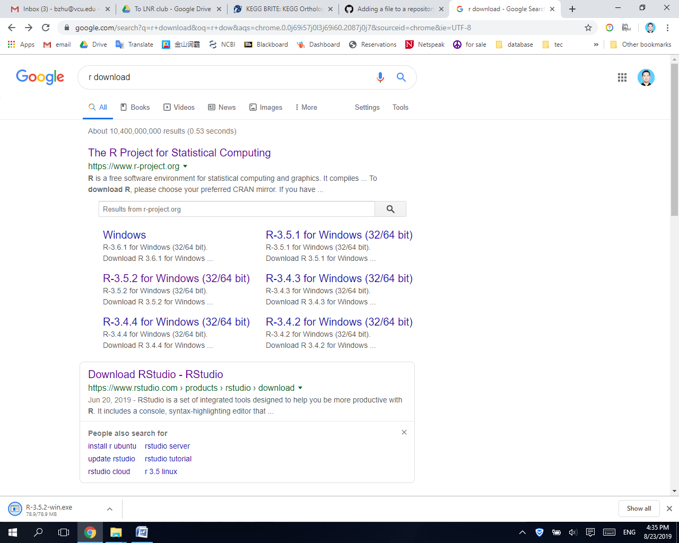

If this is the first time to use the script, you should open ‘Installation.R’, choose all of the commands and run the commands to install necessary packages for the analysis. From the second time on, you don’t need to run it again.

To run commands, you can choose the commands using your mouse, or you could move cursor to command windows, press ‘Control+A’ in Windows or ‘command+A’ in Mac to choose all of the commands and click ‘run’.

##############################################################################

1. Prepare your reads data in ‘data.csv’ file and design information in ‘design.csv’ file. You can use Google Sheets or EXCEL to edit .csv files.

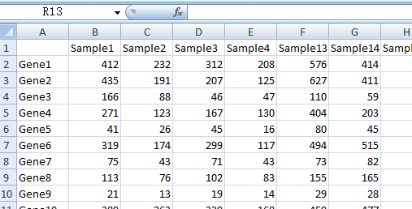 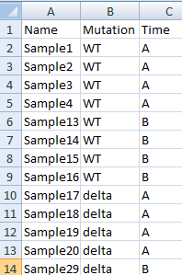

2. Open ‘EZ2RNAseq.R’ in Rstudio. Move cursor to command windows, press ‘Control+A’ in Windows or ‘command+A’ in Mac to choose all of the commands and click ‘run’.

3. Click arrows to choose figures and click ‘Export’ to export figures. The results of differentially expressed genes are exported to .csv files in the same folder.

