**Module Description**

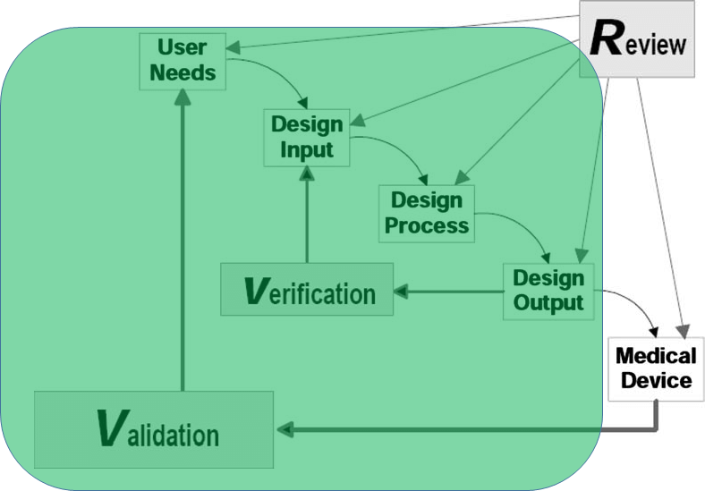

**Learning Objectives**

|  |  |  |
| --- | --- | --- |
| **Design Thinking** | **Skills** | **Tools** |
| * User need revision * Requirement generation * Design process * Requirement verification * Design Validation * Traceability Matrix | * User interviews * System component selection * Electric motor control * Motor sizing * Engineering analysis * Interface Configuration | * Power/torque/rpm * Motors * MOSFETs * Arduino * Gears * Mechanics/Electronics |

**Designette**

Intervertebral disc spacers must be light weight yet strong with the ability to withstand at least TBD N/m2 per square inch per the American Society for Testing and Materials (ASTM) standard D695. For early feasibility studies and design iteration, geometry must be optimized using 3D printed Acrylonitrile butadiene styrene (ABS). You are tasked with optimizing the spacer geometry to maximize the force required for plastic deformation while minimizing the volume of material required.

**Deliverables**

1. Completed Design Controls Worksheet
2. Circuit Diagram
3. Biosignal Calibration Data

**Tips for Success**

* Limit the scope of your project and requirements to a manageable size (<5) to ensure you can objectively assess them all.
* Take good notes when learning how to digitize transducer output. These notes are crucial to designing your circuit.
* Review bioinstrumentation course content surrounding analog to digital conversion, voltage dividers and circuit analysis.