**Cash Register**

Overview

You are writing software for a cash register, and are given two separate tasks to solve. The tasks will be described below, followed by a description of the API available to solve the tasks. Finally, there is a description of how the score is calculated and presented.

Make sure to read the entire description before attempting the tasks. Read the description for both tasks, but focus on completing the first task before starting the second.

Task 1 (4 points)

Your first task is to calculate the minimum number of bills needed to give a customer their change when purchasing an item.

To solve this task you are given a list of bill denominations (values), the price of the item, and the amount the customer payed. For this task you should assume that there are enough bills of each denomination.

Example

Given the denominations $1 and $5, the price $43, and the payment $50; the change is $50 - $43 = $7, and the minimum amount of bills is 3 ($1 + $1 + $5).

Task 2 (6 points)

Your second task is to calculate the minimum amount unreachable using at most one bill of each denomination.

To solve this task you use the same list of bill denominations as in Task 1.

Example

Given the denominations $1 and $2, the minimum unreachable amount is $4. You can reach $3 with $1 + $2. But to reach $4 you need either $1 + $1 + $1 + $1, or $1 + $1 + $2, or $2 + $2; each way requiring more than one bill of denomination.

API Description

The following data is available for you to access through the API provided. Details about the API functions and the data they provide can be found under the API tab.

* Get number of bills - The total number of denominations available.
* Get bill - The value of a denomination, they are ordered from smallest to largest starting at index 0.
* Get price - The price of the item (for Task 1).
* Get payment - The payment of the customer (for Task 1).

Canvas Description

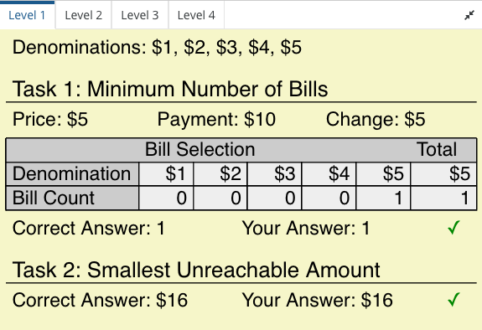

The canvas shows a breakdown of the available data and correct solutions for the tasks, and you can use the tabs to switch between the four public levels. Once you run your code it will also show your solution, and indicate whether or not it was correct.

Scoring

Focus on getting the correct output, as this is the major part of the scoring (80%). You can see your points for each level in the canvas on the bottom right when you press 'Run code', 4 points are awarded for Task 1 and 6 points are awarded for Task 2. Note that your code will be assessed using hidden levels of different configurations. Ensure your code works for all scenarios.

20% of your final score is calculated through time-complexity analysis of your solution, so if you have time try to consider how to make your solution as efficient as possible. The public levels do not take performance into account.

A tip to get started is to return 0 as the solution for each task.

