Loss functions
All weights below are read from the trained checkpoints, not from script defaults. Ω = ocean mask (land excluded from every term).

CorrDiff
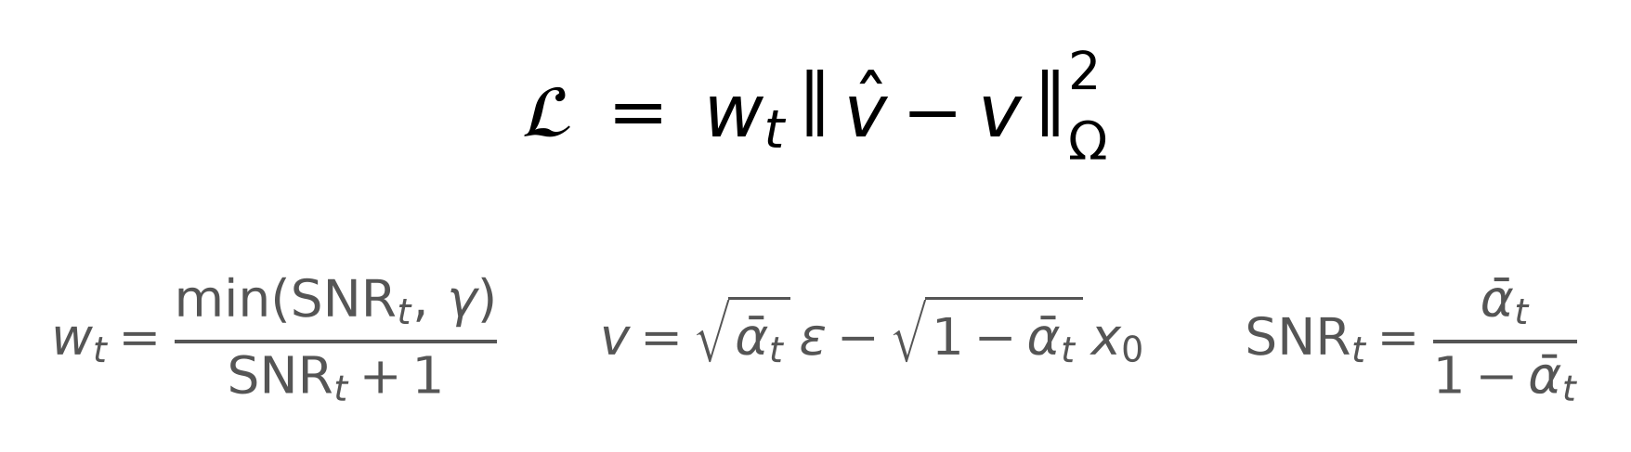
WITH OUR VALUES
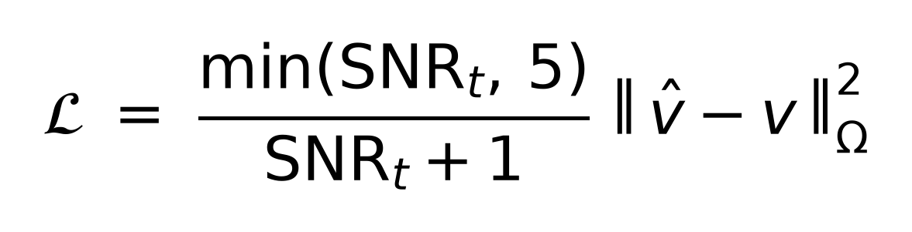
LATEX
\mathcal{L} = \frac{\min(\mathrm{SNR}_t,\,5)}{\mathrm{SNR}_t+1}
\left\|\hat{v}-v\right\|^{2}_{\Omega}
\qquad v=\sqrt{\bar{\alpha}_t}\,\varepsilon-\sqrt{1-\bar{\alpha}_t}\,x_0
EXPLANATION
One term. Plain squared error, but on v instead of on the field directly. Predicting the noise breaks down when the image is almost clean, and predicting the clean field breaks down when it is almost pure noise; v is a mix of the two that stays well behaved at both ends.
The weight w exists because a randomly drawn timestep can be trivially easy — denoising something barely noisy. Left alone those easy steps soak up most of the gradient. The weight caps them so the middle of the schedule, where the model actually decides the field's structure, gets the attention. γ = 5 is the value recommended in the paper it comes from.
There is no physics term and no observation term. This is the whole loss.
REFERENCES
- https://arxiv.org/abs/2202.00512 — v-prediction
- https://arxiv.org/abs/2303.09556 — the Min-SNR-γ weight, and γ = 5 as its default
- https://arxiv.org/abs/2102.09672 — cosine noise schedule
- https://arxiv.org/abs/2309.15214 — the deterministic-mean + residual-diffusion design (arXiv preprint, no journal version)

Stream
Two separately trained networks, so two losses. A diffusion model predicts direction; a plain regression predicts speed; the two are combined and Helmholtz-reprojected.
DIRECTION NETWORK
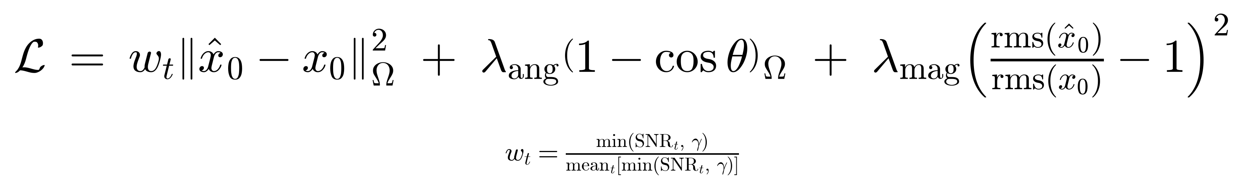
WITH OUR VALUES
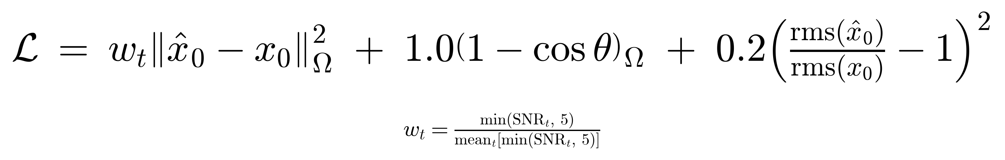
LATEX
\mathcal{L} = w_t\left\|\hat{x}_0-x_0\right\|^{2}_{\Omega}
+ 1.0\left(1-\cos\theta\right)_{\Omega}
+ 0.2\left(\frac{\mathrm{rms}(\hat{x}_0)}{\mathrm{rms}(x_0)}-1\right)^{2}
\qquad w_t=\frac{\min(\mathrm{SNR}_t,\,5)}{\mathrm{mean}_t\left[\min(\mathrm{SNR}_t,\,5)\right]}
MAGNITUDE NETWORK
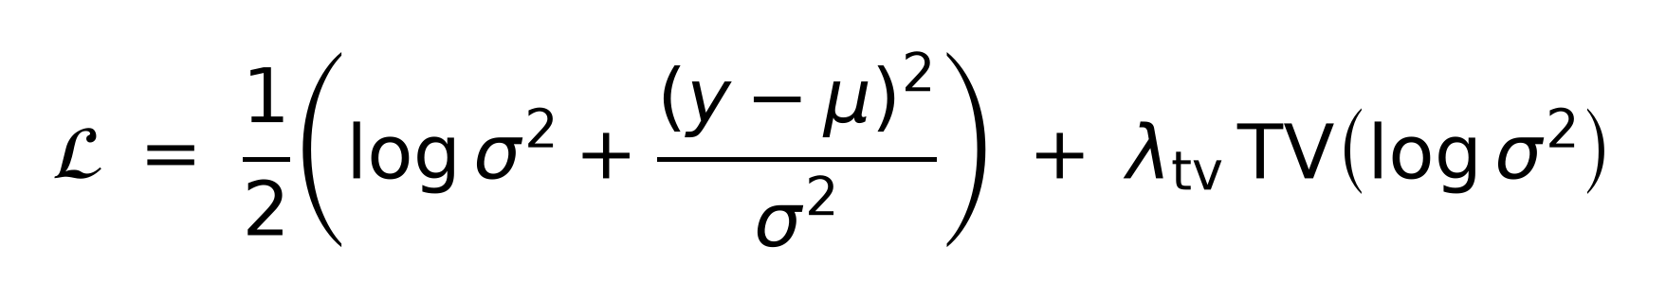
WITH OUR VALUES
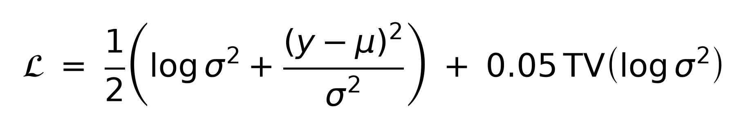
LATEX
\mathcal{L} = \tfrac{1}{2}\left(\log\sigma^{2}
+ \frac{(y-\mu)^{2}}{\sigma^{2}}\right) + 0.05\,\mathrm{TV}(\log\sigma^{2})
EXPLANATION
Direction network. Same squared-error base as CorrDiff, plus two additions. The angle term scores which way the water points, separately from how fast it goes. The magnitude term is an explicit patch against a known failure: squared error rewards hedging toward the average, which shrinks the field, so this compares the prediction's overall amplitude to the truth's and penalises shrinkage.
A fourth term was dropped on 2 Sept 2026. It correlated the model's spread of directions across draws against an empirical spread map, and existed to make the model's stated uncertainty line up with where it is actually wrong. Measured against an otherwise identical control it did the opposite — the correlation between predicted uncertainty and real error was 0.223 with the term and 0.296 without — and it also made the vorticity field worse and the intervals about 10% wider, for no gain in RMSE. No weight between 0 and 1 helped. The shipped weights no longer use it.
Magnitude network. It outputs a speed and its own confidence for every cell. Being wrong while confident is punished hard by the second part; claiming huge uncertainty everywhere is punished by the first. The balance forces an honest per-cell confidence instead of one number for the whole map. Without the log term the model would just declare infinite uncertainty and the loss would collapse to zero. The final term keeps the confidence map smooth rather than speckled.
Two caveats worth stating. A vorticity term exists in other stream loss variants in the codebase and was not used here. And λ = 0.05 on the smoothness term is the script default — that checkpoint does not record it, so it is inferred rather than read.
REFERENCES
- https://arxiv.org/abs/2303.09556 — the Min-SNR-γ weight
- https://doi.org/10.1109/ICNN.1994.374138 — predicting a mean and a variance together (the magnitude loss)
- https://arxiv.org/abs/1703.04977 — per-pixel learned uncertainty in deep networks
- https://doi.org/10.1016/0167-2789(92)90242-F — total-variation smoothness
- https://arxiv.org/abs/2203.09168 — caveat: this loss under-fits exactly where error is largest
The magnitude-matching term is ours — no citation exists, it needs describing from scratch. The spread-calibration term was also ours and has been removed.

DistAttn
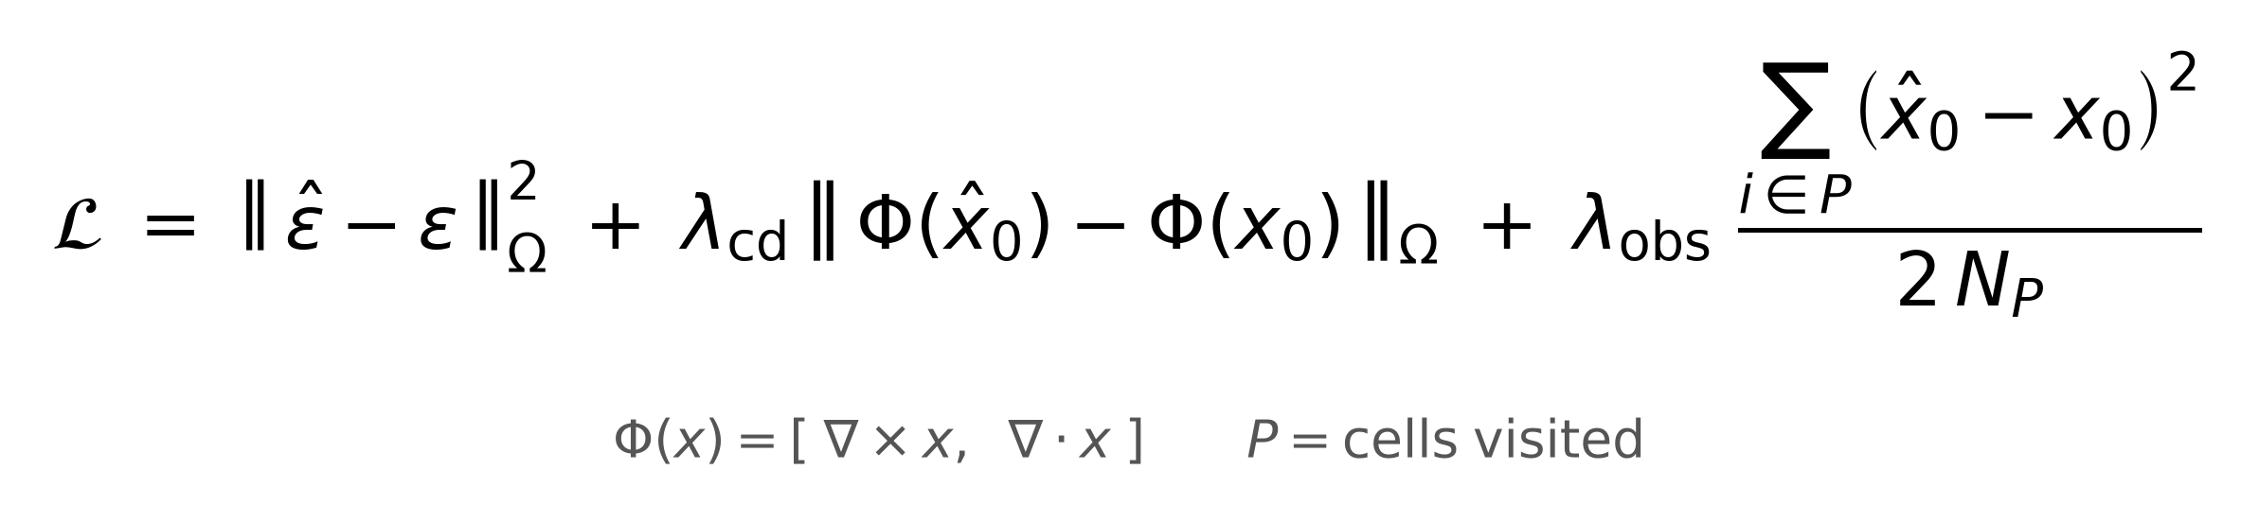
WITH OUR VALUES
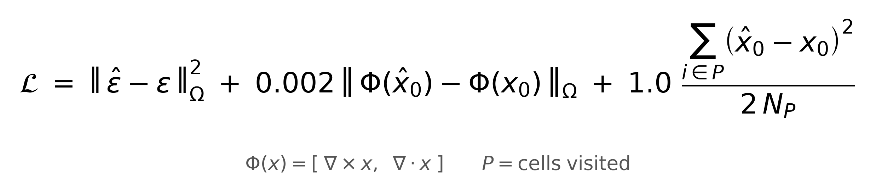
LATEX
\mathcal{L} = \left\|\hat{\varepsilon}-\varepsilon\right\|^{2}_{\Omega}
+ 0.002\left\|\Phi(\hat{x}_0)-\Phi(x_0)\right\|_{\Omega}
+ 1.0\,\frac{\sum_{i\in P}\left(\hat{x}_0-x_0\right)^{2}}{2N_P}
\qquad \Phi(x)=\left[\nabla\times x,\;\nabla\cdot x\right]
EXPLANATION
Three terms. The base is standard noise-prediction squared error.
The second term compares the curl and divergence of the prediction against the truth's — that is, whether the water rotates the right way and whether it appears or vanishes anywhere. It is a physics sanity check on the shape of the field, not on its values.
The third term forces the prediction to agree with the readings at the cells the vehicle actually drove through. It is averaged over visited cells only; averaging over the whole grid would dilute it to nothing, since the track touches under 5% of the domain.
One thing to flag: the observation term was designed to be weightable by how old each reading is, but the shipped checkpoint predates that option, so every reading was weighted equally. The age-aware version was never trained.
REFERENCES
- https://arxiv.org/abs/2006.11239 — the noise-prediction base objective
- https://doi.org/10.1016/j.jcp.2018.10.045 — precedent for physics-residual terms in a loss
The curl/divergence form and the observation-consistency term are ours — no citation, describe from scratch.

