Project Proposal – Missing Data Imputation and Result Comparison Application

Context

Rationale
The workflow of a data-scientist typically follows the following order.
1. Capturing of data
2. Preprocessing of data
3. Exploratory analysis
4. Final analysis
The majority of time out of this workflow is consumed by the preprocessing of data step. As shown in [9, p. 3, fig: 2], the cleaning and organising of data takes up an estimated 60% of a data-scientists time. This is a manual process that requires human judgement. This critical step requires tedious and rigorous testing; In particular, low-quality data imputation can result in unnatural or even worse, misleading distributions of values. The side effects of which can include poorly performing prediction models and inaccurate exploratory and final analysis.
Data imputation started with simple methods such as mean/median imputation. With the discovery of the mechanics of missing data and concepts such as MCAR (missing completely at random), MAR (missing at random) and MNAR (missing not at random), data scientists now have access to a large array of complex algorithms to choose from, which each have their own positives and drawbacks. Picking the optimal algorithm for imputation for each feature in a dataset is time-consuming and prone to error. This project’s aim is to make the decision-making step for data imputation easier by providing a touch screen dashboard interface for comparing different imputation results that are derived from different methods/algorithms of imputation. The use of a touchscreen can allow users to work on imputation of data in a collaborative environment which could help reach better overall decisions regarding options such as “What imputation algorithm is most suited for this dataset?” As a result, the project hopes to reduce the time spent on the preprocessing of datasets as well as improve the results of imputed datasets.
While applications in the past have been developed to ease data imputation, such as VIM [1], MANET [3] and AmeliaView [8], there has been little development in the way of comparing different imputations of the same dataset. Currently the solution for comparing different imputation results would be to manually create separate scripts for each imputation method and then, using the created versions of the datasets, compare them using graphs. I aim to make this process simpler by having an all-in-one package that neatly presents all this information to the user through a single dashboard. Older applications, such as the ones mentioned before lack newly discovered visualisation methods such as MissiG [5] that could prove to be more useful for analysing missingness of data. MissiG focuses on making it easy to diagnose the type of missing data (MCAR, MAR and MNAR) with visualisations for conditional and joint missingness as well as visualisations for amount missing and distribution of recorded values. This makes it especially suited for the project’s artifact, as it is able to convey a large amount of information in a single interactive glyph.

Key Background Sources
Paper | Summary and Relevance
Visualisation of missing data: a state-of-the-art survey [7] | Summary: This paper provides an overview of researched literature which focuses on visualisations of missingness of data.  Reason: This paper collates reviewed literature in the field of missingness data visualisations, comparing them on factors such as “Tasks”, “Interactability” and “Data Type”. This is highly relevant, as it gives a view into what is already well studied in the field and what is yet to be explored/not studied thoroughly.
To identify what is not there: A definition of missing-ness patterns and evaluation of missing value visualisation [6] | Summary: This paper presents an overview of the visualisation of missing data values and defines three relevant patterns of missingness to aid in understanding missingness in data.  Reason: The paper performs a user study of how different visualisations of missingness of data perform in how effective they are for users in identifying categories of missing data. Using such results can prove useful in creating a user interface tailored to ease of use.
To Explore What Isn't There - Glyph-Based Visualisation for Analysis of Missing Values [5] | Summary: This paper proposes a new visualisation method for missingness of data called MissiG and compares its performance to other visualisation methods such as Heatmaps and Parallel coordinates.  Reason: This will prove to be directly helpful for my research, as the user study specifically tests the visualisation methods based on users answering questions directly applicable to the user interface I will implement in the artifact. E.g., “Which of the following trends is most related to missing values in variable X?”
Exploring incomplete data using visualisation techniques [1] | Summary: This is the introductory paper presenting the tool VIM (Visualisation and Imputation of Missing Values) to the scientific community. It describes the mechanics of missing data and provides examples of visualisations provided by the R package VIM.  Reason: The VIM package is a highly optimised library of data imputation methods containing algorithms such as “kNN” and “hotdeck” accessible via an API. This library will be utilised in my backend implementation for the purpose of imputing data. This will also address the need for a responsive UI, as the VIM package core calculations are implemented using C++ and are optimised for performance.
Profiler: integrated statistical analysis and visualisation for data quality assessment [4] | Summary: This paper introduces “Profiler”. Profiler is a GUI application that uses data mining methods to automatically suggest visualisations for missing data, which is then intended to be used to make decisions on what method is best to use when imputing data. It also describes the architecture of the program as well as the algorithms used to identify anomalies in data.  Reason: This will prove useful when designing the interface for my artifact. It gives examples of possible designs for signifying “data quality” to the user. The paper shows a variety of visualisation methods; this can be improved upon by implementing newer visualisation methods proven to be effective that have since been discovered in other research papers [6].
Impute-VSS: A comprehensive web-based Visualisation and simulation suite for comparative data imputation and statistical evaluation [2] | Summary: Similar to Profiler [4], “Impute-VSS” is a data imputation GUI application with a focus on comparing a dataset after imputation by multiple algorithms.  Reason: This paper provides the packages used and architecture of the application, which will prove useful when creating the artifact for this dissertation. The paper includes in its conclusion possible improvements and future development which can be looked into to further the research of missing data visualisation. The paper points out the use of deep learning methodologies could be used to help draw “more profound and comprehensive comparative assessments”.

Aims and Objectives
Create a touch-screen data imputation application with a focus on the ability to compare different imputation results. Research and design visualisations for missingness of data suited for comparing sets of imputed data with user-interactive elements.
Objectives:
- Conduct research on:
  - Visualisation methods of missingness of data yet to be implemented within a data imputation applications.
  - Previously implemented missingness of data visualisations in data imputation applications. Identify.
VIM [1], MANET [3], Profiler [4] and Impute-VSS [2] are examples of applications with the purpose of analysing and imputing missing data. I plan to look over these and other similar papers to aggregate possible visualisation methods and implementations that could be of use in the development of the artifact for this project.
- Design a user interface suited for a touchscreen interface with the purpose of letting users both impute data and compare the output imputed data from various methods of imputation.
Since there is an element of human-computer interactability, designing a useable and coherent interface will be required. I plan to use Figma, a UI designing tool, to create a mockup of the layout before starting development. This will help me stay on track during the development phase of the project.
- Architect and develop a full-stack solution for:
  - Parsing and imputation of datasets utilising multiple algorithms for imputation.
  - Displaying unimputed and imputed datasets with interactive elements for viewing.
  - Allowing users to perform imputations via a GUI interface.
This objective requires aggregating examples of other GUI imputing applications and comparing how the authors have decided to design their tech stack. S. Kandel et al. [4] and V. Shrivastava et al. [2] give examples of the architecture used for their application that I can draw from directly.
- Prepare a demonstration with artificially created datasets to exhibit an example usage of missing data analysis and imputation.
To showcase an example use case, I will create a dataset containing varying types of missing data and attempt to show how using the created artifact can help in identifying the type of the missing data as well as imputing.

Planning
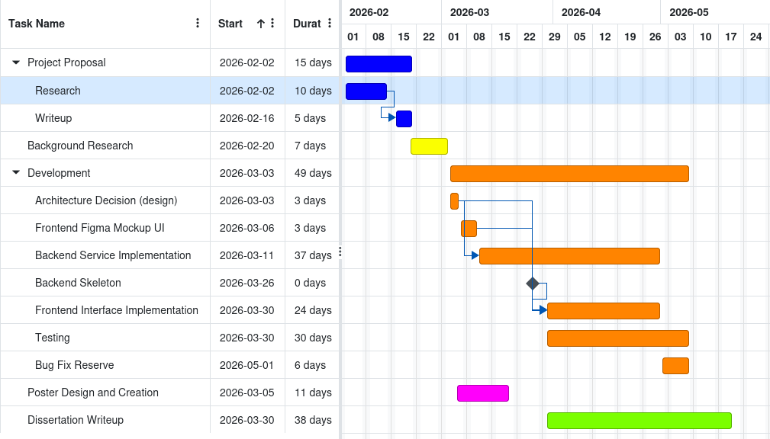Figure 1: Project Timeline
The chart Figure 1 provides an overview of the project plan. Arrows drawn signify dependency. E.g. Project Proposal Write-up depends on Project Proposal Research.
Due to a tight time constraint, an agile workflow will be most suited as opposed to the waterfall methodology.

Risks
As shown in Figure 1, there is an overlap in development between the backend and frontend implementation. To start the frontend implementation, it would require a skeleton backend at minimum to have a demonstratable prototype. If the skeleton backend were to happen to take longer than expected, the frontend step would have to be rushed or omit features. There is literature to draw upon to help with creating and designing the backend [2][4].
Another risk is my limited knowledge of VIM [1] and the R programming language. Depending on the language’s learning curve, development of the backend service may be slow at first. I have experience with other similar scripting languages such as Python, which will make this risk less significant.
As development of this project is time constrained, bugs will appear during the implementation stage. I have mitigated this by allotting a period for testing and a bug fix reserve period as shown in Figure 1. If a certain step of development were to take longer than expected, this time can be taken out of the bug-fix reserve.
References

[1]
M. Templ, A. Alfons, and P. Filzmoser, ‘Exploring incomplete data using visualization techniques’, Adv Data Anal Classif, vol. 6, no. 1, pp. 29–47, Apr. 2012, doi: 10.1007/s11634-011-0102-y.

[2]
V. Shrivastava and S. Shukla, ‘Impute-VSS: A comprehensive web-based visualization and simulation suite for comparative data imputation and statistical evaluation’, SoftwareX, vol. 30, p. 102130, May 2025, doi: 10.1016/j.softx.2025.102130.

[3]
A. Unwin, G. Hawkins, H. Hofmann, and B. Siegl, ‘Interactive Graphics for Data Sets with Missing Values—MANET’, Journal of Computational and Graphical Statistics, vol. 5, no. 2, pp. 113–122, Jun. 1996, doi: 10.1080/10618600.1996.10474700.

[4]
S. Kandel, R. Parikh, A. Paepcke, J. M. Hellerstein, and J. Heer, ‘Profiler: integrated statistical analysis and visualization for data quality assessment’, in Proceedings of the International Working Conference on Advanced Visual Interfaces, Capri Island Italy: ACM, May 2012, pp. 547–554. doi: 10.1145/2254556.2254659.

[5]
S. J. Fernstad and J. J. Westberg, ‘To Explore What Isn’t There—Glyph-Based Visualization for Analysis of Missing Values’, IEEE Trans. Visual. Comput. Graphics, vol. 28, no. 10, pp. 3513–3529, Oct. 2022, doi: 10.1109/TVCG.2021.3065124.

[6]
S. J. Fernstad, ‘To identify what is not there: A definition of missingness patterns and evaluation of missing value visualization’, Information Visualization, vol. 18, no. 2, pp. 230–250, Apr. 2019, doi: 10.1177/1473871618785387.

[7]
S. Alsufyani, M. Forshaw, and S. J. Fernstad, ‘Visualization of missing data: a state-of-the-art survey’, Sep. 27, 2024, arXiv: arXiv:2410.03712. doi: 10.48550/arXiv.2410.03712.

[8]
J. Honaker, G. King, and M. Blackwell, Amelia: A Program for Missing Data. (Nov. 08, 2024). Accessed: Feb. 16, 2026. [Online]. Available: https://cran.r-project.org/web/packages/Amelia/

[9, p. 3, fig: 2]
H. Sarih, A. P. Tchangani, K. Medjaher, and E. Pere, ‘Data preparation and preprocessing for broadcast systems monitoring in PHM framework’, in 2019 6th International Conference on Control, Decision and Information Technologies (CoDIT), Paris, France: IEEE, Apr. 2019, pp. 1444–1449. doi: 10.1109/CoDIT.2019.8820370.

