Fairness Metrics Report: 90-Day Churn Model v1.0.0
Project: Retail Analytics Decision Support Platform · Model: churn_logreg v1.0.0 · Author: Bezzel Chitsungo · Companion documents: Model Validation Report (§6), Model Card.
Read this first. The dataset has no protected attributes, and none were inferred. Country is an operational field, not a protected attribute. The analysis below uses UK vs non-UK as a supplementary operational grouping only, so that the Module 1 commitment to examine country variables for proxy effects is not ignored. It does not satisfy a protected-attribute fairness requirement. That requirement is unmet and pending instructor clarification (draft request: docs/instructor_clarification_request_DRAFT.md, not sent). Nothing in this report claims the model is fair or that bias has been eliminated.

1. Setup
- Positive prediction: flagged for a retention offer (probability ≥ 0.313903, the threshold that maximises F1 on validation).
- Outcome: churn = no sales invoice in the 90 days after the prediction date (window PROPOSED, pending Marketing).
- Groups: UK (United Kingdom) and Non-UK (all other countries). Group membership is held out of the predictors; an ablation shows a UK flag changes validation AUC by 0.0002.
- Units: customer-snapshot rows. Rows from one customer are correlated, so every interval is a customer-clustered bootstrap (95%); proportions use Wilson intervals.
- Minimum group size: 100 rows; smaller groups are tabulated but flagged and not interpreted.
- Governance thresholds (programme choices, not statistical or legal tests): disparate impact ratio within 0.80–1.25 (Module 2); group TPR and FPR within ±10% of overall (Module 1).

2. Metric definitions
Metric | Definition (Non-UK relative to UK unless stated)
Demographic parity difference (DPD) | selection rate(Non-UK) − selection rate(UK)
Disparate impact ratio (DI) | selection rate(Non-UK) ÷ selection rate(UK)
TPR difference | recall(Non-UK) − recall(UK)
FPR difference | false positive rate(Non-UK) − false positive rate(UK)
Equalised-odds difference | larger of the absolute TPR difference and absolute FPR difference
TPR or FPR vs overall | group rate ÷ overall rate (band 0.90–1.10)

3. Pre-declared validation gate (used for model selection)
Candidate | DI ratio | TPR vs overall | FPR vs overall | Passes gate
logreg | 1.007 | 1.031 | 1.002 | True
lightgbm | 0.979 | 1.022 | 0.942 | True
random_forest | 0.982 | 1.036 | 0.923 | True
Table 1. Validation gate (Mar–Apr 2011). All candidates passed, so selection followed the interpretability rule and mitigation was not triggered.

4. Test-set results for the selected model (scored once for this iteration)
Group | Rows | Churn rate | Selection rate (95% CI) | TPR (95% CI) | FPR (95% CI)
UK | 5,002 | 0.422 | 0.673 (0.660–0.686) | 0.882 (0.868–0.895) | 0.520 (0.502–0.538)
Non-UK | 532 | 0.378 | 0.699 (0.659–0.737) | 0.871 (0.817–0.910) | 0.595 (0.541–0.647)
Overall | 5,534 | 0.418 | 0.676 | 0.881 | 0.528
Table 2. Group rates on test (Wilson 95% intervals).
Comparison | Value | 95% CI (cluster bootstrap) | Governance band | Within band?
DPD | +0.026 | (-0.025, +0.081) | n/a | n/a
Disparate impact ratio | 1.039 | (0.963, 1.122) | 0.80–1.25 | True
TPR difference | -0.012 | (-0.070, +0.048) | n/a | n/a
FPR difference | +0.075 | (+0.009, +0.145) | n/a | n/a
Equalised-odds difference | 0.075 | derived from the two rows above | n/a | n/a
TPR vs overall | 0.988 | n/a | 0.90–1.10 | True
FPR vs overall | 1.127 | n/a | 0.90–1.10 | False
Table 3. Fairness metrics on test. Calibration (Brier) by group: UK 0.192, Non-UK 0.205.
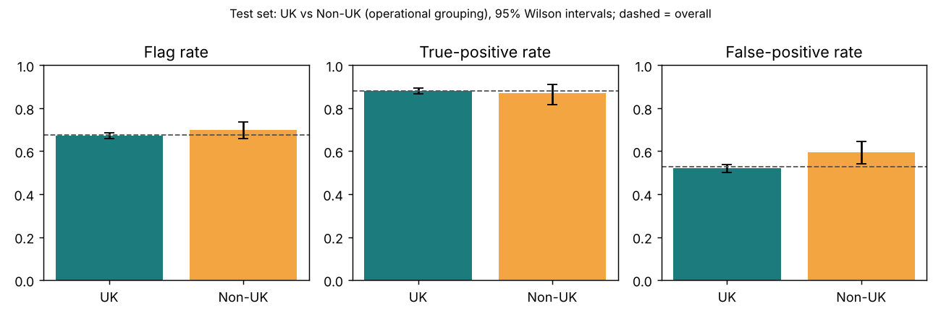
Figure 1. Selection rate, TPR and FPR by group on test with 95% intervals.
Findings. Selection rates and recall are comparable (DI 1.039 is inside the band; the DPD and TPR intervals include zero). The non-UK false positive rate is 0.075 higher; its interval (0.009 to 0.145) just excludes zero and its ratio to the overall rate (1.127) is outside the Module 1 band. Because the interval is wide (532 non-UK rows) the size of the gap is uncertain; the finding is a flag for review, not proof of unfair treatment. The non-UK group also has a different base churn rate (0.378 vs 0.422), and when base rates differ, a classifier that is not perfect generally cannot equalise selection rates and error rates at the same time.
Direction of harm. A flag triggers a retention offer, so a false positive means an unnecessary offer. Whether that is a benefit, a cost to the company or a crowding-out of other customers depends on how Marketing uses the list. This is an open question for the business, not something the model can settle.

5. Mitigation experiments
Two mitigations were run after the validation gate passed, as exploratory work. Both were fitted on training/validation only. Their test results were computed for transparency and were not used to choose a model; they are, however, further looks at the test period and are counted in the disclosure in the Validation Report (§7). Neither was adopted.
Approach | Test recall | Test flag rate | Test DI | Test FPR vs overall | Test EO difference | Test AUC
M0 unmitigated (deployed) | 0.881 | 0.676 | 1.039 | 1.127 | 0.075 | 0.765
M1 equalised-odds thresholds | 0.755 | 0.525 | 1.049 | 1.199 | 0.080 | n/a (group-specific thresholds)
M2 reweighing + refit | 0.891 | 0.688 | 1.057 | 1.142 | 0.086 | 0.765
Table 4. Before/after on test (exploratory). M1 thresholds were fitted on validation, so validation figures for M1 are in-sample and omitted here.
Neither approach brought the FPR ratio inside the band (M1 1.199, M2 1.142 vs 1.127 unmitigated), and M1 reduced recall from 0.881 to 0.755 by using group-specific thresholds, which also raises its own governance questions. Because the validation gate passed and the mitigations did not help on test, the deployed model is unmitigated. The residual disparity is disclosed and carried into the monitoring plan. Choosing between M0, M1 and M2 on the test results would be tuning on test and was not done.

6. Per-country detail (informational)
Only groups with at least 100 rows are interpreted. Others are shown to document coverage, not to support conclusions.
Country | Rows | Selection rate | TPR | FPR | Sufficient n
United Kingdom | 5002 | 0.673 | 0.882 | 0.520 | True
Germany | 123 | 0.618 | 0.921 | 0.482 | True
France | 108 | 0.639 | 0.852 | 0.568 | False
Belgium | 40 | 0.650 | 0.818 | 0.586 | False
Spain | 38 | 0.816 | 0.941 | 0.714 | False
Switzerland | 26 | 0.846 | 1.000 | 0.750 | False
Portugal | 18 | 0.611 | 0.727 | 0.429 | False
Netherlands | 14 | 0.643 | 0.800 | 0.556 | False
Australia | 13 | 0.692 | 1.000 | 0.636 | False
Channel Islands | 12 | 0.667 | 0.600 | 0.714 | False
Austria | 12 | 1.000 | 1.000 | 1.000 | False
Sweden | 12 | 0.667 | 1.000 | 0.429 | False
Table 5. Largest 12 of 34 countries by test rows (full table in reports/model/final_test_results.json). Rates for groups marked False are unreliable.

7. What this analysis cannot show
- Protected-attribute fairness. No protected attributes exist. The brief requires formal analysis of them; that cannot be done honestly with these data (see the draft clarification request).
- Individual fairness and causal questions (would the same customer be treated differently in another country?) are out of scope.
- Intersectional or per-country conclusions: groups are too small.
- Time. A single test window and a prevalence shift (0.57 validation vs 0.42 test) limit how far these numbers will carry forward.
- The 90-day churn window is PROPOSED. A different window changes labels and therefore every metric above.

8. Reproducing these numbers
PYTHONPATH=src python -m churn_model.final_eval produces reports/model/final_test_results.json (the source of Tables 2, 3 and 5), and python -m churn_model.mitigation produces reports/model/mitigation_results.json (Table 4). Both log to MLflow experiment retail-churn-90d. Re-running final_eval scores the test set again and must be disclosed as such.

