KML Data Processing Implementation (Week 1)

Contents
1. Introduction 3
2. KML Data Structure 3
3. Implementation Methodology 3
4. Data Extraction Process 3
5. Results 3
6. Conclusion 4
7.supportive evidence………………………………………………………………………….5

1. Introduction
The task during Week 1 was to grasp and apply the data processing aspect of the autonomous weed detection and spraying system. This part is essential because it will provide the basis of the entire pipeline since it will be used to extract and structure geographical data, which will subsequently be used to steer drone navigation and spraying actions. This information should be managed properly to make sure that the entire system is effective and viable.

2. KML Data Structure
KML (Keyhole Markup Language) is a widely used standard format to describe geographic data, such as points, lines, and polygons. The location of the weeds or areas of interest in a farm field is saved as KML files when applied to this project. To access the information contained in KML files, one had to comprehend their format. Special attention was paid to such features as Placemark, Point, and Polygon, containing coordinates. The coordinates are recorded in the form of longitude, latitude, and altitude, and must be read accordingly in order to obtain the proper mapping of the positions of the weeds.

3. Implementation Methodology
To process the KML data, there was adoption of a Python approach was adopted, which relied on XML. etree.An XML parsing functionality library is called ElementTree library. It was implemented by loading the KML file into the program and searching the hierarchy to find the necessary data elements. One of the main problems at this phase was XML namespaces, to which KML files are set with special namespace conventions. Once this issue was resolved, it was possible to navigate through the file and coordinate the information needed.

4. Data Extraction Process
The developed script was designed to locate all the entries of the coordinates in the KML file and convert them to a format that can be read. As the coordinates in KML are stored in the form of strings, some logic was applied to break these values and obtain the longitude and latitude parts. These were then values extracted, which were then displayed to ensure it was correct, and parsing was all going as planned. At this stage, the focus was on the quality and readability of the output, but not on optimization of performance and sophisticated processing algorithms.

5. Results
The script was able to extract geographic coordinates of the KML file, and this was evidence that the parsing technique was effective. The result showed that the data about the coordinates could be effectively recalled and deciphered, creating an organized image of the weed locations. The given result gives a good foundation to continue the development further, in which the data will be extracted and transformed into structured formats (e.g., JSON or CSV) and sent to the decision-making module.
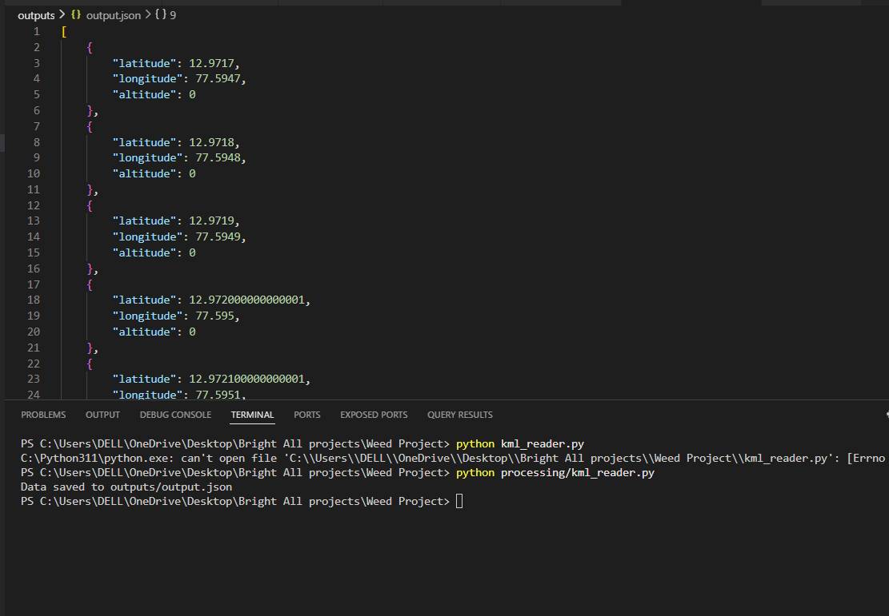
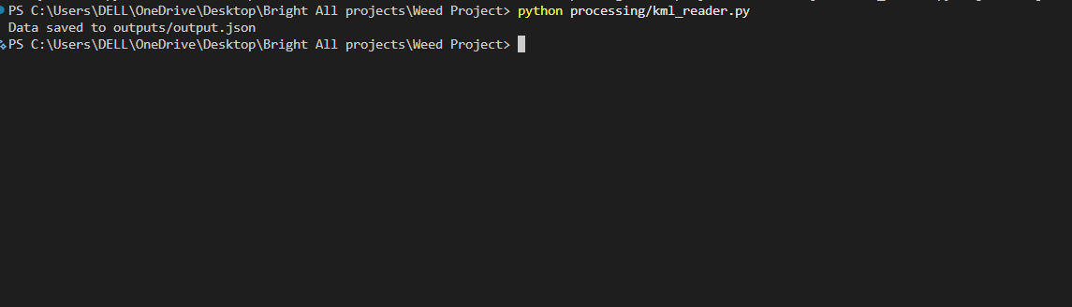

6. Conclusion
The reason is that the work completed in Week 1 is the first in the project pipeline and will be to transform KML data into a format that can be used to further manipulate the data. This step will be used to make sure that raw geographic information will be able to be used successfully in further stages of the system. The successful extraction and validation of coordinate data formed the pattern of incorporating the data on the position of the weed into the autonomous spraying system into the subsequent phases to help in making appropriate decisions and control the drone effectively.

7. Supportive evidence:
Figure 1: GitHub Commit Showing KML Code Development
This screenshot displays my GitHub commit where I created the Python script for handling KML data. In this code, I used the Element Tree library to read the KML file and extract coordinate values such as latitude and longitude. This confirms that I personally worked on implementing the data processing logic. And also providing the GitHub link here.
https://github.com/DrClevonPeris/Capstone-Project/commit/3a69f6cc5bb4faf51ba32cf52b656caabecb0f8b

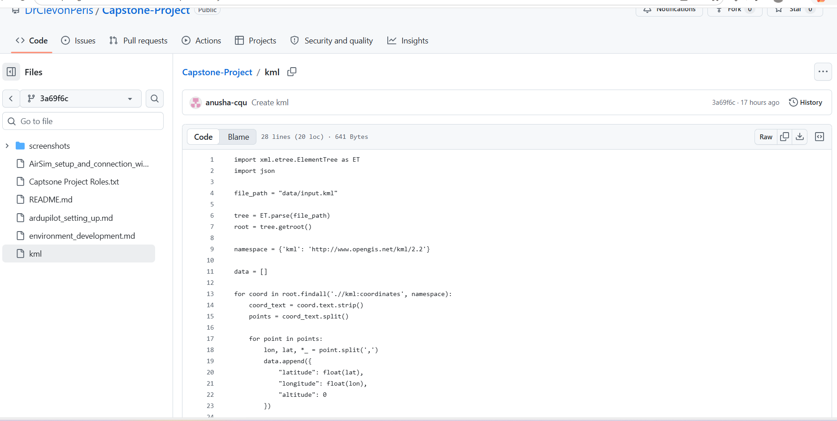
Figure 2: Generated Output from KML Processing
This screenshot shows the output produced by my program after processing the KML file. The results are structured in JSON format and include coordinate details, indicating that the script successfully converted the raw KML data into a usable format.
https://github.com/DrClevonPeris/Capstone-Project/commit/6421a4e28caaddeb5717475711d57a8a3fdf8e3b

