System Integration Set up and Project Organization (Week 1)

Student Name: Ritheesh
Student ID: 12261150

Contents
1. Introduction 3
2. Project Pipeline Understanding 3
3. Repository Set-up and Cooperation 3
4. Project Structure Design 3
5. Documentation 4
6. Data Standardization 4
7. Initial Integration Validation 5
8. Conclusion 5
9.work evidence……………………………………………………………………………….6

1. Introduction
The main goal of Week 1 was to create the background of the system integration and to enable all the team members to cooperate effectively with each other. The role is necessary since the project entails various interrelated parts, such as simulation, data processing, decision-making and implementation of drones. The lack of an organized organization and coordination would complicate and render the integration of these aspects in the later stages complex and inefficient.

2. Project Pipeline Understanding
There was a distinct idea of the overall pipeline of the project that follows the following sequence: KML → Processing → Decision → Drone → Simulation. This provided an idea of the data flow amongst different modules, and clarified the inputs/outputs of each step. With this knowledge, a formalized plan was made to plan the project in a manner that will be scalable and maintainable.

3. Repository Set-up and Cooperation
A centralized GitHub repository was created to enable version control and collaboration among team members. This will ensure that any contribution is done in a systematized way and there is a record of changes. The permissions had been configured to allow each member of the team to clone, pull and push code successfully. Best practices like consistency in naming conventions and separation of components were also observed in designing the repository.

4. Project Structure Design
To enable a modular development, a proper hierarchy of folders in the repository was established. The key directories include simulator, processing, decision and integration, which are aligned with the work of every team member. Additional directories such as data and outputs were introduced to manage the input files such as KML data and output files (such as JSON) which were processed. This design will make every module autonomous and at the same time, easy to incorporate at later stages.
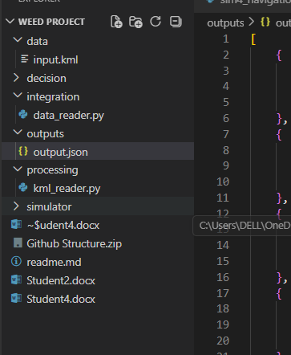

5. Documentation
To document the project overview, pipeline, module descriptions and team roles, an all-encompassing README.md was created. This is a point of focus to the entire team, and will help maintain clarity in the system architecture and responsibilities. The stage must be well documented to reduce the likelihood of being misunderstood in the further development stages.

6. Data Standardization
A standard data format was developed so as to make inter-module communication smooth. JSON has been chosen as the format of choice when storing and transferring processed data. The choice guarantees both compatibility of the output produced by the data processing block and the input needed by the decision making algorithm, as well as makes it easier to integrate with the simulation environment.

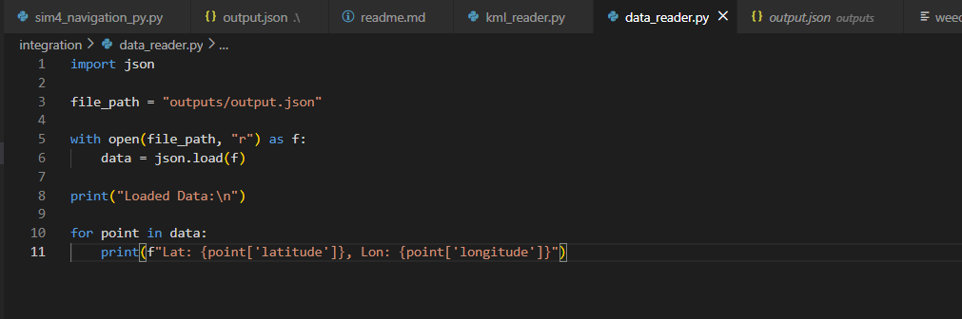

7. Initial Integration Validation
To test the configuration, a simple integration script was created to read processed information in the form of a JSON and show it in the console. This check will identify that the information is transferring correctly between modules and file paths and folder structures are functioning correctly. It is applied to give an early confirmation of the integration process during its initial stages of development.

8. Conclusion
The project is set on a solid base by the work done in Week 1, and the integration phase will be stipulated. Using the establishment of the repository, a clear structure, and the standardization of the data forms, and verification of the simple data flow the system is ready to be developed in a coordinated and efficient manner. A base like this will simplify the task of integrating all the parts into a complete autonomous simulation system in the later development phases of a drone considerably.

9.Supporting evidence
https://github.com/cquict/coit20246y24t2-journal-Ritheeshreddy1215/commit/a0fd3e80b37c14db4c3e26e8f4f32f67c1e2eebb

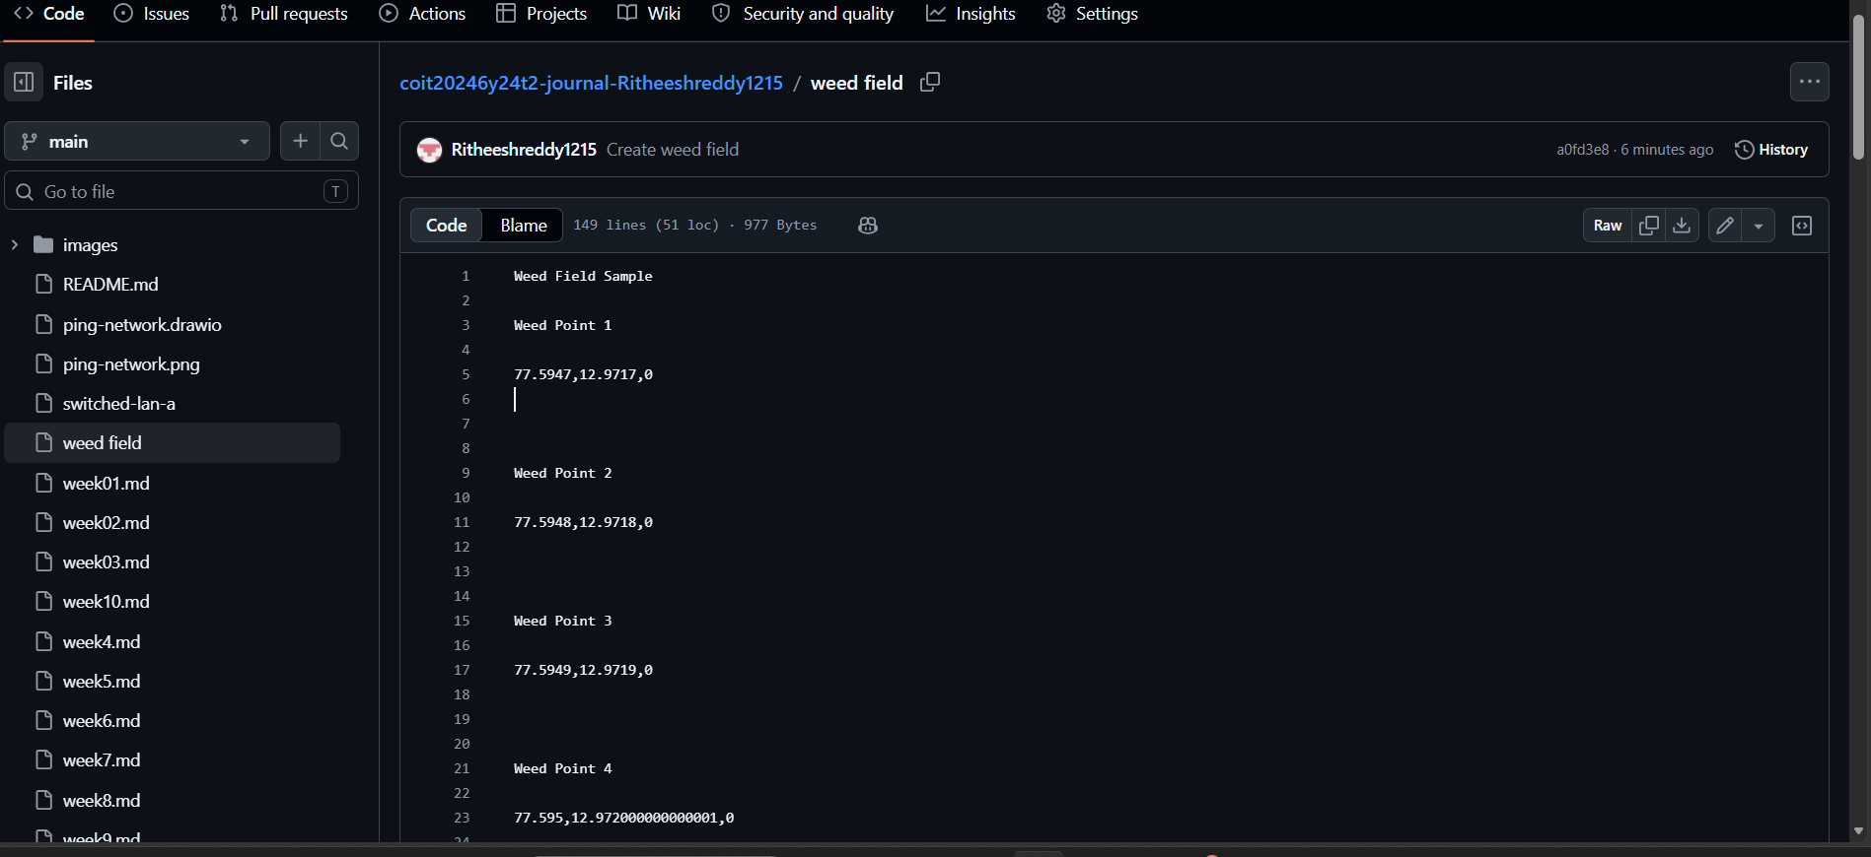
GitHub Repository Evidence of Data Integration Setup
The figure shows the GitHub repository containing the weed field data file created during Week 1. The file includes sample coordinate points representing weed locations, which are used as input for the processing and decision-making modules. This demonstrates successful repository setup, version control usage, and initial data preparation aligned with the system integration pipeline.

