Paddy Field Drone Simulation
Environment Development and Integration Report
Prepared for COIT20265: Networks and Information Security Project

Table of Contents
Chapter 1: Introduction 3
1.3 Aim and Objectives 4
Chapter 2: Literature Review 5
2.3 Unreal Engine for Simulation 5
2.4 Existing Research and Technologies 6
2.5 Gap Analysis 6
Chapter 3: Methodology/System Design 7
3.1 Overall System Architecture 7
3.2 Software and Tools Used 9
3.4 Development Methodology 9
Chapter 4: System Implementation 9
4.2 Unreal Engine Environment Setup 10
Chapter 5: Testing and Result 11
5.2 Test Cases 11
References 13

Chapter 1: Introduction
This report records the environment development and integration component of a drone simulation prototype of a paddy-field. The project is an example of a smart agriculture scenario whereby the weed fields are detected, reflected as useful coordinate information and subsequently, to serve a simulated mission of a drone spraying. The technical bridge in this work is that of transforming agricultural data to be executed in the style of a virtual mission: generating the Unreal Engine/AirSim field environment, preparing coordinate-style data representing the weeds, and interpolating this result to a mission workflow, which can then be simulated.
A simulation-first approach is employed by the prototype due to the high cost, weather-related nature, and riskiness of actual drone tests. AirSim was chosen since it is an open-source drone simulator developed as an Unreal Engine plug-in and also enables experimenting with SITL/HITL (Microsoft, 2024). This was created using Unreal Engine that offers real-time 3D creation, lighting, materials, meshes, and landscape tools of simulation scenes (Epic Games, 2025).
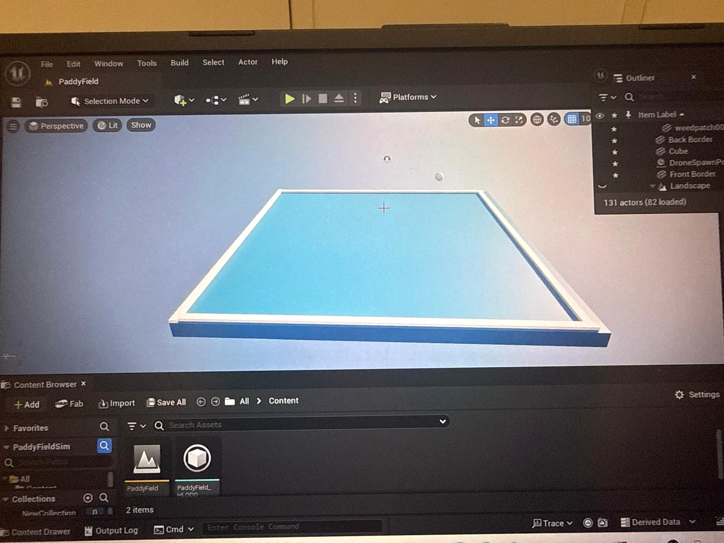
Figure 1: Initial Unreal Engine base platform for the paddy-field simulation environment.

1.3 Aim and Objectives
This work is intended to create and document a simulation environment and integration workflow of a prototype of a drone-managed paddy-field weed management. These are to simulate an environment in Unreal Engine to use in AirSim to image the paddy-fields, to simulate the appearance of the healthy crop areas and where the weed is, to prepare coordinate-based weed-zone data to be utilized by down-stream modules, to bridge the processed data and the choice of spray into a mission-ready format, and to evaluate the prototype with aid of screenshots, test-cases, logs and observed simulation behaviour.
The target product is a working report section where the environment and integration elements play a role in the overall project pipeline: KML or weed-zone input, data processing, spray decision output, waypoint mission generation, simulated drone navigation, and mission logging.

Chapter 2: Literature Review
UAVs are becoming a common tool in precision agriculture to analyze crops, identify weeds, and assist in making interventions. High resolution low altitude images can be obtained with UAVs, allowing useful field level monitoring. The recent reviews provide such concepts as aerial imaging, artificial intelligence, or target spraying as the key techniques to minimize unproductive usage of chemicals (Zhang et al., 2024; Ehrampoosh et al., 2025). Autonomous drone systems also require repeat testing; hence, simulation can also be useful.

2.3 Unreal Engine for Simulation
The prototype has the visual and spatial layer created by Unreal engine. Its editor favors surfaces, material, lighting, sky surroundings, landscapes, camera perspectives, and positioning of objects. These characteristics result in its appropriateness to build a paddy field with visual indications of crops, weed areas, irrigation waterways and fences. Unreal Engine has a broad range of use beyond the games industry, as a real-time visualisation and simulation engine, as it is capable of producing interactive scenes, with controllable objects and naturalistically rendered scenes (Epic Games, 2025). The field geometry and visual differentiation were created in Unreal Engine in this project. Green areas are healthy paddy areas, yellow areas are areas affected by weeds and blue lines are irrigation lines. The environment does not seek to replicate biological crop growth but something that can offer a realistic testbed on which to execute missions and demonstrate.

2.4 Existing Research and Technologies
Current studies in the UAV based agriculture dwell in crop monitoring, weeding detection, mapping, classification and targeted treatment. The identification of weeds using aerial shots by deep-learning systems and spraying drones are discussed as the solution that could remove weeds where only aerial spraying is needed (Zhang et al., 2024; Ehrampoosh et al., 2025). Two other known autonomous-vehicle-research tools, AirSim and Unreal Engine can both be used to simulate perception and navigation algorithms in virtual worlds that can be repeated (Shah et al., 2017). There is a tendency towards combined smart-farming systems instead of individual elements. This project flows in that direction, as it links weed-zone information to a visual environment, and mission-based workflow.

2.5 Gap Analysis
The most notable knowledge gap that the proposed work fills is the absence of an entire, locally-scaled prototype that bridges the paddy-field environment design and coordinate-based mission execution. Numerous research systems describe weed detection or autonomous flight individually, yet a capstone prototype should have an operational pipeline, which can be described, experimented on, and demonstrated. This gap is addressed by the project which establishes a test paddy-field setup and prepares an integration workflow that transforms information about the weed-zones into mission behaviour represented as waypoints. A second is gap is usability. The calculation of highly realistic simulations can be hard to execute on small hardware, so a simplified and yet transparent paddy-field model that nonetheless demonstrates positions of the weed, traffic of data, and response of the drones is implemented into the present project.

Chapter 3: Methodology/System Design
The modular design was adopted in its methodology. Each larger sub-unit of the system was considered as a subunit that received and produced inputs and outputs. The visual field and weed areas are availed by the environment component. The data-processing aspect prepares locations of weed-zone. Decision component categories the spraying action. The integration element translates the outcome into mission-ready mission points and the simulation element illustrates the movement of the drones and spray logging. This is a modular design that makes it less complex since the individual parts may be tested individually before being integrated entirely.

3.1 Overall System Architecture
The general structure starts with input of weed-zone, e.g., of KML data or coordinated points. Weed-location data is processed to extract or structure it. The decision stage would select a type of spray depending on the logic requiring, e.g. spot spray on small zones with isolated areas and blanket spray on bigger affected areas. This output is then converted into a mission format via the integration stage that includes coordinates and spray action. Lastly, the AirSim/Unreal Engine environment allows a virtual field, where the mission may be viewed and logged. The architecture isolates the data, decision and simulation concerns. This simplifies debugging: problems with waypoints, errors related to spray-actions, or environment mapping issues can be verified separately.
Component | Input | Process | Output
Weed data source | KML or prepared weed points | Provides field locations | Raw weed-zone data
Processing layer | Raw locations | Cleans and structures coordinates | x, y, z style output
Decision layer | Processed coordinates | Assigns spray category | Spot or blanket spray
Integration layer | Coordinates + spray type | Builds waypoint mission | Mission-ready file/log
Simulation layer | Waypoint commands | Runs movement in AirSim/Unreal | Drone motion and results
Table 1: Overall system architecture for the environment and integration workflow.

Risk | Impact | Likelihood | Effect | Mitigation
Incorrect coordinate conversion | High | Medium | Wrong waypoint position | Validate using small test data and visual checks
AirSim configuration failure | High | Medium | Drone API may not respond | Confirm settings file, vehicle type and API connection
Heavy environment assets | Medium | Medium | Low FPS or crashes | Limit foliage density and simplify meshes
Module format mismatch | High | Medium | Integration script fails | Use standard CSV/JSON fields and sample files
Unreal project corruption | High | Low | Loss of environment work | Use backups and GitHub version control
Table 2: Risk analysis for architecture, environment development and integration.

3.2 Software and Tools Used
The primary applications were the Unreal Engine, AirSim, Python, and GitHub, as well as auxiliary file formats: CSV, JSON, or KML. It approximated the paddy field using unreal engine, that produced materials, meshes, adjusted the sky and lighting as well as prepared the scene to be simulated. The simulation layer of the drone was AirSim. Concept Python was applied to coordinate processing, data formatting as well as integration scripts. File exchange and project management were encouraged by Github. The data was supposed to be a structured form like x, y, z, spray-type so that it could be read by other modules in future without the need to manually convert it. These platforms fit the project requirements: environment simulation by the Unreal Engine, simulation of drones by AirSim, data analysis by Python, and collaboration by GitHub.

3.4 Development Methodology
The development was by incremental prototype. The paddy field base was initially developed. Then irrigation channels, field plots, borders, crop colours were added. Once the basic field was balanced, weed patches had to be painted or put in. The drone object or spawn point was introduced when the layout of the environment was useful. Planned integration workflow had then to be based on basic coordinate and spray-action outputs. This prevented making attempts at integrating all the modules when the individual artefacts were not prepared. Incremental testing was also used. The field was tested in top and side modes, data formats were tested to be readable, and small sample data tested to be integrated to more extensive situation before bigger.

Chapter 4: System Implementation
Implementations were done with the creation of the virtual paddy field and the data pathway needed to prepare it to be integrated. The last environment includes a green paddy field, blue irrigation lines, a rectangular field area, yellow weed fields, visible boundaries, surrounding landscape, lights, and a drone/spawn, which is used to test missions.

4.2 Unreal Engine Environment Setup
The Unreal Engine setting was developed into a paddy-field environment. The main field platform was represented by initially developing a rectangular base. The addition of white and blue elements of border to outline the edge of the simulation space was done. The scene was also considered in varying angles just to ensure that the platform scale, the visibility of the borders, and the camera view was appropriate to be used in the future on the drone movement. The field was further subdivided, after preparing the base, into rectangular sections. The aerial monitoring becomes easy with the grid and paddy plots are well divided. Blue strips are depicting irrigation channels. These are not fluid simulation but as with a lot of agricultural context put on them.
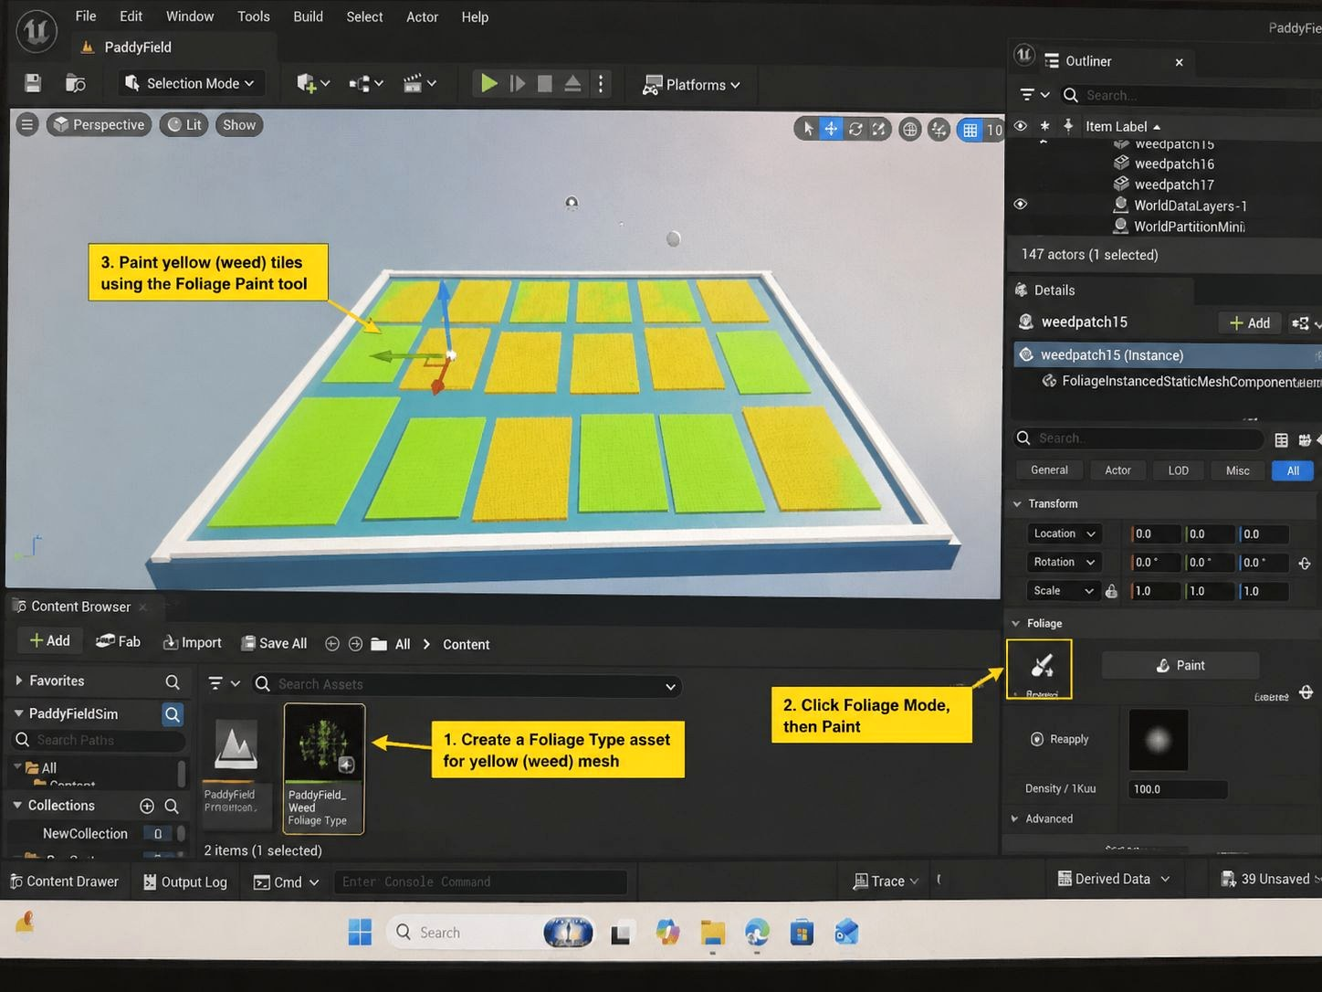
Figure 3: Paddy field divided into crop plots and irrigation channels.

Chapter 5: Testing and Result
The testing was performed on the extent to which the environment and integration process was usable, understandable and stable enough to demonstrate the prototype. It was discussed as an evaluation project, rather than a commercial farming system in the form of a prototype.

5.2 Test Cases
The test cases were developed with the main prototype requirements. The initial test was either the project Unreal Engine was launched with the necessary results being shown: the paddy-field base. In the second test, there was a check on the distinct appearance of crop and weed zones. The third test examined was whether the drone or spawn point was in an appropriate location. The fourth test examined the possibility of coordinate output being changed into a waypoint-like data. The fifth test involved testing the ability to log simulated spray actions which can be SPOT SPRAY or BLANKET SPRAY.
Test Case | Purpose | Expected Result | Evidence | Status
Environment load | Check project opens | Field platform visible | Screenshot | Pass
Crop/weed visibility | Check zone clarity | Green and yellow zones separated | Screenshot | Pass
Drone placement | Check mission start point | Drone/spawn visible in field | Screenshot | Pass
Data structure | Check integration format | Coordinates stored consistently | CSV/JSON/log | Pass
Spray log | Check mission output | SPOT or BLANKET action shown | Console/log | Partial/Prototype
Table 3: Main test cases for the environment and integration prototype.

References
Ehrampoosh, A. et al. (2025) 'Intelligent weed management using aerial image processing platforms: a review', Computers and Electronics in Agriculture. Available at: https://www.sciencedirect.com/science/article/pii/S0261219425000985 (Accessed: 1 June 2026).
Epic Games (2025) Unreal Engine Documentation. Available at: https://dev.epicgames.com/documentation/unreal-engine (Accessed: 1 June 2026).
Microsoft (2024) AirSim Documentation. Available at: https://microsoft.github.io/AirSim/ (Accessed: 1 June 2026).
PX4 (2025) AirSim Simulation. Available at: https://docs.px4.io/main/en/sim_airsim/ (Accessed: 1 June 2026).
Shah, S., Dey, D., Lovett, C. and Kapoor, A. (2017) 'AirSim: High-Fidelity Visual and Physical Simulation for Autonomous Vehicles', arXiv. Available at: https://arxiv.org/abs/1705.05065 (Accessed: 1 June 2026).
Zhang, J. et al. (2024) 'Advancements of UAV and deep learning technologies for weed detection and management in precision agriculture', Agronomy, 14(3), article 494.

