AUFIT
User’s manual
By Jean Louis-Guérin (DrCoolZic)
Revision 0.2a January 2014

Table of Content
AUFIT User’s manual 1
Table of Content 2
Presentation 3
Prerelease Note 3
Running the AUFIT Program 4
Reading Image Files 4
Reading Kryoflux FD set of stream files 4
SuperCard Pro FD image 5
Kryoflux Single file 5
Selecting the track to display Erreur ! Signet non défini.
The Histogram Graph 6
Flux Transitions Chart 6
Clock Chart 8
Data Graph 8
Zooming and Panning in the Charts 9
Track Buffer 10
Track info 10
Track layout info 10
Track content 10
Sector Buffer 12
Sector info 12
Sector layout info 12
Sectors content 12
Disk Layout 14
Disk Data 15
Protections 16
Document / Program History 21

Presentation
This document describes the usage of the AUFIT program. AUFIT is the acronym for Atari Universal Floppy-Disk Image Tool. The program can read many Floppy Disk image’s formats used with the Atari platform including images generated at the flux level by devices like SuperCard Pro, KryoFlux, and Discovery Cartridge. Once read the FD image can be analyzed and the content can be displayed using Graphical and Text outputs. It is also possible to output the information read to several image formats. It is therefore possible to use the program to convert from one format to another. Usage has been designed to be as simple as possible for casual users. However the program also provides powerful features for advanced users.

Release Note
- The program is in beta test. Most basic features are now implemented, but the the performance may be slow, and the program may terminate unexpectedly.
- Sorry but currently most of the developments are focused on functionalities and therefore I know that the GUI needs a lot of rework ☺
- Currently the program uses a large amount of memory. If you do not have a system with a lot of memory the program may run out of memory. Sometime restarting the program for looking at a new image may help.

Running the AUFIT Program
Currently the program does not requires to be installed and is provided directly as an executable: Aufit.exe. To run the program just double click the executable.
The program run under Windows Vista SP2, Windows 7 SP1, and Windows 8 or above. The program requires that the Microsoft.NET Framework 4.5 or above is installed. It also requires the Ookii Dialogs class library. The Ookii DLL is provided along with the executable and documentation.
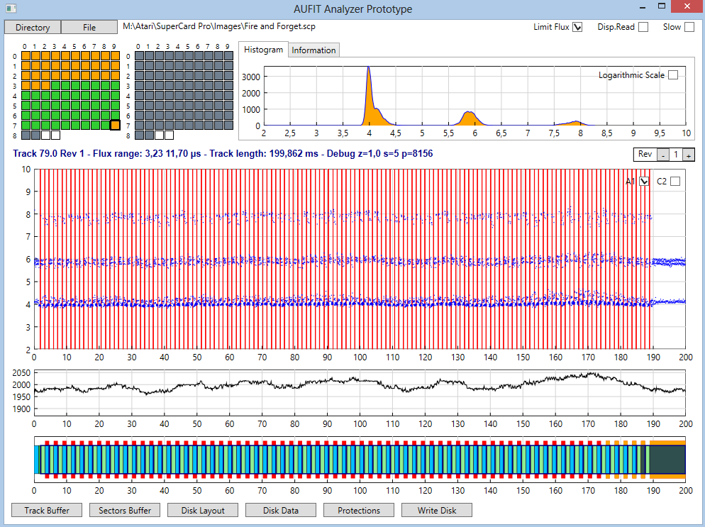

Reading Image Files
Currently the program can read a complete Floppy disk image composed of a set of KryoFlux stream files, or a SuperCopy Pro. It can also read a single track stream file.
To fully benefit from the Aufit analysis tools you need to sample at least three revolutions for each track but four is the recommended value. Please refer to the tools documentation to create FD images with 3 or more revolutions.

Reading Kryoflux FD set of stream files
You first need to use DTC to save the content of a complete floppy disk as a set of raw stream files in a directory. To read all the stream files in Aufit you must click the Directory Button. A form open and allow you to specify the location of the directory that contains the raw stream files. The stream files inside the directory can have any name but all of them must have the same “root” name (e.g. awesome) followed by .Track_Num followed by .Side followed .raw. For example awesome.00.0.raw, awesome.00.1.raw, awesome.01.0 etc. Reading all the files (usually 170 files) is IO intensive and may take some time.

SuperCard Pro FD image
You first need to use SCP to save the content of a complete floppy disk as one big file with extension .scp for example awesome.scp. To read the content of the SCP Floppy disk image you must click the File button and select the file to open.

Kryoflux Single file
It is also possible to read a unique stream file using the File button. However beware that that several commands in Aufit only make sense on a complete disk image. For example displaying the Disk Layout.

Track selection with the track grid

Once the FD image is loaded the information for the first track of the disk is displayed in the different graphs. The program also displays two track grids composed of selection buttons: one grid for each side of the floppy. At this stage a quick analysis of the track content is done and is used to determine the background color of the buttons:
- light green for normal tracks,
- light gray for unformatted tracks, and
- yellow for partially unformatted or “noisy” tracks.
As soon as a track is fully analyzed the background color will turn to:
- dark green for normal tracks,
- dark gray for unformatted/empty tracks, and
- red for protected tracks.
The currently selected track button can be identified by larger black border around the button of the grid. Leaving the mouse over a button display the track number.
If you click on a button of the track grid this will cause the track to be fully analyzed and all the graph to be updated for the selected track. The background color is therefore also updated as explained above. Once the track grids are “active” (for example by clicking one track selection button) you can move from one button to its neighbor by using the direction keys of your keyboard.
Note that full analysis of tracks is done whenever information about a track needs to be displayed. Therefore the Disk layout, Disk Data, Protections, and Write Disk buttons will force the analysis of all tracks. Once analyzed a track does not need to be reanalyzed (analysis information is saved) and therefore many operations execute faster once all the tracks have been analyzed (for example Disk Layout).

The Histogram Graph
This histogram representing the flux transition repartition and is displayed at the right of the button grid. Normally you should see three pics at 4, 6, and 8 microseconds. 
It is sometimes interesting to click the “Logarithmic Scale” check box to switch to a logarithmic scale on the Y axis. This allow to see information not visible on a linear scale. For example with DM you will see that the histogram has a lot of entries between 4 and 6 microsecond due to the “sliding fluxes” pattern used.


Flux Transitions Chart
The unprocessed flux transitions (i.e. flux directly read from the file) are displayed in a scattered chart. As a standard track is about 40000 flux, to speed up the display time only about 10000 flux transitions are displayed by default. If you want to display all the flux transitions you can click the slow check box in upper right corner of the window, this will force all the transitions to be displayed but the display will be slower. In the upper right of this chart you have two check box called A1 & C2. These check boxes are used to enable/disable the display of the 0xA1 and 0xC2 Sync Mark respectively as they would be detected by the WD1772 using a read track command (i.e. with the sync detector activated at all time). You need to refresh the display to see or hide hide the sync marks.



There is a check box button in the upper right corner of the program window called Limit Flux. By default this button is checked for unformatted track and is unchecked for formatted track but you can change its state at all time. Both the Histogram chart and the Flux Chart will be updated.
This is very useful when the track contains long flux transitions (like with NFA) to keep the graph readable.
Information about the currently selected track are displayed in a text box with the following information: track number, side, revolution, min and max value of the flux transition range, the track length, and some debug info.

Selecting Revolution Data
The box on the right indicates the currently used revolution. You can use the + and - button to select the data to display among the different revolutions sampled.
Selecting a specific revolution affect all displayed information including the track / sector buffer display.
One very nice feature is that if you set the revolution number to 0 then the transitions for all sampled revolutions are displayed! The transitions from different revolutions are separated by black lines. Of course the x timing axis is extended from 200 ms to 1000 ms. Be aware that if you check the slow button while displaying the data for all revolutions the display will be very slow as around 200000 points needs to be displayed.
This feature is nice to see protections like data over index, data beyond index, ID over index (and even Sync over index!). For example in Turrican track 2 we have the last sector that starts close to the end of the track.
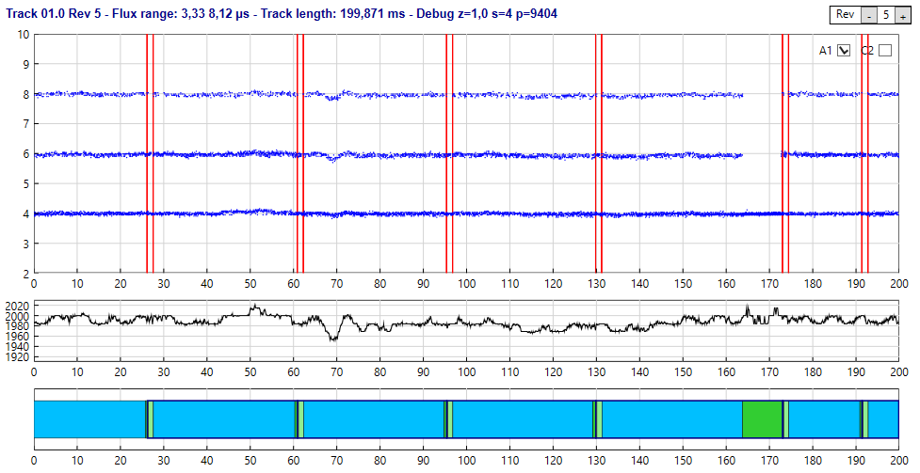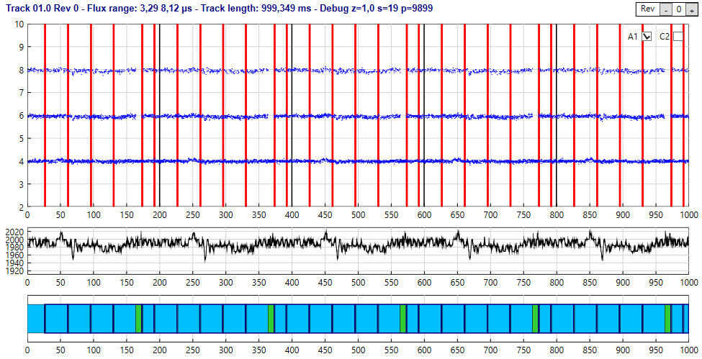
On the second chart we can see that the last sector starts close to the end and continue on the next revolution. If we now zoom we can see clearly what is happening (revolutions ends at 200 ms and is separated by a black line).
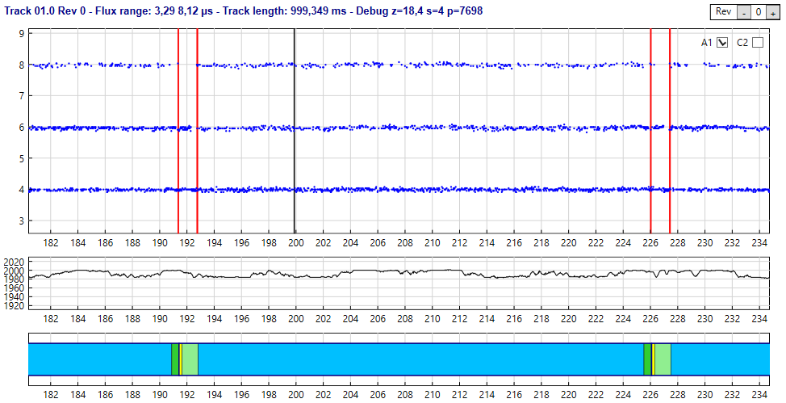

Clock Chart
The clock chart displays the period of the internal DPLL clock. The nominal period is 2000 ns but of course can vary a lot for over/under clocked sectors tracks.
This clock is computed by the DPLL and represent a running average frequency of the flux transitions fed to the DPLL. The Y scale is automatically adjusted.
The clock should normally stay stable around the 2000ns period but for protection like Copylock the period usually goes from 2000 to 2100 (5% increase) inside a sector. Some protections over clock or under clock the complete track.
In some specific cases like unformatted track/sector the period can go up to 2200ns or down to 1800ns (10% limits preset in the DPLL).
Note that this graph displays flux transitions processed by the DPLL code.

Data Graph
This graph display the data as they would be read by the read track command of the WD1772. The following color are used:
- The ID field is displayed in yellow (you probably need to zoom to see it),
- the intra-gap is displayed in light green,
- the Data field is displayed in sky blue, and
- The inter-GAP is displayed in lime green.
The data field color can change to aqua (lighter blue) for under clocked sector and dark blue for overclocked sectors and blue violet for sector with intra byte bit width variation (e.g. speedlock).
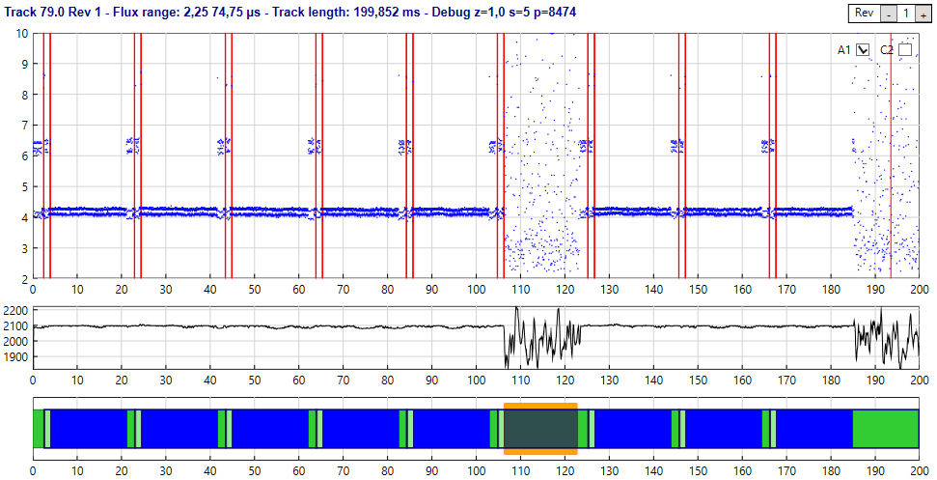
Data sectors with CRC error have a red border, and data sectors with fuzzy bits have an orange border (this also implies CRC error).
If you place the cursor over a sector in the data graph detailed information about the sector is displayed. If you double click a sector the content of this sector (as read by the FDC with a read sector command) is displayed in a separate window.
The display of the track data is processed by a complex algorithm (i.e. it is not a simple representation of a read track command). This permits to display correctly “complex” tracks containing protection like: Sector within sector, tracks with 70 sectors, tracks with one sector, etc.

Zooming and Panning in the Charts
- This functionality has been implemented to quickly provide Pan and Zoom but the use model needs to be reworked.
When the flux chart is not zoomed (default when first displayed) you can use the left button to define a zoom area (both in x and y directions). Click on the first point to start the definition of the area, keep the mouse button down and move to the second point to define a zoom area. A rubber band box is drawn that delimitates the area and when the left button is released the graph is zoomed in the area defined. The scales displayed on both axis are automatically adjusted function of the zoom factor.
Once zoomed a click with the left button allow to pan the graph. Click any point in the flux graph with the left button and while keeping the button down move the cursor. The image of the graph dynamically moves with the cursor. When you release the mouse button, the graph and the axis position are updated.
You can further zoom-in or zoom-out by using the mouse wheel.
If you want to reset the graphs to un-zoomed state click anywhere in the Flux chart with the right mouse button (this is also the way to force a redisplay).
Note that the same zoom factor is used to update the flux chart, the clock chart, and the data chart. Therefore these three graphs always stay in synchronized.
- Note that zooming in the Y direction only happen in the flux chart.
- Note that you must place the mouse in the flux chart to pan and zoom

Track Buffer
If you click the track buffer button a new window will open that display several information about the currently selected track for the defined revolution.

Track info
Contains the track/side number, the number of bytes, the track length as sampled by the imaging tool, and the number of sectors.

Track layout info
An array containing one line for each sector of a track, as well as a pre first sector that contains the GAP and eventually DATA segment information.
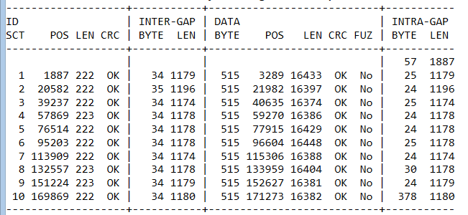
For each sector the following information is available:
- ID field: The sector ID, the position of the ID in microseconds from the index, the length of the ID field in microseconds and if the CRC of the ID is correct.
- Inter-Gap field: The number of bytes and the length of the gap in microseconds.
- Data Field: The number of bytes as decoded from the ID segment, the position in microseconds from the index, the length in microseconds, two indicators to display the status of the CRC and if the sector contains fuzzy bytes.
- Intra-Gap field: the number of bytes to reach the next sector and the length in microseconds.

Track content
A dump of all the data bytes exactly as they would have been read by the read track command of the WD1772. The data bytes are displayed by group of 16 with the following information:
- The first number is the position of the byte in the buffer (decimal value)
- The second number is the period of the first byte of the line.
- The third number is the position of the first byte of the line in microsecond relative to the index of the track.
- 16 bytes are displayed in hexadecimal
- The corresponding 16 ASCII characters for the 16 bytes.
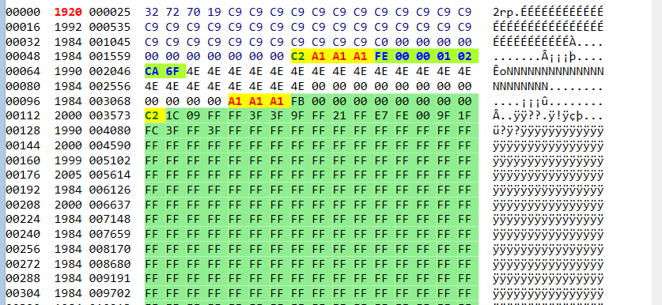
Colors and font style are used to provide additional information.
Background color:
- Red for invalid characters (F5-F7) in gap
- Coral for no flux bytes (MFM 0x0000)
- Yellow for Sync characters (MFM 0x4489 and 0x5224)
- Light green for bytes inside a ID field or a Data field.
Character color:
- Red for 0x4489 Sync characters
- Green for 0x5224Sync characters
- Blue for ID bytes
- Black for Data and intra-gap byte
- Green for inter-gap byte
Bold characters:
- For Sync characters (MFM 0x4489 and 0x5224)

Sector Buffer
If you click the sector buffer button a new window will open that display the bytes exactly as it would have been read by combining the read address and read sector commands of the WD1772.

Sector info
Contains the track/side number, and the number of sectors.

Sector layout info
An array containing one line for each sector of a track.
For each sector the following information is available:
- ID field: The sector ID, the position of the ID in microseconds from the index, the length of the ID field in microseconds and if the CRC of the ID is correct.
- Data Field: The number of bytes as decoded from the ID segment, the position in microseconds for the index, the length in microseconds, two indicators to display the status of the CRC and if the sector contains fuzzy bytes.
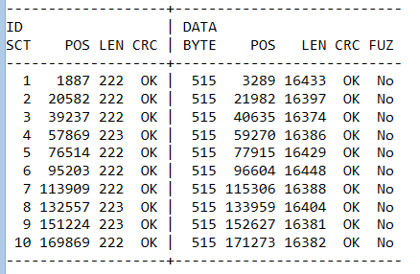

Sectors content
For each sector a line that indicates the sector number, the number of bytes for this sector, the position in microseconds from the index, the length in microseconds, indications to say if the CRC is good or bad, and if the sector has fuzzy bytes.
This is followed by a dump of all the data bytes exactly as they would have been read by the read sector command of the WD1772. The data bytes are displayed by group of 16 with the following information:
- The first number is the position of the byte in the buffer (decimal value)
- The second number is the period of the first byte of the line.
- The third number is the position of the first byte of the line in microsecond relative to the index of the track.
- 16 bytes are displayed in hexadecimal
- The corresponding 16 ASCII characters for the 16 bytes.
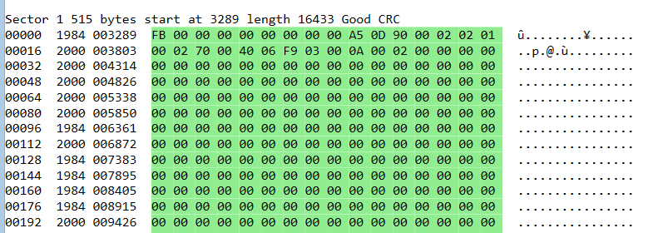
If fuzzy bytes have been found for one sector a “fuzzy mask” buffer is also displayed.
To find fuzzy bytes the Aufit program read the same sector multiple times from the different revolutions. If the content of a byte in the same position is different the mask value is the result of a xor operation.
Mask[offset] = (Sector_read_1[offset] ^ Sector_read_2[offset])
Thus same value (1&1 or 0&0) gives a result of zero and different value (0&1 or 1&0) gives a result of one. For example if the same byte is read one time as 0000 1111 and the next time as 0101 0101 the mask will be 0101 1010.
The mask can then be used to emulate fuzzy bits as follow:
FuzzyByte[offset] = (Sector[offset] & Mask[offset]) | (rand() & Mask[offset])
Where rand() is a function that randomly returns true or false.
The information for a sector presented above repeats for all sectors.
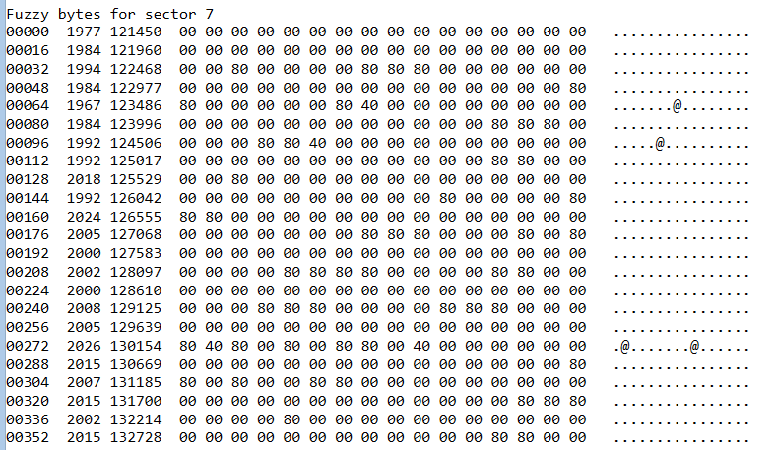

Disk Layout
If you click the Disk Layout button a new window will open to display the layout of one side of the floppy disk. The side is determined by the currently selected track. This display requires to analyze each and every tracks of the displayed side of the Floppy disk. Therefore, unless the track are already analyzed, this operation can take a long time to execute. During this operation the interface do not freeze and it is therefore possible to still select and display different tracks in the main window.
The following color information is used:
- The ID field of a sector is in white
- The Intra-gap of a sector is in light green
- The Data field of a sector is displayed:
- In Deep sky blue by default
- In blue for over clocked sector
- In Aqua for under clocked segment
- In Violet for sector with intra byte speed variation (e.g. speedlock)
- The Inter-gap are displayed in green
- Data sector with CRC error or Fuzzy bytes are displayed in red
- No Flux region are displayed in Yellow
- Sync Character are displayed in Black
For example the Turrican Game that has many protection and an irregular layout is displayed like this.
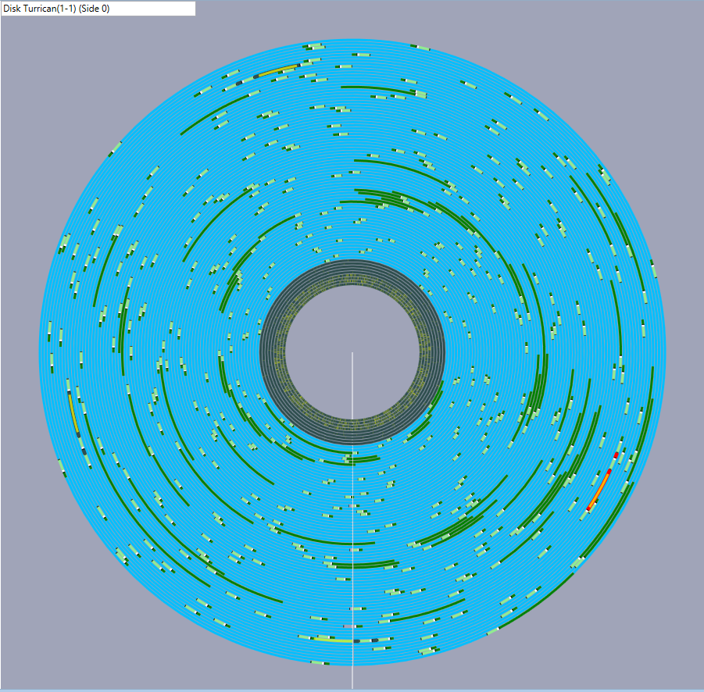

Disk Data
If you click the Disk Data button a new window will open and display the data on the floppy. This graph displays a lot of information so be patient.
The following color are used
- The Gap data are displayed in gray color proportional to the data value (so 0x00 is black and 0xFF is white and 0x55 is displayed as RGB={55,55,55}
- The Data uses the same principle but only using two color channels. For example 0x55 is displayed using RGB={00,55,55}
- The ID uses the blue channel for example RGB={00,00,55}
- NFA are displayed using yellow color
- Sync in Red
Here is an example of Disk Data Graph on the Theme Park Mystery Game
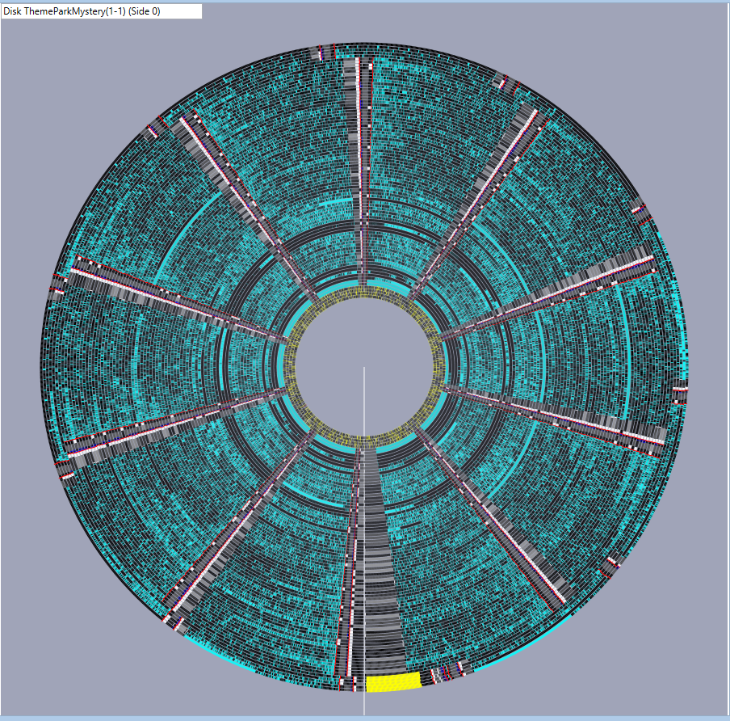

Protections
Protections are analyzed when a Track is displayed. You can use the Protection button to force the analysis of all the tracks. When a track is fully analyzed the background color in the track grid is updated as explained in Selecting the track to display. The Disk Layout and Disk Data button will also force the analysis of all the tracks.
You should select the Information tab close to the histogram to display protection information. If you use the Protection button all the protections for all the tracks are displayed in the information window.
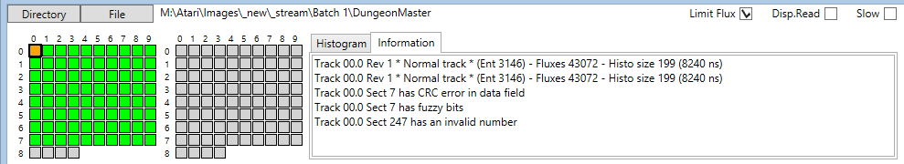
If you change the currently displayed track by clicking a track in the grid or by using the keyboard direction keys, all the protections for the selected track are displayed.
The following protections are currently analyzed.
- Track Protections
- Short Track
- Long Track
- Track has No Flux Area
- Track has data over index
- Track has data beyond index
- Track has id over index
- Missing track
- Extra track
- Sector Protections
- Sector not in sequence 1..n (used for Pasti)
- Duplicated Sectors
- Sector has invalid number
- Sector has nonstandard size (used for Pasti)
- Sector has Invalid data into Gap
- Sector has invalid sync sequence
- Sector Data has CRC error
- Sector ID has CRC error
- Sector has fuzzy bytes
- Long sector
- Short sector
- Intra sector bit width variation (e.g. speedlock)
- Sector has no data
- Sector with invalid track number
- Sector contains sector
For more details about these protections please refer to my document Atari Floppy Disk Copy Protection.

Write Disk
This button is used to save the Floppy Disk content using the Pasti STX format.
Beta release limitation:
- Currently this feature is in early test and may produce incorrect results.
- Currently the program takes an extremely conservative approach and always save track data and sector information. For more detail please refer to my Pasti File format documentation.
- However track data reuse to save space is implemented.

If the track has not yet been analyzed clicking on the Write track will force analysis of all the tracks.
When you click on the Write Disk button a form open and ask you the location and the name of the .stx file to write.

Checking Quality of generated images
This section discuss several questions around the quality of Floppy Disk images created with devices like KryoFlux or SuperCard Pro.
To some extent the quality of the image is only related to the floppy drives and floppy disks conditions and therefore independent of the imaging device used.

Cleaning
The first thing you want to do before imaging floppy disks is to clean the floppy drive head and a make sure you have spotlessly clean floppy disk.
- Cleaning the floppy drive head and cleaning the diskette can make a big difference
First always clean the floppy drive head using dedicated cleaning kits as this is a very easy to do operation.
Cleaning a floppy disk is a much more painful operation and therefore you can try to image the diskette without cleaning. If during analysis, as explained below, you find problems on the disk image you should clean the floppy diskette. The recommended way is to wipe the surface of the floppy diskette using a Q-Tip impregnated with head cleaning liquid. Normally this liquid evaporate quickly but you can use the other side of the Q-Tip to help dry the liquid in excess. There are numerous site and videos on the net that explain in detail these operations.
Important things to know when cleaning a floppy diskette:
- The side with an etiquette is the “second logical side” (side/head 1) of the diskette
- The side with the hub that engages with the drive motor is the “first logical side” (side/head 0) of the diskette.
So if you find problems on side/head 0 you need to clean the side without the etiquette (what I refer as the back side) and if you find problems with side/head 1 you need to clean the side with the etiquette (what I refer as the front side).

Analyzing Images
Now let’s move on the heart of the subject:
- How do I find if the image I have done is of good enough quality?
For that matter we use the Aufit program.
You first need to read the image you have created as explain in Reading Image Files section.
When the program read the image it already display useful information in the Track grids as the background color of each track is an indication of possible problem:
- A “normal” track has a light green background,
- an unformatted track has a light gray, and
- a track with potential problem is displayed in yellow.
At this stage only a quick Shannon Entropy analysis is done on the flux transitions histogram and a yellow color usually indicates track with partially unformatted areas or incorrectly imaged track but always require a more complete analysis.

For examples here is the result of reading an image of Sherman M4.
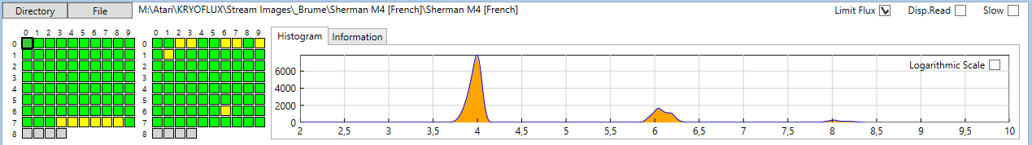
We can see that we have several tracks with a yellow background. If we click on some of these tracks we will find that in fact they are corrects.
But if we click on track 66 we can see than sector one has a lot of “dirty” flux transitions. Thanks to the DPLL these variations can be corrected and we are able to read the sector correctly. This is indicated by the fact that all the sectors read without CRC error.
But if we select the track 73 and zoom on the first sector area we can see that we also have dirty flux transitions, but here the DPLL is not capable to decode the information correctly.
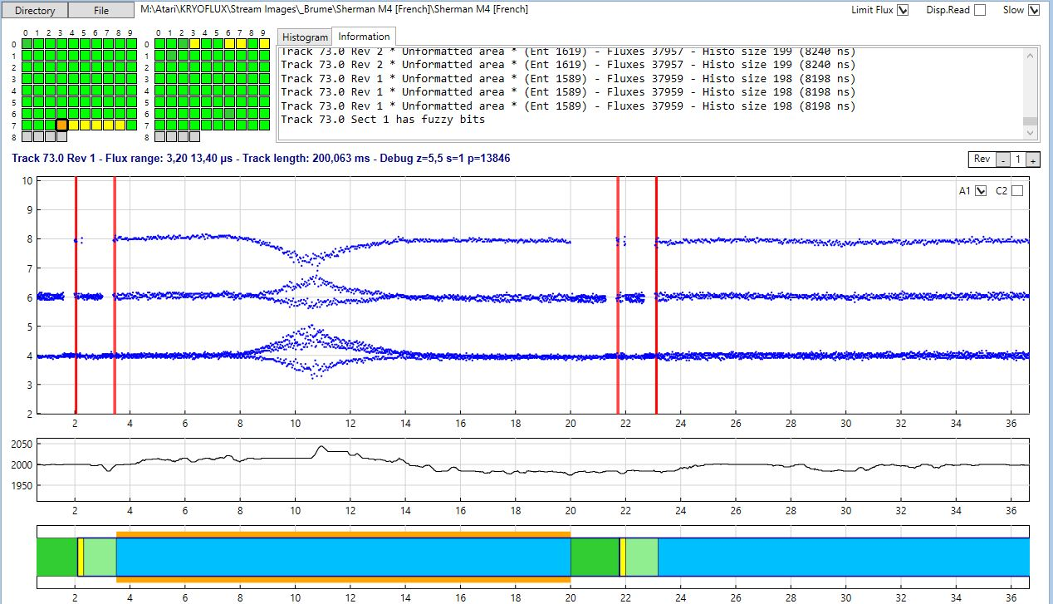
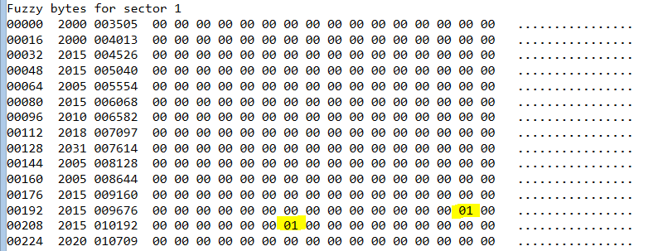
In this case we can see that the first sector is read with fuzzy bytes (orange box in data chart and indication in the information window). In fact if we further analyze the problem we can find, in the fuzzy mask buffer that only two bytes at position 206 and 214 vary between revolutions! This also why it is recommended to sample at least four revolutions as Aufit always checks fuzzy bytes by comparing the data read for all available revolutions.
In this case it seems obvious that is error is not part of a protection but due to a problem on the floppy diskette. In such case you should try to clean the diskette and image it again.
We can even look further at the problem. If we click the Sectors Buffer command we can see that on some of the revolutions the CRC is good and on some other revolutions the CRC is bad. Normally a fuzzy byte always result in a CRC error. Therefore this indicates that on some revolutions we have read the correct information. Currently Aufit is not able to use this information to create a working Past file but I may implement this feature in the future.
- You need to be aware that on an Atari system when reading sectors from a diskette an automatic retry is performed anytime a sector is not read correctly. This retry is transparent to the user and is used more often than you think.
- Therefore when you have problem clean the floppy and recreate new image, and if this still fails try to recreate the image several times. If the floppy is only marginally not read this may allow you to create a good image.
In order to find all possible problems you first need to run the Protection command and for each “protected track” (displayed with a red background in the track grid) you need to check if the problem comes from known protection or from “dirty flux transitions”. Unfortunately it seems very difficult to find out about bad images automatically and this is why you need to do a visual inspection using the different features of the Aufit program.

Document History
- V0.2 – January 18, 2014 – Added information about usage of the program, about protection analysis, and Writing Pasti files. Added a new complete section about analysis of the quality of the imaged floppy disks.
- V0.1 - January 9, 2014 – Preliminary release for v0.1 Alpha version.
- V0.0 – January 6, 2014 - preliminary first release.

Program History
- V0.2c January 22, 2014 – Bug fixes on Pasti Files generated
- V0.2a January 18, 2014 – Major change is the capability to write Pasti files. This is still experimental. Bug fixes and better read track report. Now Buffer display uses the currently displayed revolution. This allow to compare the decoded data for the different revolutions.
- V0.1b January 9, 2014 – Fixed one very nasty and tough to find bug. In .Net framework when you click a form to select a file the click event is not flushed and you get it back as a button click ... Also improved memory usage.
- V0.1a January 9, 2014 – Compared to initial release Protection analysis has been added. So only missing initial features is Pasti write capability.
Known problems: Run out of memory easily, GUI freeze with DISK DATA command.
- V0.0 January 6, 2014 – Initial alpha release on request.

