AUFIT
User’s manual
By Jean Louis-Guérin (DrCoolZic)
Revision 0.1 January, 2015

Table of Content
AUFIT User’s manual 1
Table of Content 2
Presentation 3
Beta Release Note 3
Running the AUFIT Program 4
Reading Image Files 4
Reading Kryoflux set of FD stream files 4
SuperCard Pro FD image 5
Kryoflux Single file 5
Track selection using the track grid 5
The Histogram Graph 6
Flux Transitions Chart 6
Selecting Revolution Data 7
Clock Chart 8
Data Graph 8
Zooming and Panning in the Charts 9
Track Buffer 10
Track info 10
Track layout info 10
Track content 10
Sector Buffer 12
Sector info 12
Sector layout info 12
Sectors content 12
Disk Layout 14
Disk Data 15
Protections 16
Write Disk 17
Checking Quality of generated images 18
Cleaning 18
Analyzing Images 18
Document History 21
Program History 21

Presentation
This document describes the usage of the AUFIT program. AUFIT is the acronym for Atari Universal Floppy-Disk Image Tool. The program reads several Floppy Disk image’s formats used with the Atari platform including images generated at the flux level by devices like SuperCard Pro, KryoFlux. The FD image is analyzed and its content is displayed using Graphical and Text output windows. It is also possible to write Floppy Disk images using different format like the Pasti .stx format used by many Atari emulators.
Usage has been designed to be as simple as possible for casual users. However the program also provides powerful features for advanced users.

Beta Release Note
- The program is in beta test. Most basic features are now implemented, but the program may still terminate unexpectedly.
- If program terminate because running out of memory. Restart the program and try again.

Running the AUFIT Program
Currently the program does not requires to be installed and is provided directly as an executable: Aufit.exe. To run the program just double click the executable.
The program run under Windows Vista SP2, Windows 7 SP1, and Windows 8 or above. The program requires that Microsoft.NET Framework 4.5 or above is installed. The program is provided as an executable with the documentation.
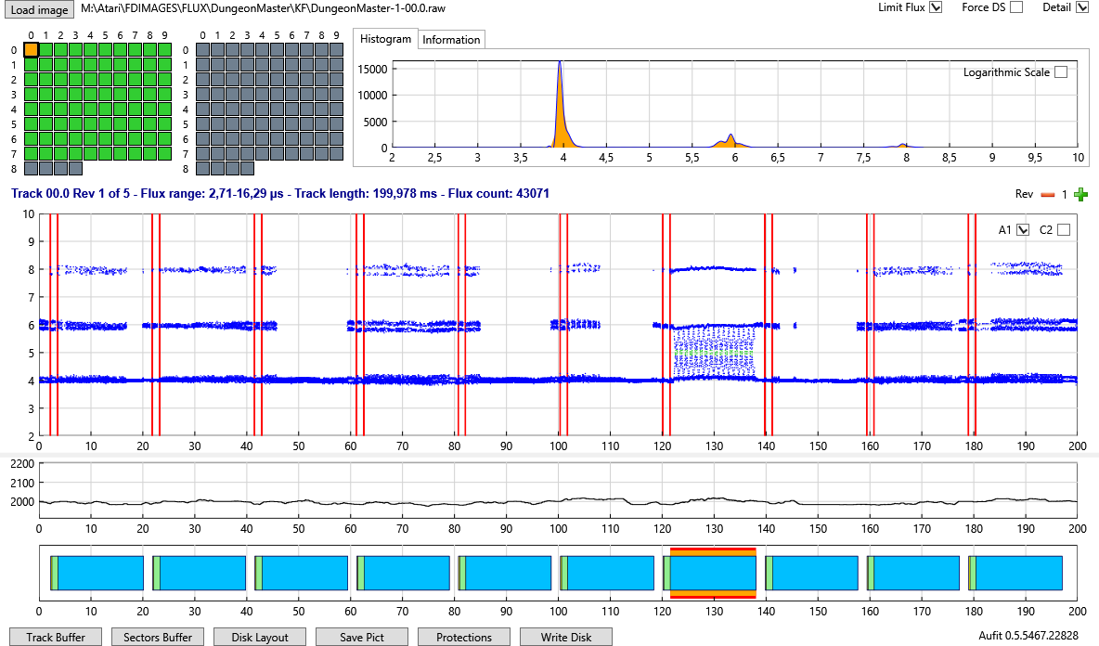

Reading Image Files
Currently the program can read a complete Floppy disk image composed of a set of KryoFlux stream files, or a SuperCopy Pro file.
To fully benefit from the Aufit analysis tools you need to sample a minimum of at least three revolutions for each track but five is the recommended value. Please refer to the tools documentation to create FD images with 3 or more revolutions.

Reading Kryoflux set of FD stream files
You first need to use DTC to save the content of a complete floppy disk as a set of raw stream files inside a directory. To read all the stream files in Aufit you must click the Load Image Button. A form open and allow you to select a raw stream files. The raw stream files inside a directory can use any name but all of them must have the same “root” name (for example awesome) followed by .Track_Num followed by .Side followed .raw.
For example awesome.00.0.raw, awesome.00.1.raw, awesome.01.0 etc. To read the complete image just click any of the raw files in the directory and all related files will be read. Reading all the files (usually 170 files) is IO intensive and may take some time.

SuperCard Pro FD image
You first need to use SCP to save the content of a complete floppy disk as one big file with the extension .scp for example awesome.scp. To read the content of the SCP Floppy disk image you must click the Load Image button and select the .scp file to open.

Other ways to select image files
Beyond the Load Image button you have two other choices to read image files:
- Select a file from the Windows explorer browser (an .scp or .raw file) drag and drop it in the Aufit main window.
- Associate .scp or .raw file extension with Aufit program. Once this is done it is possible to automatically start the Aufit program by double clicking on the associated file. This will start the program and load the selected image.

Track selection using the track grid

Once the FD image is loaded the information for the first track of the disk is displayed in the different graphs. The program also displays two track grids composed of selection buttons: one track grid for each side of the floppy. At this stage a quick analysis of the track content is done and is used to determine the background color of the buttons:
- light green for normal tracks,
- light gray for unformatted tracks, and
As soon as a track is fully analyzed the background color will turn to:
- Lime (green) for normal tracks,
- Orange for protected tracks,
- Blue for tracks with no sector but that have data that can be read (3+ sync),
- Yellow for track with possible data but no sync,
- Slate gray for unformatted/empty tracks
The currently selected track button can be identified by larger black border around the button of the grid. Leaving the mouse over a button display the track number.
If you click on a button of the track grid this will cause the track’s graphs to be updated for the selected track. Once the track grids are “active” (for example by clicking one track selection button) you can move from one button to its neighbor by using the direction keys of your keyboard.

The Histogram Graph
This histogram representing the flux transition repartition and is displayed at the right of the button grid. Normally you should see three pics at 4, 6, and 8 microseconds. 
It is sometimes interesting to click the “Logarithmic Scale” check box to switch to a logarithmic scale on the Y axis. This allow to see information not visible on a linear scale. For example with the game Dungeon Master you will see that the histogram has a lot of entries between 4 and 6 microsecond due to the “sliding fluxes” pattern used as a protection for this game.


Flux Transitions Chart
The unprocessed flux transitions (i.e. flux directly read from the file) are displayed as a scattered chart. A standard track contains about 40000 flux transitions. By default all the flux transitions are displayed. To speed up the display time, for example on a slower machine, you can uncheck the Detail check box in upper right corner of the window, this will force to display only 10000 flux transitions (about ¼ of the flux transitions). In the upper right of this chart you have two check boxes called A1 & C2. These check boxes are used to enable/disable the display of the 0xA1 and 0xC2 Sync Marks respectively as they would be detected by the WD1772 using a Read Track command (i.e. with the sync detector activated at all time). You need to refresh the display to see or hide the sync marks. By default the A1 sync marks are displayed and the C2 sync marks are not displayed.


There is a check box button in the upper right corner of the program window called Limit Flux. By default this button is checked for unformatted track and is unchecked for formatted track but you can change its state at all time. Both the Histogram chart and the Flux Chart use this checkbox and there content will be updated accordingly.
This is very useful when the track contains long flux transitions (like with NFA) to keep the graph readable.
Information about the currently selected track are displayed in a text box.

Selecting Revolution Data
The box on the right indicates the currently selected revolution. You can use the + and - button to select the data to display among the different revolutions sampled.
Selecting a specific revolution affect all displayed information including the Track Buffer and Sector Buffer display as well as writing data.
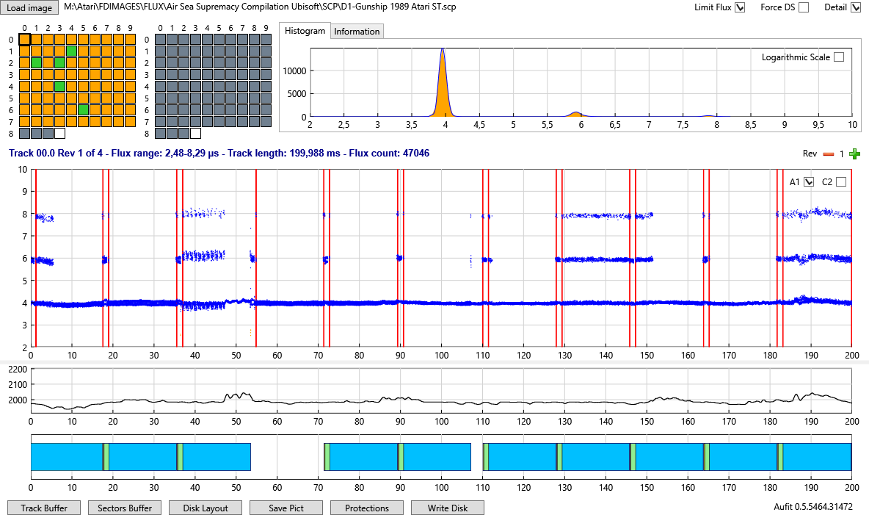

Bit Width Chart
The Bit Width chart displays the width of decoded half bit as computed by the internal DPLL clock. The nominal bit width is 2000ns but of course this value can vary a lot for over / under clocked sectors / tracks.
This bit width is computed by the DPLL and is proportional to the running average of the flux transitions fed to the DPLL. The Y scale is automatically adjusted.
The Bit Width should normally stay relatively stable around the 2000ns period but for protection like Copylock the period usually goes from 2000 to 2100 (5% increase) inside a sector. Some protections over clock or under clock the complete track.
In some specific cases like unformatted track/sector the period can go up to 2200ns or down to 1800ns, reaching the 10% limits set in the DPLL.

Data Graph
This graph displays all the sectors found on a track:
- The ID field is displayed in yellow (you probably need to zoom to see it),
- the Intra-gap field is displayed in light green,
- the Data field is displayed in blue.
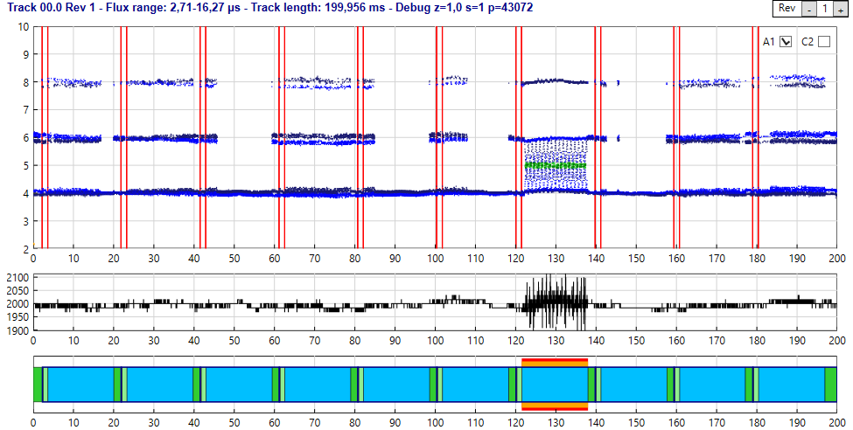
The data field color can change from Blue to Aqua (lighter blue) for under clocked sector, to Deep Sky Blue for overclocked sectors, and to Purple for sector with intra byte bit width variation (e.g. speedlock).
Data sectors with CRC error have a red border, and data sectors with fuzzy bits have an orange border.
If you place the cursor over a sector in the data graph detailed information about the sector is displayed. If you double click a sector the content of this sector (as read by the FDC with a read sector command) is displayed in a separate window.
The Data graph information uses a complex algorithm to display correctly “complex” tracks containing protection like: Sector within sector, tracks with large number of sectors, tracks with one sector, etc.

Zooming and Panning in the Charts
When the flux chart is not zoomed (default when first displayed) you can use the left mouse button to define a zoom area (zoom in both in x and y directions). Click on a first point to start the definition of the area, keep the mouse button down and move to a second point to define a zoom area. A rubber band box is drawn that delimitates the area and when the left button is released the graph is zoomed in the area defined. The scales displayed on both axis are automatically adjusted function of the zoom factor.
Once zoomed a click with the left button allow to pan the graph. Click any point in the flux graph with the left button and while keeping the button down move the cursor. The image of the graph dynamically moves with the cursor. When you release the mouse button, the graph and the axis position are updated.
You can further zoom-in or zoom-out by using the mouse wheel.
If you want to reset the graphs to un-zoomed state click anywhere in the Flux chart with the right mouse button (this is also the way to force a redisplay).
Note that the same zoom factor is used to update the flux chart, the clock chart, and the data chart. Therefore these three graphs always stay synchronized.
- Note that zooming in the Y direction only happen in the flux chart.
- You must place the mouse in the flux chart to pan and zoom any of the charts.

Track Buffer
If you click the Track Buffer button a new window will open that display several information about the currently selected track for the defined revolution.
A dump of all the data bytes exactly as they would have been read by the Read Track Command of the WD1772. The data bytes are displayed by group of 16 with the following information:
- The first number is the position of the byte in the buffer (decimal value)
- The second number is the period of the first byte of the line. If the period is 2.5% above normal the period is displayed in blue, if the period is 2.5% below normal it is displayed in red.
- The third number is the starting position of the first byte of the line in microsecond relative to the index of the track.
- 16 bytes are displayed in hexadecimal format
- The corresponding 16 ASCII characters for the 16 bytes.
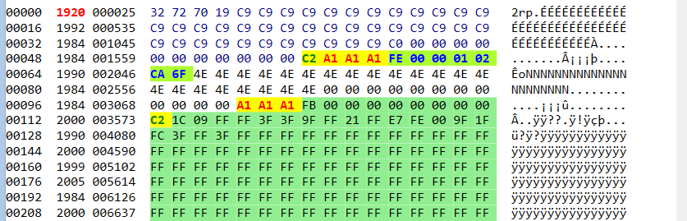
Colors and font style are used to provide additional information.
Background color:
- Light blue for invalid characters (F5-F7) into gaps
- Coral for no flux area (MFM 0x0000 / 0xFFFF)
- Yellow for Sync characters (MFM 0x4489 and 0x5224)
- Light green for bytes located inside an ID field or a Data field.
Character color:
- Red for 0x4489 Sync characters (0xA1)
- Green for 0x5224Sync characters (0xC2)
- Blue for ID bytes
- Black for Data and intra-gap byte and for inter-gap byte
Bold characters:
- For Sync characters (MFM 0x4489 and 0x5224)
Font Style
- Italic: When shifted track are used (data over index, data beyond index …) the read track command is extended to the beginning of the next revolution so the data are interpreted correctly. In that cases data beyond the index are displayed using italic style.

Sector Buffer
If you click the Sector Buffer button a new window will open that display the bytes exactly as it would have been read by combining the read address and read sector commands of the WD1772.
An array containing one line for each sector of a track.
For each sector the following information is available:
- ID field: The sector ID, the position of the ID in microseconds from the index, the length of the ID field in microseconds and if the CRC of the ID is correct.
- Data Field: The number of bytes as decoded from the ID segment, the position in microseconds for the index, the length in microseconds, two indicators to display the status of the CRC and if the sector contains fuzzy bytes.
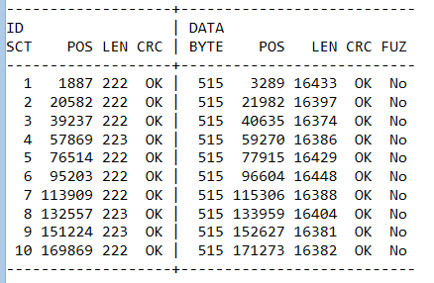

For each sector
- A line indicates the IDAM value, the ID content (Track, Side, Sect Number, Size, and CRC) and if the CRC is good or not
- A line indicates the number of bytes of the sector the position, the length, the IAM value, if the CRC is good or not, and if the sector contains fuzzy bytes.

This is followed by a dump of all the data bytes exactly as they would have been read by the read sector command of the WD1772. The data bytes are displayed by group of 16 with the following information:
- The first number is the position of the byte in the buffer (decimal value)
- The second number is the period of the first byte of the line. If the period is 2.5% above normal the period is displayed in blue, if the period is 2.5% below normal it is displayed in red.
- The third number is the position of the first byte of the line in microsecond relative to the index of the track.
- 16 bytes are displayed in hexadecimal
- The corresponding 16 ASCII characters for the 16 bytes.
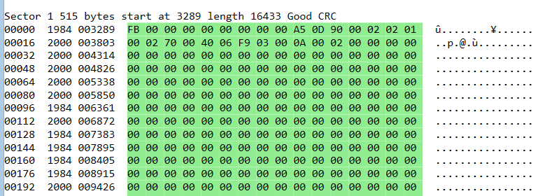
If fuzzy bytes have been found for one sector a “fuzzy mask” buffer is also displayed.
To find fuzzy bytes the Aufit program read the same sector multiple times from the different revolutions. If the content of a byte in the same position is different the mask value is the result of a xor operation.
Mask[offset] = (Sector_read_1[offset] ^ Sector_read_2[offset])
Thus same value (1&1 or 0&0) gives a result of zero and different value (0&1 or 1&0) gives a result of one. For example if the same byte is read one time as 0000 1111 and the next time as 0101 0101 the mask will be 0101 1010.
The mask can then be used to emulate fuzzy bits as follow:
FuzzyByte[offset] = (Sector[offset] & Mask[offset]) | (rand() & Mask[offset])
Where rand() is a function that randomly returns true or false.
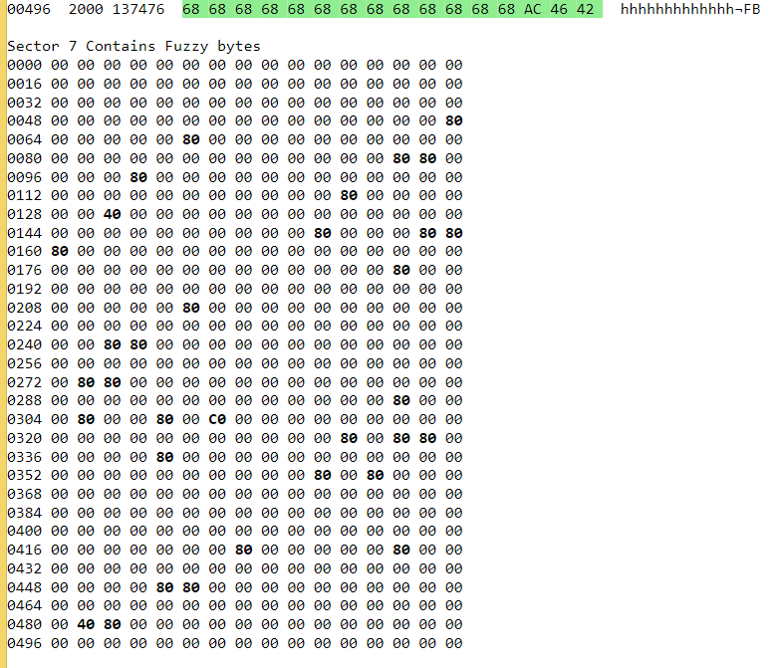
The information for a sector presented above repeats for all sectors.

Disk Layout
If you click the Disk Layout button a new window will open to display the layout of the two sides of the floppy disk.
The following color information is used:
- The ID field of a sector is in Yellow
- The Intra-gap of a sector is in light green
- The Data field of a sector is displayed:
- In Deep sky blue by default
- In blue for over clocked sector
- In Aqua for under clocked segment
- In Violet for sector with intra byte speed variation (e.g. speedlock)
- Data sector with CRC error or Fuzzy bytes are displayed in Orange
- No Flux region are displayed in Red
- Unformatted track in Gray
- Data track in Blue
- Track with “data in band” but no sync in Yellow
- Data bits outside normal range are displayed in White
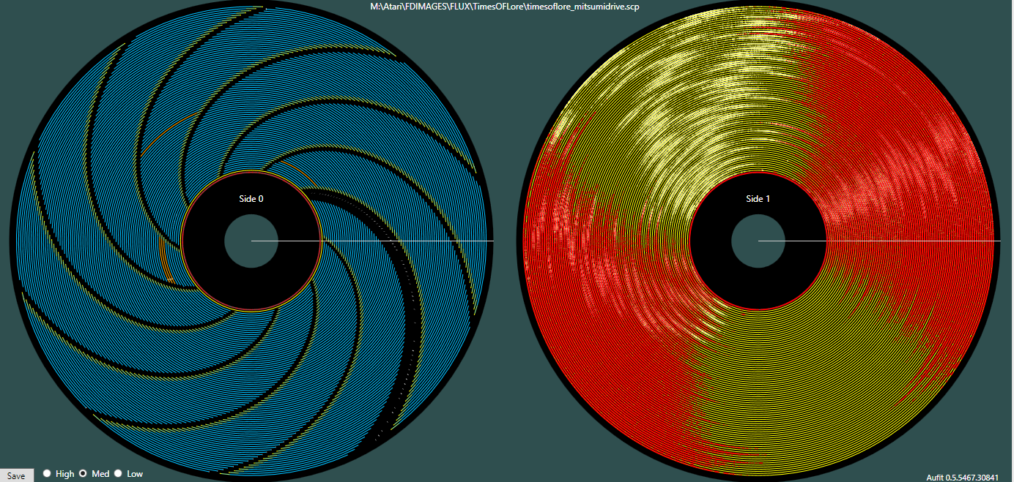

It is possible to save the layout picture with 3 resolutions (high, medium, low).

Protections
Protections are analyzed when a Track is displayed. You can use the Protection button to force an analysis of all the tracks. A track that contains protection or error is displayed in Orange.
You need to select the Information tab to display protection information (this will close the histogram tab). If you use the Protection button all the protections for all the tracks are displayed in the information window.
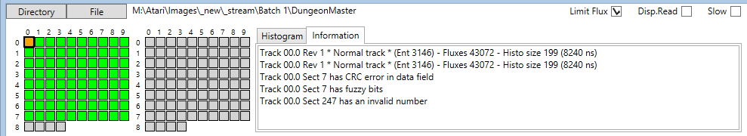
If you change the currently displayed track by clicking a track in the grid or by using the keyboard direction keys, all the protections for the selected track are displayed.
The following protections are currently analyzed.
- Track Protections
- Short track
- Long track
- Bad data into GAP
- Data beyond index
- data above index,
- ID beyond index,
- ID above index
- NFA
- Non sequential sector number (for ST format)
- Nonstandard sector size (for ST format)
- Sector Protections
- Duplicate sector number
- Nonstandard IDAM
- Invalid track number
- Invalid Side Number
- Invalid Sector number
- Invalid sector size
- ID CRC error
- Sector within sector
- Data CRC Error
- Fuzzy Sector
- Nonstandard DAM
- Long sector
- Short sector
- Sector bit width variation
- Sector with no data
For more details about these protections please refer to my document Atari Floppy Disk Copy Protection.

Write Disk
This button is used to save the Floppy Disk content using the Pasti STX format.
Beta release limitation:
- Currently the program takes an extremely conservative approach and always save track data and sector information. For more detail please refer to my Pasti File format documentation.
- However track data reuse to save space is implemented.

When you click on the Write Disk button a form open and ask you the location and the name of the .stx file to write.
- In order to produce correct stx file you must use images with data for at least three revolutions but a value of four is recommended.
If not enough data (revolutions) have been imaged a window will pop up and warn you. You are still offer the capability to force writing the stx file.
If the stx file already exist a window will pop up and ask you if you want to replace the existing file.
Normally single sided / double sided selection is computed by Aufit automatically. If you are getting error messages in Steem that an image of a track is missing on side 1 of the floppy image you may need to force Aufit to write stx file for double sided disk. For that matter please check the Force DS check Box located in the upper right corner of the window.

Checking Quality of generated images
This section discuss several questions around the quality of Floppy Disk images created with devices like KryoFlux or SuperCard Pro.
To some extent the quality of the image is only related to the floppy drives and floppy disks conditions and therefore independent of the imaging device used.

Cleaning
The first thing you want to do before imaging floppy disks is to clean the floppy drive head and a make sure you have spotlessly clean floppy disk.
- Cleaning the floppy drive head and cleaning the diskette can make a big difference
First always clean the floppy drive head using dedicated cleaning kits as this is a very easy to do operation.
Cleaning a floppy disk is a much more painful operation and therefore you can try to image the diskette without cleaning. If during analysis, as explained below, you find problems on the disk image you should clean the floppy diskette. The recommended way is to wipe the surface of the floppy diskette using a Q-Tip impregnated with head cleaning liquid. Normally this liquid evaporate quickly but you can use the other side of the Q-Tip to help dry the liquid in excess. There are numerous site and videos on the net that explain in detail these operations.
Important things to know when cleaning a floppy diskette:
- The side with an etiquette is the “second logical side” (side/head 1) of the diskette
- The side with the hub that engages with the drive motor is the “first logical side” (side/head 0) of the diskette.
So if you find problems on side/head 0 you need to clean the side without the etiquette (what I refer as the back side) and if you find problems with side/head 1 you need to clean the side with the etiquette (what I refer as the front side).

Analyzing Images
Now let’s move on the heart of the subject:
- How do I find if the image I have done is of good enough quality?
For that matter we use the Aufit program.
You first need to read the image you have created as explain in Reading Image Files section.
When the program read the image it already display useful information in the Track grids as the background color of each track is an indication of possible problem:
- A “normal” track has a light green background,
- an unformatted track has a light gray, and
- a track with potential problem is displayed in yellow.
At this stage only a quick Shannon Entropy analysis is done on the flux transitions histogram and a yellow color usually indicates track with partially unformatted areas or incorrectly imaged track but always require a more complete analysis.

For examples here is the result of reading an image of Sherman M4.
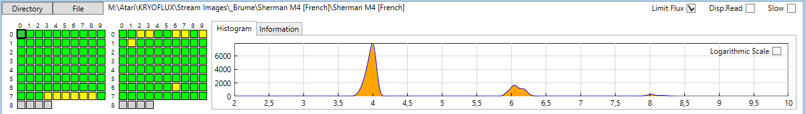
We can see that we have several tracks with a yellow background. If we click on some of these tracks we will find that in fact they are corrects.
But if we click on track 66 we can see than sector one has a lot of “dirty” flux transitions. Thanks to the DPLL these variations can be corrected and we are able to read the sector correctly. This is indicated by the fact that all the sectors read without CRC error.
But if we select the track 73 and zoom on the first sector area we can see that we also have dirty flux transitions, but here the DPLL is not capable to decode the information correctly.
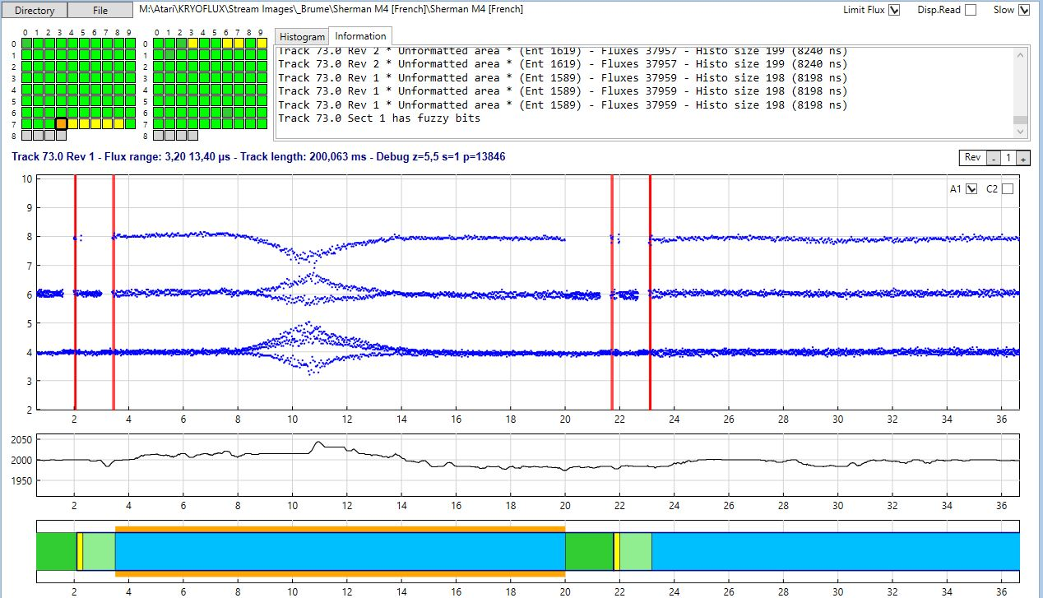
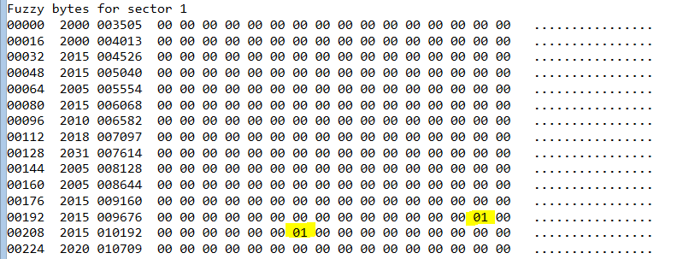
In this case we can see that the first sector is read with fuzzy bytes (orange box in data chart and indication in the information window). In fact if we further analyze the problem we can find, in the fuzzy mask buffer that only two bytes at position 206 and 214 vary between revolutions! This also why it is recommended to sample at least four revolutions as Aufit always checks fuzzy bytes by comparing the data read for all available revolutions.
In this case it seems obvious that is error is not part of a protection but due to a problem on the floppy diskette. In such case you should try to clean the diskette and image it again.
We can even look further at the problem. If we click the Sectors Buffer command we can see that on some of the revolutions the CRC is good and on some other revolutions the CRC is bad. Normally a fuzzy byte always result in a CRC error. Therefore this indicates that on some revolutions we have read the correct information. Currently Aufit is not able to use this information to create a working Past file but I may implement this feature in the future.
- You need to be aware that on an Atari system when reading sectors from a diskette an automatic retry is performed anytime a sector is not read correctly. This retry is transparent to the user and is used more often than you think.
- Therefore when you have problem clean the floppy and recreate new image, and if this still fails try to recreate the image several times. If the floppy is only marginally not read this may allow you to create a good image.
In order to find all possible problems you first need to run the Protection command and for each “protected track” (displayed with a red background in the track grid) you need to check if the problem comes from known protection or from “dirty flux transitions”. Unfortunately it seems very difficult to find out about bad images automatically and this is why you need to do a visual inspection using the different features of the Aufit program.

Document History
- V1.0 – January, 2015
- V0.4 – March 1, 2014 – Document double sided disk layout, Force DS, and color scheme changes.
- V0.3 – February 17, 2014 – Updated information for release 0.3a
- V0.2 – January 18, 2014 – Added information about usage of the program, about protection analysis, and Writing Pasti files. Added a new complete section about analysis of the quality of the imaged floppy disks.
- V0.1 - January 9, 2014 – Preliminary release for v0.1 Alpha version.
- V0.0 – January 6, 2014 - preliminary first release.

Program History
- V1.0 TODO
- V0.4b - March 1, 2014 Color scheme changed, improve disk data, fix pre sync data problem, and fix fuzzy assertion error in compare mode.
- V0.3a February 17, 2014 Check for incomplete information when writing Pasti. Corrected NFA display, improved FDC emulation. More robust: should be able to read corrupted Floppy Disk
- V0.2c January 22, 2014 – Bug fixes on Pasti Files generated
- V0.2a January 18, 2014 – Major change is the capability to write Pasti files. This is still experimental. Bug fixes and better read track report. Now Buffer display uses the currently displayed revolution. This allow to compare the decoded data for the different revolutions.
- V0.1b January 9, 2014 – Fixed one very nasty and tough to find bug. In .Net framework when you click a form to select a file the click event is not flushed and you get it back as a button click ... Also improved memory usage.
- V0.1a January 9, 2014 – Compared to initial release Protection analysis has been added. So only missing initial features is Pasti write capability.
Known problems: Run out of memory easily, GUI freeze with DISK DATA command.
- V0.0 January 6, 2014 – Initial alpha release on request.

