How to get started using the Ijulia notebooks using JuliaBox.com using the Free option

1. Go to <https://juliabox.com>

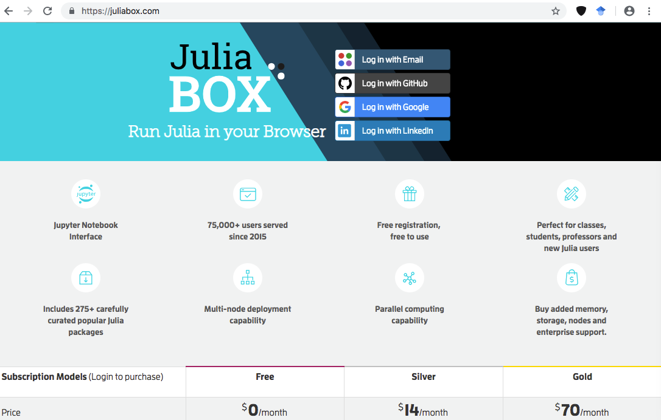

SIGN-IN using one of the various options.

1. To grab the notebooks and associated materials from

<https://github.com/beenlanced/intro2julia>

SELECT Git option here

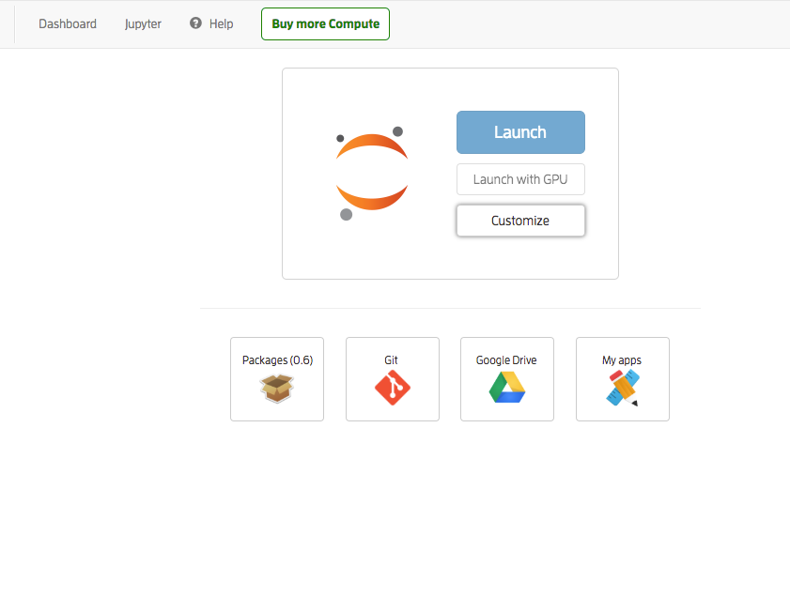

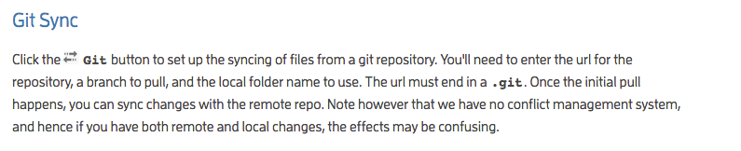

1. Clone the Git hub

Make sure to use to at .git at the end of the url like so:

<https://github.com/beenlanced/intro2julia.git>

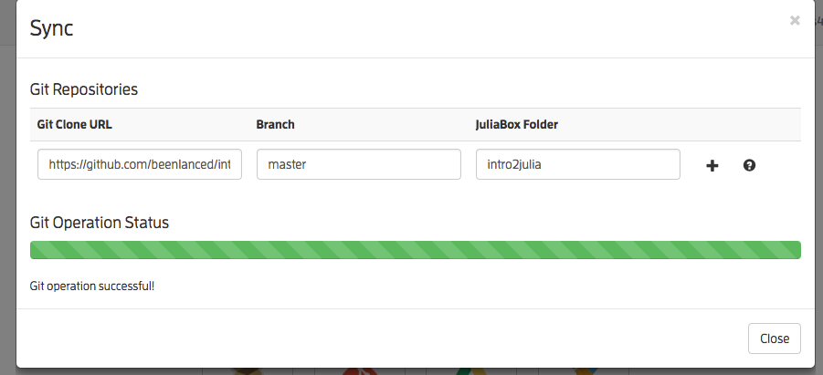

1. To See that the GIT hub repo has been added to you folders go back to the following window and then select LAUNCH



1. You will the **intro2julia** cloned repo from <https://github.com/beenlanced> in addition to whatever other folders you have including the pre-set folders from the good folks at JuliaBox.com. And there you have it have fun and enjoy

